Unión Internacional de Telecomunicaciones  Oficina de Normalización de las Telecomunicaciones | 

Ginebra, 16 de octubre de 2014

Ref:  Tel:  Fax:  Correo-e: | TSB AAP-44  AAP/MJ  +41 22 730 5860  +41 22 730 5853  tsbdir@itu.int | – A las Administraciones de los Estados Miembros de la Unión;  – A los Miembros del Sector UIT-T;  – A los Asociados del UIT-T  Copia:  – A los Presidentes y a los Vicepresidentes de las Comisiones de Estudio del UIT-T;  – Al Director de la Oficina de Desarrollo de las Telecomunicaciones;  – Al Director de la Oficina de Radiocomunicaciones

Asunto: | Situación de las Recomendaciones sometidas al proceso de aprobación alternativo (AAP)

Muy señora mía/Muy señor mío:

El proceso de aprobación alternativo (AAP) definido en la Recomendación A.8 del UIT-T se aplica a las Recomendaciones que no tienen consecuencias en materia de política o reglamentación y que no requieren, por lo tanto, la consulta formal de los Estados Miembros (véase el número 246B del Convenio de la UIT).
En el anexo 1 se enumera la lista de los textos cuyo estado ha cambiado con respecto a los anuncios TSB AAP precedentes.
Si desea formular un comentario en relación con una Recomendación sometida al AAP, le alentamos a utilizar el formulario de presentación de comentarios disponible en la página de la Recomendación que figura en el área AAP del sitio web del UIT-T, en la dirección http://www.itu.int/ITU-T/aap/ (véase también el anexo 2). Alternativamente, pueden presentarse comentarios completando el formulario del anexo 3 y remitiéndolo a la secretaría de la Comisión de Estudio correspondiente.
Le rogamos tenga en cuenta que no se alientan comentarios que se limiten a apoyar la adopción del texto en cuestión.
Le saluda atentamente,

Malcolm Johnson
Director de la Oficina de
Normalización de las Telecomunicaciones
Anexos: 3

Annex 1
(to TSB AAP-44)

Status codes used in the AAP announcements:
LC = Last Call
LJ = Last Call Judgment (includes comment resolution)
AR = Additional Review
AJ = Additional Review Judgment (includes comment resolution)
SG = For Study Group approval
A = Approved
AT = Approved with typographic corrections
AC = Approved after Additional Review of Comments
NA = Not approved
TAP = Moved to TAP (ITU-T A.8 / § 5.2)
ITU-T website entry page:
http://www.itu.int/ITU-T
Alternative approval process (AAP) welcome page:
http://www.itu.int/ITU-T/aapinfo
Note – A tutorial on the ITU-T AAP application is available under the AAP welcome page
ITU-T website AAP Recommendation search page:
http://www.itu.int/ITU-T/aap/
Study Group web pages and contacts:
SG 2 | http://www.itu.int/ITU-T/studygroups/com02 | tsbsg2@itu.int
SG 3 | http://www.itu.int/ITU-T/studygroups/com03 | tsbsg3@itu.int
SG 5 | http://www.itu.int/ITU-T/studygroups/com05 | tsbsg5@itu.int
SG 9 | http://www.itu.int/ITU-T/studygroups/com09 | tsbsg9@itu.int
SG 11 | http://www.itu.int/ITU-T/studygroups/com11 | tsbsg11@itu.int
SG 12 | http://www.itu.int/ITU-T/studygroups/com12 | tsbsg12@itu.int
SG 13 | http://www.itu.int/ITU-T/studygroups/com13 | tsbsg13@itu.int
SG 15 | http://www.itu.int/ITU-T/studygroups/com15 | tsbsg15@itu.int
SG 16 | http://www.itu.int/ITU-T/studygroups/com16 | tsbsg16@itu.int
SG 17 | http://www.itu.int/ITU-T/studygroups/com17 | tsbsg17@itu.int

Situation concerning Study Group 15 Recommendations under AAP
Rec # | Title | Last Call (LC) Period |  |  |  | Additional Review (AR) Period |  |  |  | Status
Rec # | Title | LC Start | LC End | LC  Result | LJ  Result | AR Start | AR End | AR  Result | AJ  Result | Status
G.989.2 (G.ngpon2.2) | 40-Gigabit-capable passive optical networks 2 (NG-PON2): Physical media dependent (PMD) layer specification (Summary) | 2014-07-01 | 2014-07-28 | LJ | SG |  |  |  |  | SG
G.994.1 (2012) Amd.4 | Handshake procedures for digital subscriber line transceivers: Amendment 4 - Additional codepoints for the support of G.fast (Summary) | 2014-09-16 | 2014-10-13 | SG |  |  |  |  |  | SG
G.9701 (G.fast-phy) | Fast Access to Subscriber Terminals (G.fast) - Physical layer specification (Summary) | 2014-09-16 | 2014-10-13 | SG |  |  |  |  |  | SG
G.9962 | Unified high-speed wire-line based home networking transceivers - Management specification (Summary) | 2014-09-16 | 2014-10-13 | A |  |  |  |  |  | A
Situation concerning Study Group 16 Recommendations under AAP
Rec # | Title | Last Call (LC) Period |  |  |  | Additional Review (AR) Period |  |  |  | Status
Rec # | Title | LC Start | LC End | LC  Result | LJ  Result | AR Start | AR End | AR  Result | AJ  Result | Status
F.734 (F.TPS-Reqs) | Definitions, requirements, and use cases for Telepresence Systems (Summary) | 2014-09-16 | 2014-10-13 | A |  |  |  |  |  | A
F.746.1 (F.LIMSreqs) | Requirements for Low-latency interactive multimedia streaming (Summary) | 2014-09-16 | 2014-10-13 | A |  |  |  |  |  | A
F.747.6 (H.USN-WQA) | Requirements of water quality assessment services in ubiquitous sensor network (USN) (Summary) | 2014-09-16 | 2014-10-13 | A |  |  |  |  |  | A
F.747.7 (F.NBLICreqs) | Requirements for network based location information conversion for location based applications and services (Summary) | 2014-09-16 | 2014-10-13 | A |  |  |  |  |  | A
F.748.0 (H.IoT-Reqs) | Common requirements for Internet of Things (IoT) applications (Summary) | 2014-09-16 | 2014-10-13 | A |  |  |  |  |  | A
F.748.1 (H.IoT-ID) | Requirements and common characteristics of IoT identifier for IoT service (Summary) | 2014-09-16 | 2014-10-13 | A |  |  |  |  |  | A
F.771 Amd.1 (F.771 Amd.1) | Service description and requirements for multimedia information access triggered by tag-based identification: Supporting multiple air interfaces (Summary) | 2014-09-16 | 2014-10-13 | A |  |  |  |  |  | A
G.711.1 (2009) Amd.1 (G.711.1-SWBS-Float) | Wideband embedded extension for G.711 PCM: New Annex G with an alternative implementation of stereo superwideband extension using floating-point (Summary) | 2014-09-16 | 2014-10-13 | A |  |  |  |  |  | A
G.722 (2012) Amd.1 (G.722-SWBS-Float) | 7 kHz audio-coding within 64 kbit/s: New Annex E with an alternative implementation of stereo superwideband extension using floating-point (Summary) | 2014-09-16 | 2014-10-13 | A |  |  |  |  |  | A
G.776.4 (G.SPNE) | Signal processing network equipment (Summary) | 2014-09-16 | 2014-10-13 | A |  |  |  |  |  | A
G.799.4 (G.CJB) | Procedures for control of de-jitter buffers used in PSTN-IP gateways carrying voice-band data (Summary) | 2014-09-16 | 2014-10-13 | A |  |  |  |  |  | A
H.222.0 (2012) Amd.5 | Information technology - Generic coding of moving pictures and associated audio information: Systems: Transport of MVC depth video sub-bitstream and support for HEVC low delay coding mode (Summary) | 2014-09-16 | 2014-10-13 | A |  |  |  |  |  | A
H.239 | Role management and additional media channels for H.300-series terminals (Summary) | 2014-09-16 | 2014-10-13 | A |  |  |  |  |  | A
H.248.39 | Gateway control protocol: H.248 SDP parameter identification and wildcarding (Summary) | 2014-09-16 | 2014-10-13 | A |  |  |  |  |  | A
H.248.57 | Gateway control protocol: RTP control protocol package (Summary) | 2014-09-16 | 2014-10-13 | A |  |  |  |  |  | A
H.248.89 (H.248.TCP) | Gateway control protocol: TCP support packages (Summary) | 2014-09-16 | 2014-10-13 | A |  |  |  |  |  | A
H.248.90 (H.248.TLS) | Gateway control protocol: H.248 packages for control of transport security using TLS (Summary) | 2014-09-16 | 2014-10-13 | A |  |  |  |  |  | A
H.248.91 (H.248.TLSPROF) | Guidelines on the use of H.248 capabilities for transport security in TLS networks in H.248 Profiles (Summary) | 2014-09-16 | 2014-10-13 | A |  |  |  |  |  | A
H.248.92 (H.248.SEPLINK) | Gateway control protocol: Stream endpoint interlinkage package (New) (Summary) | 2014-09-16 | 2014-10-13 | A |  |  |  |  |  | A
H.248.93 (H.248.DTLS) | Gateway control protocol: H.248 support for control of transport security using DTLS (Summary) | 2014-09-16 | 2014-10-13 | A |  |  |  |  |  | A
H.264.1 | Conformance specification for ITU-T H.264 advanced video coding (Summary) | 2014-09-16 | 2014-10-13 | A |  |  |  |  |  | A
H.265.1 (H.HEVC.Conf) | Conformance specification for ITU-T H.265 high efficiency video coding (Summary) | 2014-09-16 | 2014-10-13 | A |  |  |  |  |  | A
H.265.2 (H.HEVC.SW) | Reference software for ITU-T H.265 high efficiency video coding (Summary) | 2014-09-16 | 2014-10-13 | A |  |  |  |  |  | A
H.420 (F/H.TPS-Arch) | Telepresence System Architecture (Summary) | 2014-09-16 | 2014-10-13 | A |  |  |  |  |  | A
H.621 Amd.1 (H.621 Amd.1) | Architecture of a system for multimedia information access triggered by tag-based identification: Supporting multiple air interfaces (Summary) | 2014-09-16 | 2014-10-13 | A |  |  |  |  |  | A
H.785.0 (H.DS-DISR) | Digital signage: Requirements of disaster information services (Summary) | 2014-09-16 | 2014-10-13 | A |  |  |  |  |  | A
T.38 Amd.1 | Procedures for real-time Group 3 facsimile communication over IP networks: New Appendix VI, clarifications and corrections (Summary) | 2014-09-16 | 2014-10-13 | A |  |  |  |  |  | A
T.800 (2002) Amd.8 | Information technology - JPEG 2000 image coding system: Core coding system: Profiles for an interoperable master format (IMF) (Summary) | 2014-09-16 | 2014-10-13 | A |  |  |  |  |  | A
T.800 (2002) Cor.3 | Information technology - JPEG 2000 image coding system: Core coding system: Correction of equation G-9 (Summary) | 2014-09-16 | 2014-10-13 | A |  |  |  |  |  | A
T.800 (2002) Cor.4 | Information technology - JPEG 2000 image coding system: Core coding system: Miscellaneous corrections (Summary) | 2014-09-16 | 2014-10-13 | A |  |  |  |  |  | A
T.804 Amd.1 | Information technology - JPEG 2000 image coding system: Reference software: Reference software for the JP2 file format (Summary) | 2014-09-16 | 2014-10-13 | A |  |  |  |  |  | A
T.834 | Information technology - JPEG XR image coding system - Conformance testing (Summary) | 2014-09-16 | 2014-10-13 | A |  |  |  |  |  | A
Situation concerning Study Group 17 Recommendations under AAP
Rec # | Title | Last Call (LC) Period |  |  |  | Additional Review (AR) Period |  |  |  | Status
Rec # | Title | LC Start | LC End | LC  Result | LJ  Result | AR Start | AR End | AR  Result | AJ  Result | Status
X.520 Cor.1 | Information technology - Open Systems Interconnection - The Directory: Selected Attribute Types - Technical Corrigendum 1 (Summary) | 2014-10-16 | 2014-11-12 |  |  |  |  |  |  | LC
X.691 Cor.3 | Information technology - Specification of Packed Encoding Rules (PER) - Technical Corrigendum 3 (Summary) | 2014-10-16 | 2014-11-12 |  |  |  |  |  |  | LC
X.691 Cor.4 | Information technology - Specification of Packed Encoding Rules (PER) - Technical Corrigendum 4 (Summary) | 2014-10-16 | 2014-11-12 |  |  |  |  |  |  | LC
X.906 | Information technology - Open distributed processing - Use of UML for ODP system specifications (Summary) | 2014-08-16 | 2014-09-12 | AR |  | 2014-09-16 | 2014-10-06 | AC |  | AC
X.1157 (X.sap-7) | Technical capabilities of fraud detection and response for services with high assurance level requirements (Summary) | 2014-10-16 | 2014-11-12 |  |  |  |  |  |  | LC
X.1158 (X.sap-8) | Multi-factor authentication mechanisms using a mobile device (Summary) | 2014-10-16 | 2014-11-12 |  |  |  |  |  |  | LC
X.1159 (X.sap-9) | Delegated non-repudiation architecture based on ITU-T X.813 (Summary) | 2014-10-16 | 2014-11-12 |  |  |  |  |  |  | LC
X.1314 (X.unsec-1) | Security requirements and framework of ubiquitous networking (Summary) | 2014-10-16 | 2014-11-12 |  |  |  |  |  |  | LC
Z.161 | Testing and Test Control Notation version 3: TTCN-3 core language (Summary) | 2014-10-16 | 2014-11-12 |  |  |  |  |  |  | LC
Z.161.1 | Testing and Test Control Notation version 3: TTCN-3 language extensions: Support of interfaces with continuous signals (Summary) | 2014-10-16 | 2014-11-12 |  |  |  |  |  |  | LC
Z.161.2 | Testing and Test Control Notation version 3: TTCN-3 language extensions: Configuration and deployment support (Summary) | 2014-10-16 | 2014-11-12 |  |  |  |  |  |  | LC
Z.161.3 | Testing and Test Control Notation version 3: TTCN-3 language extensions: Advanced parameterization (Summary) | 2014-10-16 | 2014-11-12 |  |  |  |  |  |  | LC
Z.161.5 | Testing and Test Control Notation version 3: TTCN-3 Language extensions: Performance and real time testing (Summary) | 2014-10-16 | 2014-11-12 |  |  |  |  |  |  | LC
Z.165 | Testing and Test Control Notation version 3: TTCN-3 runtime interface (TRI) (Summary) | 2014-10-16 | 2014-11-12 |  |  |  |  |  |  | LC
Z.165.1 | Testing and Test Control Notation version 3: TTCN-3 language extensions: Extended TRI (Summary) | 2014-10-16 | 2014-11-12 |  |  |  |  |  |  | LC
Z.166 | Testing and Test Control Notation version 3: TTCN-3 control interface (TCI) (Summary) | 2014-10-16 | 2014-11-12 |  |  |  |  |  |  | LC

Annex 2
(to TSB AAP-44)
Using the on-line comment submission form
Comment submission
1) Go to AAP search Web page at http://www.itu.int/ITU-T/aap/
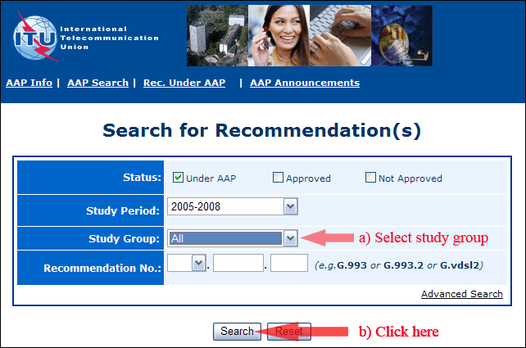
2) Select your Recommendation
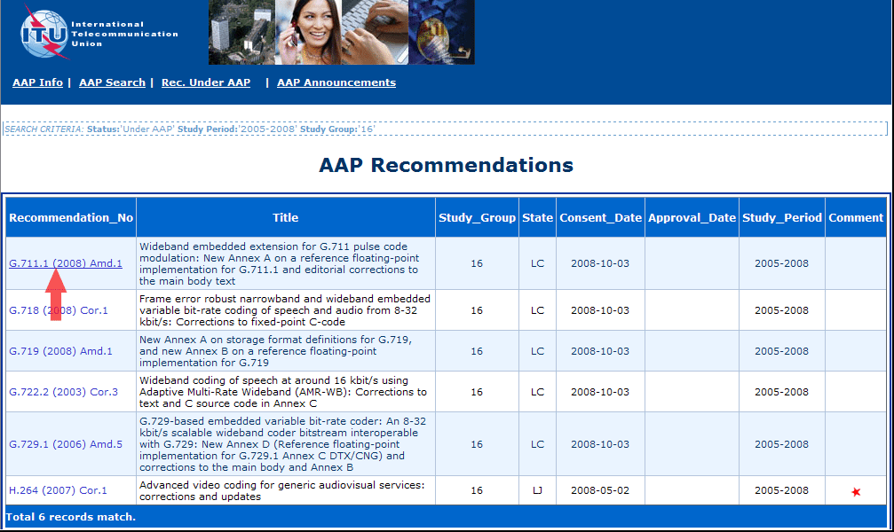
3) Click the "Submit Comment" button
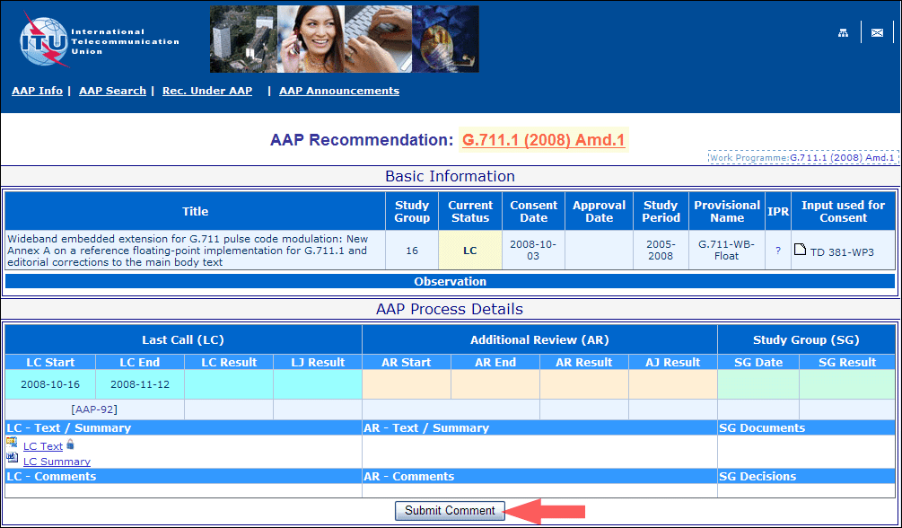
4) Complete the on-line form and click on "Submit"
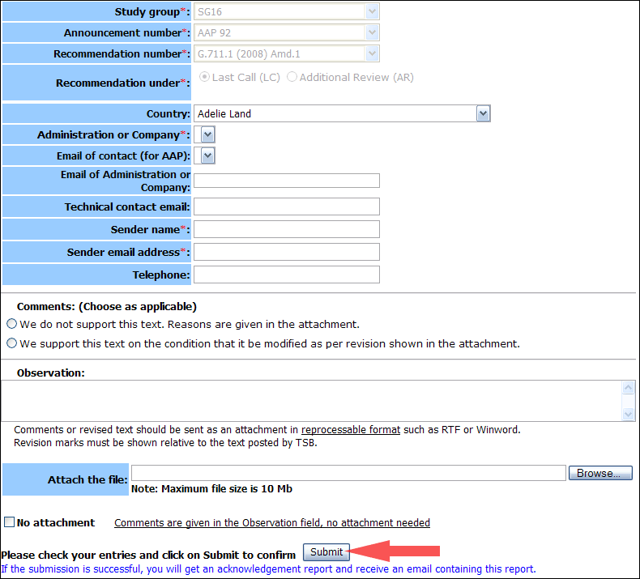
For more information, read the AAP tutorial on:
http://www.itu.int/ITU-T/aapinfo/files/AAPTutorial.pdf
Annex 3
(to TSB AAP-44)
Recommendations under LC/AR – Comment submission form
(Separate form for each Recommendation being commented upon)
ITU-T AAP comment submission form for the period 2009-2012
Study Group:
Announcement number:
Recommendation number:
Recommendation under: | Last call (LC)  Additional Review (AR)
Country:
Administration/Company:
Name of AAP Contact Person:
Email of AAP Contact Person:
Sender name:
(if different from AAP Contact Person)
Sender email address:
Telephone:
Comments:  (Choose as applicable) | We do not support this text. Reasons are given in the attachment.  We support this text on the condition that it be modified as per revision shown in the attachment.
Observations:
No attachment: Comments are given in the Observation field, no attachment needed
To be returned to: email: tsbsg....@itu.int
[or fax +41 22 730 5853]
Comments or revised text should be sent as an attachment in RTF or WinWord format.
Revision marks must be shown relative to the text posted by TSB.

