International Telecommunication Union
Telecommunication Standardization Bureau

Geneva, 16 April 2014

Ref:  Tel:  Fax:  E-mail: | TSB AAP-32  AAP/MJ  +41 22 730 5860  +41 22 730 5853  tsbdir@itu.int | – To Administrations of Member States of the Union;  – To ITU-T Sector Members;  – To ITU-T Associates  Copy:  – To the ITU-T Study Group Chairmen and Vice-Chairmen;  – To the Director of the Telecommunication Development Bureau;  – To the Director of the Radiocommunication Bureau

Subject: | Situation concerning Recommendations under the Alternative Approval Process (AAP)

Dear Sir/Madam,
The Alternative Approval Process (AAP) defined in Rec. ITU-T A.8 applies to Recommendations which do not have policy or regulatory implications and which, therefore, do not require formal consultation of Member States (see ITU Convention 246B).
Annex 1 lists those texts whose status has changed compared with previous TSB AAP Announcements.
If you wish to submit a comment relative to a Recommendation under AAP, you are encouraged to use the on-line AAP comment submission form available on the page of the Recommendation in the AAP area of the ITU-T website at http://www.itu.int/ITU-T/aap (see Annex 2). Alternatively, comments can be submitted by completing the form in Annex 3 and sending it to the secretariat of the concerned study group.
Please note that comments that simply support adoption of the text in question are not encouraged.
Yours faithfully,
Malcolm Johnson
Director of the Telecommunication Standardization Bureau
Annexes: 3

Annex 1
(to TSB AAP-32)

Status codes used in the AAP announcements:
LC = Last Call
LJ = Last Call Judgment (includes comment resolution)
AR = Additional Review
AJ = Additional Review Judgment (includes comment resolution)
SG = For Study Group approval
A = Approved
AT = Approved with typographic corrections
AC = Approved after Additional Review of Comments
NA = Not approved
TAP = Moved to TAP (ITU-T A.8 / § 5.2)
RI = Re-Initiate Alternative Approval Process (ITU-T A.8 / § 5.8)
ITU-T website entry page:
http://www.itu.int/ITU-T
Alternative approval process (AAP) welcome page:
http://www.itu.int/ITU-T/aapinfo
Note – A tutorial on the ITU-T AAP application is available under the AAP welcome page
ITU-T website AAP Recommendation search page:
http://www.itu.int/ITU-T/aap/
Study Group web pages and contacts:
SG 2 | http://www.itu.int/ITU-T/studygroups/com02 | tsbsg2@itu.int
SG 3 | http://www.itu.int/ITU-T/studygroups/com03 | tsbsg3@itu.int
SG 5 | http://www.itu.int/ITU-T/studygroups/com05 | tsbsg5@itu.int
SG 9 | http://www.itu.int/ITU-T/studygroups/com09 | tsbsg9@itu.int
SG 11 | http://www.itu.int/ITU-T/studygroups/com11 | tsbsg11@itu.int
SG 12 | http://www.itu.int/ITU-T/studygroups/com12 | tsbsg12@itu.int
SG 13 | http://www.itu.int/ITU-T/studygroups/com13 | tsbsg13@itu.int
SG 15 | http://www.itu.int/ITU-T/studygroups/com15 | tsbsg15@itu.int
SG 16 | http://www.itu.int/ITU-T/studygroups/com16 | tsbsg16@itu.int
SG 17 | http://www.itu.int/ITU-T/studygroups/com17 | tsbsg17@itu.int

Situation concerning Study Group 11 Recommendations under AAP
Rec # | Title | Last Call (LC) Period |  |  |  | Additional Review (AR) Period |  |  |  | Status
 |  | LC Start | LC End | LC  Result | LJ  Result | AR Start | AR End | AR  Result | AJ  Result
Q.3303.2 v2  (Q.3323.2 (Q.RwH248))) | Resource control protocol no.3 - Protocol at the interface between a Policy Decision Physical Entity (PD-PE) and a Policy Enforcement Physical Entity (PE-PE) (Rw interface): H.248 alternative version 2 (Summary) | 2014-03-01 | 2014-03-28 | LJ | A |  |  |  |  | A
Situation concerning Study Group 13 Recommendations under AAP
Rec # | Title | Last Call (LC) Period |  |  |  | Additional Review (AR) Period |  |  |  | Status
 |  | LC Start | LC End | LC  Result | LJ  Result | AR Start | AR End | AR  Result | AJ  Result
Q.1742.11 | IMT 2000 References (approved as of 31 December 2012) to ANSI-41 evolved Core Network with cdma2000 Access Network (Summary) | 2014-03-16 | 2014-04-12 | A |  |  |  |  |  | A
Y.2066  (Y.IoT-common-reqts) | Common requirements of Internet of Things (Summary) | 2014-03-16 | 2014-04-12 | LJ |  |  |  |  |  | LJ
Y.2067  (Y.gw-IoT-Reqts) | Common requirements and capabilities of a gateway for Internet of Things applications (Summary) | 2014-03-16 | 2014-04-12 | LJ |  |  |  |  |  | LJ
Y.3012 (Y.FNvirtreq) | Requirements of network virtualization for Future Networks (Summary) | 2014-03-16 | 2014-04-12 | A |  |  |  |  |  | A
Y.3300  (Y.SDN-FR (ex Y.FNsdn)) | Framework of Software-Defined Networking (Summary) | 2014-03-16 | 2014-04-12 | LJ |  |  |  |  |  | LJ
Y.3503 (Y.daas) | Requirements for desktop as a service (Summary) | 2014-03-16 | 2014-04-12 | LJ |  |  |  |  |  | LJ
Situation concerning Study Group 15 Recommendations under AAP
Rec # | Title | Last Call (LC) Period |  |  |  | Additional Review (AR) Period |  |  |  | Status
 |  | LC Start | LC End | LC  Result | LJ  Result | AR Start | AR End | AR  Result | AJ  Result
G.798 (2012) Amd.1 | Characteristics of optical transport network hierarchy equipment functional blocks: Amendment 1 (Summary) | 2014-04-16 | 2014-05-13 |  |  |  |  |  |  | LC
G.808.1 | Generic protection switching - Linear trail and subnetwork protection (Summary) | 2014-04-16 | 2014-05-13 |  |  |  |  |  |  | LC
G.873.1 | Optical Transport Network (OTN): Linear protection (Summary) | 2014-04-16 | 2014-05-13 |  |  |  |  |  |  | LC
G.976 | Test methods applicable to optical fibre submarine cable systems (Summary) | 2014-04-16 | 2014-05-13 |  |  |  |  |  |  | LC
G.979 (2010) Cor.1 | Characteristics of monitoring systems for optical submarine cable systems: Corrigendum 1 (Summary) | 2014-04-16 | 2014-05-13 |  |  |  |  |  |  | LC
G.984.5 | Gigabit-capable passive optical networks (GPON): Enhancement band (Summary) | 2014-04-16 | 2014-05-13 |  |  |  |  |  |  | LC
G.988 (2012) Amd.1 | ONU management and control interface (OMCI) specification: Amendment 1 - Maintenance (Summary) | 2014-04-16 | 2014-05-13 |  |  |  |  |  |  | LC
G.989.2 (G.ngpon2.2) | 40-Gigabit-capable passive optical networks 2 (NG-PON2): Physical media dependent (PMD) layer specification (Summary) | 2014-01-16 | 2014-02-12 | SG |  |  |  |  |  | RI
G.993.5 (2010) Amd.5 | Self-FEXT cancellation (vectoring) for use with VDSL2 transceivers: Amendment 5 - Exchange of transceiver IDs during initialization (Summary) | 2013-12-16 | 2014-01-12 | LJ | SG |  |  |  |  | AC
G.994.1 (2012) Amd.4 | Handshake procedures for digital subscriber line transceivers: Amendment 4 - Additional codepoints for the support of G.fast (Summary) | 2013-12-16 | 2014-01-12 | LJ | SG |  |  |  |  | RI
G.999.1 (2009) Amd.1 (G.int) | Interface between the link layer and the physical layer for digital subscriber line (DSL) transceivers: Amendment 1 Extension for upstream flow control over gamma reference point. (Summary) | 2013-12-16 | 2014-01-12 | LJ | SG |  |  |  |  | AC
G.8051/Y.1345 (2013) Amd.1 | Management aspects of the Ethernet Transport (ET) capable network element: Amendment 1 (Summary) | 2014-04-16 | 2014-05-13 |  |  |  |  |  |  | LC
G.8131/Y.1382 | Linear protection switching for MPLS transport profile (MPLS-TP) (Summary) | 2014-04-16 | 2014-05-13 |  |  |  |  |  |  | LC
G.8260 (2012) Amd.2 | Definitions and terminology for synchronization in packet networks: Amendment 2 (Summary) | 2014-04-16 | 2014-05-13 |  |  |  |  |  |  | LC
G.8261.1/Y.1361.1 (2012) Amd.1 | Packet Delay Variation Network Limits applicable to Packet Based Methods (Frequency Synchronization): Amendment 1 (Summary) | 2014-04-16 | 2014-05-13 |  |  |  |  |  |  | LC
G.8263/Y.1363 (2012) Amd.2 | Timing characteristics of packet-based equipment clocks: Amendment 2 (Summary) | 2014-04-16 | 2014-05-13 |  |  |  |  |  |  | LC
G.8264/Y.1364 | Distribution of timing information through packet networks (Summary) | 2014-04-16 | 2014-05-13 |  |  |  |  |  |  | LC
G.8265.1/Y.1365.1 | Precision time protocol telecom profile for frequency synchronization (Summary) | 2014-04-16 | 2014-05-13 |  |  |  |  |  |  | LC
G.8271.1/Y.1366.1 (2013) Amd.1 | Network limits for time synchronization in Packet networks: Amendment 1 (Summary) | 2014-04-16 | 2014-05-13 |  |  |  |  |  |  | LC
G.8273.2/Y.1368.2 | Timing characteristics of telecom boundary clocks and telecom time slave clocks (Summary) | 2014-04-16 | 2014-05-13 |  |  |  |  |  |  | LC
G.8273/Y.1368 (2013) Cor.1 | Framework of phase and time clocks: Corrigendum 1 (Summary) | 2014-04-16 | 2014-05-13 |  |  |  |  |  |  | LC
G.8275.1/Y.1369.1 | Precision time protocol telecom profile for phase/time synchronization with full timing support from the network (Summary) | 2014-04-16 | 2014-05-13 |  |  |  |  |  |  | LC
G.9701 (G.fast-phy) | Fast Access to Subscriber Terminals (G.fast) - Physical layer specification (Summary) | 2014-01-16 | 2014-02-12 | SG |  |  |  |  |  | RI
G.9961 (2010) Amd.2 (G.hn) | Unified high-speed wire-line based home networking transceivers - Data link layer specification: Amendment 2 (Summary) | 2013-12-16 | 2014-01-12 | LJ | SG |  |  |  |  | AC
G.9961 (G.hn) | Unified high-speed wire-line based home networking transceivers - Data link layer specification (Summary) | 2013-12-16 | 2014-01-12 | LJ | SG |  |  |  |  | AC
G.9962 | Unified high-speed wire-line based home networking transceivers - Management specification (Summary) | 2013-12-16 | 2014-01-12 | LJ | SG |  |  |  |  | RI
G.9963 (2011) Cor.1 | Unified high-speed wire-line based home networking transceivers - Multiple input/multiple output specification: Corrigendum 1 (Summary) | 2013-12-16 | 2014-01-12 | LJ | SG |  |  |  |  | AC
G.9972 (2010) Cor.1 | Coexistence mechanism for wireline home networking transceivers: Corrigendum 1 - Revised definition of coexisting systems categories (Summary) | 2013-12-16 | 2014-01-12 | LJ | SG |  |  |  |  | AC
G.9979  (G.99xx, 1905.1 Ext) | ITU-T Extension to the IEEE 1905.1 2013 Standard (Summary) | 2013-12-16 | 2014-01-12 | LJ | SG |  |  |  |  | RI
L.93 (L.omtl) | An optical fibre cable maintenance support, monitoring and testing system for optical fibre cable networks for trunk lines (Summary) | 2014-04-16 | 2014-05-13 |  |  |  |  |  |  | LC
Situation concerning Study Group 16 Recommendations under AAP
Rec # | Title | Last Call (LC) Period |  |  |  | Additional Review (AR) Period |  |  |  | Status
 |  | LC Start | LC End | LC  Result | LJ  Result | AR Start | AR End | AR  Result | AJ  Result
H.860 (H.MEDX) | Multimedia e-health data exchange services: data schema and supporting services (Summary) | 2014-03-16 | 2014-04-12 | A |  |  |  |  |  | A
Situation concerning Study Group 17 Recommendations under AAP
Rec # | Title | Last Call (LC) Period |  |  |  | Additional Review (AR) Period |  |  |  | Status
 |  | LC Start | LC End | LC  Result | LJ  Result | AR Start | AR End | AR  Result | AJ  Result
F.511 (F.5xx) | Directory Service - Support of tag-based identification services (Summary) | 2014-02-01 | 2014-02-28 | AR |  | 2014-03-16 | 2014-04-05 | AC |  | AC

Annex 2
(to TSB AAP-32)
Using the on-line comment submission form
Comment submission
1) Go to AAP search Web page at http://www.itu.int/ITU-T/aap/
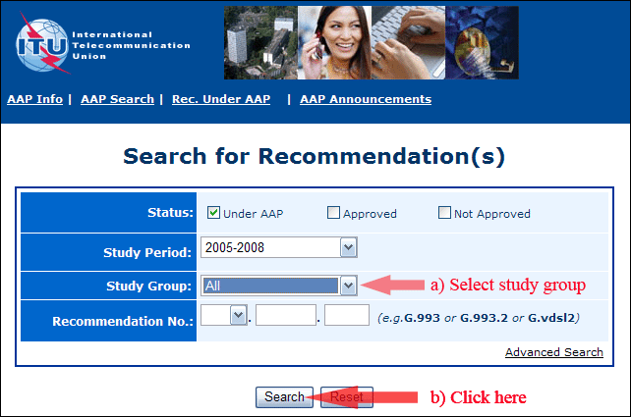
2) Select your Recommendation
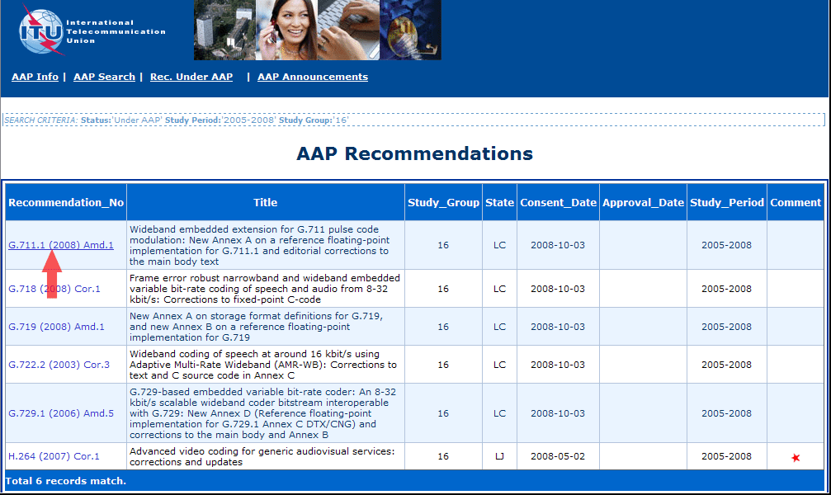
3) Click the "Submit Comment" button
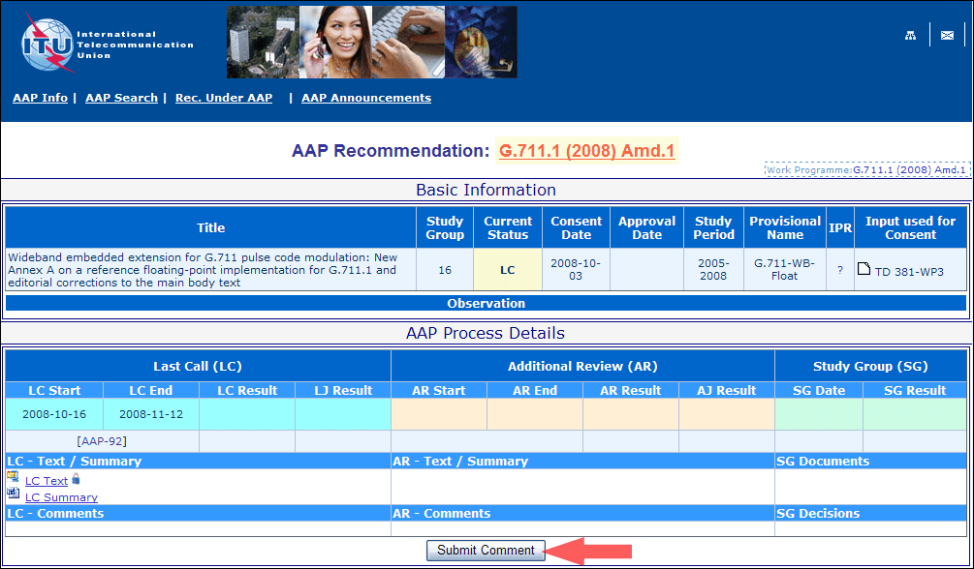
4) Complete the on-line form and click on "Submit"
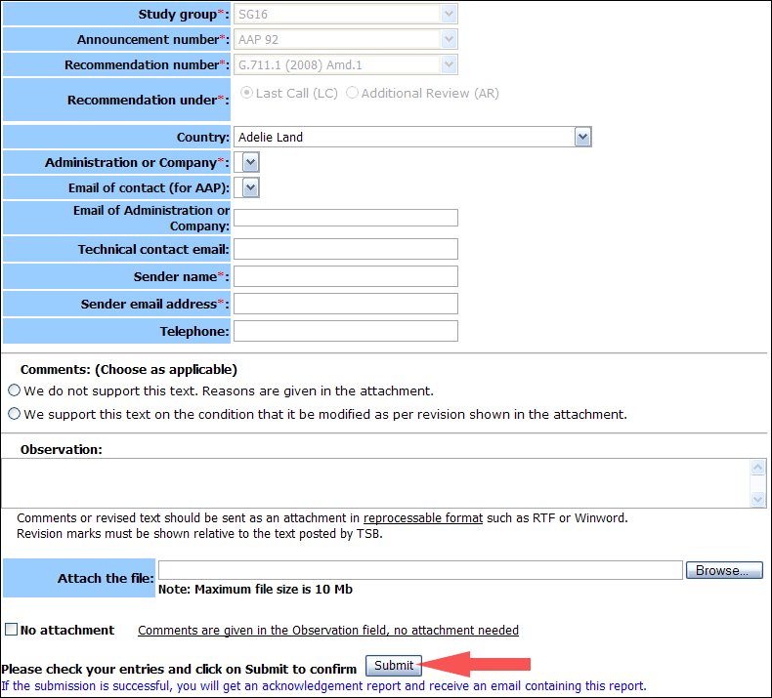
For more information, read the AAP tutorial on:
http://www.itu.int/ITU-T/aapinfo/files/AAPTutorial.pdf
Annex 3
(to TSB AAP-32)
Recommendations under LC/AR – Comment submission form
(Separate form for each Recommendation being commented upon)
ITU-T AAP comment submission form for the period 2009-2012
Study Group:
Announcement number:
Recommendation number:
Recommendation under: | Last call (LC)  Additional Review (AR)
Country:
Administration/Company:
Name of AAP Contact Person:
Email of AAP Contact Person:
Sender name:
(if different from AAP Contact Person)
Sender email address:
Telephone:
Comments:  (Choose as applicable) | We do not support this text. Reasons are given in the attachment.  We support this text on the condition that it be modified as per revision shown in the attachment.
Observations:
No attachment: Comments are given in the Observation field, no attachment needed
To be returned to: email: tsbsg....@itu.int
[or fax +41 22 730 5853]
Comments or revised text should be sent as an attachment in RTF or WinWord format.
Revision marks must be shown relative to the text posted by TSB.

