Unión Internacional de Telecomunicaciones
Oficina de Normalización de las Telecomunicaciones

Ginebra, 16 de enero de 2014

Ref:  Tel:  Fax:  Correo-e: | TSB AAP-26  AAP/MJ  +41 22 730 5860  +41 22 730 5853  tsbdir@itu.int | – A las Administraciones de los Estados Miembros de la Unión;  – A los Miembros del Sector UIT-T;  – A los Asociados del UIT-T  Copia:  – A los Presidentes y a los Vicepresidentes de las Comisiones de Estudio del UIT-T;  – Al Director de la Oficina de Desarrollo de las Telecomunicaciones;  – Al Director de la Oficina de Radiocomunicaciones

Asunto: | Situación de las Recomendaciones sometidas al proceso de aprobación alternativo (AAP)

Muy señora mía/Muy señor mío:

El proceso de aprobación alternativo (AAP) definido en la Recomendación A.8 del UIT-T se aplica a las Recomendaciones que no tienen consecuencias en materia de política o reglamentación y que no requieren, por lo tanto, la consulta formal de los Estados Miembros (véase el número 246B del Convenio de la UIT).
En el anexo 1 se enumera la lista de los textos cuyo estado ha cambiado con respecto a los anuncios TSB AAP precedentes.
Si desea formular un comentario en relación con una Recomendación sometida al AAP, le alentamos a utilizar el formulario de presentación de comentarios disponible en la página de la Recomendación que figura en el área AAP del sitio web del UIT-T, en la dirección http://www.itu.int/ITU-T/aap/ (véase también el anexo 2). Alternativamente, pueden presentarse comentarios completando el formulario del anexo 3 y remitiéndolo a la secretaría de la Comisión de Estudio correspondiente.
Le rogamos tenga en cuenta que no se alientan comentarios que se limiten a apoyar la adopción del texto en cuestión.
Le saluda atentamente,

Malcolm Johnson
Director de la Oficina de
Normalización de las Telecomunicaciones
Anexos: 3

Annex 1
(to TSB AAP-26)

Status codes used in the AAP announcements:
LC = Last Call
LJ = Last Call Judgment (includes comment resolution)
AR = Additional Review
AJ = Additional Review Judgment (includes comment resolution)
SG = For Study Group approval
A = Approved
AT = Approved with typographic corrections
AC = Approved after Additional Review of Comments
NA = Not approved
TAP = Moved to TAP (ITU-T A.8 / § 5.2)
ITU-T website entry page:
http://www.itu.int/ITU-T
Alternative approval process (AAP) welcome page:
http://www.itu.int/ITU-T/aapinfo
Note – A tutorial on the ITU-T AAP application is available under the AAP welcome page
ITU-T website AAP Recommendation search page:
http://www.itu.int/ITU-T/aap/
Study Group web pages and contacts:
SG 2 | http://www.itu.int/ITU-T/studygroups/com02 | tsbsg2@itu.int
SG 3 | http://www.itu.int/ITU-T/studygroups/com03 | tsbsg3@itu.int
SG 5 | http://www.itu.int/ITU-T/studygroups/com05 | tsbsg5@itu.int
SG 9 | http://www.itu.int/ITU-T/studygroups/com09 | tsbsg9@itu.int
SG 11 | http://www.itu.int/ITU-T/studygroups/com11 | tsbsg11@itu.int
SG 12 | http://www.itu.int/ITU-T/studygroups/com12 | tsbsg12@itu.int
SG 13 | http://www.itu.int/ITU-T/studygroups/com13 | tsbsg13@itu.int
SG 15 | http://www.itu.int/ITU-T/studygroups/com15 | tsbsg15@itu.int
SG 16 | http://www.itu.int/ITU-T/studygroups/com16 | tsbsg16@itu.int
SG 17 | http://www.itu.int/ITU-T/studygroups/com17 | tsbsg17@itu.int

Situation concerning Study Group 5 Recommendations under AAP
Rec # | Title | Last Call (LC) Period |  |  |  | Additional Review (AR) Period |  |  |  | Status
 |  | LC Start | LC End | LC  Result | LJ  Result | AR Start | AR End | AR  Result | AJ  Result
K.58 | EMC, resistibility and safety requirements and guidance for determining responsibility under co-located information and communication technology installations (Summary) | 2014-01-16 | 2014-02-12 |  |  |  |  |  |  | LC
K.95 (K.lit) | Surge parameters of isolating transformers used in telecommunication devices and equipment (Summary) | 2014-01-16 | 2014-02-12 |  |  |  |  |  |  | LC
K.96 (K.appl) | Surge protective components: Overview of surge mitigation functions and technologies (Summary) | 2014-01-16 | 2014-02-12 |  |  |  |  |  |  | LC
K.97 (K.dbs) | Lightning protection of distributed base stations (Summary) | 2014-01-16 | 2014-02-12 |  |  |  |  |  |  | LC
L.1002 (L.adapter Phase 2 (L.UPA portable)) | External universal power adapter solutions for portable information and communication technology devices (Summary) | 2014-01-16 | 2014-02-12 |  |  |  |  |  |  | LC
L.1005 (L.UCS test suites) | Test suites for assessment of the universal charger solution (Summary) | 2014-01-16 | 2014-02-12 |  |  |  |  |  |  | LC
L.1010 (L.Green-batteries) | Green batteries solution for mobile phones and other hand-held information and communication technology devices (Summary) | 2014-01-16 | 2014-02-12 |  |  |  |  |  |  | LC
L.1101 (L.rareMetals-measurement) | Measurement methods to characterize rare metals in information and communication technology goods (Summary) | 2014-01-16 | 2014-02-12 |  |  |  |  |  |  | LC
L.1320 (L.MandM_infra) | Energy efficiency metrics and measurement for power and cooling equipment for telecommunications and data centres (Summary) | 2014-01-16 | 2014-02-12 |  |  |  |  |  |  | LC
L.1340 (L.ref) | Informative values on the energy efficiency of telecommunication equipment (Summary) | 2014-01-16 | 2014-02-12 |  |  |  |  |  |  | LC
L.1500 (L.adaptationFramework) | Framework for information and communication technologies (ICTs) and adaptation to the effects of climate change (Summary) | 2014-01-16 | 2014-02-12 |  |  |  |  |  |  | LC
Situation concerning Study Group 9 Recommendations under AAP
Rec # | Title | Last Call (LC) Period |  |  |  | Additional Review (AR) Period |  |  |  | Status
 |  | LC Start | LC End | LC  Result | LJ  Result | AR Start | AR End | AR  Result | AJ  Result
J.181 (J.181-rev) | Digital program insertion cueing message for cable television systems (Summary) | 2013-12-16 | 2014-01-12 | A |  |  |  |  |  | A
J.287 (J.ascs-api) | Automation System to Compression System Communications Applications Program Interface (API) (Summary) | 2013-12-16 | 2014-01-12 | A |  |  |  |  |  | A
J.382 (J.atrans-spec) | Advanced digital downstream transmission systems for television, sound and data services for cable distribution (Summary) | 2013-12-16 | 2014-01-12 | A |  |  |  |  |  | A
J.604 (J.svc) | Requirements for Scalable Video Transmission System over Cable Network (Summary) | 2013-12-16 | 2014-01-12 | A |  |  |  |  |  | A
P.913 (P.av-dist (ex J.av-dist)) | Methods for subjectively assessing audiovisual quality of internet video and distribution quality television, including separate assessment of video quality and audio quality, and including multiple environments (Summary) | 2013-12-16 | 2014-01-12 | A |  |  |  |  |  | A
Situation concerning Study Group 11 Recommendations under AAP
Rec # | Title | Last Call (LC) Period |  |  |  | Additional Review (AR) Period |  |  |  | Status
 |  | LC Start | LC End | LC  Result | LJ  Result | AR Start | AR End | AR  Result | AJ  Result
Q.3614 (Q.OIP/OIR) | Originating identification presentation and originating identification restriction protocol specification as next-generation network supplementary service (Summary) | 2013-12-16 | 2014-01-12 | A |  |  |  |  |  | A
Situation concerning Study Group 12 Recommendations under AAP
Rec # | Title | Last Call (LC) Period |  |  |  | Additional Review (AR) Period |  |  |  | Status
 |  | LC Start | LC End | LC  Result | LJ  Result | AR Start | AR End | AR  Result | AJ  Result
E.804 (E.MQoS) | QoS Aspects for Popular Services in Mobile Networks (Summary) | 2014-01-16 | 2014-02-12 |  |  |  |  |  |  | LC
E.807 (E.CCH-QoE) | Definitions, associated measurement methods and guidance targets of user-centric parameters for call handling in cellular mobile voice service (Summary) | 2014-01-16 | 2014-02-12 |  |  |  |  |  |  | LC
G.107 | The E-model: a computational model for use in transmission planning (Summary) | 2014-01-16 | 2014-02-12 |  |  |  |  |  |  | LC
G.1029 (G.VSDF) | Voice Service Diagnosis Framework (Summary) | 2014-01-16 | 2014-02-12 |  |  |  |  |  |  | LC
G.1030 | Estimating end-to-end performance in IP networks for data applications (Summary) | 2014-01-16 | 2014-02-12 |  |  |  |  |  |  | LC
G.1031 (G.QoE-web) | QoE factors in web-browsing (Summary) | 2014-01-16 | 2014-02-12 |  |  |  |  |  |  | LC
P.381 | Technical requirements and test methods for the universal wired headset or headphone interface of digital mobile terminals (Summary) | 2014-01-16 | 2014-02-12 |  |  |  |  |  |  | LC
P.581 | Use of head and torso simulator (HATS) for hands-free and handset terminal testing (Summary) | 2014-01-16 | 2014-02-12 |  |  |  |  |  |  | LC
P.806 (P.MULTI) | A Subjective Quality Test Methodology using Multiple Rating Scales (Summary) | 2014-01-16 | 2014-02-12 |  |  |  |  |  |  | LC
P.1501 (P.STMWeb) | Subjective testing Methodology for web browsing (Summary) | 2014-01-16 | 2014-02-12 |  |  |  |  |  |  | LC
Situation concerning Study Group 13 Recommendations under AAP
Rec # | Title | Last Call (LC) Period |  |  |  | Additional Review (AR) Period |  |  |  | Status
 |  | LC Start | LC End | LC  Result | LJ  Result | AR Start | AR End | AR  Result | AJ  Result
Y.1903 (Y.miptv-req) | Functional requirements of Mobile IPTV (Summary) | 2013-12-01 | 2014-01-12 | A |  |  |  |  |  | A
Y.2064 (Y.energy-hn) | Energy saving using smart objects in home networks (Summary) | 2013-12-01 | 2014-01-12 | A |  |  |  |  |  | A
Y.2065 (Y.EHM-Reqts) | Service and capability requirements for e-health monitoring services (Summary) | 2013-12-01 | 2014-01-12 | LJ |  |  |  |  |  | LJ
Y.2253 (Y.MC-streaming) | Capabilities for multi-connection to support streaming service (Summary) | 2013-12-01 | 2014-01-12 | A |  |  |  |  |  | A
Y.2254 (Y.MC-eMMTel) | Capabilities of multi-connection to support enhanced Multimedia Telephony (eMMTel) services (Summary) | 2013-12-01 | 2014-01-12 | A |  |  |  |  |  | A
Y.3032 (Y.FNID-config) | Configurations of node identifiers and their mapping with locators in future networks (Summary) | 2013-12-01 | 2014-01-12 | A |  |  |  |  |  | A
Y.3033 (Y.FNDAN) | Framework of Data Aware Networking for Future Networks (Summary) | 2013-12-01 | 2014-01-12 | A |  |  |  |  |  | A
Y.3045 (Y.SUN-cdf) | Smart Ubiquitous Networks - Functional architecture of content delivery (Summary) | 2013-12-01 | 2014-01-12 | A |  |  |  |  |  | A
Y.3511 (Y.ccic) | Framework of inter-cloud for network and infrastructure (Summary) | 2013-12-01 | 2014-01-12 | LJ |  |  |  |  |  | LJ
Situation concerning Study Group 15 Recommendations under AAP
Rec # | Title | Last Call (LC) Period |  |  |  | Additional Review (AR) Period |  |  |  | Status
 |  | LC Start | LC End | LC  Result | LJ  Result | AR Start | AR End | AR  Result | AJ  Result
G.984.3 | Gigabit-capable Passive Optical Networks (GPON): Transmission convergence layer specification (Summary) | 2013-12-16 | 2014-01-12 | A |  |  |  |  |  | A
G.987.3 (G.xgpon.3) | 10-Gigabit-capable passive optical networks (XG-PON): Transmission convergence (TC) layer specification (Summary) | 2013-12-16 | 2014-01-12 | A |  |  |  |  |  | A
G.989.2 (G.ngpon2.2) | 40-Gigabit-capable passive optical networks 2 (NG-PON2): Physical media dependent (PMD) layer specification (Summary) | 2014-01-16 | 2014-02-12 |  |  |  |  |  |  | LC
G.993.2 (2011) Amd.5 | Very high speed digital subscriber line transceivers 2 (VDSL2): Amendment 5 Short reach VDSL2 with reduced power and enhanced data rate (Summary) | 2013-12-16 | 2014-01-12 | A |  |  |  |  |  | A
G.993.5 (2010) Amd.5 | Self-FEXT cancellation (vectoring) for use with VDSL2 transceivers: Amendment 5 - Exchange of transceiver IDs during initialization (Summary) | 2013-12-16 | 2014-01-12 | LJ |  |  |  |  |  | LJ
G.994.1 (2012) Amd.3 | Handshake procedures for digital subscriber line transceivers: Amendment 3 - Codepoints for G.998.4 extensions and exchange of transfer ID (Summary) | 2013-12-16 | 2014-01-12 | A |  |  |  |  |  | A
G.994.1 (2012) Amd.4 | Handshake procedures for digital subscriber line transceivers: Amendment 4 - Additional codepoints for the support of G.fast (Summary) | 2013-12-16 | 2014-01-12 | LJ |  |  |  |  |  | LJ
G.998.4 (2010) Amd.3 | Improved impulse noise protection for DSL transceivers: Amendment 3 - Extended memory for enhanced bit rates with retransmission (Summary) | 2013-12-16 | 2014-01-12 | A |  |  |  |  |  | A
G.999.1 (2009) Amd.1 (G.int) | Interface between the link layer and the physical layer for digital subscriber line (DSL) transceivers: Amendment 1 Extension for upstream flow control over gamma reference point. (Summary) | 2013-12-16 | 2014-01-12 | LJ |  |  |  |  |  | LJ
G.9701 (G.fast-phy) | Fast Access to Subscriber Terminals (G.fast) - Physical layer specification (Summary) | 2014-01-16 | 2014-02-12 |  |  |  |  |  |  | LC
G.9903 (G.g3-plc) | Narrow-band orthogonal frequency division multiplexing power line communication transceivers for G3-PLC networks (Summary) | 2013-12-16 | 2014-01-12 | LJ |  |  |  |  |  | LJ
G.9960 (2011) Amd.1 | Unified high-speed wire-line based home networking transceivers - System architecture and physical layer specification: Amendment 1 (Summary) | 2013-12-16 | 2014-01-12 | A |  |  |  |  |  | A
G.9961 (2010) Amd.2 (G.hn) | Unified high-speed wire-line based home networking transceivers - Data link layer specification: Amendment 2 (Summary) | 2013-12-16 | 2014-01-12 | LJ |  |  |  |  |  | LJ
G.9961 (G.hn) | Unified high-speed wire-line based home networking transceivers - Data link layer specification (Summary) | 2013-12-16 | 2014-01-12 | LJ |  |  |  |  |  | LJ
G.9962 | Unified high-speed wire-line based home networking transceivers - Management specification (Summary) | 2013-12-16 | 2014-01-12 | LJ |  |  |  |  |  | LJ
G.9963 (2011) Amd.1 | Unified high-speed wire-line based home networking transceivers - Multiple input/multiple output specification: Amendment 1 (Summary) | 2013-12-16 | 2014-01-12 | A |  |  |  |  |  | A
G.9963 (2011) Cor.1 | Unified high-speed wire-line based home networking transceivers - Multiple input/multiple output specification: Corrigendum 1 (Summary) | 2013-12-16 | 2014-01-12 | LJ |  |  |  |  |  | LJ
G.9972 (2010) Cor.1 | Coexistence mechanism for wireline home networking transceivers: Corrigendum 1 - Revised definition of coexisting systems categories (Summary) | 2013-12-16 | 2014-01-12 | LJ |  |  |  |  |  | LJ
G.9979 (G.99xx, 1905.1 Ext) | ITU-T Extension to the IEEE 1905.1 2013 Standard (Summary) | 2013-12-16 | 2014-01-12 | LJ |  |  |  |  |  | LJ
Situation concerning Study Group 16 Recommendations under AAP
Rec # | Title | Last Call (LC) Period |  |  |  | Additional Review (AR) Period |  |  |  | Status
 |  | LC Start | LC End | LC  Result | LJ  Result | AR Start | AR End | AR  Result | AJ  Result
F.746.2 (F.UDExch) | Service description for user data exchange between functional components in network entities and terminals (Summary) | 2014-01-16 | 2014-02-12 |  |  |  |  |  |  | LC
F.747.5 (F.USN-ALI) | Requirements and functional architecture of an automatic location identification system for ubiquitous sensor network (USN) applications and services (Summary) | 2013-12-16 | 2014-01-12 | A |  |  |  |  |  | A
G.161.1 (G.DNH) | Do-no-harm testing (Summary) | 2013-12-16 | 2014-01-12 | A |  |  |  |  |  | A
H.222.0 (2012) Amd.1 (H.222.0 (2006) Amd.8) | Information technology - Generic coding of moving pictures and associated audio information: Systems: Extensions for simplified carriage of MPEG-4 over MPEG-2 (Summary) | 2013-12-16 | 2014-01-12 | A |  |  |  |  |  | A
H.222.0 (2012) Amd.2 (H.222.0 (2006) Amd.9) | Information technology - Generic coding of moving pictures and associated audio information: Systems: Signalling of Transport profiles, signalling MVC view association to eye and MIME type registration (Summary) | 2013-12-16 | 2014-01-12 | A |  |  |  |  |  | A
H.222.0 (2012) Amd.3 | Information technology - Generic coding of moving pictures and associated audio information: Systems: Transport of HEVC video over MPEG-2 systems (Summary) | 2013-12-16 | 2014-01-12 | A |  |  |  |  |  | A
H.222.0 (2012) Amd.4 | Information technology - Generic coding of moving pictures and associated audio information: Systems: Support for event signalling in Transport Stream in MPEG-2 systems (Summary) | 2013-12-16 | 2014-01-12 | A |  |  |  |  |  | A
H.235.0 | H.323 security: Framework for security in H-series (H.323 and other H.245-based) multimedia systems (Summary) | 2013-12-16 | 2014-01-12 | A |  |  |  |  |  | A
H.235.6 | H.323 security: Encryption profile with native H.235/H.245 key management (Summary) | 2013-12-16 | 2014-01-12 | A |  |  |  |  |  | A
H.248.80 (H.248.SDP-MAPPER) | Gateway control protocol: Usage of the revised SDP offer / answer model with H.248 (Summary) | 2013-12-16 | 2014-01-12 | A |  |  |  |  |  | A
H.248.86 (H.248.DPI) | Gateway control protocol: H.248 Support for deep packet inspection (Summary) | 2013-12-16 | 2014-01-12 | A |  |  |  |  |  | A
H.248.87 (H.248.RTCPROF) | Gateway control protocol: Guidelines on the use of H.248 capabilities for performance monitoring in RTP networks in H.248 Profiles (Summary) | 2013-12-16 | 2014-01-12 | A |  |  |  |  |  | A
H.248.88 (H.248.RTPTOPO, ex H.248.R) | Gateway control protocol: RTP topology dependent RTCP handling by ITU-T H.248 media gateways with IP terminations (Summary) | 2013-12-16 | 2014-01-12 | A |  |  |  |  |  | A
H.264 (V9) | Advanced video coding for generic audiovisual services (Summary) | 2014-01-16 | 2014-02-12 |  |  |  |  |  |  | LC
H.341 (1999) Cor.1 | Multimedia Management Information Base: Updates to MIB definitions (Summary) | 2013-12-16 | 2014-01-12 | A |  |  |  |  |  | A
H.722 (H.IPTV-TDES.3) | IPTV terminal device: Full-fledged model (Summary) | 2013-12-16 | 2014-01-12 | A |  |  |  |  |  | A

Annex 2
(to TSB AAP-26)
Using the on-line comment submission form
Comment submission
1) Go to AAP search Web page at http://www.itu.int/ITU-T/aap/
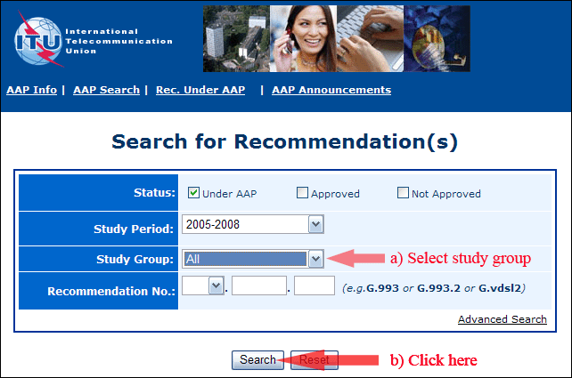
2) Select your Recommendation
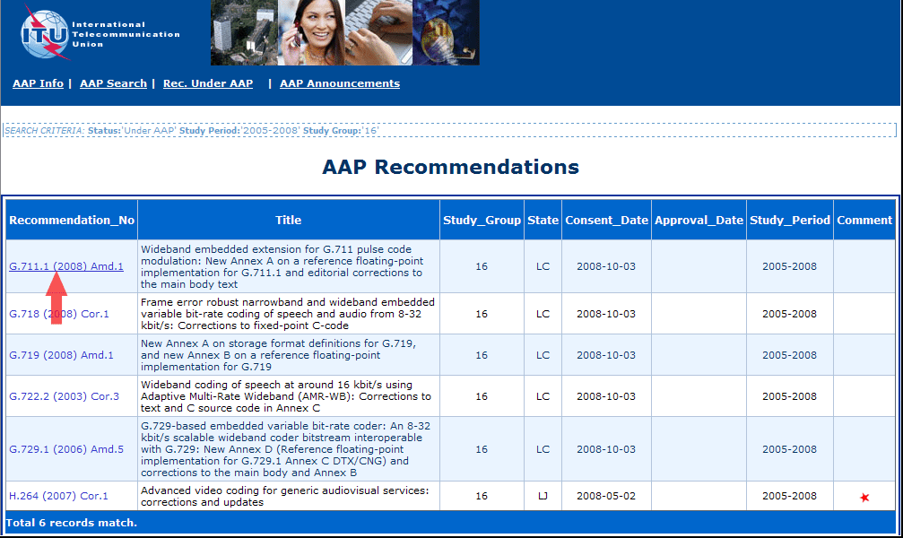
3) Click the "Submit Comment" button
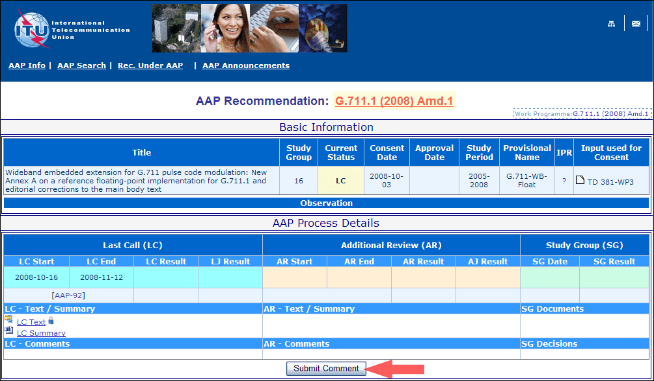
4) Complete the on-line form and click on "Submit"
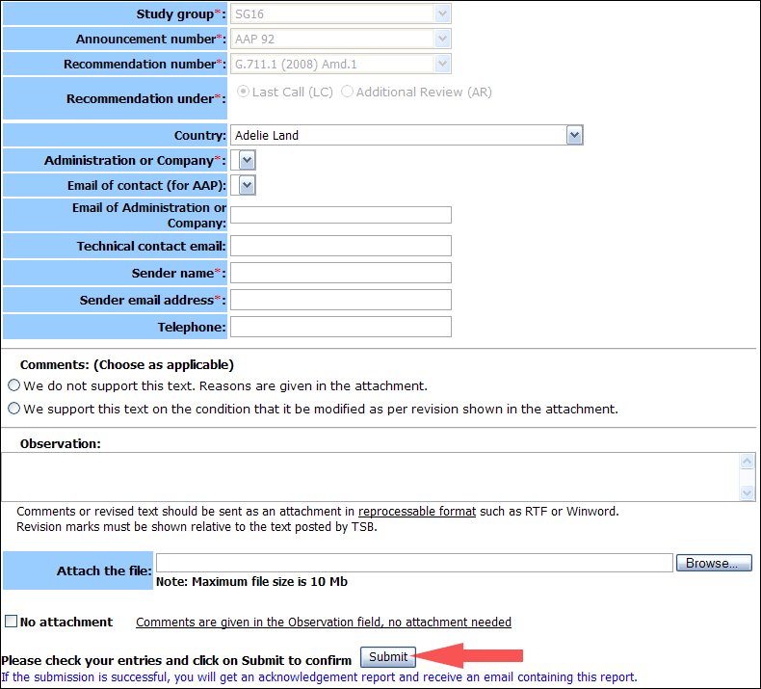
For more information, read the AAP tutorial on:
http://www.itu.int/ITU-T/aapinfo/files/AAPTutorial.pdf
Annex 3
(to TSB AAP-26)
Recommendations under LC/AR – Comment submission form
(Separate form for each Recommendation being commented upon)
ITU-T AAP comment submission form for the period 2009-2012
Study Group:
Announcement number:
Recommendation number:
Recommendation under: | Last call (LC)  Additional Review (AR)
Country:
Administration/Company:
Name of AAP Contact Person:
Email of AAP Contact Person:
Sender name:
(if different from AAP Contact Person)
Sender email address:
Telephone:
Comments:  (Choose as applicable) | We do not support this text. Reasons are given in the attachment.  We support this text on the condition that it be modified as per revision shown in the attachment.
Observations:
No attachment: Comments are given in the Observation field, no attachment needed
To be returned to: email: tsbsg....@itu.int
[or fax +41 22 730 5853]
Comments or revised text should be sent as an attachment in RTF or WinWord format.
Revision marks must be shown relative to the text posted by TSB.

