International Telecommunication Union
Telecommunication Standardization Bureau

Geneva, 16 December 2013

Ref:  Tel:  Fax:  E-mail: | TSB AAP-25  AAP/MJ  +41 22 730 5860  +41 22 730 5853  tsbdir@itu.int | – To Administrations of Member States of the Union;  – To ITU-T Sector Members;  – To ITU-T Associates  Copy:  – To the ITU-T Study Group Chairmen and Vice-Chairmen;  – To the Director of the Telecommunication Development Bureau;  – To the Director of the Radiocommunication Bureau

Subject: | Situation concerning Recommendations under the Alternative Approval Process (AAP)

Dear Sir/Madam,
The Alternative Approval Process (AAP) defined in Rec. ITU-T A.8 applies to Recommendations which do not have policy or regulatory implications and which, therefore, do not require formal consultation of Member States (see ITU Convention 246B).
Annex 1 lists those texts whose status has changed compared with previous TSB AAP Announcements.
If you wish to submit a comment relative to a Recommendation under AAP, you are encouraged to use the on-line AAP comment submission form available on the page of the Recommendation in the AAP area of the ITU-T website at http://www.itu.int/ITU-T/aap (see Annex 2). Alternatively, comments can be submitted by completing the form in Annex 3 and sending it to the secretariat of the concerned study group.
Please note that comments that simply support adoption of the text in question are not encouraged.
In view of ITU closing at the end of December period, please note that no AAP announcement will be issued on 1 January 2014. Consequently, the deadline for some texts has been exceptionally extended, since it falls around that period.
Yours faithfully,
Malcolm Johnson
Director of the Telecommunication Standardization Bureau
Annexes: 3

Annex 1
(to TSB AAP-25)

Status codes used in the AAP announcements:
LC = Last Call
LJ = Last Call Judgment (includes comment resolution)
AR = Additional Review
AJ = Additional Review Judgment (includes comment resolution)
SG = For Study Group approval
A = Approved
AT = Approved with typographic corrections
AC = Approved after Additional Review of Comments
NA = Not approved
TAP = Moved to TAP (ITU-T A.8 / § 5.2)
ITU-T website entry page:
http://www.itu.int/ITU-T
Alternative approval process (AAP) welcome page:
http://www.itu.int/ITU-T/aapinfo
Note – A tutorial on the ITU-T AAP application is available under the AAP welcome page
ITU-T website AAP Recommendation search page:
http://www.itu.int/ITU-T/aap/
Study Group web pages and contacts:
SG 2 | http://www.itu.int/ITU-T/studygroups/com02 | tsbsg2@itu.int
SG 3 | http://www.itu.int/ITU-T/studygroups/com03 | tsbsg3@itu.int
SG 5 | http://www.itu.int/ITU-T/studygroups/com05 | tsbsg5@itu.int
SG 9 | http://www.itu.int/ITU-T/studygroups/com09 | tsbsg9@itu.int
SG 11 | http://www.itu.int/ITU-T/studygroups/com11 | tsbsg11@itu.int
SG 12 | http://www.itu.int/ITU-T/studygroups/com12 | tsbsg12@itu.int
SG 13 | http://www.itu.int/ITU-T/studygroups/com13 | tsbsg13@itu.int
SG 15 | http://www.itu.int/ITU-T/studygroups/com15 | tsbsg15@itu.int
SG 16 | http://www.itu.int/ITU-T/studygroups/com16 | tsbsg16@itu.int
SG 17 | http://www.itu.int/ITU-T/studygroups/com17 | tsbsg17@itu.int

Situation concerning Study Group 5 Recommendations under AAP
Rec # | Title | Last Call (LC) Period |  |  |  | Additional Review (AR) Period |  |  |  | Status
 |  | LC Start | LC End | LC  Result | LJ  Result | AR Start | AR End | AR  Result | AJ  Result
L.1430 (L.methodology_ICT project) | Methodology for assessment of the environmental impact of information and communication technology greenhouse gas and energy projects (Summary) | 2013-03-01 | 2013-03-28 | LJ | AR | 2013-07-16 | 2013-08-05 | AJ | SG | AC
Situation concerning Study Group 9 Recommendations under AAP
Rec # | Title | Last Call (LC) Period |  |  |  | Additional Review (AR) Period |  |  |  | Status
 |  | LC Start | LC End | LC  Result | LJ  Result | AR Start | AR End | AR  Result | AJ  Result
J.181 (J.181-rev) | Digital program insertion cueing message for cable television systems (Summary) | 2013-12-16 | 2014-01-12 |  |  |  |  |  |  | LC
J.287 (J.ascs-api) | Automation System to Compression System Communications Applications Program Interface (API) (Summary) | 2013-12-16 | 2014-01-12 |  |  |  |  |  |  | LC
J.382 (J.atrans-spec) | Advanced digital downstream transmission systems for television, sound and data services for cable distribution (Summary) | 2013-12-16 | 2014-01-12 |  |  |  |  |  |  | LC
J.604 (J.svc) | Requirements for Scalable Video Transmission System over Cable Network (Summary) | 2013-12-16 | 2014-01-12 |  |  |  |  |  |  | LC
P.913 (P.av-dist (ex J.av-dist)) | Methods for subjectively assessing audiovisual quality of internet video and distribution quality television, including separate assessment of video quality and audio quality, and including multiple environments (Summary) | 2013-12-16 | 2014-01-12 |  |  |  |  |  |  | LC
Situation concerning Study Group 11 Recommendations under AAP
Rec # | Title | Last Call (LC) Period |  |  |  | Additional Review (AR) Period |  |  |  | Status
 |  | LC Start | LC End | LC  Result | LJ  Result | AR Start | AR End | AR  Result | AJ  Result
Q.3614 (Q.OIP/OIR) | Originating identification presentation and originating identification restriction protocol specification as next-generation network supplementary service (Summary) | 2013-12-16 | 2014-01-12 |  |  |  |  |  |  | LC
Situation concerning Study Group 15 Recommendations under AAP
Rec # | Title | Last Call (LC) Period |  |  |  | Additional Review (AR) Period |  |  |  | Status
 |  | LC Start | LC End | LC  Result | LJ  Result | AR Start | AR End | AR  Result | AJ  Result
G.984.3 | Gigabit-capable Passive Optical Networks (GPON): Transmission convergence layer specification (Summary) | 2013-12-16 | 2014-01-12 |  |  |  |  |  |  | LC
G.987.3 (G.xgpon.3) | 10-Gigabit-capable passive optical networks (XG-PON): Transmission convergence (TC) layer specification (Summary) | 2013-12-16 | 2014-01-12 |  |  |  |  |  |  | LC
G.993.2 (2011) Amd.5 | Very high speed digital subscriber line transceivers 2 (VDSL2): Amendment 5 Short reach VDSL2 with reduced power and enhanced data rate (Summary) | 2013-12-16 | 2014-01-12 |  |  |  |  |  |  | LC
G.993.5 (2010) Amd.5 | Self-FEXT cancellation (vectoring) for use with VDSL2 transceivers: Amendment 5 - Exchange of transceiver IDs during initialization (Summary) | 2013-12-16 | 2014-01-12 |  |  |  |  |  |  | LC
G.994.1 (2012) Amd.3 | Handshake procedures for digital subscriber line transceivers: Amendment 3 - Codepoints for G.998.4 extensions and exchange of transfer ID (Summary) | 2013-12-16 | 2014-01-12 |  |  |  |  |  |  | LC
G.994.1 (2012) Amd.4 | Handshake procedures for digital subscriber line transceivers: Amendment 4 - Additional codepoints for the support of G.fast (Summary) | 2013-12-16 | 2014-01-12 |  |  |  |  |  |  | LC
G.998.4 (2010) Amd.3 | Improved impulse noise protection for DSL transceivers: Amendment 3 - Extended memory for enhanced bit rates with retransmission (Summary) | 2013-12-16 | 2014-01-12 |  |  |  |  |  |  | LC
G.999.1 (2009) Amd.1 (G.int) | Interface between the link layer and the physical layer for digital subscriber line (DSL) transceivers: Amendment 1 Extension for upstream flow control over gamma reference point. (Summary) | 2013-12-16 | 2014-01-12 |  |  |  |  |  |  | LC
G.9903 (G.g3-plc) | Narrow-band orthogonal frequency division multiplexing power line communication transceivers for G3-PLC networks (Summary) | 2013-12-16 | 2014-01-12 |  |  |  |  |  |  | LC
G.9960 (2011) Amd.1 | Unified high-speed wire-line based home networking transceivers - System architecture and physical layer specification: Amendment 1 (Summary) | 2013-12-16 | 2014-01-12 |  |  |  |  |  |  | LC
G.9961 (2010) Amd.2 (G.hn) | Unified high-speed wire-line based home networking transceivers - Data link layer specification: Amendment 2 (Summary) | 2013-12-16 | 2014-01-12 |  |  |  |  |  |  | LC
G.9961 (G.hn) | Unified high-speed wire-line based home networking transceivers - Data link layer specification (Summary) | 2013-12-16 | 2014-01-12 |  |  |  |  |  |  | LC
G.9962 | Unified high-speed wire-line based home networking transceivers - Management specification (Summary) | 2013-12-16 | 2014-01-12 |  |  |  |  |  |  | LC
G.9963 (2011) Amd.1 | Unified high-speed wire-line based home networking transceivers - Multiple input/multiple output specification: Amendment 1 (Summary) | 2013-12-16 | 2014-01-12 |  |  |  |  |  |  | LC
G.9963 (2011) Cor.1 | Unified high-speed wire-line based home networking transceivers - Multiple input/multiple output specification: Corrigendum 1 (Summary) | 2013-12-16 | 2014-01-12 |  |  |  |  |  |  | LC
G.9972 (2010) Cor.1 | Coexistence mechanism for wireline home networking transceivers: Corrigendum 1 - Revised definition of coexisting systems categories (Summary) | 2013-12-16 | 2014-01-12 |  |  |  |  |  |  | LC
G.9979 (G.99xx, 1905.1 Ext) | ITU-T Extension to the IEEE 1905.1 2013 Standard (Summary) | 2013-12-16 | 2014-01-12 |  |  |  |  |  |  | LC
Situation concerning Study Group 16 Recommendations under AAP
Rec # | Title | Last Call (LC) Period |  |  |  | Additional Review (AR) Period |  |  |  | Status
 |  | LC Start | LC End | LC  Result | LJ  Result | AR Start | AR End | AR  Result | AJ  Result
F.747.5 (F.USN-ALI) | Requirements and functional architecture of an automatic location identification system for ubiquitous sensor network (USN) applications and services (Summary) | 2013-12-16 | 2014-01-12 |  |  |  |  |  |  | LC
G.161.1 (G.DNH) | Do-no-harm testing (Summary) | 2013-12-16 | 2014-01-12 |  |  |  |  |  |  | LC
H.222.0 (2012) Amd.1 (H.222.0 (2006) Amd.8) | Information technology - Generic coding of moving pictures and associated audio information: Systems: Extensions for simplified carriage of MPEG-4 over MPEG-2 (Summary) | 2013-12-16 | 2014-01-12 |  |  |  |  |  |  | LC
H.222.0 (2012) Amd.2 (H.222.0 (2006) Amd.9) | Information technology - Generic coding of moving pictures and associated audio information: Systems: Signalling of Transport profiles, signalling MVC view association to eye and MIME type registration (Summary) | 2013-12-16 | 2014-01-12 |  |  |  |  |  |  | LC
H.222.0 (2012) Amd.3 | Information technology - Generic coding of moving pictures and associated audio information: Systems: Transport of HEVC video over MPEG-2 systems (Summary) | 2013-12-16 | 2014-01-12 |  |  |  |  |  |  | LC
H.222.0 (2012) Amd.4 | Information technology - Generic coding of moving pictures and associated audio information: Systems: Support for event signalling in Transport Stream in MPEG-2 systems (Summary) | 2013-12-16 | 2014-01-12 |  |  |  |  |  |  | LC
H.235.0 | H.323 security: Framework for security in H-series (H.323 and other H.245-based) multimedia systems (Summary) | 2013-12-16 | 2014-01-12 |  |  |  |  |  |  | LC
H.235.6 | H.323 security: Encryption profile with native H.235/H.245 key management (Summary) | 2013-12-16 | 2014-01-12 |  |  |  |  |  |  | LC
H.248.80 (H.248.SDP-MAPPER) | Gateway control protocol: Usage of the revised SDP offer / answer model with H.248 (Summary) | 2013-12-16 | 2014-01-12 |  |  |  |  |  |  | LC
H.248.86 (H.248.DPI) | Gateway control protocol: H.248 Support for deep packet inspection (Summary) | 2013-12-16 | 2014-01-12 |  |  |  |  |  |  | LC
H.248.87 (H.248.RTCPROF) | Gateway control protocol: Guidelines on the use of H.248 capabilities for performance monitoring in RTP networks in H.248 Profiles (Summary) | 2013-12-16 | 2014-01-12 |  |  |  |  |  |  | LC
H.248.88 (H.248.RTPTOPO, ex H.248.R) | Gateway control protocol: RTP topology dependent RTCP handling by ITU-T H.248 media gateways with IP terminations (Summary) | 2013-12-16 | 2014-01-12 |  |  |  |  |  |  | LC
H.341 (1999) Cor.1 | Multimedia Management Information Base: Updates to MIB definitions (Summary) | 2013-12-16 | 2014-01-12 |  |  |  |  |  |  | LC
H.722 (H.IPTV-TDES.3) | IPTV terminal device: Full-fledged model (Summary) | 2013-12-16 | 2014-01-12 |  |  |  |  |  |  | LC

Annex 2
(to TSB AAP-25)
Using the on-line comment submission form
Comment submission
1) Go to AAP search Web page at http://www.itu.int/ITU-T/aap/
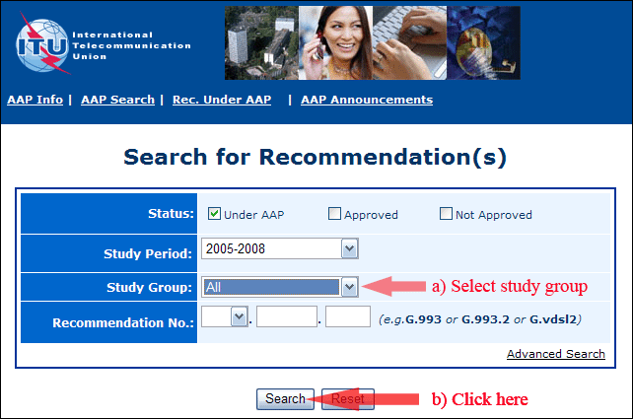
2) Select your Recommendation
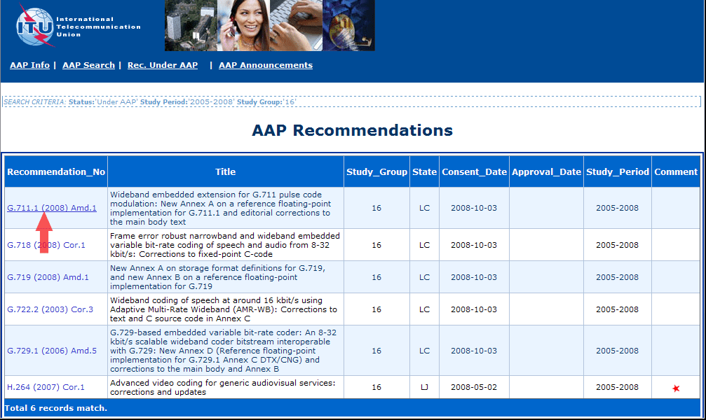
3) Click the "Submit Comment" button
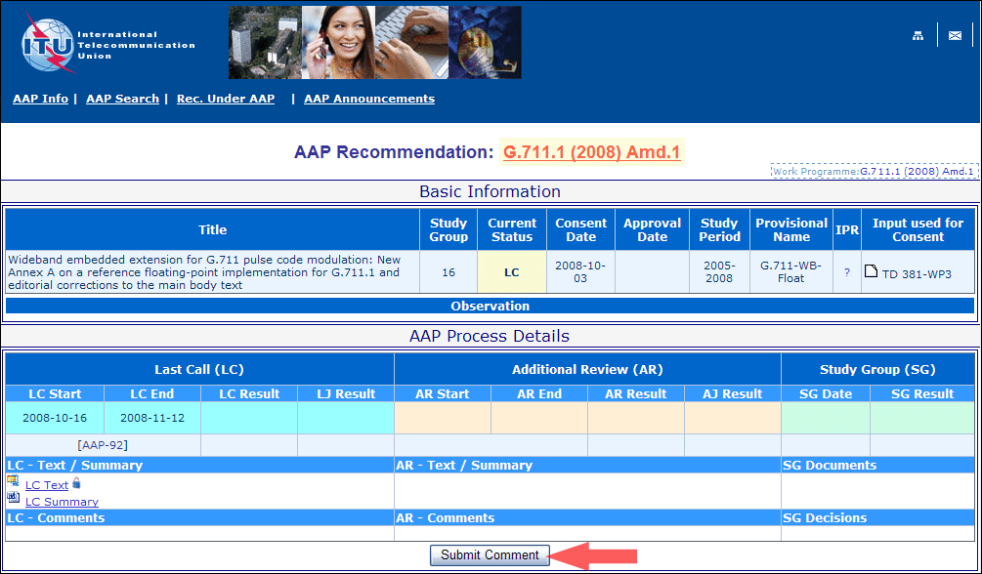
4) Complete the on-line form and click on "Submit"
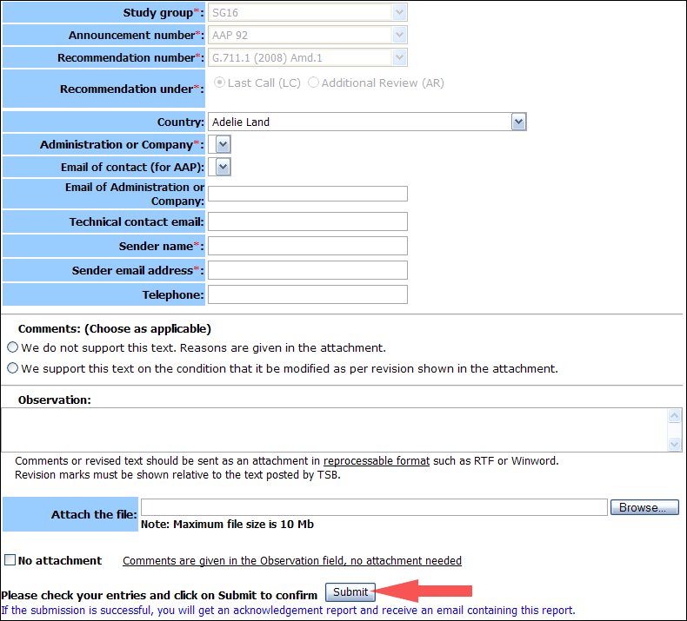
For more information, read the AAP tutorial on:
http://www.itu.int/ITU-T/aapinfo/files/AAPTutorial.pdf
Annex 3
(to TSB AAP-25)
Recommendations under LC/AR – Comment submission form
(Separate form for each Recommendation being commented upon)
ITU-T AAP comment submission form for the period 2009-2012
Study Group:
Announcement number:
Recommendation number:
Recommendation under: | Last call (LC)  Additional Review (AR)
Country:
Administration/Company:
Name of AAP Contact Person:
Email of AAP Contact Person:
Sender name:
(if different from AAP Contact Person)
Sender email address:
Telephone:
Comments:  (Choose as applicable) | We do not support this text. Reasons are given in the attachment.  We support this text on the condition that it be modified as per revision shown in the attachment.
Observations:
No attachment: Comments are given in the Observation field, no attachment needed
To be returned to: email: tsbsg....@itu.int
[or fax +41 22 730 5853]
Comments or revised text should be sent as an attachment in RTF or WinWord format.
Revision marks must be shown relative to the text posted by TSB.

