Unión Internacional de Telecomunicaciones
Oficina de Normalización de las Telecomunicaciones

Ginebra, 01 de septiembre de 2013

Ref:  Tel:  Fax:  Correo-e: | TSB AAP-18  AAP/MJ  +41 22 730 5860  +41 22 730 5853  tsbdir@itu.int | – A las Administraciones de los Estados Miembros de la Unión;  – A los Miembros del Sector UIT-T;  – A los Asociados del UIT-T  Copia:  – A los Presidentes y a los Vicepresidentes de las Comisiones de Estudio del UIT-T;  – Al Director de la Oficina de Desarrollo de las Telecomunicaciones;  – Al Director de la Oficina de Radiocomunicaciones

Asunto: | Situación de las Recomendaciones sometidas al proceso de aprobación alternativo (AAP)

Muy señora mía/Muy señor mío:

El proceso de aprobación alternativo (AAP) definido en la Recomendación A.8 del UIT-T se aplica a las Recomendaciones que no tienen consecuencias en materia de política o reglamentación y que no requieren, por lo tanto, la consulta formal de los Estados Miembros (véase el número 246B del Convenio de la UIT).
En el anexo 1 se enumera la lista de los textos cuyo estado ha cambiado con respecto a los anuncios TSB AAP precedentes.
Si desea formular un comentario en relación con una Recomendación sometida al AAP, le alentamos a utilizar el formulario de presentación de comentarios disponible en la página de la Recomendación que figura en el área AAP del sitio web del UIT-T, en la dirección http://www.itu.int/ITU-T/aap/ (véase también el anexo 2). Alternativamente, pueden presentarse comentarios completando el formulario del anexo 3 y remitiéndolo a la secretaría de la Comisión de Estudio correspondiente.
Le rogamos tenga en cuenta que no se alientan comentarios que se limiten a apoyar la adopción del texto en cuestión.
Le saluda atentamente,

Malcolm Johnson
Director de la Oficina de
Normalización de las Telecomunicaciones
Anexos: 3

Annex 1
(to TSB AAP-18)

Status codes used in the AAP announcements:
LC = Last Call
LJ = Last Call Judgment (includes comment resolution)
AR = Additional Review
AJ = Additional Review Judgment (includes comment resolution)
SG = For Study Group approval
A = Approved
AT = Approved with typographic corrections
AC = Approved after Additional Review of Comments
NA = Not approved
TAP = Moved to TAP (ITU-T A.8 / § 5.2)
ITU-T website entry page:
http://www.itu.int/ITU-T
Alternative approval process (AAP) welcome page:
http://www.itu.int/ITU-T/aapinfo
Note – A tutorial on the ITU-T AAP application is available under the AAP welcome page
ITU-T website AAP Recommendation search page:
http://www.itu.int/ITU-T/aap/
Study Group web pages and contacts:
SG 2 | http://www.itu.int/ITU-T/studygroups/com02 | tsbsg2@itu.int
SG 3 | http://www.itu.int/ITU-T/studygroups/com03 | tsbsg3@itu.int
SG 5 | http://www.itu.int/ITU-T/studygroups/com05 | tsbsg5@itu.int
SG 9 | http://www.itu.int/ITU-T/studygroups/com09 | tsbsg9@itu.int
SG 11 | http://www.itu.int/ITU-T/studygroups/com11 | tsbsg11@itu.int
SG 12 | http://www.itu.int/ITU-T/studygroups/com12 | tsbsg12@itu.int
SG 13 | http://www.itu.int/ITU-T/studygroups/com13 | tsbsg13@itu.int
SG 15 | http://www.itu.int/ITU-T/studygroups/com15 | tsbsg15@itu.int
SG 16 | http://www.itu.int/ITU-T/studygroups/com16 | tsbsg16@itu.int
SG 17 | http://www.itu.int/ITU-T/studygroups/com17 | tsbsg17@itu.int

Situation concerning Study Group 15 Recommendations under AAP
Rec # | Title | Last Call (LC) Period |  |  |  | Additional Review (AR) Period |  |  |  | Status
 |  | LC Start | LC End | LC  Result | LJ  Result | AR Start | AR End | AR  Result | AJ  Result
G.650.1 (2010) Cor.1 | Definitions and test methods for linear, deterministic attributes of single-mode fibre and cable: Corrigendum 1 (Summary) | 2013-08-01 | 2013-08-28 | A |  |  |  |  |  | A
G.703 (2001) Amd.1 | Physical/electrical characteristics of hierarchical digital interfaces: Amendment 1 (Summary) | 2013-08-01 | 2013-08-28 | A |  |  |  |  |  | A
G.709/Y.1331 (2012) Amd.2 | Interfaces for the Optical Transport Network (OTN): Amendment 2 (Summary) | 2013-08-01 | 2013-08-28 | LJ |  |  |  |  |  | LJ
G.783 (2006) Amd.4 | Characteristics of synchronous digital hierarchy (SDH) equipment functional blocks : Amendment 4 (Summary) | 2013-08-01 | 2013-08-28 | A |  |  |  |  |  | A
G.798.1 (2013) Amd.1 | Types and characteristics of optical transport network equipment: Amendment 1 (Summary) | 2013-08-01 | 2013-08-28 | A |  |  |  |  |  | A
G.870/Y.1352 (2012) Cor.1 | Terms and definitions for Optical Transport Networks (OTN): Corrigendum 1 (Summary) | 2013-08-01 | 2013-08-28 | A |  |  |  |  |  | A
G.872 (2012) Amd.1 | Architecture of optical transport networks: Amendment 1 (Summary) | 2013-08-01 | 2013-08-28 | LJ |  |  |  |  |  | LJ
G.874 | Management aspects of optical transport network elements (Summary) | 2013-08-01 | 2013-08-28 | A |  |  |  |  |  | A
G.874.1 (2012) Amd.1 | Optical transport network (OTN): Protocol-neutral management information model for the network element view: Amendment 1 (Summary) | 2013-08-01 | 2013-08-28 | A |  |  |  |  |  | A
G.992.3 (2009) Cor.3 | Asymmetric digital subscriber line transceivers 2 (ADSL2): Corrigendum 3 (Summary) | 2013-08-01 | 2013-08-28 | A |  |  |  |  |  | A
G.993.2 (2011) Amd.4 | Very high speed digital subscriber line transceivers 2 (VDSL2): Amendment 4 (Summary) | 2013-08-01 | 2013-08-28 | A |  |  |  |  |  | A
G.993.5 (2010) Amd.4 | Self-FEXT cancellation (vectoring) for use with VDSL2 transceivers: Amendment 4 (Summary) | 2013-08-01 | 2013-08-28 | LJ |  |  |  |  |  | LJ
G.994.1 (2012) Amd.2 | Handshake procedures for digital subscriber line (DSL) transceivers: Amendment 2 (Summary) | 2013-08-01 | 2013-08-28 | A |  |  |  |  |  | A
G.996.2 (2009) Amd.4 | Single-ended line testing for digital subscriber lines (DSL): Amendment 4 (Summary) | 2013-08-01 | 2013-08-28 | A |  |  |  |  |  | A
G.997.1 (2012) Amd.3 | Physical layer management for digital subscriber line transceivers: Amendment 3 (Summary) | 2013-08-01 | 2013-08-28 | A |  |  |  |  |  | A
G.998.1 (2005) Amd.1 | ATM-based multi-pair bonding: Amendment 1 (Summary) | 2013-08-01 | 2013-08-28 | A |  |  |  |  |  | A
G.998.2 (2005) Amd.3 | Ethernet-based multi-pair bonding: Amendment 3 (Summary) | 2013-08-01 | 2013-08-28 | A |  |  |  |  |  | A
G.998.3 (2005) Amd.1 | Multi-pair bonding using time-division inverse multiplexing: Amendment 1 (Summary) | 2013-08-01 | 2013-08-28 | A |  |  |  |  |  | A
G.7712/Y.1703 (2010) Amd.1 | Architecture and specification of data communication network: Amendment 1 (Summary) | 2013-08-01 | 2013-08-28 | LJ |  |  |  |  |  | LJ
G.8011.1/Y.1307.1 | Ethernet private line service (Summary) | 2013-08-01 | 2013-08-28 | A |  |  |  |  |  | A
G.8011.2/Y.1307.2 | Ethernet virtual private line service (Summary) | 2013-08-01 | 2013-08-28 | A |  |  |  |  |  | A
G.8011.3/Y.1307.3 | Ethernet virtual private LAN service (Summary) | 2013-08-01 | 2013-08-28 | A |  |  |  |  |  | A
G.8011.4/Y.1307.4 | Ethernet private tree and Ethernet virtual private Tree services (Summary) | 2013-08-01 | 2013-08-28 | A |  |  |  |  |  | A
G.8011.5/Y.1307.5 | Ethernet private LAN service (Summary) | 2013-08-01 | 2013-08-28 | A |  |  |  |  |  | A
G.8011/Y.1307 (2012) Cor.1 | Ethernet over Transport – Ethernet service characteristics: Corrigendum 1 (Summary) | 2013-08-01 | 2013-08-28 | A |  |  |  |  |  | A
G.8013/Y.1731 | OAM functions and mechanisms for Ethernet-based networks (Summary) | 2013-08-01 | 2013-08-28 | LJ |  |  |  |  |  | LJ
G.8021/Y.1341 (2012) Amd.2 | Characteristics of Ethernet Transport network equipment functional blocks: Amendment 1 (Summary) | 2013-08-01 | 2013-08-28 | LJ |  |  |  |  |  | LJ
G.8031/Y.1342 (2011) Amd.1 | Ethernet linear protection switching: Amendment 1 (Summary) | 2013-08-01 | 2013-08-28 | A |  |  |  |  |  | A
G.8051/Y.1345 (G.eot-mgmt) | Management aspects of the Ethernet Transport (ET) capable network element (Summary) | 2013-08-01 | 2013-08-28 | A |  |  |  |  |  | A
G.8052/Y.1346 (G.eot-mgmt-info) | Protocol-neutral management information model for the Ethernet Transport capable network element (Summary) | 2013-08-01 | 2013-08-28 | A |  |  |  |  |  | A
G.8113.1/Y.1372.1 (2012) Amd.1 | Operations, administration and maintenance mechanism for MPLS-TP in packet transport network (PTN): Amendment 1 (Summary) | 2013-08-01 | 2013-08-28 | A |  |  |  |  |  | A
G.8113.2/Y.1372.2 (2012) Amd.1 | Operations, administration and maintenance mechanisms for MPLS-TP networks using the tools defined for MPLS: Amendment 1 (Summary) | 2013-08-01 | 2013-08-28 | A |  |  |  |  |  | A
G.8121.1/Y.1381.1 | Characteristics of MPLS-TP equipment functional blocks supporting ITU-T G.8113.1/Y.1372.1 (Summary) | 2013-08-01 | 2013-08-28 | LJ |  |  |  |  |  | LJ
G.8121.2/Y.1381.2 | Characteristics of MPLS-TP equipment functional blocks supporting ITU-T G.8113.2/Y.1372.2 (Summary) | 2013-08-01 | 2013-08-28 | LJ |  |  |  |  |  | LJ
G.8121/Y.1381 | Characteristics of MPLS-TP equipment functional blocks (Summary) | 2013-08-01 | 2013-08-28 | LJ |  |  |  |  |  | LJ
G.8151/Y.1374 (2012) Amd.2 | Management aspects of the MPLS-TP network element: Amendment 2 (Summary) | 2013-08-01 | 2013-08-28 | LJ |  |  |  |  |  | LJ
G.8260 (2012) Amd.1 | Definitions and terminology for synchronization in packet networks: Amendment 1 (Summary) | 2013-08-01 | 2013-08-28 | A |  |  |  |  |  | A
G.8261/Y.1361 | Timing and synchronization aspects in packet networks (Summary) | 2013-08-01 | 2013-08-28 | A |  |  |  |  |  | A
G.8263/Y.1363 (2012) Amd.1 (G.paclock-bis) | Timing characteristics of packet-based equipment clocks: Amendment 1 (Summary) | 2013-08-01 | 2013-08-28 | LJ |  |  |  |  |  | LJ
G.8271.1/Y.1366.1 (G.pactiming-bis) | Network Limits for Time Synchronization in Packet Networks (Summary) | 2013-08-01 | 2013-08-28 | LJ |  |  |  |  |  | LJ
G.8271/Y.1366 (2012) Amd.1 | Time and phase synchronization aspects of Packet Networks: Amendment 1 (Summary) | 2013-08-01 | 2013-08-28 | LJ |  |  |  |  |  | LJ
G.8272/Y.1367 (2012) Amd.1 | Timing characteristics of primary reference time clock: Amendment 1 (Summary) | 2013-08-01 | 2013-08-28 | LJ |  |  |  |  |  | LJ
G.8273/Y.1368 | Framework of phase and time clocks (Summary) | 2013-08-01 | 2013-08-28 | LJ |  |  |  |  |  | LJ
G.9801 (G.epon) | Ethernet passive optical networks using OMCI (Summary) | 2013-08-01 | 2013-08-28 | A |  |  |  |  |  | A
G.9902 (2012) Amd.2 | Narrow-band orthogonal frequency division multiplexing power line communication ransceivers for ITU-T G.hnem networks: Amendment 2 (Summary) | 2013-08-01 | 2013-08-28 | A |  |  |  |  |  | A
G.9905 (G.cmsr) | Centralized metric-based source routing (Summary) | 2013-08-01 | 2013-08-28 | A |  |  |  |  |  | A
G.9959 (2012) Amd.1 | Short range narrowband digital radiocommunication transceivers – PHY and MAC layer specifications: Amendment 1 (Summary) | 2013-08-01 | 2013-08-28 | LJ |  |  |  |  |  | LJ
G.9962 (2013) Amd.1 (G.hn) | Unified high-speed wire-line based home networking transceivers - Management specification: Amendment 1 (Summary) | 2013-08-01 | 2013-08-28 | A |  |  |  |  |  | A

Annex 2
(to TSB AAP-18)
Using the on-line comment submission form
Comment submission
1) Go to AAP search Web page at http://www.itu.int/ITU-T/aap/
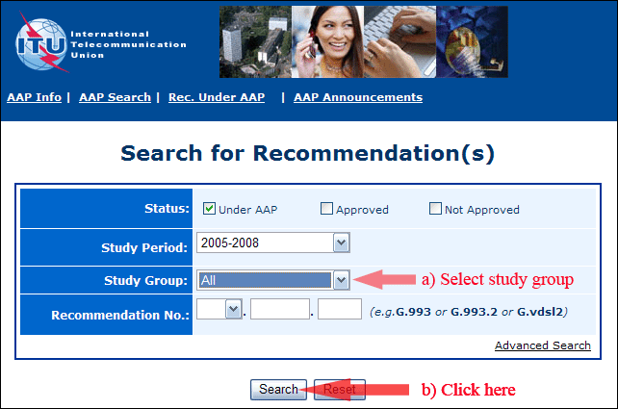
2) Select your Recommendation
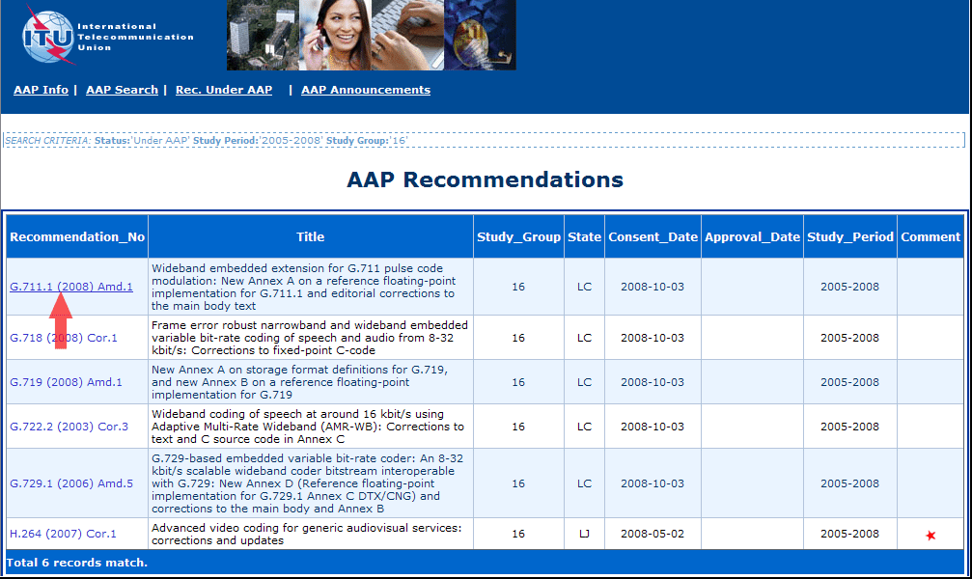
3) Click the "Submit Comment" button
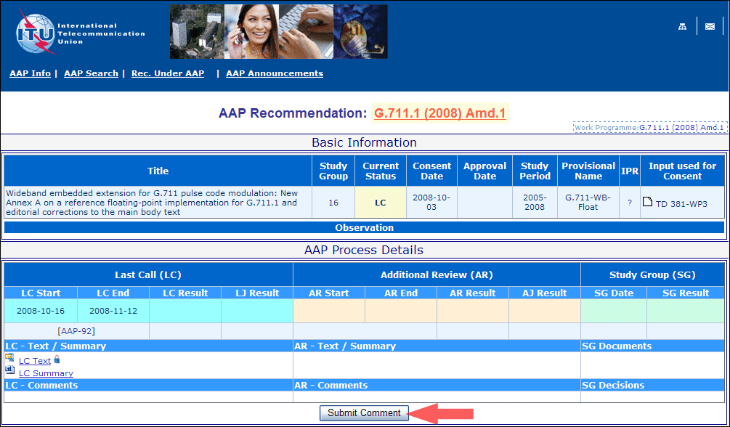
4) Complete the on-line form and click on "Submit"
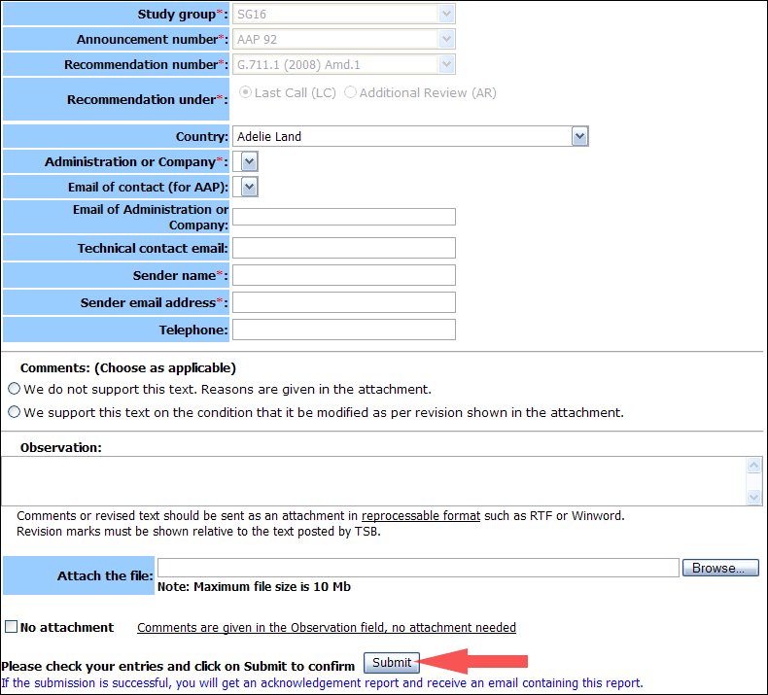
For more information, read the AAP tutorial on:
http://www.itu.int/ITU-T/aapinfo/files/AAPTutorial.pdf
Annex 3
(to TSB AAP-18)
Recommendations under LC/AR – Comment submission form
(Separate form for each Recommendation being commented upon)
ITU-T AAP comment submission form for the period 2009-2012
Study Group:
Announcement number:
Recommendation number:
Recommendation under: | Last call (LC)  Additional Review (AR)
Country:
Administration/Company:
Name of AAP Contact Person:
Email of AAP Contact Person:
Sender name:
(if different from AAP Contact Person)
Sender email address:
Telephone:
Comments:  (Choose as applicable) | We do not support this text. Reasons are given in the attachment.  We support this text on the condition that it be modified as per revision shown in the attachment.
Observations:
No attachment: Comments are given in the Observation field, no attachment needed
To be returned to: email: tsbsg....@itu.int
[or fax +41 22 730 5853]
Comments or revised text should be sent as an attachment in RTF or WinWord format.
Revision marks must be shown relative to the text posted by TSB.

