|  |  |
| --- | --- |
|  | الا تحــاد الــدولي للاتصــالات  *مكتب تقييس الاتصالات* |

|  |  |  |
| --- | --- | --- |
|  |  | جنيف، 1 سبتمبر 2013 |
| المرجع:    الهاتف:  الفاكس:  البريد الإلكتروني: | **TSB AAP-18**  AAP/MJ  +41 22 730 5860  +41 22 730 5853  tsbdir@itu.int | - إلى إدارات الدول الأعضاء في الاتحاد؛  - إلى أعضاء قطاع تقييس الاتصالات؛  - إلى المنتسبين إلى قطاع تقييس الاتصالات  **نسخة إلى:**  - رؤساء لجان الدراسات في قطاع تقييس الاتصالات ونوابهم؛  - مدير مكتب تنمية الاتصالات؛  - مدير مكتب الاتصالات الراديوية |

الموضوع: **حالة التوصيات الخاضعة لعملية الموافقة البديلة (AAP)**

حضرات السادة والسيدات،

تحية طيبة وبعد،

تنطبق عملية الموافقة البديلة (AAP) المعرفة في التوصية ITU‑T A.8 على التوصيات التي لا تنطوي على بعد سياسي أوتنظيمي ولا تتطلب بالتالي استشارة الدول الأعضاء رسمياً (انظر الرقم 246B من اتفاقية الاتحاد).

ويتضمن **الملحق 1** لائحة بالنصوص التي تغيرت حالتها مقارنة بما جاء في إعلانات عملية الموافقة البديلة السابقة.

إذا رغبتم في تقديم تعليق بشأن توصية ما خاضعة لعملية الموافقة البديلة، فنرجو منكم استعمال استمارة التعليق على الخط المتوفّرة على موقع قطاع تقييس الاتصالات على صفحة عملية الموافقة البديلة [http://www.itu.int/ITU-T/aap](http://www.itu.int/ITU-T/aap/) على المدخل الخاص بالتوصية المعنية (انظر **الملحق** (**2**. وبديلاً من ذلك، يمكنكم تقديم التعليقات باستكمال الاستمارة الواردة في **الملحق 3** وإرسالها إلى أمانة لجنة الدراسات المعنية بالأمر.

وتجدر الإشارة إلى أنه يفضّل عدم إرسال تعليقات تقتصر على تأييد اعتماد النص قيد النظر.

وتفضلوا بقبول فائق الاحترام والتقدير.

مالكولم جونسون  
مدير مكتب تقييس الاتصالات

**الملحقات:** 3

Annex 1

(to TSB AAP-18)

Status codes used in the AAP announcements:

LC = Last Call

LJ = Last Call Judgment (includes comment resolution)

AR = Additional Review

AJ = Additional Review Judgment (includes comment resolution)

SG = For Study Group approval

A = Approved

AT = Approved with typographic corrections

AC = Approved after Additional Review of Comments

NA = Not approved

TAP = Moved to TAP (ITU-T A.8 / § 5.2)

ITU-T website entry page:

[http://www.itu.int/ITU-T](http://www.itu.int/ITU-T/)

Alternative approval process (AAP) welcome page:

[http://www.itu.int/ITU-T/aapinfo](http://www.itu.int/ITU-T/aapinfo/)

Note – A tutorial on the ITU-T AAP application is available under the AAP welcome page

ITU-T website AAP Recommendation search page:

<http://www.itu.int/ITU-T/aap/>

Study Group web pages and contacts:

|  |  |  |
| --- | --- | --- |
| SG 2 | <http://www.itu.int/ITU-T/studygroups/com02> | [tsbsg2@itu.int](mailto:tsbsg2@itu.int) |
| SG 3 | <http://www.itu.int/ITU-T/studygroups/com03> | [tsbsg3@itu.int](mailto:tsbsg3@itu.int) |
| SG 5 | <http://www.itu.int/ITU-T/studygroups/com05> | [tsbsg5@itu.int](mailto:tsbsg5@itu.int) |
| SG 9 | <http://www.itu.int/ITU-T/studygroups/com09> | [tsbsg9@itu.int](mailto:tsbsg9@itu.int) |
| SG 11 | <http://www.itu.int/ITU-T/studygroups/com11> | [tsbsg11@itu.int](mailto:tsbsg11@itu.int) |
| SG 12 | <http://www.itu.int/ITU-T/studygroups/com12> | [tsbsg12@itu.int](mailto:tsbsg12@itu.int) |
| SG 13 | <http://www.itu.int/ITU-T/studygroups/com13> | [tsbsg13@itu.int](mailto:tsbsg13@itu.int) |
| SG 15 | <http://www.itu.int/ITU-T/studygroups/com15> | [tsbsg15@itu.int](mailto:tsbsg15@itu.int) |
| SG 16 | <http://www.itu.int/ITU-T/studygroups/com16> | [tsbsg16@itu.int](mailto:tsbsg16@itu.int) |
| SG 17 | <http://www.itu.int/ITU-T/studygroups/com17> | [tsbsg17@itu.int](mailto:tsbsg17@itu.int) |

Situation concerning Study Group 15 Recommendations under AAP

| **Rec #** | **Title** | **Last Call (LC) Period** | | | | **Additional Review (AR) Period** | | | | Status |
| --- | --- | --- | --- | --- | --- | --- | --- | --- | --- | --- |
| **LC Start** | **LC End** | **LC Result** | **LJ Result** | **AR Start** | **AR End** | **AR Result** | **AJ Result** |
| [G.650.1 (2010) Cor.1](http://www.itu.int/itu-t/aap/AAPRecDetails.aspx?AAPSeqNo=2835) | Definitions and test methods for linear, deterministic attributes of single-mode fibre and cable: Corrigendum 1 ([Summary](https://www.itu.int/ITU-T/aap/dologin_aap.asp?id=T0102000B130801MSWE.doc&group=15)) | 2013-08-01 | 2013-08-28 | A |  |  |  |  |  | A |
| [G.703 (2001) Amd.1](http://www.itu.int/itu-t/aap/AAPRecDetails.aspx?AAPSeqNo=2854) | Physical/electrical characteristics of hierarchical digital interfaces: Amendment 1 ([Summary](https://www.itu.int/ITU-T/aap/dologin_aap.asp?id=T0102000B260801MSWE.docx&group=15)) | 2013-08-01 | 2013-08-28 | A |  |  |  |  |  | A |
| [G.709/Y.1331 (2012) Amd.2](http://www.itu.int/itu-t/aap/AAPRecDetails.aspx?AAPSeqNo=2856) | Interfaces for the Optical Transport Network (OTN): Amendment 2 ([Summary](https://www.itu.int/ITU-T/aap/dologin_aap.asp?id=T0102000B280801MSWE.docx&group=15)) | 2013-08-01 | 2013-08-28 | LJ |  |  |  |  |  | LJ |
| [G.783 (2006) Amd.4](http://www.itu.int/itu-t/aap/AAPRecDetails.aspx?AAPSeqNo=2857) | Characteristics of synchronous digital hierarchy (SDH) equipment functional blocks : Amendment 4 ([Summary](https://www.itu.int/ITU-T/aap/dologin_aap.asp?id=T0102000B290802MSWE.docx&group=15)) | 2013-08-01 | 2013-08-28 | A |  |  |  |  |  | A |
| [G.798.1 (2013) Amd.1](http://www.itu.int/itu-t/aap/AAPRecDetails.aspx?AAPSeqNo=2855) | Types and characteristics of optical transport network equipment: Amendment 1 ([Summary](https://www.itu.int/ITU-T/aap/dologin_aap.asp?id=T0102000B270801MSWE.doc&group=15)) | 2013-08-01 | 2013-08-28 | A |  |  |  |  |  | A |
| [G.870/Y.1352 (2012) Cor.1](http://www.itu.int/itu-t/aap/AAPRecDetails.aspx?AAPSeqNo=2838) | Terms and definitions for Optical Transport Networks (OTN): Corrigendum 1 ([Summary](https://www.itu.int/ITU-T/aap/dologin_aap.asp?id=T0102000B160801MSWE.docx&group=15)) | 2013-08-01 | 2013-08-28 | A |  |  |  |  |  | A |
| [G.872 (2012) Amd.1](http://www.itu.int/itu-t/aap/AAPRecDetails.aspx?AAPSeqNo=2858) | Architecture of optical transport networks: Amendment 1 ([Summary](https://www.itu.int/ITU-T/aap/dologin_aap.asp?id=T0102000B2A0801MSWE.docx&group=15)) | 2013-08-01 | 2013-08-28 | LJ |  |  |  |  |  | LJ |
| [G.874](http://www.itu.int/itu-t/aap/AAPRecDetails.aspx?AAPSeqNo=2867) | Management aspects of optical transport network elements ([Summary](https://www.itu.int/ITU-T/aap/dologin_aap.asp?id=T0102000B330801MSWE.docx&group=15)) | 2013-08-01 | 2013-08-28 | A |  |  |  |  |  | A |
| [G.874.1 (2012) Amd.1](http://www.itu.int/itu-t/aap/AAPRecDetails.aspx?AAPSeqNo=2868) | Optical transport network (OTN): Protocol-neutral management information model for the network element view: Amendment 1 ([Summary](https://www.itu.int/ITU-T/aap/dologin_aap.asp?id=T0102000B340801MSWE.doc&group=15)) | 2013-08-01 | 2013-08-28 | A |  |  |  |  |  | A |
| [G.992.3 (2009) Cor.3](http://www.itu.int/itu-t/aap/AAPRecDetails.aspx?AAPSeqNo=2824) | Asymmetric digital subscriber line transceivers 2 (ADSL2): Corrigendum 3 ([Summary](https://www.itu.int/ITU-T/aap/dologin_aap.asp?id=T0102000B080801MSWE.docx&group=15)) | 2013-08-01 | 2013-08-28 | A |  |  |  |  |  | A |
| [G.993.2 (2011) Amd.4](http://www.itu.int/itu-t/aap/AAPRecDetails.aspx?AAPSeqNo=2825) | Very high speed digital subscriber line transceivers 2 (VDSL2): Amendment 4 ([Summary](https://www.itu.int/ITU-T/aap/dologin_aap.asp?id=T0102000B090801MSWE.docx&group=15)) | 2013-08-01 | 2013-08-28 | A |  |  |  |  |  | A |
| [G.993.5 (2010) Amd.4](http://www.itu.int/itu-t/aap/AAPRecDetails.aspx?AAPSeqNo=2826) | Self-FEXT cancellation (vectoring) for use with VDSL2 transceivers: Amendment 4 ([Summary](https://www.itu.int/ITU-T/aap/dologin_aap.asp?id=T0102000B0A0801MSWE.docx&group=15)) | 2013-08-01 | 2013-08-28 | LJ |  |  |  |  |  | LJ |
| [G.994.1 (2012) Amd.2](http://www.itu.int/itu-t/aap/AAPRecDetails.aspx?AAPSeqNo=2827) | Handshake procedures for digital subscriber line (DSL) transceivers: Amendment 2 ([Summary](https://www.itu.int/ITU-T/aap/dologin_aap.asp?id=T0102000B0B0801MSWE.docx&group=15)) | 2013-08-01 | 2013-08-28 | A |  |  |  |  |  | A |
| [G.996.2 (2009) Amd.4](http://www.itu.int/itu-t/aap/AAPRecDetails.aspx?AAPSeqNo=2828) | Single-ended line testing for digital subscriber lines (DSL): Amendment 4 ([Summary](https://www.itu.int/ITU-T/aap/dologin_aap.asp?id=T0102000B0C0801MSWE.docx&group=15)) | 2013-08-01 | 2013-08-28 | A |  |  |  |  |  | A |
| [G.997.1 (2012) Amd.3](http://www.itu.int/itu-t/aap/AAPRecDetails.aspx?AAPSeqNo=2829) | Physical layer management for digital subscriber line transceivers: Amendment 3 ([Summary](https://www.itu.int/ITU-T/aap/dologin_aap.asp?id=T0102000B0D0801MSWE.docx&group=15)) | 2013-08-01 | 2013-08-28 | A |  |  |  |  |  | A |
| [G.998.1 (2005) Amd.1](http://www.itu.int/itu-t/aap/AAPRecDetails.aspx?AAPSeqNo=2830) | ATM-based multi-pair bonding: Amendment 1 ([Summary](https://www.itu.int/ITU-T/aap/dologin_aap.asp?id=T0102000B0E0801MSWE.docx&group=15)) | 2013-08-01 | 2013-08-28 | A |  |  |  |  |  | A |
| [G.998.2 (2005) Amd.3](http://www.itu.int/itu-t/aap/AAPRecDetails.aspx?AAPSeqNo=2831) | Ethernet-based multi-pair bonding: Amendment 3 ([Summary](https://www.itu.int/ITU-T/aap/dologin_aap.asp?id=T0102000B0F0801MSWE.docx&group=15)) | 2013-08-01 | 2013-08-28 | A |  |  |  |  |  | A |
| [G.998.3 (2005) Amd.1](http://www.itu.int/itu-t/aap/AAPRecDetails.aspx?AAPSeqNo=2832) | Multi-pair bonding using time-division inverse multiplexing: Amendment 1 ([Summary](https://www.itu.int/ITU-T/aap/dologin_aap.asp?id=T0102000B100801MSWE.docx&group=15)) | 2013-08-01 | 2013-08-28 | A |  |  |  |  |  | A |
| [G.7712/Y.1703 (2010) Amd.1](http://www.itu.int/itu-t/aap/AAPRecDetails.aspx?AAPSeqNo=2869) | Architecture and specification of data communication network: Amendment 1 ([Summary](https://www.itu.int/ITU-T/aap/dologin_aap.asp?id=T0102000B350801MSWE.doc&group=15)) | 2013-08-01 | 2013-08-28 | LJ |  |  |  |  |  | LJ |
| [G.8011.1/Y.1307.1](http://www.itu.int/itu-t/aap/AAPRecDetails.aspx?AAPSeqNo=2844) | Ethernet private line service ([Summary](https://www.itu.int/ITU-T/aap/dologin_aap.asp?id=T0102000B1C0801MSWE.doc&group=15)) | 2013-08-01 | 2013-08-28 | A |  |  |  |  |  | A |
| [G.8011.2/Y.1307.2](http://www.itu.int/itu-t/aap/AAPRecDetails.aspx?AAPSeqNo=2845) | Ethernet virtual private line service ([Summary](https://www.itu.int/ITU-T/aap/dologin_aap.asp?id=T0102000B1D0801MSWE.doc&group=15)) | 2013-08-01 | 2013-08-28 | A |  |  |  |  |  | A |
| [G.8011.3/Y.1307.3](http://www.itu.int/itu-t/aap/AAPRecDetails.aspx?AAPSeqNo=2846) | Ethernet virtual private LAN service ([Summary](https://www.itu.int/ITU-T/aap/dologin_aap.asp?id=T0102000B1E0801MSWE.docx&group=15)) | 2013-08-01 | 2013-08-28 | A |  |  |  |  |  | A |
| [G.8011.4/Y.1307.4](http://www.itu.int/itu-t/aap/AAPRecDetails.aspx?AAPSeqNo=2847) | Ethernet private tree and Ethernet virtual private Tree services ([Summary](https://www.itu.int/ITU-T/aap/dologin_aap.asp?id=T0102000B1F0801MSWE.docx&group=15)) | 2013-08-01 | 2013-08-28 | A |  |  |  |  |  | A |
| [G.8011.5/Y.1307.5](http://www.itu.int/itu-t/aap/AAPRecDetails.aspx?AAPSeqNo=2848) | Ethernet private LAN service ([Summary](https://www.itu.int/ITU-T/aap/dologin_aap.asp?id=T0102000B200801MSWE.docx&group=15)) | 2013-08-01 | 2013-08-28 | A |  |  |  |  |  | A |
| [G.8011/Y.1307 (2012) Cor.1](http://www.itu.int/itu-t/aap/AAPRecDetails.aspx?AAPSeqNo=2843) | Ethernet over Transport – Ethernet service characteristics: Corrigendum 1 ([Summary](https://www.itu.int/ITU-T/aap/dologin_aap.asp?id=T0102000B1B0801MSWE.doc&group=15)) | 2013-08-01 | 2013-08-28 | A |  |  |  |  |  | A |
| [G.8013/Y.1731](http://www.itu.int/itu-t/aap/AAPRecDetails.aspx?AAPSeqNo=2849) | OAM functions and mechanisms for Ethernet-based networks ([Summary](https://www.itu.int/ITU-T/aap/dologin_aap.asp?id=T0102000B210801MSWE.doc&group=15)) | 2013-08-01 | 2013-08-28 | LJ |  |  |  |  |  | LJ |
| [G.8021/Y.1341 (2012) Amd.2](http://www.itu.int/itu-t/aap/AAPRecDetails.aspx?AAPSeqNo=2850) | Characteristics of Ethernet Transport network equipment functional blocks: Amendment 1 ([Summary](https://www.itu.int/ITU-T/aap/dologin_aap.asp?id=T0102000B220801MSWE.docx&group=15)) | 2013-08-01 | 2013-08-28 | LJ |  |  |  |  |  | LJ |
| [G.8031/Y.1342 (2011) Amd.1](http://www.itu.int/itu-t/aap/AAPRecDetails.aspx?AAPSeqNo=2842) | Ethernet linear protection switching: Amendment 1 ([Summary](https://www.itu.int/ITU-T/aap/dologin_aap.asp?id=T0102000B1A0801MSWE.docx&group=15)) | 2013-08-01 | 2013-08-28 | A |  |  |  |  |  | A |
| [G.8051/Y.1345 (G.eot-mgmt)](http://www.itu.int/itu-t/aap/AAPRecDetails.aspx?AAPSeqNo=2870) | Management aspects of the Ethernet Transport (ET) capable network element ([Summary](https://www.itu.int/ITU-T/aap/dologin_aap.asp?id=T0102000B360801MSWE.docx&group=15)) | 2013-08-01 | 2013-08-28 | A |  |  |  |  |  | A |
| [G.8052/Y.1346 (G.eot-mgmt-info)](http://www.itu.int/itu-t/aap/AAPRecDetails.aspx?AAPSeqNo=2871) | Protocol-neutral management information model for the Ethernet Transport capable network element ([Summary](https://www.itu.int/ITU-T/aap/dologin_aap.asp?id=T0102000B370801MSWE.doc&group=15)) | 2013-08-01 | 2013-08-28 | A |  |  |  |  |  | A |
| [G.8113.1/Y.1372.1 (2012) Amd.1](http://www.itu.int/itu-t/aap/AAPRecDetails.aspx?AAPSeqNo=2836) | Operations, administration and maintenance mechanism for MPLS-TP in packet transport network (PTN): Amendment 1 ([Summary](https://www.itu.int/ITU-T/aap/dologin_aap.asp?id=T0102000B140801MSWE.doc&group=15)) | 2013-08-01 | 2013-08-28 | A |  |  |  |  |  | A |
| [G.8113.2/Y.1372.2 (2012) Amd.1](http://www.itu.int/itu-t/aap/AAPRecDetails.aspx?AAPSeqNo=2837) | Operations, administration and maintenance mechanisms for MPLS-TP networks using the tools defined for MPLS: Amendment 1 ([Summary](https://www.itu.int/ITU-T/aap/dologin_aap.asp?id=T0102000B150801MSWE.docx&group=15)) | 2013-08-01 | 2013-08-28 | A |  |  |  |  |  | A |
| [G.8121.1/Y.1381.1](http://www.itu.int/itu-t/aap/AAPRecDetails.aspx?AAPSeqNo=2852) | Characteristics of MPLS-TP equipment functional blocks supporting ITU-T G.8113.1/Y.1372.1 ([Summary](https://www.itu.int/ITU-T/aap/dologin_aap.asp?id=T0102000B240801MSWE.docx&group=15)) | 2013-08-01 | 2013-08-28 | LJ |  |  |  |  |  | LJ |
| [G.8121.2/Y.1381.2](http://www.itu.int/itu-t/aap/AAPRecDetails.aspx?AAPSeqNo=2853) | Characteristics of MPLS-TP equipment functional blocks supporting ITU-T G.8113.2/Y.1372.2 ([Summary](https://www.itu.int/ITU-T/aap/dologin_aap.asp?id=T0102000B250801MSWE.docx&group=15)) | 2013-08-01 | 2013-08-28 | LJ |  |  |  |  |  | LJ |
| [G.8121/Y.1381](http://www.itu.int/itu-t/aap/AAPRecDetails.aspx?AAPSeqNo=2851) | Characteristics of MPLS-TP equipment functional blocks ([Summary](https://www.itu.int/ITU-T/aap/dologin_aap.asp?id=T0102000B230801MSWE.docx&group=15)) | 2013-08-01 | 2013-08-28 | LJ |  |  |  |  |  | LJ |
| [G.8151/Y.1374 (2012) Amd.2](http://www.itu.int/itu-t/aap/AAPRecDetails.aspx?AAPSeqNo=2872) | Management aspects of the MPLS-TP network element: Amendment 2 ([Summary](https://www.itu.int/ITU-T/aap/dologin_aap.asp?id=T0102000B380801MSWE.docx&group=15)) | 2013-08-01 | 2013-08-28 | LJ |  |  |  |  |  | LJ |
| [G.8260 (2012) Amd.1](http://www.itu.int/itu-t/aap/AAPRecDetails.aspx?AAPSeqNo=2859) | Definitions and terminology for synchronization in packet networks: Amendment 1 ([Summary](https://www.itu.int/ITU-T/aap/dologin_aap.asp?id=T0102000B2B0801MSWE.docx&group=15)) | 2013-08-01 | 2013-08-28 | A |  |  |  |  |  | A |
| [G.8261/Y.1361](http://www.itu.int/itu-t/aap/AAPRecDetails.aspx?AAPSeqNo=2860) | Timing and synchronization aspects in packet networks ([Summary](https://www.itu.int/ITU-T/aap/dologin_aap.asp?id=T0102000B2C0801MSWE.doc&group=15)) | 2013-08-01 | 2013-08-28 | A |  |  |  |  |  | A |
| [G.8263/Y.1363 (2012) Amd.1 (G.paclock-bis)](http://www.itu.int/itu-t/aap/AAPRecDetails.aspx?AAPSeqNo=2861) | Timing characteristics of packet-based equipment clocks: Amendment 1 ([Summary](https://www.itu.int/ITU-T/aap/dologin_aap.asp?id=T0102000B2D0801MSWE.docx&group=15)) | 2013-08-01 | 2013-08-28 | LJ |  |  |  |  |  | LJ |
| [G.8271.1/Y.1366.1 (G.pactiming-bis)](http://www.itu.int/itu-t/aap/AAPRecDetails.aspx?AAPSeqNo=2863) | Network Limits for Time Synchronization in Packet Networks ([Summary](https://www.itu.int/ITU-T/aap/dologin_aap.asp?id=T0102000B2F0801MSWE.doc&group=15)) | 2013-08-01 | 2013-08-28 | LJ |  |  |  |  |  | LJ |
| [G.8271/Y.1366 (2012) Amd.1](http://www.itu.int/itu-t/aap/AAPRecDetails.aspx?AAPSeqNo=2874) | Time and phase synchronization aspects of Packet Networks: Amendment 1 ([Summary](https://www.itu.int/ITU-T/aap/dologin_aap.asp?id=T0102000B3A0801MSWE.doc&group=15)) | 2013-08-01 | 2013-08-28 | LJ |  |  |  |  |  | LJ |
| [G.8272/Y.1367 (2012) Amd.1](http://www.itu.int/itu-t/aap/AAPRecDetails.aspx?AAPSeqNo=2864) | Timing characteristics of primary reference time clock: Amendment 1 ([Summary](https://www.itu.int/ITU-T/aap/dologin_aap.asp?id=T0102000B300801MSWE.docx&group=15)) | 2013-08-01 | 2013-08-28 | LJ |  |  |  |  |  | LJ |
| [G.8273/Y.1368](http://www.itu.int/itu-t/aap/AAPRecDetails.aspx?AAPSeqNo=2865) | Framework of phase and time clocks ([Summary](https://www.itu.int/ITU-T/aap/dologin_aap.asp?id=T0102000B310810MSWE.docx&group=15)) | 2013-08-01 | 2013-08-28 | LJ |  |  |  |  |  | LJ |
| [G.9801 (G.epon)](http://www.itu.int/itu-t/aap/AAPRecDetails.aspx?AAPSeqNo=2873) | Ethernet passive optical networks using OMCI ([Summary](https://www.itu.int/ITU-T/aap/dologin_aap.asp?id=T0102000B390801MSWE.docx&group=15)) | 2013-08-01 | 2013-08-28 | A |  |  |  |  |  | A |
| [G.9902 (2012) Amd.2](http://www.itu.int/itu-t/aap/AAPRecDetails.aspx?AAPSeqNo=2833) | Narrow-band orthogonal frequency division multiplexing power line communication ransceivers for ITU-T G.hnem networks: Amendment 2 ([Summary](https://www.itu.int/ITU-T/aap/dologin_aap.asp?id=T0102000B110801MSWE.docx&group=15)) | 2013-08-01 | 2013-08-28 | A |  |  |  |  |  | A |
| [G.9905 (G.cmsr)](http://www.itu.int/itu-t/aap/AAPRecDetails.aspx?AAPSeqNo=2875) | Centralized metric-based source routing ([Summary](https://www.itu.int/ITU-T/aap/dologin_aap.asp?id=T0102000B3B0801MSWE.docx&group=15)) | 2013-08-01 | 2013-08-28 | A |  |  |  |  |  | A |
| [G.9959 (2012) Amd.1](http://www.itu.int/itu-t/aap/AAPRecDetails.aspx?AAPSeqNo=2834) | Short range narrowband digital radiocommunication transceivers – PHY and MAC layer specifications: Amendment 1 ([Summary](https://www.itu.int/ITU-T/aap/dologin_aap.asp?id=T0102000B120801MSWE.docx&group=15)) | 2013-08-01 | 2013-08-28 | LJ |  |  |  |  |  | LJ |
| [G.9962 (2013) Amd.1 (G.hn)](http://www.itu.int/itu-t/aap/AAPRecDetails.aspx?AAPSeqNo=2823) | Unified high-speed wire-line based home networking transceivers - Management specification: Amendment 1 ([Summary](https://www.itu.int/ITU-T/aap/dologin_aap.asp?id=T0102000B070801MSWE.docx&group=15)) | 2013-08-01 | 2013-08-28 | A |  |  |  |  |  | A |

Annex 2

(to TSB AAP-18)

Using the on-line comment submission form

Comment submission

1) Go to AAP search Web page at <http://www.itu.int/ITU-T/aap/>

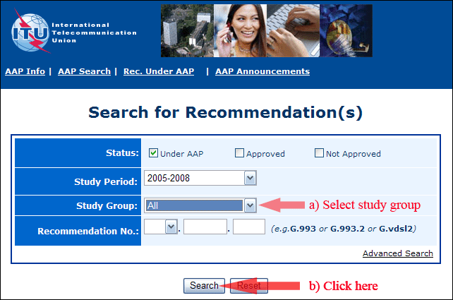

2) Select your Recommendation

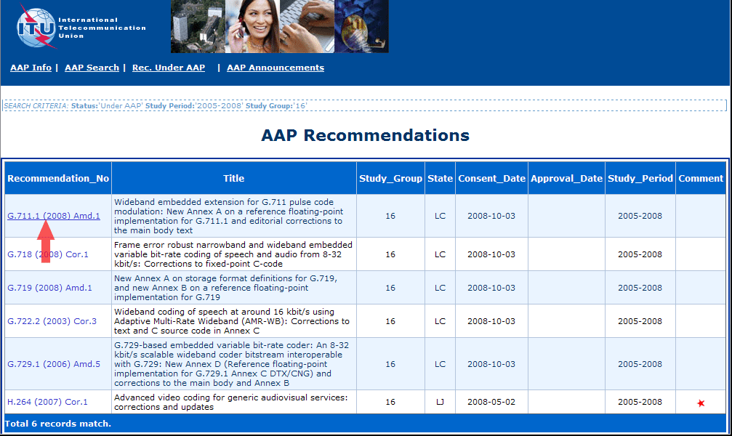

3) Click the "Submit Comment" button

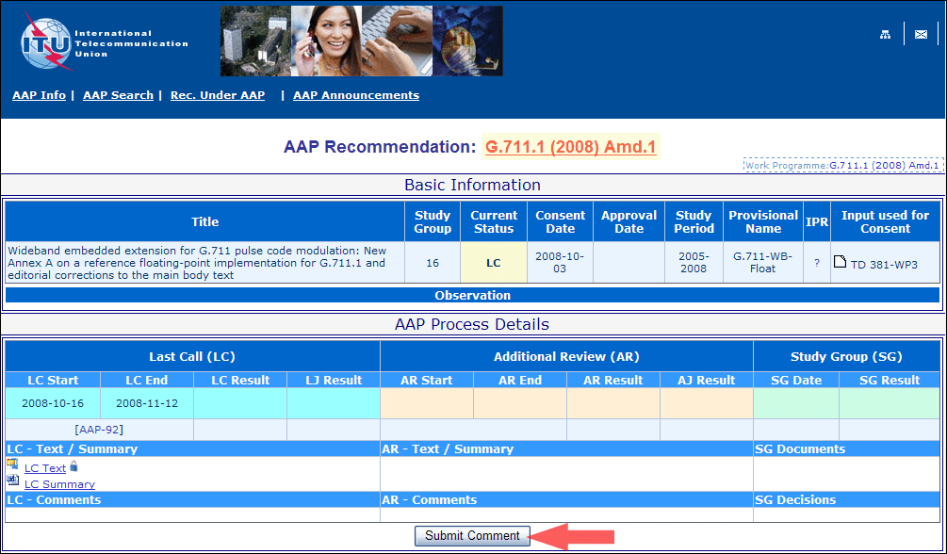

4) Complete the on-line form and click on "Submit"

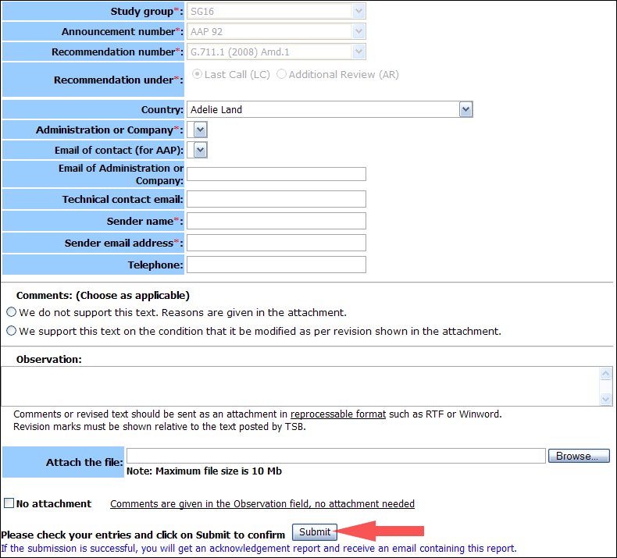

For more information, read the AAP tutorial on:   
<http://www.itu.int/ITU-T/aapinfo/files/AAPTutorial.pdf>

Annex 3

(to TSB AAP-18)

Recommendations under LC/AR – Comment submission form

*(Separate form for each Recommendation being commented upon)*

|  |  |
| --- | --- |
| ITU-T AAP comment submission form for the period 2009-2012 | |
| **Study Group:** |  |
| **Announcement number:** |  |
| **Recommendation number:** |  |
| **Recommendation under:** | Last call (LC)   Additional Review (AR) |
| **Country:** |  |
| **Administration/Company:** |  |
| **Name of AAP Contact Person:** |  |
| **Email of AAP Contact Person:** |  |
| **Sender name: (if different from AAP Contact Person)** |  |
| **Sender email address:** |  |
| **Telephone:** |  |
| **Comments: (Choose as applicable)** | We do not support this text. Reasons are given in the attachment.   We support this text on the condition that it be modified as per revision shown in the attachment. |
| **Observations:** |  |

**No attachment:** Comments are given in the Observation field, no attachment needed

*To be returned to: email:* [*tsbsg....@itu.int*](mailto:tsbsg....@itu.int) *[or fax +41 22 730 5853]  
Comments or revised text should be sent as an attachment in RTF or WinWord format.  
Revision marks must be shown relative to the text posted by TSB.*