Unión Internacional de Telecomunicaciones
Oficina de Normalización de las Telecomunicaciones

Ginebra, 16 de mayo de 2013

Ref:  Tel:  Fax:  Correo-e: | TSB AAP-11  AAP/MJ  +41 22 730 5860  +41 22 730 5853  tsbdir@itu.int | – A las Administraciones de los Estados Miembros de la Unión;  – A los Miembros del Sector UIT-T;  – A los Asociados del UIT-T  Copia:  – A los Presidentes y a los Vicepresidentes de las Comisiones de Estudio del UIT-T;  – Al Director de la Oficina de Desarrollo de las Telecomunicaciones;  – Al Director de la Oficina de Radiocomunicaciones

Asunto: | Situación de las Recomendaciones sometidas al proceso de aprobación alternativo (AAP)

Muy señora mía/Muy señor mío:

El proceso de aprobación alternativo (AAP) definido en la Recomendación A.8 del UIT-T se aplica a las Recomendaciones que no tienen consecuencias en materia de política o reglamentación y que no requieren, por lo tanto, la consulta formal de los Estados Miembros (véase el número 246B del Convenio de la UIT).
En el anexo 1 se enumera la lista de los textos cuyo estado ha cambiado con respecto a los anuncios TSB AAP precedentes.
Si desea formular un comentario en relación con una Recomendación sometida al AAP, le alentamos a utilizar el formulario de presentación de comentarios disponible en la página de la Recomendación que figura en el área AAP del sitio web del UIT-T, en la dirección http://www.itu.int/ITU-T/aap/ (véase también el anexo 2). Alternativamente, pueden presentarse comentarios completando el formulario del anexo 3 y remitiéndolo a la secretaría de la Comisión de Estudio correspondiente.
Le rogamos tenga en cuenta que no se alientan comentarios que se limiten a apoyar la adopción del texto en cuestión.
Le saluda atentamente,

Malcolm Johnson
Director de la Oficina de
Normalización de las Telecomunicaciones
Anexos: 3

Annex 1
(to TSB AAP-11)

Status codes used in the AAP announcements:
LC = Last Call
LJ = Last Call Judgment (includes comment resolution)
AR = Additional Review
AJ = Additional Review Judgment (includes comment resolution)
SG = For Study Group approval
A = Approved
AT = Approved with typographic corrections
AC = Approved after Additional Review of Comments
NA = Not approved
TAP = Moved to TAP (ITU-T A.8 / § 5.2)
ITU-T website entry page:
http://www.itu.int/ITU-T
Alternative approval process (AAP) welcome page:
http://www.itu.int/ITU-T/aapinfo
Note – A tutorial on the ITU-T AAP application is available under the AAP welcome page
ITU-T website AAP Recommendation search page:
http://www.itu.int/ITU-T/aap/
Study Group web pages and contacts:
SG 2 | http://www.itu.int/ITU-T/studygroups/com02 | tsbsg2@itu.int
SG 3 | http://www.itu.int/ITU-T/studygroups/com03 | tsbsg3@itu.int
SG 5 | http://www.itu.int/ITU-T/studygroups/com05 | tsbsg5@itu.int
SG 9 | http://www.itu.int/ITU-T/studygroups/com09 | tsbsg9@itu.int
SG 11 | http://www.itu.int/ITU-T/studygroups/com11 | tsbsg11@itu.int
SG 12 | http://www.itu.int/ITU-T/studygroups/com12 | tsbsg12@itu.int
SG 13 | http://www.itu.int/ITU-T/studygroups/com13 | tsbsg13@itu.int
SG 15 | http://www.itu.int/ITU-T/studygroups/com15 | tsbsg15@itu.int
SG 16 | http://www.itu.int/ITU-T/studygroups/com16 | tsbsg16@itu.int
SG 17 | http://www.itu.int/ITU-T/studygroups/com17 | tsbsg17@itu.int

Situation concerning Study Group 12 Recommendations under AAP
Rec # | Title | Last Call (LC) Period |  |  |  | Additional Review (AR) Period |  |  |  | Status
 |  | LC Start | LC End | LC  Result | LJ  Result | AR Start | AR End | AR  Result | AJ  Result
G.1011 | Reference guide to quality of experience assessment methodologies | 2013-04-16 | 2013-05-13 | A |  |  |  |  |  | A
P.58 | Head and torso simulator for telephonometry | 2013-04-16 | 2013-05-13 | A |  |  |  |  |  | A
P.800.2 (P.MOS) | Mean Opinion Score (MOS) interpretation and reporting | 2013-04-16 | 2013-05-13 | A |  |  |  |  |  | A
P.863.1 (P.863.x) | Application Guide for Recommendation ITU-T P.863 | 2013-04-16 | 2013-05-13 | A |  |  |  |  |  | A
P.1201.2 (Amd.1) | Parametric non-intrusive assessment of audiovisual media streaming quality - higher resolution application area: Amendment 1 | 2013-04-16 | 2013-05-13 | A |  |  |  |  |  | A
P.1202.2 (P.NBAMS-HR) | Parametric non-intrusive bitstream assessment of video media streaming quality - higher resolution application area | 2013-04-16 | 2013-05-13 | AT |  |  |  |  |  | AT
Y.1545 (Y.RMQoSInt (ex Y.OAQoS)) | Roadmap of quality of service of interconnected networks using Internet protocol | 2013-04-16 | 2013-05-13 | A |  |  |  |  |  | A
Situation concerning Study Group 15 Recommendations under AAP
Rec # | Title | Last Call (LC) Period |  |  |  | Additional Review (AR) Period |  |  |  | Status
 |  | LC Start | LC End | LC  Result | LJ  Result | AR Start | AR End | AR  Result | AJ  Result
G.9903 (2012) Amd.1 | Narrow-band orthogonal frequency division multiplexing power line communication transceivers for G3-PLC networks: Amendment 1 | 2013-02-16 | 2013-03-15 | LJ | AR | 2013-04-16 | 2013-05-06 | AC |  | AC
G.9961 (2010) Cor.2 (G.hn) | Unified high-speed wire-line based home networking transceivers - Data link layer specification: Corrigendum 2 | 2013-02-16 | 2013-03-15 | LJ | SG |  |  |  |  | SG
G.9962 (G.hn) | Unified high-speed wire-line based home networking transceivers - Management specification | 2013-02-16 | 2013-03-15 | LJ | SG |  |  |  |  | SG
Situation concerning Study Group 17 Recommendations under AAP
Rec # | Title | Last Call (LC) Period |  |  |  | Additional Review (AR) Period |  |  |  | Status
 |  | LC Start | LC End | LC  Result | LJ  Result | AR Start | AR End | AR  Result | AJ  Result
X.1037 (X.ipv6-secguide) | Technical security guideline on deploying IPv6 | 2013-05-16 | 2013-06-12 |  |  |  |  |  |  | LC
X.1092 (X.tif) | Integrated framework for telebiometric data protection in e-health and telemedicines | 2013-05-16 | 2013-06-12 |  |  |  |  |  |  | LC
X.1156 (X.sap-6) | Non-repudiation framework based on a one time password | 2013-05-16 | 2013-06-12 |  |  |  |  |  |  | LC
X.1198 (X.iptvsec-8) | Virtual machine-based security platform for renewable IPTV service and content protection | 2013-05-16 | 2013-06-12 |  |  |  |  |  |  | LC

Annex 2
(to TSB AAP-11)
Using the on-line comment submission form
Comment submission
1) Go to AAP search Web page at http://www.itu.int/ITU-T/aap/
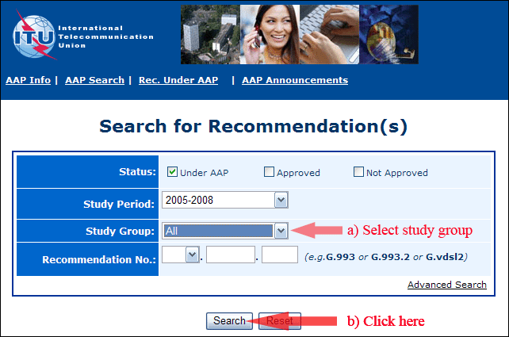
2) Select your Recommendation
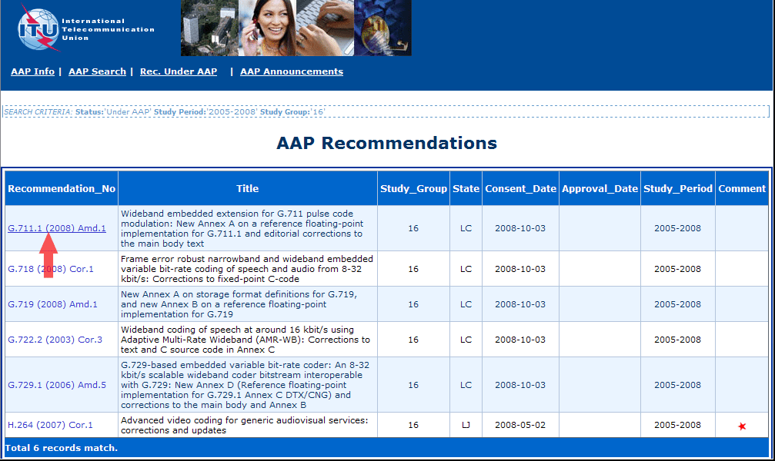
3) Click the "Submit Comment" button
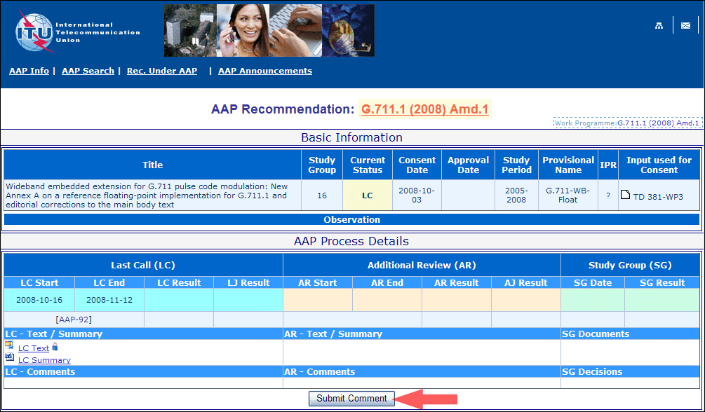
4) Complete the on-line form and click on "Submit"
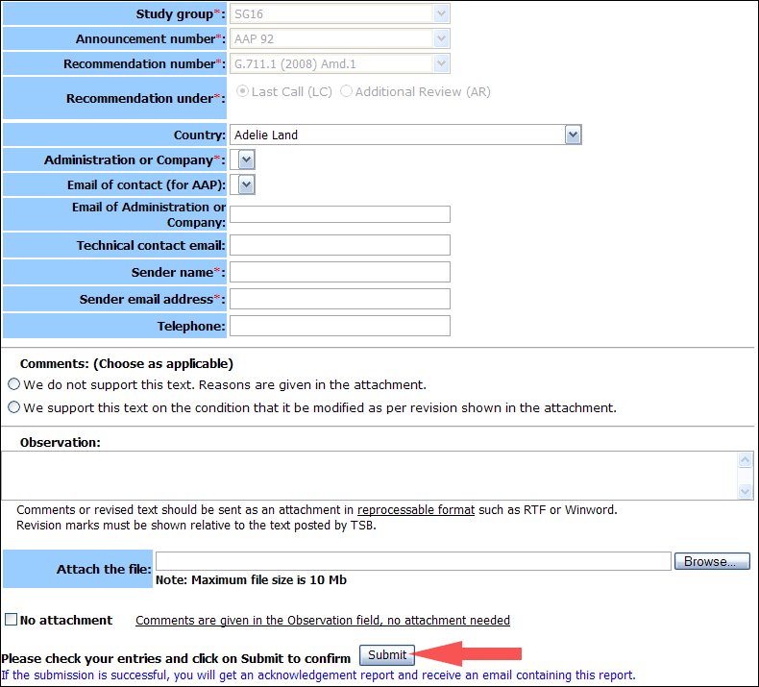
For more information, read the AAP tutorial on:
http://www.itu.int/ITU-T/aapinfo/files/AAPTutorial.pdf
Annex 3
(to TSB AAP-11)
Recommendations under LC/AR – Comment submission form
(Separate form for each Recommendation being commented upon)
ITU-T AAP comment submission form for the period 2009-2012
Study Group:
Announcement number:
Recommendation number:
Recommendation under: | Last call (LC)  Additional Review (AR)
Country:
Administration/Company:
Name of AAP Contact Person:
Email of AAP Contact Person:
Sender name:
(if different from AAP Contact Person)
Sender email address:
Telephone:
Comments:  (Choose as applicable) | We do not support this text. Reasons are given in the attachment.  We support this text on the condition that it be modified as per revision shown in the attachment.
Observations:
No attachment: Comments are given in the Observation field, no attachment needed
To be returned to: email: tsbsg....@itu.int
[or fax +41 22 730 5853]
Comments or revised text should be sent as an attachment in RTF or WinWord format.
Revision marks must be shown relative to the text posted by TSB.

