|  |  |
| --- | --- |
|  | الا تحــاد الــدولي للاتصــالات  *مكتب تقييس الاتصالات* |

|  |  |  |
| --- | --- | --- |
|  |  | جنيف، 16 مايو 2013 |
| المرجع:    الهاتف:  الفاكس:  البريد الإلكتروني: | **TSB AAP-11**  AAP/MJ  +41 22 730 5860  +41 22 730 5853  tsbdir@itu.int | - إلى إدارات الدول الأعضاء في الاتحاد؛  - إلى أعضاء قطاع تقييس الاتصالات؛  - إلى المنتسبين إلى قطاع تقييس الاتصالات  **نسخة إلى:**  - رؤساء لجان الدراسات في قطاع تقييس الاتصالات ونوابهم؛  - مدير مكتب تنمية الاتصالات؛  - مدير مكتب الاتصالات الراديوية |

الموضوع: **حالة التوصيات الخاضعة لعملية الموافقة البديلة (AAP)**

حضرات السادة والسيدات،

تحية طيبة وبعد،

تنطبق عملية الموافقة البديلة (AAP) المعرفة في التوصية ITU‑T A.8 على التوصيات التي لا تنطوي على بعد سياسي أوتنظيمي ولا تتطلب بالتالي استشارة الدول الأعضاء رسمياً (انظر الرقم 246B من اتفاقية الاتحاد).

ويتضمن **الملحق 1** لائحة بالنصوص التي تغيرت حالتها مقارنة بما جاء في إعلانات عملية الموافقة البديلة السابقة.

إذا رغبتم في تقديم تعليق بشأن توصية ما خاضعة لعملية الموافقة البديلة، فنرجو منكم استعمال استمارة التعليق على الخط المتوفّرة على موقع قطاع تقييس الاتصالات على صفحة عملية الموافقة البديلة [http://www.itu.int/ITU-T/aap](http://www.itu.int/ITU-T/aap/) على المدخل الخاص بالتوصية المعنية (انظر **الملحق** (**2**. وبديلاً من ذلك، يمكنكم تقديم التعليقات باستكمال الاستمارة الواردة في **الملحق 3** وإرسالها إلى أمانة لجنة الدراسات المعنية بالأمر.

وتجدر الإشارة إلى أنه يفضّل عدم إرسال تعليقات تقتصر على تأييد اعتماد النص قيد النظر.

وتفضلوا بقبول فائق الاحترام والتقدير.

مالكولم جونسون  
مدير مكتب تقييس الاتصالات

**الملحقات:** 3

Annex 1

(to TSB AAP-11)

Status codes used in the AAP announcements:

LC = Last Call

LJ = Last Call Judgment (includes comment resolution)

AR = Additional Review

AJ = Additional Review Judgment (includes comment resolution)

SG = For Study Group approval

A = Approved

AT = Approved with typographic corrections

AC = Approved after Additional Review of Comments

NA = Not approved

TAP = Moved to TAP (ITU-T A.8 / § 5.2)

ITU-T website entry page:

[http://www.itu.int/ITU-T](http://www.itu.int/ITU-T/)

Alternative approval process (AAP) welcome page:

[http://www.itu.int/ITU-T/aapinfo](http://www.itu.int/ITU-T/aapinfo/)

Note – A tutorial on the ITU-T AAP application is available under the AAP welcome page

ITU-T website AAP Recommendation search page:

<http://www.itu.int/ITU-T/aap/>

Study Group web pages and contacts:

|  |  |  |
| --- | --- | --- |
| SG 2 | <http://www.itu.int/ITU-T/studygroups/com02> | [tsbsg2@itu.int](mailto:tsbsg2@itu.int) |
| SG 3 | <http://www.itu.int/ITU-T/studygroups/com03> | [tsbsg3@itu.int](mailto:tsbsg3@itu.int) |
| SG 5 | <http://www.itu.int/ITU-T/studygroups/com05> | [tsbsg5@itu.int](mailto:tsbsg5@itu.int) |
| SG 9 | <http://www.itu.int/ITU-T/studygroups/com09> | [tsbsg9@itu.int](mailto:tsbsg9@itu.int) |
| SG 11 | <http://www.itu.int/ITU-T/studygroups/com11> | [tsbsg11@itu.int](mailto:tsbsg11@itu.int) |
| SG 12 | <http://www.itu.int/ITU-T/studygroups/com12> | [tsbsg12@itu.int](mailto:tsbsg12@itu.int) |
| SG 13 | <http://www.itu.int/ITU-T/studygroups/com13> | [tsbsg13@itu.int](mailto:tsbsg13@itu.int) |
| SG 15 | <http://www.itu.int/ITU-T/studygroups/com15> | [tsbsg15@itu.int](mailto:tsbsg15@itu.int) |
| SG 16 | <http://www.itu.int/ITU-T/studygroups/com16> | [tsbsg16@itu.int](mailto:tsbsg16@itu.int) |
| SG 17 | <http://www.itu.int/ITU-T/studygroups/com17> | [tsbsg17@itu.int](mailto:tsbsg17@itu.int) |

Situation concerning Study Group 12 Recommendations under AAP

| **Rec #** | **Title** | **Last Call (LC) Period** | | | | **Additional Review (AR) Period** | | | | Status |
| --- | --- | --- | --- | --- | --- | --- | --- | --- | --- | --- |
| **LC Start** | **LC End** | **LC Result** | **LJ Result** | **AR Start** | **AR End** | **AR Result** | **AJ Result** |
| [G.1011](http://www.itu.int/itu-t/aap/AAPRecDetails.aspx?AAPSeqNo=2800) | Reference guide to quality of experience assessment methodologies | 2013-04-16 | 2013-05-13 | A |  |  |  |  |  | A |
| [P.58](http://www.itu.int/itu-t/aap/AAPRecDetails.aspx?AAPSeqNo=2798) | Head and torso simulator for telephonometry | 2013-04-16 | 2013-05-13 | A |  |  |  |  |  | A |
| [P.800.2 (P.MOS)](http://www.itu.int/itu-t/aap/AAPRecDetails.aspx?AAPSeqNo=2797) | Mean Opinion Score (MOS) interpretation and reporting | 2013-04-16 | 2013-05-13 | A |  |  |  |  |  | A |
| [P.863.1 (P.863.x)](http://www.itu.int/itu-t/aap/AAPRecDetails.aspx?AAPSeqNo=2794) | Application Guide for Recommendation ITU-T P.863 | 2013-04-16 | 2013-05-13 | A |  |  |  |  |  | A |
| [P.1201.2 (Amd.1)](http://www.itu.int/itu-t/aap/AAPRecDetails.aspx?AAPSeqNo=2795) | Parametric non-intrusive assessment of audiovisual media streaming quality - higher resolution application area: Amendment 1 | 2013-04-16 | 2013-05-13 | A |  |  |  |  |  | A |
| [P.1202.2 (P.NBAMS-HR)](http://www.itu.int/itu-t/aap/AAPRecDetails.aspx?AAPSeqNo=2796) | Parametric non-intrusive bitstream assessment of video media streaming quality - higher resolution application area | 2013-04-16 | 2013-05-13 | AT |  |  |  |  |  | AT |
| [Y.1545 (Y.RMQoSInt (ex Y.OAQoS))](http://www.itu.int/itu-t/aap/AAPRecDetails.aspx?AAPSeqNo=2799) | Roadmap of quality of service of interconnected networks using Internet protocol | 2013-04-16 | 2013-05-13 | A |  |  |  |  |  | A |

Situation concerning Study Group 15 Recommendations under AAP

| **Rec #** | **Title** | **Last Call (LC) Period** | | | | **Additional Review (AR) Period** | | | | Status |
| --- | --- | --- | --- | --- | --- | --- | --- | --- | --- | --- |
| **LC Start** | **LC End** | **LC Result** | **LJ Result** | **AR Start** | **AR End** | **AR Result** | **AJ Result** |
| [G.9903 (2012) Amd.1](http://www.itu.int/itu-t/aap/AAPRecDetails.aspx?AAPSeqNo=2771) | Narrow-band orthogonal frequency division multiplexing power line communication transceivers for G3-PLC networks: Amendment 1 | 2013-02-16 | 2013-03-15 | LJ | AR | 2013-04-16 | 2013-05-06 | AC |  | AC |
| [G.9961 (2010) Cor.2 (G.hn)](http://www.itu.int/itu-t/aap/AAPRecDetails.aspx?AAPSeqNo=2772) | Unified high-speed wire-line based home networking transceivers - Data link layer specification: Corrigendum 2 | 2013-02-16 | 2013-03-15 | LJ | SG |  |  |  |  | SG |
| [G.9962 (G.hn)](http://www.itu.int/itu-t/aap/AAPRecDetails.aspx?AAPSeqNo=2773) | Unified high-speed wire-line based home networking transceivers - Management specification | 2013-02-16 | 2013-03-15 | LJ | SG |  |  |  |  | SG |

Situation concerning Study Group 17 Recommendations under AAP

| **Rec #** | **Title** | **Last Call (LC) Period** | | | | **Additional Review (AR) Period** | | | | Status |
| --- | --- | --- | --- | --- | --- | --- | --- | --- | --- | --- |
| **LC Start** | **LC End** | **LC Result** | **LJ Result** | **AR Start** | **AR End** | **AR Result** | **AJ Result** |
| [X.1037 (X.ipv6-secguide)](http://www.itu.int/itu-t/aap/AAPRecDetails.aspx?AAPSeqNo=2804) | Technical security guideline on deploying IPv6 | 2013-05-16 | 2013-06-12 |  |  |  |  |  |  | LC |
| [X.1092 (X.tif)](http://www.itu.int/itu-t/aap/AAPRecDetails.aspx?AAPSeqNo=2801) | Integrated framework for telebiometric data protection in e-health and telemedicines | 2013-05-16 | 2013-06-12 |  |  |  |  |  |  | LC |
| [X.1156 (X.sap-6)](http://www.itu.int/itu-t/aap/AAPRecDetails.aspx?AAPSeqNo=2802) | Non-repudiation framework based on a one time password | 2013-05-16 | 2013-06-12 |  |  |  |  |  |  | LC |
| [X.1198 (X.iptvsec-8)](http://www.itu.int/itu-t/aap/AAPRecDetails.aspx?AAPSeqNo=2803) | Virtual machine-based security platform for renewable IPTV service and content protection | 2013-05-16 | 2013-06-12 |  |  |  |  |  |  | LC |

Annex 2

(to TSB AAP-11)

Using the on-line comment submission form

Comment submission

1) Go to AAP search Web page at <http://www.itu.int/ITU-T/aap/>

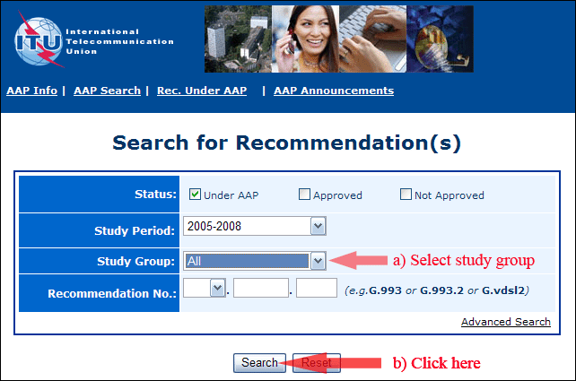

2) Select your Recommendation

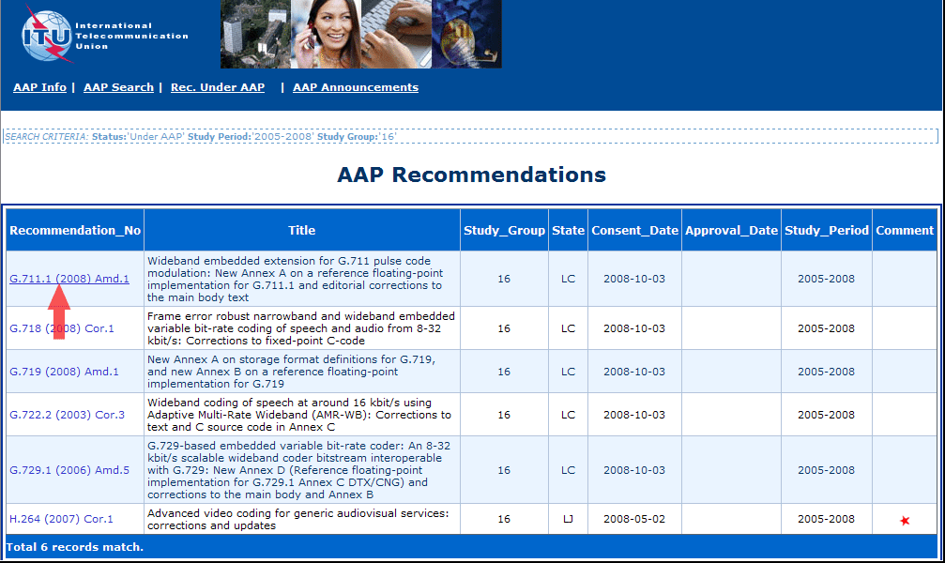

3) Click the "Submit Comment" button

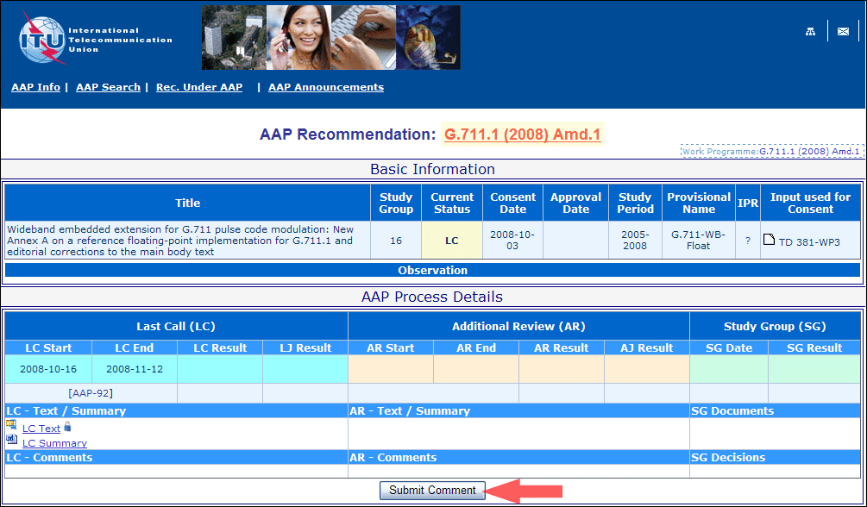

4) Complete the on-line form and click on "Submit"

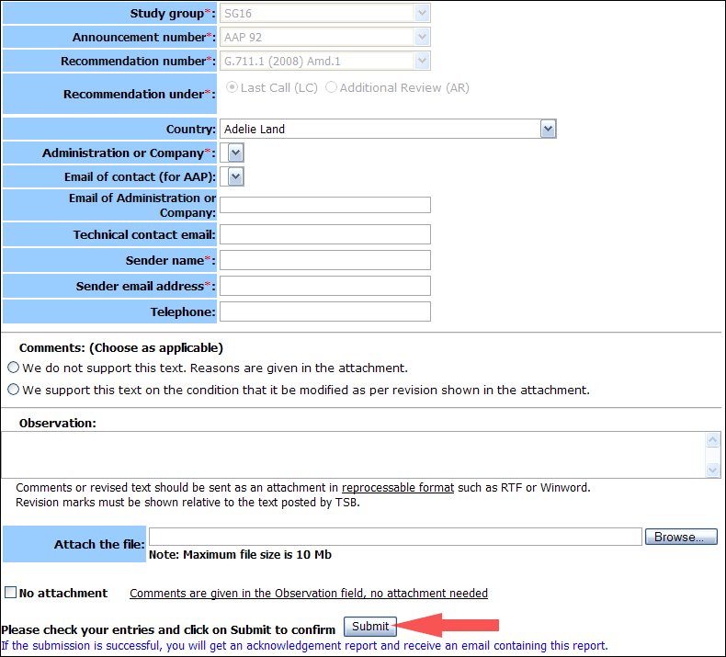

For more information, read the AAP tutorial on:   
<http://www.itu.int/ITU-T/aapinfo/files/AAPTutorial.pdf>

Annex 3

(to TSB AAP-11)

Recommendations under LC/AR – Comment submission form

*(Separate form for each Recommendation being commented upon)*

|  |  |
| --- | --- |
| ITU-T AAP comment submission form for the period 2009-2012 | |
| **Study Group:** |  |
| **Announcement number:** |  |
| **Recommendation number:** |  |
| **Recommendation under:** | Last call (LC)   Additional Review (AR) |
| **Country:** |  |
| **Administration/Company:** |  |
| **Name of AAP Contact Person:** |  |
| **Email of AAP Contact Person:** |  |
| **Sender name: (if different from AAP Contact Person)** |  |
| **Sender email address:** |  |
| **Telephone:** |  |
| **Comments: (Choose as applicable)** | We do not support this text. Reasons are given in the attachment.   We support this text on the condition that it be modified as per revision shown in the attachment. |
| **Observations:** |  |

**No attachment:** Comments are given in the Observation field, no attachment needed

*To be returned to: email:* [*tsbsg....@itu.int*](mailto:tsbsg....@itu.int) *[or fax +41 22 730 5853]  
Comments or revised text should be sent as an attachment in RTF or WinWord format.  
Revision marks must be shown relative to the text posted by TSB.*