الا تحــاد الــدولي للاتصــالات
مكتب تقييس الاتصالات

 |  | جنيف، 16 سبتمبر 2012
المرجع:  الهاتف:  الفاكس:  البريد الإلكتروني: | TSB AAP-90  AAP/MJ  +41 22 730 5860  +41 22 730 5853  tsbdir@itu.int | - إلى إدارات الدول الأعضاء في الاتحاد؛  - إلى أعضاء قطاع تقييس الاتصالات؛  - إلى المنتسبين إلى قطاع تقييس الاتصالات  نسخة إلى:  - رؤساء لجان الدراسات في قطاع تقييس الاتصالات ونوابهم؛  - مدير مكتب تنمية الاتصالات؛  - مدير مكتب الاتصالات الراديوية

الموضوع: حالة التوصيات الخاضعة لعملية الموافقة البديلة (AAP)

حضرات السادة والسيدات،
تحية طيبة وبعد،
تنطبق عملية الموافقة البديلة (AAP) المعرفة في التوصية ITU-T A.8 على التوصيات التي لا تنطوي على بعد سياسي أوتنظيمي ولا تتطلب بالتالي استشارة الدول الأعضاء رسمياً (انظر الرقم 246B من اتفاقية الاتحاد).
ويتضمن الملحق 1 لائحة بالنصوص التي تغيرت حالتها مقارنة بما جاء في إعلانات عملية الموافقة البديلة السابقة.
إذا رغبتم في تقديم تعليق بشأن توصية ما خاضعة لعملية الموافقة البديلة، فنرجو منكم استعمال استمارة التعليق على الخط المتوفّرة على موقع قطاع تقييس الاتصالات على صفحة عملية الموافقة البديلة http://www.itu.int/ITU-T/aap على المدخل الخاص بالتوصية المعنية (انظر الملحق (2. وبديلاً من ذلك، يمكنكم تقديم التعليقات باستكمال الاستمارة الواردة في الملحق 3 وإرسالها إلى أمانة لجنة الدراسات المعنية بالأمر.
وتجدر الإشارة إلى أنه يفضّل عدم إرسال تعليقات تقتصر على تأييد اعتماد النص قيد النظر.

وتفضلوا بقبول فائق الاحترام والتقدير.
مالكولم جونسون
مدير مكتب تقييس الاتصالات

الملحقات: 3

Annex 1
(to TSB AAP-90)

Status codes used in the AAP announcements:
LC = Last Call
LJ = Last Call Judgment (includes comment resolution)
AR = Additional Review
AJ = Additional Review Judgment (includes comment resolution)
SG = For Study Group approval
A = Approved
AT = Approved with typographic corrections
AC = Approved after Additional Review of Comments
NA = Not approved
TAP = Moved to TAP (ITU-T A.8 / § 5.2)
ITU-T website entry page:
http://www.itu.int/ITU-T
Alternative approval process (AAP) welcome page:
http://www.itu.int/ITU-T/aapinfo
Note – A tutorial on the ITU-T AAP application is available under the AAP welcome page
ITU-T website AAP Recommendation search page:
http://www.itu.int/ITU-T/aap/
Study Group web pages and contacts:
SG 2 | http://www.itu.int/ITU-T/studygroups/com02 | tsbsg2@itu.int
SG 3 | http://www.itu.int/ITU-T/studygroups/com03 | tsbsg3@itu.int
SG 5 | http://www.itu.int/ITU-T/studygroups/com05 | tsbsg5@itu.int
SG 9 | http://www.itu.int/ITU-T/studygroups/com09 | tsbsg9@itu.int
SG 11 | http://www.itu.int/ITU-T/studygroups/com11 | tsbsg11@itu.int
SG 12 | http://www.itu.int/ITU-T/studygroups/com12 | tsbsg12@itu.int
SG 13 | http://www.itu.int/ITU-T/studygroups/com13 | tsbsg13@itu.int
SG 15 | http://www.itu.int/ITU-T/studygroups/com15 | tsbsg15@itu.int
SG 16 | http://www.itu.int/ITU-T/studygroups/com16 | tsbsg16@itu.int
SG 17 | http://www.itu.int/ITU-T/studygroups/com17 | tsbsg17@itu.int

Situation concerning Study Group 12 Recommendations under AAP
Rec # | Title | Last Call (LC) Period |  |  |  | Additional Review (AR) Period |  |  |  | Status
Rec # | Title | LC Start | LC End | LC  Result | LJ  Result | AR Start | AR End | AR  Result | AJ  Result | Status
P.1201 (P.NAMS) | Parametric non-intrusive assessment of audiovisual media streaming quality | 2012-09-16 | 2012-10-13 |  |  |  |  |  |  | LC
P.1201.1 (P.NAMS-LR) | Parametric non-intrusive assessment of audiovisual media streaming quality - lower resolution application area | 2012-09-16 | 2012-10-13 |  |  |  |  |  |  | LC
P.1201.2 (P.NAMS-HR) | Parametric non-intrusive assessment of audiovisual media streaming quality - higher resolution application area | 2012-09-16 | 2012-10-13 |  |  |  |  |  |  | LC
P.1202 (P.NBAMS) | Parametric non-intrusive bitstream assessment of video media streaming quality | 2012-09-16 | 2012-10-13 |  |  |  |  |  |  | LC
P.1202.1 (P.NBAMS-LR) | Parametric non-intrusive bitstream assessment of video media streaming quality - lower resolution application area | 2012-09-16 | 2012-10-13 |  |  |  |  |  |  | LC
Situation concerning Study Group 16 Recommendations under AAP
Rec # | Title | Last Call (LC) Period |  |  |  | Additional Review (AR) Period |  |  |  | Status
Rec # | Title | LC Start | LC End | LC  Result | LJ  Result | AR Start | AR End | AR  Result | AJ  Result | Status
G.711.1 (G.711.1) | Wideband embedded extension for G.711 pulse code modulation | 2012-08-16 | 2012-09-12 | A |  |  |  |  |  | A
G.722 (G.722) | 7 kHz audio-coding within 64 kbit/s | 2012-08-16 | 2012-09-12 | A |  |  |  |  |  | A
Situation concerning Study Group 17 Recommendations under AAP
Rec # | Title | Last Call (LC) Period |  |  |  | Additional Review (AR) Period |  |  |  | Status
Rec # | Title | LC Start | LC End | LC  Result | LJ  Result | AR Start | AR End | AR  Result | AJ  Result | Status
E.115 (2010) Cor.1 | Corrigendum 1 to ITU-T E.115 (2010) | 2012-09-16 | 2012-10-13 |  |  |  |  |  |  | LC
X.500 | Information technology - Open Systems Interconnection - The Directory: Overview of concepts, models and services | 2012-09-16 | 2012-10-13 |  |  |  |  |  |  | LC
X.501 | Information technology - Open Systems Interconnection - The Directory: Models | 2012-09-16 | 2012-10-13 |  |  |  |  |  |  | LC
X.501 (2008) Cor.3 | Information technology - Open Systems Interconnection -The Directory - Models - Technical Corrigendum 3 | 2012-09-16 | 2012-10-13 |  |  |  |  |  |  | LC
X.509 | Information technology - Open Systems Interconnection - The Directory: Public-key and attribute certificate frameworks | 2012-09-16 | 2012-10-13 |  |  |  |  |  |  | LC
X.509 (2008) Cor.3 | Information technology - Open Systems Interconnection -The Directory - Public-key and attribute certificate frameworks - Technical Corrigendum 3 | 2012-09-16 | 2012-10-13 |  |  |  |  |  |  | LC
X.511 | Information technology - Open Systems Interconnection - The Directory: Abstract service definition | 2012-09-16 | 2012-10-13 |  |  |  |  |  |  | LC
X.511 (2008) Cor.3 | Information technology - Open Systems Interconnection -The Directory - Abstract service definition- Technical Corrigendum 3 | 2012-09-16 | 2012-10-13 |  |  |  |  |  |  | LC
X.518 | Information technology - Open Systems Interconnection - The Directory: Procedures for distributed operations | 2012-09-16 | 2012-10-13 |  |  |  |  |  |  | LC
X.518 (2008) Cor.2 | Information technology - Open Systems Interconnection -The Directory - Procedures for distributed operations- Technical Corrigendum 2 | 2012-09-16 | 2012-10-13 |  |  |  |  |  |  | LC
X.519 | Information technology - Open Systems Interconnection - The Directory: Protocols | 2012-09-16 | 2012-10-13 |  |  |  |  |  |  | LC
X.520 | Information technology - Open Systems Interconnection - The Directory - Selected attribute types | 2012-09-16 | 2012-10-13 |  |  |  |  |  |  | LC
X.520 (2008) Cor.3 | Information technology - Open Systems Interconnection -The Directory - Selected attribute types- Technical Corrigendum 3 | 2012-09-16 | 2012-10-13 |  |  |  |  |  |  | LC
X.521 | Information technology - Open Systems Interconnection - The Directory: Selected object classes | 2012-09-16 | 2012-10-13 |  |  |  |  |  |  | LC
X.525 | Information technology - Open Systems Interconnection - The Directory: Replication | 2012-09-16 | 2012-10-13 |  |  |  |  |  |  | LC
X.667 | Information technology - Procedures for the operation of Object Identifier Registration Authorities: Generation of Universally Unique identifier (UUIDS) and their use in object identifiers | 2012-09-16 | 2012-10-13 |  |  |  |  |  |  | LC
X.1164 (X.p2p-4) | Use of service providers' user authentication infrastructure to implement public key infrastructure for peer-to-peer networks | 2012-09-16 | 2012-10-13 |  |  |  |  |  |  | LC
X.1196 (X.iptvsec-6) | Framework for the downloadable service and content protection system in the mobile Internet Protocol Television (IPTV) environment | 2012-09-16 | 2012-10-13 |  |  |  |  |  |  | LC
X.1313 (X.usnsec-3) | Security requirements for wireless sensor network routing | 2012-09-16 | 2012-10-13 |  |  |  |  |  |  | LC
Z.104 Amd.1 | Data and action language in SDL-2010 Annex C - Language binding | 2012-09-16 | 2012-10-13 |  |  |  |  |  |  | LC
Z.151 | User Requirements Notation (URN) – Language definition | 2012-09-16 | 2012-10-13 |  |  |  |  |  |  | LC

Annex 2
(to TSB AAP-90)
Using the on-line comment submission form
Comment submission
1) Go to AAP search Web page at http://www.itu.int/ITU-T/aap/
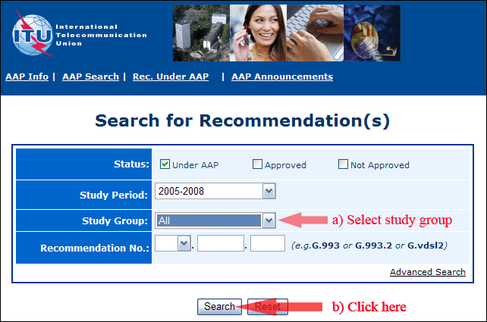
2) Select your Recommendation
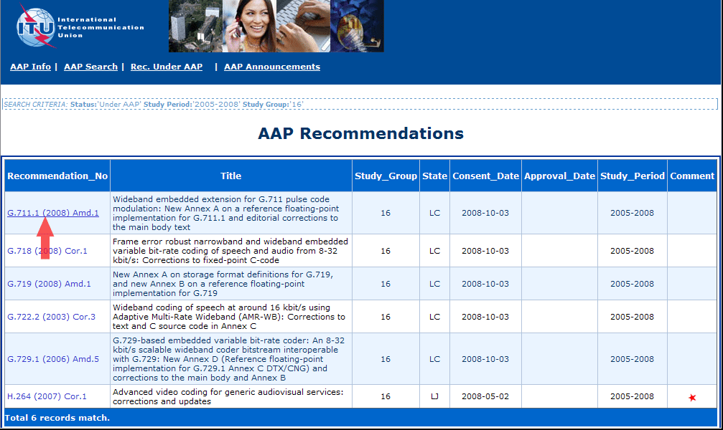
3) Click the "Submit Comment" button
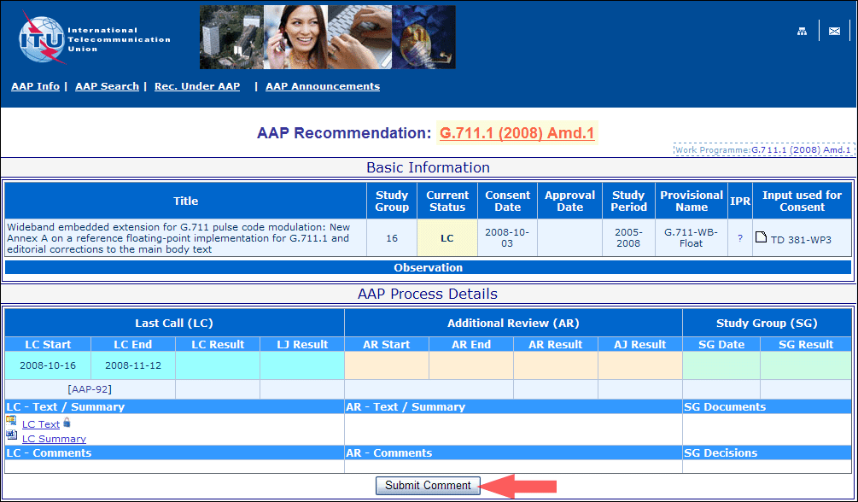
4) Complete the on-line form and click on "Submit"
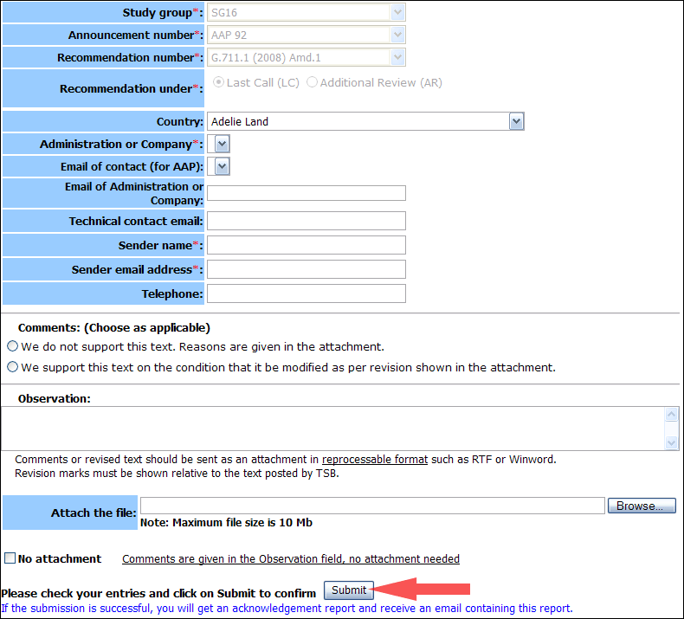
For more information, read the AAP tutorial on:
http://www.itu.int/ITU-T/aapinfo/files/AAPTutorial.pdf
Annex 3
(to TSB AAP-90)
Recommendations under LC/AR – Comment submission form
(Separate form for each Recommendation being commented upon)
ITU-T AAP comment submission form for the period 2009-2012
Study Group:
Announcement number:
Recommendation number:
Recommendation under: | Last call (LC)  Additional Review (AR)
Country:
Administration/Company:
Name of AAP Contact Person:
Email of AAP Contact Person:
Sender name:
(if different from AAP Contact Person)
Sender email address:
Telephone:
Comments:  (Choose as applicable) | We do not support this text. Reasons are given in the attachment.  We support this text on the condition that it be modified as per revision shown in the attachment.
Observations:
No attachment: Comments are given in the Observation field, no attachment needed
To be returned to: email: tsbsg....@itu.int
[or fax +41 22 730 5853]
Comments or revised text should be sent as an attachment in RTF or WinWord format.
Revision marks must be shown relative to the text posted by TSB.

