الا تحــاد الــدولي للاتصــالات
مكتب تقييس الاتصالات

 |  | جنيف، 16 مايو 2012
المرجع:  الهاتف:  الفاكس:  البريد الإلكتروني: | TSB AAP-82  AAP/MJ  +41 22 730 5860  +41 22 730 5853  tsbdir@itu.int | - إلى إدارات الدول الأعضاء في الاتحاد؛  - إلى أعضاء قطاع تقييس الاتصالات؛  - إلى المنتسبين إلى قطاع تقييس الاتصالات  نسخة إلى:  - رؤساء لجان الدراسات في قطاع تقييس الاتصالات ونوابهم؛  - مدير مكتب تنمية الاتصالات؛  - مدير مكتب الاتصالات الراديوية

الموضوع: حالة التوصيات الخاضعة لعملية الموافقة البديلة (AAP)

حضرات السادة والسيدات،
تحية طيبة وبعد،
تنطبق عملية الموافقة البديلة (AAP) المعرفة في التوصية ITU-T A.8 على التوصيات التي لا تنطوي على بعد سياسي أوتنظيمي ولا تتطلب بالتالي استشارة الدول الأعضاء رسمياً (انظر الرقم 246B من اتفاقية الاتحاد).
ويتضمن الملحق 1 لائحة بالنصوص التي تغيرت حالتها مقارنة بما جاء في إعلانات عملية الموافقة البديلة السابقة.
إذا رغبتم في تقديم تعليق بشأن توصية ما خاضعة لعملية الموافقة البديلة، فنرجو منكم استعمال استمارة التعليق على الخط المتوفّرة على موقع قطاع تقييس الاتصالات على صفحة عملية الموافقة البديلة http://www.itu.int/ITU-T/aap على المدخل الخاص بالتوصية المعنية (انظر الملحق (2. وبديلاً من ذلك، يمكنكم تقديم التعليقات باستكمال الاستمارة الواردة في الملحق 3 وإرسالها إلى أمانة لجنة الدراسات المعنية بالأمر.
وتجدر الإشارة إلى أنه يفضّل عدم إرسال تعليقات تقتصر على تأييد اعتماد النص قيد النظر.

وتفضلوا بقبول فائق الاحترام والتقدير.
مالكولم جونسون
مدير مكتب تقييس الاتصالات

الملحقات: 3

Annex 1
(to TSB AAP-82)

Status codes used in the AAP announcements:
LC = Last Call
LJ = Last Call Judgment (includes comment resolution)
AR = Additional Review
AJ = Additional Review Judgment (includes comment resolution)
SG = For Study Group approval
A = Approved
AT = Approved with typographic corrections
AC = Approved after Additional Review of Comments
NA = Not approved
TAP = Moved to TAP (ITU-T A.8 / § 5.2)
ITU-T website entry page:
http://www.itu.int/ITU-T
Alternative approval process (AAP) welcome page:
http://www.itu.int/ITU-T/aapinfo
Note – A tutorial on the ITU-T AAP application is available under the AAP welcome page
ITU-T website AAP Recommendation search page:
http://www.itu.int/ITU-T/aap/
Study Group web pages and contacts:
SG 2 | http://www.itu.int/ITU-T/studygroups/com02 | tsbsg2@itu.int
SG 3 | http://www.itu.int/ITU-T/studygroups/com03 | tsbsg3@itu.int
SG 5 | http://www.itu.int/ITU-T/studygroups/com05 | tsbsg5@itu.int
SG 9 | http://www.itu.int/ITU-T/studygroups/com09 | tsbsg9@itu.int
SG 11 | http://www.itu.int/ITU-T/studygroups/com11 | tsbsg11@itu.int
SG 12 | http://www.itu.int/ITU-T/studygroups/com12 | tsbsg12@itu.int
SG 13 | http://www.itu.int/ITU-T/studygroups/com13 | tsbsg13@itu.int
SG 15 | http://www.itu.int/ITU-T/studygroups/com15 | tsbsg15@itu.int
SG 16 | http://www.itu.int/ITU-T/studygroups/com16 | tsbsg16@itu.int
SG 17 | http://www.itu.int/ITU-T/studygroups/com17 | tsbsg17@itu.int

Situation concerning Study Group 2 Recommendations under AAP
Rec # | Title | Last Call (LC) Period |  |  |  | Additional Review (AR) Period |  |  |  | Status
Rec # | Title | LC Start | LC End | LC  Result | LJ  Result | AR Start | AR End | AR  Result | AJ  Result | Status
E.139 (E.PIAP) | Public Internet Access Points (PIAPs) | 2012-04-16 | 2012-05-13 | A |  |  |  |  |  | A
M.1402 | Formalization of data for service management | 2012-04-16 | 2012-05-13 | A |  |  |  |  |  | A
M.3347 (X.service-activation) | Requirements for the NGN Service Activation of NMS-EMS Interface | 2012-04-16 | 2012-05-13 | A |  |  |  |  |  | A
Q.818 (Q.ws-xml) | Web-service based Management Services | 2012-04-16 | 2012-05-13 | A |  |  |  |  |  | A
X.782 (X.ws-xml) | Guidelines for defining Web-services for managed objects and management interfaces | 2012-04-16 | 2012-05-13 | AT |  |  |  |  |  | AT
Situation concerning Study Group 9 Recommendations under AAP
Rec # | Title | Last Call (LC) Period |  |  |  | Additional Review (AR) Period |  |  |  | Status
Rec # | Title | LC Start | LC End | LC  Result | LJ  Result | AR Start | AR End | AR  Result | AJ  Result | Status
J.185 (J.fmc-rev) | Transmission equipment for transferring multi-channel television signals over optical access networks by frequency modulation conversion | 2012-05-16 | 2012-06-12 |  |  |  |  |  |  | LC
J.381 (J.atrans-req) | Requirements for advanced digital cable transmission technologies | 2012-05-16 | 2012-06-12 |  |  |  |  |  |  | LC
J.1101 (J.vodoc-req) | Functional requirements for IP-based switched digital video using Data Over Cable Service Interface Specifications | 2012-05-16 | 2012-06-12 |  |  |  |  |  |  | LC
Situation concerning Study Group 13 Recommendations under AAP
Rec # | Title | Last Call (LC) Period |  |  |  | Additional Review (AR) Period |  |  |  | Status
Rec # | Title | LC Start | LC End | LC  Result | LJ  Result | AR Start | AR End | AR  Result | AJ  Result | Status
Y.3031 (Y.FNid) | Identification framework in future networks | 2012-03-01 | 2012-03-28 | LJ | AR | 2012-04-16 | 2012-05-06 | AC |  | AC
Situation concerning Study Group 15 Recommendations under AAP
Rec # | Title | Last Call (LC) Period |  |  |  | Additional Review (AR) Period |  |  |  | Status
Rec # | Title | LC Start | LC End | LC  Result | LJ  Result | AR Start | AR End | AR  Result | AJ  Result | Status
G.984.6 (2008) Amd. 2 | Gigabit-capable Passive Optical Networks (GPON): Reach extender (RE) units - Amendment 2 | 2012-01-16 | 2012-02-12 | LJ | AR | 2012-04-16 | 2012-05-06 | AC |  | AC
G.987 | 10-Gigabit-capable passive optical network (XG-PON) systems: Definitions, abbreviations and acronyms | 2012-05-16 | 2012-06-12 |  |  |  |  |  |  | LC
G.987.4 (G.xgpon.re) | 10-Gigabit-capable Passive Optical Networks (XG-PON): Reach extension | 2012-01-16 | 2012-02-12 | LJ | AR | 2012-05-16 | 2012-06-05 |  |  | AR
G.988 (2010) Cor.1 | ONU management and control interface (OMCI) specification: Corrigendum 1 | 2012-05-16 | 2012-06-12 |  |  |  |  |  |  | LC
G.993.2 (2011) Cor.1 | Very high speed digital subscriber line transceivers 2 (VDSL2): Corrigendum 1 | 2012-05-16 | 2012-06-12 |  |  |  |  |  |  | LC
G.993.5 (2010) Cor.2 | Self-FEXT cancellation (vectoring) for use with VDSL2 transceivers: Corrigendum 2 | 2012-05-16 | 2012-06-12 |  |  |  |  |  |  | LC
G.994.1 | Handshake procedures for digital subscriber line (DSL) transceivers | 2012-05-16 | 2012-06-12 |  |  |  |  |  |  | LC
G.997.1 | Physical layer management for digital subscriber line (DSL) transceivers | 2012-05-16 | 2012-06-12 |  |  |  |  |  |  | LC
G.998.4 (2010) Cor.4 | Improved impulse noise protection for DSL transceivers: Corrigendum 4 | 2012-05-16 | 2012-06-12 |  |  |  |  |  |  | LC
G.8013/Y.1731 (2011) Amd.1 | OAM functions and mechanisms for Ethernet based networks: Amendment 1 | 2012-01-16 | 2012-02-12 | LJ | AR | 2012-04-16 | 2012-05-06 | AC |  | AC
G.8021/Y.1341 | Characteristics of Ethernet transport network equipment functional blocks | 2012-01-16 | 2012-02-12 | LJ | AR | 2012-04-16 | 2012-05-06 | AC |  | AC

Annex 2
(to TSB AAP-82)
Using the on-line comment submission form
Comment submission
1) Go to AAP search Web page at http://www.itu.int/ITU-T/aap/
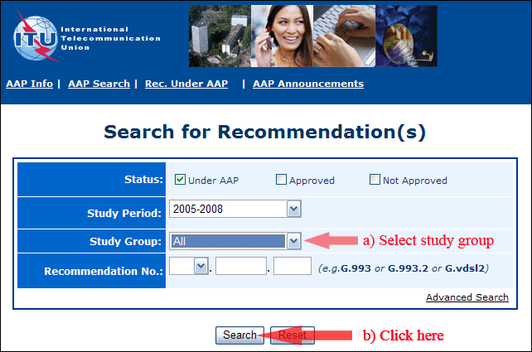
2) Select your Recommendation
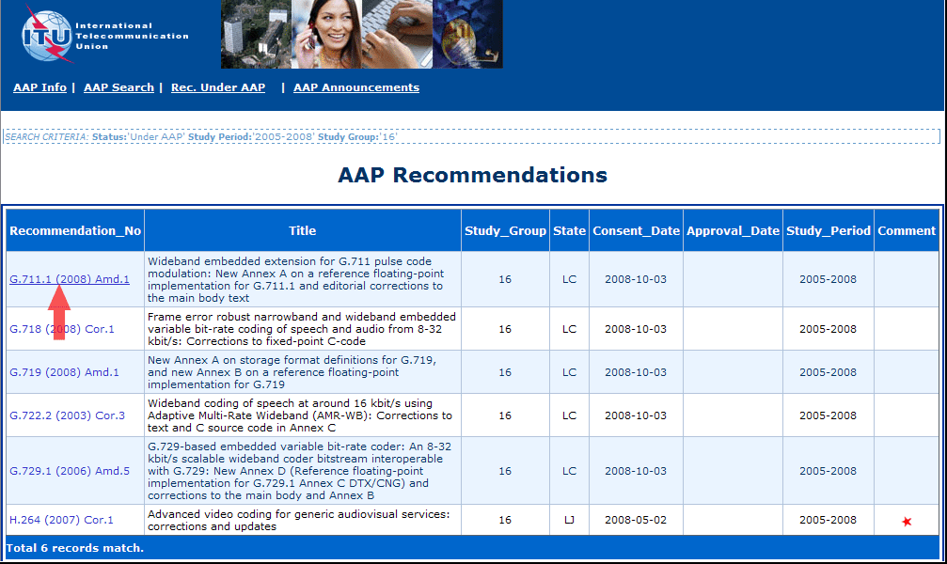
3) Click the "Submit Comment" button
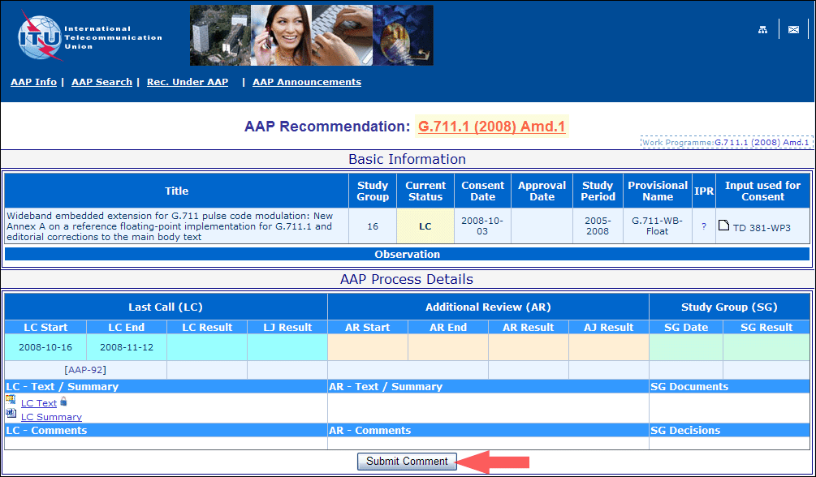
4) Complete the on-line form and click on "Submit"
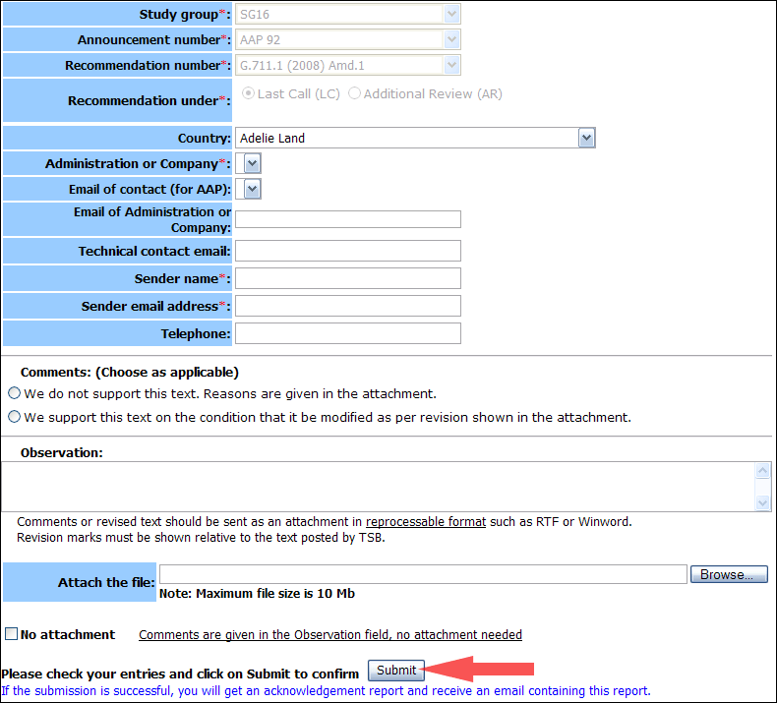
For more information, read the AAP tutorial on:
http://www.itu.int/ITU-T/aapinfo/files/AAPTutorial.pdf
Annex 3
(to TSB AAP-82)
Recommendations under LC/AR – Comment submission form
(Separate form for each Recommendation being commented upon)
ITU-T AAP comment submission form for the period 2009-2012
Study Group:
Announcement number:
Recommendation number:
Recommendation under: | Last call (LC)  Additional Review (AR)
Country:
Administration/Company:
Name of AAP Contact Person:
Email of AAP Contact Person:
Sender name:
(if different from AAP Contact Person)
Sender email address:
Telephone:
Comments:  (Choose as applicable) | We do not support this text. Reasons are given in the attachment.  We support this text on the condition that it be modified as per revision shown in the attachment.
Observations:
No attachment: Comments are given in the Observation field, no attachment needed
To be returned to: email: tsbsg....@itu.int
[or fax +41 22 730 5853]
Comments or revised text should be sent as an attachment in RTF or WinWord format.
Revision marks must be shown relative to the text posted by TSB.

