Unión Internacional de Telecomunicaciones
Oficina de Normalización de las Telecomunicaciones

Ginebra, 16 de enero de 2012

Ref:  Tel:  Fax:  Correo-e: | TSB AAP-74  AAP/MJ  +41 22 730 5860  +41 22 730 5853  tsbdir@itu.int | – A las Administraciones de los Estados Miembros de la Unión;  – A los Miembros del Sector UIT-T;  – A los Asociados del UIT-T  Copia:  – A los Presidentes y a los Vicepresidentes de las Comisiones de Estudio del UIT-T;  – Al Director de la Oficina de Desarrollo de las Telecomunicaciones;  – Al Director de la Oficina de Radiocomunicaciones

Asunto: | Situación de las Recomendaciones sometidas al proceso de aprobación alternativo (AAP)

Muy señora mía/Muy señor mío:

El proceso de aprobación alternativo (AAP) definido en la Recomendación A.8 del UIT-T se aplica a las Recomendaciones que no tienen consecuencias en materia de política o reglamentación y que no requieren, por lo tanto, la consulta formal de los Estados Miembros (véase el número 246B del Convenio de la UIT).
En el anexo 1 se enumera la lista de los textos cuyo estado ha cambiado con respecto a los anuncios TSB AAP precedentes.
Si desea formular un comentario en relación con una Recomendación sometida al AAP, le alentamos a utilizar el formulario de presentación de comentarios disponible en la página de la Recomendación que figura en el área AAP del sitio web del UIT-T, en la dirección http://www.itu.int/ITU-T/aap/ (véase también el anexo 2). Alternativamente, pueden presentarse comentarios completando el formulario del anexo 3 y remitiéndolo a la secretaría de la Comisión de Estudio correspondiente.
Le rogamos tenga en cuenta que no se alientan comentarios que se limiten a apoyar la adopción del texto en cuestión.
Le saluda atentamente,

Malcolm Johnson
Director de la Oficina de
Normalización de las Telecomunicaciones
Anexos: 3

Annex 1
(to TSB AAP-74)

Status codes used in the AAP announcements:
LC = Last Call
LJ = Last Call Judgment (includes comment resolution)
AR = Additional Review
AJ = Additional Review Judgment (includes comment resolution)
SG = For Study Group approval
A = Approved
AT = Approved with typographic corrections
AC = Approved after Additional Review of Comments
NA = Not approved
TAP = Moved to TAP (ITU-T A.8 / § 5.2)
ITU-T website entry page:
http://www.itu.int/ITU-T
Alternative approval process (AAP) welcome page:
http://www.itu.int/ITU-T/aapinfo
Note – A tutorial on the ITU-T AAP application is available under the AAP welcome page
ITU-T website AAP Recommendation search page:
http://www.itu.int/ITU-T/aap/
Study Group web pages and contacts:
SG 2 | http://www.itu.int/ITU-T/studygroups/com02 | tsbsg2@itu.int
SG 3 | http://www.itu.int/ITU-T/studygroups/com03 | tsbsg3@itu.int
SG 5 | http://www.itu.int/ITU-T/studygroups/com05 | tsbsg5@itu.int
SG 9 | http://www.itu.int/ITU-T/studygroups/com09 | tsbsg9@itu.int
SG 11 | http://www.itu.int/ITU-T/studygroups/com11 | tsbsg11@itu.int
SG 12 | http://www.itu.int/ITU-T/studygroups/com12 | tsbsg12@itu.int
SG 13 | http://www.itu.int/ITU-T/studygroups/com13 | tsbsg13@itu.int
SG 15 | http://www.itu.int/ITU-T/studygroups/com15 | tsbsg15@itu.int
SG 16 | http://www.itu.int/ITU-T/studygroups/com16 | tsbsg16@itu.int
SG 17 | http://www.itu.int/ITU-T/studygroups/com17 | tsbsg17@itu.int

Situation concerning Study Group 5 Recommendations under AAP
Rec # | Title | Last Call (LC) Period |  |  |  | Additional Review (AR) Period |  |  |  | Status
 |  | LC Start | LC End | LC  Result | LJ  Result | AR Start | AR End | AR  Result | AJ  Result
L.1420 (L.ORG) | Methodology for energy consumption and greenhouse gas emissions impact assessment of Information and Communication Technologies in organizations | 2011-10-16 | 2011-11-12 | LJ | AR | 2012-01-16 | 2012-02-05 |  |  | AR
Situation concerning Study Group 9 Recommendations under AAP
Rec # | Title | Last Call (LC) Period |  |  |  | Additional Review (AR) Period |  |  |  | Status
 |  | LC Start | LC End | LC  Result | LJ  Result | AR Start | AR End | AR  Result | AJ  Result
J.205 (J.acf-req) | Requirements for harmonized Application Control Framework supporting hybrid broadcast & broadband applications | 2011-12-16 | 2012-01-12 | A |  |  |  |  |  | A
J.295 (J.adcstb-req) | Advanced cable set-top box requirement | 2011-12-16 | 2012-01-12 | A |  |  |  |  |  | A
J.706  (J.tgtdst-overview) | The overview of target content distribution | 2011-12-16 | 2012-01-12 | A |  |  |  |  |  | A
J.707 (J.target-dist) | Messages and protocols enabling target content distribution for integrated broadband cable networks | 2011-12-16 | 2012-01-12 | A |  |  |  |  |  | A
J.902 (J.ftvdf) | Multi-layer data structure for scalable view-range representation | 2011-12-16 | 2012-01-12 | A |  |  |  |  |  | A
J.1001 (J.rcas-req) | Requirements for conditional access client software remote renewable security system | 2011-12-16 | 2012-01-12 | A |  |  |  |  |  | A
Situation concerning Study Group 11 Recommendations under AAP
Rec # | Title | Last Call (LC) Period |  |  |  | Additional Review (AR) Period |  |  |  | Status
 |  | LC Start | LC End | LC  Result | LJ  Result | AR Start | AR End | AR  Result | AJ  Result
Q.3303.3 v2 (Q.RwDiameterv2) | Resource control protocol no.3 (rcp3) Protocol at the interface between Policy Decision Physical Entity (PD-PE) and Policy Enforcement Physical Entity (PE-PE) (Rw interface): Diameter Profile version 2 | 2011-11-01 | 2011-11-28 | LJ | AR | 2012-01-16 | 2012-02-05 |  |  | AR
Q.3909  (Q.NGN interoperability) | The framework and overview of NGN conformance and interoperability testing | 2011-11-01 | 2011-11-28 | LJ | AT |  |  |  |  | AT
Q.3950  (Q.nid-test-arch) | Testing and model network architecture for tag-based identification systems and functions | 2011-11-01 | 2011-11-28 | LJ | AT |  |  |  |  | AT
Situation concerning Study Group 12 Recommendations under AAP
Rec # | Title | Last Call (LC) Period |  |  |  | Additional Review (AR) Period |  |  |  | Status
 |  | LC Start | LC End | LC  Result | LJ  Result | AR Start | AR End | AR  Result | AJ  Result
P.501 | Test signals for use in telephonometry | 2011-12-01 | 2012-01-12 | A |  |  |  |  |  | A
Situation concerning Study Group 13 Recommendations under AAP
Rec # | Title | Last Call (LC) Period |  |  |  | Additional Review (AR) Period |  |  |  | Status
 |  | LC Start | LC End | LC  Result | LJ  Result | AR Start | AR End | AR  Result | AJ  Result
Y.2057 (Y.ipv6split) | Framework of Identifiers and Locators Separation in IPv6-based Next Generation Networks | 2011-11-01 | 2011-11-28 | LJ | AT |  |  |  |  | AT
Y.3011 (Y.FNvirt) | Framework of network virtualization for Future Networks | 2011-11-16 | 2011-12-13 | AR |  | 2011-12-16 | 2012-01-12 | AC |  | AC
Y.3021 (Y.FNenergy) | Framework of energy saving for Future Networks | 2011-11-01 | 2011-11-28 | LJ | AR | 2011-12-16 | 2012-01-12 | AC |  | AC
Situation concerning Study Group 15 Recommendations under AAP
Rec # | Title | Last Call (LC) Period |  |  |  | Additional Review (AR) Period |  |  |  | Status
 |  | LC Start | LC End | LC  Result | LJ  Result | AR Start | AR End | AR  Result | AJ  Result
G.664 | Optical safety procedures and requirements for optical transport systems | 2012-01-16 | 2012-02-12 |  |  |  |  |  |  | LC
G.671 | Transmission characteristics of optical components and subsystems | 2012-01-16 | 2012-02-12 |  |  |  |  |  |  | LC
G.694.1 | Spectral Grids for WDM Applications: DWDM Frequency Grid | 2012-01-16 | 2012-02-12 |  |  |  |  |  |  | LC
G.697 | Optical monitoring for dense wavelength division multiplexing systems | 2012-01-16 | 2012-02-12 |  |  |  |  |  |  | LC
G.698.3 (G.sdapp) | Multichannel seeded DWDM applications with single-channel optical interfaces | 2012-01-16 | 2012-02-12 |  |  |  |  |  |  | LC
G.709/Y.1331 | Interfaces for the Optical Transport Network (OTN) | 2012-01-16 | 2012-02-12 |  |  |  |  |  |  | LC
G.783 (2006) Amd.3 | Characteristics of Synchronous Digital Hierarchy (SDH) Equipment Functional Blocks: Amendment 3 | 2012-01-16 | 2012-02-12 |  |  |  |  |  |  | LC
G.798 (2010) Amd.2 | Characteristics of optical transport network hierarchy equipment functional blocks: Amendment 2 | 2012-01-16 | 2012-02-12 |  |  |  |  |  |  | LC
G.798 (2010) Cor.2 | Characteristics of optical transport network hierarchy equipment functional blocks: Corrigendum 2 | 2012-01-16 | 2012-02-12 |  |  |  |  |  |  | LC
G.800 | Unified functional architecture of transport networks | 2012-01-16 | 2012-02-12 |  |  |  |  |  |  | LC
G.806 | Characteristics of Transport Equipment - Description Methodology and Generic Functionality | 2012-01-16 | 2012-02-12 |  |  |  |  |  |  | LC
G.808.1 (2010) Amd.1 | Generic Protection Switching - Linear Trail and Subnetwork Protection: Amendment 1 | 2012-01-16 | 2012-02-12 |  |  |  |  |  |  | LC
G.870/Y.1352 | Terms and definitions for Optical Transport Networks (OTN) | 2012-01-16 | 2012-02-12 |  |  |  |  |  |  | LC
G.873.2 | Optical Transport Network (OTN) - Ring Protection | 2012-01-16 | 2012-02-12 |  |  |  |  |  |  | LC
G.874 (2010) Amd.1 | Management aspects of optical transport network elements: Amendment 1 | 2012-01-16 | 2012-02-12 |  |  |  |  |  |  | LC
G.959.1 | Optical transport networks physical layer interfaces | 2012-01-16 | 2012-02-12 |  |  |  |  |  |  | LC
G.984.1 (2008) Amd.2 | Gigabit-capable Passive Optical Networks (GPON): General charateristics: Amendment 2 | 2012-01-16 | 2012-02-12 |  |  |  |  |  |  | LC
G.984.3 (2008) Amd.3 | Gigabit-capable Passive Optical Networks (GPON): Transmission convergence layer specification - Amendment 3 | 2012-01-16 | 2012-02-12 |  |  |  |  |  |  | LC
G.984.6 (2008) Amd. 2 | Gigabit-capable Passive Optical Networks (GPON): Reach extender (RE) units - Amendment 2 | 2012-01-16 | 2012-02-12 |  |  |  |  |  |  | LC
G.987.1 (2010) Amd.1 | 10Gigabit-capable Passive Optical Networks (XG-PON): General Requirements: Amendment 1 | 2012-01-16 | 2012-02-12 |  |  |  |  |  |  | LC
G.987.2 (2010) Amd.1 | 10-Gigabit-capable passive optical networks (XG-PON): Physical media dependent (PMD) layer specification: Amendment 1 | 2012-01-16 | 2012-02-12 |  |  |  |  |  |  | LC
G.987.3 (2010) Amd.1 (G.xgpon.3) | 10-Gigabit-capable passive optical networks (XG-PON): Transmission convergence (TC) specifications: Amendment 1 | 2012-01-16 | 2012-02-12 |  |  |  |  |  |  | LC
G.987.4 (G.xgpon.re) | 10-Gigabit-capable Passive Optical Networks (XG-PON): Reach extension | 2012-01-16 | 2012-02-12 |  |  |  |  |  |  | LC
G.988 (2010) Amd.2 | ONU management and control interface (OMCI): Amendment 2 | 2012-01-16 | 2012-02-12 |  |  |  |  |  |  | LC
G.993.2 | Very high speed digital subscriber line transceivers 2 (VDSL2) | 2011-10-01 | 2011-10-28 | LJ | SG |  |  |  |  | AC
G.993.2 (2011) Amd.1 | Very high speed digital subscriber line transceivers 2 (VDSL2): Amendment 1 | 2012-01-16 | 2012-02-12 |  |  |  |  |  |  | LC
G.993.5 (2010) Amd.1 (G.vector) | Self-FEXT cancellation (vectoring) for use with VDSL2 transceivers: Amendment 1 | 2011-10-01 | 2011-10-28 | LJ | SG |  |  |  |  | AC
G.994.1 (2007) Amd.8 (G.hs) | Handshake procedures for digital subscriber line (DSL) transceivers - Amendment 8 | 2011-10-01 | 2011-10-28 | LJ | SG |  |  |  |  | AC
G.996.2 (2009) Amd.2 (G.lt Amd.1) | Line Testing for Digital Subscriber Lines (DSL): Amendment 2 | 2012-01-16 | 2012-02-12 |  |  |  |  |  |  | LC
G.997.1 (2009) Amd.4 | Physical layer management for digital subscriber line (DSL) transceivers: Amendment 4 | 2011-10-01 | 2011-10-28 | LJ | SG |  |  |  |  | AC
G.997.1 (2009) Amd.5 | Physical layer management for digital subscriber line (DSL) transceivers: Amendment 5 | 2012-01-16 | 2012-02-12 |  |  |  |  |  |  | LC
G.998.4 (2010) Amd.2 | Improved impulse noise protection for DSL transceivers: Amendment 2 | 2012-01-16 | 2012-02-12 |  |  |  |  |  |  | LC
G.998.4 (2010) Cor.3 | Improved impulse noise protection for DSL transceivers: Corrigendum 3 | 2011-10-01 | 2011-10-28 | LJ | SG |  |  |  |  | AC
G.7041/Y.1303 (2011) Amd.1 | Generic Framing Procedure (GFP): Amendment 1 | 2012-01-16 | 2012-02-12 |  |  |  |  |  |  | LC
G.7044/Y.1347 (2011) Amd.1 (G.hao) | Hitless Adjustment of ODUflex(GFP) (HAO): Amendment 1 | 2012-01-16 | 2012-02-12 |  |  |  |  |  |  | LC
G.7710/Y.1701 | Common equipment management function requirements | 2012-01-16 | 2012-02-12 |  |  |  |  |  |  | LC
G.7714/Y.1705 (2010) Amd.1 | Generalized Automatic Discovery Techniques: Amemdment 1 | 2012-01-16 | 2012-02-12 |  |  |  |  |  |  | LC
G.8001/Y.1354 | Terms and definitions for Ethernet frames over Transport | 2012-01-16 | 2012-02-12 |  |  |  |  |  |  | LC
G.8013/Y.1731 (2011) Amd.1 | OAM functions and mechanisms for Ethernet based networks: Amendment 1 | 2012-01-16 | 2012-02-12 |  |  |  |  |  |  | LC
G.8021/Y.1341 | Characteristics of Ethernet transport network equipment functional blocks | 2012-01-16 | 2012-02-12 |  |  |  |  |  |  | LC
G.8031/Y.1342 (2011) Cor.1 | Ethernet linear protection switching: Corrigendum 1 | 2012-01-16 | 2012-02-12 |  |  |  |  |  |  | LC
G.8032/Y.1344 | Ethernet Ring Protection Switching | 2012-01-16 | 2012-02-12 |  |  |  |  |  |  | LC
G.8080/Y.1304 (G.ason) | Architecture for the automatically switched optical network (ASON) | 2012-01-16 | 2012-02-12 |  |  |  |  |  |  | LC
G.8081/Y.1353 | Terms and definitions for Automatically Switched Optical Networks (ASON) | 2012-01-16 | 2012-02-12 |  |  |  |  |  |  | LC
G.8110.1/Y.1370.1 | Architecture of MPLS Transport Profile (MPLS-TP) layer network | 2011-09-01 | 2011-09-28 | LJ | SG |  |  |  |  | AC
G.8113.2/Y.1372.2 (G.tpoam G.mplstpoam) | Operations, administration and maintenance mechanisms for MPLS-TP networks using the tools defined for MPLS | 2011-10-16 | 2011-11-12 | SG |  |  |  |  |  | NA
G.8121/Y.1381 | Characteristics of MPLS-TP Network Equipment Functional Blocks | 2012-01-16 | 2012-02-12 |  |  |  |  |  |  | LC
G.8151/Y.1374 (G.tmpls-mgmt) | Management aspects of the MPLS-TP network element | 2012-01-16 | 2012-02-12 |  |  |  |  |  |  | LC
G.8251 (2010) Amd.2 | The control of jitter and wander within the optical transport network (OTN): Amendment 2 | 2012-01-16 | 2012-02-12 |  |  |  |  |  |  | LC
G.8251 (2010) Cor.1 | The control of jitter and wander within the optical transport network (OTN): Corrigendum 1 | 2012-01-16 | 2012-02-12 |  |  |  |  |  |  | LC
G.8260 | Definitions and terminology for synchronization in packet networks | 2012-01-16 | 2012-02-12 |  |  |  |  |  |  | LC
G.8261.1/Y.1361.1 | Packet Delay Variation Network Limits applicable to Packet Based Methods (Frequency Synchronization) | 2012-01-16 | 2012-02-12 |  |  |  |  |  |  | LC
G.8262/Y.1362 (2010) Amd.1 | Timing characteristics of a synchronous Ethernet equipment slave clock (EEC): Amendment 1 | 2012-01-16 | 2012-02-12 |  |  |  |  |  |  | LC
G.8263/Y.1363 (G.paclock-bis) | Timing characteristics of packet based equipment clocks (PEC) and packet based service clocks (PSC) | 2012-01-16 | 2012-02-12 |  |  |  |  |  |  | LC
G.8264/Y.1364 (2008) Amd.2 (G.pacmod) | Distribution of timing information through packet networks: Amendment 2 | 2012-01-16 | 2012-02-12 |  |  |  |  |  |  | LC
G.8264/Y.1364 (2008) Cor.2 (G.pacmod) | Distribution of timing information through packet networks: Corrigendum 2 | 2012-01-16 | 2012-02-12 |  |  |  |  |  |  | LC
G.8271/Y.1366 (G.pactiming-bis) | Time and phase synchronization aspects of packet networks | 2012-01-16 | 2012-02-12 |  |  |  |  |  |  | LC
G.9956 (2011) Cor.1 (G.hnem) | Narrow-band OFDM power line communication transceivers - Data link layer specification: Corrigendum 1 | 2012-01-16 | 2012-02-12 |  |  |  |  |  |  | LC
G.9959 (ex. G.wnb) | Wireless narrow-band networks | 2012-01-16 | 2012-02-12 |  |  |  |  |  |  | LC
G.9960 | Unified high-speed wire-line based home networking transceivers - System architecture and physical layer specification | 2011-10-01 | 2011-10-28 | LJ | SG |  |  |  |  | AC
G.9961 (2010) Amd.1 | Data link layer (DLL) for unified high-speed wire-line based home networking transceivers: Amendment 1 | 2011-03-16 | 2011-04-12 | LJ | SG |  |  |  |  | RI
G.9961 (2010) Cor.1 | Data link layer (DLL) for unified high-speed wire-line based home networking transceivers: Corrigendum 1 | 2011-03-16 | 2011-04-12 | LJ | SG |  |  |  |  | AC
G.9963 (G.hn-MIMO) | Unified high-speed wire-line based home networking transceivers - Multiple Input/Multiple Output (MIMO) | 2011-10-01 | 2011-10-28 | LJ | SG |  |  |  |  | AC
L.89 (L.aid, L.dwpg) | Design of suspension wires, telecommunication poles and guys for optical access networks | 2012-01-16 | 2012-02-12 |  |  |  |  |  |  | LC
L.90 (L.oanbs) | Optical Access Networks topologies for Broadband Services | 2012-01-16 | 2012-02-12 |  |  |  |  |  |  | LC
O.173 | Jitter measuring equipment for digital systems which are based on the Optical Transport Network (OTN) | 2012-01-16 | 2012-02-12 |  |  |  |  |  |  | LC
O.174 (2009) Cor.2 | Jitter and wander measuring equipment for digital systems which are based on synchronous Ethernet technology: Corrigendum 2 | 2012-01-16 | 2012-02-12 |  |  |  |  |  |  | LC
Situation concerning Study Group 16 Recommendations under AAP
Rec # | Title | Last Call (LC) Period |  |  |  | Additional Review (AR) Period |  |  |  | Status
 |  | LC Start | LC End | LC  Result | LJ  Result | AR Start | AR End | AR  Result | AJ  Result
H.248.12 | Gateway control protocol: H.248.1 packages for H.323 and H.324 interworking | 2012-01-16 | 2012-02-12 |  |  |  |  |  |  | LC
H.248.34 | Gateway control protocol: Stimulus analogue line package | 2012-01-16 | 2012-02-12 |  |  |  |  |  |  | LC
H.248.48 (H.248.QHR) | Gateway control protocol: RTCP XR block reporting package | 2012-01-16 | 2012-02-12 |  |  |  |  |  |  | LC
H.248.50 Cor.1 | Gateway control protocol: NAT traversal toolkit packages: Corrections and clarification | 2012-01-16 | 2012-02-12 |  |  |  |  |  |  | LC
H.248.79 (H.248.PACKETS) | Gateway control protocol: Guidelines for packet-based streams | 2012-01-16 | 2012-02-12 |  |  |  |  |  |  | LC
H.248.83 (H.248.MGINST) | Gateway control protocol: Media gateway Instance Package | 2012-01-16 | 2012-02-12 |  |  |  |  |  |  | LC
H.264 (V7) | Advanced video coding for generic audiovisual services | 2011-12-16 | 2012-01-12 | A |  |  |  |  |  | A
H.264.1 (V4) | Conformance specification for H.264 advanced video coding | 2011-12-16 | 2012-01-12 | A |  |  |  |  |  | A
H.264.2 (V4) | Reference software for H.264 advanced video coding | 2011-12-16 | 2012-01-12 | A |  |  |  |  |  | A
H.641 (H.SNMF) | SNMP-based sensor network management framework | 2012-01-16 | 2012-02-12 |  |  |  |  |  |  | LC
T.800 (2002) Amd.5 | Information technology - JPEG 2000 image coding system: Core coding system: Enhancements for digital cinema and archive profiles (additional frame rates) | 2011-12-16 | 2012-01-12 | A |  |  |  |  |  | A
T.805 | Information technology – JPEG 2000 image coding system: Compound image file format | 2011-12-16 | 2012-01-12 | A |  |  |  |  |  | A
T.810 (2006) Amd.1 | Information technology - JPEG 2000 image coding system: Wireless: IP based wireless networks | 2011-12-16 | 2012-01-12 | A |  |  |  |  |  | A
T.832 (T.JXR-2) | Information technology - JPEG XR image coding system - Image coding specification | 2011-12-16 | 2012-01-12 | A |  |  |  |  |  | A
T.835 (V2) | Information technology - JPEG XR image coding system - Reference software | 2011-12-16 | 2012-01-12 | A |  |  |  |  |  | A
Situation concerning Study Group 17 Recommendations under AAP
Rec # | Title | Last Call (LC) Period |  |  |  | Additional Review (AR) Period |  |  |  | Status
 |  | LC Start | LC End | LC  Result | LJ  Result | AR Start | AR End | AR  Result | AJ  Result
Z.100 | Specification and description language: Overview of SDL-2010 | 2011-09-16 | 2011-10-13 | LJ | AR | 2011-12-01 | 2011-12-21 | AC |  | AC
Z.101 | Specification and description language: Basic SDL-2010 | 2011-09-16 | 2011-10-13 | LJ | AR | 2011-12-01 | 2011-12-21 | AC |  | AC
Z.102 | Specification and description language: Comprehensive SDL-2010 | 2011-09-16 | 2011-10-13 | LJ | AR | 2011-12-01 | 2011-12-21 | AC |  | AC
Z.103 | Specification and description language: Shorthand notation and annotation in SDL-2010 | 2011-09-16 | 2011-10-13 | LJ | AR | 2011-12-01 | 2011-12-21 | AC |  | AC
Z.104 | Specification and description language: Data and action language in SDL-2010 | 2011-09-16 | 2011-10-13 | LJ | AR | 2011-12-01 | 2011-12-21 | AC |  | AC
Z.105 | Specification and description language: SDL-2010 combined with ASN.1 modules | 2011-09-16 | 2011-10-13 | LJ | AR | 2011-12-01 | 2011-12-21 | AC |  | AC
Z.106 | Specification and description language: Common interchange format for SDL-2010 | 2011-09-16 | 2011-10-13 | LJ | AR | 2011-12-01 | 2011-12-21 | AC |  | AC

Annex 2
(to TSB AAP-74)
Using the on-line comment submission form
Comment submission
1) Go to AAP search Web page at http://www.itu.int/ITU-T/aap/
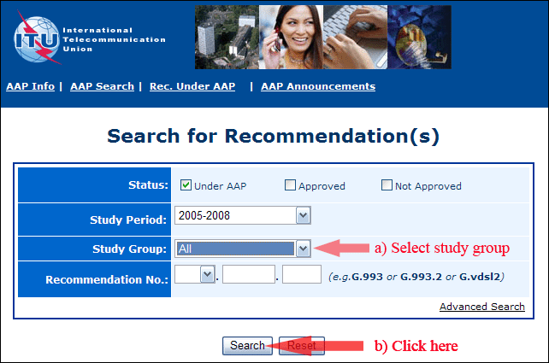
2) Select your Recommendation
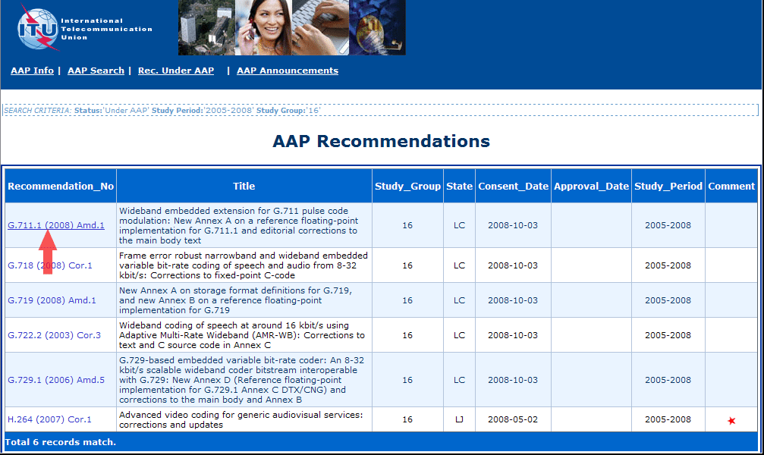
3) Click the "Submit Comment" button
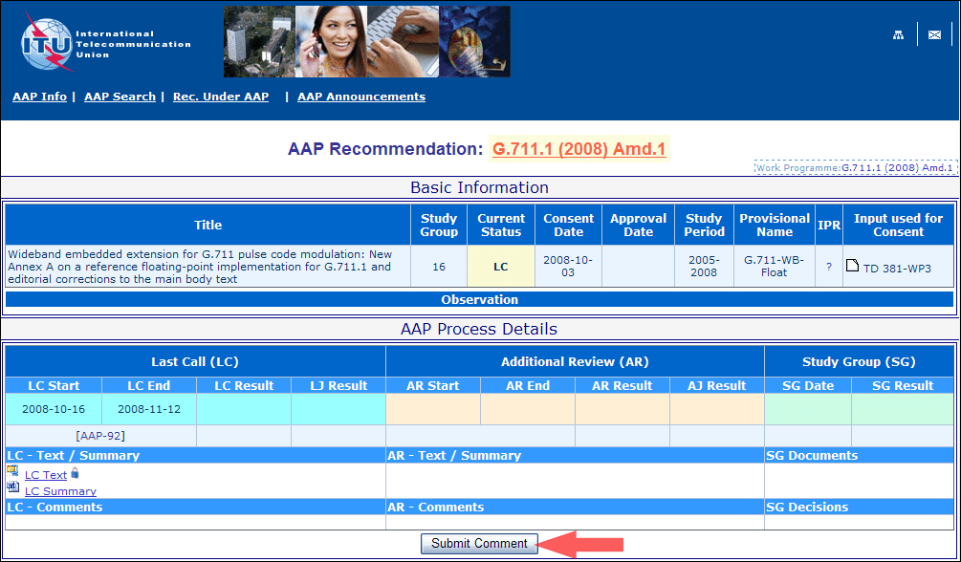
4) Complete the on-line form and click on "Submit"
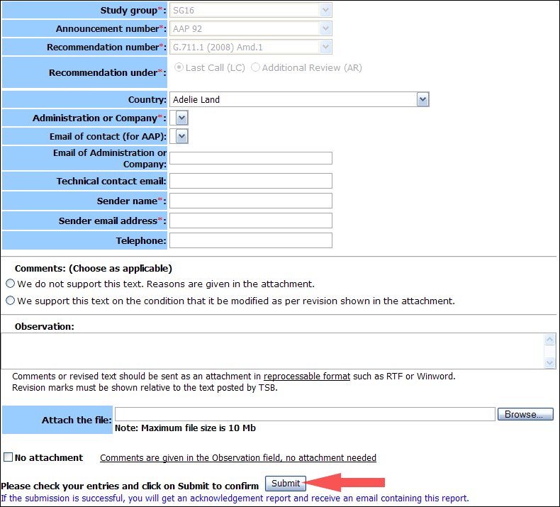
For more information, read the AAP tutorial on:
http://www.itu.int/ITU-T/aapinfo/files/AAPTutorial.pdf
Annex 3
(to TSB AAP-74)
Recommendations under LC/AR – Comment submission form
(Separate form for each Recommendation being commented upon)
ITU-T AAP comment submission form for the period 2009-2012
Study Group:
Announcement number:
Recommendation number:
Recommendation under: | Last call (LC)  Additional Review (AR)
Country:
Administration/Company:
Name of AAP Contact Person:
Email of AAP Contact Person:
Sender name:
(if different from AAP Contact Person)
Sender email address:
Telephone:
Comments:  (Choose as applicable) | We do not support this text. Reasons are given in the attachment.  We support this text on the condition that it be modified as per revision shown in the attachment.
Observations:
No attachment: Comments are given in the Observation field, no attachment needed
To be returned to: email: tsbsg....@itu.int
[or fax +41 22 730 5853]
Comments or revised text should be sent as an attachment in RTF or WinWord format.
Revision marks must be shown relative to the text posted by TSB.

