Union Internationale des Telecommunications
Bureau de la normalisation des télécommunications

Genève, le 16 décembre 2011

Réf:  Tél:  Fax:  E-mail: | TSB AAP-73  AAP/MJ  +41 22 730 5860  +41 22 730 5853  tsbdir@itu.int | – Aux administrations des Etats Membres de l'Union;  – Aux Membres du Secteur UIT-T;  – Aux Associés de l'UIT-T  Copie:  – Aux Présidents et Vice-Présidents des Commissions d'études de l'UIT-T;  – Au Directeur du Bureau de développement des télécommunications;  – Au Directeur du Bureau des radiocommunications

Objet: | Etat des Recommandations auxquelles s'applique la variante de la procédure d'approbation (AAP)

Madame, Monsieur,

La variante de la procédure d'approbation (AAP), définie dans la Recommandation UIT-T A.8, s'applique aux Recommandations qui n'ont pas d'incidence politique ou réglementaire et ne nécessitent donc pas une consultation formelle des Etats Membres (voir le numéro 246B de la Convention de l'UIT).
L'Annexe 1 énumère les textes dont le statut a changé par rapport aux annonces TSB AAP antérieures.
Si vous souhaitez soumettre des observations sur une Recommandation ayant fait l'objet de la procédure AAP, vous êtes encouragés à utiliser le formulaire en ligne de soumission des observations AAP, disponible dans l'espace AAP du site web de l'UIT-T à l'adresse http://www.itu.int/ITU-T/aap/, à la page de la Recommandation concernée (voir l'Annexe 2). Vous pouvez aussi soumettre vos observations en remplissant le formulaire figurant à l'Annexe 3 et en l'envoyant au secrétariat de la Commission d'études concernée.
Veuillez noter que les observations ayant simplement pour objet d'appuyer l'adoption du texte en question ne sont pas encouragées.
Veuillez noter également qu'en raison de la fermeture annuelle de l'UIT fin décembre, aucune annonce AAP ne paraîtra en date du 1er janvier 2012. En conséquence, le délai de certains textes annoncés a été repoussé car la date limite coïncidait avec cette période.
Veuillez agréer, Madame, Monsieur, l'assurance de ma considération distinguée.
Malcolm Johnson
Directeur du Bureau de la normalisation des télécommunications

Annexes: 3

Annex 1
(to TSB AAP-73)

Status codes used in the AAP announcements:
LC = Last Call
LJ = Last Call Judgment (includes comment resolution)
AR = Additional Review
AJ = Additional Review Judgment (includes comment resolution)
SG = For Study Group approval
A = Approved
AT = Approved with typographic corrections
AC = Approved after Additional Review of Comments
NA = Not approved
TAP = Moved to TAP (ITU-T A.8 / § 5.2)
ITU-T website entry page:
http://www.itu.int/ITU-T
Alternative approval process (AAP) welcome page:
http://www.itu.int/ITU-T/aapinfo
Note – A tutorial on the ITU-T AAP application is available under the AAP welcome page
ITU-T website AAP Recommendation search page:
http://www.itu.int/ITU-T/aap/
Study Group web pages and contacts:
SG 2 | http://www.itu.int/ITU-T/studygroups/com02 | tsbsg2@itu.int
SG 3 | http://www.itu.int/ITU-T/studygroups/com03 | tsbsg3@itu.int
SG 5 | http://www.itu.int/ITU-T/studygroups/com05 | tsbsg5@itu.int
SG 9 | http://www.itu.int/ITU-T/studygroups/com09 | tsbsg9@itu.int
SG 11 | http://www.itu.int/ITU-T/studygroups/com11 | tsbsg11@itu.int
SG 12 | http://www.itu.int/ITU-T/studygroups/com12 | tsbsg12@itu.int
SG 13 | http://www.itu.int/ITU-T/studygroups/com13 | tsbsg13@itu.int
SG 15 | http://www.itu.int/ITU-T/studygroups/com15 | tsbsg15@itu.int
SG 16 | http://www.itu.int/ITU-T/studygroups/com16 | tsbsg16@itu.int
SG 17 | http://www.itu.int/ITU-T/studygroups/com17 | tsbsg17@itu.int

Situation concerning Study Group 9 Recommendations under AAP
Rec # | Title | Last Call (LC) Period |  |  |  | Additional Review (AR) Period |  |  |  | Status
 |  | LC Start | LC End | LC  Result | LJ  Result | AR Start | AR End | AR  Result | AJ  Result
J.205 (J.acf-req) | Requirements for harmonized Application Control Framework supporting hybrid broadcast & broadband applications | 2011-12-16 | 2012-01-12 |  |  |  |  |  |  | LC
J.295 (J.adcstb-req) | Advanced cable set-top box requirement | 2011-12-16 | 2012-01-12 |  |  |  |  |  |  | LC
J.706  (J.tgtdst-overview) | The overview of target content distribution | 2011-12-16 | 2012-01-12 |  |  |  |  |  |  | LC
J.707 (J.target-dist) | Messages and protocols enabling target content distribution for integrated broadband cable networks | 2011-12-16 | 2012-01-12 |  |  |  |  |  |  | LC
J.902 (J.ftvdf) | Multi-layer data structure for scalable view-range representation | 2011-12-16 | 2012-01-12 |  |  |  |  |  |  | LC
J.1001 (J.rcas-req) | Requirements for conditional access client software remote renewable security system | 2011-12-16 | 2012-01-12 |  |  |  |  |  |  | LC
Situation concerning Study Group 12 Recommendations under AAP
Rec # | Title | Last Call (LC) Period |  |  |  | Additional Review (AR) Period |  |  |  | Status
 |  | LC Start | LC End | LC  Result | LJ  Result | AR Start | AR End | AR  Result | AJ  Result
E.803 (E.QoSNT) | Quality of Service parameters of non-utilisation stages of ICT services | 2011-11-16 | 2011-12-13 | AT |  |  |  |  |  | AT
G.107 | The E-model: a computational model for use in transmission planning | 2011-11-16 | 2011-12-13 | A |  |  |  |  |  | A
G.107.1 (G.WBEM) | Wideband E-model | 2011-11-16 | 2011-12-13 | A |  |  |  |  |  | A
P.10/G.100 (2006) Amd.3 | New definitions for inclusion in Recommendation ITU-T P.10/G.100 | 2011-11-16 | 2011-12-13 | A |  |  |  |  |  | A
P.56 | Objective measurement of active speech level | 2011-11-16 | 2011-12-13 | A |  |  |  |  |  | A
P.57 | Artificial ears | 2011-11-16 | 2011-12-13 | A |  |  |  |  |  | A
P.58 | Head and torso simulator for telephonometry | 2011-11-16 | 2011-12-13 | A |  |  |  |  |  | A
Y.1541 | Network performance objectives for IP-based services | 2011-11-16 | 2011-12-13 | A |  |  |  |  |  | A
Y.1565 (Y.15HN) | Home Network Performance Parameters | 2011-11-16 | 2011-12-13 | A |  |  |  |  |  | A
Situation concerning Study Group 13 Recommendations under AAP
Rec # | Title | Last Call (LC) Period |  |  |  | Additional Review (AR) Period |  |  |  | Status
 |  | LC Start | LC End | LC  Result | LJ  Result | AR Start | AR End | AR  Result | AJ  Result
Y.3011 (Y.FNvirt) | Framework of network virtualization for Future Networks | 2011-11-16 | 2011-12-13 | AR |  | 2011-12-16 | 2012-01-12 |  |  | AR
Y.3021 (Y.FNenergy) | Framework of energy saving for Future Networks | 2011-11-01 | 2011-11-28 | LJ | AR | 2011-12-16 | 2012-01-12 |  |  | AR
Situation concerning Study Group 16 Recommendations under AAP
Rec # | Title | Last Call (LC) Period |  |  |  | Additional Review (AR) Period |  |  |  | Status
 |  | LC Start | LC End | LC  Result | LJ  Result | AR Start | AR End | AR  Result | AJ  Result
H.264 (V7) | Advanced video coding for generic audiovisual services | 2011-12-16 | 2012-01-12 |  |  |  |  |  |  | LC
H.264.1 (V4) | Conformance specification for H.264 advanced video coding | 2011-12-16 | 2012-01-12 |  |  |  |  |  |  | LC
H.264.2 (V4) | Reference software for H.264 advanced video coding | 2011-12-16 | 2012-01-12 |  |  |  |  |  |  | LC
T.800 (2002) Amd.5 | Information technology - JPEG 2000 image coding system: Core coding system: Enhancements for digital cinema and archive profiles (additional frame rates) | 2011-12-16 | 2012-01-12 |  |  |  |  |  |  | LC
T.805 | Information technology – JPEG 2000 image coding system: Compound image file format | 2011-12-16 | 2012-01-12 |  |  |  |  |  |  | LC
T.810 (2006) Amd.1 | Information technology - JPEG 2000 image coding system: Wireless: IP based wireless networks | 2011-12-16 | 2012-01-12 |  |  |  |  |  |  | LC
T.832 (T.JXR-2) | Information technology - JPEG XR image coding system - Image coding specification | 2011-12-16 | 2012-01-12 |  |  |  |  |  |  | LC
T.835 (V2) | Information technology - JPEG XR image coding system - Reference software | 2011-12-16 | 2012-01-12 |  |  |  |  |  |  | LC

Annex 2
(to TSB AAP-73)
Using the on-line comment submission form
Comment submission
1) Go to AAP search Web page at http://www.itu.int/ITU-T/aap/
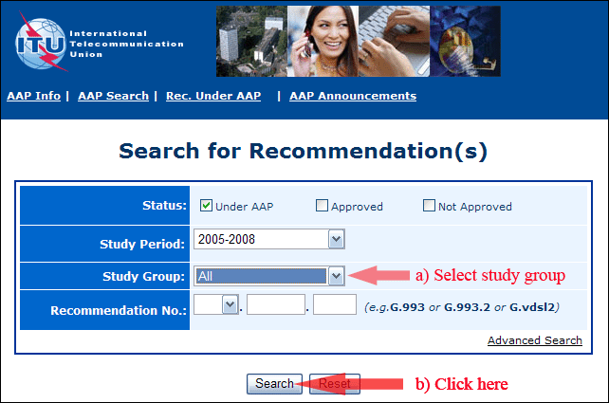
2) Select your Recommendation
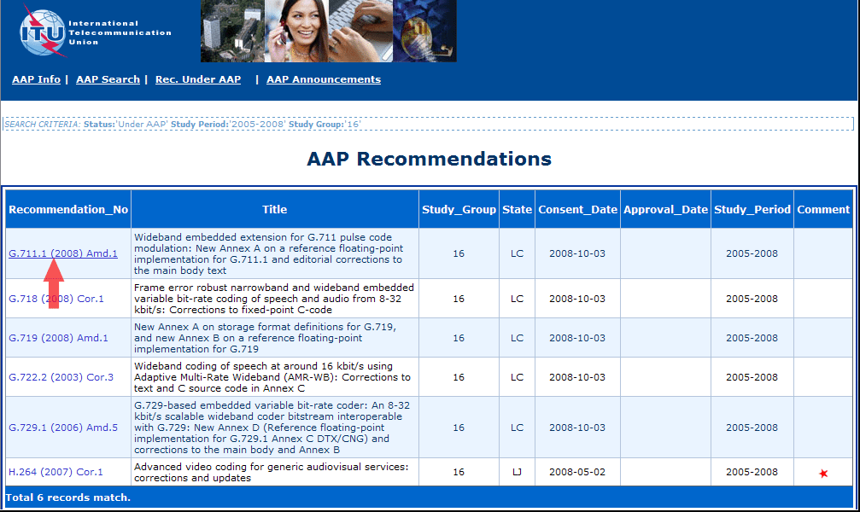
3) Click the "Submit Comment" button
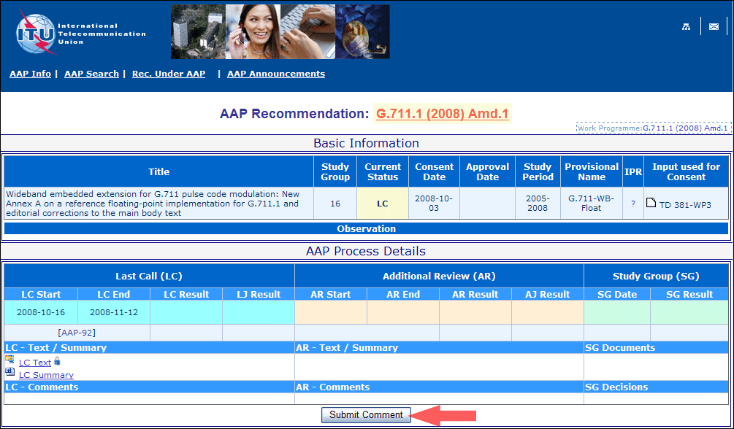
4) Complete the on-line form and click on "Submit"
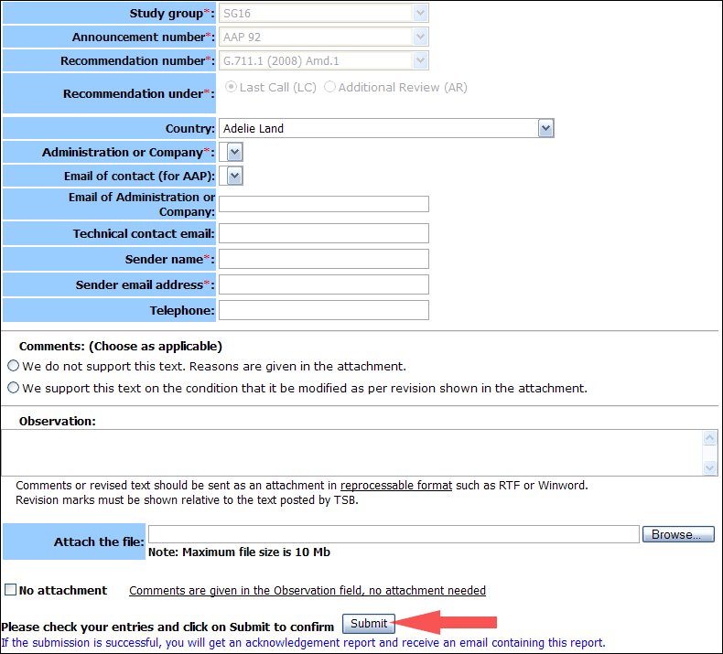
For more information, read the AAP tutorial on:
http://www.itu.int/ITU-T/aapinfo/files/AAPTutorial.pdf
Annex 3
(to TSB AAP-73)
Recommendations under LC/AR – Comment submission form
(Separate form for each Recommendation being commented upon)
ITU-T AAP comment submission form for the period 2009-2012
Study Group:
Announcement number:
Recommendation number:
Recommendation under: | Last call (LC)  Additional Review (AR)
Country:
Administration/Company:
Name of AAP Contact Person:
Email of AAP Contact Person:
Sender name:
(if different from AAP Contact Person)
Sender email address:
Telephone:
Comments:  (Choose as applicable) | We do not support this text. Reasons are given in the attachment.  We support this text on the condition that it be modified as per revision shown in the attachment.
Observations:
No attachment: Comments are given in the Observation field, no attachment needed
To be returned to: email: tsbsg....@itu.int
[or fax +41 22 730 5853]
Comments or revised text should be sent as an attachment in RTF or WinWord format.
Revision marks must be shown relative to the text posted by TSB.

