Международный союз электросвязи
Бюро стандартизации электросвязи

Женева, 16 октября 2011

Осн.:  Тел.:  Факс:  Эл. почта: | TSB AAP-69  AAP/MJ  +41 22 730 5860  +41 22 730 5853  tsbdir@itu.int | – Администрациям Государств – Членов Союза;  – Членам Сектора МСЭ-Т;  – Ассоциированным членам МСЭ-Т  Копии:  – Председателям и заместителям председателей Исследовательских комиссий МСЭ-Т;  – Директору Бюро Развития Электросвязи;  – Директору Бюро Радиосвязи

Предмет: | Положение относительно Рекомендаций, рассматриваемых в соответствии с альтернативным процессом утверждения (АПУ)

Уважаемая госпожа,
уважаемый господин,

Альтернативный процесс утверждения (АПУ), определенный в Рекомендации МСЭ-Т А.8, распространяется на Рекомендации, которые не имеют политических или регламентарных последствий и которые поэтому не требуют официальных консультаций с Государствами-Членами (см. п. 246B Конвенции МСЭ).
В Приложении 1 содержится перечень текстов, статус которых изменился по сравнению с предыдущими объявлениями об АПУ БСЭ.
Если вы желаете представить замечания относительно какой-либо Рекомендации, рассматриваемой в соответствии с АПУ, рекомендуем Вам использовать онлайновую форму для представления замечаний по АПУ, которая размещена на странице этой Рекомендации в разделе веб-сайта МСЭ-Т, посвященном АПУ, по адресу: http://www.itu.int/ITU-T/aap/ (см. Приложение 2). Замечания можно представить иным способом, заполнив приведенную в Приложении 3 форму и направив ее в секретариат заинтересованной исследовательской комиссии.
Просим принять к сведению, что не рекомендуется представлять замечания, являющиеся не чем иным, как поддержкой рассматриваемого текста.
С уважением,
Малколм Джонсон
Директор Бюро
стандартизации электросвязи
Приложения: 3

Annex 1
(to TSB AAP-69)

Status codes used in the AAP announcements:
LC = Last Call
LJ = Last Call Judgment (includes comment resolution)
AR = Additional Review
AJ = Additional Review Judgment (includes comment resolution)
SG = For Study Group approval
A = Approved
AT = Approved with typographic corrections
AC = Approved after Additional Review of Comments
NA = Not approved
TAP = Moved to TAP (ITU-T A.8 / § 5.2)
ITU-T website entry page:
http://www.itu.int/ITU-T
Alternative approval process (AAP) welcome page:
http://www.itu.int/ITU-T/aapinfo
Note – A tutorial on the ITU-T AAP application is available under the AAP welcome page
ITU-T website AAP Recommendation search page:
http://www.itu.int/ITU-T/aap/
Study Group web pages and contacts:
SG 2 | http://www.itu.int/ITU-T/studygroups/com02 | tsbsg2@itu.int
SG 3 | http://www.itu.int/ITU-T/studygroups/com03 | tsbsg3@itu.int
SG 5 | http://www.itu.int/ITU-T/studygroups/com05 | tsbsg5@itu.int
SG 9 | http://www.itu.int/ITU-T/studygroups/com09 | tsbsg9@itu.int
SG 11 | http://www.itu.int/ITU-T/studygroups/com11 | tsbsg11@itu.int
SG 12 | http://www.itu.int/ITU-T/studygroups/com12 | tsbsg12@itu.int
SG 13 | http://www.itu.int/ITU-T/studygroups/com13 | tsbsg13@itu.int
SG 15 | http://www.itu.int/ITU-T/studygroups/com15 | tsbsg15@itu.int
SG 16 | http://www.itu.int/ITU-T/studygroups/com16 | tsbsg16@itu.int
SG 17 | http://www.itu.int/ITU-T/studygroups/com17 | tsbsg17@itu.int

Situation concerning Study Group 5 Recommendations under AAP
Rec # | Title | Last Call (LC) Period |  |  |  | Additional Review (AR) Period |  |  |  | Status
Rec # | Title | LC Start | LC End | LC  Result | LJ  Result | AR Start | AR End | AR  Result | AJ  Result | Status
K.20 | Resistibility of telecommunication equipment installed in a telecommunications centre to overvoltages and overcurrents | 2011-10-16 | 2011-11-12 |  |  |  |  |  |  | LC
K.21 | Resistibility of telecommunication equipment installed in customer premises to overvoltages and overcurrents | 2011-10-16 | 2011-11-12 |  |  |  |  |  |  | LC
K.44 | Resistibility tests for telecommunication equipment exposed to overvoltages and overcurrents – Basic Recommendation | 2011-10-16 | 2011-11-12 |  |  |  |  |  |  | LC
K.45 | Resistibility of telecommunication equipment installed in the access and trunk networks to overvoltages and overcurrents | 2011-10-16 | 2011-11-12 |  |  |  |  |  |  | LC
K.85 (K.hnwr) | Requirements for the mitigation of lightning effects on home networks installed in customer premises | 2011-10-16 | 2011-11-12 |  |  |  |  |  |  | LC
K.86 (K.lcl) | Method for measuring Longitudinal Conversion Loss (9kHz - 30MHz) | 2011-10-16 | 2011-11-12 |  |  |  |  |  |  | LC
K.87 (K.sec) | Guide for the application of electromagnetic security requirements - Basic Recommendation | 2011-10-16 | 2011-11-12 |  |  |  |  |  |  | LC
K.88 (K.NGN) | EMC requirements for Next Generation Network equipment | 2011-10-16 | 2011-11-12 |  |  |  |  |  |  | LC
L.1100 (L.raremetals) | A method to provide recycling information of rare metals in ICT products | 2011-10-16 | 2011-11-12 |  |  |  |  |  |  | LC
L.1410 (L.GNS) | Methodology for environmental impact assessment of information and communication technologies goods, networks and services | 2011-10-16 | 2011-11-12 |  |  |  |  |  |  | LC
L.1420 (L.ORG) | Methodology for energy consumption and greenhouse gas emissions impact assessment of Information and Communication Technologies in organizations | 2011-10-16 | 2011-11-12 |  |  |  |  |  |  | LC
Situation concerning Study Group 9 Recommendations under AAP
Rec # | Title | Last Call (LC) Period |  |  |  | Additional Review (AR) Period |  |  |  | Status
Rec # | Title | LC Start | LC End | LC  Result | LJ  Result | AR Start | AR End | AR  Result | AJ  Result | Status
J.380.1 (J.dpi-asi.1) | Digital Program Insertion – Advertising Systems Interfaces: Part 1 – Advertising Systems Overview | 2011-10-16 | 2011-11-12 |  |  |  |  |  |  | LC
J.380.2 (J.dpi-asi.2) | Digital Program Insertion–Advertising Systems Interfaces: Part 2 - Core data elements | 2011-10-16 | 2011-11-12 |  |  |  |  |  |  | LC
J.380.3 (J.dpi-asi.3) | Digital Program Insertion – Advertising Systems Interfaces: Part 3 – Ad Management Service Interface | 2011-10-16 | 2011-11-12 |  |  |  |  |  |  | LC
J.380.4 (J.dpi-asi.4) | Digital Program Insertion–Advertising Systems Interfaces: Part 4 – Content Information Service (CIS) | 2011-10-16 | 2011-11-12 |  |  |  |  |  |  | LC
J.380.5 (J.dpi-asi.5) | Digital Program Insertion–Advertising Systems Interfaces: Part 5 – Placement Opportunity Information Service | 2011-10-16 | 2011-11-12 |  |  |  |  |  |  | LC
J.380.6 (J.dpi-asi.6) | Digital Program Insertion – Advertising Systems Interfaces: Part 6 – Subscriber Information Service | 2011-10-16 | 2011-11-12 |  |  |  |  |  |  | LC
J.380.7 (J.dpi-asi.7) | Digital Program Insertion–Advertising Systems Interfaces: Part 7 – Message Transport | 2011-10-16 | 2011-11-12 |  |  |  |  |  |  | LC
J.380.8 (J.dpi-asi.8) | Digital Program Insertion–Advertising Systems Interfaces: Part 8 – General Information Service | 2011-10-16 | 2011-11-12 |  |  |  |  |  |  | LC
Situation concerning Study Group 15 Recommendations under AAP
Rec # | Title | Last Call (LC) Period |  |  |  | Additional Review (AR) Period |  |  |  | Status
Rec # | Title | LC Start | LC End | LC  Result | LJ  Result | AR Start | AR End | AR  Result | AJ  Result | Status
G.8110.1/Y.1370.1 | Architecture of MPLS Transport Profile (MPLS-TP) layer network | 2011-09-01 | 2011-09-28 | LJ |  |  |  |  |  | LJ
G.8113.2/Y.1372.2 (G.tpoam G.mplstpoam) | Operations, administration and maintenance mechanisms for MPLS-TP networks using the tools defined for MPLS | 2011-10-16 | 2011-11-12 |  |  |  |  |  |  | LC
G.9956 (G.hnem) | Narrow-band OFDM power line communication transceivers - Data link layer specification | 2011-03-16 | 2011-04-12 | LJ | AR | 2011-10-16 | 2011-11-05 |  |  | AR
Situation concerning Study Group 17 Recommendations under AAP
Rec # | Title | Last Call (LC) Period |  |  |  | Additional Review (AR) Period |  |  |  | Status
Rec # | Title | LC Start | LC End | LC  Result | LJ  Result | AR Start | AR End | AR  Result | AJ  Result | Status
X.680 (2008) Cor.1 | Draft Technical Corrigendum X.680 | ISO/IEC 8824-1:2008/Cor.1: 2011 Information technology - Abstract Syntax Notation One (ASN.1): Specification of basic notation | 2011-09-16 | 2011-10-13 | A |  |  |  |  |  | A
X.681 (2008) Cor.1 | Draft Technical Corrigendum X.681 | ISO/IEC 8824-2:2008/Cor.1:2011 Information technology - Abstract Syntax Notation One (ASN.1): Information object specification | 2011-09-16 | 2011-10-13 | A |  |  |  |  |  | A
X.690 (2008) Cor.1 | Draft Technical Corrigendum X.690 | ISO/IEC 8825-1:2008/Cor.1:2011 Information technology - ASN.1 encoding rules: Specification of Basic Encoding Rules (BER), Canonical Encoding Rules (CER) and Distinguished Encoding Rules (DER) | 2011-09-16 | 2011-10-13 | A |  |  |  |  |  | A
X.691 (2008) Cor.1 | Draft Technical Corrgiendum X.691 | ISO/IEC 8825-2:2008/Cor.1:2011 Information technology - ASN.1 encoding rules: Specification of Packed Encoding Rules (PER) | 2011-09-16 | 2011-10-13 | A |  |  |  |  |  | A
X.692 (2008) Cor.1 | Draft Techcial Corrgendum X.692 | ISO/IEC 8825-3:2008/Cor.1:2011 Information technology - ASN.1 encoding rules: Specification of Encoding Control Notation (ECN) | 2011-09-16 | 2011-10-13 | A |  |  |  |  |  | A
X.693 (2008) Cor.1 | Draft Technical Corrigendum X.693 | ISO/IEC 8825-4:2008/Cor.1:2011 Information technology - ASN.1 encoding rules: XML Encoding Rules (XER) | 2011-09-16 | 2011-10-13 | A |  |  |  |  |  | A
X.694 (2008) Cor.1 | Draft Technical Corrigendum X.694 | ISO/IEC 8825-5:2008/Cor.1:2011 Information technology - ASN.1 encoding rules: Mapping W3C XML schema definitions into ASN.1 | 2011-09-16 | 2011-10-13 | A |  |  |  |  |  | A
X.891 (2005) Cor.1 | Draft Technical Corrigendum X.891 | ISO/IEC 24824-1:2005/Cor.1:2011 Information technology - Generic applications of ASN.1: Fast Infoset | 2011-09-16 | 2011-10-13 | A |  |  |  |  |  | A
X.1080.1 (X.th1) | e-Health and world-wide telemedicines - Generic telecommunication protocol | 2011-09-16 | 2011-10-13 | A |  |  |  |  |  | A
X.1081 (2004) Amd.3 | The telebiometric multimodal model - A framework for the specification of security and safety aspects of telebiometrics - Amendment 3: Enhancement to support a new modality (ELECTRO) | 2011-09-16 | 2011-10-13 | A |  |  |  |  |  | A
X.1193 (X.iptvsec-3) | Key management framework for secure internet protocol television (IPTV) services | 2011-09-16 | 2011-10-13 | A |  |  |  |  |  | A
Z.100 | Specification and description language: Overview of SDL-2010 | 2011-09-16 | 2011-10-13 | LJ |  |  |  |  |  | LJ
Z.101 | Specification and description language: Basic SDL-2010 | 2011-09-16 | 2011-10-13 | LJ |  |  |  |  |  | LJ
Z.102 | Specification and description language: Comprehensive SDL-2010 | 2011-09-16 | 2011-10-13 | LJ |  |  |  |  |  | LJ
Z.103 | Specification and description language: Shorthand notation and annotation in SDL-2010 | 2011-09-16 | 2011-10-13 | LJ |  |  |  |  |  | LJ
Z.104 | Specification and description language: Data and action language in SDL-2010 | 2011-09-16 | 2011-10-13 | LJ |  |  |  |  |  | LJ
Z.105 | Specification and description language: SDL-2010 combined with ASN.1 modules | 2011-09-16 | 2011-10-13 | LJ |  |  |  |  |  | LJ
Z.106 | Specification and description language: Common interchange format for SDL-2010 | 2011-09-16 | 2011-10-13 | LJ |  |  |  |  |  | LJ

Annex 2
(to TSB AAP-69)
Using the on-line comment submission form
Comment submission
1) Go to AAP search Web page at http://www.itu.int/ITU-T/aap/
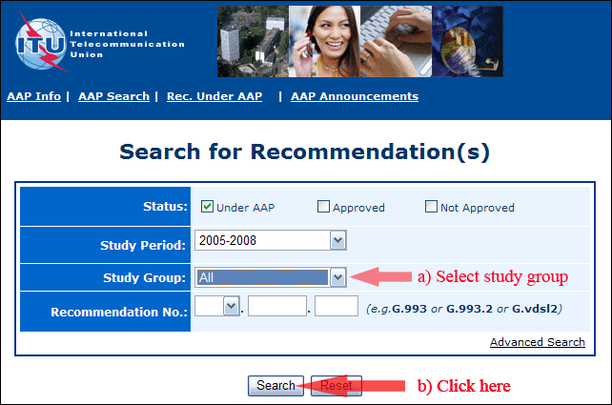
2) Select your Recommendation
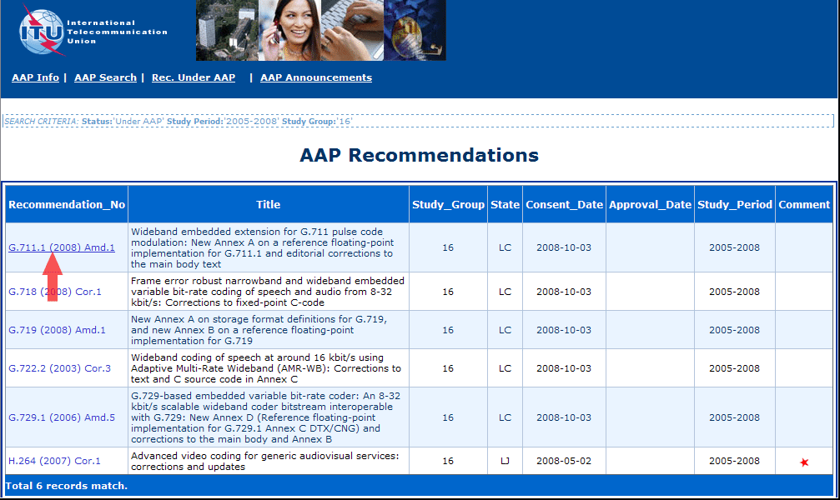
3) Click the "Submit Comment" button
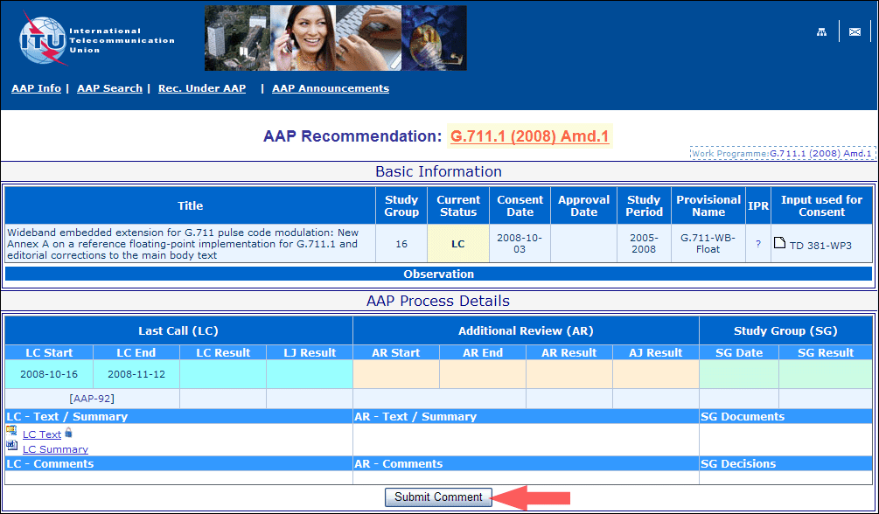
4) Complete the on-line form and click on "Submit"
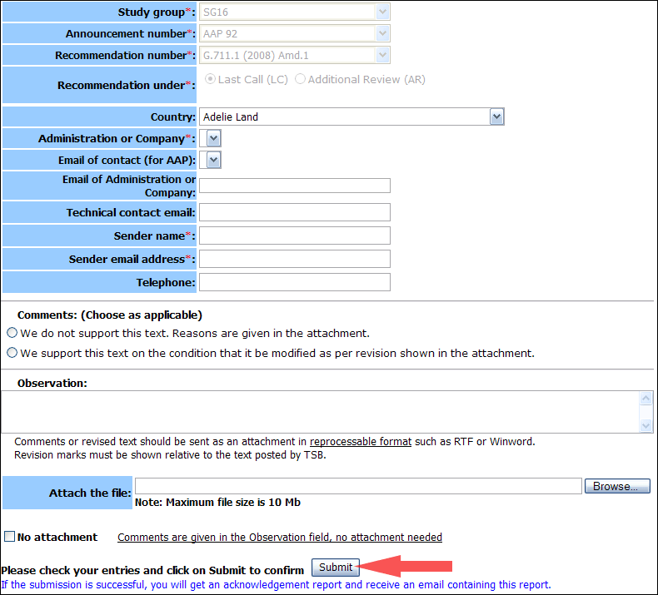
For more information, read the AAP tutorial on:
http://www.itu.int/ITU-T/aapinfo/files/AAPTutorial.pdf
Annex 3
(to TSB AAP-69)
Recommendations under LC/AR – Comment submission form
(Separate form for each Recommendation being commented upon)
ITU-T AAP comment submission form for the period 2009-2012
Study Group:
Announcement number:
Recommendation number:
Recommendation under: | Last call (LC)  Additional Review (AR)
Country:
Administration/Company:
Name of AAP Contact Person:
Email of AAP Contact Person:
Sender name:
(if different from AAP Contact Person)
Sender email address:
Telephone:
Comments:  (Choose as applicable) | We do not support this text. Reasons are given in the attachment.  We support this text on the condition that it be modified as per revision shown in the attachment.
Observations:
No attachment: Comments are given in the Observation field, no attachment needed
To be returned to: email: tsbsg....@itu.int
[or fax +41 22 730 5853]
Comments or revised text should be sent as an attachment in RTF or WinWord format.
Revision marks must be shown relative to the text posted by TSB.

