Union Internationale des Telecommunications  Bureau de la normalisation des télécommunications | 

Genève, le 1 avril 2010

Réf:  Tél:  Fax:  E-mail: | TSB AAP-33  AAP/MJ  +41 22 730 5860  +41 22 730 5853  tsbdir@itu.int | – Aux administrations des Etats Membres de l'Union;  – Aux Membres du Secteur UIT-T;  – Aux Associés de l'UIT-T  Copie:  – Aux Présidents et Vice-Présidents des Commissions d'études de l'UIT-T;  – Au Directeur du Bureau de développement des télécommunications;  – Au Directeur du Bureau des radiocommunications

Objet: | Etat des Recommandations auxquelles s'applique la variante de la procédure d'approbation (AAP)

Madame, Monsieur,

La variante de la procédure d'approbation (AAP), définie dans la Recommandation UIT-T A.8, s'applique aux Recommandations qui n'ont pas d'incidence politique ou réglementaire et ne nécessitent donc pas une consultation formelle des Etats Membres (voir le numéro 246B de la Convention de l'UIT).
L'Annexe 1 énumère les textes dont le statut a changé par rapport aux annonces TSB AAP antérieures.
Si vous souhaitez soumettre des observations sur une Recommandation ayant fait l'objet de la procédure AAP, vous êtes encouragés à utiliser le formulaire en ligne de soumission des observations AAP, disponible dans l'espace AAP du site web de l'UIT-T à l'adresse http://www.itu.int/ITU-T/aap/, à la page de la Recommandation concernée (voir l'Annexe 2). Vous pouvez aussi soumettre vos observations en remplissant le formulaire figurant à l'Annexe 3 et en l'envoyant au secrétariat de la Commission d'études concernée.
Veuillez noter que les observations ayant simplement pour objet d'appuyer l'adoption du texte en question ne sont pas encouragées.
Veuillez agréer, Madame, Monsieur, l'assurance de ma considération distinguée.
Malcolm Johnson
Directeur du Bureau de la normalisation des télécommunications

Annexes: 3
Annex 1
(to TSB AAP-33)

Status codes used in the AAP announcements:
LC = Last Call
LJ = Last Call Judgment (includes comment resolution)
AR = Additional Review
AJ = Additional Review Judgment (includes comment resolution)
SG = For Study Group approval
A = Approved
AT = Approved with typographic corrections
AC = Approved after Additional Review of Comments
NA = Not approved
TAP = Moved to TAP (ITU-T A.8 / § 5.2)
ITU-T website entry page:
http://www.itu.int/ITU-T
Alternative approval process (AAP) welcome page:
http://www.itu.int/ITU-T/aapinfo
Note – A tutorial on the ITU-T AAP application is available under the AAP welcome page
ITU-T website AAP Recommendation search page:
http://www.itu.int/ITU-T/aap/
Study Group web pages and contacts:
SG 2 | http://www.itu.int/ITU-T/studygroups/com02 | tsbsg2@itu.int
SG 3 | http://www.itu.int/ITU-T/studygroups/com03 | tsbsg3@itu.int
SG 5 | http://www.itu.int/ITU-T/studygroups/com05 | tsbsg5@itu.int
SG 9 | http://www.itu.int/ITU-T/studygroups/com09 | tsbsg9@itu.int
SG 11 | http://www.itu.int/ITU-T/studygroups/com11 | tsbsg11@itu.int
SG 12 | http://www.itu.int/ITU-T/studygroups/com12 | tsbsg12@itu.int
SG 13 | http://www.itu.int/ITU-T/studygroups/com13 | tsbsg13@itu.int
SG 15 | http://www.itu.int/ITU-T/studygroups/com15 | tsbsg15@itu.int
SG 16 | http://www.itu.int/ITU-T/studygroups/com16 | tsbsg16@itu.int
SG 17 | http://www.itu.int/ITU-T/studygroups/com17 | tsbsg17@itu.int

Situation concerning Study Group 9 Recommendations under AAP
Rec # | Title | Last Call (LC) Period |  |  |  | Additional Review (AR) Period |  |  |  | Status
Rec # | Title | LC Start | LC End | LC  Result | LJ  Result | AR Start | AR End | AR  Result | AJ  Result | Status
J.200 | Worldwide common core - Application environment for digital interactive television services | 2010-04-01 | 2010-04-28 |  |  |  |  |  |  | LC
Situation concerning Study Group 11 Recommendations under AAP
Rec # | Title | Last Call (LC) Period |  |  |  | Additional Review (AR) Period |  |  |  | Status
Rec # | Title | LC Start | LC End | LC  Result | LJ  Result | AR Start | AR End | AR  Result | AJ  Result | Status
Q.3222 (Q.nacp.Ng) | Requirements and protocol at the Ng interface between transport location management physical entities | 2010-02-01 | 2010-02-28 | LJ | SG |  |  |  |  | SG
X.603.1 (2007) Amd.2 | Information technology - Relayed multicast protocol: Specification for simplex group applications - Amendment 2: Revision of sub-control data and code-value | 2010-02-01 | 2010-02-28 | LJ | AT |  |  |  |  | AT
X.604 (X.mmc-1) | Mobile multicast communications - Framework | 2010-02-01 | 2010-02-28 | LJ | AT |  |  |  |  | AT
Situation concerning Study Group 13 Recommendations under AAP
Rec # | Title | Last Call (LC) Period |  |  |  | Additional Review (AR) Period |  |  |  | Status
Rec # | Title | LC Start | LC End | LC  Result | LJ  Result | AR Start | AR End | AR  Result | AJ  Result | Status
Y.1911 (Y.iptvintwrm) | Interworking between NGNs in support of nomadic IPTV services | 2010-02-16 | 2010-03-15 | SG |  |  |  |  |  | SG
Y.1991 (Y.iptvterms) | Terms and definitions for IPTV | 2010-02-16 | 2010-03-15 | AT |  |  |  |  |  | AT
Y.2012  (Y.NGN-FRA rev1  (ex Y.NGN-FRA R2)) | Functional requirements and architecture of the NGN | 2010-02-16 | 2010-03-15 | SG |  |  |  |  |  | SG
Y.2014  (Y.NACF rev1  (ex Y.NACF)) | Network attachment control functions in next generation networks | 2010-02-16 | 2010-03-15 | A |  |  |  |  |  | A
Y.2206 (Y.dsnreq) | Requirements for distributed service network (DSN) | 2010-02-16 | 2010-03-15 | LJ |  |  |  |  |  | LJ
Y.2216 (Y.ngn-mcc) | NGN capability requirements to support multimedia communication centre (MCC) service | 2010-02-16 | 2010-03-15 | A |  |  |  |  |  | A
Y.2613 (Y.PTDN) | The general technical architecture for public packet telecommunication data network (PTDN) | 2010-02-16 | 2010-03-15 | A |  |  |  |  |  | A
Situation concerning Study Group 15 Recommendations under AAP
Rec # | Title | Last Call (LC) Period |  |  |  | Additional Review (AR) Period |  |  |  | Status
Rec # | Title | LC Start | LC End | LC  Result | LJ  Result | AR Start | AR End | AR  Result | AJ  Result | Status
G.993.2 (2006)  Amd. 5 | Very high speed Digital subscriber Line Transceivers 2 - Amendment 5 | 2009-10-16 | 2009-11-12 | LJ | AR | 2010-04-01 | 2010-04-21 |  |  | AR
G.993.5 (G.vector) | Self-FEXT Cancellation (Vectoring) for use with VDSL2 transceivers | 2009-10-16 | 2009-11-12 | LJ | AR | 2010-04-01 | 2010-04-21 |  |  | AR
G.994.1 (2007)  Amd.5 | Handshake procedures for digital subscriber line (DSL) transceivers - Amendment 5 | 2009-10-16 | 2009-11-12 | LJ | AR | 2010-04-01 | 2010-04-21 |  |  | AR
G.997.1 (2009) Amd.1 | Physical layer management for digital subscriber line (DSL) transceivers - Amendment 1 | 2009-10-16 | 2009-11-12 | LJ | AR | 2010-04-01 | 2010-04-21 |  |  | AR
G.998.4 (G.inp) | Improved Impulse Noise Protection (INP) for DSL Transceivers | 2009-10-16 | 2009-11-12 | LJ | AR | 2010-04-01 | 2010-04-21 |  |  | AR
G.999.1 Corr1 | LINK layer to PHY layer interface | 2010-02-01 | 2010-02-28 | LJ | AR | 2010-04-01 | 2010-04-21 |  |  | AR
Situation concerning Study Group 16 Recommendations under AAP
Rec # | Title | Last Call (LC) Period |  |  |  | Additional Review (AR) Period |  |  |  | Status
Rec # | Title | LC Start | LC End | LC  Result | LJ  Result | AR Start | AR End | AR  Result | AJ  Result | Status
G.191 V5 (STL2008) | Software tools for speech and audio coding standardization | 2010-03-01 | 2010-03-28 | A |  |  |  |  |  | A
G.718 (2008) Amd. 2 (G.718-SWB) | Variable bit rate embedded coding of speech signals: New Annex B on superwideband scalable extension for G.718 and corrections to main body fixed-point C-code and description text | 2010-03-01 | 2010-03-28 | A |  |  |  |  |  | A
G.729.1 (2006)  Amd. 6  (G.729.1-SWB) | G.729-based embedded variable bit-rate coder: An 8-32 kbit/s scalable wideband coder bitstream interoperable with G.729: New Annex E on superwideband scalable extension for G.729.1 | 2010-03-01 | 2010-03-28 | A |  |  |  |  |  | A
H.264.2 (V3) | Reference software for H.264 advanced video coding | 2010-03-01 | 2010-03-28 | LJ |  |  |  |  |  | LJ
H.740 (H.IPTV-AEH) | Application event handling for IPTV services | 2009-11-16 | 2009-12-13 | LJ | AR | 2010-03-01 | 2010-03-21 | AJ |  | AJ
T.802 (2005) Amd.1 | Information technology - JPEG 2000 image coding system: Motion JPEG 2000: Additional profiles for archiving applications | 2009-11-16 | 2009-12-13 | LJ | AR | 2010-04-01 | 2010-04-21 |  |  | AR

Annex 2
(to TSB AAP-33)
Using the on-line comment submission form
Comment submission
1) Go to AAP search Web page at http://www.itu.int/ITU-T/aap/
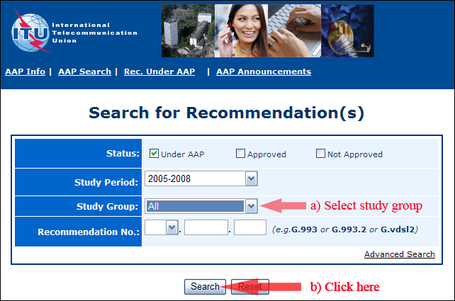
2) Select your Recommendation
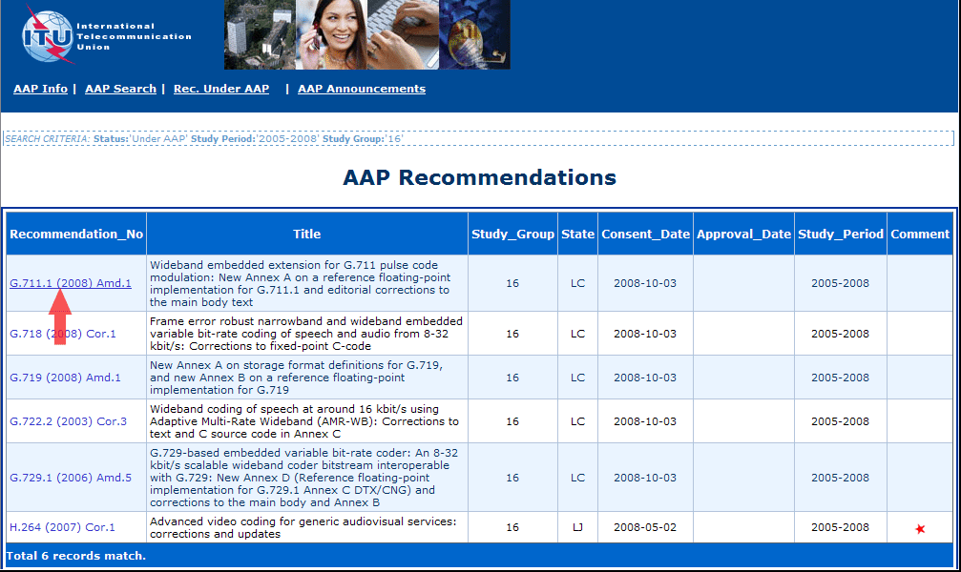
3) Click the "Submit Comment" button
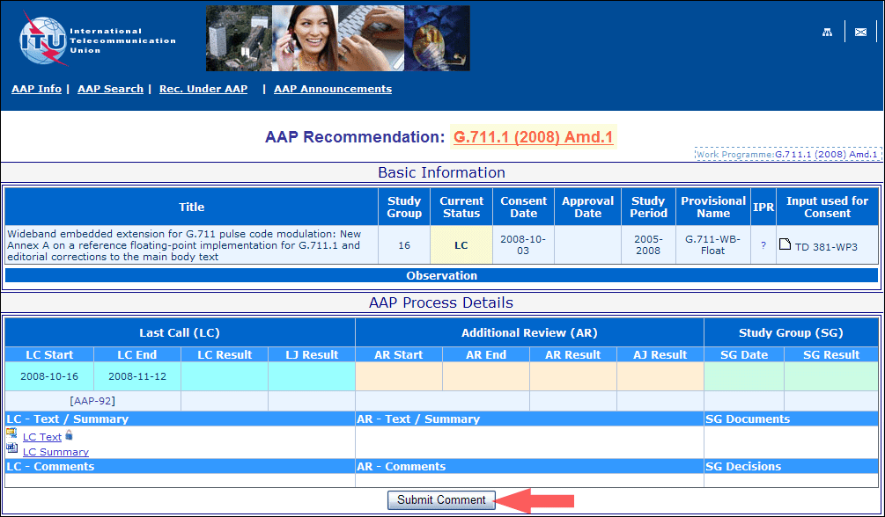
4) Complete the on-line form and click on "Submit"
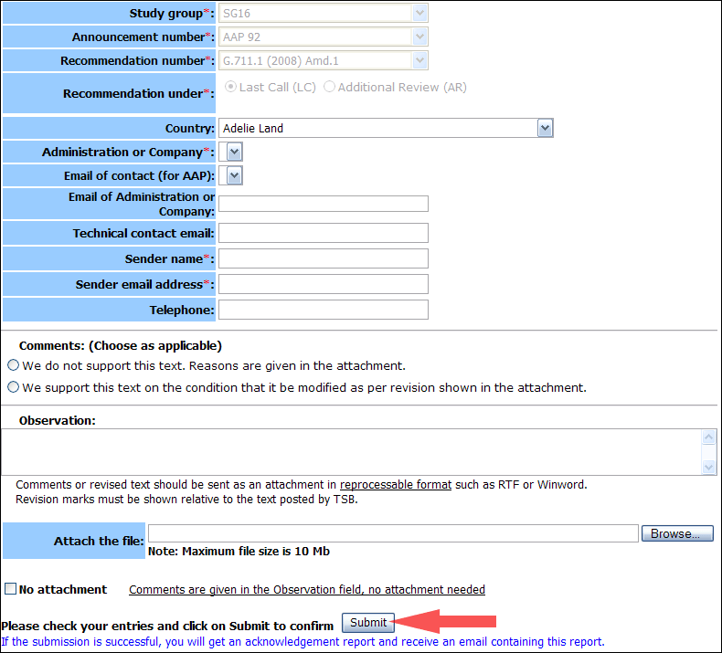
For more information, read the AAP tutorial on:
http://www.itu.int/ITU-T/aapinfo/files/AAPTutorial.pdf
Annex 3
(to TSB AAP-33)
Recommendations under LC/AR – Comment submission form
(Separate form for each Recommendation being commented upon)
ITU-T AAP comment submission form for the period 2009-2012
Study Group:
Announcement number:
Recommendation number:
Recommendation under: | Last call (LC)  Additional Review (AR)
Country:
Administration/Company:
Name of AAP Contact Person:
Email of AAP Contact Person:
Sender name:
(if different from AAP Contact Person)
Sender email address:
Telephone:
Comments:  (Choose as applicable) | We do not support this text. Reasons are given in the attachment.  We support this text on the condition that it be modified as per revision shown in the attachment.
Observations:
No attachment: Comments are given in the Observation field, no attachment needed
To be returned to: email: tsbsg....@itu.int
[or fax +41 22 730 5853]
Comments or revised text should be sent as an attachment in RTF or WinWord format.
Revision marks must be shown relative to the text posted by TSB.

