国 际 电 信 联 盟  电信标准化局 | 
2010年1月16日 ，日内瓦

参考号:  电话:  传真:  电子邮件: | 电信标准化局AAP-28  AAP/MJ  +41 22 730 5860  +41 22 730 5853  tsbdir@itu.int | – 致国际电联成员国各主管部门；  – 致ITU-T各部门成员；  – 致ITU-T 部门准成员  抄送：  – 电信标准化局研究组主席和副主席  – 电信发展局主任  – 无线电通信局主任

事由: | 有关采用替换批准程序（AAP）处理的建议书的情况

先生/女士，
ITU-T A.8 建议书中规定的建议书替换批准程序 (AAP) 适用于那些不会产生政策或 监管影响、因而不需与成员国正式协商的建议书（见国际电联《公约》第246B款）。
附件1列出了那些在以往电信标准化局AAP预告后地位发生变化的案文。
如您希望针对某个适用AAP的建议书提出意见，请使用可在ITU-T网站AAP区域 （http://www.itu.int/ITU-T/aap）的“建议书”网页上获取的《AAP意见在线提交表格》 （见附件2）。或者，可填妥附件3 中的表格并将意见发送给相关研究组的秘书处。
敬请留意，我们不鼓励提交仅支持通过所涉案文而没有实质内容的意见。

顺致敬意！

马尔科姆•琼森
电信标准化局主任

附件：3件
Annex 1
(to TSB AAP-28)

Status codes used in the AAP announcements:
LC = Last Call
LJ = Last Call Judgment (includes comment resolution)
AR = Additional Review
AJ = Additional Review Judgment (includes comment resolution)
SG = For Study Group approval
A = Approved
AT = Approved with typographic corrections
AC = Approved after Additional Review of Comments
NA = Not approved
TAP = Moved to TAP (ITU-T A.8 / § 5.2)
ITU-T website entry page:
http://www.itu.int/ITU-T
Alternative approval process (AAP) welcome page:
http://www.itu.int/ITU-T/aapinfo
Note – A tutorial on the ITU-T AAP application is available under the AAP welcome page
ITU-T website AAP Recommendation search page:
http://www.itu.int/ITU-T/aap/
Study Group web pages and contacts:
SG 2 | http://www.itu.int/ITU-T/studygroups/com02 | tsbsg2@itu.int
SG 3 | http://www.itu.int/ITU-T/studygroups/com03 | tsbsg3@itu.int
SG 5 | http://www.itu.int/ITU-T/studygroups/com05 | tsbsg5@itu.int
SG 9 | http://www.itu.int/ITU-T/studygroups/com09 | tsbsg9@itu.int
SG 11 | http://www.itu.int/ITU-T/studygroups/com11 | tsbsg11@itu.int
SG 12 | http://www.itu.int/ITU-T/studygroups/com12 | tsbsg12@itu.int
SG 13 | http://www.itu.int/ITU-T/studygroups/com13 | tsbsg13@itu.int
SG 15 | http://www.itu.int/ITU-T/studygroups/com15 | tsbsg15@itu.int
SG 16 | http://www.itu.int/ITU-T/studygroups/com16 | tsbsg16@itu.int
SG 17 | http://www.itu.int/ITU-T/studygroups/com17 | tsbsg17@itu.int

Situation concerning Study Group 2 Recommendations under AAP
Rec # | Title | Last Call (LC) Period |  |  |  | Additional Review (AR) Period |  |  |  | Status
Rec # | Title | LC Start | LC End | LC  Result | LJ  Result | AR Start | AR End | AR  Result | AJ  Result | Status
E.4110 (E.41NGNS) | Framework for operations requirements of Next Generation Networks and Services | 2009-12-01 | 2010-01-12 | A |  |  |  |  |  | A
M.3700  (X.object -neutral) | Common management services - Object Management - Requirements and Analysis - Protocol Neutral | 2009-12-01 | 2010-01-12 | LJ |  |  |  |  |  | LJ
M.3701  (X.state-neutral) | Common management services - State Management - Requirements and analysis - Protocol Neutral | 2009-12-01 | 2010-01-12 | LJ |  |  |  |  |  | LJ
M.3702  (X.notif-neutral) | Common Management Services - Notification management - Requirement and Analysis - Protocol Neutral | 2009-12-01 | 2010-01-12 | LJ |  |  |  |  |  | LJ
M.3704  (X.perf-neutral) | Common Management Service - Performance Management - Requirements and Analysis -Protocol Neutral | 2009-12-01 | 2010-01-12 | LJ |  |  |  |  |  | LJ
Situation concerning Study Group 5 Recommendations under AAP
Rec # | Title | Last Call (LC) Period |  |  |  | Additional Review (AR) Period |  |  |  | Status
Rec # | Title | LC Start | LC End | LC  Result | LJ  Result | AR Start | AR End | AR  Result | AJ  Result | Status
K.56 | Protection of radio base stations against lightning discharges | 2009-11-01 | 2009-11-28 | LJ | AR | 2009-12-16 | 2010-01-12 | AJ |  | AJ
Situation concerning Study Group 9 Recommendations under AAP
Rec # | Title | Last Call (LC) Period |  |  |  | Additional Review (AR) Period |  |  |  | Status
Rec # | Title | LC Start | LC End | LC  Result | LJ  Result | AR Start | AR End | AR  Result | AJ  Result | Status
J.201 | Harmonization of declarative content formats for interactive television applications | 2009-11-16 | 2009-12-13 | LJ | A |  |  |  |  | A
J.249 (J.redref) | Perceptual video quality measurement techniques for digital cable television in the presence of a reduced reference | 2009-12-01 | 2010-01-12 | LJ |  |  |  |  |  | LJ
J.700 | IPTV service requirements and framework for secondary distribution | 2009-11-16 | 2009-12-13 | LJ | A |  |  |  |  | A
J.704  (J.spi-req, J.sdp-req) | Functional requirements of the service provider interface for television primary and secondary distribution and associated interactive services | 2009-11-16 | 2009-12-13 | LJ | A |  |  |  |  | A
Situation concerning Study Group 13 Recommendations under AAP
Rec # | Title | Last Call (LC) Period |  |  |  | Additional Review (AR) Period |  |  |  | Status
Rec # | Title | LC Start | LC End | LC  Result | LJ  Result | AR Start | AR End | AR  Result | AJ  Result | Status
Y.2221 (Y.USN-reqts) | Requirements for support of Ubiquitous Sensor Network (USN) applications and services in the NGN environment | 2009-10-01 | 2009-10-28 | LJ | AR | 2009-12-16 | 2010-01-12 | AC |  | AC
Situation concerning Study Group 15 Recommendations under AAP
Rec # | Title | Last Call (LC) Period |  |  |  | Additional Review (AR) Period |  |  |  | Status
Rec # | Title | LC Start | LC End | LC  Result | LJ  Result | AR Start | AR End | AR  Result | AJ  Result | Status
G.709/Y.1331 | Interfaces for the Optical Transport Network (OTN) | 2009-10-16 | 2009-11-12 | LJ | AR | 2009-12-01 | 2009-12-21 | AC |  | AC
G.986 (G.gbe) | 1 Gbit/s point-to-point Ethernet based optical access system | 2009-10-16 | 2009-11-12 | LJ | AR | 2009-12-16 | 2010-01-12 | AC |  | AC
G.987.1 (G.xgpon.1) | 10-Gigabit-capable Passive Optical Networks (XG-PON): General Requirements | 2009-10-16 | 2009-11-12 | LJ | AR | 2009-12-16 | 2010-01-12 | AC |  | AC
G.987.2 | 10-Gigabit-capable passive optical networks (XG-PON): Physical Media Dependent (PMD) layer specification | 2009-10-16 | 2009-11-12 | LJ | AR | 2009-12-16 | 2010-01-12 | AC |  | AC
G.7716/Y.1707 (G.lcs) | Architecture of Control Plane Operations | 2009-10-16 | 2009-11-12 | LJ | AR | 2009-12-16 | 2010-01-12 | AC |  | AC
G.8011.3/Y.1307.3 | Ethernet Virtual Private LAN Service | 2009-10-16 | 2009-11-12 | LJ | AR | 2010-01-16 | 2010-02-05 |  |  | AR
G.8011.4/Y.1307.4 | Ethernet Virtual Private Routed Multipoint Service | 2009-10-16 | 2009-11-12 | LJ | AR | 2010-01-16 | 2010-02-05 |  |  | AR
G.8011.5/Y.1307.5 | Ethernet Private LAN service | 2009-10-16 | 2009-11-12 | LJ | AR | 2010-01-16 | 2010-02-05 |  |  | AR
G.8251 (2001) Amd.2 | The control of jitter and wander within the optical transport network (OTN) | 2009-10-16 | 2009-11-12 | LJ | AR | 2009-12-16 | 2010-01-12 | AC |  | AC
G.8262/Y.1362 (2007) Amd.2 | Timing characteristics of a synchronous Ethernet equipment slave clock (EEC) | 2009-10-16 | 2009-11-12 | LJ | AR | 2009-12-16 | 2010-01-12 | AC |  | AC
Situation concerning Study Group 16 Recommendations under AAP
Rec # | Title | Last Call (LC) Period |  |  |  | Additional Review (AR) Period |  |  |  | Status
Rec # | Title | LC Start | LC End | LC  Result | LJ  Result | AR Start | AR End | AR  Result | AJ  Result | Status
G.720.1 (G.GSAD) | Generic sound activity detection | 2009-12-16 | 2010-01-12 | A |  |  |  |  |  | A
H.248.1 v3 Amd.2 | Gateway Control Protocol: Version 3: New Appendix IV, plus corrections and clarifications | 2009-11-16 | 2009-12-13 | LJ | AT |  |  |  |  | AT
H.248.71 (H.248.RECRTCP) | Gateway Control Protocol: RTCP support packages | 2010-01-16 | 2010-02-12 |  |  |  |  |  |  | LC
H.264 (V5) | Advanced video coding for generic audiovisual services | 2009-12-16 | 2010-01-12 | LJ |  |  |  |  |  | LJ
T.834 (T.JXR-4) | Information technology - JPEG XR image coding system - Part 4: Conformance testing | 2009-12-01 | 2010-01-12 | A |  |  |  |  |  | A
T.835 (T.JXR-5) | Information technology - JPEG XR image coding system - Part 5: Reference software | 2009-12-01 | 2010-01-12 | A |  |  |  |  |  | A

Annex 2
(to TSB AAP-28)
Using the on-line comment submission form
Comment submission
1) Go to AAP search Web page at http://www.itu.int/ITU-T/aap/
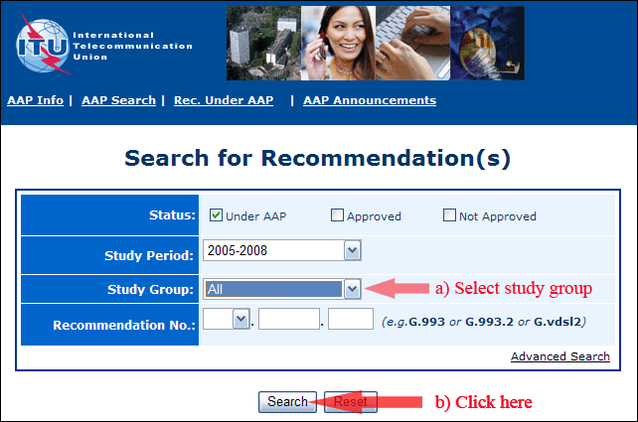
2) Select your Recommendation
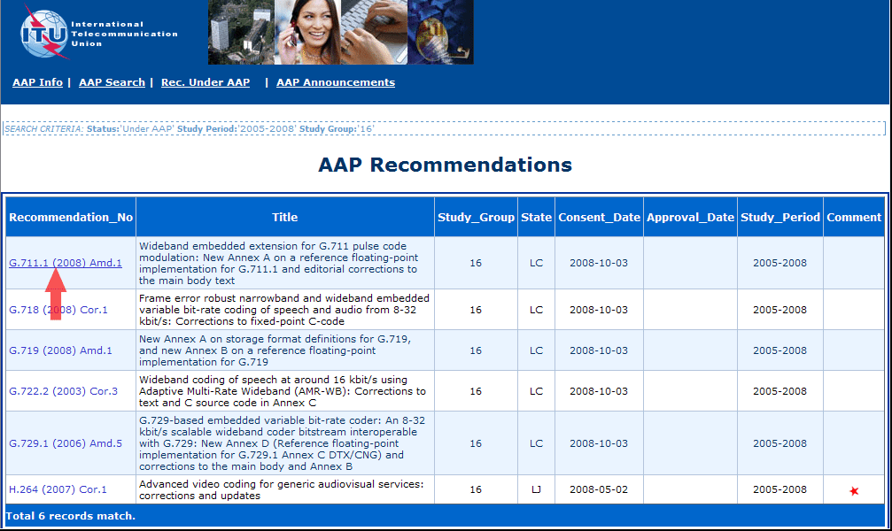
3) Click the "Submit Comment" button
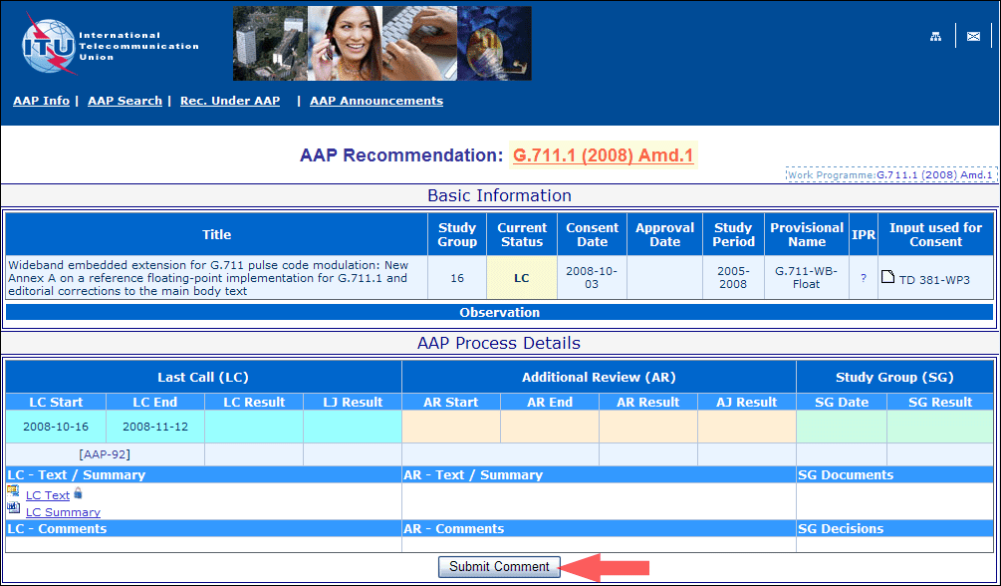
4) Complete the on-line form and click on "Submit"
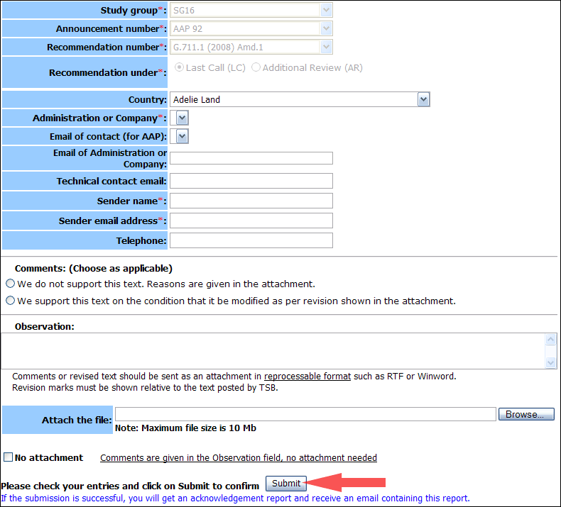
For more information, read the AAP tutorial on:
http://www.itu.int/ITU-T/aapinfo/files/AAPTutorial.pdf
Annex 3
(to TSB AAP-28)
Recommendations under LC/AR – Comment submission form
(Separate form for each Recommendation being commented upon)
ITU-T AAP comment submission form for the period 2009-2012
Study Group:
Announcement number:
Recommendation number:
Recommendation under: | Last call (LC)  Additional Review (AR)
Country:
Administration/Company:
Name of AAP Contact Person:
Email of AAP Contact Person:
Sender name:
(if different from AAP Contact Person)
Sender email address:
Telephone:
Comments:  (Choose as applicable) | We do not support this text. Reasons are given in the attachment.  We support this text on the condition that it be modified as per revision shown in the attachment.
Observations:
No attachment: Comments are given in the Observation field, no attachment needed
To be returned to: email: tsbsg....@itu.int
[or fax +41 22 730 5853]
Comments or revised text should be sent as an attachment in RTF or WinWord format.
Revision marks must be shown relative to the text posted by TSB.

