الا تحــاد الــدولي للاتصــالات
مكتب تقييس الاتصالات

 |  | جنيف، 16 يناير 2010
المرجع:  الهاتف:  الفاكس:  البريد الإلكتروني: | TSB AAP-28  AAP/MJ  +41 22 730 5860  +41 22 730 5853  tsbdir@itu.int | - إلى إدارات الدول الأعضاء في الاتحاد؛  - إلى أعضاء قطاع تقييس الاتصالات؛  - إلى المنتسبين إلى قطاع تقييس الاتصالات  نسخة إلى:  - رؤساء لجان الدراسات في قطاع تقييس الاتصالات ونوابهم؛  - مدير مكتب تنمية الاتصالات؛  - مدير مكتب الاتصالات الراديوية

الموضوع: حالة التوصيات الخاضعة لعملية الموافقة البديلة (AAP)

حضرات السادة والسيدات،
تحية طيبة وبعد،
تنطبق عملية الموافقة البديلة (AAP) المعرفة في التوصية ITU-T A.8 على التوصيات التي لا تنطوي على بعد سياسي أوتنظيمي ولا تتطلب بالتالي استشارة الدول الأعضاء رسمياً (انظر الرقم 246B من اتفاقية الاتحاد).
ويتضمن الملحق 1 لائحة بالنصوص التي تغيرت حالتها مقارنة بما جاء في إعلانات عملية الموافقة البديلة السابقة.
إذا رغبتم في تقديم تعليق بشأن توصية ما خاضعة لعملية الموافقة البديلة، فنرجو منكم استعمال استمارة التعليق على الخط المتوفّرة على موقع قطاع تقييس الاتصالات على صفحة عملية الموافقة البديلة http://www.itu.int/ITU-T/aap على المدخل الخاص بالتوصية المعنية (انظر الملحق (2. وبديلاً من ذلك، يمكنكم تقديم التعليقات باستكمال الاستمارة الواردة في الملحق 3 وإرسالها إلى أمانة لجنة الدراسات المعنية بالأمر.
وتجدر الإشارة إلى أنه يفضّل عدم إرسال تعليقات تقتصر على تأييد اعتماد النص قيد النظر.

وتفضلوا بقبول فائق الاحترام والتقدير.
مالكولم جونسون
مدير مكتب تقييس الاتصالات

الملحقات: 3
Annex 1
(to TSB AAP-28)

Status codes used in the AAP announcements:
LC = Last Call
LJ = Last Call Judgment (includes comment resolution)
AR = Additional Review
AJ = Additional Review Judgment (includes comment resolution)
SG = For Study Group approval
A = Approved
AT = Approved with typographic corrections
AC = Approved after Additional Review of Comments
NA = Not approved
TAP = Moved to TAP (ITU-T A.8 / § 5.2)
ITU-T website entry page:
http://www.itu.int/ITU-T
Alternative approval process (AAP) welcome page:
http://www.itu.int/ITU-T/aapinfo
Note – A tutorial on the ITU-T AAP application is available under the AAP welcome page
ITU-T website AAP Recommendation search page:
http://www.itu.int/ITU-T/aap/
Study Group web pages and contacts:
SG 2 | http://www.itu.int/ITU-T/studygroups/com02 | tsbsg2@itu.int
SG 3 | http://www.itu.int/ITU-T/studygroups/com03 | tsbsg3@itu.int
SG 5 | http://www.itu.int/ITU-T/studygroups/com05 | tsbsg5@itu.int
SG 9 | http://www.itu.int/ITU-T/studygroups/com09 | tsbsg9@itu.int
SG 11 | http://www.itu.int/ITU-T/studygroups/com11 | tsbsg11@itu.int
SG 12 | http://www.itu.int/ITU-T/studygroups/com12 | tsbsg12@itu.int
SG 13 | http://www.itu.int/ITU-T/studygroups/com13 | tsbsg13@itu.int
SG 15 | http://www.itu.int/ITU-T/studygroups/com15 | tsbsg15@itu.int
SG 16 | http://www.itu.int/ITU-T/studygroups/com16 | tsbsg16@itu.int
SG 17 | http://www.itu.int/ITU-T/studygroups/com17 | tsbsg17@itu.int

Situation concerning Study Group 2 Recommendations under AAP
Rec # | Title | Last Call (LC) Period |  |  |  | Additional Review (AR) Period |  |  |  | Status
Rec # | Title | LC Start | LC End | LC  Result | LJ  Result | AR Start | AR End | AR  Result | AJ  Result | Status
E.4110 (E.41NGNS) | Framework for operations requirements of Next Generation Networks and Services | 2009-12-01 | 2010-01-12 | A |  |  |  |  |  | A
M.3700  (X.object -neutral) | Common management services - Object Management - Requirements and Analysis - Protocol Neutral | 2009-12-01 | 2010-01-12 | LJ |  |  |  |  |  | LJ
M.3701  (X.state-neutral) | Common management services - State Management - Requirements and analysis - Protocol Neutral | 2009-12-01 | 2010-01-12 | LJ |  |  |  |  |  | LJ
M.3702  (X.notif-neutral) | Common Management Services - Notification management - Requirement and Analysis - Protocol Neutral | 2009-12-01 | 2010-01-12 | LJ |  |  |  |  |  | LJ
M.3704  (X.perf-neutral) | Common Management Service - Performance Management - Requirements and Analysis -Protocol Neutral | 2009-12-01 | 2010-01-12 | LJ |  |  |  |  |  | LJ
Situation concerning Study Group 5 Recommendations under AAP
Rec # | Title | Last Call (LC) Period |  |  |  | Additional Review (AR) Period |  |  |  | Status
Rec # | Title | LC Start | LC End | LC  Result | LJ  Result | AR Start | AR End | AR  Result | AJ  Result | Status
K.56 | Protection of radio base stations against lightning discharges | 2009-11-01 | 2009-11-28 | LJ | AR | 2009-12-16 | 2010-01-12 | AJ |  | AJ
Situation concerning Study Group 9 Recommendations under AAP
Rec # | Title | Last Call (LC) Period |  |  |  | Additional Review (AR) Period |  |  |  | Status
Rec # | Title | LC Start | LC End | LC  Result | LJ  Result | AR Start | AR End | AR  Result | AJ  Result | Status
J.201 | Harmonization of declarative content formats for interactive television applications | 2009-11-16 | 2009-12-13 | LJ | A |  |  |  |  | A
J.249 (J.redref) | Perceptual video quality measurement techniques for digital cable television in the presence of a reduced reference | 2009-12-01 | 2010-01-12 | LJ |  |  |  |  |  | LJ
J.700 | IPTV service requirements and framework for secondary distribution | 2009-11-16 | 2009-12-13 | LJ | A |  |  |  |  | A
J.704  (J.spi-req, J.sdp-req) | Functional requirements of the service provider interface for television primary and secondary distribution and associated interactive services | 2009-11-16 | 2009-12-13 | LJ | A |  |  |  |  | A
Situation concerning Study Group 13 Recommendations under AAP
Rec # | Title | Last Call (LC) Period |  |  |  | Additional Review (AR) Period |  |  |  | Status
Rec # | Title | LC Start | LC End | LC  Result | LJ  Result | AR Start | AR End | AR  Result | AJ  Result | Status
Y.2221 (Y.USN-reqts) | Requirements for support of Ubiquitous Sensor Network (USN) applications and services in the NGN environment | 2009-10-01 | 2009-10-28 | LJ | AR | 2009-12-16 | 2010-01-12 | AC |  | AC
Situation concerning Study Group 15 Recommendations under AAP
Rec # | Title | Last Call (LC) Period |  |  |  | Additional Review (AR) Period |  |  |  | Status
Rec # | Title | LC Start | LC End | LC  Result | LJ  Result | AR Start | AR End | AR  Result | AJ  Result | Status
G.709/Y.1331 | Interfaces for the Optical Transport Network (OTN) | 2009-10-16 | 2009-11-12 | LJ | AR | 2009-12-01 | 2009-12-21 | AC |  | AC
G.986 (G.gbe) | 1 Gbit/s point-to-point Ethernet based optical access system | 2009-10-16 | 2009-11-12 | LJ | AR | 2009-12-16 | 2010-01-12 | AC |  | AC
G.987.1 (G.xgpon.1) | 10-Gigabit-capable Passive Optical Networks (XG-PON): General Requirements | 2009-10-16 | 2009-11-12 | LJ | AR | 2009-12-16 | 2010-01-12 | AC |  | AC
G.987.2 | 10-Gigabit-capable passive optical networks (XG-PON): Physical Media Dependent (PMD) layer specification | 2009-10-16 | 2009-11-12 | LJ | AR | 2009-12-16 | 2010-01-12 | AC |  | AC
G.7716/Y.1707 (G.lcs) | Architecture of Control Plane Operations | 2009-10-16 | 2009-11-12 | LJ | AR | 2009-12-16 | 2010-01-12 | AC |  | AC
G.8011.3/Y.1307.3 | Ethernet Virtual Private LAN Service | 2009-10-16 | 2009-11-12 | LJ | AR | 2010-01-16 | 2010-02-05 |  |  | AR
G.8011.4/Y.1307.4 | Ethernet Virtual Private Routed Multipoint Service | 2009-10-16 | 2009-11-12 | LJ | AR | 2010-01-16 | 2010-02-05 |  |  | AR
G.8011.5/Y.1307.5 | Ethernet Private LAN service | 2009-10-16 | 2009-11-12 | LJ | AR | 2010-01-16 | 2010-02-05 |  |  | AR
G.8251 (2001) Amd.2 | The control of jitter and wander within the optical transport network (OTN) | 2009-10-16 | 2009-11-12 | LJ | AR | 2009-12-16 | 2010-01-12 | AC |  | AC
G.8262/Y.1362 (2007) Amd.2 | Timing characteristics of a synchronous Ethernet equipment slave clock (EEC) | 2009-10-16 | 2009-11-12 | LJ | AR | 2009-12-16 | 2010-01-12 | AC |  | AC
Situation concerning Study Group 16 Recommendations under AAP
Rec # | Title | Last Call (LC) Period |  |  |  | Additional Review (AR) Period |  |  |  | Status
Rec # | Title | LC Start | LC End | LC  Result | LJ  Result | AR Start | AR End | AR  Result | AJ  Result | Status
G.720.1 (G.GSAD) | Generic sound activity detection | 2009-12-16 | 2010-01-12 | A |  |  |  |  |  | A
H.248.1 v3 Amd.2 | Gateway Control Protocol: Version 3: New Appendix IV, plus corrections and clarifications | 2009-11-16 | 2009-12-13 | LJ | AT |  |  |  |  | AT
H.248.71 (H.248.RECRTCP) | Gateway Control Protocol: RTCP support packages | 2010-01-16 | 2010-02-12 |  |  |  |  |  |  | LC
H.264 (V5) | Advanced video coding for generic audiovisual services | 2009-12-16 | 2010-01-12 | LJ |  |  |  |  |  | LJ
T.834 (T.JXR-4) | Information technology - JPEG XR image coding system - Part 4: Conformance testing | 2009-12-01 | 2010-01-12 | A |  |  |  |  |  | A
T.835 (T.JXR-5) | Information technology - JPEG XR image coding system - Part 5: Reference software | 2009-12-01 | 2010-01-12 | A |  |  |  |  |  | A

Annex 2
(to TSB AAP-28)
Using the on-line comment submission form
Comment submission
1) Go to AAP search Web page at http://www.itu.int/ITU-T/aap/
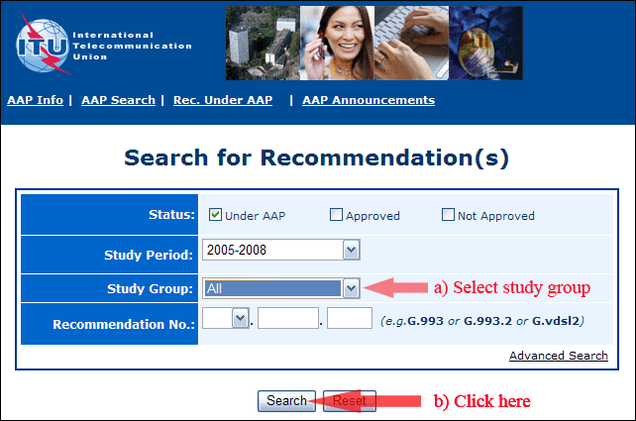
2) Select your Recommendation
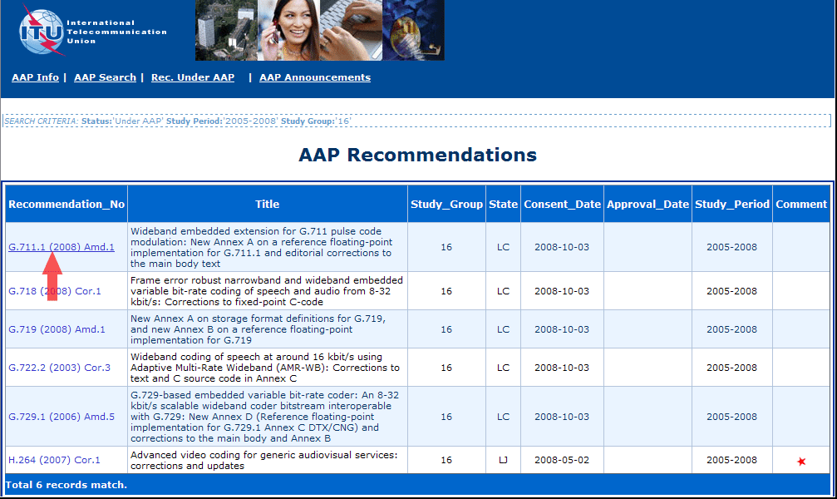
3) Click the "Submit Comment" button
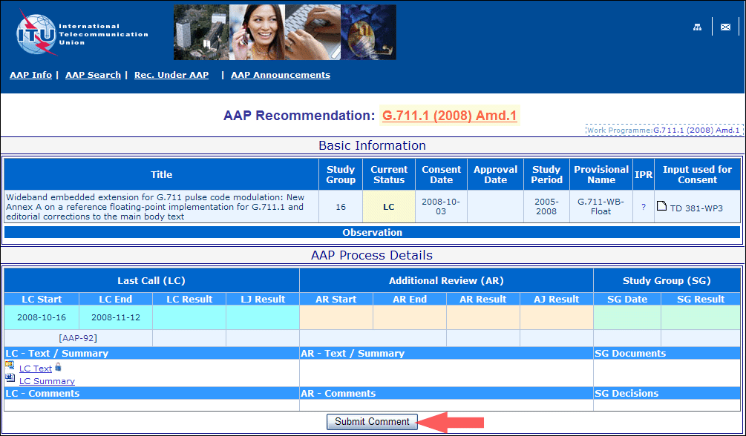
4) Complete the on-line form and click on "Submit"
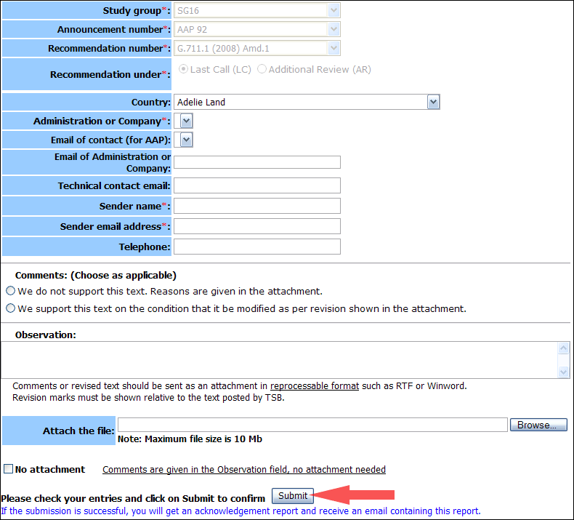
For more information, read the AAP tutorial on:
http://www.itu.int/ITU-T/aapinfo/files/AAPTutorial.pdf
Annex 3
(to TSB AAP-28)
Recommendations under LC/AR – Comment submission form
(Separate form for each Recommendation being commented upon)
ITU-T AAP comment submission form for the period 2009-2012
Study Group:
Announcement number:
Recommendation number:
Recommendation under: | Last call (LC)  Additional Review (AR)
Country:
Administration/Company:
Name of AAP Contact Person:
Email of AAP Contact Person:
Sender name:
(if different from AAP Contact Person)
Sender email address:
Telephone:
Comments:  (Choose as applicable) | We do not support this text. Reasons are given in the attachment.  We support this text on the condition that it be modified as per revision shown in the attachment.
Observations:
No attachment: Comments are given in the Observation field, no attachment needed
To be returned to: email: tsbsg....@itu.int
[or fax +41 22 730 5853]
Comments or revised text should be sent as an attachment in RTF or WinWord format.
Revision marks must be shown relative to the text posted by TSB.

