الا تحــاد الــدولي للاتصــالات
مكتب تقييس الاتصالات

 |  | جنيف، 16 ديسمبر 2009
المرجع:  الهاتف:  الفاكس:  البريد الإلكتروني: | TSB AAP-27  AAP/MJ  +41 22 730 5860  +41 22 730 5853  tsbdir@itu.int | - إلى إدارات الدول الأعضاء في الاتحاد؛  - إلى أعضاء قطاع تقييس الاتصالات؛  - إلى المنتسبين إلى قطاع تقييس الاتصالات  نسخة إلى:  - رؤساء لجان الدراسات في قطاع تقييس الاتصالات ونوابهم؛  - مدير مكتب تنمية الاتصالات؛  - مدير مكتب الاتصالات الراديوية

الموضوع: حالة التوصيات الخاضعة لعملية الموافقة البديلة (AAP)

حضرات السادة والسيدات،
تحية طيبة وبعد،
تنطبق عملية الموافقة البديلة (AAP) المعرفة في التوصية ITU-T A.8 على التوصيات التي لا تنطوي على بعد سياسي أوتنظيمي ولا تتطلب بالتالي استشارة الدول الأعضاء رسمياً (انظر الرقم 246B من اتفاقية الاتحاد).
ويتضمن الملحق 1 لائحة بالنصوص التي تغيرت حالتها مقارنة بما جاء في إعلانات عملية الموافقة البديلة السابقة.
إذا رغبتم في تقديم تعليق بشأن توصية ما خاضعة لعملية الموافقة البديلة، فنرجو منكم استعمال استمارة التعليق على الخط المتوفّرة على موقع قطاع تقييس الاتصالات على صفحة عملية الموافقة البديلة http://www.itu.int/ITU-T/aap على المدخل الخاص بالتوصية المعنية (انظر الملحق (2. وبديلاً من ذلك، يمكنكم تقديم التعليقات باستكمال الاستمارة الواردة في الملحق 3 وإرسالها إلى أمانة لجنة الدراسات المعنية بالأمر.
وتجدر الإشارة إلى أنه يفضّل عدم إرسال تعليقات تقتصر على تأييد اعتماد النص قيد النظر.
نظراً لإغلاق مكاتب الاتحاد في نهاية ديسمبر، يرجى الإحاطة علماً بأنه لن ينشر إعلان AAP في 1 يناير 2010. ونظراً لتزامن الموعد النهائي لبعض النصوص المعلنة مع فترة العطلة هذه، فقد تم تمديد موعدها بصفة استثنائية.
وتفضلوا بقبول فائق الاحترام والتقدير.
مالكولم جونسون
مدير مكتب تقييس الاتصالات

الملحقات: 3
Annex 1
(to TSB AAP-27)

Status codes used in the AAP announcements:
LC = Last Call
LJ = Last Call Judgment (includes comment resolution)
AR = Additional Review
AJ = Additional Review Judgment (includes comment resolution)
SG = For Study Group approval
A = Approved
AT = Approved with typographic corrections
AC = Approved after Additional Review of Comments
NA = Not approved
TAP = Moved to TAP (ITU-T A.8 / § 5.2)
ITU-T website entry page:
http://www.itu.int/ITU-T
Alternative approval process (AAP) welcome page:
http://www.itu.int/ITU-T/aapinfo
Note – A tutorial on the ITU-T AAP application is available under the AAP welcome page
ITU-T website AAP Recommendation search page:
http://www.itu.int/ITU-T/aap/
Study Group web pages and contacts:
SG 2 | http://www.itu.int/ITU-T/studygroups/com02 | tsbsg2@itu.int
SG 3 | http://www.itu.int/ITU-T/studygroups/com03 | tsbsg3@itu.int
SG 5 | http://www.itu.int/ITU-T/studygroups/com05 | tsbsg5@itu.int
SG 9 | http://www.itu.int/ITU-T/studygroups/com09 | tsbsg9@itu.int
SG 11 | http://www.itu.int/ITU-T/studygroups/com11 | tsbsg11@itu.int
SG 12 | http://www.itu.int/ITU-T/studygroups/com12 | tsbsg12@itu.int
SG 13 | http://www.itu.int/ITU-T/studygroups/com13 | tsbsg13@itu.int
SG 15 | http://www.itu.int/ITU-T/studygroups/com15 | tsbsg15@itu.int
SG 16 | http://www.itu.int/ITU-T/studygroups/com16 | tsbsg16@itu.int
SG 17 | http://www.itu.int/ITU-T/studygroups/com17 | tsbsg17@itu.int

Situation concerning Study Group 5 Recommendations under AAP
Rec # | Title | Last Call (LC) Period |  |  |  | Additional Review (AR) Period |  |  |  | Status
Rec # | Title | LC Start | LC End | LC  Result | LJ  Result | AR Start | AR End | AR  Result | AJ  Result | Status
K.56 | Protection of radio base stations against lightning discharges | 2009-11-01 | 2009-11-28 | LJ | AR | 2009-12-16 | 2010-01-12 |  |  | AR
Situation concerning Study Group 9 Recommendations under AAP
Rec # | Title | Last Call (LC) Period |  |  |  | Additional Review (AR) Period |  |  |  | Status
Rec # | Title | LC Start | LC End | LC  Result | LJ  Result | AR Start | AR End | AR  Result | AJ  Result | Status
J.201 | Harmonization of declarative content formats for interactive television applications | 2009-11-16 | 2009-12-13 | LJ |  |  |  |  |  | LJ
J.700 | IPTV service requirements and framework for secondary distribution | 2009-11-16 | 2009-12-13 | LJ |  |  |  |  |  | LJ
J.704  (J.spi-req, J.sdp-req) | Functional requirements of the service provider interface for television primary and secondary distribution and associated interactive services | 2009-11-16 | 2009-12-13 | LJ |  |  |  |  |  | LJ
Situation concerning Study Group 12 Recommendations under AAP
Rec # | Title | Last Call (LC) Period |  |  |  | Additional Review (AR) Period |  |  |  | Status
Rec # | Title | LC Start | LC End | LC  Result | LJ  Result | AR Start | AR End | AR  Result | AJ  Result | Status
P.501 | Test signals for use in telephonometry | 2009-11-16 | 2009-12-13 | A |  |  |  |  |  | A
P.581 | Use of head and torso simulator (HATS) for hands-free and handset terminal testing | 2009-11-16 | 2009-12-13 | A |  |  |  |  |  | A
P.1110 (P.CarHFTWB) | Wideband hands-free communication in motor vehicles | 2009-11-16 | 2009-12-13 | A |  |  |  |  |  | A
Y.1563 (2009) Amd.1 (Annex B to Y.1563) | New Annex B - Terminology for consecutive severely errored seconds in ethernet services | 2009-11-16 | 2009-12-13 | A |  |  |  |  |  | A
Situation concerning Study Group 13 Recommendations under AAP
Rec # | Title | Last Call (LC) Period |  |  |  | Additional Review (AR) Period |  |  |  | Status
Rec # | Title | LC Start | LC End | LC  Result | LJ  Result | AR Start | AR End | AR  Result | AJ  Result | Status
Y.2221 (Y.USN-reqts) | Requirements for support of Ubiquitous Sensor Network (USN) applications and services in the NGN environment | 2009-10-01 | 2009-10-28 | LJ | AR | 2009-12-16 | 2010-01-12 |  |  | AR
Y.2237 (Y.cmoip) | Functional model, service scenarios and use cases for QoS enabled mobile VoIP service | 2009-10-01 | 2009-10-28 | LJ | SG |  |  |  |  | SG
Situation concerning Study Group 15 Recommendations under AAP
Rec # | Title | Last Call (LC) Period |  |  |  | Additional Review (AR) Period |  |  |  | Status
Rec # | Title | LC Start | LC End | LC  Result | LJ  Result | AR Start | AR End | AR  Result | AJ  Result | Status
G.986 (G.gbe) | 1 Gbit/s point-to-point Ethernet based optical access system | 2009-10-16 | 2009-11-12 | LJ | AR | 2009-12-16 | 2010-01-12 |  |  | AR
G.987 (G.xgpon.def) | 10-Gigabit-capable passive optical network (XG-PON) systems: Definitions, Abbreviations, and Acronyms | 2009-10-16 | 2009-11-12 | LJ | AR | 2009-12-16 | 2010-01-12 |  |  | AR
G.987.1 (G.xgpon.1) | 10-Gigabit-capable Passive Optical Networks (XG-PON): General Requirements | 2009-10-16 | 2009-11-12 | LJ | AR | 2009-12-16 | 2010-01-12 |  |  | AR
G.987.2 | 10-Gigabit-capable passive optical networks (XG-PON): Physical Media Dependent (PMD) layer specification | 2009-10-16 | 2009-11-12 | LJ | AR | 2009-12-16 | 2010-01-12 |  |  | AR
G.7716/Y.1707 (G.lcs) | Architecture of Control Plane Operations | 2009-10-16 | 2009-11-12 | LJ | AR | 2009-12-16 | 2010-01-12 |  |  | AR
G.8032/Y.1344 | Ethernet Ring Protection Switching | 2009-11-16 | 2009-12-13 | LJ |  |  |  |  |  | LJ
G.8251 (2001) Amd.2 | The control of jitter and wander within the optical transport network (OTN) | 2009-10-16 | 2009-11-12 | LJ | AR | 2009-12-16 | 2010-01-12 |  |  | AR
G.8262/Y.1362 (2007) Amd.2 | Timing characteristics of a synchronous Ethernet equipment slave clock (EEC) | 2009-10-16 | 2009-11-12 | LJ | AR | 2009-12-16 | 2010-01-12 |  |  | AR
Situation concerning Study Group 16 Recommendations under AAP
Rec # | Title | Last Call (LC) Period |  |  |  | Additional Review (AR) Period |  |  |  | Status
Rec # | Title | LC Start | LC End | LC  Result | LJ  Result | AR Start | AR End | AR  Result | AJ  Result | Status
F.743 (F.VSreqs) | Requirements and services description for visual surveillance | 2009-11-16 | 2009-12-13 | A |  |  |  |  |  | A
F.744 (F.USN-MW) | Service description and requirements for ubiquitous sensor network middleware | 2009-11-16 | 2009-12-13 | A |  |  |  |  |  | A
G.720.1 (G.GSAD) | Generic sound activity detection | 2009-12-16 | 2010-01-12 |  |  |  |  |  |  | LC
G.799.2 (G.MDCSPNE) | Mechanism for dynamic coordination of signal processing functions | 2009-11-16 | 2009-12-13 | A |  |  |  |  |  | A
H.222.0 (2006) Amd.3 Cor.1 | Information technology - Generic coding of moving pictures and associated audio information: Systems: Transport of scalable video over ITU-T Rec. H.222.0 | ISO/IEC 13818-1: Corrections | 2009-11-16 | 2009-12-13 | A |  |  |  |  |  | A
H.222.0 (2006) Amd.4 (H.222.0-MVC) | Information technology - Generic coding of moving pictures and associated audio information: Systems: Transport of multiview video over ITU-T Rec. H.222.0 | ISO/IEC 13818-1 | 2009-11-16 | 2009-12-13 | A |  |  |  |  |  | A
H.222.0 (2006) Cor.3 | Information technology - Generic coding of moving pictures and associated audio information: Systems: Corrections concerning VBV buffer size, semantics of splice_type and removal rate from transport buffer for H.264 | ISO/IEC 14496-10 advanced video coding | 2009-11-16 | 2009-12-13 | A |  |  |  |  |  | A
H.225.0 (V7) | Call signalling protocols and media stream packetization for packet-based multimedia communication systems | 2009-11-16 | 2009-12-13 | AT |  |  |  |  |  | AT
H.241 (2006) Amd.2 (H.241 Appendix II) | Extended video procedures and control signals for H.300-series terminals: New Clause 8.3.2.14, H.264 MaxFPS frame rate parameter and revisions to Appendix II (Examples of the set submode procedure) | 2009-11-16 | 2009-12-13 | A |  |  |  |  |  | A
H.245 (V15) | Control protocol for multimedia communication | 2009-11-16 | 2009-12-13 | AT |  |  |  |  |  | AT
H.248.1 v3 Amd.2 | Gateway Control Protocol: Version 3: New Appendix IV, plus corrections and clarifications | 2009-11-16 | 2009-12-13 | LJ |  |  |  |  |  | LJ
H.248.4 (V2) | Gateway control protocol: Transport over Stream Control Transmission Protocol (SCTP) | 2009-11-16 | 2009-12-13 | A |  |  |  |  |  | A
H.248.5 (V2) | Gateway control protocol: Gateway control protocol: Transport over ATM | 2009-11-16 | 2009-12-13 | A |  |  |  |  |  | A
H.248.64 (H.248.IPR) | Gateway control protocol: IP router packages | 2009-11-16 | 2009-12-13 | A |  |  |  |  |  | A
H.248.67 (H.248.TrM) | Gateway Control Protocol: GCP Transport Mode Indication Package | 2009-11-16 | 2009-12-13 | A |  |  |  |  |  | A
H.248.72 (H.248.MONA) | Gateway Control Protocol: H.248 support for MONA | 2009-11-16 | 2009-12-13 | A |  |  |  |  |  | A
H.248.9 (V3) | Gateway control protocol: Advanced media server packages | 2009-11-16 | 2009-12-13 | A |  |  |  |  |  | A
H.264 (V5) | Advanced video coding for generic audiovisual services | 2009-12-16 | 2010-01-12 |  |  |  |  |  |  | LC
H.323 v7 | Packet-based multimedia communications systems | 2009-11-16 | 2009-12-13 | AT |  |  |  |  |  | AT
H.460.23 (H.460.natdet) | Network address translator and firewall device determination in H.323 systems | 2009-11-16 | 2009-12-13 | A |  |  |  |  |  | A
H.460.24 (H.460.p2pnat) | Point to point media through network address translators and firewalls within H.323 systems | 2009-11-16 | 2009-12-13 | A |  |  |  |  |  | A
H.740 (H.IPTV-AEH) | Application event handling for IPTV services | 2009-11-16 | 2009-12-13 | LJ |  |  |  |  |  | LJ
H.762  (H.IPTV-MAFR.2) | Lightweight interactive multimedia framework (LIME) for IPTV services | 2009-11-16 | 2009-12-13 | LJ |  |  |  |  |  | LJ
I.733 (2009) Cor.1 | Voice on ATM circuit multiplication equipment: Corrections to clause 9.2.3 | 2009-11-16 | 2009-12-13 | A |  |  |  |  |  | A
T.800 (2002) Amd.4 | Information technology - JPEG 2000 image coding system: Core coding system: Profiles for broadcast applications | 2009-11-16 | 2009-12-13 | LJ |  |  |  |  |  | LJ
T.802 (2005) Amd.1 | Information technology - JPEG 2000 image coding system: Motion JPEG 2000: Additional profiles for archiving applications | 2009-11-16 | 2009-12-13 | LJ |  |  |  |  |  | LJ
T.808 (2005) Amd.4 | Information technology - JPEG 2000 image coding system: Interactivity tools, APIs and protocols: JPIP server and client profiles | 2009-11-16 | 2009-12-13 | LJ |  |  |  |  |  | LJ
T.832 (2009) Cor.1 | Information technology - JPEG XR image coding system - Part 2: Image coding specification: Corrections and clarifications | 2009-11-16 | 2009-12-13 | A |  |  |  |  |  | A
V.153 (V.IP2IP-VxF) | Interworking between T.38 and V.152 using IP peering for realtime facsimile services | 2009-11-16 | 2009-12-13 | A |  |  |  |  |  | A

Annex 2
(to TSB AAP-27)
Using the on-line comment submission form
Comment submission
1) Go to AAP search Web page at http://www.itu.int/ITU-T/aap/
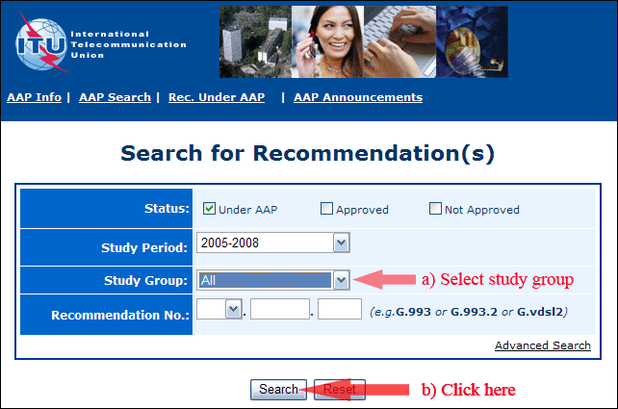
2) Select your Recommendation
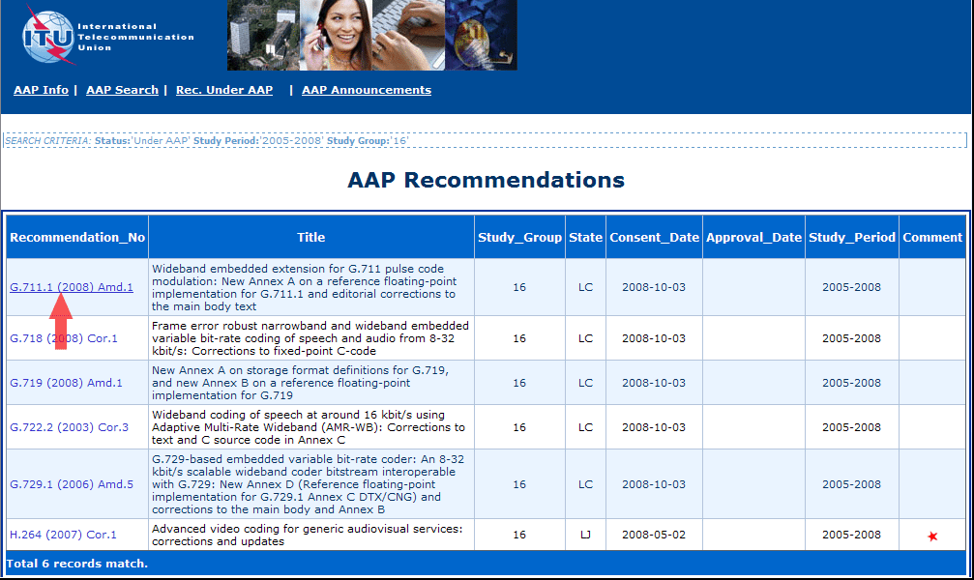
3) Click the "Submit Comment" button
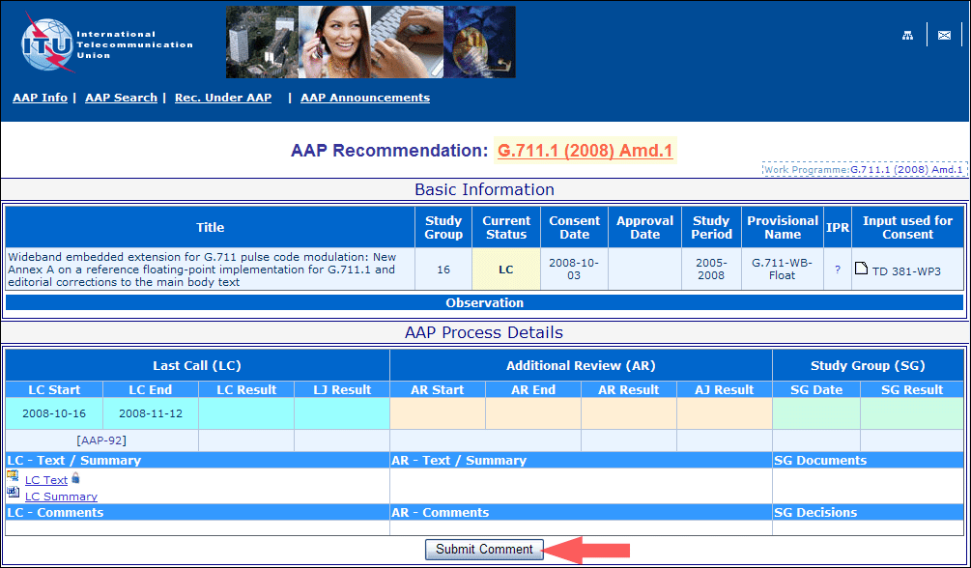
4) Complete the on-line form and click on "Submit"
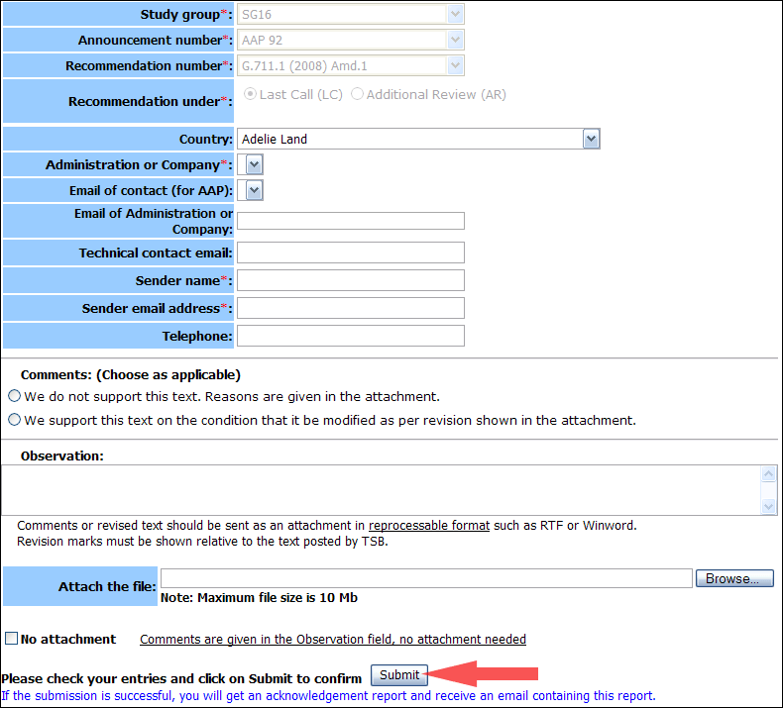
For more information, read the AAP tutorial on:
http://www.itu.int/ITU-T/aapinfo/files/AAPTutorial.pdf
Annex 3
(to TSB AAP-27)
Recommendations under LC/AR – Comment submission form
(Separate form for each Recommendation being commented upon)
ITU-T AAP comment submission form for the period 2009-2012
Study Group:
Announcement number:
Recommendation number:
Recommendation under: | Last call (LC)  Additional Review (AR)
Country:
Administration/Company:
Name of AAP Contact Person:
Email of AAP Contact Person:
Sender name:
(if different from AAP Contact Person)
Sender email address:
Telephone:
Comments:  (Choose as applicable) | We do not support this text. Reasons are given in the attachment.  We support this text on the condition that it be modified as per revision shown in the attachment.
Observations:
No attachment: Comments are given in the Observation field, no attachment needed
To be returned to: email: tsbsg....@itu.int
[or fax +41 22 730 5853]
Comments or revised text should be sent as an attachment in RTF or WinWord format.
Revision marks must be shown relative to the text posted by TSB.

