Международный союз электросвязи
Бюро стандартизации электросвязи

Женева, 16 ноября 2009

Осн.:  Тел.:  Факс:  Эл. почта: | TSB AAP-25  AAP/MJ  +41 22 730 5860  +41 22 730 5853  tsbdir@itu.int | – Администрациям Государств – Членов Союза;  – Членам Сектора МСЭ-Т;  – Ассоциированным членам МСЭ-Т  Копии:  – Председателям и заместителям председателей Исследовательских комиссий МСЭ-Т;  – Директору Бюро Развития Электросвязи;  – Директору Бюро Радиосвязи

Предмет: | Положение относительно Рекомендаций, рассматриваемых в соответствии с альтернативным процессом утверждения (АПУ)

Уважаемая госпожа,
уважаемый господин,

Альтернативный процесс утверждения (АПУ), определенный в Рекомендации МСЭ-Т А.8, распространяется на Рекомендации, которые не имеют политических или регламентарных последствий и которые поэтому не требуют официальных консультаций с Государствами-Членами (см. п. 246B Конвенции МСЭ).
В Приложении 1 содержится перечень текстов, статус которых изменился по сравнению с предыдущими объявлениями об АПУ БСЭ.
Если вы желаете представить замечания относительно какой-либо Рекомендации, рассматриваемой в соответствии с АПУ, рекомендуем Вам использовать онлайновую форму для представления замечаний по АПУ, которая размещена на странице этой Рекомендации в разделе веб-сайта МСЭ-Т, посвященном АПУ, по адресу: http://www.itu.int/ITU-T/aap/ (см. Приложение 2). Замечания можно представить иным способом, заполнив приведенную в Приложении 3 форму и направив ее в секретариат заинтересованной исследовательской комиссии.
Просим принять к сведению, что не рекомендуется представлять замечания, являющиеся не чем иным, как поддержкой рассматриваемого текста.
С уважением,
Малколм Джонсон
Директор Бюро
стандартизации электросвязи
Приложения: 3
Annex 1
(to TSB AAP-25)

Status codes used in the AAP announcements:
LC = Last Call
LJ = Last Call Judgment (includes comment resolution)
AR = Additional Review
AJ = Additional Review Judgment (includes comment resolution)
SG = For Study Group approval
A = Approved
AT = Approved with typographic corrections
AC = Approved after Additional Review of Comments
NA = Not approved
TAP = Moved to TAP (ITU-T A.8 / § 5.2)
ITU-T website entry page:
http://www.itu.int/ITU-T
Alternative approval process (AAP) welcome page:
http://www.itu.int/ITU-T/aapinfo
Note – A tutorial on the ITU-T AAP application is available under the AAP welcome page
ITU-T website AAP Recommendation search page:
http://www.itu.int/ITU-T/aap/
Study Group web pages and contacts:
SG 2 | http://www.itu.int/ITU-T/studygroups/com02 | tsbsg2@itu.int
SG 3 | http://www.itu.int/ITU-T/studygroups/com03 | tsbsg3@itu.int
SG 5 | http://www.itu.int/ITU-T/studygroups/com05 | tsbsg5@itu.int
SG 9 | http://www.itu.int/ITU-T/studygroups/com09 | tsbsg9@itu.int
SG 11 | http://www.itu.int/ITU-T/studygroups/com11 | tsbsg11@itu.int
SG 12 | http://www.itu.int/ITU-T/studygroups/com12 | tsbsg12@itu.int
SG 13 | http://www.itu.int/ITU-T/studygroups/com13 | tsbsg13@itu.int
SG 15 | http://www.itu.int/ITU-T/studygroups/com15 | tsbsg15@itu.int
SG 16 | http://www.itu.int/ITU-T/studygroups/com16 | tsbsg16@itu.int
SG 17 | http://www.itu.int/ITU-T/studygroups/com17 | tsbsg17@itu.int

Situation concerning Study Group 9 Recommendations under AAP
Rec # | Title | Last Call (LC) Period |  |  |  | Additional Review (AR) Period |  |  |  | Status
Rec # | Title | LC Start | LC End | LC  Result | LJ  Result | AR Start | AR End | AR  Result | AJ  Result | Status
J.201 | Harmonization of declarative content formats for interactive television applications | 2009-11-16 | 2009-12-13 |  |  |  |  |  |  | LC
J.700 | IPTV service requirements and framework for secondary distribution | 2009-11-16 | 2009-12-13 |  |  |  |  |  |  | LC
J.704 (J.spi-req, J.sdp-req) | Functional requirements of the service provider interface for television primary and secondary distribution and associated interactive services | 2009-11-16 | 2009-12-13 |  |  |  |  |  |  | LC
Situation concerning Study Group 11 Recommendations under AAP
Rec # | Title | Last Call (LC) Period |  |  |  | Additional Review (AR) Period |  |  |  | Status
Rec # | Title | LC Start | LC End | LC  Result | LJ  Result | AR Start | AR End | AR  Result | AJ  Result | Status
Q.761 (1999) Amd. 4 | Support for the Customized Alerting Tone (CAT) service | 2009-10-01 | 2009-10-28 | LJ | A |  |  |  |  | A
Q.762 (1999) Amd. 5 | Support for the Customized Alerting Tone (CAT) service | 2009-10-01 | 2009-10-28 | LJ | A |  |  |  |  | A
Q.763 (1999) Amd. 6 | Support for the Customized Alerting Tone (CAT) service | 2009-10-01 | 2009-10-28 | LJ | A |  |  |  |  | A
Q.1902.1 (2001) Amd. 3 | Support for Customized Alerting Tone (CAT) service | 2009-10-01 | 2009-10-28 | LJ | A |  |  |  |  | A
Q.1902.2 (2001) Amd. 5 | Support for the Customized Alerting Tone (CAT) service | 2009-10-01 | 2009-10-28 | LJ | A |  |  |  |  | A
Q.1902.3 (2001) Amd. 5 | Support for the Customized Alerting Tone (CAT) service | 2009-10-01 | 2009-10-28 | LJ | A |  |  |  |  | A
Q.3306.1 | Protocol at the Rd interface between intra-domain Policy Decision Physical Entities (PD-PEs) (Rd interface) | 2009-10-01 | 2009-10-28 | LJ | AT |  |  |  |  | AT
Q.3309 (Q.QCP) | QoS Coordination Protocol | 2009-10-01 | 2009-10-28 | LJ | A |  |  |  |  | A
X.603.1 (2007) Amd.1 | Information technology - Relayed multicast protocol: Specification for simplex group applications - Amendment 1: Security extensions | 2009-10-16 | 2009-11-12 | LJ |  |  |  |  |  | LJ
Situation concerning Study Group 12 Recommendations under AAP
Rec # | Title | Last Call (LC) Period |  |  |  | Additional Review (AR) Period |  |  |  | Status
Rec # | Title | LC Start | LC End | LC  Result | LJ  Result | AR Start | AR End | AR  Result | AJ  Result | Status
P.501 | Test signals for use in telephonometry | 2009-11-16 | 2009-12-13 |  |  |  |  |  |  | LC
P.581 | Use of head and torso simulator (HATS) for hands-free and handset terminal testing | 2009-11-16 | 2009-12-13 |  |  |  |  |  |  | LC
P.1110 (P.CarHFTWB) | Wideband hands-free communication in motor vehicles | 2009-11-16 | 2009-12-13 |  |  |  |  |  |  | LC
Y.1563 (2009) Amd.1 (Annex B to Y.1563) | New Annex B - Terminology for consecutive severely errored seconds in ethernet services | 2009-11-16 | 2009-12-13 |  |  |  |  |  |  | LC
Situation concerning Study Group 15 Recommendations under AAP
Rec # | Title | Last Call (LC) Period |  |  |  | Additional Review (AR) Period |  |  |  | Status
Rec # | Title | LC Start | LC End | LC  Result | LJ  Result | AR Start | AR End | AR  Result | AJ  Result | Status
G.652 | Characteristics of a single-mode optical fibre cable | 2009-10-16 | 2009-11-12 | LJ |  |  |  |  |  | LJ
G.655 | Characteristics of a non-zero dispersion shifted single-mode optical fibre and cable | 2009-10-16 | 2009-11-12 | A |  |  |  |  |  | A
G.657 | Characteristics of a bending loss insensitive single mode optical fibre and cable for the access network | 2009-10-16 | 2009-11-12 | A |  |  |  |  |  | A
G.693 | Optical interfaces for intra-office systems | 2009-10-16 | 2009-11-12 | A |  |  |  |  |  | A
G.695 | Optical interfaces for coarse wavelength division multiplexing applications | 2009-10-16 | 2009-11-12 | A |  |  |  |  |  | A
G.697 | Optical monitoring for DWDM systems | 2009-10-16 | 2009-11-12 | A |  |  |  |  |  | A
G.698.1 | Multichannel DWDM applications with single channel optical interfaces | 2009-10-16 | 2009-11-12 | LJ |  |  |  |  |  | LJ
G.698.2 | Amplified multichannel DWDM applications with single channel optical interfaces | 2009-10-16 | 2009-11-12 | A |  |  |  |  |  | A
G.707/Y.1322 (2007) Amd.2 | Network node interface for the synchronous digital hierarchy (SDH) | 2009-10-16 | 2009-11-12 | A |  |  |  |  |  | A
G.709/Y.1331 | Interfaces for the Optical Transport Network (OTN) | 2009-10-16 | 2009-11-12 | LJ |  |  |  |  |  | LJ
G.781 (2008) Cor.1 | Synchronization Layer Functions | 2009-10-16 | 2009-11-12 | A |  |  |  |  |  | A
G.783 (2006) Amd.2 | Characteristics of Synchronous Digital Hierarchy (SDH) Equipment Functional Blocks | 2009-10-16 | 2009-11-12 | LJ |  |  |  |  |  | LJ
G.808.1 | Generic Protection Switching - Linear Trail and Subnetwork Protection | 2009-10-16 | 2009-11-12 | LJ |  |  |  |  |  | LJ
G.870/Y.1352 (2008) Amd.1 | Terms and definitions for Optical Transport Networks (OTN) | 2009-10-16 | 2009-11-12 | LJ |  |  |  |  |  | LJ
G.959.1 | Optical transport networks physical layer interfaces | 2009-10-16 | 2009-11-12 | A |  |  |  |  |  | A
G.973.1 (G.lcasub) | Longitudinal compatible DWDM applications for repeaterless optical fibre submarine cable systems | 2009-10-16 | 2009-11-12 | LJ |  |  |  |  |  | LJ
G.984.3 (2008) Amd.2 | Gigabit-capable Passive Optical Networks (GPON): Transmission convergence layer specification - Amendment 2 | 2009-10-16 | 2009-11-12 | A |  |  |  |  |  | A
G.984.4 (2008) Amd.2 | Gigabit-capable passive optical network (GPON): ONT management and control interface specification - Amendment 2 | 2009-10-16 | 2009-11-12 | A |  |  |  |  |  | A
G.984.6 (2008) Amd. 1 | Gigabit-capable Passive Optical Networks (GPON): Reach extender (RE) units - Amendment 1 | 2009-10-16 | 2009-11-12 | A |  |  |  |  |  | A
G.986 (G.gbe) | 1 Gbit/s point-to-point Ethernet based optical access system | 2009-10-16 | 2009-11-12 | LJ |  |  |  |  |  | LJ
G.987 (G.xgpon.def) | 10-Gigabit-capable passive optical network (XG-PON) systems: Definitions, Abbreviations, and Acronyms | 2009-10-16 | 2009-11-12 | LJ |  |  |  |  |  | LJ
G.987.1 (G.xgpon.1) | 10-Gigabit-capable Passive Optical Networks (XG-PON): General Requirements | 2009-10-16 | 2009-11-12 | LJ |  |  |  |  |  | LJ
G.987.2 | 10-Gigabit-capable passive optical networks (XG-PON): Physical Media Dependent (PMD) layer specification | 2009-10-16 | 2009-11-12 | LJ |  |  |  |  |  | LJ
G.992.3 (2009) Cor.1 | Asymmetric digital subscriber line transceivers 2 (ADSL2) - Corrigendum 1 | 2009-10-16 | 2009-11-12 | A |  |  |  |  |  | A
G.993.2 (2006) Amd. 5 | Very high speed Digital subscriber Line Transceivers 2 - Amendment 5 | 2009-10-16 | 2009-11-12 | LJ |  |  |  |  |  | LJ
G.993.5 (G.vector) | Self-FEXT Cancellation (Vectoring) for use with VDSL2 transceivers | 2009-10-16 | 2009-11-12 | LJ |  |  |  |  |  | LJ
G.994.1 (2007) Amd.5 | Handshake procedures for digital subscriber line (DSL) transceivers - Amendment 5 | 2009-10-16 | 2009-11-12 | LJ |  |  |  |  |  | LJ
G.997.1 (2009) Amd.1 | Physical layer management for digital subscriber line (DSL) transceivers - Amendment 1 | 2009-10-16 | 2009-11-12 | LJ |  |  |  |  |  | LJ
G.997.1 (2009) Cor.1 | Physical layer management for digital subscriber line (DSL) transceivers - Corrigendum 1 | 2009-10-16 | 2009-11-12 | LJ |  |  |  |  |  | LJ
G.998.4 (G.inp) | Improved Impulse Noise Protection (INP) for DSL Transceivers | 2009-10-16 | 2009-11-12 | LJ |  |  |  |  |  | LJ
G.7710/Y.1701 (2007) Cor.1 | Common equipment management function requirements | 2009-10-16 | 2009-11-12 | A |  |  |  |  |  | A
G.7713/Y.1704 | Distributed Call and Connection Management (DCM) | 2009-10-16 | 2009-11-12 | A |  |  |  |  |  | A
G.7716/Y.1707 (G.lcs) | Architecture of Control Plane Operations | 2009-10-16 | 2009-11-12 | LJ |  |  |  |  |  | LJ
G.8011.3/Y.1307.3 | Ethernet Virtual Private LAN Service | 2009-10-16 | 2009-11-12 | LJ |  |  |  |  |  | LJ
G.8011.4/Y.1307.4 | Ethernet Virtual Private Routed Multipoint Service | 2009-10-16 | 2009-11-12 | LJ |  |  |  |  |  | LJ
G.8011.5/Y.1307.5 | Ethernet Private LAN service | 2009-10-16 | 2009-11-12 | LJ |  |  |  |  |  | LJ
G.8021/Y.1341 (2007) Amd.2 | Characteristics of Ethernet Transport Network Equipment Functional Blocks | 2009-10-16 | 2009-11-12 | LJ |  |  |  |  |  | LJ
G.8031/Y.1342 | Ethernet linear protection switching | 2009-10-16 | 2009-11-12 | A |  |  |  |  |  | A
G.8032/Y.1344 | Ethernet Ring Protection Switching | 2009-11-16 | 2009-12-13 |  |  |  |  |  |  | LC
G.8051/Y.1345 (G.eot-mgmt) | Management aspects of the Ethernet-over-Transport (EoT) capable network element | 2009-10-16 | 2009-11-12 | A |  |  |  |  |  | A
G.8251 (2001) Amd.2 | The control of jitter and wander within the optical transport network (OTN) | 2009-10-16 | 2009-11-12 | LJ |  |  |  |  |  | LJ
G.8262/Y.1362 (2007) Amd.2 | Timing characteristics of a synchronous Ethernet equipment slave clock (EEC) | 2009-10-16 | 2009-11-12 | LJ |  |  |  |  |  | LJ
G.8264/Y.1364 (2008) Cor.1 | Timing distribution through packet networks | 2009-10-16 | 2009-11-12 | A |  |  |  |  |  | A
G.9972 (G.cx) | Coexistence mechanism for wireline home networking transceivers | 2009-10-16 | 2009-11-12 | LJ |  |  |  |  |  | LJ
L.81 (L.wsn) | Monitoring systems for outside plant facilities | 2009-10-16 | 2009-11-12 | A |  |  |  |  |  | A
O.174 (O.SyncEjitter) | Jitter and wander measuring equipment for a synchronous packet network | 2009-10-16 | 2009-11-12 | A |  |  |  |  |  | A
Situation concerning Study Group 16 Recommendations under AAP
Rec # | Title | Last Call (LC) Period |  |  |  | Additional Review (AR) Period |  |  |  | Status
Rec # | Title | LC Start | LC End | LC  Result | LJ  Result | AR Start | AR End | AR  Result | AJ  Result | Status
F.743 (F.VSreqs) | Requirements and services description for visual surveillance | 2009-11-16 | 2009-12-13 |  |  |  |  |  |  | LC
F.744 (F.USN-MW) | Service description and requirements for ubiquitous sensor network middleware | 2009-11-16 | 2009-12-13 |  |  |  |  |  |  | LC
G.799.2 (G.MDCSPNE) | Mechanism for dynamic coordination of signal processing functions | 2009-11-16 | 2009-12-13 |  |  |  |  |  |  | LC
H.222.0 (2006) Amd.3 Cor.1 | Information technology - Generic coding of moving pictures and associated audio information: Systems: Transport of scalable video over ITU-T Rec. H.222.0 | ISO/IEC 13818-1: Corrections | 2009-11-16 | 2009-12-13 |  |  |  |  |  |  | LC
H.222.0 (2006) Amd.4 (H.222.0-MVC) | Information technology - Generic coding of moving pictures and associated audio information: Systems: Transport of multiview video over ITU-T Rec. H.222.0 | ISO/IEC 13818-1 | 2009-11-16 | 2009-12-13 |  |  |  |  |  |  | LC
H.222.0 (2006) Cor.3 | Information technology - Generic coding of moving pictures and associated audio information: Systems: Corrections concerning VBV buffer size, semantics of splice_type and removal rate from transport buffer for H.264 | ISO/IEC 14496-10 advanced video coding | 2009-11-16 | 2009-12-13 |  |  |  |  |  |  | LC
H.225.0 (V7) | Call signalling protocols and media stream packetization for packet-based multimedia communication systems | 2009-11-16 | 2009-12-13 |  |  |  |  |  |  | LC
H.241 (2006) Amd.2 (H.241 Appendix II) | Extended video procedures and control signals for H.300-series terminals: New Clause 8.3.2.14, H.264 MaxFPS frame rate parameter and revisions to Appendix II (Examples of the set submode procedure) | 2009-11-16 | 2009-12-13 |  |  |  |  |  |  | LC
H.245 (V15) | Control protocol for multimedia communication | 2009-11-16 | 2009-12-13 |  |  |  |  |  |  | LC
H.248.1 v3 Amd.2 | Gateway Control Protocol: Version 3: New Appendix IV, plus corrections and clarifications | 2009-11-16 | 2009-12-13 |  |  |  |  |  |  | LC
H.248.4 (V2) | Gateway control protocol: Transport over Stream Control Transmission Protocol (SCTP) | 2009-11-16 | 2009-12-13 |  |  |  |  |  |  | LC
H.248.5 (V2) | Gateway control protocol: Gateway control protocol: Transport over ATM | 2009-11-16 | 2009-12-13 |  |  |  |  |  |  | LC
H.248.64 (H.248.IPR) | Gateway control protocol: IP router packages | 2009-11-16 | 2009-12-13 |  |  |  |  |  |  | LC
H.248.67 (H.248.TrM) | Gateway Control Protocol: GCP Transport Mode Indication Package | 2009-11-16 | 2009-12-13 |  |  |  |  |  |  | LC
H.248.72 (H.248.MONA) | Gateway Control Protocol: H.248 support for MONA | 2009-11-16 | 2009-12-13 |  |  |  |  |  |  | LC
H.248.9 (V3) | Gateway control protocol: Advanced media server packages | 2009-11-16 | 2009-12-13 |  |  |  |  |  |  | LC
H.323 v7 | Packet-based multimedia communications systems | 2009-11-16 | 2009-12-13 |  |  |  |  |  |  | LC
H.460.23 (H.460.natdet) | Network address translator and firewall device determination in H.323 systems | 2009-11-16 | 2009-12-13 |  |  |  |  |  |  | LC
H.460.24 (H.460.p2pnat) | Point to point media through network address translators and firewalls within H.323 systems | 2009-11-16 | 2009-12-13 |  |  |  |  |  |  | LC
H.740 (H.IPTV-AEH) | Application event handling for IPTV services | 2009-11-16 | 2009-12-13 |  |  |  |  |  |  | LC
H.762 (H.IPTV-MAFR.2) | Lightweight interactive multimedia framework (LIME) for IPTV services | 2009-11-16 | 2009-12-13 |  |  |  |  |  |  | LC
I.733 (2009) Cor.1 | Voice on ATM circuit multiplication equipment: Corrections to clause 9.2.3 | 2009-11-16 | 2009-12-13 |  |  |  |  |  |  | LC
T.800 (2002) Amd.4 | Information technology - JPEG 2000 image coding system: Core coding system: Profiles for broadcast applications | 2009-11-16 | 2009-12-13 |  |  |  |  |  |  | LC
T.802 (2005) Amd.1 | Information technology - JPEG 2000 image coding system: Motion JPEG 2000: Additional profiles for archiving applications | 2009-11-16 | 2009-12-13 |  |  |  |  |  |  | LC
T.808 (2005) Amd.4 | Information technology - JPEG 2000 image coding system: Interactivity tools, APIs and protocols: JPIP server and client profiles | 2009-11-16 | 2009-12-13 |  |  |  |  |  |  | LC
T.832 (2009) Cor.1 | Information technology - JPEG XR image coding system - Part 2: Image coding specification: Corrections and clarifications | 2009-11-16 | 2009-12-13 |  |  |  |  |  |  | LC
V.153 (V.IP2IP-VxF) | Interworking between T.38 and V.152 using IP peering for realtime facsimile services | 2009-11-16 | 2009-12-13 |  |  |  |  |  |  | LC

Annex 2
(to TSB AAP-25)
Using the on-line comment submission form
Comment submission
1) Go to AAP search Web page at http://www.itu.int/ITU-T/aap/
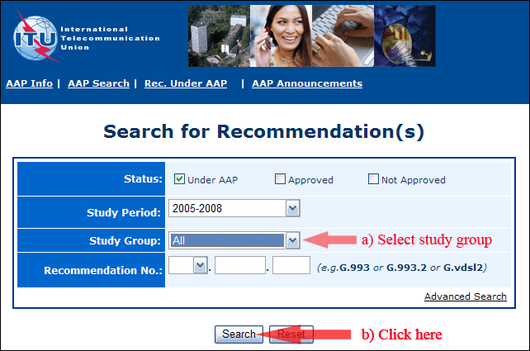
2) Select your Recommendation
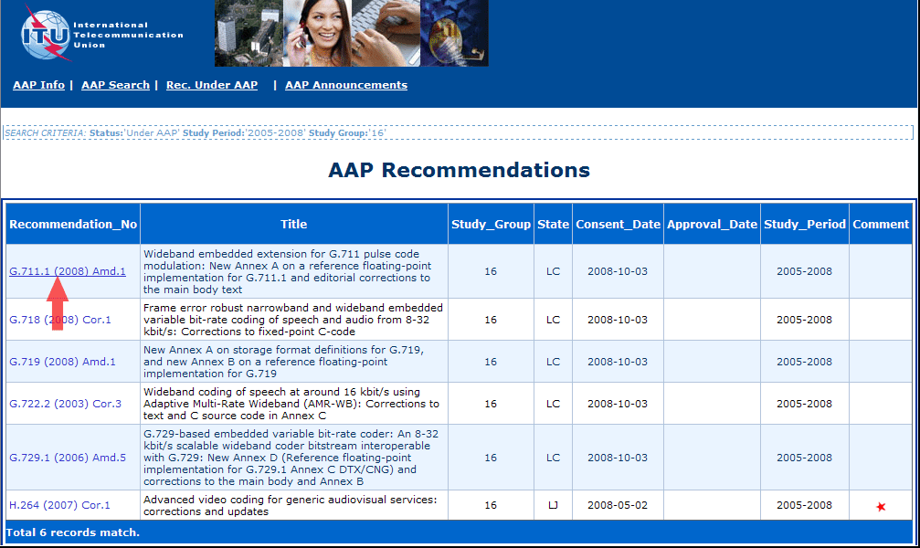
3) Click the "Submit Comment" button
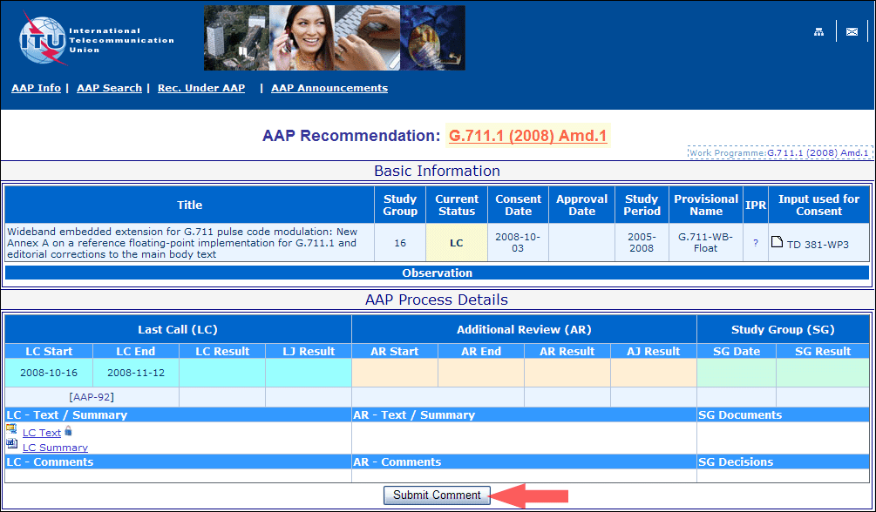
4) Complete the on-line form and click on "Submit"
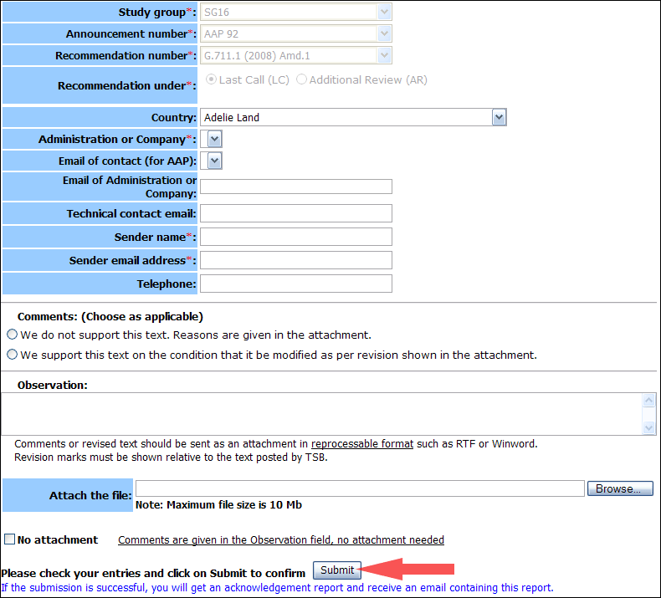
For more information, read the AAP tutorial on:
http://www.itu.int/ITU-T/aapinfo/files/AAPTutorial.pdf
Annex 3
(to TSB AAP-25)
Recommendations under LC/AR – Comment submission form
(Separate form for each Recommendation being commented upon)
ITU-T AAP comment submission form for the period 2009-2012
Study Group:
Announcement number:
Recommendation number:
Recommendation under: | Last call (LC)  Additional Review (AR)
Country:
Administration/Company:
Name of AAP Contact Person:
Email of AAP Contact Person:
Sender name:
(if different from AAP Contact Person)
Sender email address:
Telephone:
Comments:  (Choose as applicable) | We do not support this text. Reasons are given in the attachment.  We support this text on the condition that it be modified as per revision shown in the attachment.
Observations:
No attachment: Comments are given in the Observation field, no attachment needed
To be returned to: email: tsbsg....@itu.int
[or fax +41 22 730 5853]
Comments or revised text should be sent as an attachment in RTF or WinWord format.
Revision marks must be shown relative to the text posted by TSB.

