Union Internationale des Telecommunications  Bureau de la normalisation des télécommunications | 

Genève, le 16 novembre 2009

Réf:  Tél:  Fax:  E-mail: | TSB AAP-25  AAP/MJ  +41 22 730 5860  +41 22 730 5853  tsbdir@itu.int | – Aux administrations des Etats Membres de l'Union;  – Aux Membres du Secteur UIT-T;  – Aux Associés de l'UIT-T  Copie:  – Aux Présidents et Vice-Présidents des Commissions d'études de l'UIT-T;  – Au Directeur du Bureau de développement des télécommunications;  – Au Directeur du Bureau des radiocommunications

Objet: | Etat des Recommandations auxquelles s'applique la variante de la procédure d'approbation (AAP)

Madame, Monsieur,

La variante de la procédure d'approbation (AAP), définie dans la Recommandation UIT-T A.8, s'applique aux Recommandations qui n'ont pas d'incidence politique ou réglementaire et ne nécessitent donc pas une consultation formelle des Etats Membres (voir le numéro 246B de la Convention de l'UIT).
L'Annexe 1 énumère les textes dont le statut a changé par rapport aux annonces TSB AAP antérieures.
Si vous souhaitez soumettre des observations sur une Recommandation ayant fait l'objet de la procédure AAP, vous êtes encouragés à utiliser le formulaire en ligne de soumission des observations AAP, disponible dans l'espace AAP du site web de l'UIT-T à l'adresse http://www.itu.int/ITU-T/aap/, à la page de la Recommandation concernée (voir l'Annexe 2). Vous pouvez aussi soumettre vos observations en remplissant le formulaire figurant à l'Annexe 3 et en l'envoyant au secrétariat de la Commission d'études concernée.
Veuillez noter que les observations ayant simplement pour objet d'appuyer l'adoption du texte en question ne sont pas encouragées.
Veuillez agréer, Madame, Monsieur, l'assurance de ma considération distinguée.
Malcolm Johnson
Directeur du Bureau de la normalisation des télécommunications

Annexes: 3
Annex 1
(to TSB AAP-25)

Status codes used in the AAP announcements:
LC = Last Call
LJ = Last Call Judgment (includes comment resolution)
AR = Additional Review
AJ = Additional Review Judgment (includes comment resolution)
SG = For Study Group approval
A = Approved
AT = Approved with typographic corrections
AC = Approved after Additional Review of Comments
NA = Not approved
TAP = Moved to TAP (ITU-T A.8 / § 5.2)
ITU-T website entry page:
http://www.itu.int/ITU-T
Alternative approval process (AAP) welcome page:
http://www.itu.int/ITU-T/aapinfo
Note – A tutorial on the ITU-T AAP application is available under the AAP welcome page
ITU-T website AAP Recommendation search page:
http://www.itu.int/ITU-T/aap/
Study Group web pages and contacts:
SG 2 | http://www.itu.int/ITU-T/studygroups/com02 | tsbsg2@itu.int
SG 3 | http://www.itu.int/ITU-T/studygroups/com03 | tsbsg3@itu.int
SG 5 | http://www.itu.int/ITU-T/studygroups/com05 | tsbsg5@itu.int
SG 9 | http://www.itu.int/ITU-T/studygroups/com09 | tsbsg9@itu.int
SG 11 | http://www.itu.int/ITU-T/studygroups/com11 | tsbsg11@itu.int
SG 12 | http://www.itu.int/ITU-T/studygroups/com12 | tsbsg12@itu.int
SG 13 | http://www.itu.int/ITU-T/studygroups/com13 | tsbsg13@itu.int
SG 15 | http://www.itu.int/ITU-T/studygroups/com15 | tsbsg15@itu.int
SG 16 | http://www.itu.int/ITU-T/studygroups/com16 | tsbsg16@itu.int
SG 17 | http://www.itu.int/ITU-T/studygroups/com17 | tsbsg17@itu.int

Situation concerning Study Group 9 Recommendations under AAP
Rec # | Title | Last Call (LC) Period |  |  |  | Additional Review (AR) Period |  |  |  | Status
Rec # | Title | LC Start | LC End | LC  Result | LJ  Result | AR Start | AR End | AR  Result | AJ  Result | Status
J.201 | Harmonization of declarative content formats for interactive television applications | 2009-11-16 | 2009-12-13 |  |  |  |  |  |  | LC
J.700 | IPTV service requirements and framework for secondary distribution | 2009-11-16 | 2009-12-13 |  |  |  |  |  |  | LC
J.704 (J.spi-req, J.sdp-req) | Functional requirements of the service provider interface for television primary and secondary distribution and associated interactive services | 2009-11-16 | 2009-12-13 |  |  |  |  |  |  | LC
Situation concerning Study Group 11 Recommendations under AAP
Rec # | Title | Last Call (LC) Period |  |  |  | Additional Review (AR) Period |  |  |  | Status
Rec # | Title | LC Start | LC End | LC  Result | LJ  Result | AR Start | AR End | AR  Result | AJ  Result | Status
Q.761 (1999) Amd. 4 | Support for the Customized Alerting Tone (CAT) service | 2009-10-01 | 2009-10-28 | LJ | A |  |  |  |  | A
Q.762 (1999) Amd. 5 | Support for the Customized Alerting Tone (CAT) service | 2009-10-01 | 2009-10-28 | LJ | A |  |  |  |  | A
Q.763 (1999) Amd. 6 | Support for the Customized Alerting Tone (CAT) service | 2009-10-01 | 2009-10-28 | LJ | A |  |  |  |  | A
Q.1902.1 (2001) Amd. 3 | Support for Customized Alerting Tone (CAT) service | 2009-10-01 | 2009-10-28 | LJ | A |  |  |  |  | A
Q.1902.2 (2001) Amd. 5 | Support for the Customized Alerting Tone (CAT) service | 2009-10-01 | 2009-10-28 | LJ | A |  |  |  |  | A
Q.1902.3 (2001) Amd. 5 | Support for the Customized Alerting Tone (CAT) service | 2009-10-01 | 2009-10-28 | LJ | A |  |  |  |  | A
Q.3306.1 | Protocol at the Rd interface between intra-domain Policy Decision Physical Entities (PD-PEs) (Rd interface) | 2009-10-01 | 2009-10-28 | LJ | AT |  |  |  |  | AT
Q.3309 (Q.QCP) | QoS Coordination Protocol | 2009-10-01 | 2009-10-28 | LJ | A |  |  |  |  | A
X.603.1 (2007) Amd.1 | Information technology - Relayed multicast protocol: Specification for simplex group applications - Amendment 1: Security extensions | 2009-10-16 | 2009-11-12 | LJ |  |  |  |  |  | LJ
Situation concerning Study Group 12 Recommendations under AAP
Rec # | Title | Last Call (LC) Period |  |  |  | Additional Review (AR) Period |  |  |  | Status
Rec # | Title | LC Start | LC End | LC  Result | LJ  Result | AR Start | AR End | AR  Result | AJ  Result | Status
P.501 | Test signals for use in telephonometry | 2009-11-16 | 2009-12-13 |  |  |  |  |  |  | LC
P.581 | Use of head and torso simulator (HATS) for hands-free and handset terminal testing | 2009-11-16 | 2009-12-13 |  |  |  |  |  |  | LC
P.1110 (P.CarHFTWB) | Wideband hands-free communication in motor vehicles | 2009-11-16 | 2009-12-13 |  |  |  |  |  |  | LC
Y.1563 (2009) Amd.1 (Annex B to Y.1563) | New Annex B - Terminology for consecutive severely errored seconds in ethernet services | 2009-11-16 | 2009-12-13 |  |  |  |  |  |  | LC
Situation concerning Study Group 15 Recommendations under AAP
Rec # | Title | Last Call (LC) Period |  |  |  | Additional Review (AR) Period |  |  |  | Status
Rec # | Title | LC Start | LC End | LC  Result | LJ  Result | AR Start | AR End | AR  Result | AJ  Result | Status
G.652 | Characteristics of a single-mode optical fibre cable | 2009-10-16 | 2009-11-12 | LJ |  |  |  |  |  | LJ
G.655 | Characteristics of a non-zero dispersion shifted single-mode optical fibre and cable | 2009-10-16 | 2009-11-12 | A |  |  |  |  |  | A
G.657 | Characteristics of a bending loss insensitive single mode optical fibre and cable for the access network | 2009-10-16 | 2009-11-12 | A |  |  |  |  |  | A
G.693 | Optical interfaces for intra-office systems | 2009-10-16 | 2009-11-12 | A |  |  |  |  |  | A
G.695 | Optical interfaces for coarse wavelength division multiplexing applications | 2009-10-16 | 2009-11-12 | A |  |  |  |  |  | A
G.697 | Optical monitoring for DWDM systems | 2009-10-16 | 2009-11-12 | A |  |  |  |  |  | A
G.698.1 | Multichannel DWDM applications with single channel optical interfaces | 2009-10-16 | 2009-11-12 | LJ |  |  |  |  |  | LJ
G.698.2 | Amplified multichannel DWDM applications with single channel optical interfaces | 2009-10-16 | 2009-11-12 | A |  |  |  |  |  | A
G.707/Y.1322 (2007) Amd.2 | Network node interface for the synchronous digital hierarchy (SDH) | 2009-10-16 | 2009-11-12 | A |  |  |  |  |  | A
G.709/Y.1331 | Interfaces for the Optical Transport Network (OTN) | 2009-10-16 | 2009-11-12 | LJ |  |  |  |  |  | LJ
G.781 (2008) Cor.1 | Synchronization Layer Functions | 2009-10-16 | 2009-11-12 | A |  |  |  |  |  | A
G.783 (2006) Amd.2 | Characteristics of Synchronous Digital Hierarchy (SDH) Equipment Functional Blocks | 2009-10-16 | 2009-11-12 | LJ |  |  |  |  |  | LJ
G.808.1 | Generic Protection Switching - Linear Trail and Subnetwork Protection | 2009-10-16 | 2009-11-12 | LJ |  |  |  |  |  | LJ
G.870/Y.1352 (2008) Amd.1 | Terms and definitions for Optical Transport Networks (OTN) | 2009-10-16 | 2009-11-12 | LJ |  |  |  |  |  | LJ
G.959.1 | Optical transport networks physical layer interfaces | 2009-10-16 | 2009-11-12 | A |  |  |  |  |  | A
G.973.1 (G.lcasub) | Longitudinal compatible DWDM applications for repeaterless optical fibre submarine cable systems | 2009-10-16 | 2009-11-12 | LJ |  |  |  |  |  | LJ
G.984.3 (2008) Amd.2 | Gigabit-capable Passive Optical Networks (GPON): Transmission convergence layer specification - Amendment 2 | 2009-10-16 | 2009-11-12 | A |  |  |  |  |  | A
G.984.4 (2008) Amd.2 | Gigabit-capable passive optical network (GPON): ONT management and control interface specification - Amendment 2 | 2009-10-16 | 2009-11-12 | A |  |  |  |  |  | A
G.984.6 (2008) Amd. 1 | Gigabit-capable Passive Optical Networks (GPON): Reach extender (RE) units - Amendment 1 | 2009-10-16 | 2009-11-12 | A |  |  |  |  |  | A
G.986 (G.gbe) | 1 Gbit/s point-to-point Ethernet based optical access system | 2009-10-16 | 2009-11-12 | LJ |  |  |  |  |  | LJ
G.987 (G.xgpon.def) | 10-Gigabit-capable passive optical network (XG-PON) systems: Definitions, Abbreviations, and Acronyms | 2009-10-16 | 2009-11-12 | LJ |  |  |  |  |  | LJ
G.987.1 (G.xgpon.1) | 10-Gigabit-capable Passive Optical Networks (XG-PON): General Requirements | 2009-10-16 | 2009-11-12 | LJ |  |  |  |  |  | LJ
G.987.2 | 10-Gigabit-capable passive optical networks (XG-PON): Physical Media Dependent (PMD) layer specification | 2009-10-16 | 2009-11-12 | LJ |  |  |  |  |  | LJ
G.992.3 (2009) Cor.1 | Asymmetric digital subscriber line transceivers 2 (ADSL2) - Corrigendum 1 | 2009-10-16 | 2009-11-12 | A |  |  |  |  |  | A
G.993.2 (2006) Amd. 5 | Very high speed Digital subscriber Line Transceivers 2 - Amendment 5 | 2009-10-16 | 2009-11-12 | LJ |  |  |  |  |  | LJ
G.993.5 (G.vector) | Self-FEXT Cancellation (Vectoring) for use with VDSL2 transceivers | 2009-10-16 | 2009-11-12 | LJ |  |  |  |  |  | LJ
G.994.1 (2007) Amd.5 | Handshake procedures for digital subscriber line (DSL) transceivers - Amendment 5 | 2009-10-16 | 2009-11-12 | LJ |  |  |  |  |  | LJ
G.997.1 (2009) Amd.1 | Physical layer management for digital subscriber line (DSL) transceivers - Amendment 1 | 2009-10-16 | 2009-11-12 | LJ |  |  |  |  |  | LJ
G.997.1 (2009) Cor.1 | Physical layer management for digital subscriber line (DSL) transceivers - Corrigendum 1 | 2009-10-16 | 2009-11-12 | LJ |  |  |  |  |  | LJ
G.998.4 (G.inp) | Improved Impulse Noise Protection (INP) for DSL Transceivers | 2009-10-16 | 2009-11-12 | LJ |  |  |  |  |  | LJ
G.7710/Y.1701 (2007) Cor.1 | Common equipment management function requirements | 2009-10-16 | 2009-11-12 | A |  |  |  |  |  | A
G.7713/Y.1704 | Distributed Call and Connection Management (DCM) | 2009-10-16 | 2009-11-12 | A |  |  |  |  |  | A
G.7716/Y.1707 (G.lcs) | Architecture of Control Plane Operations | 2009-10-16 | 2009-11-12 | LJ |  |  |  |  |  | LJ
G.8011.3/Y.1307.3 | Ethernet Virtual Private LAN Service | 2009-10-16 | 2009-11-12 | LJ |  |  |  |  |  | LJ
G.8011.4/Y.1307.4 | Ethernet Virtual Private Routed Multipoint Service | 2009-10-16 | 2009-11-12 | LJ |  |  |  |  |  | LJ
G.8011.5/Y.1307.5 | Ethernet Private LAN service | 2009-10-16 | 2009-11-12 | LJ |  |  |  |  |  | LJ
G.8021/Y.1341 (2007) Amd.2 | Characteristics of Ethernet Transport Network Equipment Functional Blocks | 2009-10-16 | 2009-11-12 | LJ |  |  |  |  |  | LJ
G.8031/Y.1342 | Ethernet linear protection switching | 2009-10-16 | 2009-11-12 | A |  |  |  |  |  | A
G.8032/Y.1344 | Ethernet Ring Protection Switching | 2009-11-16 | 2009-12-13 |  |  |  |  |  |  | LC
G.8051/Y.1345 (G.eot-mgmt) | Management aspects of the Ethernet-over-Transport (EoT) capable network element | 2009-10-16 | 2009-11-12 | A |  |  |  |  |  | A
G.8251 (2001) Amd.2 | The control of jitter and wander within the optical transport network (OTN) | 2009-10-16 | 2009-11-12 | LJ |  |  |  |  |  | LJ
G.8262/Y.1362 (2007) Amd.2 | Timing characteristics of a synchronous Ethernet equipment slave clock (EEC) | 2009-10-16 | 2009-11-12 | LJ |  |  |  |  |  | LJ
G.8264/Y.1364 (2008) Cor.1 | Timing distribution through packet networks | 2009-10-16 | 2009-11-12 | A |  |  |  |  |  | A
G.9972 (G.cx) | Coexistence mechanism for wireline home networking transceivers | 2009-10-16 | 2009-11-12 | LJ |  |  |  |  |  | LJ
L.81 (L.wsn) | Monitoring systems for outside plant facilities | 2009-10-16 | 2009-11-12 | A |  |  |  |  |  | A
O.174 (O.SyncEjitter) | Jitter and wander measuring equipment for a synchronous packet network | 2009-10-16 | 2009-11-12 | A |  |  |  |  |  | A
Situation concerning Study Group 16 Recommendations under AAP
Rec # | Title | Last Call (LC) Period |  |  |  | Additional Review (AR) Period |  |  |  | Status
Rec # | Title | LC Start | LC End | LC  Result | LJ  Result | AR Start | AR End | AR  Result | AJ  Result | Status
F.743 (F.VSreqs) | Requirements and services description for visual surveillance | 2009-11-16 | 2009-12-13 |  |  |  |  |  |  | LC
F.744 (F.USN-MW) | Service description and requirements for ubiquitous sensor network middleware | 2009-11-16 | 2009-12-13 |  |  |  |  |  |  | LC
G.799.2 (G.MDCSPNE) | Mechanism for dynamic coordination of signal processing functions | 2009-11-16 | 2009-12-13 |  |  |  |  |  |  | LC
H.222.0 (2006) Amd.3 Cor.1 | Information technology - Generic coding of moving pictures and associated audio information: Systems: Transport of scalable video over ITU-T Rec. H.222.0 | ISO/IEC 13818-1: Corrections | 2009-11-16 | 2009-12-13 |  |  |  |  |  |  | LC
H.222.0 (2006) Amd.4 (H.222.0-MVC) | Information technology - Generic coding of moving pictures and associated audio information: Systems: Transport of multiview video over ITU-T Rec. H.222.0 | ISO/IEC 13818-1 | 2009-11-16 | 2009-12-13 |  |  |  |  |  |  | LC
H.222.0 (2006) Cor.3 | Information technology - Generic coding of moving pictures and associated audio information: Systems: Corrections concerning VBV buffer size, semantics of splice_type and removal rate from transport buffer for H.264 | ISO/IEC 14496-10 advanced video coding | 2009-11-16 | 2009-12-13 |  |  |  |  |  |  | LC
H.225.0 (V7) | Call signalling protocols and media stream packetization for packet-based multimedia communication systems | 2009-11-16 | 2009-12-13 |  |  |  |  |  |  | LC
H.241 (2006) Amd.2 (H.241 Appendix II) | Extended video procedures and control signals for H.300-series terminals: New Clause 8.3.2.14, H.264 MaxFPS frame rate parameter and revisions to Appendix II (Examples of the set submode procedure) | 2009-11-16 | 2009-12-13 |  |  |  |  |  |  | LC
H.245 (V15) | Control protocol for multimedia communication | 2009-11-16 | 2009-12-13 |  |  |  |  |  |  | LC
H.248.1 v3 Amd.2 | Gateway Control Protocol: Version 3: New Appendix IV, plus corrections and clarifications | 2009-11-16 | 2009-12-13 |  |  |  |  |  |  | LC
H.248.4 (V2) | Gateway control protocol: Transport over Stream Control Transmission Protocol (SCTP) | 2009-11-16 | 2009-12-13 |  |  |  |  |  |  | LC
H.248.5 (V2) | Gateway control protocol: Gateway control protocol: Transport over ATM | 2009-11-16 | 2009-12-13 |  |  |  |  |  |  | LC
H.248.64 (H.248.IPR) | Gateway control protocol: IP router packages | 2009-11-16 | 2009-12-13 |  |  |  |  |  |  | LC
H.248.67 (H.248.TrM) | Gateway Control Protocol: GCP Transport Mode Indication Package | 2009-11-16 | 2009-12-13 |  |  |  |  |  |  | LC
H.248.72 (H.248.MONA) | Gateway Control Protocol: H.248 support for MONA | 2009-11-16 | 2009-12-13 |  |  |  |  |  |  | LC
H.248.9 (V3) | Gateway control protocol: Advanced media server packages | 2009-11-16 | 2009-12-13 |  |  |  |  |  |  | LC
H.323 v7 | Packet-based multimedia communications systems | 2009-11-16 | 2009-12-13 |  |  |  |  |  |  | LC
H.460.23 (H.460.natdet) | Network address translator and firewall device determination in H.323 systems | 2009-11-16 | 2009-12-13 |  |  |  |  |  |  | LC
H.460.24 (H.460.p2pnat) | Point to point media through network address translators and firewalls within H.323 systems | 2009-11-16 | 2009-12-13 |  |  |  |  |  |  | LC
H.740 (H.IPTV-AEH) | Application event handling for IPTV services | 2009-11-16 | 2009-12-13 |  |  |  |  |  |  | LC
H.762 (H.IPTV-MAFR.2) | Lightweight interactive multimedia framework (LIME) for IPTV services | 2009-11-16 | 2009-12-13 |  |  |  |  |  |  | LC
I.733 (2009) Cor.1 | Voice on ATM circuit multiplication equipment: Corrections to clause 9.2.3 | 2009-11-16 | 2009-12-13 |  |  |  |  |  |  | LC
T.800 (2002) Amd.4 | Information technology - JPEG 2000 image coding system: Core coding system: Profiles for broadcast applications | 2009-11-16 | 2009-12-13 |  |  |  |  |  |  | LC
T.802 (2005) Amd.1 | Information technology - JPEG 2000 image coding system: Motion JPEG 2000: Additional profiles for archiving applications | 2009-11-16 | 2009-12-13 |  |  |  |  |  |  | LC
T.808 (2005) Amd.4 | Information technology - JPEG 2000 image coding system: Interactivity tools, APIs and protocols: JPIP server and client profiles | 2009-11-16 | 2009-12-13 |  |  |  |  |  |  | LC
T.832 (2009) Cor.1 | Information technology - JPEG XR image coding system - Part 2: Image coding specification: Corrections and clarifications | 2009-11-16 | 2009-12-13 |  |  |  |  |  |  | LC
V.153 (V.IP2IP-VxF) | Interworking between T.38 and V.152 using IP peering for realtime facsimile services | 2009-11-16 | 2009-12-13 |  |  |  |  |  |  | LC

Annex 2
(to TSB AAP-25)
Using the on-line comment submission form
Comment submission
1) Go to AAP search Web page at http://www.itu.int/ITU-T/aap/
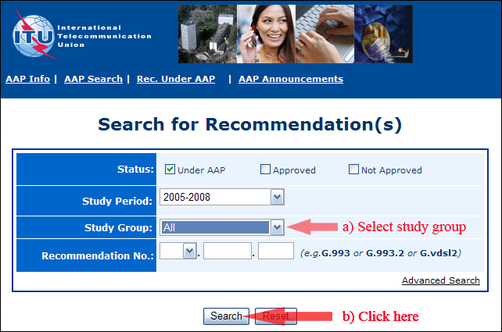
2) Select your Recommendation
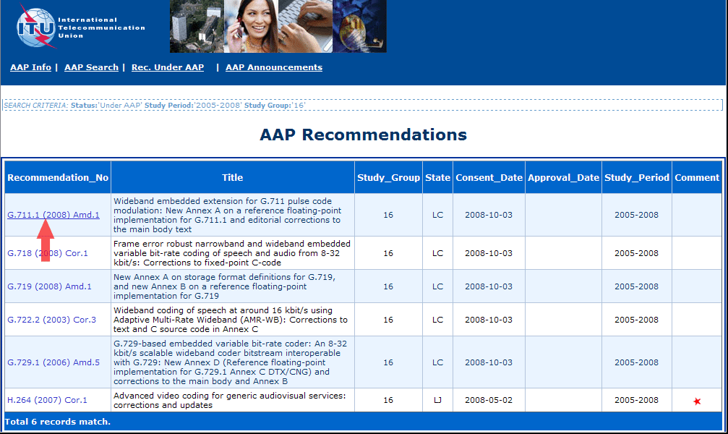
3) Click the "Submit Comment" button
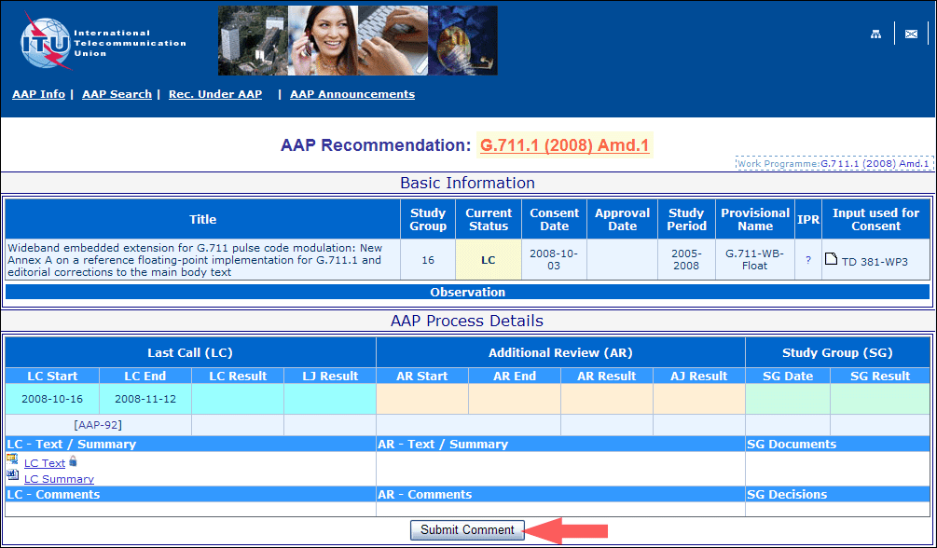
4) Complete the on-line form and click on "Submit"
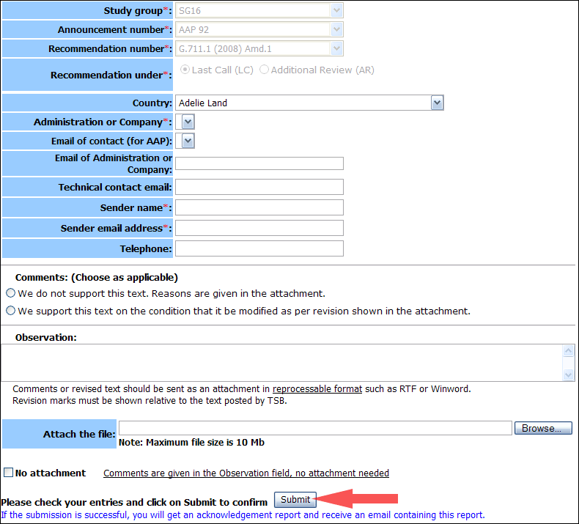
For more information, read the AAP tutorial on:
http://www.itu.int/ITU-T/aapinfo/files/AAPTutorial.pdf
Annex 3
(to TSB AAP-25)
Recommendations under LC/AR – Comment submission form
(Separate form for each Recommendation being commented upon)
ITU-T AAP comment submission form for the period 2009-2012
Study Group:
Announcement number:
Recommendation number:
Recommendation under: | Last call (LC)  Additional Review (AR)
Country:
Administration/Company:
Name of AAP Contact Person:
Email of AAP Contact Person:
Sender name:
(if different from AAP Contact Person)
Sender email address:
Telephone:
Comments:  (Choose as applicable) | We do not support this text. Reasons are given in the attachment.  We support this text on the condition that it be modified as per revision shown in the attachment.
Observations:
No attachment: Comments are given in the Observation field, no attachment needed
To be returned to: email: tsbsg....@itu.int
[or fax +41 22 730 5853]
Comments or revised text should be sent as an attachment in RTF or WinWord format.
Revision marks must be shown relative to the text posted by TSB.

