Международный союз электросвязи
Бюро стандартизации электросвязи

Женева, 16 октября 2009

Осн.:  Тел.:  Факс:  Эл. почта: | TSB AAP-23  AAP/MJ  +41 22 730 5860  +41 22 730 5853  tsbdir@itu.int | – Администрациям Государств – Членов Союза;  – Членам Сектора МСЭ-Т;  – Ассоциированным членам МСЭ-Т  Копии:  – Председателям и заместителям председателей Исследовательских комиссий МСЭ-Т;  – Директору Бюро Развития Электросвязи;  – Директору Бюро Радиосвязи

Предмет: | Положение относительно Рекомендаций, рассматриваемых в соответствии с альтернативным процессом утверждения (АПУ)

Уважаемая госпожа,
уважаемый господин,

Альтернативный процесс утверждения (АПУ), определенный в Рекомендации МСЭ-Т А.8, распространяется на Рекомендации, которые не имеют политических или регламентарных последствий и которые поэтому не требуют официальных консультаций с Государствами-Членами (см. п. 246B Конвенции МСЭ).
В Приложении 1 содержится перечень текстов, статус которых изменился по сравнению с предыдущими объявлениями об АПУ БСЭ.
Если вы желаете представить замечания относительно какой-либо Рекомендации, рассматриваемой в соответствии с АПУ, рекомендуем Вам использовать онлайновую форму для представления замечаний по АПУ, которая размещена на странице этой Рекомендации в разделе веб-сайта МСЭ-Т, посвященном АПУ, по адресу: http://www.itu.int/ITU-T/aap/ (см. Приложение 2). Замечания можно представить иным способом, заполнив приведенную в Приложении 3 форму и направив ее в секретариат заинтересованной исследовательской комиссии.
Просим принять к сведению, что не рекомендуется представлять замечания, являющиеся не чем иным, как поддержкой рассматриваемого текста.
С уважением,
Малколм Джонсон
Директор Бюро
стандартизации электросвязи
Приложения: 3
Annex 1
(to TSB AAP-23)

Status codes used in the AAP announcements:
LC = Last Call
LJ = Last Call Judgment (includes comment resolution)
AR = Additional Review
AJ = Additional Review Judgment (includes comment resolution)
SG = For Study Group approval
A = Approved
AT = Approved with typographic corrections
AC = Approved after Additional Review of Comments
NA = Not approved
TAP = Moved to TAP (ITU-T A.8 / § 5.2)
ITU-T website entry page:
http://www.itu.int/ITU-T
Alternative approval process (AAP) welcome page:
http://www.itu.int/ITU-T/aapinfo
Note – A tutorial on the ITU-T AAP application is available under the AAP welcome page
ITU-T website AAP Recommendation search page:
http://www.itu.int/ITU-T/aap/
Study Group web pages and contacts:
SG 2 | http://www.itu.int/ITU-T/studygroups/com02 | tsbsg2@itu.int
SG 3 | http://www.itu.int/ITU-T/studygroups/com03 | tsbsg3@itu.int
SG 5 | http://www.itu.int/ITU-T/studygroups/com05 | tsbsg5@itu.int
SG 9 | http://www.itu.int/ITU-T/studygroups/com09 | tsbsg9@itu.int
SG 11 | http://www.itu.int/ITU-T/studygroups/com11 | tsbsg11@itu.int
SG 12 | http://www.itu.int/ITU-T/studygroups/com12 | tsbsg12@itu.int
SG 13 | http://www.itu.int/ITU-T/studygroups/com13 | tsbsg13@itu.int
SG 15 | http://www.itu.int/ITU-T/studygroups/com15 | tsbsg15@itu.int
SG 16 | http://www.itu.int/ITU-T/studygroups/com16 | tsbsg16@itu.int
SG 17 | http://www.itu.int/ITU-T/studygroups/com17 | tsbsg17@itu.int

Situation concerning Study Group 11 Recommendations under AAP
Rec # | Title | Last Call (LC) Period |  |  |  | Additional Review (AR) Period |  |  |  | Status
Rec # | Title | LC Start | LC End | LC  Result | LJ  Result | AR Start | AR End | AR  Result | AJ  Result | Status
X.603.1 (2007) Amd.1 | Information technology - Relayed multicast protocol: Specification for simplex group applications - Amendment 1: Security extensions | 2009-10-16 | 2009-11-12 |  |  |  |  |  |  | LC
Situation concerning Study Group 15 Recommendations under AAP
Rec # | Title | Last Call (LC) Period |  |  |  | Additional Review (AR) Period |  |  |  | Status
Rec # | Title | LC Start | LC End | LC  Result | LJ  Result | AR Start | AR End | AR  Result | AJ  Result | Status
G.652 | Characteristics of a single-mode optical fibre cable | 2009-10-16 | 2009-11-12 |  |  |  |  |  |  | LC
G.655 | Characteristics of a non-zero dispersion shifted single-mode optical fibre and cable | 2009-10-16 | 2009-11-12 |  |  |  |  |  |  | LC
G.657 | Characteristics of a bending loss insensitive single mode optical fibre and cable for the access network | 2009-10-16 | 2009-11-12 |  |  |  |  |  |  | LC
G.693 | Optical interfaces for intra-office systems | 2009-10-16 | 2009-11-12 |  |  |  |  |  |  | LC
G.695 | Optical interfaces for coarse wavelength division multiplexing applications | 2009-10-16 | 2009-11-12 |  |  |  |  |  |  | LC
G.697 | Optical monitoring for DWDM systems | 2009-10-16 | 2009-11-12 |  |  |  |  |  |  | LC
G.698.1 | Multichannel DWDM applications with single channel optical interfaces | 2009-10-16 | 2009-11-12 |  |  |  |  |  |  | LC
G.698.2 | Amplified multichannel DWDM applications with single channel optical interfaces | 2009-10-16 | 2009-11-12 |  |  |  |  |  |  | LC
G.707/Y.1322 (2007) Amd.2 | Network node interface for the synchronous digital hierarchy (SDH) | 2009-10-16 | 2009-11-12 |  |  |  |  |  |  | LC
G.709/Y.1331 | Interfaces for the Optical Transport Network (OTN) | 2009-10-16 | 2009-11-12 |  |  |  |  |  |  | LC
G.781 (2008) Cor.1 | Synchronization Layer Functions | 2009-10-16 | 2009-11-12 |  |  |  |  |  |  | LC
G.783 (2006) Amd.2 | Characteristics of Synchronous Digital Hierarchy (SDH) Equipment Functional Blocks | 2009-10-16 | 2009-11-12 |  |  |  |  |  |  | LC
G.808.1 | Generic Protection Switching - Linear Trail and Subnetwork Protection | 2009-10-16 | 2009-11-12 |  |  |  |  |  |  | LC
G.870/Y.1352 (2008) Amd.1 | Terms and definitions for Optical Transport Networks (OTN) | 2009-10-16 | 2009-11-12 |  |  |  |  |  |  | LC
G.959.1 | Optical transport networks physical layer interfaces | 2009-10-16 | 2009-11-12 |  |  |  |  |  |  | LC
G.973.1 (G.lcasub) | Longitudinal compatible DWDM applications for repeaterless optical fibre submarine cable systems | 2009-10-16 | 2009-11-12 |  |  |  |  |  |  | LC
G.984.3 (2008) Amd.2 | Gigabit-capable Passive Optical Networks (GPON): Transmission convergence layer specification - Amendment 2 | 2009-10-16 | 2009-11-12 |  |  |  |  |  |  | LC
G.984.4 (2008) Amd.2 | Gigabit-capable passive optical network (GPON): ONT management and control interface specification - Amendment 2 | 2009-10-16 | 2009-11-12 |  |  |  |  |  |  | LC
G.984.6 (2008)  Amd. 1 | Gigabit-capable Passive Optical Networks (GPON): Reach extender (RE) units - Amendment 1 | 2009-10-16 | 2009-11-12 |  |  |  |  |  |  | LC
G.986 (G.gbe) | 1 Gbit/s point-to-point Ethernet based optical access system | 2009-10-16 | 2009-11-12 |  |  |  |  |  |  | LC
G.987 (G.xgpon.def) | 10-Gigabit-capable passive optical network (XG-PON) systems: Definitions, Abbreviations, and Acronyms | 2009-10-16 | 2009-11-12 |  |  |  |  |  |  | LC
G.987.1 (G.xgpon.1) | 10Gigabit-capable Passive Optical Networks (XG-PON): General Requirements | 2009-10-16 | 2009-11-12 |  |  |  |  |  |  | LC
G.987.2 | 10-Gigabit-capable passive optical networks (XG-PON): Physical Media Dependent (PMD) layer specification | 2009-10-16 | 2009-11-12 |  |  |  |  |  |  | LC
G.992.3 (2009) Cor.1 | Asymmetric digital subscriber line transceivers 2 (ADSL2) - Corrigendum 1 | 2009-10-16 | 2009-11-12 |  |  |  |  |  |  | LC
G.993.2 (2006)  Amd. 5 | Very high speed Digital subscriber Line Transceivers 2 - Amendment 5 | 2009-10-16 | 2009-11-12 |  |  |  |  |  |  | LC
G.993.5 (G.vector) | Self-FEXT Cancellation (Vectoring) for use with VDSL2 transceivers | 2009-10-16 | 2009-11-12 |  |  |  |  |  |  | LC
G.994.1 (2007) Amd.5 | Handshake procedures for digital subscriber line (DSL) transceivers - Amendment 5 | 2009-10-16 | 2009-11-12 |  |  |  |  |  |  | LC
G.996.2 (2009) Amd.1 (G.lt Amd.1) | Line Testing for Digital Subscriber Lines (DSL) | 2009-06-01 | 2009-06-28 | LJ | SG |  |  |  |  | AC
G.997.1 (2009) Amd.1 | Physical layer management for digital subscriber line (DSL) transceivers - Amendment 1 | 2009-10-16 | 2009-11-12 |  |  |  |  |  |  | LC
G.997.1 (2009) Cor.1 | Physical layer management for digital subscriber line (DSL) transceivers - Corrigendum 1 | 2009-10-16 | 2009-11-12 |  |  |  |  |  |  | LC
G.998.4 (G.inp) | Improved Impulse Noise Protection (INP) for DSL Transceivers | 2009-10-16 | 2009-11-12 |  |  |  |  |  |  | LC
G.999.1 | LINK layer to PHY layer interface | 2009-01-16 | 2009-02-12 | LJ | AR | 2009-06-01 | 2009-06-21 | AJ | SG | AC
G.7710/Y.1701 (2007) Cor.1 | Common equipment management function requirements | 2009-10-16 | 2009-11-12 |  |  |  |  |  |  | LC
G.7713/Y.1704 | Distributed Call and Connection Management (DCM) | 2009-10-16 | 2009-11-12 |  |  |  |  |  |  | LC
G.7716/Y.1707 (G.lcs) | Architecture of Control Plane Operations | 2009-10-16 | 2009-11-12 |  |  |  |  |  |  | LC
G.8011.3/Y.1307.3 | Ethernet Virtual Private LAN Service | 2009-10-16 | 2009-11-12 |  |  |  |  |  |  | LC
G.8011.4/Y.1307.4 | Ethernet Virtual Private Rooted Multipoint Service | 2009-10-16 | 2009-11-12 |  |  |  |  |  |  | LC
G.8011.5/Y.1307.5 | Ethernet Private LAN service | 2009-10-16 | 2009-11-12 |  |  |  |  |  |  | LC
G.8021/Y.1341 (2007) Amd.2 | Characteristics of Ethernet Transport Network Equipment Functional Blocks | 2009-10-16 | 2009-11-12 |  |  |  |  |  |  | LC
G.8031/Y.1342 | Ethernet linear protection switching | 2009-10-16 | 2009-11-12 |  |  |  |  |  |  | LC
G.8051/Y.1345  (G.eot-mgmt) | Management aspects of the Ethernet-over-Transport (EoT) capable network element | 2009-10-16 | 2009-11-12 |  |  |  |  |  |  | LC
G.8251 (2001) Amd.2 | The control of jitter and wander within the optical transport network (OTN) | 2009-10-16 | 2009-11-12 |  |  |  |  |  |  | LC
G.8262/Y.1362 (2007) Amd.2 | Timing characteristics of a synchronous Ethernet equipment slave clock (EEC) | 2009-10-16 | 2009-11-12 |  |  |  |  |  |  | LC
G.8264/Y.1364 (2008) Cor.1 | Timing distribution through packet networks | 2009-10-16 | 2009-11-12 |  |  |  |  |  |  | LC
G.9960 (G.hn) | Next generation home networking transceivers | 2009-01-16 | 2009-02-12 | LJ | SG |  |  |  |  | AC
G.9972 (G.cx) | Coexistence mechanism for wireline home networking transceivers | 2009-10-16 | 2009-11-12 |  |  |  |  |  |  | LC
L.81 (L.wsn) | Monitoring systems for outside plant facilities | 2009-10-16 | 2009-11-12 |  |  |  |  |  |  | LC
O.174 (O.SyncEjitter) | Jitter and wander measuring equipment for a synchronous packet network | 2009-10-16 | 2009-11-12 |  |  |  |  |  |  | LC

Annex 2
(to TSB AAP-23)
Using the on-line comment submission form
Comment submission
1) Go to AAP search Web page at http://www.itu.int/ITU-T/aap/
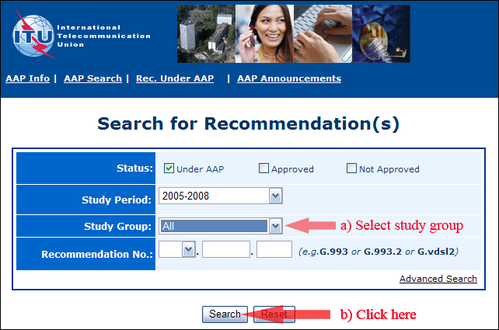
2) Select your Recommendation
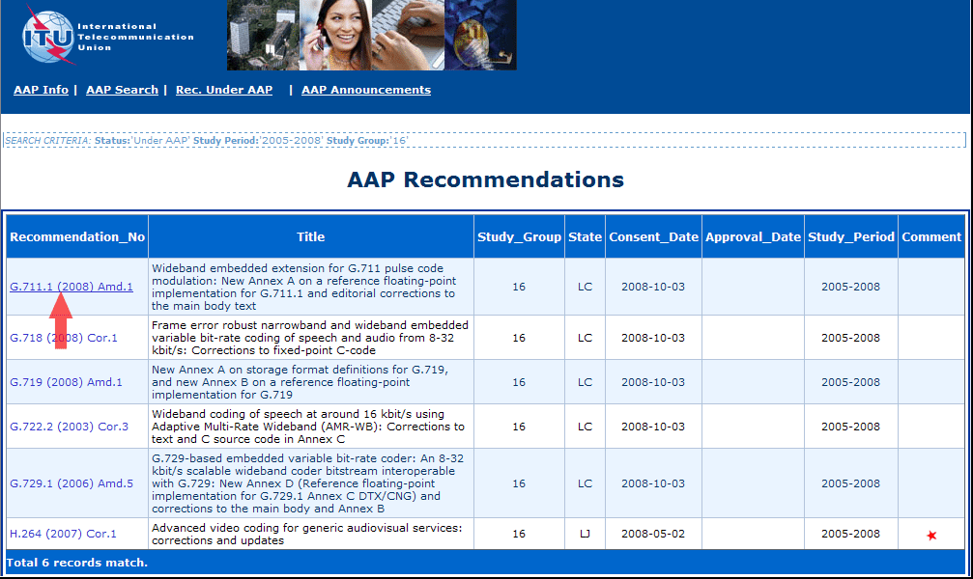
3) Click the "Submit Comment" button
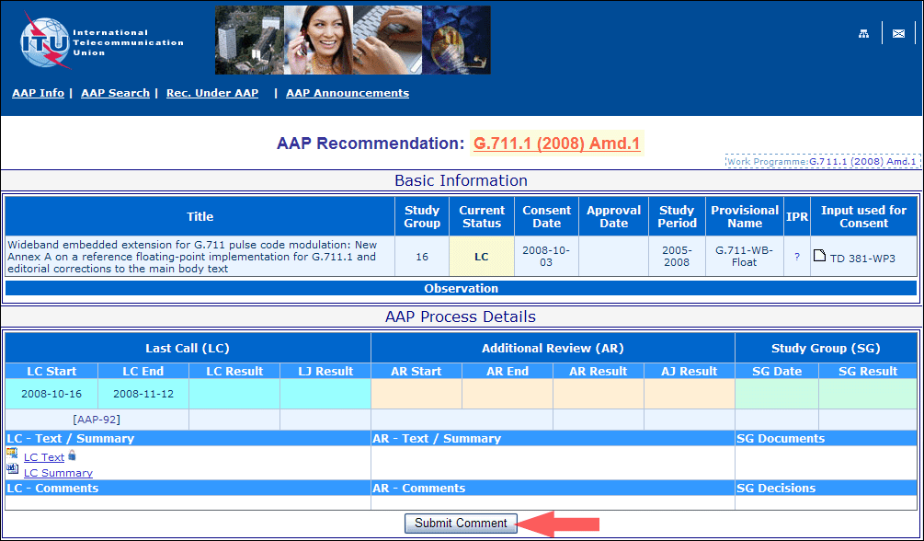
4) Complete the on-line form and click on "Submit"
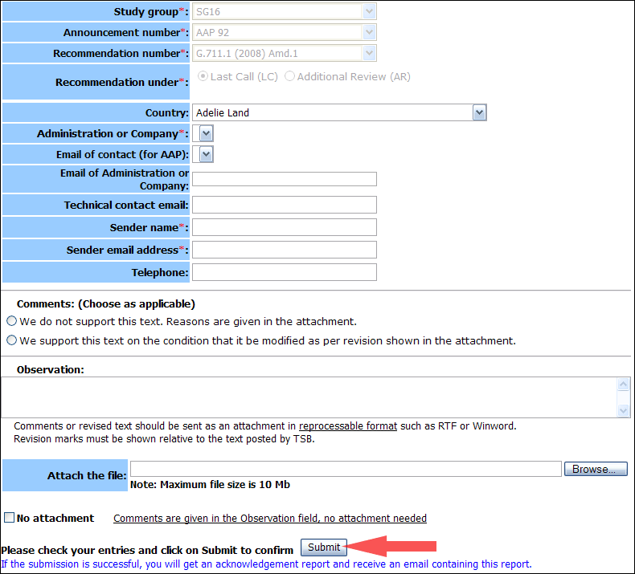
For more information, read the AAP tutorial on:
http://www.itu.int/ITU-T/aapinfo/files/AAPTutorial.pdf
Annex 3
(to TSB AAP-23)
Recommendations under LC/AR – Comment submission form
(Separate form for each Recommendation being commented upon)
ITU-T AAP comment submission form for the period 2009-2012
Study Group:
Announcement number:
Recommendation number:
Recommendation under: | Last call (LC)  Additional Review (AR)
Country:
Administration/Company:
Name of AAP Contact Person:
Email of AAP Contact Person:
Sender name:
(if different from AAP Contact Person)
Sender email address:
Telephone:
Comments:  (Choose as applicable) | We do not support this text. Reasons are given in the attachment.  We support this text on the condition that it be modified as per revision shown in the attachment.
Observations:
No attachment: Comments are given in the Observation field, no attachment needed
To be returned to: email: tsbsg....@itu.int
[or fax +41 22 730 5853]
Comments or revised text should be sent as an attachment in RTF or WinWord format.
Revision marks must be shown relative to the text posted by TSB.

