国 际 电 信 联 盟  电信标准化局 | 
2009年2月16日 ，日内瓦

参考号:  电话:  传真:  电子邮件: | 电信标准化局AAP-7  AAP/MJ  +41 22 730 5860  +41 22 730 5853  tsbdir@itu.int | – 致国际电联成员国各主管部门；  – 致ITU-T各部门成员；  – 致ITU-T 部门准成员  抄送：  – 电信标准化局研究组主席和副主席  – 电信发展局主任  – 无线电通信局主任

事由: | 有关采用替换批准程序（AAP）处理的建议书的情况

先生/女士，
ITU-T A.8 建议书中规定的建议书替换批准程序 (AAP) 适用于那些不会产生政策或 监管影响、因而不需与成员国正式协商的建议书（见国际电联《公约》第246B款）。
附件1列出了那些在以往电信标准化局AAP预告后地位发生变化的案文。
如您希望针对某个适用AAP的建议书提出意见，请使用可在ITU-T网站AAP区域 （http://www.itu.int/ITU-T/aap）的“建议书”网页上获取的《AAP意见在线提交表格》 （见附件2）。或者，可填妥附件3 中的表格并将意见发送给相关研究组的秘书处。
敬请留意，我们不鼓励提交仅支持通过所涉案文而没有实质内容的意见。

顺致敬意！

马尔科姆•琼森
电信标准化局主任

附件：3件
Annex 1
(to TSB AAP-7)

Status codes used in the AAP announcements:
LC = Last Call
LJ = Last Call Judgment (includes comment resolution)
AR = Additional Review
AJ = Additional Review Judgment (includes comment resolution)
SG = For Study Group approval
A = Approved
AT = Approved with typographic corrections
AC = Approved after Additional Review of Comments
NA = Not approved
TAP = Moved to TAP (ITU-T A.8 / § 5.2)
ITU-T website entry page:
http://www.itu.int/ITU-T
Alternative approval process (AAP) welcome page:
http://www.itu.int/ITU-T/aapinfo
Note – A tutorial on the ITU-T AAP application is available under the AAP welcome page
ITU-T website AAP Recommendation search page:
http://www.itu.int/ITU-T/aap/
Study Group web pages and contacts:
SG 2 | http://www.itu.int/ITU-T/studygroups/com02 | tsbsg2@itu.int
SG 3 | http://www.itu.int/ITU-T/studygroups/com03 | tsbsg3@itu.int
SG 5 | http://www.itu.int/ITU-T/studygroups/com05 | tsbsg5@itu.int
SG 9 | http://www.itu.int/ITU-T/studygroups/com09 | tsbsg9@itu.int
SG 11 | http://www.itu.int/ITU-T/studygroups/com11 | tsbsg11@itu.int
SG 12 | http://www.itu.int/ITU-T/studygroups/com12 | tsbsg12@itu.int
SG 13 | http://www.itu.int/ITU-T/studygroups/com13 | tsbsg13@itu.int
SG 15 | http://www.itu.int/ITU-T/studygroups/com15 | tsbsg15@itu.int
SG 16 | http://www.itu.int/ITU-T/studygroups/com16 | tsbsg16@itu.int
SG 17 | http://www.itu.int/ITU-T/studygroups/com17 | tsbsg17@itu.int

Situation concerning Study Group 15 Recommendations under AAP
Rec # | Title | Last Call (LC) Period |  |  |  | Additional Review (AR) Period |  |  |  | Status
Rec # | Title | LC Start | LC End | LC  Result | LJ  Result | AR Start | AR End | AR  Result | AJ  Result | Status
G.709/Y.1331 (2003) Amd.3 | Interfaces for the optical transport network (OTN) | 2009-01-16 | 2009-02-12 | LJ |  |  |  |  |  | LJ
G.800 (2007) Amd.1 | Unified functional architecture of transport networks | 2008-12-16 | 2009-01-12 | LJ | AR | 2009-02-16 | 2009-03-08 |  |  | AR
G.984.3 (2008) Amd.1 | Gigabit-capable Passive Optical Networks (G PON): Transmission convergence layer specification. Amendment 1 | 2009-01-16 | 2009-02-12 | A |  |  |  |  |  | A
G.984.4 (2008) Amd.1 | Gigabit-capable passive optical network (G-PON): ONT management and control interface specification | 2009-01-16 | 2009-02-12 | LJ |  |  |  |  |  | LJ
G.994.1 (2007) Amd.3 | Handshake procedures for Digital Subscriber line (DSL) transceivers | 2009-01-16 | 2009-02-12 | LJ |  |  |  |  |  | LJ
G.996.2 (G.lt) | Line Testing for Digital Subscriber lines (DSL) | 2009-01-16 | 2009-02-12 | LJ |  |  |  |  |  | LJ
G.997.1 | Physical layer management for Digital Subscriber Line (DSL) transceivers | 2009-01-16 | 2009-02-12 | LJ |  |  |  |  |  | LJ
G.999.1 | LINK layer to PHY layer interface | 2009-01-16 | 2009-02-12 | LJ |  |  |  |  |  | LJ
G.8032/Y.1344 (2008) Amd.1 | Ethernet Ring protection | 2009-01-16 | 2009-02-12 | LJ |  |  |  |  |  | LJ
G.9960 (G.hn) | Next generation home networking transceivers | 2009-01-16 | 2009-02-12 | LJ |  |  |  |  |  | LJ
Situation concerning Study Group 16 Recommendations under AAP
Rec # | Title | Last Call (LC) Period |  |  |  | Additional Review (AR) Period |  |  |  | Status
Rec # | Title | LC Start | LC End | LC  Result | LJ  Result | AR Start | AR End | AR  Result | AJ  Result | Status
G.168 (V6) | Digital network echo cancellers | 2009-02-16 | 2009-03-15 |  |  |  |  |  |  | LC
G.711.1 (2008) Amd.2 | Wideband embedded extension for G.711 pulse code modulation: New Annex B on G.711.1 usage in H.245 and editorial corrections to the main body text | 2009-02-16 | 2009-03-15 |  |  |  |  |  |  | LC
G.718 (2008) Amd.1 (G.718-Float) | Frame error robust narrowband and wideband embedded variable bit-rate coding of speech and audio from 8-32 kbit/s: Floating point annex plus corrections to fixed-point C-code and description text | 2009-02-16 | 2009-03-15 |  |  |  |  |  |  | LC
G.719 (2008) Amd.2 | Low-complexity, full-band audio coding for high-quality, conversational applications: New Annex C on G.719 packet format, capability identifiers and capability parameters | 2009-02-16 | 2009-03-15 |  |  |  |  |  |  | LC
G.763 (1998) Cor.1 | Digital circuit multiplication equipment using G.726 ADPCM and digital speech interpolation: Corrections | 2009-02-16 | 2009-03-15 |  |  |  |  |  |  | LC
H.221 (V8) | Frame structure for a 64 to 1920 kbit/s channel in audiovisual teleservices | 2009-02-16 | 2009-03-15 |  |  |  |  |  |  | LC
H.222.0 (2006) Amd.3 (H.222.0-SVC) | Information technology - Generic coding of moving pictures and associated audio information: Systems: Transport of scalable video over ITU-T Rec. H.222.0 | ISO/IEC 13818-1 | 2009-02-16 | 2009-03-15 |  |  |  |  |  |  | LC
H.222.0 (2006) Cor.2 | Information technology - Generic coding of moving pictures and associated audio information: Systems: Correction of transfer rate Rxn in the T-STD model | 2009-02-16 | 2009-03-15 |  |  |  |  |  |  | LC
H.230 (V7) | Frame-synchronous control and indication signals for audiovisual systems | 2009-02-16 | 2009-03-15 |  |  |  |  |  |  | LC
H.235.6 (2005) Cor.1 | H.323 security: Voice encryption profile with native H.235/H.245 key management: Correction of defects | 2009-02-16 | 2009-03-15 |  |  |  |  |  |  | LC
H.242 (V7) | System for establishing communication between audiovisual terminals using digital channels up to 2 Mbit/s | 2009-02-16 | 2009-03-15 |  |  |  |  |  |  | LC
H.248.14 Rev.1 ((Ed. 0.2)) | Gateway control protocol: Inactivity timer package | 2009-02-16 | 2009-03-15 |  |  |  |  |  |  | LC
H.248.19 (2004) Amd.2 | Gateway Control Protocol: Decomposed multipoint control unit, audio, video and data conferencing packages: Floor Control Enhancements | 2009-02-16 | 2009-03-15 |  |  |  |  |  |  | LC
H.248.42 (H.248.42 (2006) Amd.1) | Gateway control protocol: DCME interworking package: Parameters for enhanced event reporting control | 2009-02-16 | 2009-03-15 |  |  |  |  |  |  | LC
H.248.52 Amd.1 | Gateway Control Protocol: QoS Support Packages: Clarifications and updates to the Differentiated Services package | 2009-02-16 | 2009-03-15 |  |  |  |  |  |  | LC
H.248.53 | Gateway Control Protocol: Traffic Management Packages | 2009-02-16 | 2009-03-15 |  |  |  |  |  |  | LC
H.248.56 Cor.1 | Gateway control protocol: Packages for virtual private network support: VLAN package clarifications | 2009-02-16 | 2009-03-15 |  |  |  |  |  |  | LC
H.248.60 (H.248.cci) | Gateway control protocol: Identification of content of communication | 2009-02-16 | 2009-03-15 |  |  |  |  |  |  | LC
H.248.61 (H.248.ipocs) | Gateway Control Protocol: Packages for Network Level H.248 Statistics | 2009-02-16 | 2009-03-15 |  |  |  |  |  |  | LC
H.248.63 (H.248.resman) | Gateway Control Protocol: Resource Management Packages | 2009-02-16 | 2009-03-15 |  |  |  |  |  |  | LC
H.248.65 (H.248.RSVP) | Gateway control protocol: Support of the resource reservation protocol | 2009-02-16 | 2009-03-15 |  |  |  |  |  |  | LC
H.248.68 (H.248.RDT) | Gateway control protocol: Removal of Digits and Tones package | 2009-02-16 | 2009-03-15 |  |  |  |  |  |  | LC
H.248.69 (H.248.MSRP) | Gateway control protocol: Packages for MSRP and H.248 Interworking | 2009-02-16 | 2009-03-15 |  |  |  |  |  |  | LC
H.248.70 (H.248.DMI) | Gateway Control Protocol: Dialling Method Information Packages | 2009-02-16 | 2009-03-15 |  |  |  |  |  |  | LC
H.262 (2000) Amd.3 | Information technology - Generic coding of moving pictures and associated audio information: Video: New level for 1080@50p/60p | 2009-02-16 | 2009-03-15 |  |  |  |  |  |  | LC
H.264 (V4) (H.264-MVC) | Advanced video coding for generic audiovisual services | 2009-02-16 | 2009-03-15 |  |  |  |  |  |  | LC
H.701 (H.IPTV-CDER) | Content Delivery Error Recovery for IPTV services | 2009-02-16 | 2009-03-15 |  |  |  |  |  |  | LC
H.721 (H.IPTV-TDES.2) | IPTV Terminal Device, Basic Model | 2009-02-16 | 2009-03-15 |  |  |  |  |  |  | LC
H.760 (H.IPTV-MAFR.0) | Overview of Multimedia Application Frameworks for IPTV | 2009-02-16 | 2009-03-15 |  |  |  |  |  |  | LC
I.733 (G.vclad) | Voice on ATM Multiplication Equipment | 2009-02-16 | 2009-03-15 |  |  |  |  |  |  | LC
T.800 (2002) Amd.2 | Information technology - JPEG 2000 image coding system: Core coding system: Extended profiles for cinema and video production and archival applications | 2009-02-16 | 2009-03-15 |  |  |  |  |  |  | LC
T.803 (2002) Cor.1 | Information technology -JPEG 2000 image coding system: Conformance testing: Correction to G.4.4 | 2009-02-16 | 2009-03-15 |  |  |  |  |  |  | LC
T.832 (T.JXR-2) | Information technology - JPEG XR image coding system - Part 2: Image coding specification | 2009-02-16 | 2009-03-15 |  |  |  |  |  |  | LC
V.152 (2009) Amd.1 (V.152 Annex/Appendix [X]) | New Annex B on use of data signal detection and silence insertion in voiceband data and new Annex C on use of V.21 preamble for echo canceller control in a V.152 gateway | 2009-02-16 | 2009-03-15 |  |  |  |  |  |  | LC

Annex 2
(to TSB AAP-7)
Using the on-line comment submission form
Comment submission
1) Go to AAP search Web page at http://www.itu.int/ITU-T/aap/
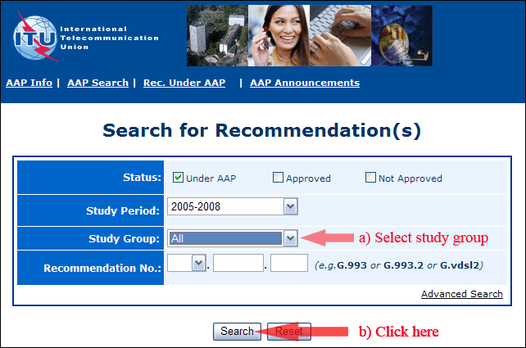
2) Select your Recommendation
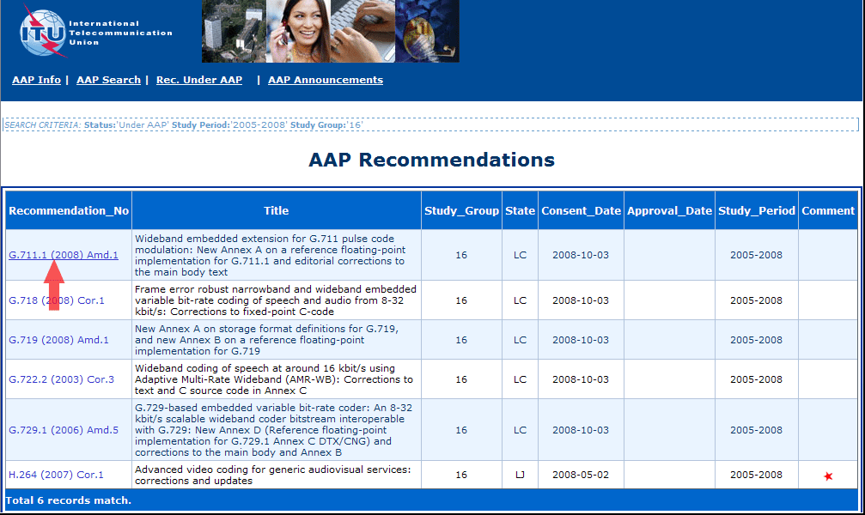
3) Click the "Submit Comment" button
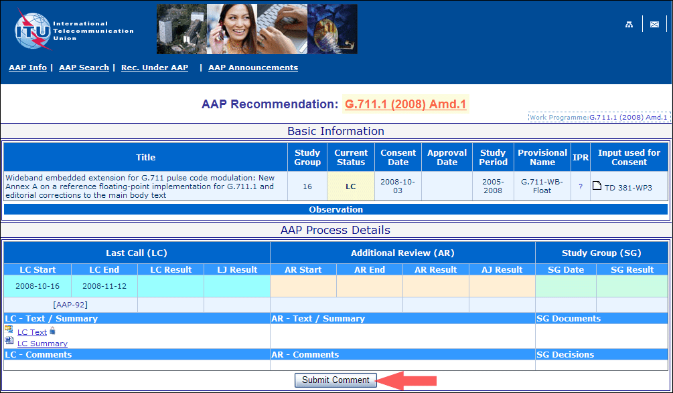
4) Complete the on-line form and click on "Submit"
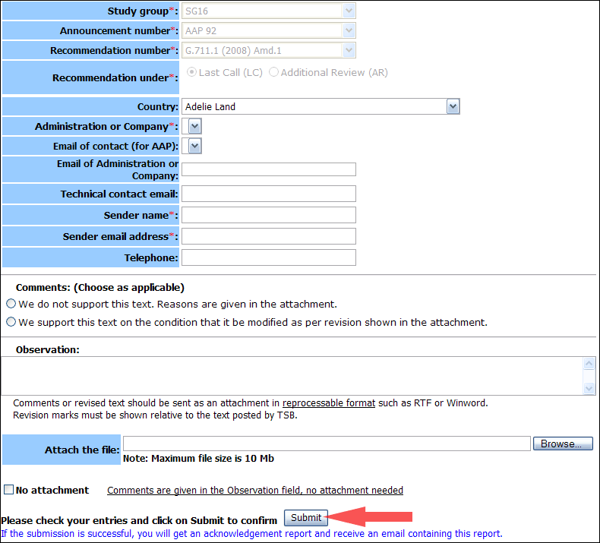
For more information, read the AAP tutorial on:
http://www.itu.int/ITU-T/aapinfo/files/AAPTutorial.pdf
Annex 3
(to TSB AAP-7)
Recommendations under LC/AR – Comment submission form
(Separate form for each Recommendation being commented upon)
ITU-T AAP comment submission form for the period 2009-2012
Study Group:
Announcement number:
Recommendation number:
Recommendation under: | Last call (LC)  Additional Review (AR)
Country:
Administration/Company:
Name of AAP Contact Person:
Email of AAP Contact Person:
Sender name:
(if different from AAP Contact Person)
Sender email address:
Telephone:
Comments:  (Choose as applicable) | We do not support this text. Reasons are given in the attachment.  We support this text on the condition that it be modified as per revision shown in the attachment.
Observations:
No attachment: Comments are given in the Observation field, no attachment needed
To be returned to: email: tsbsg....@itu.int
[or fax +41 22 730 5853]
Comments or revised text should be sent as an attachment in RTF or WinWord format.
Revision marks must be shown relative to the text posted by TSB.

