Unión Internacional de Telecomunicaciones  Oficina de Normalización de las Telecomunicaciones | 

Ginebra, 16 de diciembre de 2008

Ref:  Tel:  Fax:  Correo-e: | TSB AAP-4  AAP/MJ  +41 22 730 5860  +41 22 730 5853  tsbdir@itu.int | – A las Administraciones de los Estados Miembros de la Unión;  – A los Miembros del Sector UIT-T;  – A los Asociados del UIT-T  Copia:  – A los Presidentes y a los Vicepresidentes de las Comisiones de Estudio del UIT-T;  – Al Director de la Oficina de Desarrollo de las Telecomunicaciones;  – Al Director de la Oficina de Radiocomunicaciones

Asunto: | Situación de las Recomendaciones sometidas al proceso de aprobación alternativo (AAP)

Muy señora mía/Muy señor mío:

El proceso de aprobación alternativo (AAP) definido en la Recomendación A.8 del UIT-T se aplica a las Recomendaciones que no tienen consecuencias en materia de política o reglamentación y que no requieren, por lo tanto, la consulta formal de los Estados Miembros (véase el número 246B del Convenio de la UIT).
En el anexo 1 se enumera la lista de los textos cuyo estado ha cambiado con respecto a los anuncios TSB AAP precedentes.
Si desea formular un comentario en relación con una Recomendación sometida al AAP, le alentamos a utilizar el formulario de presentación de comentarios disponible en la página de la Recomendación que figura en el área AAP del sitio web del UIT-T, en la dirección http://www.itu.int/ITU-T/aap/ (véase también el anexo 2). Alternativamente, pueden presentarse comentarios completando el formulario del anexo 3 y remitiéndolo a la secretaría de la Comisión de Estudio correspondiente.
Le rogamos tenga en cuenta que no se alientan comentarios que se limiten a apoyar la adopción del texto en cuestión.
Le ruego tomar nota que en vista del cierre anual de la UIT, no se publicará ningún anuncio AAP el 1 de enero de 2009. En consecuencia, la fecha límite de algunos textos ha sido prolongada ya que esta fecha límite cae alrededor de este período.
Le saluda atentamente,

Malcolm Johnson
Director de la Oficina de
Normalización de las Telecomunicaciones
Anexos: 3
Annex 1
(to TSB AAP-4)

Status codes used in the AAP announcements:
LC = Last Call
LJ = Last Call Judgment (includes comment resolution)
AR = Additional Review
AJ = Additional Review Judgment (includes comment resolution)
SG = For Study Group approval
A = Approved
AT = Approved with typographic corrections
AC = Approved after Additional Review of Comments
NA = Not approved
TAP = Moved to TAP (ITU-T A.8 / § 5.2)
ITU-T website entry page:
http://www.itu.int/ITU-T
Alternative approval process (AAP) welcome page:
http://www.itu.int/ITU-T/aapinfo
Note – A tutorial on the ITU-T AAP application is available under the AAP welcome page
ITU-T website AAP Recommendation search page:
http://www.itu.int/ITU-T/aap/
Study Group web pages and contacts:
SG 2 | http://www.itu.int/ITU-T/studygroups/com02 | tsbsg2@itu.int
SG 3 | http://www.itu.int/ITU-T/studygroups/com03 | tsbsg3@itu.int
SG 5 | http://www.itu.int/ITU-T/studygroups/com05 | tsbsg5@itu.int
SG 9 | http://www.itu.int/ITU-T/studygroups/com09 | tsbsg9@itu.int
SG 11 | http://www.itu.int/ITU-T/studygroups/com11 | tsbsg11@itu.int
SG 12 | http://www.itu.int/ITU-T/studygroups/com12 | tsbsg12@itu.int
SG 13 | http://www.itu.int/ITU-T/studygroups/com13 | tsbsg13@itu.int
SG 15 | http://www.itu.int/ITU-T/studygroups/com15 | tsbsg15@itu.int
SG 16 | http://www.itu.int/ITU-T/studygroups/com16 | tsbsg16@itu.int
SG 17 | http://www.itu.int/ITU-T/studygroups/com17 | tsbsg17@itu.int

Situation concerning Study Group 5 Recommendations under AAP
Rec # | Title | Last Call (LC) Period |  |  |  | Additional Review (AR) Period |  |  |  | Status
Rec # | Title | LC Start | LC End | LC  Result | LJ  Result | AR Start | AR End | AR  Result | AJ  Result | Status
K.11 | Principles of protection against overvoltages and overcurrents | 2008-12-16 | 2009-01-12 |  |  |  |  |  |  | LC
K.77 (K.var) | Characteristics of Metal Oxide Varistors (MOVs) for the protection of telecommunications installations | 2008-12-16 | 2009-01-12 |  |  |  |  |  |  | LC
Situation concerning Study Group 12 Recommendations under AAP
Rec # | Title | Last Call (LC) Period |  |  |  | Additional Review (AR) Period |  |  |  | Status
Rec # | Title | LC Start | LC End | LC  Result | LJ  Result | AR Start | AR End | AR  Result | AJ  Result | Status
G.1080 (G.IPTV-QoE) | Quality of experience requirements for IPTV services | 2008-06-16 | 2008-07-13 | LJ | AR | 2008-11-16 | 2008-12-06 | AC |  | AC
Y.1563 (Y.ETHperf) | Ethernet frame transfer and availability performance | 2008-06-16 | 2008-07-13 | LJ | AR | 2008-12-16 | 2009-01-12 |  |  | AR
Situation concerning Study Group 13 Recommendations under AAP
Rec # | Title | Last Call (LC) Period |  |  |  | Additional Review (AR) Period |  |  |  | Status
Rec # | Title | LC Start | LC End | LC  Result | LJ  Result | AR Start | AR End | AR  Result | AJ  Result | Status
Y.2015 (Y.ipsplit) | General requirements for ID/locator separation in NGN | 2008-10-16 | 2008-11-12 | LJ | SG |  |  |  |  | SG
Y.2111 (Y.RACF-R2) | Resource and admission control functions in Next Generation Networks | 2008-10-16 | 2008-11-12 | LJ | AT |  |  |  |  | AT
Y.2113 (Y.enet) | Ethernet QoS control for Next Generation Networks | 2008-10-16 | 2008-11-12 | LJ | SG |  |  |  |  | SG
Y.2235 (Y.cwbs) | Converged web-browsing service scenarios in NGN | 2008-10-16 | 2008-11-12 | LJ | AT |  |  |  |  | AT
Y.2612 (Y.FPBN-addr) | Generic requirements and framework of FPBN addressing, routing and forwarding | 2008-10-16 | 2008-11-12 | LJ | SG |  |  |  |  | SG
Y.2807 (Y.mpls-mob) | MPLS-based mobility capabilities for NGN services | 2008-10-16 | 2008-11-12 | LJ | SG |  |  |  |  | SG
Situation concerning Study Group 15 Recommendations under AAP
Rec # | Title | Last Call (LC) Period |  |  |  | Additional Review (AR) Period |  |  |  | Status
Rec # | Title | LC Start | LC End | LC  Result | LJ  Result | AR Start | AR End | AR  Result | AJ  Result | Status
G.671 | Transmission characteristics of optical components and subsystems | 2008-12-16 | 2009-01-12 |  |  |  |  |  |  | LC
G.709/Y.1331 Cor.2 | Interfaces for the Optical Transport Network (OTN) | 2008-12-16 | 2009-01-12 |  |  |  |  |  |  | LC
G.798 Cor.1 | Characteristics of optical transport network hierarchy equipment functional blocks | 2008-12-16 | 2009-01-12 |  |  |  |  |  |  | LC
G.800 Amd.1 | Unified functional architecture of transport networks | 2008-12-16 | 2009-01-12 |  |  |  |  |  |  | LC
G.806 | Characteristics of Transport Equipment - Description Methodology and Generic Functionality | 2008-12-16 | 2009-01-12 |  |  |  |  |  |  | LC
G.808.1 (2006) Amd.1 | Generic protection switching - Linear trail and subnetwork protection | 2008-12-16 | 2009-01-12 |  |  |  |  |  |  | LC
G.985 Amd.1 | 100 Mbit/s point-to-point Ethernet based optical access system | 2008-12-16 | 2009-01-12 |  |  |  |  |  |  | LC
G.992.3 | Asymmetric digital subscriber line transcivers 2 (ADSL2) | 2008-12-16 | 2009-01-12 |  |  |  |  |  |  | LC
G.992.5 | Asymmetric Digital subscriber Line (ASDL) transceivers - Extended bandwidth ADSL2 (ADSL2plus) | 2008-12-16 | 2009-01-12 |  |  |  |  |  |  | LC
G.993.2 (2006) Amd.4 | Very high speed Digital subscriber Line Transceivers 2 | 2008-12-16 | 2009-01-12 |  |  |  |  |  |  | LC
G.7041 Amd.1 | Generic framing procedure (GFP) | 2008-12-16 | 2009-01-12 |  |  |  |  |  |  | LC
G.8011.1/Y.1307.1 | Ethernet Private Line Service | 2008-12-16 | 2009-01-12 |  |  |  |  |  |  | LC
G.8011.2/Y.1307.2 | Ethernet Virtual Private Line Service | 2008-12-16 | 2009-01-12 |  |  |  |  |  |  | LC
G.8011/Y.1307 | Ethernet over Transport – Ethernet Service Characteristics | 2008-12-16 | 2009-01-12 |  |  |  |  |  |  | LC
G.8021/Y.1341 Amd.1 | Characteristics of Ethernet Transport Network Equipment Functional Blocks | 2008-12-16 | 2009-01-12 |  |  |  |  |  |  | LC
G.9970 (G.hnta) | Generic Home Network Transport Architecture | 2008-12-16 | 2009-01-12 |  |  |  |  |  |  | LC
O.182 Amd.1 | Equipment to assess error performance on Optical Transport Network (OTN) interfaces | 2008-12-16 | 2009-01-12 |  |  |  |  |  |  | LC
X.85/Y.1321 Amd.2 | IP over SDH using LAPS | 2008-12-16 | 2009-01-12 |  |  |  |  |  |  | LC
Y.1714 | MPLS management and OAM Framework | 2008-12-16 | 2009-01-12 |  |  |  |  |  |  | LC
Situation concerning Study Group 16 Recommendations under AAP
Rec # | Title | Last Call (LC) Period |  |  |  | Additional Review (AR) Period |  |  |  | Status
Rec # | Title | LC Start | LC End | LC  Result | LJ  Result | AR Start | AR End | AR  Result | AJ  Result | Status
G.729.1 (2006) Amd.5 | G.729-based embedded variable bit-rate coder: An 8-32 kbit/s scalable wideband coder bitstream interoperable with G.729: New Annex D (Reference floating-point implementation for G.729.1 Annex C DTX/CNG) and corrections to the main body and Annex B | 2008-10-16 | 2008-11-12 | AR |  | 2008-11-16 | 2008-12-06 | AC |  | AC
H.264 (2007) Cor.1 | Advanced video coding for generic audiovisual services: corrections and updates | 2008-06-16 | 2008-07-13 | LJ | AR | 2008-12-16 | 2009-01-12 |  |  | AR
Situation concerning Study Group 17 Recommendations under AAP
Rec # | Title | Last Call (LC) Period |  |  |  | Additional Review (AR) Period |  |  |  | Status
Rec # | Title | LC Start | LC End | LC  Result | LJ  Result | AR Start | AR End | AR  Result | AJ  Result | Status
X.1056 (X.sim) | Security incident management guidelines for telecommunications organizations | 2008-12-16 | 2009-01-12 |  |  |  |  |  |  | LC
Z.167 (Z.146) | Testing and Test Control Notation version 3 (TTCN-3): Using ASN.1 with TTCN-3 | 2008-11-01 | 2008-11-28 | A |  |  |  |  |  | A
Z.169 | Testing and Test Control Notation version 3 (TTCN-3): TTCN-3 and the Use of XML | 2008-11-01 | 2008-11-28 | A |  |  |  |  |  | A

Annex 2
(to TSB AAP-4)
Using the on-line comment submission form
Comment submission
1) Go to AAP search Web page at http://www.itu.int/ITU-T/aap/
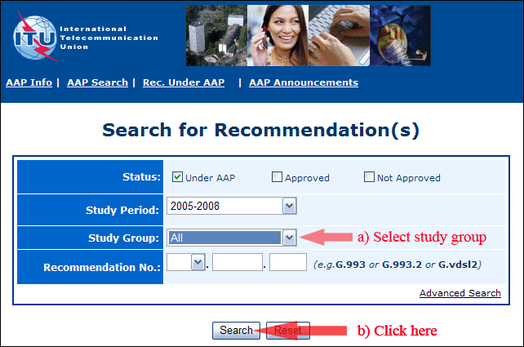
2) Select your Recommendation
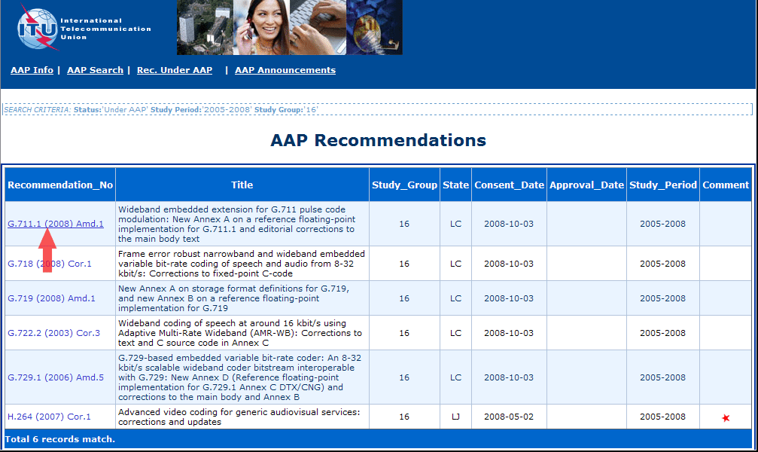
3) Click the "Submit Comment" button
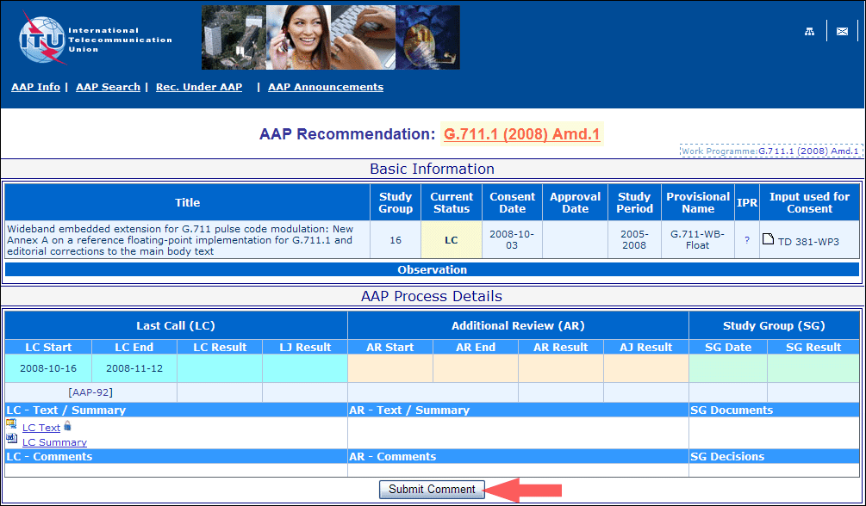
4) Complete the on-line form and click on "Submit"
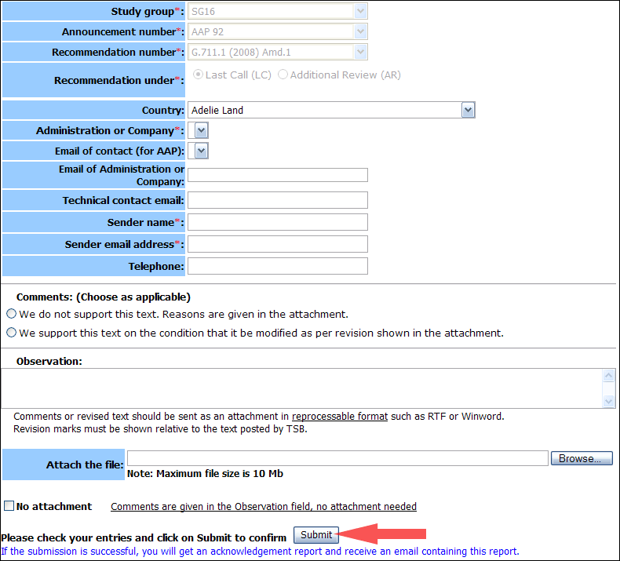
For more information, read the AAP tutorial on:
http://www.itu.int/ITU-T/aapinfo/files/AAPTutorial.pdf
Annex 3
(to TSB AAP-4)
Recommendations under LC/AR – Comment submission form
(Separate form for each Recommendation being commented upon)
ITU-T AAP comment submission form for the period 2009-2012
Study Group:
Announcement number:
Recommendation number:
Recommendation under: | Last call (LC)  Additional Review (AR)
Country:
Administration/Company:
Name of AAP Contact Person:
Email of AAP Contact Person:
Sender name:
(if different from AAP Contact Person)
Sender email address:
Telephone:
Comments:  (Choose as applicable) | We do not support this text. Reasons are given in the attachment.  We support this text on the condition that it be modified as per revision shown in the attachment.
Observations:
No attachment: Comments are given in the Observation field, no attachment needed
To be returned to: email: tsbsg....@itu.int
[or fax +41 22 730 5853]
Comments or revised text should be sent as an attachment in RTF or WinWord format.
Revision marks must be shown relative to the text posted by TSB.

