International Telecommunication Union  Telecommunication Standardization Bureau | 

Geneva, 16 December 2008

Ref:  Tel:  Fax:  E-mail: | TSB AAP-4  AAP/MJ  +41 22 730 5860  +41 22 730 5853  tsbdir@itu.int | – To Administrations of Member States of the Union;  – To ITU-T Sector Members;  – To ITU-T Associates  Copy:  – To the ITU-T Study Group Chairmen and Vice-Chairmen;  – To the Director of the Telecommunication Development Bureau;  – To the Director of the Radiocommunication Bureau

Subject: | Situation concerning Recommendations under the Alternative Approval Process (AAP)

Dear Sir/Madam,
The Alternative Approval Process (AAP) defined in Rec. ITU-T A.8 (2006) applies to Recommendations which do not have policy or regulatory implications and which, therefore, do not require formal consultation of Member States (see ITU Convention 246B).
Annex 1 lists those texts whose status has changed compared with previous TSB AAP Announcements.
If you wish to submit a comment relative to a Recommendation under AAP, you are encouraged to use the on-line AAP comment submission form available on the page of the Recommendation in the AAP area of the ITU-T website at http://www.itu.int/ITU-T/aap (see Annex 2). Alternatively, comments can be submitted by completing the form in Annex 3 and sending it to the secretariat of the concerned study group.
Please note that comments that simply support adoption of the text in question are not encouraged.
In view of ITU closing at the end of December period, please note that no AAP announcement will be issued on 1 January 2009. Consequently, the deadline for some texts has been exceptionally extended, since it falls around that period.
Yours faithfully,
Malcolm Johnson
Director of the Telecommunication Standardization Bureau
Annexes: 3
Annex 1
(to TSB AAP-4)

Status codes used in the AAP announcements:
LC = Last Call
LJ = Last Call Judgment (includes comment resolution)
AR = Additional Review
AJ = Additional Review Judgment (includes comment resolution)
SG = For Study Group approval
A = Approved
AT = Approved with typographic corrections
AC = Approved after Additional Review of Comments
NA = Not approved
TAP = Moved to TAP (ITU-T A.8 / § 5.2)
ITU-T website entry page:
http://www.itu.int/ITU-T
Alternative approval process (AAP) welcome page:
http://www.itu.int/ITU-T/aapinfo
Note – A tutorial on the ITU-T AAP application is available under the AAP welcome page
ITU-T website AAP Recommendation search page:
http://www.itu.int/ITU-T/aap/
Study Group web pages and contacts:
SG 2 | http://www.itu.int/ITU-T/studygroups/com02 | tsbsg2@itu.int
SG 3 | http://www.itu.int/ITU-T/studygroups/com03 | tsbsg3@itu.int
SG 5 | http://www.itu.int/ITU-T/studygroups/com05 | tsbsg5@itu.int
SG 9 | http://www.itu.int/ITU-T/studygroups/com09 | tsbsg9@itu.int
SG 11 | http://www.itu.int/ITU-T/studygroups/com11 | tsbsg11@itu.int
SG 12 | http://www.itu.int/ITU-T/studygroups/com12 | tsbsg12@itu.int
SG 13 | http://www.itu.int/ITU-T/studygroups/com13 | tsbsg13@itu.int
SG 15 | http://www.itu.int/ITU-T/studygroups/com15 | tsbsg15@itu.int
SG 16 | http://www.itu.int/ITU-T/studygroups/com16 | tsbsg16@itu.int
SG 17 | http://www.itu.int/ITU-T/studygroups/com17 | tsbsg17@itu.int

Situation concerning Study Group 5 Recommendations under AAP
Rec # | Title | Last Call (LC) Period |  |  |  | Additional Review (AR) Period |  |  |  | Status
Rec # | Title | LC Start | LC End | LC  Result | LJ  Result | AR Start | AR End | AR  Result | AJ  Result | Status
K.11 | Principles of protection against overvoltages and overcurrents | 2008-12-16 | 2009-01-12 |  |  |  |  |  |  | LC
K.77 (K.var) | Characteristics of Metal Oxide Varistors (MOVs) for the protection of telecommunications installations | 2008-12-16 | 2009-01-12 |  |  |  |  |  |  | LC
Situation concerning Study Group 12 Recommendations under AAP
Rec # | Title | Last Call (LC) Period |  |  |  | Additional Review (AR) Period |  |  |  | Status
Rec # | Title | LC Start | LC End | LC  Result | LJ  Result | AR Start | AR End | AR  Result | AJ  Result | Status
G.1080 (G.IPTV-QoE) | Quality of experience requirements for IPTV services | 2008-06-16 | 2008-07-13 | LJ | AR | 2008-11-16 | 2008-12-06 | AC |  | AC
Y.1563 (Y.ETHperf) | Ethernet frame transfer and availability performance | 2008-06-16 | 2008-07-13 | LJ | AR | 2008-12-16 | 2009-01-12 |  |  | AR
Situation concerning Study Group 13 Recommendations under AAP
Rec # | Title | Last Call (LC) Period |  |  |  | Additional Review (AR) Period |  |  |  | Status
Rec # | Title | LC Start | LC End | LC  Result | LJ  Result | AR Start | AR End | AR  Result | AJ  Result | Status
Y.2015 (Y.ipsplit) | General requirements for ID/locator separation in NGN | 2008-10-16 | 2008-11-12 | LJ | SG |  |  |  |  | SG
Y.2111 (Y.RACF-R2) | Resource and admission control functions in Next Generation Networks | 2008-10-16 | 2008-11-12 | LJ | AT |  |  |  |  | AT
Y.2113 (Y.enet) | Ethernet QoS control for Next Generation Networks | 2008-10-16 | 2008-11-12 | LJ | SG |  |  |  |  | SG
Y.2235 (Y.cwbs) | Converged web-browsing service scenarios in NGN | 2008-10-16 | 2008-11-12 | LJ | AT |  |  |  |  | AT
Y.2612 (Y.FPBN-addr) | Generic requirements and framework of FPBN addressing, routing and forwarding | 2008-10-16 | 2008-11-12 | LJ | SG |  |  |  |  | SG
Y.2807 (Y.mpls-mob) | MPLS-based mobility capabilities for NGN services | 2008-10-16 | 2008-11-12 | LJ | SG |  |  |  |  | SG
Situation concerning Study Group 15 Recommendations under AAP
Rec # | Title | Last Call (LC) Period |  |  |  | Additional Review (AR) Period |  |  |  | Status
Rec # | Title | LC Start | LC End | LC  Result | LJ  Result | AR Start | AR End | AR  Result | AJ  Result | Status
G.671 | Transmission characteristics of optical components and subsystems | 2008-12-16 | 2009-01-12 |  |  |  |  |  |  | LC
G.709/Y.1331 Cor.2 | Interfaces for the Optical Transport Network (OTN) | 2008-12-16 | 2009-01-12 |  |  |  |  |  |  | LC
G.798 Cor.1 | Characteristics of optical transport network hierarchy equipment functional blocks | 2008-12-16 | 2009-01-12 |  |  |  |  |  |  | LC
G.800 Amd.1 | Unified functional architecture of transport networks | 2008-12-16 | 2009-01-12 |  |  |  |  |  |  | LC
G.806 | Characteristics of Transport Equipment - Description Methodology and Generic Functionality | 2008-12-16 | 2009-01-12 |  |  |  |  |  |  | LC
G.808.1 (2006) Amd.1 | Generic protection switching - Linear trail and subnetwork protection | 2008-12-16 | 2009-01-12 |  |  |  |  |  |  | LC
G.985 Amd.1 | 100 Mbit/s point-to-point Ethernet based optical access system | 2008-12-16 | 2009-01-12 |  |  |  |  |  |  | LC
G.992.3 | Asymmetric digital subscriber line transcivers 2 (ADSL2) | 2008-12-16 | 2009-01-12 |  |  |  |  |  |  | LC
G.992.5 | Asymmetric Digital subscriber Line (ASDL) transceivers - Extended bandwidth ADSL2 (ADSL2plus) | 2008-12-16 | 2009-01-12 |  |  |  |  |  |  | LC
G.993.2 (2006) Amd.4 | Very high speed Digital subscriber Line Transceivers 2 | 2008-12-16 | 2009-01-12 |  |  |  |  |  |  | LC
G.7041 Amd.1 | Generic framing procedure (GFP) | 2008-12-16 | 2009-01-12 |  |  |  |  |  |  | LC
G.8011.1/Y.1307.1 | Ethernet Private Line Service | 2008-12-16 | 2009-01-12 |  |  |  |  |  |  | LC
G.8011.2/Y.1307.2 | Ethernet Virtual Private Line Service | 2008-12-16 | 2009-01-12 |  |  |  |  |  |  | LC
G.8011/Y.1307 | Ethernet over Transport – Ethernet Service Characteristics | 2008-12-16 | 2009-01-12 |  |  |  |  |  |  | LC
G.8021/Y.1341 Amd.1 | Characteristics of Ethernet Transport Network Equipment Functional Blocks | 2008-12-16 | 2009-01-12 |  |  |  |  |  |  | LC
G.9970 (G.hnta) | Generic Home Network Transport Architecture | 2008-12-16 | 2009-01-12 |  |  |  |  |  |  | LC
O.182 Amd.1 | Equipment to assess error performance on Optical Transport Network (OTN) interfaces | 2008-12-16 | 2009-01-12 |  |  |  |  |  |  | LC
X.85/Y.1321 Amd.2 | IP over SDH using LAPS | 2008-12-16 | 2009-01-12 |  |  |  |  |  |  | LC
Y.1714 | MPLS management and OAM Framework | 2008-12-16 | 2009-01-12 |  |  |  |  |  |  | LC
Situation concerning Study Group 16 Recommendations under AAP
Rec # | Title | Last Call (LC) Period |  |  |  | Additional Review (AR) Period |  |  |  | Status
Rec # | Title | LC Start | LC End | LC  Result | LJ  Result | AR Start | AR End | AR  Result | AJ  Result | Status
G.729.1 (2006) Amd.5 | G.729-based embedded variable bit-rate coder: An 8-32 kbit/s scalable wideband coder bitstream interoperable with G.729: New Annex D (Reference floating-point implementation for G.729.1 Annex C DTX/CNG) and corrections to the main body and Annex B | 2008-10-16 | 2008-11-12 | AR |  | 2008-11-16 | 2008-12-06 | AC |  | AC
H.264 (2007) Cor.1 | Advanced video coding for generic audiovisual services: corrections and updates | 2008-06-16 | 2008-07-13 | LJ | AR | 2008-12-16 | 2009-01-12 |  |  | AR
Situation concerning Study Group 17 Recommendations under AAP
Rec # | Title | Last Call (LC) Period |  |  |  | Additional Review (AR) Period |  |  |  | Status
Rec # | Title | LC Start | LC End | LC  Result | LJ  Result | AR Start | AR End | AR  Result | AJ  Result | Status
X.1056 (X.sim) | Security incident management guidelines for telecommunications organizations | 2008-12-16 | 2009-01-12 |  |  |  |  |  |  | LC
Z.167 (Z.146) | Testing and Test Control Notation version 3 (TTCN-3): Using ASN.1 with TTCN-3 | 2008-11-01 | 2008-11-28 | A |  |  |  |  |  | A
Z.169 | Testing and Test Control Notation version 3 (TTCN-3): TTCN-3 and the Use of XML | 2008-11-01 | 2008-11-28 | A |  |  |  |  |  | A

Annex 2
(to TSB AAP-4)
Using the on-line comment submission form
Comment submission
1) Go to AAP search Web page at http://www.itu.int/ITU-T/aap/
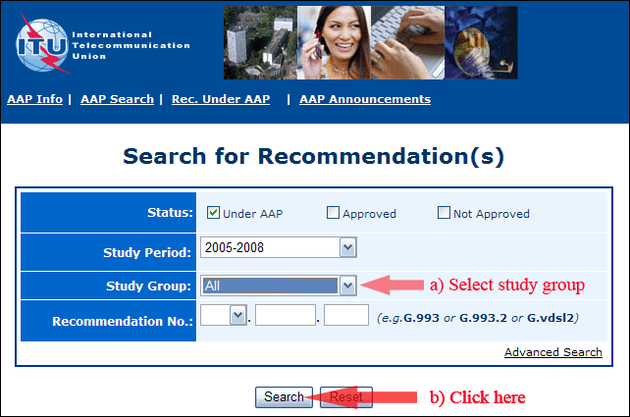
2) Select your Recommendation
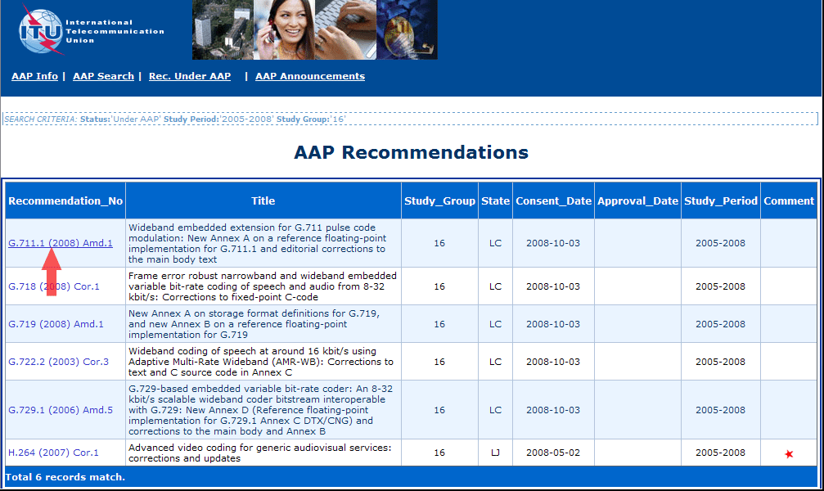
3) Click the "Submit Comment" button
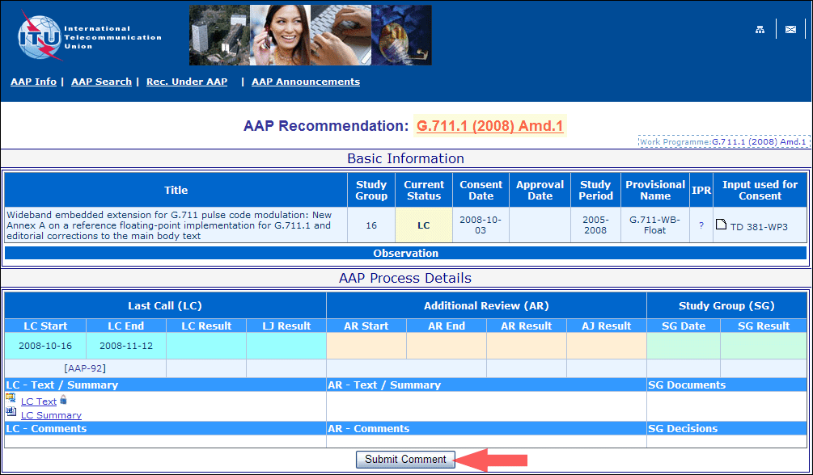
4) Complete the on-line form and click on "Submit"
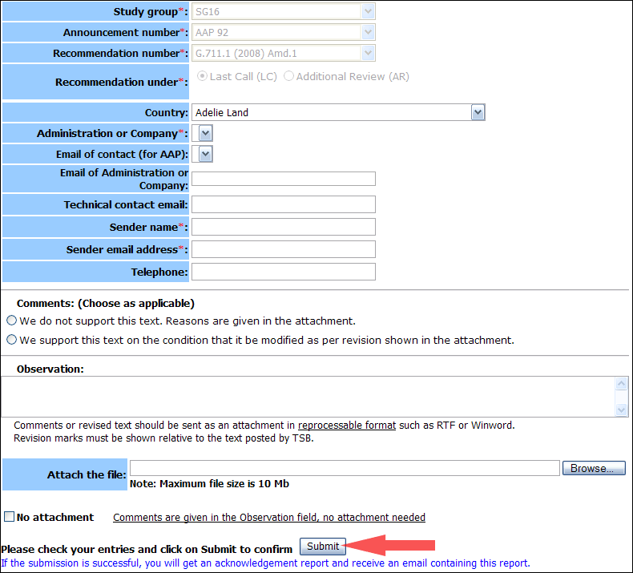
For more information, read the AAP tutorial on:
http://www.itu.int/ITU-T/aapinfo/files/AAPTutorial.pdf
Annex 3
(to TSB AAP-4)
Recommendations under LC/AR – Comment submission form
(Separate form for each Recommendation being commented upon)
ITU-T AAP comment submission form for the period 2009-2012
Study Group:
Announcement number:
Recommendation number:
Recommendation under: | Last call (LC)  Additional Review (AR)
Country:
Administration/Company:
Name of AAP Contact Person:
Email of AAP Contact Person:
Sender name:
(if different from AAP Contact Person)
Sender email address:
Telephone:
Comments:  (Choose as applicable) | We do not support this text. Reasons are given in the attachment.  We support this text on the condition that it be modified as per revision shown in the attachment.
Observations:
No attachment: Comments are given in the Observation field, no attachment needed
To be returned to: email: tsbsg....@itu.int
[or fax +41 22 730 5853]
Comments or revised text should be sent as an attachment in RTF or WinWord format.
Revision marks must be shown relative to the text posted by TSB.

