Practical Information
1. Venue
Mielparque-Hiroshima
6-36, Moto-machi, Naka-ku, Hiroshima-city, Hiroshima, 730-0011, Japan
TEL： +81-82-222-8501 / FAX：+81-82-222-7995 / E-mail：front@mph-wedding.jp
For more detailed Information about Mielparque-Hiroshima, please see:
http://www.mielparque.jp/hrs/eng.html
2. Access
Please see Attachment 1 for details.

3. Hotel
A total of 100 rooms of 3 hotels around the venue have been blocked for the participants with special rates. When the rooms with the special rates are fully booked, the rates will not be guaranteed.

3.1 Hotel list
The above-mentioned three hotels are listed in Attachment 2.

3.2 Hotel Reservations
Participants wishing to make reservations should send reservation form to the hotels directly by using the reservation form in Attachment 3 and will be informed confirmation number from respective hotel. The preferential rates apply only to the reservation made by using the reservation from in Attachment 3.

Any reservations should NOT be made by free e-mail account, such as @hotmail.com, @yahoo.com, @google.com and so on. Those participants who only use free e-mail accounts are kindly requested to make the reservation by fax.

You can cancel your reservation without any charge if done 2 days before your arrival or earlier. If cancelled 1 day before the date of your arrival, 20 percent of the first night will be charged. If cancelled on your arrival date, 80 percent of the first night will be charged. In case of no-show, 100 percent of the first night will be charged.

4. General Information on Japan and Hiroshima
4.1 Passports and Visas
All foreign visitors entering Japan must have a valid passport. Participants from countries whose citizens require visas should, well in advance, apply for a visa at a Japanese Embassy or consulate in their respective countries. The following provides information relating to enter Japan.
http://www.mofa.go.jp/j_info/visit/visa/index.html

Those participants who need the VISA supporting letter for entering Japan should fill out completely the “VISA Support Documents Application Form” and “Curriculum Vitae” in Attachment 4 and fax or e-mail them together with a “Copy of passport (page of photo)” to the CONTACT POINT in §8 by 28, February 2009, at the latest.

4.2 Electrical appliance
Japan operates on 100 volts for electrical appliances. The frequency is 60 Hz in western Japan including Hiroshima and Osaka (50 Hz in eastern Japan including Tokyo). The type of power outlet/connector used in Japan is “A” type which is two parallel pronged type.
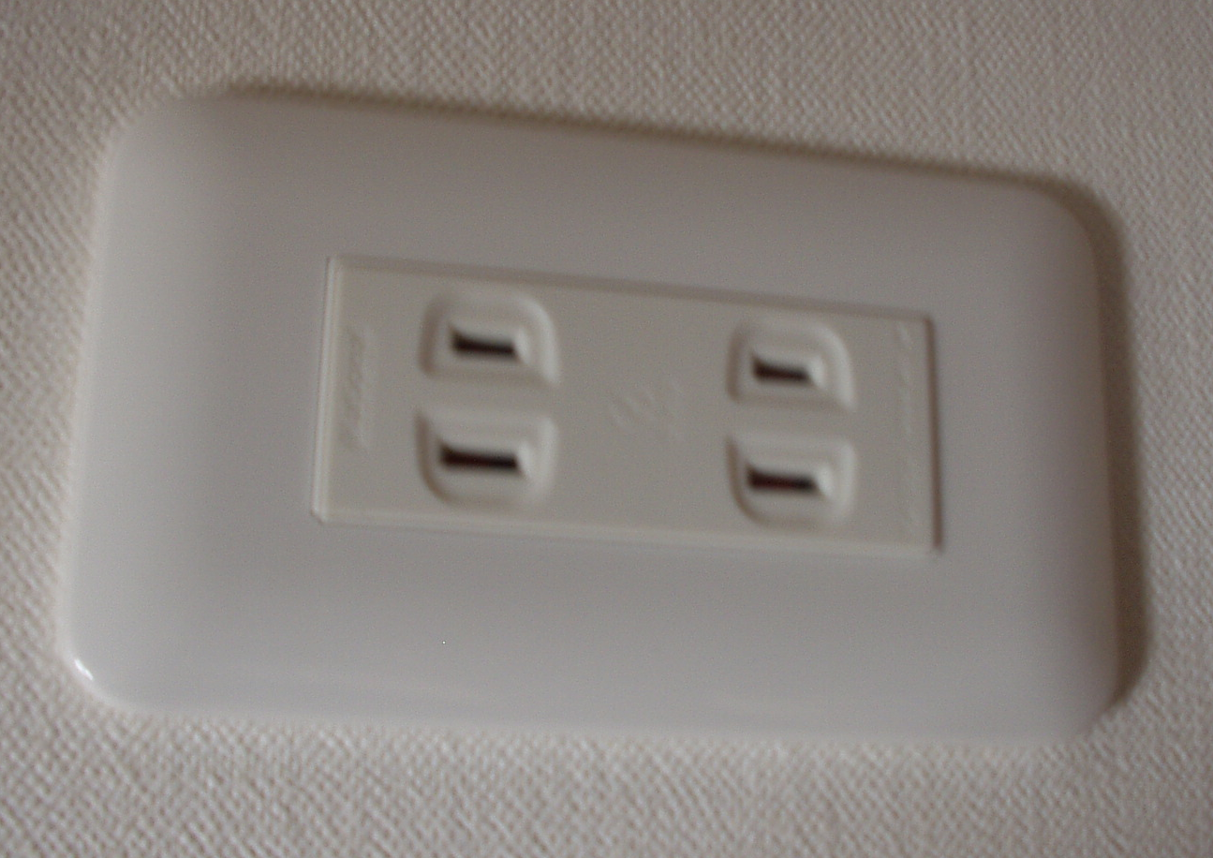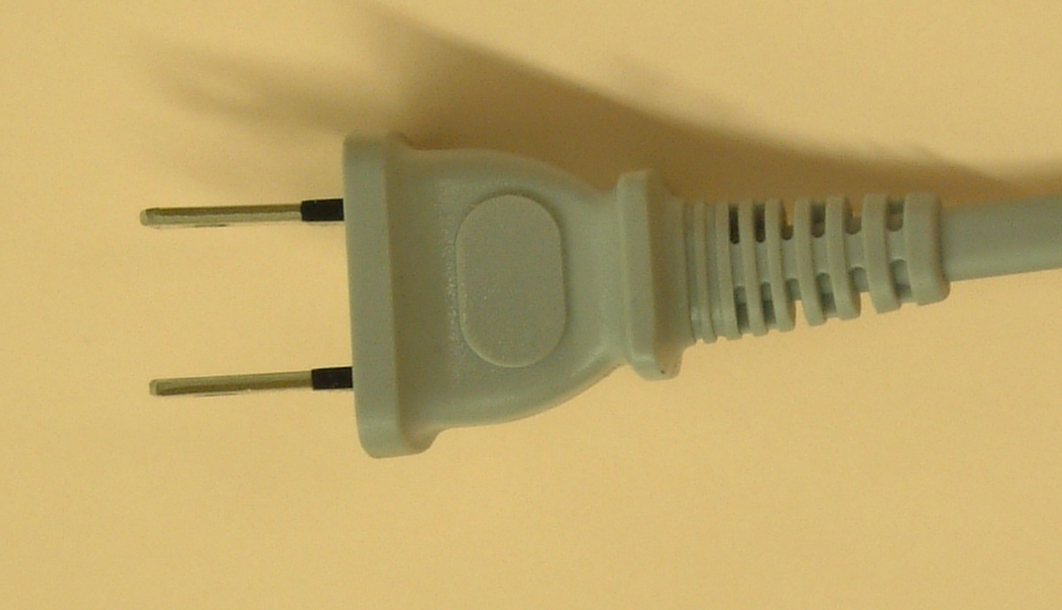
If your appliances operate on a different voltage, please bring your own transformers.

4.3 Currency and exchange
Only Japanese Yen is acceptable at stores and restaurants. At foreign exchange banks and other authorized money exchangers, you can buy Yen on presentation of your passport for major foreign currencies.

4.4 Exchange Rate
On line spot exchange rates are shown at: http://www.bk.mufg.jp/gdocs/kinri/list_j/kinri/kawase.html
1 USD 90.03 (JPY)
1 Euro 126.46 (JPY) as of 30, Dec 2009.

4.5 Business hours
Banks are open Monday through Friday from 9:00 to 15:00 and are closed on Saturdays, Sundays and national holidays. Foreign currency exchange is available at Japan Post Bank that is located on 1st floor of the venue from 9:00 to 18:00 Monday through Friday. Hiroshima Naka Post Office that is located on 1st floor of the venue is open from 8:00 to 20:00 Monday through Friday. Most department stores and shops are open from 10:00 to 20:00 hours in Hiroshima.

4.6 Tipping
Tipping is not necessary.

4.7 Climate
The climate of Japan is characterized by four distinct seasons: spring, summer, autumn and winter. The climate of Hiroshima in spring is fickle and there is much difference between the warmest and the coldest temperatures. In March it starts to get warm. Average temperature during the season is around 6℃-15℃ (42.8°-59 ° F).

  - Time Zone
GMT+9

5． Laptop at the meetings
Wireless LAN will be provided in all the meeting rooms.

6. Tourist Information on Hiroshima
Please see
http://www.kankou.pref.hiroshima.jp/global/english/index.htm
http://www.channelj.co.jp/meta/setouc_hirosh_e_033007.asx

7. Social Event
A welcome reception will be held at the room “Heisei” on the 6th floor of Mielparque-Hiroshima on the evening of Tuesday, 24 March,2009.

8. Contact Point
If you have any questions about this Practical Information, please contact:

Mr. Kojun Matsumoto and Ms. Hideyo Banishky
The ITU Association of Japan, Inc.
1-8-6, Kaji-cho, Chiyoda-ku, Tokyo 101-0044, Japan
Tel : +81-3-5207-5722
Fax: +81-3-5207-5731
E-mail address: fg-hiroshima@ituaj.jp

Attachment 1

【Access to Hiroshima】
【Source: Hiroshima Convention & Visitors Bureau】

【Flight Information to Hiroshima (2008/11/1～2009/1/31)】
Please find incoming and outgoing flight schedule at Hiroshima airport as of 5 of Jan, 2009.
Updated information will be provided at http://www.hij.airport.jp/english/.

International Flight (Once per day)
 | Flight Schedule
Hiroshima Dalian | Mon - Sun
Hiroshima Beijing | Mon, Wed, Thu, Fri, Sun
Hiroshima Shanghai | Mon - Sun
Hiroshima Seoul | Mon - Sun
Hiroshima Taipei | Mon - Sun
Hiroshima Bangkok | Mon, Fri
Hiroshima Guam | Sun, Thu

Domestic Flight between Narita and Hiroshima (Once per day)
 | Flight Schedule | Travel Time/Fare(One way / Normal)
Hiroshima Narita | Mon - Sun | 100 min / ¥33,000

Domestic Flight between Haneda and Hiroshima (15 flights per day)
 | Flight Schedule | Travel Time/Fare(One way / Normal)
Hiroshima Haneda | Mon - Sun | 90 min / ¥33,000
Data: As of 5 of Jan 2009

【Access from Centre of Hiroshima to Mielparque-Hiroshima】

By Streetcar
From the South Exit (streetcar side) of JR Hiroshima Station
15 minute ride on streetcar #2, bound for Hiroden Miyajima Guchi, or streetcar #6, bound
for Eba. Please get off at Kamiyacho west streetcar stop and 1 minute-walk to Mielparque-Hiroshima.

From Hiroshima Harbor
30 minute ride on streetcar #3 bound for Hiroden Nishi Hiroshima. Please get off at Kamiyacho west streetcar stop and 1 minute-walk to Mielparque-Hiroshima.
By Bus
From the South Exit of the JR Hiroshima Station
10 minute ride on the #9 Depot Bus. Please get off at Hiroshima Bus Center and 1 minute-walk to Mielparque-Hiroshima.
From Hiroshima Airport
60 minute ride on the Limousine Bus.
Please get off at the Hiroshima Bus Center and 1 minute-walk to the hotel.

Attachment 2

No. | Hotel Name  (Check-in/Check-out time) | Single | Twin  Single use | Twin  Twin use | Address  Phone/Fax
No. | Hotel Name  (Check-in/Check-out time) | Number of Rooms |  |  | Address  Phone/Fax
1 | Rihga Royal Hotel Hiroshima  13:00/11:00 | ¥ 12,000  (24 m² ) | ¥ 17,000  （34 m² ) | ¥ 22,000/room  （34 m² ) | 6-78 Motomachi, Naka-ku, Hiroshima 730-0011  TEL：+81-82-502-1121  FAX：+81-82-228-5415  E-mail：hiroshima@rihga.co.jp  (3 minute-walk to Mielparque-  Hiroshima)
1 | Rihga Royal Hotel Hiroshima  13:00/11:00 | 20 Rooms
2 | ANA Crowneplaza Hotel Hiroshima  13:00/11:00 | ¥ 11,500  (20 m² ) | ¥ 15,000  (27 m² ) | ¥ 19,000/room  ( 27 m² ) | 7-20Nakamachi,Naka-ku, Hiroshima 730-0037  TEL：+81-82-241-1111  FAX：+81-82-241-9123  E-mail：room@anacrowneplaza-hiroshima.jp  (10 minute-walk to Mielparque-  Hiroshima )
2 | ANA Crowneplaza Hotel Hiroshima  13:00/11:00 | 17 Rooms
3 | Mielparque-Hiroshima  15:00/10:00 | ¥ 7,350  (16m² ) | ¥ 8,850  （23m² ) | ¥ 12,500/ room  （23 m² ) | 6-36 Moto-machi,Naka-ku, Hiroshima730-0011  TEL：+81-82-222-8501  FAX：+81-82-222-7995  E-mail：front@mph-wedding.jp
3 | Mielparque-Hiroshima  15:00/10:00 | 60 Rooms
Notes:

* Room rates are the special ones for the meeting of FG-ICT&CC in Hiroshima.
* Room rates include 10% service charge and 5% tax. Breakfast is included.
* When all the rooms are fully booked with those participants, the preferential rates are
not guaranteed.
* If cancelled 1 day before the date of your arrival, 20 percent of the first night will be
charged. If cancelled on your arrival date, 80 percent of the first night will be charged. In case of no-show, 100 percent of the first night will be charged.

Attachment 3

Hotel Reservation Form for Focus Group on ICT & CC in Japan
(24 -27 March 2009)

Please complete and return this form directly to the Hotel

Rihga Royal Hotel Hiroshima FAX: +8182-228-5415 / E-mail: hiroshima@rihga.co.jp
ANA Crowneplaza Hotel Hiroshima
FAX: +81-82-241-9123/ E-mail: room@anacrowneplaza-hiroshima.jp
Mielparque-Hiroshima FAX: +81-82-222-7995/ E-mail: front@mph-wedding.jp

FULL NAME: □ Prof. □ Dr. □ Mr. □ Ms.
Last name Middle name First name

ORGANIZATION:

FULL ADDRESS: □ Office □ Home

Postcode: Country:
Phone: + Fax: + E-mail:

Name of Accompanying Person(s), if any: □Mr. □Ms.
Family name Middle name First name
Flight Schedule
Arrival Date: Time: Flight #: Name of airport:
Departure Date: Time: Flight #: Name of airport:
HOTEL ACCOMMODATION
Hotel Name | Number of room(s) | Check in date | Check out date
 | Single :  Twin Single Use: .  Twin Twin Use: . | Date： | Date：
CREDIT CARD
□ American Express □ Diners Club □ JCB □ MasterCard □ VISA
Card number: Expiration date:

Name of card holder:

Authorized signature: Date:

Signature:

The ITU Association of Japan, Inc.

Tel: +81-3-5207-5722 Fax: +81-3-5207-5731 E-mail: fg-hiroshima@ituaj.jp
Attention to: Koujun Matsumoto (Mr) and Hideyo Banishky (Ms)
Attachment 4
Visa Support Documents Application Form
Participants who need an invitation letter and/or visa supporting documents for entering Japan shall fill out COMPLETELY the “Visa Support Documents Application Form” and “Curriculum Vitae” in block letters (English). Please send them together with a “Copy of passport (page of photo)” to the above address by fax and/or e-mail no later than 28 of February, 2009.
1. FULL NAME □ Mr. / □ Ms
(English) __________________ __________________ _________________ (Given Name) (Middle Name) (Family Name)
(Chinese) __________________ __________________ _________________
* For those having Chinese nationality, please write clearly your full name in both Chinese and English.
2. PASSPORT INFORMATION
Nationality: _____________________ Age: as of 28 February, 2009.
Passport number: _______________________ Date of expiry: ______/_____/_____
(Day / Month / Year)
Date of birth: _______/______ /________ Place of birth:_________________
(Day / Month / Year)
3. COMPANY NAME, JOB TITLE and COMPANY ADDRESS
Company name: _____________________________________________________
Job Title/Department:___________________________________________________
Company address: ____________________________________________________
* For those having Chinese nationality, please fill out the blank above clearly in both Chinese and English.
4. TELEPHONE NUMBER, FAX NUMBER and E-MAIL ADDRESS
Telephone number: _____________________ Fax number:__________________
E-mail address: ______________________________________________
5. STAYING PLACE in Japan (HOTEL) ______________________________________
6. FLIGHT INFORMATION (TO/FROM JAPAN)
Arrival
Flight No. _____________________ Time/Date/Month_______/__________/____________
Name of airport (arrival) ________________________________
Departure
Flight No. ___________________ Time/Date/Month _________/__________/__________
Name of airport (departure) __________________

CURRICULUM VITAE

1. FULL NAME
2. HOME ADDRESS
3.HOME TELEPHONE
NUMBER
4. NATIONALITY

5. WORK EXPERIENCE

6. EDUCATION

