INTERNATIONAL TELECOMMUNICATION UNION  TELECOMMUNICATION  STANDARDIZATION SECTOR  STUDY PERIOD 2009-2012 |  | Joint Coordination Activity on Accessibility and human Factors (JCA-AHF)
 |  | Doc. 191
English only
Original: English
Source: | JCA-AHF Convener
Title: | World's First Virtual Master's in Disability Policy - Fellowships Available

This information was brought up to the attention of the JCA-AHF Convener:
World's First Virtual Master's in Disability Policy - Fellowships Available: American University proposing fellowships for students with disabilities

The Institute on Disability and Public Policy (IDPP) is currently accepting applications for the world's first virtual Master's degree in disability studies and public policy. The Master's in Comparative and International Disability Policy, offered by the School of International Service at American University, is the centerpiece program of the IDPP. Fifteen full fellowships will be awarded by The Nippon Foundation, with
preference given to students from the ASEAN region who are blind, deaf, and/or mobility impaired. Applications are accepted on a rolling basis. Applications will accepted and evaluated until the
2012 cohort has been filled.

_________________

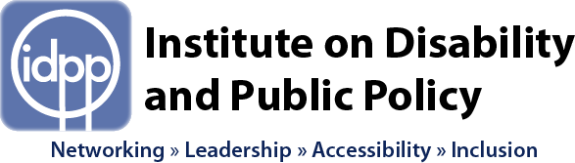
Apply Now for World’s First Virtual Master’s in Disability Policy – Fellowships Available
The Institute on Disability and Public Policy (IDPP) is currently accepting applications for the world’s first virtual Master’s degree in disability studies and public policy. The Master’s in Comparative and International Disability Policy, offered by the School of International Service at American University, is the centerpiece program of the IDPP. Fifteen full fellowships will be awarded by The Nippon Foundation, with preference given to students from the ASEAN region who are blind, deaf, and/or mobility impaired. Applications are accepted on a rolling basis. We will continue to accept and evaluate applications until the 2012 cohort has been filled.
The degree is taught in a blended cyberlearning environment, and focuses on the analysis and understanding of public policy for persons with disabilities. The program’s cyberinfrastructure cuts across geographic boundaries, allowing faculty to teach and students to be taught entirely online. Students have the option of completing the CIDP program as an accelerated one year or extended part-time program. Courses can be experienced in real-time or accessed on-demand. Courses incorporate universal design principles, and are accessible to blind, deaf, and mobility impaired students.
“Through a network of outstanding universities and accessible e-learning techniques, we enable students to become leaders of international disability policy in the public, private, and NGO sectors,” states Dr. Derrick L. Cogburn, IDPP/COTELCO Executive Director. Led by COTELCO and generously funded by The Nippon Foundation, the IDPP is a partnership network among nine academic institutions and two outreach partners.

For more information, please visit our Web site.
###

