INTERNATIONAL TELECOMMUNICATION UNION  TELECOMMUNICATION  STANDARDIZATION SECTOR  STUDY PERIOD 2009-2012 |  | Joint Coordination Activity on Accessibility and human Factors (JCA-AHF)
 |  | Doc. 144
English only
Original: English
Source: | JCA-AHF Convener
Title: | Mobile Accessible and Assistive Technologies and Services for Persons with Disabilities: An ITU-G3ict Global Report prepared in Collaboration with CIS (document submitted by BDT Focal Point for Question 20-1/, Second Meeting of ITU-D Study Group 1 Geneva, 5-9 September 2011)
This document is submitted for information.

Telecommunication  Development Sector  Study Groups |  | 
Second Meeting of ITU-D Study Group 1
Geneva, 5-9 September 2011
 |  | Document 1/118-E
 |  | 7 July 2011
 |  | Original: English only
 |  | For action
Question 20-1/1: Access to telecommunication services and information and communication technologies (ICTs) by persons with disabilities
SOURCE | BDT Focal Point for Question 20-1/1
TITLE | Mobile Accessible and Assistive Technologies and Services for Persons with Disabilities: An ITU-G3ict Global Report prepared in Collaboration with CIS
Action required: | Participants are invited to consider this contribution in the framework of the work of Question 20-1/1.
Abstract:
This contribution is a PowerPoint presentation with speaking notes which identifies many of the key issues related to mobile and assistive technologies and services for PwDs. The Study Group is kindly requested to consider this document that will be presented by Mr. Axel Leblois, Executive Director, G3ict.

Focal Point: Name/organization/entity: Ms Susan Schorr, BDT Focal Point for Question 20-1/1, BDT/PKM/SIS
Phone number: +41 22 730 5638
Email: susan.schorr@itu.int

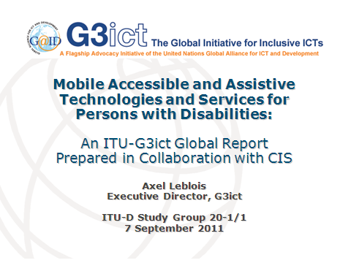 | Slide 1  This presentation will cover the main areas of our joint report with ITU-D developed in cooperation with the Center for Internet and Society.
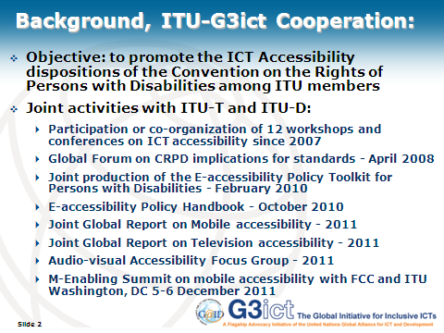 | Slide 2  By way of background, the cooperation between G3ict and ITU is meant to promote the ICT Accessibility dispositions of the Convention on the Rights of Persons with Disabilities (CRPD) among ITU members. G3ict itself was formed in 2006 by former members of the United Nations Preparatory Committee for the Convention who foresaw the need to promote its ICT accessibility dispositions among future States Parties. Those are indeed very significant in that they elevate the requirement of accessibility to ICTs on par with accessibility to the built environment and transportation.  Cooperation between ITU and G3ict is substantial and covers awareness raising as well as capacity building programs for policy makers, regulators and organizations of persons with disabilities. The e-accessibility policy toolkit for persons with disabilities as well as multiple reports jointly produced have become a unique knowledge resource with case studies and references from around the world.
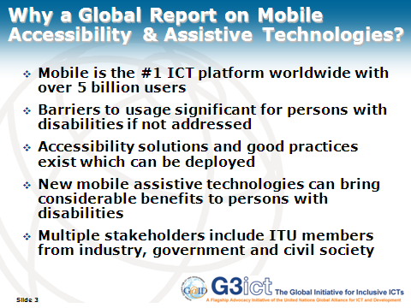 | Slide 3  The CRPD promotes both ICT accessibility and assistive technologies. In this context, mobile has become the most significant ICT platform with over 5 billion devices in use around the world. Mobile services are widespread among developed and developing nations alike. As a result, mobile has become an indispensable tool for all people in all domains of activity. Persons with disabilities, however, can be excluded from the benefits of mobile technology and services is handsets, applications and services are not designed to be accessible. While those barriers can be daunting, solutions exist that are successfully implemented by leading mobile service providers around the world. It is therefore important to share those good practices and to facilitate their replication.  One important additional consideration is the emergence of new assistive technologies operating on mobile platforms. Because of the economies of scale of the mobile market, mobile assistive technologies an be affordable and bring the benefits of anywhere anytime usage by persons with disabilities.  In order for those promises to materialize, however, multiple stakeholders cooperation is indispensable including industry, persons with disabilities, regulators and civil society.
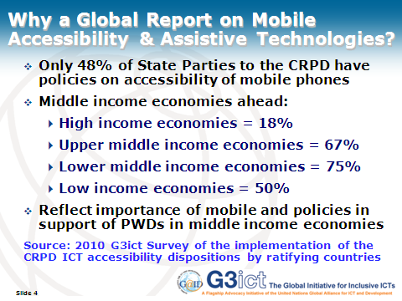 | Slide 4  Why a Global Report on Mobile Accessibility & Assistive Technologies?  Only 48% of State Parties to the CRPD have policies on accessibility of mobile phones  Middle income economies ahead:  High income economies = 18%  Upper middle income economies = 67%  Lower middle income economies = 75%  Low income economies = 50%  Reflect importance of mobile and policies in support of PWDs in middle income economies
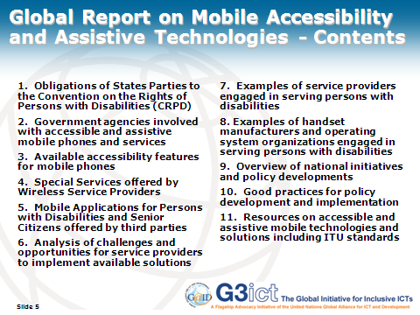 | Slide 5  The Global Report on Mobile Accessibility covers the following topics (read slide).  1. Obligations of States Parties to the Convention on the Rights of Persons with Disabilities (CRPD)  2. Government agencies involved with accessible and assistive mobile phones and services  3. Available accessibility features for mobile phones  4. Special Services offered by Wireless Service Providers  5. Mobile Applications for Persons with Disabilities and Senior Citizens offered by third parties  Analysis of challenges and opportunities for service providers to implement available solutions  7. Examples of service providers engaged in serving persons with disabilities  8. Examples of handset manufacturers and operating system organizations engaged in serving persons with disabilities  9. Overview of national initiatives and policy developments  10. Good practices for policy development and implementation  11. Resources on accessible and assistive mobile technologies and solutions including ITU standards
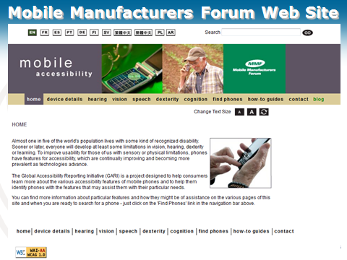 | Slide 6  As one seeks basic references on mobile accessibility, a good resource is the Mobile Manufacturers Forum web site. It includes a large number of handset manufacturers and covers all the accessibility features which handset can offer. It also helps seek the right model by type of impairment and country. G3ict recommends the use of the same categories when looking at accessibility features. We also added “illiteracy” in our upcoming Global Report as an additional category, both because it is a significant factor in many developing countries and because it affects many persons with disabilities, including persons born deaf or blind and who did not have access to special education.
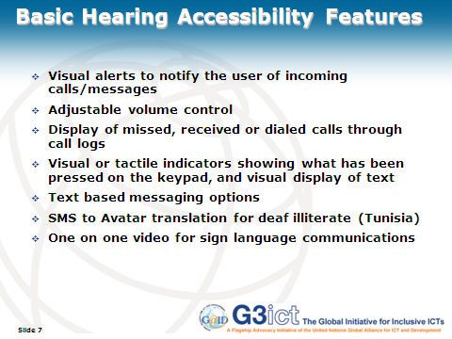 | Slide 7  Accessibility features for hearing include:  Visual alerts to notify the user of incoming calls/messages  Adjustable volume control  Display of missed, received or dialed calls through call logs  Visual or tactile indicators showing what has been pressed on the keypad, and visual display of text  Text based messaging options  SMS to Avatar translation for deaf illiterate (Tunisia)  One on one video for sign language communications
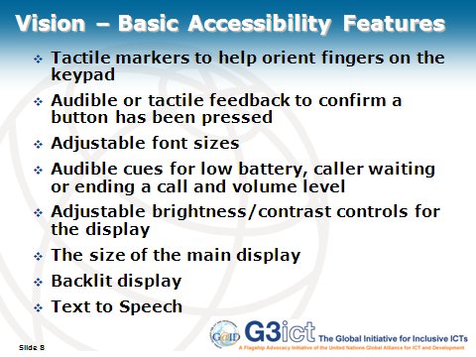 | Slide 8  Vision accessibility features include:  Tactile markers to help orient fingers on the keypad  Audible or tactile feedback to confirm a button has been pressed  Adjustable font sizes  Audible cues for low battery, caller waiting or ending a call and volume level  Adjustable brightness/contrast controls for the display  The size of the main display  Backlit display  Text to Speech
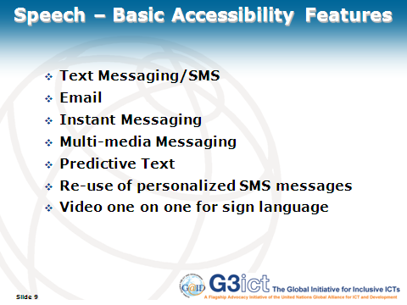 | Slide 9  Speech accessibility features include:  Text Messaging/SMS  Email  Instant Messaging  Multi-media Messaging  Predictive Text  Re-use of personalized SMS messages  Video one on one for sign language
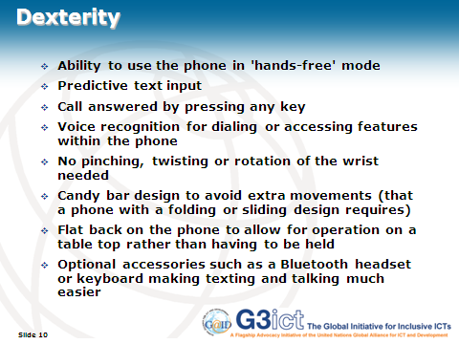 | Slide 10  Dexterity accessibility features include:  Ability to use the phone in 'hands-free' mode  Predictive text input  Call answered by pressing any key  Voice recognition for dialing or accessing features within the phone  No pinching, twisting or rotation of the wrist needed  Candy bar design to avoid extra movements (that a phone with a folding or sliding design requires)  Flat back on the phone to allow for operation on a table top rather than having to be held  Optional accessories such as a Bluetooth headset or keyboard making texting and talking much easier
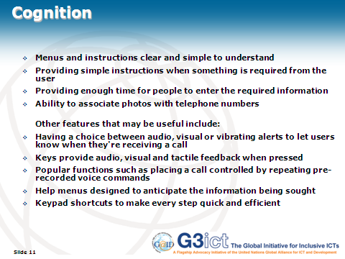 | Slide 11  Cognitive accessibility features include:  Menus and instructions clear and simple to understand  Providing simple instructions when something is required from the user  Providing enough time for people to enter the required information  Ability to associate photos with telephone numbers  Other features that may be useful include:  Having a choice between audio, visual or vibrating alerts to let users know when they're receiving a call  Keys provide audio, visual and tactile feedback when pressed  Popular functions such as placing a call controlled by repeating pre-recorded voice commands  Help menus designed to anticipate the information being sought  Keypad shortcuts to make every step quick and efficient
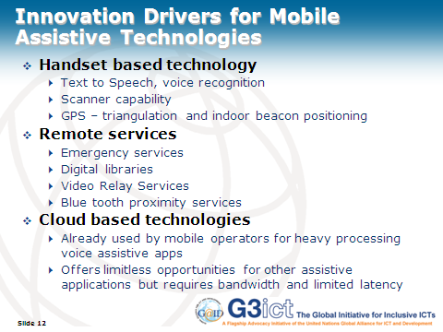 | Slide 12  As noted earlier, the mobile platform offers not only accessibility features but also assistive technologies which can directly address the need of persons with specific disabilities. This includes:  Handset based technology  Text to Speech, voice recognition  Scanner capability  GPS – triangulation and indoor beacon positioning  Remote services  Emergency services  Digital libraries  Video Relay Services  Blue tooth proximity services  Cloud based technologies  Already used by mobile operators for heavy processing voice assistive apps  Offers limitless opportunities for other assistive applications but requires bandwidth and limited latency
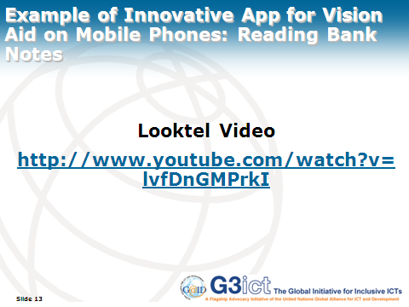 | Slide 13  Looktel video
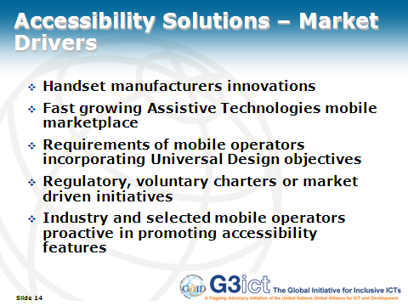 | Slide 14  Accessibility Solutions – Market Drivers  Handset manufacturers innovations  Fast growing Assistive Technologies mobile marketplace  Requirements of mobile operators incorporating Universal Design objectives  Regulatory, voluntary charters or market driven initiatives  Industry and selected mobile operators proactive in promoting accessibility features
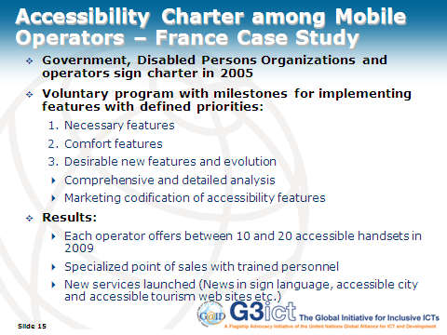 | Slide 15  Accessibility Charter among Mobile Operators – France Case Study  Government, Disabled Persons Organizations and operators sign charter in 2005  Voluntary program with milestones for implementing features with defined priorities:  Necessary features  Comfort features  Desirable new features and evolution  Comprehensive and detailed analysis  Marketing codification of accessibility features  Results:  Each operator offers between 10 and 20 accessible handsets in 2009  Specialized point of sales with trained personnel  New services launched (News in sign language, accessible city and accessible tourism web sites etc.)
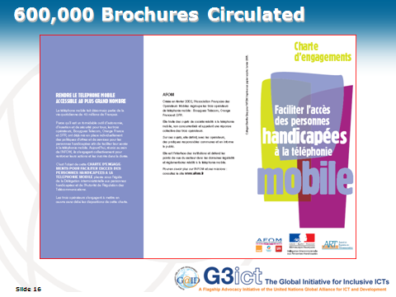 | Slide 16  600,000 Brochures like the one on the slide were circulated
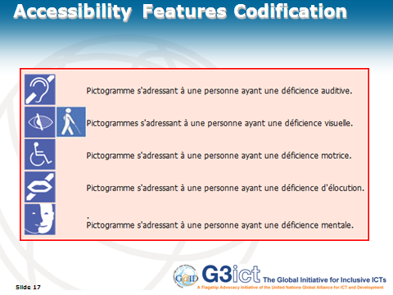 | Slide 17  The Charter codified the desired accessibility features
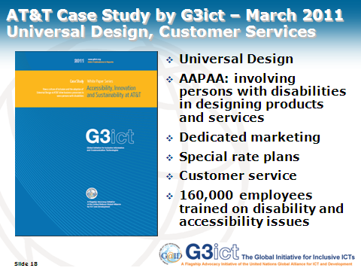 | Slide 18  - Universal Design  - AAPAA: involving persons with disabilities in designing products and services  - Dedicated marketing  - Special rate plans  - Customer service  - 160,000 employees trained on disability and accessibility issues
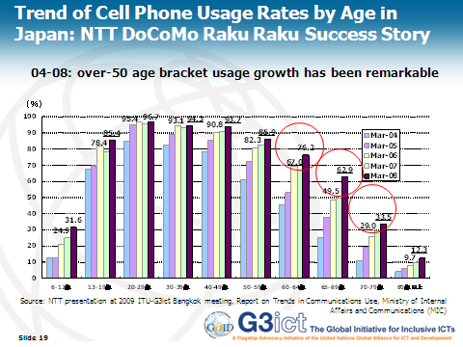 | Slide 19  This graph shows the trends of the mobile phone usage rate by age.  Two distinct characteristics can be seen from this graph.  One is that Japanese total mobile phone market is trending toward saturation.  The other is that the over-50 age bracket in particular shows remarkable growth.  Given this circumstance, over the age of 50 market seems to be a very attractive for us.  So, we believe it’s important to offer a rich lineup of mobile phones for seniors to choose from.
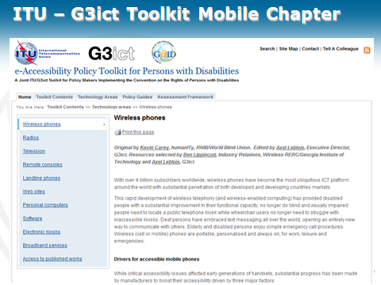 | Slide 20  e-Accessibility Policy Toolkit for persons with Disabilities
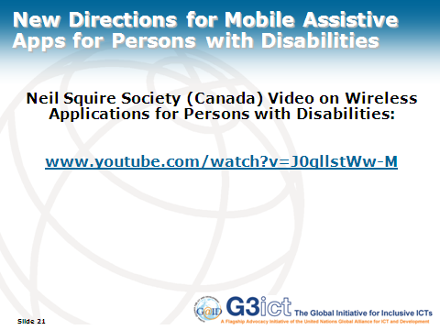 | Slide 21  Neil Squire Society (Canada) Video on Wireless Applications for Persons with Disabilities
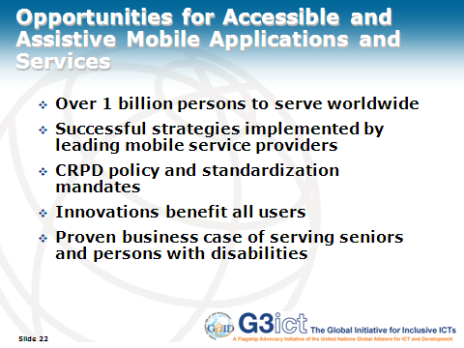 | Slide 22  Opportunities for Accessible and Assistive Mobile Applications and Services  Over one billion persons to serve worldwide  Successful strategies implemented by leading mobile service providers  United Nations Convention on the Rights of Persons with Disabilities policy and standardization mandates  Innovations benefit all users  Proven business case of serving seniors and persons with disabilities
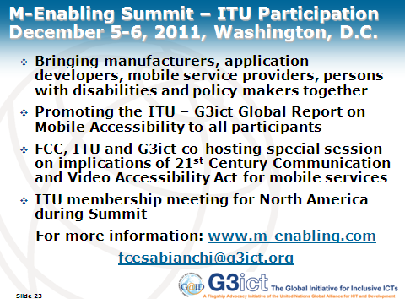 | Slide 23  M-Enabling Summit – ITU Participation  December 5  Bringing manufacturers, application developers, mobile service providers, persons with disabilities and policy makers together  Promoting the ITU – G3ict Global Report on Mobile Accessibility to all participants  FCC, ITU and G3ict co-hosting special session on implications of 21st Century Communication and Video Accessibility Act for mobile services  ITU membership meeting for North America during Summit




