LIST OF HOTELS AND HOTEL TRANSFER RESERVATION FORM

Event Venue
Hotel “Dedeman Silk Road Tashkent ”
Conference room “Silk Road”, 1st floor
Amir Temur Str.,C 4, No 7/8, Tashkent, 700000, Uzbekistan
Tel: +(998) 71 120 37 00, +(998) 71 134 85 85
Fax: +(998) 71 134 42 42
www.dedeman.com

Hotel “Dedeman Silk Road Tashkent ” ****
Amir Temur Str.,C 4, No 7/8, Tashkent
700000, Uzbekistan
Tel: +(998) 71 120 37 00, +(998) 71 134 85 85
Fax: +(998) 71 134 42 42
www.dedeman.com

Accommodation of the fellowship holders is envisaged in this hotel.
Located 8 km from Tashkent International Airport, in the city center of Tashkent, this is also the venue of the Forum itself.
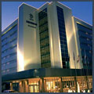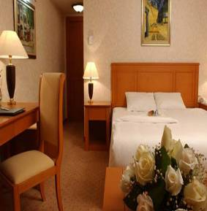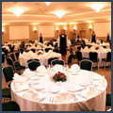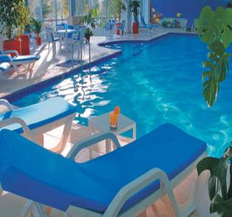

Room Type | Special Rates
Standard Room | USD 65.00
Double Room | USD 85.00
Deluxe | USD 70.00
Junior Suite | USD 250.00
Extra bed - 20 USD except in suite rooms. Accompanying guest is free of charge in suite rooms.
Rich Open Buffet Breakfast and all local taxes are inclusive of single or double occupancy
Free Usage of Life Style Health Center (indoor & outdoor swimming pools, sauna, gym)
Free Unlimited Wireless Internet service in all Guest Rooms.
Free Wireless Internet service on the Public Area.
All above mentioned room rates are valid until 31.12.2008
InterContinental Tashkent *****
107A, A.Temur Street,
Tashkent, 100084, Uzbekistan
Tel.: (998 71) 1207000 ext. 4229
Fax: (998 71) 1206459
www.ihg.com

Opened in 1997, established 5 star hotel is ideally located within a business park near the National Bank of Uzbekistan, Shopping Centre and the Telecommunication Center, adjacent to a lake and near the main trade fair site, close to city center. Distance from International airport: 10 km or 20 minutes drive. Distance to city center: 5 km.

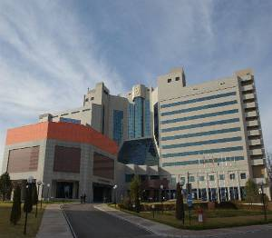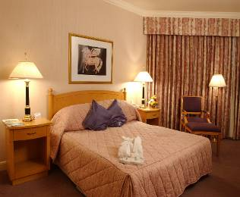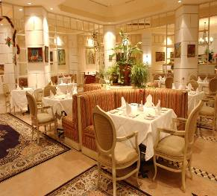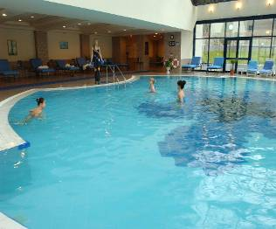

Room Type | Special Rates
Standard Room | USD 130.00
Double Room | USD 168.00
Superior Room | USD 150.00
Junior Suite | USD 300.00
Room rate includes one Full American Buffet breakfast. And also free of charge: Instant check-in/check-out, Luggage storage, in-room-safe, 24 hours security, 24 hours services of Fitness Center, 24 hours services of Gymnasium; use of Swimming Pool, Steam and Sauna during working hours, Wireless internet access in the Hotel Lobby. Also available Currency exchange office and Ticket Office of “Lufthansa” Airlines.

Payment for the services shall be made by guest's credit card (American Express /Visa/ EuroMaster card) or by bank transfer.

Radisson SAS Hotel Tashkent ****
88, A.Temur Street,
Tashkent, 100084, Uzbekistan
Tel.: +998 71 1204900
Fax: +998 71 1204902
www.radissonsas.com

The Radisson SAS Hotel in Tashkent is on the Amir Temur road, in the heart of the banking and business district. The hotel is just 15 minutes from the international airport and has 111 beautifully designed rooms with all modern amenities: individually controlled heating and air-conditioning system, direct-dial telephones and Internet port, electronic safe, TV Set with 24 worldwide channels, bathroom with bath-tub, mini-bar and hair-drier. The Hotel has 2 Bars, 2 Restaurants, Fitness center (swimming pool, sauna and gym), 24 hours open Business Center with all facilities, laundry & dry-cleaning service, outdoor parking lot, currency exchange office.

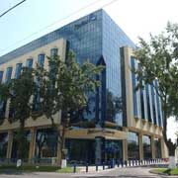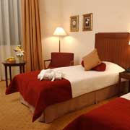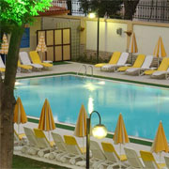

Room Type | Special Rates
Standard Single | 85 USD
Standard Double | 115 USD
Junior Suite | 200 USD
Executive Suite | 350 USD
The above rates include:
- open Buffet breakfast;
- fitness center use: swimming pool, sauna and gym;
- complimentary Internet in the room & wireless internet use in all public areas;
- V.A.T.
check-in time at the hotel is 14:00 and check-out is 12:00 (noon).
Accounts can be settled by major credit cards: Visa, AmEx, MasterCard, Diners Club, JCB or Cash.
If participants need a hotel reservation, they are kindly asked to complete the HOTEL AND TRANSFER RESERVATION FORM (Annex 4) and send it to the national coordinator Mrs. Umida Musayeva, Senior Specialist of International Relations Coordination Department of the Communications and Information Agency of Uzbekistan. by fax: + 998 71 139-87-82, or e-mail : musaeva@aci.uz, by 15 May 2008 at the latest. (for inquries, tel: +998 71 138-41-41)

 | ITU Regional Development Forum 2008: “Bridging the ICT Standardization Gap in Developing Countries” for CIS, CEE and Baltic countries, Tashkent, Uzbekistan, 10 – 11 June 2008  and  CIS WTSA-08 Preparatory Meeting,  12 – 13 June 2008, Tashkent, Uzbekistan,

HOTEL AND TRANSFER RESERVATION FORM

This form should be sent to the national coordinator in Republic of Uzbekistan, to ensure booking of hotel and transfer to and from the airport by fax at: + 998 71 139-87-81 or by e-mail: musaeva@aci.uz, info@aci.uz

Information about the hotels – see Annex 2
Family name -------------------------------------------------------------------------------------------------------------------

First name ------------------------------------------------------------------------------------------------------------------

Address ------------------------------------------------------------------------ Tel: -------------------------------

----------------------------------------------------------------------------------------- Fax: -------------------------------

----------------------------------------------------------------------------------------- E-mail: ------------------------------
Name of Hotel ------------------------

------------ single/double room(s) at the Regional Development Forum preferential rate
from________________________ June 2008 to________________________June 2008

Date ------------------------------------------------------ Signature ---------------------------------------------------

TRANSFER INFORMATION

Transportation will be provided from the airport to the hotels and to the venue of the Forum.

Date of Arrival |  |  | Time of Arrival |  | FLIGHT NO.
Date of Departure |  |  | Time of Departure |  | FLIGHT NO.

