 | ITU Regional Development Forum 2008: “Bridging the ICT Standardization Gap in Developing Countries”  19-20 May 2008  WTSA-08 Preparatory Meeting for the Americas region  21-22 May 2008  Brasilia, Brazil | 

Practical Information

VENUE OF THE EVENTS

Agência Nacional de Telecomunicações - ANATEL
Espaço Cultural
SAUS Quadra 06 Bloco C
ZIP Code 70070-940
Brasília/DF - Brazil
Tel: +55 61 2312-2000
Fax: +55 61 2312-2244
Website: http://www.anatel.gov.br

WORKING LANGUAGES
The Forum will be conducted in Portuguese, English and Spanish with simultaneous interpretation.

REGISTRATION OF DELEGATES
Registration will start on May 19th from 08:00 am at the reception desk in the meeting venue.

WORKING HOURS
The opening ceremony will take place on May 19th at 09:30 am.
The proposed working hours are as follows: 09:00 am–12:30 pm and 02:00 pm–05:30 pm.

LIST OF PROPOSED/RECOMMENDED HOTELS

Hotel | Rates
KUBITSCHEK PLAZA – 5-star  Setor Hoteleiro Norte – Qd. 02 - l. E  Tel: +55 61 3319-3543  Fax: +55 61 33289366  E-mail: reservas@kubitschek.com.br | Standard:  Single: R$ 220,00 (US$ 129.00) + 10%  double: R$ 260,00 (US$ 152.00) + 10%  Breakfast Included  (+ R$ 2,00/day tourism tax)
CARLTON HOTEL – 5-star  Setor Hoteleiro Sul – SHS – Qd.. 05 – Bl. G  Tel: +55 61 3224-8819  Fax: +55 61 3226-8109  http://www.carltonhotelbrasilia.com.br | Standard:  Single: R$ 160,00 (US$ 94.10) + 10%  Double: R$ 190,00 (US$ 111.75) + 10%  Breakfast Included  (+ R$ 2,00/night (room tax)

Hotel | Rates
CONFORT SUÍTES BRASÍLIA – 4-star  Setor Hoteleiro Norte SHN - Qd. 04 Bl. D  Tel: +55 61 3424-6000  Fax: +55 61 3424-6001  Atlantica Hotels International  http://www.atlanticahotels.com.br | Standard:  Single: R$ 170,00 (US$ 100.00) + 15%  Double: R$ 190,00 (US$ 111.00) + 15%  Master: R$ 285,00 (US$ 167.00) + 15%  Breakfast Included.
MANHATTAN PLAZA – 4-star  Setor Hoteleiro Norte – SHN Qd. 02 – Bloco A  Tel: +55 61 3319-3543  Fax: +55 61 33289366  E-mail: reservas@manhattan.com.br | Standard:  Single: R$ 198,00 (US$ 116.00) + 10%  Double: R$ 238,00 (US$ 140.00) + 1%  Breakfast Included  (+ R$ 2,00/day tourism tax)
MELIÁ CONFORT PARK – 4-star  Setor Hoteleiro Sul – SHS Qd. 06 – Conj. A  Lote 01 - Bloco F  Tel: +55 61 3218-4747  Fax: +55 61 3218-4705  http://www.solmelia.com | Standard:  Single/Double: R$ 201,00 (US$ 118.00) + 5% Tax  Breakfast Included.  (+ R$ 2,00/day tourism tax)
HOTEL DAS NAÇÕES – 3-star  Setor Hoteleiro Sul – SHS - Qd. 04 – Bl. I  Tel: +55 61 3322 8050 // 3217 8000  Fax: +55 61 3225 7722  http://www.hoteldasnacoes.com.br | Standard:  Single: R$ 130,00 (US$ 76.00) + 10%  Double: R$ 170,00 (US$ 100.00) + 15%  Breakfast Included.
ST PAUL HOTEL – 3-star  Setor Hoteleiro Sul – SHS Qd. 2 Bl. H  Tel.: +55 61 2102-8400  Fax: +55 61 3224-3935  http://www.hotelstpaul.com.br | Standard:  Single: R$ 135,00 (US$ 79.00) + 10%  Double: R$ 160,00 (US$ 94.00) + 10%  Breakfast Included.  (+ R$ 2,00/day tourism tax)
- HOTEL RESERVATION
Hotel reservations should be made directly to the selected hotel, by using the attached “Hotel Reservation Form”. Please send a copy of the Hotel Reservation Form to the contact person in the host country by fax: +55 61 2312 2244 or by e-mail to: agrippa@anatel.gov.br .

TRANSPORTATION

- From the Juscelino Kubitschek International Airport to the proposed hotels:
20 minutes by taxi (R$ 35,00 - R$ 40,00), approximately USD 23.50

- From Anatel´s Espaço Cultural (venue of the meeting) to the proposed hotels:
5 minutes by taxi (R$ 10,00 - R$ 15,00), approximately USD 9.00.

Registered taxi services are available both at the Juscelino Kubitschek International Airport and at the proposed hotels.

VISA AND HEALTH FORMALITIES

Delegates should be aware that, according to the Brazilian health regulations, participants arriving from Bolivia, Colombia, Ecuador, Peru and Venezuela must hold an international health/vaccination card issued by the World Health Organization (WHO), which states that a yellow fever vaccination has been taken no less than 10 days and no more than 10 years prior to departure.

Since there is an epidemic of yellow fever in the Central Region of Brazil, participants from other countries not listed above are advised to take the yellow fever vaccination ten days prior to the event, even though it is not required by the Brazilian immigration.

Please contact a Brazilian Consulate in your country to make sure whether any entry visa is required.

Should any delegate face difficulties in obtaining a Brazilian visa, please contact the International Affairs Office at Anatel (Ms. Andrea Grippa, Tel: +55 61 2312 1702,
Fax: +55 61 2312 2244, agrippa@anatel.gov.br).
- CLIMATE

The temperature in Brasilia varies during daytime from 20 to 30ºC and in the evening time from 18 to 20ºC.

ELECTRIC POWER

Electricity in Brazil is 110 Volts, however, in Brasilia, the location in which the events will take place, electricity is 220 Volts. If you travel to Brasilia with a device that does not accept 220 Volts at 60 Hertz, you will need a voltage converter. The venue will provide electric plugs with an earth connector, just like figure 1 below. The most common electric plug outside of the venue (hotels, etc.) will be like figures 2 and 3.

Figure 1  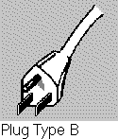 | Figure 2   | Figure 3  

CURRENCY
Payments are made in local currency only. For reference, the current rate is approximately R$ (Real) 1.70 to US$ 1.00 (February 26th, 2008). Note that exchange rates can float in Brazil.

Banks are open from 11:00 a.m. to 4:00 p.m. on weekdays. Foreign currency and traveler’s checks can be exchanged into Reais in some specific banks in Brasilia (Banco do Brasil, Banco Central, Banco de Boston and Citibank). The organizers of the event recommend you to exchange money at the counters or bank agencies of Banco do Brasil located in the international airports of Rio de Janeiro, Sao Paulo and Brasilia.

Credit cards (VISA, MasterCard, American Express and Diners Club) are generally accepted at hotels, department stores and restaurants.

Tipping is a common practice in bars and restaurants. A normal tip is 10% of the price on the bill. Sometimes the tip is already included in the bill.

TIME DIFFERENCE

Local time: GMT-03:00

- ABOUT BRASILIA
Brasilia, capital of Brazil, is in the Federal District, west central Brazil. It is situated in a savannah at an elevation of about 1100 m (about 3300 ft) and has a mild, dry climate. Brasília is a city of striking modern appearance and was constructed (beginning in 1957) on an uninhabited site to replace crowded Rio de Janeiro as the national capital. The city layout, which was designed by the Brazilian urban planner Lúcio Costa, resembles a jetliner in shape. Along the “fuselage”, which is the city's main axis, are the offices of the national government; the “wings” contain blocks of residential apartment buildings and foreign embassies. At the nose of the “fuselage” is the Plaza of the Three Powers, in which is set a circular, largely underground cathedral; this, and all the city's other major buildings, were designed by the noted Brazilian architect Oscar Niemeyer. Beyond the cathedral is the Palace of the Dawn, the presidential residence; it is set at the edge of a lake, which was formed by the damming of the Paranoá River and borders the city on three sides.
Estimated population:  2.320.453 inhabitants | Area: 5.782,80 km2 | Average altitude: 1.100 m
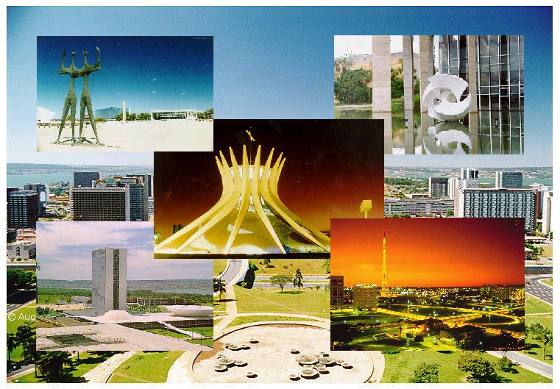

Additional Information about Brasilia can be obtained at:
http://www.embratur.gov.br
http://en.wikipedia.org/wiki/Brasilia

CONTACT PERSONS

AGÊNCIA NACIONAL DE TELECOMUNICAÇÕES (ANATEL)

Ms. ANDREA GRIPPA
Tel: + 55 61 2312 1702
Fax: + 55 61 2312 2244
E-mail: agrippa@anatel.gov.br

ITU AMERICAS REGIONAL OFFICE

Mrs. LUCIENE TAVARES
Tel: + 55 61 2312 2736
Fax:: + 55 61 2312 2738

E-mail: luciene.tavares@itu.int

ITU HEADQUARTERS

Mr. PAOLO ROSA
Tel: + 41 22 730 5235
Fax: + 41 22 730 5853
E-mail: tsbworkshops@itu.int

