ICTs and
Climate Change

ITU-T Technology Watch Report 3
December 2007

This report looks at the potential role that information and communication technologies (ICTs) play at different stages of the process of climate change, from contributing to global warming, to monitoring it, to mitigating its impact on the most vulnerable parts of the globe, to developing long-term solutions, both directly in the ICT sector and in other sectors like energy, transport, buildings etc. The final sections examine what ITU-T is already doing in this field and describe strategic options for the future.

ITU-T Technology Watch Reports are intended to provide an up-to-date assessment of promising new technologies in a language that is accessible to non-specialists, with a view to:
- Identifying candidate technologies for standardization work within ITU.
- Assessing their implications for ITU Membership, especially developing countries.
Other reports in the series include:
#1 Intelligent Transport System and CALM
#2 Telepresence: High-Performance Video-Conferencing
#3 ICTs and Climate Change
#4 Ubiquitous Sensor Networks
#5 Remote Collaboration Tools
#6 Technical Aspects of Lawful Interception
#7 NGNs and Energy Efficiency

Acknowledgements
This report was prepared by Dr Tim Kelly (tsbtechwatch@itu.int). It has benefited from contributions and comments from Alexandre Vassiliev, Kerstin Ludwig and Martin Adolph.
The opinions expressed in this report are those of the authors and do not necessarily reflect the views of the International Telecommunication Union or its membership.
This report was reviewed by TSAG in December 2007 and subsequently modified and expanded as the background report for two ITU Symposia on ICTs and Climate Change (www.itu.int/ITU-T/worksem/climatechange/).
This report, along with other Technology Watch Reports can be found at
www.itu.int/ITU-T/techwatch.
Please send your comments to tsbtechwatch@itu.int or join the Technology Watch Correspondence Group, which provides a platform to share views, ideas and requirements on new/emerging technologies and to comment on the Reports.
The Technology Watch function is managed by the ITU-T Standardization Policy Division.

© ITU 2008
All rights reserved. No part of this publication may be reproduced, by any means whatsoever, without the prior written permission of ITU.
ICTs and Climate Change

In October 2007, the Nobel Peace Prize was awarded jointly to former US vice-president Al Gore and to the UN Intergovernmental Panel on Climate Change (IPCC) with a citation “for their efforts to build up and disseminate greater knowledge about man-made climate change, and to lay the foundations for the measures that are needed to counteract such change”.
The award recognizes that climate change represents a threat to mankind on a similar plane to violent conflict and war, and indeed can lead to a breakdown of peace because of the increased competition for the earth’s resources. Information and Communication Technologies (ICTs) are undoubtedly part of the cause of global warming as witnessed, for instance, by the millions of computer screens that are left switched on overnight in offices around the world. But ICTs can also be part of a solution. This Technology Watch briefing report looks at the potential role that ICTs play at different stages of the process, from contributing to global warming (section 1), to monitoring it (2), to mitigating its impact on the most vulnerable parts of the globe (3), to developing long-term solutions, both directly in the ICT sector and in other sectors like energy, transport, buildings etc (4). The final sections look at what ITU-T is already doing in this field (5) strategic options (6), and the campaign for a climate-neutral UN (7).

1 Climate change and the impact of ICTs

There are a number of different causes of climate change, many of which are naturally generated (e.g., variations in solar radiation, volcanic activity etc). However, it is man-made climate change that is of major concern because it appears to be leading to a progressive and accelerating warming of the planet, as a result of the release of greenhouse gases (GHG), primarily carbon-based emissions. As shown in Figure 1, taken from the work of the IPCC, global greenhouse gas emissions have risen by 70 per cent since 1970.
As a consequence, global average temperatures have risen by around half a degree centigrade (from 14° to 14.5°C) since 1950, and there has been a rise in sea level of around 10 cm and a reduction of Northern hemisphere snow cover of around 2 million km² over the same period (see Figure 2). Since measurements began, eleven of the warmest annual average temperatures recorded have been in the last twelve years.
The primary sources of GHG are energy production and consumption, transport, buildings, land-use change, waste management etc. Other industries, including the ICT Sector, generate around 4 per cent of total GHG, but this would be much higher – around 14 per cent – if indirect energy use were included. The ICT Sector itself contributes around 2.5 per cent of GHG, which is much smaller than its share of global Gross Domestic Product (GDP).

Figure 1: Total Greenhouse Gases (in Gigatonnes of Carbon Dioxide equivalents – GtCO2-eq)
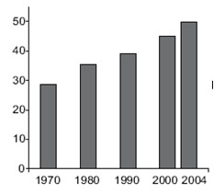
Source: IPCC (WG 3 contribution to 4th assessment report)

Indeed, because the main output of the ICT Sector is information rather than physical goods (“bits”, not “atoms”) it can be seen as part of the solution rather than problem. Nevertheless, ICTs are far from innocent in the matter of climate change:
- The major contribution of ICTs to climate change comes from the proliferation of user devices, all of which need power and radiate heat. For instance, in the decade between 1996 and 2006, the number of mobile phones rose from 145 million to 2.7 billion. Over the same period, estimated Internet users grew from 50 million to 1.1 billion. In 1996, virtually all residential Internet users were using dial-up whereas by 2006 a majority had always-on broadband connections, further increasing power use.
- In addition to the proliferation of users, each individual user may now own many more devices. For instance, in the field of consumer electronics, whereas twenty years ago a single television might have provided entertainment for a household, now a typical family in a developed country might own multiple television sets, as well as a digital cinema, video-recorder, a DVD player, a hard-drive recorder, one or more set-top box decoders etc, many of which are routinely left on standby overnight.
- As these ICT devices acquire more processing power, their requirements for power and for cooling, also rise. For instance, third generation (3G) mobile phones, which operate at higher frequencies and need more power than 2G ones (for instance, for Internet access, digital signal processing, polyphonic ringtones etc) and therefore more power is required to keep them charged.
- An increasing percentage of ICT usage might be regarded as “unnecessary”, in the sense that it is spam email, SMS and voice calls, or the storage rather than deletion of old material.
ICT use will only grow over time, and it is important therefore that the industry takes steps now to curb and ultimately reduce its carbon emissions.

Figure 2: Long-term changes related to the climate
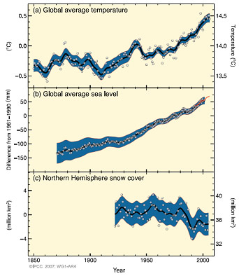
Source: IPCC, WG1 contribution to 4th assessment report

2 ICT use in monitoring climate change

The science of climate change, which has developed over the last century or so, has benefited greatly from the parallel development of ICTs. The typical locations for climate research – such as the polar ice caps, glaciers, volcanoes, the ocean bed or the upper layers of the atmosphere – are inhospitable, and remote monitoring and data collection using ICT-equipped sensors (telemetry) is essential for research. Even more useful has been the development of aerial photography, satellite imagery, grid technology and in particular the use of global positioning by satellite (GPS) for tracking slow, long-term movement, for instance of glaciers or ice floes (see Figure 3). The World Glacier Monitoring Service uses an integrative multi-level approach to document glacier changes that links satellite remote sensing and GPS data with aerial photography, in-situ measurements and computer modeling of glacial mass balance, with research spread over many decades.

Figure 3: Retreat of the Trift Glacier, Switzerland
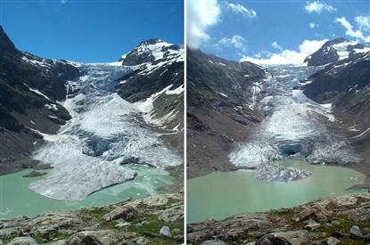
Source: Swiss Academy of Sciences.
Note: The glacier retreated by around 200m between 2004 and 2005

In addition to monitoring the effects of climate change, ICTs have also proved invaluable in computer modeling of the earth’s atmosphere, beginning with the work of computer pioneer von Neumann in the late 1940s. Meteorological services are among the most demanding users of the world’s fastest supercomputers, and produce progressively more sophisticated general circulation models of climate. For instance, the Hadley Centre for Climate Change in the United Kingdom runs a variety of climate models on a suite of NEC SX-6 supercomputers which have processing power equivalent to 1’000 times that of a top-of-the-range desktop PC. The numerical climate models are linked via Bracknell, one of 15 regional and three global telecommunication hubs of the World Meteorological Organization (WMO’s) Global Telecommunications System (GTS), which is linked to its World Weather Watch Global Climate Observing System (GCOS) (see Figure 4). In addition, by using the unused processing cycles of thousands of linked computers, it is possible for scientists, and even amateurs, to conduct climate modeling experiments. Sophisticated computer systems also help run the system of tradable permits for carbon emissions which are one of the main implementation tools of the Kyoto Protocol.

Figure 4: WMO Global Climate Observing System
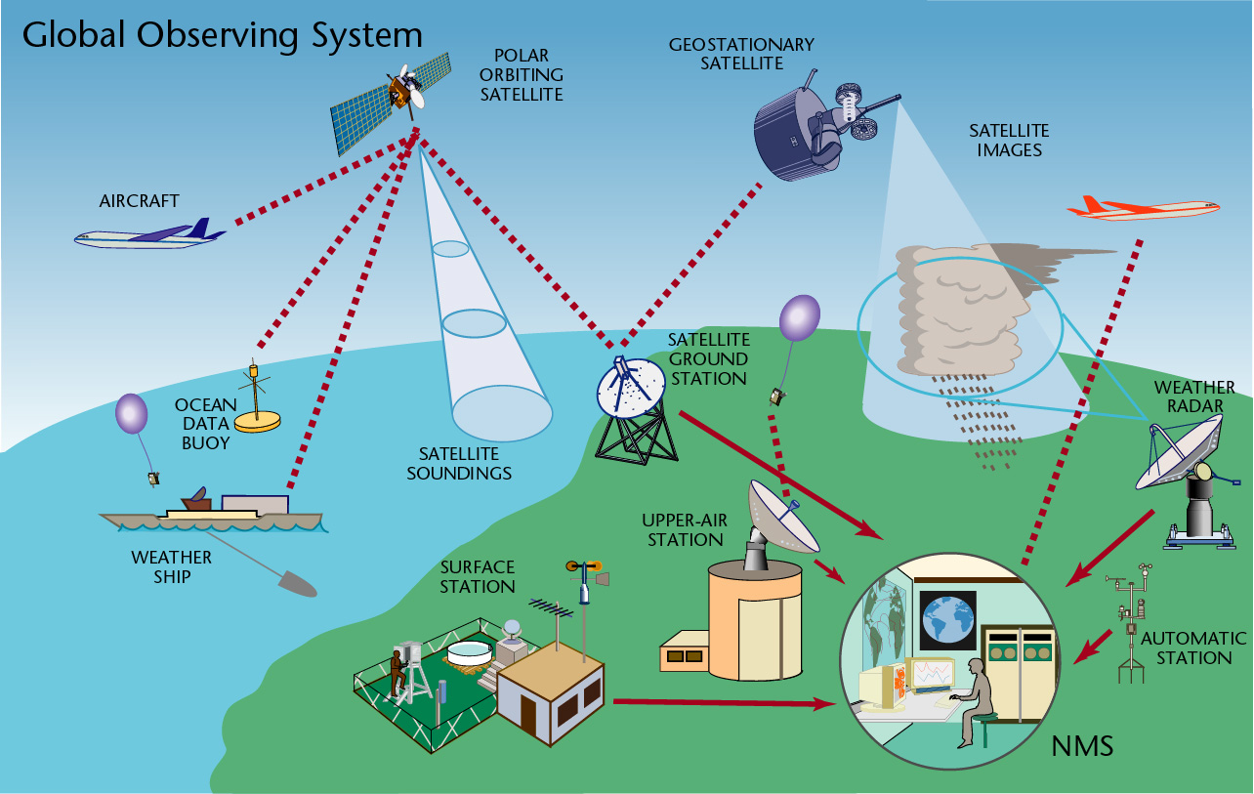
Source: World Meteorological Organisation
Note: NMS = National Meteorological Service

3 ICTs for mitigating the local effects of climate change

The impact of global warming on the world’s climate to date (see Figure 2) is relatively small compared with what can be expected in the future, even if the increase in GHG is stabilized. The IPCC, in its 4th assessment report, predicts a rise in average temperatures of 1.1-6.4°C during the 21st century. According to the report, stabilization of greenhouse gas concentrations is possible at a reasonable cost, with stabilization between 445 ppm and 535 ppm CO₂ equivalent costing less than 3% of global GDP by 2030. However, the results are likely to be highly uneven in their distribution, with low-lying coastal areas (e.g., small island developing states, Bangladesh delta, Netherlands) at risk because of rising sea levels; sub-Saharan Africa at risk due to desertification; a growing number of environmental refugees and increased pressure on sources of fresh water and on vulnerable ecosystems such as coral reefs, tundra, coastal wetlands etc.
At the Antalya ITU Plenipotentiary Conference in 2006, Member States adopted Resolution 136 on the “Use of telecommunications/ICTs for monitoring and management in emergency and disaster situations for early warning, prevention, mitigation and relief” which, inter alia, calls upon the Directors of the Bureaux to continue their technical studies and to support the development of early-warning, mitigation and relief systems. ITU-T’s work in this field includes standardization of call priority in emergency situations (e.g., Recommendation E.106 on the International Emergency Preference System for disaster relief). ITU-T also leads the Partnership Coordination Panel on Telecommunications for Disaster Relief (PCP-TDR), which falls under the responsibility of ITU-T Study Group 2. Its terms of reference include monitoring and promoting technical standardization work in this area.
One of the outcomes of ITU-T Study Group 2’s work is the assignment of a special E.164 country code (888) to the United Nations Office for the Coordination of Humanitarian Affairs (OCHA) for the purpose of facilitating the provision of an international system of naming and addressing for terminals involved in disaster relief activities. This might be used in an area of a country that has been cut off from the national telecommunications system of that country, or for natural disasters covering many countries, such as a tsunami (see Box 1). A number of regional and sub-regional workshops have been held on telecommunications/ICTs for disaster relief, and a Global Forum on 10-12 December 2007 in Geneva.
ICTs can also play a role in environmental protection, waste management and in environmentally-friendly supply chain management. These applications fall under Programme 3 of the Doha Action Plan of ITU-D, notably WTDC-06 Resolution 52. ITU-D will shortly publish a set of guidelines on technology and policy aspects of eEnvironment applications and practices in national development planning.

4 ICTs and concerted action against global warming

The key to combatting global warming is to stabilize and eventually reduce the emission of GHG. International success has been achieved with a reduction in ozone depleting substances (such as chlorofluorocarbon (CFC) gases) to 20 per cent of their 1990 levels by 2004, thanks to the 1987 Montreal Protocol. However, emissions of carbon dioxide have grown by around 80 per cent since 1970 and, despite the 1997 Kyoto Protocol, which set targets for a reduction by 5 per cent of 1990 levels by 2008-2012, there seems little sign of this rate of growth slowing. The next stop for the international community is the UN Climate Change Conference, in Bali from 3-14 December 2007, where it is hoped that a breakthrough can be made.

Reducing carbon emissions will require changes in lifestyle and behaviour, but changes in management practices can also have a positive impact. New energy infrastructure investments are urgently required to move towards cleaner energy production, but there is also much that can be done in reducing energy consumption, in changing agricultural practices and through land-use change. Other longer-term, more high-tech solutions include ocean fertilization, creating a global sunshade and carbon sequestration. It is clear that any mitigation strategy must have multiple elements and ICTs can help with this, either:
Box 1: Tsunami early warning systems: Message sent, but was it received?
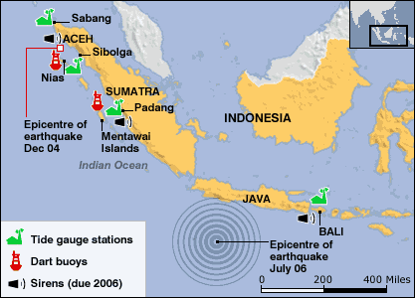 | A good example of the use of ICTs for disaster relief is the establishment of a tsunami early-warning and mitigation system for the Indian Ocean, following the tsunami of 26 December 2004, operating under the aegis of UNESCO’s International Oceanographic Commission. A similar system has existed in the Pacific Ocean since 1965 and the Indian Ocean system is based on 25 seismic stations, 26 national tsunami centres and three deep ocean sensors, with messages sent by satellite phone. It became operational in June 2006. However, when it was needed for real the following month (see map), as a result of the Java earthquake, no message was relayed to coastal areas of Indonesia and hundreds of people were killed by the ensuing tidal wave. In a test
conducted on 24 January 2007, the average delay between a message being sent (by SMS and email) and a response received back ranged between a minimum of two minutes (seven countries) and 31 hours (Indonesia), with three countries failing to respond at all. UNESCO has admitted that more coordination among governments is needed.
Source: Adapted from IOC/UNESCO and BBC.

- Directly, by reducing the ICT sector’s own energy requirements (see Box 2 on next-generation networks). An example is provided by the members of the European Telecommunication Networks Operators’ association (ETNO), who signed an environmental charter in 1996 on sustainability. Between 2001 and 2003, 25 ETNO member telcos succeeded in reducing their overall carbon emissions by 7 per cent and their carbon intensity (per unit of turnover) by 14 per cent (see Figure 5).
- Indirectly, through using ICTs for carbon displacement (see Box 3 on the ETNO/WWF initiative).

Figure 5: Reduction in grams of CO₂ per unit of turnover
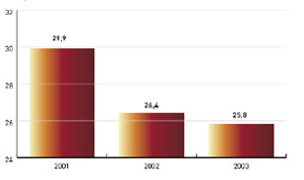
Source: ETNO.
Note: Based on survey of 25 ETNO Member.

- In a systemic way, by providing the technology to implement and monitor carbon reductions in other sectors of the economy (see Box 4 on ICTs and intelligent transport systems).
This distinction between the direct, indirect and systemic value of ICTs in mitigating the effects of global warming provides a useful conceptual framework for analysis of what ITU-T is already doing in the field of climate change (section 5) and the options open to it in formulating a broader strategy (6).

Box 2: Next-generation energy consumption for next-generation networks
The telecommunications industry is currently undergoing a major revolution as it migrates from today’s separate networks (for voice, mobile, data etc) to a single, unified IP-based next-generation network (NGN). The savings will be achieved in a number of ways:
- A significant decrease in the number of switching centres required. For instance, BT’s 21st Century Network (21CN) will require only 100-120 metropolitan nodes compared with its current 3’000 locations;
- More tolerant climatic range specifications for NGN switching locations, which are raised from 35 degrees (between 5 and 40°C) to 50 degrees (between -5 and 45°C). As a result, the switching sites can be fresh-air cooled in most countries rather than requiring special air conditioning.
- NGNs may make use of more recent standards, such as VDSL2 (ITU-T G.993.2), which specifies three power modes (full, low-power and sleep), whereas VDSL has only a single power mode (full power).
However, a particular concern relates to computer data centres, which have very demanding requirements for air-conditioning, electricity supply back-up etc. It is estimated that the five leading search companies use some two million servers. The total power required to run and cool these data centres amounts to around 5 GW and represents some 30 per cent of their total costs. Projects to reduce power consumption by data centres include the “Green grid” consortium involving AMD, Intel, Dell, Sun HP, IBM and others. Other initiatives to reduce power consumption include the “WattWatt” community website established by the IEC for sharing ideas on energy efficiency and the “GridWise” initiative of the US Dept of Energy which allows remote control of virtual thermostats via a web interface.
Sources: Adapted from various sources including Young (2007), Schiwy (2005), AMD, GridWise and IEC.

5 What ITU is already doing on climate change
Box 3: Saving the climate @ the speed of light
A joint initiative between the European Telecommunication Network Operators’ association (ETNO) and the World Wide Fund for nature (WWF), called “Saving the climate @ the speed of light”, is designed to show how ICTs can be used to displace carbon emissions within the European Union. The initiative sprang out of the World Summit on the Information Society (WSIS), following a conference on Telecommunications and Sustainability held in Budapest, 25-26 November 2004. The partners have developed a two part roadmap:
- The first target is to reduce EU carbon emissions by 50 million CO₂ equivalent tonnes annually by 2010 through the strategic use of ICTs;
- The second would be a more ambitious target for 2020, to be set before 2010.
A number of areas in which ICTs can reduce carbon emissions have been identified:
- By reducing the need for travel through video- and audio-conferencing, and by facilitating remote participation in meetings. It is estimated that each 1 per cent reduction in business travel in the EU, amounting to around 50 million audio/video-conference calls, would save around one million tonnes of CO₂ emissions annually.
- Through flexible working patterns, such as telecommuting, facilitated by ICTs. Each one million EU telecommuters would save around one million tonnes of CO₂ emissions annually. A similar study in the United States, where commuting distances tend to be longer, found that today’s 3.9 million telecommuters save between 10-14 million tonnes of CO₂ equivalent.
- By promoting sustainable consumption and development, through “dematerialization” (replacing atoms with bits), for instance through online phone billing (to save on paper bills), online submission of tax forms, by using IPTV to replace trips to the DVD store, by using e-commerce to reduce shopping trips etc.
Source: ETNO and WWF.

ITU, and especially ITU-T via its Study Groups, is already very active in standardization work and other studies that are relevant to climate change, in particular in the areas of energy efficiency, reduced power consumption, mitigation of the effects of climatic change and technologies for reducing carbon emissions. The following examples provide an insight into some of this work:
- ITU-T’s work focuses on the reduction of power requirements of telecommunication equipment including terminal devices and networking equipment. Energy efficient ICT equipment will reduce the production of GHG and hence reduce global warming. ITU-T Study Group 15 (“Optical and other transport network infrastructures”) is in the process of initiating studies to investigate ways to reduce the power consumption of telecommunications equipment. Contributions on power saving for G-PON related studies are already being considered and a survey has been carried out under Q2/15.
- A major focus of ITU’s work in recent years has been on Next-Generation Networks (NGN), which are expected by some commentators (Dittberner Associates) to reduce energy consumption by 40 per cent compared to today’s PSTN (see Box 2).

Box 4: ICTs and intelligent transport systems
In addition to reducing the direct effects of the ICT sector on climate change, and the indirect effects through using ICTs for displacement of carbon emissions, ICT-based technologies can also have a systemic impact on other sectors of the economy and of society, and can help in providing a basis for sustainable development. The potential systemic impact of ICTs is particularly apparent in the transport sector which, according to the Stern report, accounts for 14 per cent of total greenhouse gas emissions.
ICTs can be applied to transport through the development of Intelligent Transport Systems (ITS). Although the main focus of ITS is on the safety, management and efficiency of transport systems, ITS can also be used to reduce their environmental impact. For example:
- Parking guidance systems can lead motorists to the most appropriate parking space, and thereby reduce engine time;
- Similarly, GPS use for navigation or vehicle dispatch can reduce journey time;
- Road pricing schemes, such as the congestion charge in London, can encourage greater use of public transport and reduce congestion, thereby reducing journey times.
ITU’s main efforts in this field are geared towards the annual “Fully Networked Car” workshops, organized jointly with ISO and IEC, the third of which will be held in Geneva, 5-8 March 2008. A particular focus of this event will be ICTs and climate change, with papers presented on:  - Cars as environmental sensors;  - Alternative route/transport planning;  - ICT-enabled energy efficiency  - Car-to-grid energy transfer. | 
Source: ITU-T Technology Watch Briefing Report #1.

- Two of the most promising technologies for improving energy efficiency are radio-frequency identification (RFID) and sensors, which can be combined together to form a ubiquitous sensor network (USN). This technology can be used in many different environmental applications, such as temperature control, efficient control of heating and lighting, telemetry etc. ITU-T has established a “Joint Coordination Activity on Network Aspects of Identification Systems (including RFID)” to coordinate work in this area.
- ITU-T’s mission, from the very earliest days, has included telecommunications for disaster relief and for emergency services, which are particularly important in mitigating the effects of climate change, for instance from flooding due to rising sea levels, or increased incidence of violent storms and hurricanes. Virtually all ITU-T Study Groups are active in this area, notably Study Group 2 which has the lead on telecommunications for disaster relief/early warning (see section 3 above).
- In terms of technologies for reducing carbon emission, virtually every single application of telecommunications—from the telegraph to the telephone call to the email— might be considered as replacing the need for a physical journey. The work of ITU-T’s Study Group 16, on multimedia, is of particular importance, notably in terms of standards for remote collaboration, such as the H series of ITU-T Recommendations on audiovisual and multimedia systems, including video-conferencing, which provide a means for people to collaborate at a distance without needing to travel. Higher performance systems, like telepresence, should help to reduce resistance to the use of these tools.
- ITU is also active in the field of intelligent transport systems, which can help to reduce carbon emissions, for instance by reducing congestion (see Box 4).
- Finally, greater use of recycling and the safe disposal of waste can assist in reducing global warming and the release of GHG. One area of study within ITU-T is “Environmental and Safety Procedures for Outside Plant” (ITU-T Study Group 6). Environmental protection procedures now in place in many countries will affect the selection of materials and mode of installation in outside plant. Study items include environmental aspects resulting from outside plant material recycling. Recommendations are being developed to implement these considerations while recycling copper and optical cables materials.

6 Options for an ITU strategy on climate change

Climate change is a concern for all of humanity and requires efforts on the part of all sections of society. ITU is called upon, inter alia, to “promote, at the international level, the adoption of a broader approach to the issues of telecommunications in the global information economy and society” (CS §9), and thus should exercise leadership in this area. There are a number of options where ITU, in particular the Telecommunication Standardization sector (ITU-T), may take a lead:
- ITU-T and ITU-D will jointly organize a symposium on the topic of ICTs and climate change to be held in Japan or the United Kingdom in April 2008. This symposium will assist in developing an ITU strategy in this field and for identifying areas for future standardization work.
- On the basis of the proceedings of the symposium, and on relevant standardization work, it may be useful to for ITU-T and ITU-D to issue a handbook on ICTs and climate change, in collaboration with ITU-D, focusing on best practice guidelines and assistance to developing countries.
- In addition to those areas identified in section 5 above where work in ITU-T Study Groups is already proceeding, there may be other ways in which standardization work could be carried out. For instance on:
- Energy efficiency, both for devices and for networks;
- Wider climatic tolerance for telecommunications/ICT infrastructure equipment, thereby reducing the requirement for air-conditioning;
- Carbon displacement technologies, like TelePresence (see Technology Watch Briefing Report #2), video-conferencing and other remote collaboration tools, or on mitigating the effects of climate change, such as recycling of telecommunication waste and telecommunications for disaster relief.
- One specific area for standardization work would be the development of a standardized methodology for calculating the carbon footprint associated with the use of telecommunications/ICT equipment. This could apply both to telecommunication service providers and for calculating the carbon displacement effect of ICTs. This project could be carried out with the assistance of a specialist carbon audit company, such as the Carbon Disclosure Project. ISO has already worked on this issue for other sectors of the economy, notably in the three-part standard ISO 14064:2006 which gives guidelines for measuring the release of greenhouse gases.
- TSAG, at its 3-7 December 2007 meeting, agreed upon a liaison statement (TD/520), addressed to all Study Groups, which invites them to assess all existing and new ITU-T Recommendations in the light of climate change, and to report on actions taken. TSAG also proposed that ITU-T establish a target for reductions in GHG emissions that could be enabled by the implementation of ITU-T Recommendations.
- ITU may wish to give more emphasis to facilitating remote participation, for instance by using collaborative tools for broadcasting meetings or by changing participation rules to allow remote participants to make contributions in meetings etc, thereby avoiding travel.
- ITU-T could seek partnerships for sustainable development. ITU was one of the founding partners of the Global e-Sustainability Initiative (GeSI), which sprang out of the Millennium Summit and which has specific working groups on climate change and eWaste. ITU has also recently joined the UN Environment Management Group and will participate in its efforts towards a climate-neutral UN (see section 7). ITU-T may also consider joining the ETNO/WWF partnership (see Box 3) which has been one of the most active in this area, or contributing to IEC’s WattWatt website for electrical energy efficiency.
- As a particular type of partnership, ITU-T may consider more active participation in the climate change efforts of the UN system as a whole, for instance in the preparations for the World Climate Conference-3, to be held in Geneva, October 12-16 2009. Ten UN agencies, led by WMO, already participate in the international organizing committee, and ITU could seek also to join this work. ITU-T may also seek a more active role in facilitating the work of WSIS action line C7 themes on e-Environment and e-Science, for which ITU was named by WSIS as a co-facilitator along with WMO and UNEP.
- ITU-T and ITU-D may offer capacity-building in the field of ICTs and climate change, both through face-to-face workshops and regional forums and through its eLearning programme, to reduce travel requirements.
- ITU may also consider registering some of its own development programmes that are likely to produce a reduction in carbon emissions (for instance, in eLearning, or remote collaboration at meetings) with the Clean Development Mechanism (CDM), established under the Kyoto Protocol, so that it may benefit from the purchase of carbon offsets.

7 Towards a climate-neutral UN

The UN Secretary-General, Ban Ki-moon, has made action on climate change one of the cornerstones of his new mandate and hosted a high-level event in New York on 24 September 2007. He challenged ITU to do the same during his visit to ITU in July 2007. In June 2007, a policy to move towards a climate-neutral UN was announced, under the aegis of the UN Environment Management Group in which ITU participates. Such a commitment would require coordinated policies in a number of areas, including procurement, waste management, paper use, recycling, sustainable development etc. The first step is to estimate the current level of greenhouse gas emissions, to identify areas for reductions, and to consider acquiring carbon offsets to “neutralize” those emissions that cannot be further reduced. This can be done through the Clean Development Mechanism (CDM), established under the Kyoto Protocol. It is important that the UN take a common approach and harmonize the methodology for estimating carbon emissions and purchase of offsets.
Within the UN system, the United Nations Framework Convention on Climate Change (UNFCCC) has been climate-neutral since 2005 and the United Nations Environment Programme (UNEP) will be climate-neutral as from January 2008. Among other intergovernmental organizations, the World Bank has been climate-neutral at its HQ and in major meetings since 2006. Should a similar commitment be made by ITU? Already, considerable progress has been made, especially in the reduction of paper use and the availability of free recommendations online (see Box 5). However, any commitment would require much more detailed study of the existing level of emissions and high-level decisions by ITU’s ruling bodies.

Box 5: ITU-T Recommendations Online and the reduction of carbon emissions
In 1995, when ITU made its first steps in the transition to electronic publishing, ITU-T printed some 368’534 copies of Recommendations, of an average size of 42 pages each. A further one million unsold copies were in stock. In 2007, ITU-T will distribute more than three million Recommendations through free download, but will print only just over 10’000 copies. If ITU-T were still printing (instead of distributing for free online) all its Recommendations, this would require logging around 23 Douglas Fir trees per year, at an annual loss to the environment through absorption ability of 25.3 tonnes of CO₂ over a 100-year period.
To this should be added the cost of transporting the printed Recommendations to customers. In 1995, the level of publication sales (159’669 printed ITU-T Recommendations were sold in that year), required some 108 tonnes of CO₂ emission. By 2007, this had been reduced to just 1.5 tonnes. However, in the absence of free Recommendations online, carbon emissions would have been multiplied over 20-fold rather than decreasing. Thus it can be seen that ITU-T’s transition from paper to electronic publishing represents a major saving for the environment.
Source: ITU, based on analysis using the GHG protocol tool (see: www.GHGprotocol.org) and carbon absorption estimates at www.carbon-info.org.

Glossary of abbreviations and acronyms used in the document

21CN Twenty-first Century Network
2G Second Generation mobile communications
3G Third Generation mobile communications
BOINC Berkeley Open Infrastructure for Networked Computing
C Centigrade
CALM Continuous Air Interface for Long and Medium Range communications
CDM Clean Development Mechanism
CFC Chlorofluorocarbon gases
CO₂ Carbon dioxide
CS ITU Constitution
DVD Digital Versatile Disc
ETNO European Telecommunication Network Operators’ association
EU European Union
GCOS Global Climate Observatory System
GDP Gross Domestic Product
GeSI Global eSustainability Initiative
GHG Greenhouse Gases
G-PON Gigabit Passive Optical Network
GPS Global Positioning by Satellite
GtCo₂-eq Gigatonnes of Carbon Dioxide equivalent
GTS Global Telecommunication System
GW GigaWatts
ICTs Information and Communication Technologies
IEC International Electrotechnical Commission
IOC International Oceanographic Commission
IPCC Intergovernmental Panel on Climate Change
IPTV Internet Protocol Television
ISO International Organization for Standardization
ITS Intelligent Transport Systems
ITU International Telecommunication Union
ITU-T ITU Telecommunication standardization sector
NGN Next-Generation Network
NMS National Meteorological Service
OCHA Office for the Coordination of Humanitarian Affairs
PC Personal Computer
PCP-TDR Partnership Coordination Panel on Telecommunications for Disaster Relief
RFID Radio Frequency Identification
SMS Short Message Service
TSAG Telecommunication Standardization Advisory Group (in ITU-T)
UN United Nations
UNEP United Nations Environment Programme
UNESCO United Nations Educational Scientific and Cultural Organization
UNFCCC United Nations Framework Convention on Climate Change
USN Ubiquitous Sensor Network
VDSL Very high speed Digital Subscriber Line
WG Working Group
WMO World Meteorological Organization
WSIS World Summit on the Information Society
WWF World Wide Fund for nature

Endnotes and references for further reading

UN Intergovernmental Panel of Climate Change (IPCC), Working Group 3 contribution on “Climate Change Mitigation” to the Fourth Assessment Report, 2007, available at: www.mnp.nl/ipcc/pages_media/AR4-chapters.html.
IPCC, Working Group 1 contribution on “The physical science basis” to the Fourth Assessment Report, 2007, available at: www.ipcc-wg1.ucar.edu/wg1/wg1-report.html.
Speech by Mr Rajendra Pachauri, Chairman of the IPCC, to the UN High-level event on climate change, 24 September 2007, available at: www.ipcc.ch/Pachauri_240907.pdf and accompanying presentation at: www.ipcc.ch/UN_NYC_24thSep2007.ppt.
See “The impact of ICT on global emissions”, report prepared by McKinsey for the UN Environment Group, 24 October 2007.
For an account of the history of the science of climate change, see Spencer Weart’s website at: www.aip.org/history/climate/index.html.
For a description of the WMO’s Global Telecommunication System, see: www.wmo.int/pages/prog/www/TEM/gts.html.
The World Weather Watch programme is described at: www.wmo.int/pages/prog/www/index_en.html and the global climate observing system at: www.wmo.int/pages/prog/www/OSY/GOS.html.
See for instance www.climateprediction.net/index.php which claims to be the world’s largest experiment on climate modeling and uses a programme called BOINC (Berkeley Open Infrastructure for Networked Computing) for distributed computing.
See “The heat is on”, survey of climate change in The Economist, Sept 7 2006 edition, available at: www.economist.com/opinion/displaystory.cfm?story_id=7852924, and IPCC Working Group 3 contribution on “Climate Change Mitigation” to the Fourth Assessment Report, 2007, at: www.mnp.nl/ipcc/pages_media/AR4-chapters.html.
All three Sectors are involved in activities related to emergency telecommunications, and an inter-sectoral task force has been established to coordinate this work. Relevant ITU-R Recommendations include F.1105 (2006), BO.1774 (2007), S1001 (2006), and a number of different Recommendations in the M series (mobile, radiodetermination, amateur and related satellite services).
For more information on the PCP-TDR, see: www.itu.int/ITU-T/special-projects/pcptdr.
For more information on eEnvironment activities, see the ITU-D website at: www.itu.int/ITU-D/cyb/app/e-env.html/
For more on the Bali conference, see the UN Framework Convention on Climate Change (UNFCCC) website at: www.unfccc.int/meetings/cop_13/items/4049.php. The call for a breakthrough in Bali was made by the UN Secretary-General at the conference “The Future in our hands”, 24 September 2007 in New York, see: www.un.org/climatechange/2007highlevel/summary.shtml.
Dittberner Associates International (www.dittberner.com/) have constructed a number of models showing the benefits of NGN, which show and average 40 per cent saving in energy requirements as well as a 40 per cent saving in investment requirements and an 80 per cent saving in space requirements (see for instance presentation at: www.iee.org.hk/iee/files/58.pdf).
The UN environment management group website is at: www.unemg.org/.
The website for the Secretary-General’s high-level event on climate change, “The future in our hands: Addressing the leadership challenge of climate change”, 24 September 2007, can be found at: www.un.org/climatechange/2007highlevel/index.shtml.
The term “climate-neutral” is more accurate that “carbon-neutral” in that carbon is only one of many greenhouse gases.
More details on the Clean Development Mechanism can be found on the website at: www.cdm.unfccc.int/index.html.
The UN has chosen to use the GHG Protocol, a tool developed by the World Resources Institute and the World Business Council for Sustainable Development, see www.GHGprotocol.org.

