Draft ETSI TR DD V1.1 (2010-07)
Technical Report
Overview of the Coexistence Issues Stemming from the Current Digital Dividend Decisions

Annex G: Cordless Audio (Radio Microphones, Wireless Headphones, Baby Alarms and In-Ear Monitors (IEM)) in the band 863-865MHz

<

Reference
<Workitem>
Keywords
<keyword>
ETSI
650 Route des Lucioles
F-06921 Sophia Antipolis Cedex - FRANCE

Tel.: +33 4 92 94 42 00 Fax: +33 4 93 65 47 16

Siret N° 348 623 562 00017 - NAF 742 C
Association à but non lucratif enregistrée à la
Sous-Préfecture de Grasse (06) N° 7803/88

Important notice
Individual copies of the present document can be downloaded from:
http://www.etsi.org
The present document may be made available in more than one electronic version or in print. In any case of existing or perceived difference in contents between such versions, the reference version is the Portable Document Format (PDF). In case of dispute, the reference shall be the printing on ETSI printers of the PDF version kept on a specific network drive within ETSI Secretariat.
Users of the present document should be aware that the document may be subject to revision or change of status. Information on the current status of this and other ETSI documents is available at http://portal.etsi.org/tb/status/status.asp
If you find errors in the present document, please send your comment to one of the following services:
http://portal.etsi.org/chaircor/ETSI_support.asp
Copyright Notification
No part may be reproduced except as authorized by written permission.
The copyright and the foregoing restriction extend to reproduction in all media.

© European Telecommunications Standards Institute 2010.
All rights reserved.
DECTTM, PLUGTESTSTM, UMTSTM, TIPHONTM, the TIPHON logo and the ETSI logo are Trade Marks of ETSI registered for the benefit of its Members.
3GPPTM is a Trade Mark of ETSI registered for the benefit of its Members and of the 3GPP Organizational Partners.
LTE™ is a Trade Mark of ETSI currently being registered
for the benefit of its Members and of the 3GPP Organizational Partners.
GSM® and the GSM logo are Trade Marks registered and owned by the GSM Association.

Contents
Intellectual Property Rights 4
Foreword 4
1 Definitions, symbols and abbreviations 4
1.1 Symbols 4
1.2 Abbreviations 5
Annex G: Cordless Audio 5
G.1 Executive Summary 5
G.2 Introduction 6
G.3 Cordless audio devices found in the 863-865MHz band 6
G.4 Test setup 6
G.5 Observations 9
G.5.1 Immunity level of cordless audio against an 857MHz LTE signal 10
History 11

Intellectual Property Rights
IPRs essential or potentially essential to the present document may have been declared to ETSI. The information pertaining to these essential IPRs, if any, is publicly available for ETSI members and non-members, and can be found in ETSI SR 000 314: "Intellectual Property Rights (IPRs); Essential, or potentially Essential, IPRs notified to ETSI in respect of ETSI standards", which is available from the ETSI Secretariat. Latest updates are available on the ETSI Web server (http://webapp.etsi.org/IPR/home.asp).
Pursuant to the ETSI IPR Policy, no investigation, including IPR searches, has been carried out by ETSI. No guarantee can be given as to the existence of other IPRs not referenced in ETSI SR 000 314 (or the updates on the ETSI Web server) which are, or may be, or may become, essential to the present document.

Foreword
This Technical Report (TR) has been produced by CENELEC – ETSI Joint Working Group on the Digital Dividend interference issues.
Since the changes in spectrum allocation for the broadcasting band 470-862MHz resulting from the WRC decision of 2007 were announced, the European Commission (EC) and the Electronic Communications Committee (ECC) moved quickly to consider “The identification of common and minimal (least restrictive) technical conditions for 790 MHz – 862 MHz for the digital dividend in the European Union” (CEPT Report 30). Following the reports acceptance an ECC Decision (DEC (09)03) was agreed and published, an EC non binding decision has been published in May 2010.
However, whilst the adverse effects on terrestrial television reception have received some attention during the ECC work on the EC mandate, a number of areas affecting domestic reception of television and use of wireless broadband, had not been considered these include ‘white space devices’ and emergency services. During the early part of 2009 interference problems where identified by the Hybrid Fibre Coaxial networks (HFC) industry, following a number of meetings and workshop the Commission sent a letter of clarification to the European Standards Organizations (ESO) requesting standardization work to address the issues which had been identified.
In addition to the HFC networks, communal aerial systems and cordless audio have been identified as victims.
During the work of the Joint ETSI-CENELEC working group on Digital Dividend issues and the work by UK Digital Communications Knowledge Transfer Network (DCKTN), the question was raised of interference into devices operating outside the target band of 790-862MHz. This paper is a response to the question.
The Devices identified have been available since the mid 1990s in this frequency band and are mainly for domestic and amateur use. It is the only pan European spectrum available for radio microphones.
We thank various manufacturers for their assistance in these tests.
This annex identifying the issues for cordless Audio is part of the ESO response to the Commission.

1 Definitions, symbols and abbreviations

1.1 Symbols
For the purposes of the present document, the following symbols apply:
dB decibel
dBm power ratio in dB (decibels) referenced to one milliWatt (mW)
kHz kiloHertz – 1 thousand cycles per second
MHz MegaHertz – 1 million cycles per second
mW milliWatts

1.2 Abbreviations
For the purposes of the present document, the following abbreviations apply:
CEPT European Conference of Postal and Telecommunications Administrations
EC European Commission
ECC European Communications Committee
ECN Electronic Communications Network
ERP Effective Radiated Power
FDD Frequency Division Duplex
FM Frequency Modulation
GSM Global System for Mobile communications
LTE Long-Term Evolution
QPSK Quadrature Phase Shift Keying
RF Radio Frequency
SC-FDMA Single Carrier – Frequency Division Multiple Access

Annex G: Cordless Audio

G.1 Executive Summary
A variety of six professional, semi-professional and consumer “cordless audio” devices operating in the license-exempt frequency band 863-865MHz conforming to the harmonised standards EN 301 357 or EN 300 422 were tested for susceptibility to a 10MHz bandwidth LTE signal transmitting from 700MHz to 862MHz emulating both the base station and terminal unit. The term ‘cordless audio’ covers a range of devices, all of which feature a transmitter with an audio input, and a receiver with an audio output, and includes devices such as radio microphones, wireless headphones and tour guide systems.
- 50% of devices were adversely affected by a simulated Electronic Communications Network (ECN) terminal unit operating at the highest frequency channel (857MHz);
- A third of devices were susceptible to LTE transmissions below the proposed ‘uplink’ section of the band (below 832MHz);
- One device out of six was susceptible to LTE transmissions below the lowest edge of the proposed ECN band (below 779MHz).
ECN terminal units can use up to 316mW (ECC Decision (09)03 and EC Decision 210/267/EU). Those devices susceptible to interference on the highest planned LTE terminal unit channel, centred at 857MHz, will start to show interference at powers above 0.15mW ERP (LTE signal transmitted from a 3m distance). This is a conservative figure with the cordless audio transmitter and receiver within 1.5m of each other, whereas normal operating conditions for the cordless audio equipment would probably be in the range 3-5m.
One unit also showed interference from the base station transmit frequencies, which could well affect a large percentage of existing wireless headphone users.

G.2 Introduction
The frequency allocation of 863-865MHz for cordless audio devices has been available since the mid-1990s. It is primarily populated by a mix of consumer and semi-professional equipment which has a life expectancy in excess of 9 years and professional equipment whose life expectancy will be greater than 12 years: therefore currently there will be a wide range of equipment in use which will be both analogue and digital. In addition to these devices there is an allocation at 864.8-865MHz for cordless baby alarms; these have not been tested but are likely to have a poorer immunity as they normally conform to EN 300 220.
Whilst the specific applications vary, the fundamental requirement is to receive audio frequency data (from voice or other source), convert it to RF and transmit to a receiver, where it is demodulated back to audio frequency for onward transmission or use. Transmitters may be built into microphones or have an audio input socket. Receivers may be integrated into headphones or have an audio output socket.
The information and technical specification of the Electronic Communications Networks (ECN) systems will be found in CEPT Report 30 and ECC Decision (09)03. Information sources used within this document can be found in the ETSI docbox at: http://docbox.etsi.org/Etsi_Cenelec/PUBLIC%20FOLDER%20on%20DD/.

G.3 Cordless audio devices found in the 863-865MHz band
Cordless audio devices intended for use by consumers or professionals are available in a wide variety of application-specific forms. Audio quality and receiver performance will vary greatly between consumer and professional equipment. Common uses include:
- Wireless headphones for consumer markets. These will commonly be plugged into the headphone outlet of televisions, radios, Hi-Fi systems, games consoles and similar devices;
- Consumer radio microphones, used with karaoke systems, camcorders and similar devices;
- Radio microphones for semi-professional markets;
- Radio microphones for professional markets;
- Portable wireless microphone and receiver for professional markets;
- Butt transmitters, these are plug-on units for existing audio microphones;
- In Ear Monitoring systems (IEM) enable performers to hear the combined audio output of other musicians or singers;
- Tour guide systems. These systems allow a tour guide to provide a commentary on the subject of the tour. In some cases there will be more than one frequency in use to allow additional languages to be used; a voice quality 7 kHz audio bandwidth is common in these devices;
- Baby Alarms consisting of a sensitive microphone in the vicinity of a baby with the receiver adjacent to parents or other adults.
These devices may use FM or digital modulation with an output power below 10mW. The receivers are capable of receiving signals in the 863-865MHz band.

G.4 Test setup
The objective was to determine if ECNs operating in the reallocated band 790-862MHz using LTE modulation will cause interference to incumbent devices transmitting and receiving in the 863-865MHz band. As the cordless audio devices consists of two parts (a transmitter that broadcasts to a receiver or receivers in the vicinity), it was necessary for both components to be operating normally in the presence of an interfering signal in the 790-862MHz band to determine if there is potential for interference to the transmitter and/or the receiver.
ECNs are primarily a data service, unlike the existing GSM systems which are primarily voice orientated. Initial offerings of ECNs using LTE modulation schemes are likely to include data dongles which may well be in close proximity to domestic equipment. Various tests have been carried out within Europe and ECN terminal units have been shown to cause interference up to 4m from the terminal unit, this means that terminal units in adjacent flats or rooms may well generate interference into domestic setups. As these devices migrate into ‘mobile phones’ the possibility of these being in close proximity to radio microphones or even on the user of the cordless audio device will increase.
The cordless audio devices were set up in the anechoic chamber at a 3m separation distance from the interferer antenna. Initially the cordless audio transmitter was located centrally and held stationary whilst the output of the receive unit was monitored as it was being moved around in proximity to the cordless audio transmitter. The locations were exchanged, and testing repeated. Moving the cordless audio units enables the impact of any nulls or peaks in the transmit power of both the LTE and cordless audio signals to be overcome.
The devices were either mains-powered or powered by fully-charged or new batteries.
A 1 kHz audio tone was supplied to the transmit device, and the output of the receive device monitored on headphones in every case.
The interferer was a 316mW ERP LTE signal transmitted in a 10MHz bandwidth, using a Frequency Division Duplex scheme. The characteristics of the signal are contained in Table 1.
Radio format | Bandwidth | Standard rev | Access technique | Modulation | Waveform name
FDD Uplink | 10MHz | 2008-09 | SC-FDMA | Full-filled QPSK | LTE_FDD_UL_10
Table 1: LTE modulation parameters
The field strength was monitored by a NARDA probe, which can be seen in Figure 2 below.
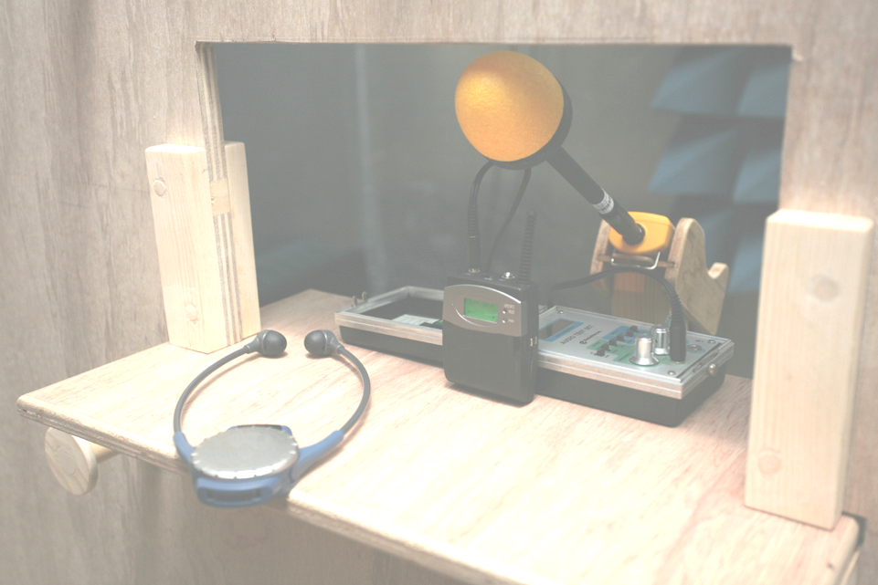
Figure 2: a tour guide system comprising of transmitter (square black device) and receiver (blue headphones with integral receiver) during test preparation. The 1kHz tone generator can be seen behind the transmitter, and a NARDA field strength probe can be seen behind that.
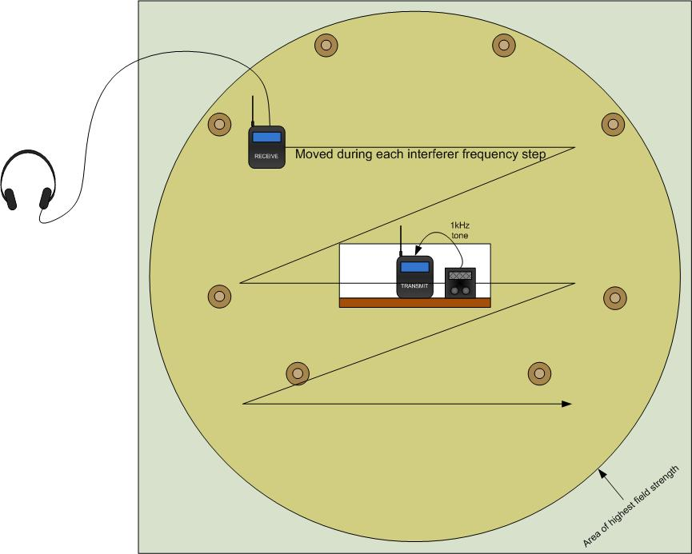
Figure 3: Test support board layout. In this example a portable transmitter broadcasts from a central location and a portable receiver is moved around the board.
Signal generator
RF amplifier
3 meters
1.5 meters
Bilog antenna
Cable 3
Cable 6

Control room
Chamber

Receive
Transmit
Test support
Movement of receive unit
Figure 4: Test environment and arrangement of equipment

G.5 Observations
These results were obtained from 4th-12th May 2010.
LTE generator centre frequency (1MHz steps) | FM Wireless headphones | Semi-professional radio microphone | Professional radio microphone system 1 | Professional radio microphone system 2 | Professional portable wireless microphone and receiver | Tour guide system
700-769
770-779 | *
780-789 | **
790-799 | **
800-809 | **
810-819 | *
820-829 | * | *
830-839 | ** | **
840-849 | ** | *
850-856 | ** | **
857 - highest potential 10MHz LTE Centre Frequency | ** | ** | ***
Key:
* | Mild LTE noise present
** | Moderate LTE noise present
*** | Strong LTE noise present
Table 2: cordless audio devices operating in 863-865 MHz. Susceptibility to LTE operating from 700 – 857MHz.
When listening to high quality music over a system any noise or interference is unacceptable. Where a radio microphone is in use, any interference will ruin a production or cause the audio amplification to overload with possible harm to the audience.
System susceptibility varied dependant on the physical location of the receiver relative to both the interfering transmission antenna and the cordless audio transmitter: nulls and peaks were detected during lateral movement around the 3m separation point, which in most cases had a reasonable or dramatic effect on the scale of the interference.
Where the operating frequency could be selected, 861.3MHz was set as the frequency of transmission/reception for the cordless audio unit. Where selection could not be made, transmission was within the 863-865MHz band.
A 10MHz bandwidth LTE signal with a centre frequency of 857MHz will occupy the range 852-862MHz.

G.5.1 Immunity level of cordless audio against an 857MHz LTE signal
Three of the six devices tested are susceptible to signals radiated within the proposed 790-862MHz band. ECC Decision 09/03 provides for a terminal unit power of 23dBm +/- 2dB. For the purposes of testing a 25dBm signal has been used and stepped down where interference was observed, in an attempt to discern the power boundary where interference ceases. Table 3 shows the signal levels where interference to the cordless audio equipment starts to be observed.
 | Radiated power (ERP, dBm) | Radiated power (ERP, mW)
FM Wireless headphones | 13.96 | 24.88
Semi-professional radio microphone | 15.3 | 33.88
Professional radio microphone system 1 | -8.14 | 0.15
Table 3: maximum 10MHz bandwidth LTE signal power
In addition whilst the base station out-of-band emissions are stringent at -49.5dBm EIRP, there is the possibility of interference from base stations under some circumstances, especially with the older cordless audio and baby alarm systems. The slide below reproduced by kind permission of UK Ofcom provides a graphic view of the energy dispersion over the band; this is obtained from the block edge mask contained in CEPT Report 30.
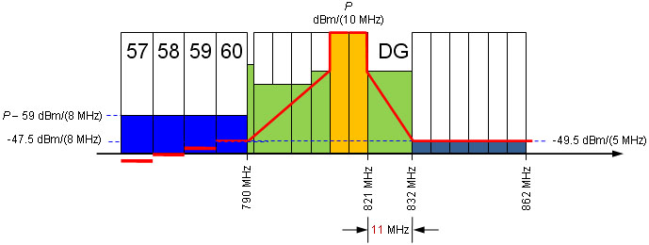
Figure 1: excerpt from presentation “MFCN base station emission limits for different 800 MHz licensees”, UK Ofcom.

History
Document history
V1 | June 2010 | Document creation
V1.1 | July 2010 | Editorial amendments to annex numbering

