International Telecommunication Union

Open Communication Architecture Forum

OCAF Focus Group

CGOE Components

SNMP Client

Version 1.0

July 2006

Y.cgoe-cmpts-Annex snmp.clnt
Carrier grade open environment components
ANNEX snmp.clnt
The SNMP client CGOE component
Summary
This Annex specifies the SNMP client CGOE component.
Keywords
<Optional>

1 Scope
This Annex specifies the SNMP client CGOE component.

2 References
The following ITU-T Recommendations and other references contain provisions, which, through reference in this text, constitute provisions of this Recommendation. At the time of publication, the editions indicated were valid. All Recommendations and other references are subject to revision; users of this Recommendation are therefore encouraged to investigate the possibility of applying the most recent edition of the Recommendations and other references listed below. A list of the currently valid ITU-T Recommendations is regularly published.
The reference to a document within this Recommendation does not give it, as a stand-alone document, the status of a Recommendation
Editor’s note: To be completed

3 Definitions
Editor’s note: To be completed
This Recommendation defines the following terms:
3.1 Application: (See Recommendation Y.CGOE)
3.2 Carrier grade: (See Recommendation Y.CGOE)
3.3 CGOE component: (See Recommendation Y.CGOE)
3.4 End-to-End Security: End-to-end security refers to security between two Diameter nodes, possibly communicating through Diameter Agents.
3.5 Functional requirements: (See Recommendation Y.CGOE)
3.6 Middleware: (See Recommendation Y.CGOE)
3.7 Non-functional requirements: (See Recommendation Y.CGOE)
Agent In computer science, a software agent is a piece of autonomous, or semi-autonomous proactive and reactive, computer software. Many individual communicative software agents may form a multi-agent system.
(Taken from Wikipedia http://en.wikipedia.org/wiki/Software_agent )
Client-Server Client-Server is a network application architecture which separates the client (usually the graphical user interface) from the server. Each instance of the client software connects to a server or application server.
Client-Server is a scalable architecture whereby each computer or process on the network is either a client or a server. Server software runs mostly on powerful computers dedicated for exclusive use to running the application. Client software on the other hand generally runs on common PCs or workstations. Clients get all or most of their information and rely on the application server for things such as configuration files, stock quotes, business application programs or to offload compute intensive application tasks back the server to keep the client computers (and client computer user) free to perform other tasks.
(Taken from Wikipedia http://en.wikipedia.org/wiki/Client-server )
Framework In software development, a Framework is a defined support structure in which another software project can be organized and developed. Typically, a framework may include support programs, code libraries and a scripting language amongst other software to help develop and glue together the different components of your project.
(Taken from Wikipedia http://en.wikipedia.org/wiki/Framework )
Interface In general usage, an interface is the point, area, or surface along which two substances or other qualitatively different things meet; it is also used metaphorically for the juncture between items. The word interface is sometimes (perhaps only in engineering) shortened to "i/f" or IF.
(Taken from Wikipedia http://en.wikipedia.org/wiki/Interface)
MIB A management information base (MIB) comprises a collection of objects in a (virtual) database used to manage entities (such as routers and switches) in a network. Objects in the MIB are defined using Abstract Syntax Notation One (ASN.1). The database is hierarchical (tree structured) and entries are addressed through object identifiers. Internet documentation RFCs discuss MIBs, notably RFC1065 (http://www.ietf.org/rfc/rfc1065.txt), "Structure and Identification of Management Information for TCP/IP based internets", and its two companions, RFC 1066 (http://www.ietf.org/rfc/rfc1066.txt), "Management Information Base for Network Management of TCP/IP-based internets", and RFC 1067 (http://www.ietf.org/rfc/rfc1067.txt), "A Simple Network Management Protocol".
(Taken from Wikipedia http://en.wikipedia.org/wiki/Management_information_base )
PDU In telecommunications, the term protocol data unit (PDU) has the following meanings:
1. Information that is delivered as a unit among peer entities of a network and that may contain control information, address information, or data.
2. In layered systems, a unit of data that is specified in a protocol of a given layer and that consists of protocol-control information of the given layer and possibly user data of that layer.
(Taken from http://en.wikipedia.org/wiki/PDU )
Protocol In computing, a protocol is a convention or standard that controls or enables the connection, communication, and data transfer between two computing endpoints. Protocols may be implemented by hardware, software, or a combination of the two. At the lowest level, a protocol defines a hardware connection.
(Taken from Wikipedia http://en.wikipedia.org/wiki/Protocol )
Security In telecommunication, the term security has the following meanings:
A condition that results from the establishment and maintenance of protective measures that ensures a state of inviolability from hostile acts or influences.
With respect to classified matter, the condition that prevents unauthorized persons from having access to official information that is safeguarded in the interests of national security.
Measures taken by a military unit, an activity or installation to protect itself against all acts designed to, or which may, impair its effectiveness.
(Taken from Wikipedia http://en.wikipedia.org/wiki/Security )

4 Abbreviations
Editor’s note: To be completed
AAA | Authentication, Authorization and Accounting
CGOE | Carrier Grade Open Environment
SNMP | Simple Network Management Protocol

5 Conventions
This Recommendation uses the CGOE component diagram conventions detailed in clause 5 of the main body of this Recommendation.

6 The SNMP client CGOE component

6.1 General
A Simple Network Management Protocol (SNMP) is a component that operates as an interface. It allows two entities to communicate with each other in a directed manner for requesting, writing and notifying management data. The SNMP framework is more than a protocol for moving data. It consists of a data modeling language, definitions of management information (the Management Information Base, or MIB), a protocol definition and security and administration.
The component SNMP acts as a server, which provides a concrete communication facility.
A technology independent description is in Figure snmp.clnt.1/Y.cgoe.cmpts.
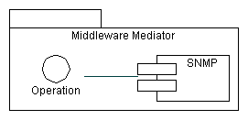
Figure snmp.clnt.1/Y.cgoe.cmpts - Technology Independent View
This shows that a SNMP offers the capability for communication based on operations. This is the primary interface for a SNMP Interface.
SNMP has three main subcomponents as shown in Figure snmp.clnt.2/Y.cgoe.cmpts.
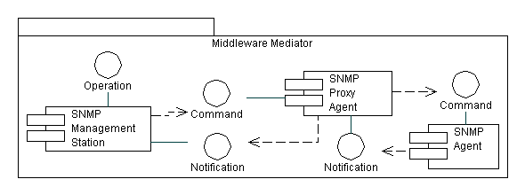
Figure snmp.clnt.2/Y.cgoe.cmpts - Subcomponents
The SNMP Management Station behaves like a client in a client-server system whereas the SNMP Agent behaves like the server in a client-server system. If a server contains several subsystems each of which offers a separate SNMP interface the use of SNMP proxy agents becomes necessary. Each SNMP agent communicates through the singleton instance of a SNMP proxy agent with a SNMP Management Station.
The interface operation of SNMP offers several operations as shown in Figure snmp.clnt.3/Y.cgoe.cmpts.
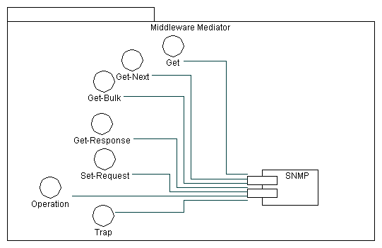
Figure snmp.clnt.3/Y.cgoe.cmpts - Operations of SNMP
The interface operation includes a set of operation which can be divided into two main classes. The first class of the operations (Get, Get-Bulk, Get-Next, Get-Response and Set-Request) is used to initiate communication from the SNMP Management Station. This allows a client to write or to request information from a server. The second class of operation (Trap) is used to initiate communication from a SNMP Agent or a SNMP Subagent. This allows a server to inform a client spontaneously about any kind of events.
This document focuses on the Client (Management Station) part of the SNMP component. However most of the description holds also for the Server (Agent) part of the SNMP component.

6.2 Relationship with other CGOE components
A CGOE compliant SNMP Client interface makes use of other interfaces as shown in illustration 4. These are secondary interfaces which are described in the CGOE documentation for each component. Each of these secondary interfaces will have one or more technology-specific instances.
The CGOE component SNMP Client is used by the CGOE component OAM&P Middleware. SNMP is an optional interface which may be present or not to the OAM&P Middleware.
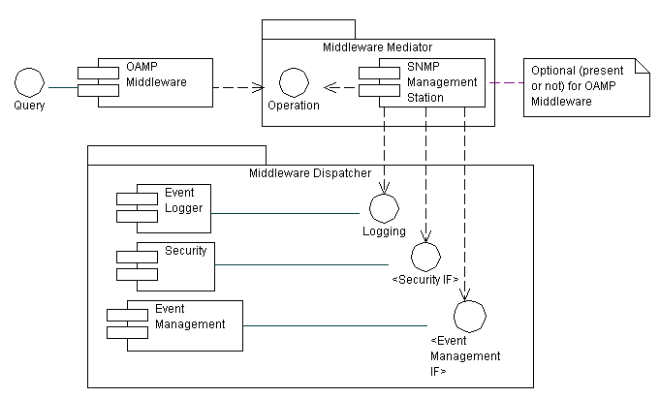
Illustration 4 secondary Interfaces

6.3 Internal functional properties

6.3.1 Proxy Forwarder Applications
A proxy forwarder application deals with forwarding SNMP messages to target applications, e.g. when the target application cannot be reached directly. The implementation is optional.
Standards
IETF RFC 2573

6.3.2 Security
Security deals with message level security and targets authentication, encryption and timeliness checking.
Standards
IETF RFC 2571, IETF RFC 2574

6.3.3 Access Control
Access Control deals with an access control model that defines mechanisms whether access to a managed object should be allowed.
Standards
IETF RFC 2571, IETF RFC 2574, IETF RFC 2575

6.3.4 Tracing
Tracing deals with monitoring communication traffic for the purpose of error finding
Standards
None

6.4 Non-functional properties

6.4.1 Transaction Scalability
This property measures how many PDU can be transferred per second.
Unit of measure: PDU/second

6.4.2 Availability
This property measures the (maximal) downtime of the component within a given time unit, typically a year.
Unit of measure: %

6.4.3 Reliability
This property measures a) if all data are transmitted, b) received in the original order and c) that there are no data duplicates.
Unit of measure: Yes/No

6.4.4 Extensibility
This property measures if an additional MIB may be integrated into an installed and running system.
Unit of measure: Yes/No

6.4.5 Modification of multitude Data Records
This property measures if a command of the interface operation supports modifying more than one data record.
Unit of measure: Yes/No

6.4.6 Compatibility
This property measures how different versions of the component may replace each other.
Unit of measure: total / with restrictions / none

6.4.7 Recovery
This property measures the behavior of the components if there is no response or confirmation e.g. due to a temporary outage.
Unit of measure: yes / partly / no

6.5 Interfaces

6.5.1 SNMP Client-IF-01 <Operation>
Provides the communication commands, the used management information base (MIB) and the user management.
Standard
IETF RFC 2570, IETF RFC 2574, IETF RFC 2500

6.5.2 SNMP Client-IF-02 <Notification>
Provides the trap notification
Standard
IETF RFC 2570, IETF RFC 2573, IETF RFC 2500

6.5.3 SNMP Client-IF-03 <Logging>
Provides the capability to log any transaction in relation to the component SNMP.
Standard
GAP (Possible Solution the logging component of the specific Middleware can be used)

6.5.4 SNMP Client-IF-04 <Security IF>
The <Security IF> is the interface to the component Security. Security also includes access control.
Standard
GAP

6.5.5 SNMP Client-IF-05 <Event Management IF>
The <Event Management IF> is the interface to the component Event Manager.
Standard
GAP

6.5.6 SNMP Client-IF-06 <Data Definition Language>
Provides the mechanisms used for describing and naming objects for the purpose of management. The specifications of the data definition language include the "Structure of Management Information Version 2 (SMIv2)” and related specifications. The Structure of Management Information (SMIv2) defines fundamental data types, an object model, and the rules for writing and revising MIB modules.
Standard
IETF RFC 2570, IETF RFC 2578

6.5.7 SNMP Client-IF-07 <User Datagram Protocol>
Provides the mechanisms used for transferring any user datagram over the internet protocol.
Standard
IETF RFC 0768, STD 006

7 Security
Editor’s note: To be added

____________________________
Bibliography
Editor’s note: To be added
__________________

