International Telecommunication Union

Open Communication Architecture Forum

OCAF Focus Group

CGOE Components

Performance Manager

Version 1.0

July 2006

Y.cgoe-cmpts-Annex perfmgr
Carrier grade open environment components
ANNEX perfmgr
The performance manager CGOE component
Summary
This Annex specifies the performance manager CGOE component.
Keywords
<Optional>

1 Scope
This Annex specifies the CSCF CGOE component.

2 References
The following ITU-T Recommendations and other references contain provisions, which, through reference in this text, constitute provisions of this Recommendation. At the time of publication, the editions indicated were valid. All Recommendations and other references are subject to revision; users of this Recommendation are therefore encouraged to investigate the possibility of applying the most recent edition of the Recommendations and other references listed below. A list of the currently valid ITU-T Recommendations is regularly published.
The reference to a document within this Recommendation does not give it, as a stand-alone document, the status of a Recommendation
Editor’s note: To be completed

3 Definitions
Editor’s note: To be completed
This Recommendation defines the following terms:
3.1 Application: (See Recommendation Y.CGOE)
3.2 Carrier grade: (See Recommendation Y.CGOE)
3.3 CGOE component: (See Recommendation Y.CGOE)
3.4 End-to-End Security: End-to-end security refers to security between two Diameter nodes, possibly communicating through Diameter Agents.
3.5 Functional requirements: (See Recommendation Y.CGOE)
3.6 Middleware: (See Recommendation Y.CGOE)
3.7 Non-functional requirements: (See Recommendation Y.CGOE)

4 Abbreviations
Editor’s note: To be completed
AAA | Authentication, Authorization and Accounting
CGOE | Carrier Grade Open Environment

5 Conventions
This Recommendation uses the CGOE component diagram conventions detailed in clause 5 of the main body of this Recommendation.

6 The performance manager CGOE component

6.1 General
Performance Monitoring consists of three sub-components which can be situated on one or more hardware system and software application. The objectives of these components are as follows –
- Collection and Aggregation of performance data into a single repository for monitoring the performance of the application and network infrastructure.
- Collect/Accept real-time notifications of performance degradation that enable the other components or user to act quickly and resolve issues before it become apparent to the end users.
- Generate detailed reports that give a complete view of applications, systems and network infrastructure performance.
- Provide on-demand reports that enable troubleshooting, decisions making to achieve optimal performance and resource planning.
The three keys sub-components of Performance Monitoring are –
- Data Collection agents – acquire performance metric from Operating Systems, Network Devices, Databases, Applications and etc…
- Performance Monitoring Server – serves as the agent controller, performance data repository and performance data analyzer.
- Console – serves as control point for monitoring the landscape of the solution. It provides all the monitored system operating status, and the performance data and events.

6.2 Relationship with other CGOE components
Performance Monitoring offers services to other CGOE software components to enable them to proactively control traffic to and resources of the systems.
Performance Monitoring relies on other CGOE components to provide performance data. The agent sub-components that collect data can either be integrated into other components with an open API or as a stand alone component that collects metrics from the Operating System, Database, Network elements and Applications.
Performance Monitoring also offers other CGOE components real-time, snapshots, summary and customized reports.

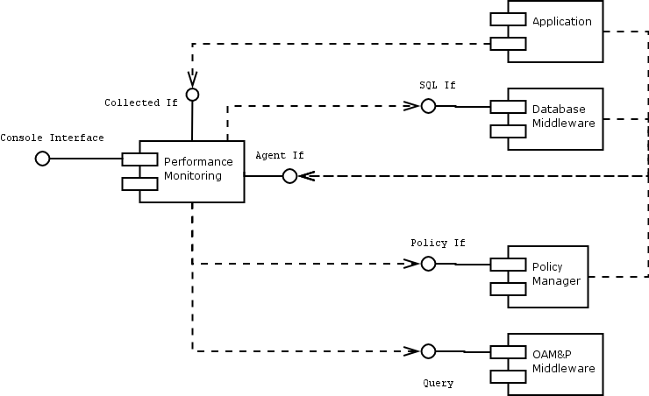

6.3 Internal functional properties

6.3.1 Performance Monitoring Server Component
The Server component controls and configures all data collection requirement. It provide a centralize data storage of all performance metrics and automated policy-based notification of other components on performance. Data collected from the agent component are forwarded internally to this component where they are aggregated and consolidated. The consolidated data are stored and performance policy based analysis and notification is provided to subscribe components.

6.3.2 Performance Monitoring Console Component
The Console component uses the consolidated data to generate reporting, in the following environment:
a) On-demand and scheduled reporting.
b) Web-based GUI to configured the performance monitoring and provides configurable reports on historical data, network infrastructure performance and reports.
c) XML-Gateway to external database and application.

6.3.3 Performance Monitoring Agent Component
Agent component can collect data from external resources using a variety of protocols that include SNMP/MIB, CORBA, TL1, ASCII, SQL, XML and CSV. It should also provide an SDK to enable develop of new agent to extend support for any new technology and other vendor equipments.
The configuration and data collection requirement is provided by the server component. The collected data is forwarded to the server component. Where it is aggregated and correlated and stored in the database. The consolidated data is then provided to the console component which will expose to other components, external console and applications.

6.4 Non-functional properties
Editor’s Note: Text invited

6.5 Interfaces
The performance monitoring component must have interfaces to the operating system, to other system components and/or to other NEs, to protocols, to the applications and for notifications.

6.5.1 Performance manager-IF-01 <Interfaces to the operating system>
Between the performance monitoring component and the operating system interfaces are needed for:
- the CPU occupancy pro task group,
- the total CPU occupancy and
- memory usage and paging
- I/O usage.
Standard SNMP/MIB 2 can be used between the component agent and the operating system.

6.5.2 Performance manager-IF-02 <Interfaces to other components and Applications>
Data collection Interfaces to other components are used to collect:
a) Throughput (i.e. sessions per second0
b) Response Time
c) Concurrency (i.e. number of sessions with a give hold time per session over a given duration).
d) Resource consumption (i.e. memory usage per session; cpu usage per session; disk usage per session if required).
e) Database transaction MIB
f) Network performance.
Standard Interfaces provided by agent:
a) SNMP/MIB2
b) SDK for integrating within the component
c) XML/CORBA
d) SQL.
The server sub-component uses other components interface to provide notification.

6.5.3 Performance manager-IF-03 <Interfaces to the console or external applications>
The Console sub-component provides the following interfaces –
a) WEB based GUI – for web based information system.
b) XML – for exchange data with applications, external databases and reporting systems.

7 Security
Editor’s note: To be added

_____________________
Bibliography
Editor’s note: To be added
_______________________

