International Telecommunication Union

Open Communication Architecture Forum

OCAF Focus Group

CGOE Components

OAM&P

Version 1.0

July 2006

Y.cgoe-cmpts-Annex oamp
Carrier grade open environment components
ANNEX oamp
The OAM&P CGOE component
Summary
This Annex specifies the OAM&P CGOE component.
Keywords
<Optional>

1 Scope
This Annex specifies the OAM&P CGOE component.

2 References
The following ITU-T Recommendations and other references contain provisions, which, through reference in this text, constitute provisions of this Recommendation. At the time of publication, the editions indicated were valid. All Recommendations and other references are subject to revision; users of this Recommendation are therefore encouraged to investigate the possibility of applying the most recent edition of the Recommendations and other references listed below. A list of the currently valid ITU-T Recommendations is regularly published.
The reference to a document within this Recommendation does not give it, as a stand-alone document, the status of a Recommendation
Editor’s note: To be completed

3 Definitions
Editor’s note: To be completed
This Recommendation defines the following terms:
3.1 Application: (See Recommendation Y.CGOE)
3.2 Carrier grade: (See Recommendation Y.CGOE)
3.3 CGOE component: (See Recommendation Y.CGOE)
3.4 End-to-End Security: End-to-end security refers to security between two Diameter nodes, possibly communicating through Diameter Agents.
3.5 Functional requirements: (See Recommendation Y.CGOE)
3.6 Middleware: (See Recommendation Y.CGOE)
3.7 Non-functional requirements: (See Recommendation Y.CGOE)

4 Abbreviations
Editor’s note: To be completed
AAA | Authentication, Authorization and Accounting
CGOE | Carrier Grade Open Environment

5 Conventions
This Recommendation uses the CGOE component diagram conventions detailed in clause 5 of the main body of this Recommendation.

6 Clause 6 of the Recommendation

6.1 General
OAM&P Middleware is a component and an optional interface that provides an abstract software layer that shall be used by any software, especially by other CGOE components, in modeling its managed objects independently of the query interface / language. It provides a “neutral” modeling technique and maps this to the appropriate or required OAM&P interface, e.g. SNMP, http, XML, etc.
The OAM&P middleware runs as a server offering the advantage, that the abstract software layer is available at runtime.
A technology independent description is in Figure oamp.1/Y.cgoe.cmpts.
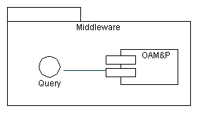
Figure ntp.1/Y.cgoe.cmpts - Technology Independent View
This shows that OAM&P middleware offers the capability for abstraction layer support with a technology independent Query interface. This is the primary interface for OAM&P Middleware.
The component OAM&P middleware includes at least the following classes of subcomponents:
- Application Programming Interface (API)
- Dispatcher
- Mediator
The subcomponents are shown in Figure ntp.2/Y.cgoe.cmpts.
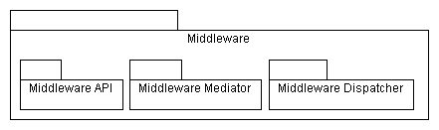
Figure ntp.2/Y.cgoe.cmpts - OAM&P Middleware Subcomponents
Components of the application level shall use according to the component ‘System Model’ the API offered by the OAM&P middleware. The API supports functionality according the standard model for network management ‘FCAPS’, which is an acronym for Faults, Configuration, Accounting, Performance, Security, the categories into which the model breaks the various network management tasks.
The dispatcher is responsible for invoking related support components such as ‘Logging’, ‘Alarm List’ or ‘Event Management’.
Mediators are used for mapping issues to the interface components ‘Diameter’, ‘FTP’, ‘HTTP’, ‘NTP’, ‘SIP’ and ‘SNMP’.

6.2 Relationship with other CGOE components
A CGOE compliant OAM&P Middleware makes use of other interfaces as shown in Figure ntp.3/Y.cgoe.cmpts. These are secondary interfaces which are described in the CGOE documentation for each component. Each of these secondary interfaces will have one or more technology-specific instances.
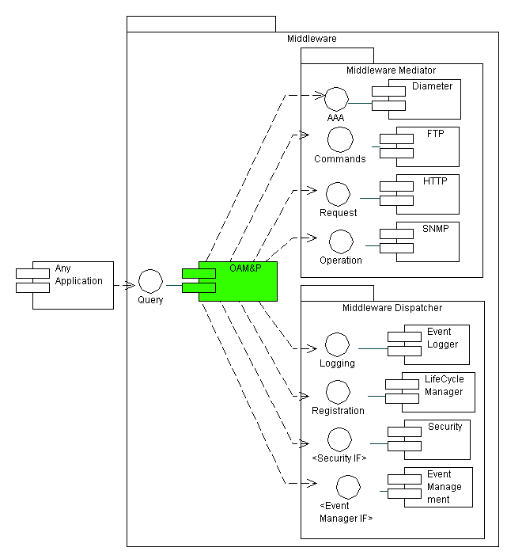
Figure ntp.3/Y.cgoe.cmpts - Secondary Interfaces
An application will use the query interface of the middleware.
The Query interface may be used optionally by any other CGOE components. If it is used it offers the advantage that all secondary interfaces, especially Diameter, FTP, HTTP and SNMP, are hidden by the OAM&P Middleware component. This provides the capability of technology independent analysis, design and implementation for those applications that make use of the Query interface of the CGOE component OAM&P Middleware. Additionally the use of the Query interface provides ‘automatically’ the use of supporting interfaces like Logging and Registration hidden from the calling CGOE components.

6.3 Internal functional properties

6.3.1 Mapping to Interfaces/Languages
Mapping deals with mapping an incoming query onto the concrete secondary interface. Besides selecting a secondary interface the content of the incoming query is also mapped onto the related command of the secondary interface.
Standards
Gap - A standard neutral modeling technique is missing.

6.3.2 Role Assignment
The OAM&P middleware supports role information assigned to any given query. If possible this may include evaluation of role information with subsequent action and forwarding via the secondary interface.
Standards
Gap - A standard neutral modeling technique is missing.

6.4 Non-functional properties

6.4.1 Recovery
This property measures the behavior of the components if there is no response or confirmation e.g. due to a temporary outage.
Unit of measure: yes / partly / no

6.5 Interfaces

6.5.1 OAM&P Middleware-IF-01 <Query>
Provides an optional abstract interface for CGOE components to support technology independent analysis, design and implementation for concrete interfaces like Diameter, FTP, HTTP and SNMP. Additionally the OAM&P middleware hides for other CGOE components the use of supporting interfaces like Logging and Registration.
Standard
Gap - A standard neutral modeling technique is missing.

6.5.2 OAM&P Middleware-IF-02 <AAA>
The AAA interface is the interface of CGOE component Diameter. If the component Diameter is present, the AAA interface is hidden from other components and is invoked by OAM&P middleware instead of to be invoked by another CGOE component directly.
Standard
IETF RFC 3588

6.5.3 OAM&P Middleware-IF-03 <FTP Commands>
Provides the communication commands for component FTP. If the component FTP is present, the FTP Commands interface is hidden from other components and is invoked by OAM&P middleware instead of to be invoked by another CGOE component directly.
Standard
IETF RFC 959, STD 009, updated by RFC 2228, RFC 2640, RFC 2773

6.5.4 OAM&P Middleware-IF-04 <Request>
Provides the capability to communicate using HTTP. If the component HTTP is present, the Request interface is hidden from other components and is invoked by OAM&P middleware instead of to be invoked by another CGOE component directly.
Standard
IETF RFC 2616

6.5.5 OAM&P Middleware-IF-05 <Operation>
Provides the communication commands, the used management information base (MIB) and the user management of CGOE component SNMP. If the component SNMP is present, the Operation interface is hidden from other components and is invoked by OAM&P middleware instead of to be invoked by another CGOE component directly.
Standard
IETF RFC 2570, IETF RFC 2574, IETF RFC 2500

6.5.6 OAM&P Middleware-IF-06 <Logging>
Provides the capability to log any transaction in relation to the component OAM&P Middleware. The use of this interface is optional and depends on the addressed concrete interface.
Standard
GAP

6.5.7 OAM&P Middleware-IF-07 <Registration>
Registration is the interface to the component Lifecycle Manager. The use of this interface is optional and depends on the addressed concrete interface.
Standard
GAP

6.5.8 OAM&P Middleware-IF-08 <Security IF>
The <Security IF> is the interface to the component Security. Security also includes access control. The use of this interface is optional and depends on the addressed concrete interface.
Standard
GAP

6.5.9 OAM&P Middleware-IF-09 <Event Management IF>
The <Event Management IF> is the interface to the component Event Manager. The use of this interface is optional and depends on the addressed concrete interface.
Standard
GAP

6.5.10 OAM&P Middleware-IF-10 <Management Interface>
Provides the opportunity for remote configurability of the OAM&P middleware, e.g. a further secondary interface is activated during normal operation.
Standard
Gap - A standard neutral modeling technique is missing.

7 Security
Editor’s note: To be added

_____________________
Bibliography
Editor’s note: To be added
_____________________

