International Telecommunication Union

Open Communication Architecture Forum

OCAF Focus Group

CGOE Components

FTP Server

Version 1.0

July 2006

Y.cgoe-cmpts-Annex ftp.svr
Carrier grade open environment components
ANNEX ftp.svr
The FTP server CGOE component
Summary
This Annex specifies the FTP server CGOE component.
Keywords
<Optional>

1 Scope
This Annex specifies the FTP server CGOE component.

2 References
The following ITU-T Recommendations and other references contain provisions, which, through reference in this text, constitute provisions of this Recommendation. At the time of publication, the editions indicated were valid. All Recommendations and other references are subject to revision; users of this Recommendation are therefore encouraged to investigate the possibility of applying the most recent edition of the Recommendations and other references listed below. A list of the currently valid ITU-T Recommendations is regularly published.
The reference to a document within this Recommendation does not give it, as a stand-alone document, the status of a Recommendation
Editor’s note: To be completed

3 Definitions
Editor’s note: To be completed
This Recommendation defines the following terms:
3.1 Application: (See Recommendation Y.CGOE)
3.2 Carrier grade: (See Recommendation Y.CGOE)
3.3 CGOE component: (See Recommendation Y.CGOE)
3.4 End-to-End Security: End-to-end security refers to security between two Diameter nodes, possibly communicating through Diameter Agents.
3.5 Functional requirements: (See Recommendation Y.CGOE)
3.6 Middleware: (See Recommendation Y.CGOE)
3.7 Non-functional requirements: (See Recommendation Y.CGOE)

4 Abbreviations
Editor’s note: To be completed
AAA | Authentication, Authorization and Accounting
CGOE | Carrier Grade Open Environment

5 Conventions
This Recommendation uses the CGOE component diagram conventions detailed in clause 5 of the main body of this Recommendation.

6 Clause 6 of the Recommendation

6.1 General
A File Transfer Protocol (FTP) is a component that operates as an interface. It allows 1) to promote sharing of files (computer programs and/or data), 2) to encourage indirect or implicit (via programs) use of remote computers, 3) to shield a user from variations in file storage systems among hosts, and 4) to transfer data reliably and efficiently. FTP, though usable directly by a user at a terminal, is designed mainly for use by programs. The security of FTP can be increased by the use of FTP security extensions.
The component FTP acts as a server, which provides a concrete communication facility.
A technology independent description is in Figure ftp.svr.1/Y.cgoe.cmpts.
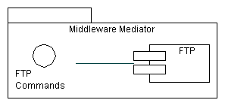
Figure ftp.svr.1/Y.cgoe.cmpts - Technology Independent View
This shows that FTP offers the capability for communication based on commands. This is the primary interface for a FTP component.
FTP has a Client-Server-Architecture. A principle description is in Figure ftp.svr.2/Y.cgoe.cmpts.
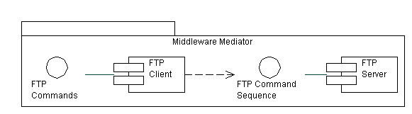
Figure ftp.svr.2/Y.cgoe.cmpts - FTP Client-Server-Architecture
This document focuses on the Server part of the FTP component. However most of the description holds also for the Client part of the FTP component.

6.2 Relationship with other CGOE components
A CGOE compliant FTP Server component makes use of other interfaces as shown in Figure ftp.svr.3/Y.cgoe.cmpts. These are secondary interfaces which are described in the CGOE documentation for each component. Each of these secondary interfaces will have one or more technology-specific instances.
The CGOE component FTP Server is used by the CGOE component OAM&P Middleware. FTP is an optional interface which may be present or not to the OAM&P Middleware.
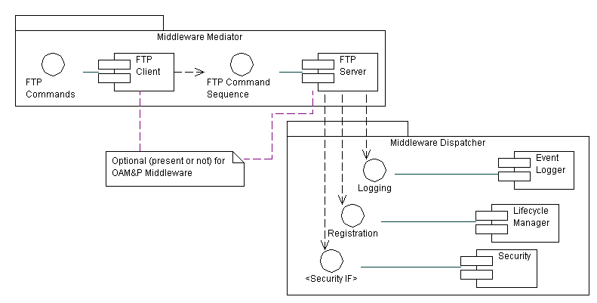
Figure ftp.svr.2/Y.cgoe.cmpts - Secondary Interfaces

6.3 Internal functional properties

6.3.1 Data Connection
A data connection is used to transfer files.
Standard
IETF RFC 959, STD 009, updated by RFC 2228, RFC 2640, RFC 2773

6.3.2 Tracing
Tracing deals with monitoring communication traffic for the purpose of error finding
Standards
None

6.4 Non-functional properties

6.4.1 Transaction Performance
This property measures how many data can be transferred per second on a data connection
Unit of measure: Bytes/second

6.4.2 Modification of multitude Data Records
This property measures if a command of the interface operation supports modifying more than one data record.
Unit of measure: Yes/No

6.4.3 Recovery
This property measures the behaviour of the components if there is no response or confirmation e.g. due to a temporary outage.
Unit of measure: yes / partly / no

6.5 Interfaces

6.5.1 FTP server-IF-01 <FTP Commands>
Provides the communication commands.
Note: This also includes command sequences.
Standard
IETF RFC 959, STD 009, updated by RFC 2228, RFC 2640, RFC 2773
IETF RFC 2228 for Security Extensions

6.5.2 FTP server-IF-02 <Logging>
Provides the capability to log any transaction in relation to the component FTP.
Standard
GAP (Possible Solution the logging component of the specific Middleware can be used)

6.5.3 FTP server-IF-03 <Security IF>
The <Security IF> is the interface to the component Security. Security also includes access control to files and directories.
Standard
GAP

6.5.4 FTP server-IF-04 <Registration>
Registration is the interface to the component Lifecycle Manager.
Standard
GAP

6.5.5 FTP Server-IF-05 <Telnet>
The purpose of the TELNET Protocol is to provide a fairly general, bi-directional, eight-bit byte oriented communications facility. A TELNET connection is a Transmission Control Protocol (TCP) connection used to transmit data with interspersed TELNET control information.
Standard
IETF RFC 854/855, STD 008

6.5.6 FTP Server-IF-06 <File System>
Provides the capability to create, delete, read, write and modify files and directories. This includes also access rights.
Standard
IETF RFC 854/855, STD 008

7 Security
Editor’s note: To be added

________________
Bibliography
Editor’s note: To be added
____________________

