International Telecommunication Union

Open Communication Architecture Forum

OCAF Focus Group

CGOE Components

Data Model

Version 1.0

July 2006

Y.cgoe-cmpts-Annex dms
Carrier grade open environment components
ANNEX dms
The data model CGOE component
Summary
This Annex specifies the data model services CGOE component.
Keywords
<Optional>

1 Scope
This Annex specifies the data model services CGOE component.

2 References
The following ITU-T Recommendations and other references contain provisions, which, through reference in this text, constitute provisions of this Recommendation. At the time of publication, the editions indicated were valid. All Recommendations and other references are subject to revision; users of this Recommendation are therefore encouraged to investigate the possibility of applying the most recent edition of the Recommendations and other references listed below. A list of the currently valid ITU-T Recommendations is regularly published.
The reference to a document within this Recommendation does not give it, as a stand-alone document, the status of a Recommendation
Editor’s note: To be completed

3 Definitions
Editor’s note: To be completed
This Recommendation defines the following terms:
3.1 Application: (See Recommendation Y.CGOE)
3.2 Carrier grade: (See Recommendation Y.CGOE)
3.3 CGOE component: (See Recommendation Y.CGOE)
3.4 End-to-End Security: End-to-end security refers to security between two Diameter nodes, possibly communicating through Diameter Agents.
3.5 Functional requirements: (See Recommendation Y.CGOE)
3.6 Middleware: (See Recommendation Y.CGOE)
3.7 Non-functional requirements: (See Recommendation Y.CGOE)

4 Abbreviations
Editor’s note: To be completed
AAA | Authentication, Authorization and Accounting
CGOE | Carrier Grade Open Environment

5 Conventions
This Recommendation uses the CGOE component diagram conventions detailed in clause 5 of the main body of this Recommendation.

6 The data model CGOE component

6.1 General
The data model component provides a well-defined data schema of system and service-level information for use by the system model and higher level application services. Data model components provide a layer of abstraction between system-level operations, application configuration and low-level operations, and actual data storage and formatting. The abstraction layer shields system model and application-level operations from changes in lower level services (i.e., substitution of an existing service), as well as changes in configuration data and underlying formats. Data model components may also be used directly for storage of data by system-level and application-level services.

Data model components differ from database middleware components by means of the kinds of data that they are intended to store. Data model components are somewhat limited in scope compared to the general nature of database middleware; they are not intended for high throughput distributed transaction data operations or data federation.

The kinds of information to be exposed by the data model components include:

- Configuration data: Comprises well-structured or semi-structured data associated with OS-level services, application-level configuration, and system-level and application-level state.
- System data: Consists of data regarding system operation, such as hardware capabilities, memory consumption, and system load.
- Provisioning data: Includes descriptions and associated data for the creation of new instances of system-level and lower-level application objects.
- Low-level API data: Data model abstractions may be used to shield higher-level and system-level services from the gritty details of low-level API data.

Data model components should provide a means for creating, managing, description, and removing data schemas. When acting as a layer of abstraction on top of another lower-level data format, data model services components should provide an adaptive layer for ensuring consistency between the low-level data format and the abstracted data model during operations.

Data models can be stored and exposed via a variety of mechanisms, such as LDAP, XML, or even relational data stores.

6.2 Relationship with other CGOE components
Data model services component provides a layer of data abstraction to lower level configuration, system, and application data. These services are provided to the system model to enable system-level operations. Data model services are also provided to application-level logic via application middleware to higher level application services.

The relationship between the data model services component and other CGOE components are shown in Figure dms.1/Y.cgoe.cmpts.

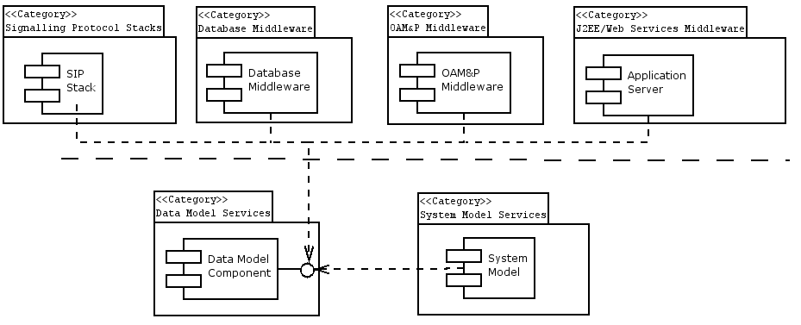
Figure 1 - Relationship of Data Model Services Components with the CGOE

6.3 Internal functional properties

6.3.1 Hierarchical, Object, and Relational Data Modeling
Data can be stored and expressed in a variety of ways. The method used to describe the data influences the kind of technology used to structure, manage, and provide access to the data. COTS components may provide varying support for each of these data paradigms: hierarchical, object, and relational data storage.

6.3.2 XML and XML tooling
Extensible Markup Language (XML) provides a standard, platform neutral data format. XML uses a hierarchical format for expressing data and provides a set of tools (in the form of data schemas) for verifying the integrity of the document. Data model components may use XML as an internal format for data storage, either within the file system or within another storage mechanism, such as a relational database or LDAP.
The data model component may also provide tooling for manipulating XML data. If XML is used for representation of the underlying data store, then XML tooling may be used to perform operations on the data store contents.
Role of Standards:
- XML v1.0 or later (W3C)
  - The W3C XML data format specification

6.4 Non-functional properties

6.4.1 Size of Data Store
The amount of data that needs to be stored within data model, as well as the kind of operations needed to present and enforce model views of the data, play a crucial role in selecting the data model component technology. COTS components should include a description of much data needs to be managed by the store, how frequently the data must be accessed, and how volatile the data might be –especially with regards to system data. For models of data stores, some discussion of distribution of the data store (such as distribution of LDAP servers) may be appropriate.

6.5 Interfaces

6.5.1 Data model services-IF-01 <LDAP>
The lightweight directory access protocol provides access to enterprise information directories. The directory uses a data model that consists of a tree of data entities that may span one or more servers. Each entity has a unique designation and an associated set of data attributes that provide a description of the data entity. Multiple directories working in tandem may choose to perform caching of data entries. Directories can be used for storing user, service, and device information.

Standards:
- RFC3377 – Lightweight Directory Access Protocol (v3): Technical Specification
  - This specification groups together a series of RFCs that comprise the general LDAP specification, including the LDAP wire format, information syntax, and authentication methods

6.5.2 Data model services IF-02 <Relational Database>
A relational database provides access to data in a relational format, where items are organized into tables and then accessed, reassembled, or combined during query using relational primitives. Relational databases provide a means of expressing relationships between data entities via keys and table constraints. The most comment method of accessing relational data is via the structured query language (SQL). SQL can be used for gathering data and assembling data views.

Standards:
- SQL-99
  - Describes the structured query language used to access relational data stores.

7 Security
Editor’s note: To be added

_______________________
Bibliography
Editor’s note: To be added
____________________________

