International Telecommunication Union

Open Communication Architecture Forum

OCAF Focus Group

CGOE Components

Database Middleware

Version 1.0

July 2006

Y.cgoe-cmpts-Annex db.mid
Carrier grade open environment components
ANNEX db.mid
The database middleware CGOE component
Summary
This Annex specifies the database middleware CGOE component.
Keywords
<Optional>

1 Scope
This Annex specifies the database middleware CGOE component.

2 References
The following ITU-T Recommendations and other references contain provisions, which, through reference in this text, constitute provisions of this Recommendation. At the time of publication, the editions indicated were valid. All Recommendations and other references are subject to revision; users of this Recommendation are therefore encouraged to investigate the possibility of applying the most recent edition of the Recommendations and other references listed below. A list of the currently valid ITU-T Recommendations is regularly published.
The reference to a document within this Recommendation does not give it, as a stand-alone document, the status of a Recommendation
Editor’s note: To be completed

3 Definitions
Editor’s note: To be completed
This Recommendation defines the following terms:
3.1 Application: (See Recommendation Y.CGOE)
3.2 Carrier grade: (See Recommendation Y.CGOE)
3.3 CGOE component: (See Recommendation Y.CGOE)
3.4 End-to-End Security: End-to-end security refers to security between two Diameter nodes, possibly communicating through Diameter Agents.
3.5 Functional requirements: (See Recommendation Y.CGOE)
3.6 Middleware: (See Recommendation Y.CGOE)
3.7 Non-functional requirements: (See Recommendation Y.CGOE)

4 Abbreviations
Editor’s note: To be completed
AAA | Authentication, Authorization and Accounting
CGOE | Carrier Grade Open Environment

5 Conventions
This Recommendation uses the CGOE component diagram conventions detailed in clause 5 of the main body of this Recommendation.

6 The database middleware CGOE component

6.1 General
The database middleware component provides unified interfaces storage and retrieval of structured, semi-structured, and unstructured (via meta-data) data from back-end storage. If multiple, heterogeneous data sources exist, database middleware can be used to provide consolidated, transparent data access via database federation or database virtualization. Application access to database middleware is provided in the form of database middleware clients that provides platform specific APIs whose implementations are optimized for various kinds of data access and transactional characteristics.
Data sources come in a variety of formats: relational databases (RDBMS) for storage of highly structured data, object oriented databases (OODBMS) for storage of units of data in the form of objects, indexed databases, file-system databases with flat file or XML content, etc. The database middleware provides location abstraction; clients and data sources may reside on a single system or data sources may be distributed through out the network or in some cases across network boundaries.
Database middleware clients manipulate data primarily through a query mechanism. The query mechanism allows for the insertion, deletion, location, and removal of data entries, as well as the establishment and searching of relationships between data entries. The location abstraction offered by the database middleware enables a single query to traverse multiple, distributed data sources via federation or virtualization capabilities. A single query may perform joining and restricting of data views, data aggregation, and execution of built-in data-level function within the database middleware itself. A variety of query interfaces may be supported, including SQL, web-service, and message queue access.

6.2 Relationship with other CGOE components
The broad applicability, shared commonality, and numerous combinations of functional properties for database middleware products and solutions have resulted in the creation of a database middleware component description that also comprises a COTS category within the CGOE. Database middleware is used to store business data, application state, and meta-data regarding services and service content. The different kinds of data query access are provided to upward and lateral components within the CGOE. The Database Middleware component makes use of southbound components for high availability features. The relationship between the Database Middleware component and other CGOE components is depicted in Figure db.mid.1/Y.cgoe.cmpts.
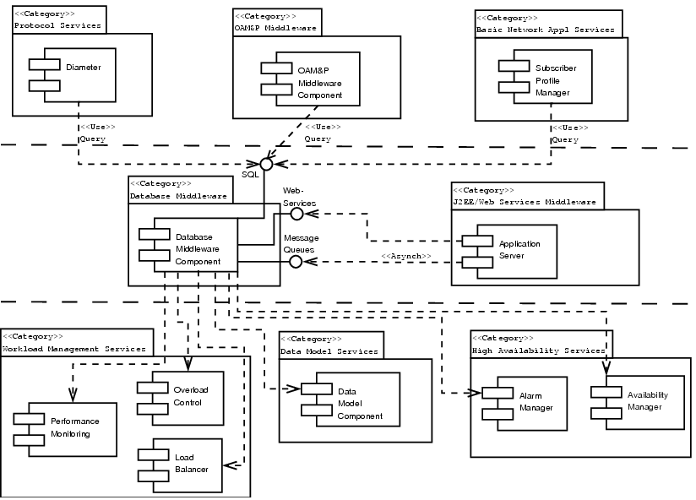
Figure db.mid.1/Y.cgoe.cmpts - Relationship of the Database Middleware Component and the CGOE

6.3 Internal functional properties

6.3.1 Connectivity and Authentication
The Database Middleware in conjunction with the database middleware client manages the connectivity between the application and the underlying data source. Connections may be pooled either by transparently or by request of the application. Connections may also be shared amongst applications via additional middleware services. Database Middleware should support a batch mode for operations, allowing for multiple queries to be grouped together and executed simultaneously. Batching of operations helps enhance perform for high transaction volumes.
Client authentication must be supported by the database middleware component. The database middleware should be able to integrate with external authorization mechanisms or at minimum store authorization information internally. The authorization mechanism should incorporate the concept of data permissions to control the kinds of data, database-level function, and views of data that a particular end user can access via an application.
The middleware should have an understanding of client sessions and provide support for distributed session management. Client authentication to each underlying data source should be accomplished either by passing authentication information within the session via the database middleware to the data source or by using a delegation model.

6.3.2 Data Integration and Transformation
A database middleware component must be able to combine data from different sources, and even different stores, and provide consistent, consolidated presentations of the data (known as data views). Views provide a means of constructing and maintaining data models across multiple data entities and back-end sources. The database middleware should be able to understand and enforce relationships between data entities, such as foreign keys, unique identifiers, and data constraints.
When executing a query, it may be desirable from an application standpoint to perform some computation, data aggregation, or transformation of the end results at the database level. The database middleware should provide some means for storing built-in computational function or a means for storing database level code for execution by the application during the query. Examples of this kind of functionality include built-in math operations, set operations on row results, and XML processing of database fields. The application may also wish to specify a return format other than SQL suitable for transport over a non-SQL mechanism, such as an XML representation for transport over a web-service.

6.3.3 Transaction Support
Operations on data usually require atomicity, the assurance that all steps of an operation must succeed for data to be changed or else the entire operation results in failure with no effect. Support for transactions may be provided within the database middleware client API or the data query languages, and transaction capability must be integrated into the database middleware. In addition, as complex transactions may span multiple entities within an enterprise, the database middleware should provide facilities for participating within a distributed transaction. Support for transactions may also include multi-step transaction functionality, which allows for smaller atomic steps to be grouped into larger transactions with different recovery policies.
Database middleware should provide a means of specifying recovery policies for transactions. A recovery policy is the set of actions taken to be taken when execution of a transaction fails. This policy may be set in conjunction with the query definition or may be specified at a higher level within the database middleware itself.

6.3.4 Support for Federation and Data Virtualization
Data is usually distributed in varying sources throughout the network. These data sources may share similar characteristics, such as structured relational databases, or may differ considerably, as in the case of semi-structured and unstructured content. Data federation and data virtualization function provide a means for integrating these heterogeneous data sources and constructing singular, consistent views of business data. Heterogeneous data sources can be made available to higher level services via a virtual data layer. For semi-structured data, the database middleware usually provides an adaptive layer than can extract appropriate information from the data and enforce proper data semantics during data operation. To accommodate unstructured data, meta-data is stored within the database with a description of the unstructured data and an external pointer to the data’s retrieval.
A key benefit of incorporating federation and virtualization function within the database middleware is to enforce consistent transaction, data caching, and relationship semantics across heterogeneous data sources. While data sources may differ in their transactional capabilities, the database middleware can help enforce consistent transactional semantics through more complex orchestration. In addition, the database middleware can also offer significant performance benefits when accessing data via caching of the distributed queries.

6.4 Non-functional properties

6.4.1 Stable vs. Volatile Storage
Underlying data may be stored in-memory or on stable storage. In-memory databases offer significant performance gains at the cost of data loss during shutdown or complete failure. In-memory implementations are usually appropriate for real-time, high volume data, where stale data quickly loses value. Stable storage is used for storing persistent data. Storage size may vary significantly, from smaller stores of application and business data to larger warehouses of business audit data, documents, and archives. To avoid stable storage becoming a bottleneck for throughput, database middleware usually compensates via use of caching or by making use of Storage Area Network (SAN) technology for underlying storage.

6.4.2 Size of Data Store and Retrieval Latency
The order of magnitude of data that must be managed by the database middleware plays a crucial role in selection of database technology and database performance. As the size of the data store increases, the amount of computation and latency associated with data operations increase. COTS components should provide descriptions of how much data must be managed by the store and any associated latency requirements if necessary. The size of the store will have an effect on the type of technology chosen, as well as the expected throughput and scalability requirements.

6.4.3 Distributed Query Caching
Query caching avoids expensive redundant computational overhead by storing query results in fast memory. When data sources are distributed across the network, query caching can be used to help move data closer to the edge of the network, providing faster data access to clients.

6.4.4 Data Partitioning
Data partitioning divides up data storage contents according to application usage and information relevancy. By splitting up data stores into smaller partitions with known query semantics, data queries can be directed to the specific store, resulting in smaller, more efficient search.

6.4.5 Data Staleness
Depending on the caching scheme used, query caching might result in providing the data access client with potentially stale data. COTS component can provide descriptions on the bounds of data aging within the caching scheme used, as well as any limits on tolerance of data staleness on behalf of the data access client.

6.5 Interfaces

6.5.1 Database middleware – IF-01 <SQL>
SQL is a database middleware interface that provides data query and schema definition capabilities. Vendor extensions may enhance the SQL dialect to include built-in transaction support and more complex aggregation function. Vendors may also provide built-in database middleware function that extends the capabilities of SQL-based queries via functions calls during query execution.

Standards:
- SQL-99
  - Standard definition of SQL syntax and primitives
- JDBC (4.0 specification or later)
  - Provides database connectivity and APIs for query execution and transactions
- ODBC (3.5 specification or later)
  - Provides database connectivity and APIs for query execution and transactions

6.5.2 Database middleware – IF-02 <Web-Services>
A web-services interface to database middleware allows heterogeneous clients to invoke a data query via a single interface. Due to performance constraints, the web-service interface should not be used for high volume data or set operations. It is intended to provide a convenient means to access application and business data from enterprise service layers, such as an end-user portal. Depending on the bindings used for the web-service, the underlying data will be marshaled into the appropriate format (likely XML), and sent over the bound transport (such as HTTP or message queues). Web-service interfaces are particularly useful for retrieving singleton data, i.e., information for a specific user.
Standards:
- XML v1.0 or later (W3C)
- Provides a standard, platform-neutral data format
- HTTP v1.1 (W3C)
- Provides a transport for the underlying web service
- SOAP v1.2 (W3C)
- Provides a message format for data encapsulation and transport

6.5.3 Database middleware – IF-03 <Message Queues>
Message queues extend the query model to provide asynchronous access to database middleware. Message queues are associated with data handlers within the database middleware that interpret message contents and perform operations on data accordingly. Likewise, results are converted to the appropriate message format by the database middleware handler and sent back to the application via the queue.
The asynchronous data access model can be a useful tool in designing an application, solution, or service. It can reduce processing latency and promote loose coupling. An example use of this paradigm is for data archiving, where an application can place data items on a queue at leisure during processing for archiving by a data warehouse. As archival may be a relatively high latency action, the asynchronous capability offered by the message queue can be convenient for design.
Standards:
- JMS
  - API for accessing message queues from Java services

7 Security
Editor’s note: To be added

_________________________
Bibliography
Editor’s note: To be added

__________________________

