Information note #1

Please note that for accessing the CICG meeting rooms, NGN-GSI participants have to enter the CICG building via the “Entrée Dunant” from 16 to 26 April 2007 (Entrée Dunant is in front of the Romana Restaurant).

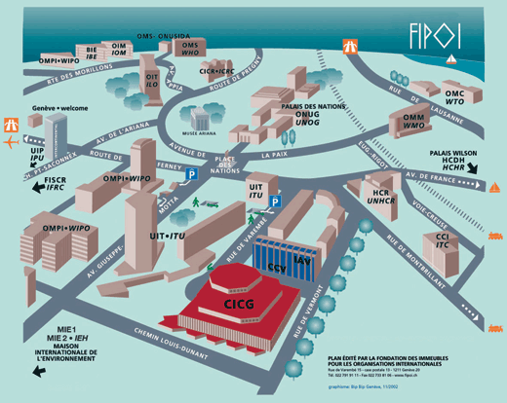

On 27 April 2007 the main entrance can be used.

Please also note that NGN-GSI participants will have access to the bar in CICG (1st floor) but not to the cafeteria from 16 to 25 April 2007.

As usual, the ITU cafeterias will be open those days.

Thank you for your understanding.

TSB Logistics

