

INFORMATION FOR PARTICIPANTS
Rapporteur Meeting of ITU-T STUDY GROUP 9
and ITU-R STUDY GROUP 6
1 General
The meetings will take place from August 3rd to August 5th 2009 in Rio de Janeiro, Brazil.

2 Place of the meetings
The meeting sessions will be held in:
Hotel Transamerica Flat
Av. Gastão Senges, 395
Barra da Tijuca
Rio de Janeiro, Brazil

3 Working hours
Subject to further modification, it is proposed that the working hours be the following:
09:00 - 12:00 hours and 14:00 - 17:00 hours
It is also suggested that a break of 15 to 20 minutes be taken at a suitable moment, ideally at 10:30 hours in the morning and at 15:30 hours in the afternoon. A suggested detailed schedule can is available in Annex 1 of this document.

4 Documentation

4.1 Documents for Presentations
Participants are invited to present their contribution and/or presentation in advance to enable its distribution among participants.
Documents that are schedule to be presented by participants should be submitted by July 29th 2009. These documents will be made available to all participants in a CD.
Documents should be sent to the following e-mail addresses:

ITU-T - Study Group 9 AND ITU-R STUDY GROUP 6
Masaru Takechi, Japan  ITU-T SG9 Q4/9 Rapporteur  takechi.m-fa@nhk.or.jp | AND | Ana Eliza Faria e Silva, Brazil  Meeting Organizer  ana.eliza@tvglobo.com.br

5 Wireless Broadband Access
Free IEEE 802.11a/b/g wireless Internet access is available within the premises of the events meeting room. Participants are strongly advised to come with wireless cards that support 802.11a/b/g frequencies. The client card must be Wi-Fi compliant, which assures interoperability between vendors.

5.1. Important Reminders for Wireless Usage
- The external LAN, which includes the wireless LAN, is not meant to be a secured environment. Encryption is not in use so participants shall take their own measures to protect their data.
- For security you should use end-to-end encryption technologies such as VPN technologies to keep your communications safe.
- Your laptop should be equipped with:
  - personal firewall software;
  - good virus scanning program with up-to-date virus database;
  - spyware detection programs.
- From applications point of view, wireless connections are good for web browsing but not so good for big file transfers.
- Although the Internet infrastructure at the meeting rooms is considerable, we’d like to request participants to avoid applications that demand too much bandwidth, such as video and audio streaming and virtual desktop applications. Network use should be restricted to web browsers, office applications and e-mails in order to limit network strain.
- Before taking out your external wireless card (or any other PC Card device from its slot), you should first properly stop it.
- Wireless cards do drain power from your laptop (sometimes quite significantly). So turn off your wireless card when not using the network to save power and extend the life of your battery.

6 Parking
Parking is available at the events location at a daily fee of R$ 25,00 (US$ 12,65). To avoid fines, participants are advised to respect these parking restrictions, particularly in the area adjacent to the main entrance. Other parking spaces are also available at commercial centers near the event location.

7 Electrical Current
Electrical current in Rio de Janeiro is alternative 110 V @ 60 Hz. Hotels commonly provide transformers to 220 V at request whenever available. These can also be found at local markets if necessary.

Annex 1
Event Location and Lodging

1. Purpose
Provide a brief guideline regarding event location, transportation, lodging and additional information for participants travelling to Brazil.

2. Events Location and Lodging
All meetings will take place in the Hotel Transamerica Flats, located in Barra da Tijuca , about 35 minutes from the Galeão International Airport, or 45 minutes from the Santos Dumont and downtown. The map bellow displays the location of the nearby hotels and commercial areas.
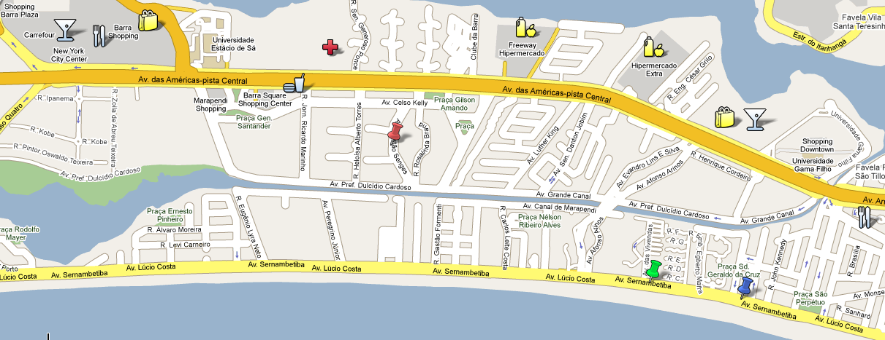

3. Transportation
Barra da Tijuca is a neighbourhood located on the west part of Rio de Janeiro city, with a many commercial areas, supermarkets and entertainment centres. The distances between some of these areas and the event location can be significant; therefore it might be advisable to use hotel shuttle services or local taxi services for transportation.
Taxi fees for transit inside Barra da Tijuca cost around US$ 12,00 and can be scheduled in the receptions of most hotels.
TAXI SERVICES IN BARRA DA TIJUCA
Barra Vips Taxi | (21) 2426 2800
Barra Taxi | (21) 2447 8811  (21) 3506 1800
Amarelinho Barra Taxi | (21) 2490 3500
Rio Barra Taxi | (21) 3325 5637
Jardim Oceânico Barra Taxi | (21) 2491 0968

4. Weather in Rio de Janeiro
Please remember that the event will take place during winter in Brazil. Average temperature for the month of August in Rio de Janeiro is around 22 ºC (72 ºF), ranging form 17 to 30 ºC (63 to 85 ºF). Conditions are often cloudy or partly cloudy, with occasional rain. Relative humidity averages around 78%.

5. Currency in Brazil
The currency in Brazil is called “Reais”( [ree-a-is]) and is the only accepted currency in the general market in country. However, most stores, restaurants and hotels also work with widely accepted international credit cards flags, like American Express, Visa, Mastercard and others.
Exchange services from other currencies are available at the airport, hotels and other locations in Barra da Tijuca. Exchange rate from US Dollars was around US$ 0,49 (to R$ 1,00) in June 2009.
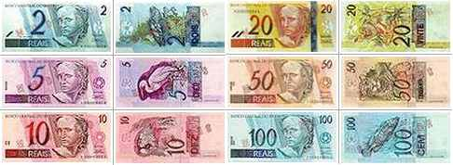

6. Travelling to Rio de Janeiro
Most participants do not need a visa to travel to Rio de Janeiro. However, we highly recommend that all international participants check if there is a visa requirement for entering Brazil prior to their travel.
This information can be found in the Brazilian embassy or consulate in the native country of the participant.
No vaccination certificate is required from people entering the country, except from those arriving from countries and regions endemic to yellow fever.

7. Language
Portuguese is the official language of Brazil, but a considerable portion of the population in Rio de Janeiro also understands English or Spanish.
Annex 2

Rapporteur Meeting of ITU-T Study Group 9 and ITU-R Study Group 6
Tentative Schedule v.1.0
 | August 3rd |  | August 4th |  | August 5th
09:00 - 09:30 | Opening Address to Participants |  | Documents Discussions |  | Report preparation and discussion
09:30 - 10:00 | Documents Presentation |  | Documents Discussions |  | Report preparation and discussion
10:00 - 10:30 | Documents Presentation |  | Documents Discussions |  | Report preparation and discussion
10:30 - 11:00 | Coffee Break |  | Coffee Break |  | Coffee Break
10:30 - 11:00 | Documents Presentation and Q&A |  | Documents Discussions |  | Documents Discussions and Final Report
11:00 - 11:30 | Documents Presentation and Q&A |  | Documents Discussions |  | Documents Discussions and Final Report
11:30 - 12:00 | Documents Presentation and Q&A |  | Documents Discussions |  | Documents Discussions and Final Report
12:00 - 12:30 | Lunch |  | Lunch |  | Lunch
12:30 - 13:00 | Lunch |  | Lunch |  | Lunch
13:00 - 13:30 | Lunch |  | Lunch |  | Lunch
13:30 - 14:00 | Lunch |  | Lunch |  | Lunch
14:00 - 14:30 | Documents Presentation |  | Documents Discussions |  | Visit to TV Globo Production Studios  Projac
14:30 - 15:00 | Documents Presentation |  | Documents Discussions |  | Visit to TV Globo Production Studios  Projac
15:00 - 15:30 | Documents Presentation |  | Documents Discussions |  | Visit to TV Globo Production Studios  Projac
15:30 - 16:00 | Documents Presentation |  | Documents Discussions |  | Visit to TV Globo Production Studios  Projac
15:30 - 16:00 | Coffee Break |  | Coffee Break |  | Visit to TV Globo Production Studios  Projac
16:00 - 16:30 | Demonstrations and Other businesss |  | Drafting activities |  | Visit to TV Globo Production Studios  Projac
16:30 - 17:00 | Demonstrations and Other businesss |  | Drafting activities |  | Visit to TV Globo Production Studios  Projac

