Table of contents

Page
I. Introduction 1
II. Trends in eHealth 2
III. Landscape of eHealth Standardization 8
IV. ITU-T Multimedia Framework for eHealth Applications 9
V. Conclusion: Standards and eHealth 10
Glossary of acronyms 12
Notes, Sources, and Further Reading 13

Standards and eHealth

I. Introduction
The World Health Organization (WHO) defines eHealth as “the cost-effective and secure use of information and communications technologies in support of health and health-related fields, including health-care services, health surveillance, health literature, and health education, knowledge and research.” Electronic health (eHealth) systems continue to hold great promise for improving global access to healthcare services and health informatics, particularly in the developing world.
Advancements in remotely administered medicine increasingly enable virtual multimedia delivery of medical consultation, remote imaging services, specialized medical diagnostics, and remote medical procedures. Standardized electronic medical records promise to facilitate the digital exchange of patient data among a patient’s primary care physician and other health providers. Aggregated, anonymized health data mined from these digital records hold the potential to improve the efficacy of health research. eHealth informatics and online health scholarship increasingly improve healthcare by improving patients knowledge about medical conditions and treatments, provisioning the latest medical scholarship and advancements to medical schools in poor and underserved regions, and providing up-to-date healthcare information for policy makers. Another long term trend in medicine is the use of genomic data (e.g. genetic markers), as part of personalized electronic health records, to assist with diagnosis and treatment decisions.
These same technological advancements in electronic healthcare are creating heightened public policy concerns about patient privacy, information security, and the role of electronic genomic repositories in enabling genetic discrimination. Technological obstacles that hinder the promise of eHealth systems include the lack of global interoperability standards for eHealth and technical infrastructure barriers, particularly in the developing world.

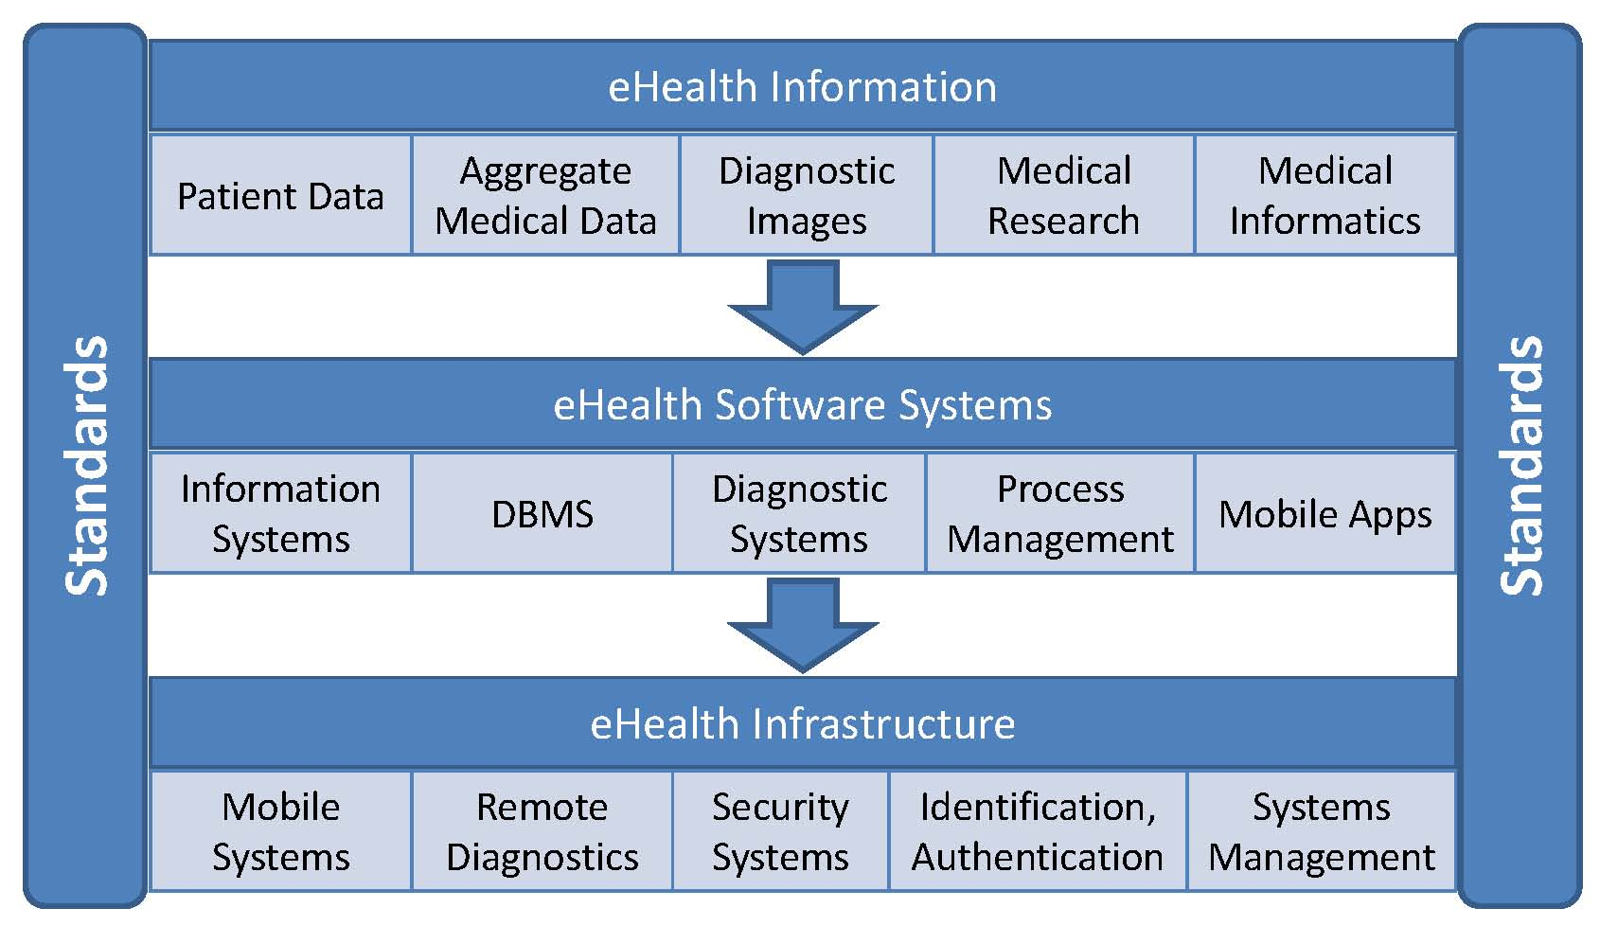

Many of these challenges can be addressed through advancements in technical standards for eHealth. Standards create the necessary interoperability among healthcare systems; minimize the risks of new technology development; prevent single vendor lock-in; reduce costs by enabling market competition and eliminating the need for expensive and customized solutions; ensure widespread adoption; and address specific concerns about privacy, security, and patient identification. This report envisions the future of eHealth, presents a snapshot of the current eHealth standardization landscape including initiatives by CEN, DICOM, HL7, and ISO, as well as the ITU-T, describes some obstacles that must be overcome, and identifies the emerging standardization opportunities and activities within the ITU that will contribute to the global deployment of efficient and secure eHealth systems.

II. Trends in eHealth
This section describes four emerging trends in eHealth systems that use information and communication technologies for the delivery of healthcare services and for the digital recordation, storage, and sharing of medical information:
• Genomic Medicine
• Standardized Electronic Health Records
• Remote Healthcare and Diagnostics
• Aggregated Public Health Data.
Genomic Medicine
Possibly the most significant trend in medicine will be the use of genomic data (e.g. genetic markers) in assisting with disease prevention, diagnosis, and treatment decisions. Accordingly, one of the most forward-looking areas for standardization exists at the intersection of information technology and genomic medicine. A human genome contains all of a person’s genes and associated DNA. The international project known as the Human Genome Project completed mapping the entire human genome in 2003. The medical profession has just begun to use genetic information in direct clinical care. Clinical uses of genomic information include the ability to anticipate a patient’s response to pharmaceutical therapies; the detection of diseases or tumors; and the identification of inherited conditions or a patient’s proclivity to develop a disease.
For example, DNA tests for mutations of the BRCA1 and BRCA2 genes are indicators of hereditary patterns of breast cancer. Medical experts believe society to be approaching “an era of ‘genomic medicine’ in which new diagnostic and therapeutic approaches to common multifactorial conditions are emerging.”
As genomic medicine evolves, it will be exceptionally data intensive as well as computationally demanding. The future of genomic medicine in clinical practice, also sometimes referred to as personalized medicine, will rely upon the availability of sophisticated medical information systems in provider facilities. On a more macro level, medical discoveries related to the identification of gene mutations and variations will require “international collaborations of large-scale sequencing centers generating terabytes of sequence data at speeds and costs that seemed inconceivable 5 years ago.” At present, electronic health record systems are generally not equipped to accommodate genomic data. As genetic testing, diagnosis, and treatment becomes more commonplace, this information will need to be held in electronic records and be able to be exchanged among providers.
There are many other intersections between genomic medicine and information and communication technologies. One unique aspect of genetic testing is that patients have the option to bypass healthcare providers entirely and order genomic tests directly on the Internet. This is a rapidly advancing and controversial area of medicine. These tests are used for prenatal screening to identify genetic conditions in unborn children; identification of inherited genetic conditions that predispose an individual to certain conditions and illnesses; identification of whether an individual is a carrier of an altered gene; and diagnoses of specific diseases. Standardization efforts related to privacy, pseudonymization, and security have to extend to direct consumption of genetic tests over the Internet in addition to health care provider mediated testing and diagnosis.
Standardized Electronic Health Records
Medical information systems have historically captured and stored clinical and administrative patient data in proprietary formats only understood by a single system and not interoperable with other providers’ systems. Emerging standards for Electronic Health Records (EHRs) are attempting to create common digital formats and structures for integrating a variety of information about a patient and allowing this information to be exchanged among medical information systems developed by different manufacturers. As shown in the accompanying figure, the types of information integrated within EHRs include clinical observations, medical histories, treatments, allergies, diagnostic images, legal permissions, patient information, and drugs administered.

The trend anticipated by the medical community is for these electronic records to be accessible by patients so they can check their medical histories online. Sometimes called “personally controlled Electronic Health Records,” these digital records could provide information such as a history of immunizations, medications, allergies, symptoms, conditions, and diagnostic test results. The records would also include a history of doctor and hospital visits and treatments performed.
This type of online record could be highly beneficial for patients, who would have a single account of their entire medical history, presumably enabling them to make more informed medical decisions and eliminating the need for patients to recount their medical histories every time they visited a new healthcare provider. Electronic health records are also advantageous to overall health systems by creating greater efficiencies within health provider systems through the reduction in administrative paperwork and redundant tests. This cost savings would apply both to private medical providers and to governments, which incur a significant percentage of health care costs even in countries that do not provide universal healthcare. Electronic health records can also improve overall healthcare quality by reducing incidents of adverse drug interactions and providing a more accurate medical history from which medical providers, as well as patients, can make informed decisions.
Because of these benefits, national governments are increasingly instituting policies and investing funds to improve health care by establishing some form of electronic health record system. For example, Australia will invest more than $466 million to establish a “secure system of personally controlled electronic health records.” In the United States, the American Recovery and Reinvestment Act of 2009 similarly allocated many millions of dollars in contracts to provide electronic medical records. Government incentives take the form of either direct funding of electronic health record projects or more indirect means such as tax incentives for healthcare providers who demonstrate use of an electronic health record system.
There are significant policy, technological, and social barriers to realizing the potential benefits of electronic health records. One infrastructural challenge, particularly in the developing world, is the inability of citizens and healthcare providers alike to obtain the information and communication technologies and telecommunications services necessary to access electronic health records. Perhaps the most significant challenge is interoperability. Unless a critical mass of healthcare providers adheres to the same standards for electronic health records, the system will not provide the anticipated cost efficiencies and healthcare quality improvements. eHealth interoperability requires multiple information systems to be able to “exchange both computer interpretable data and human interpretable information and knowledge.”

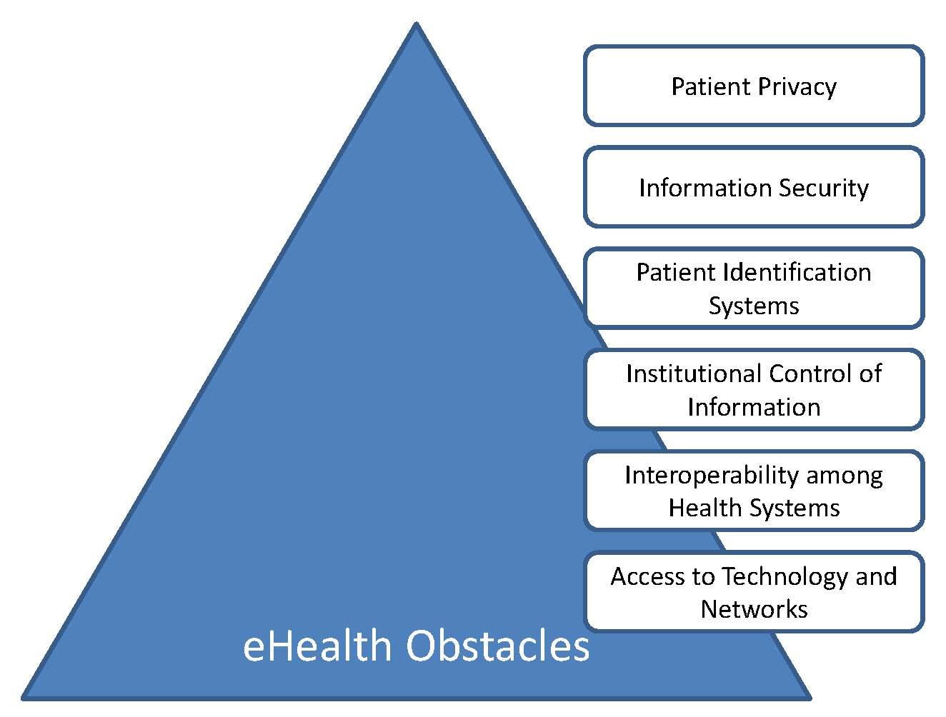

It also requires a universal identification number system to uniquely identify each patient. On an even more practical level is the question of where, physically, the personalized electronic health records are stored, whether on a computer in a primary care provider’s office or on a government or third party server. The decision about where to store the information will have repercussions to the longevity, security, and quality of the stored electronic records.
Personalized electronic healthcare records also raise concerns about data security and individual privacy. Social questions include the extent of user control over the content of electronic healthcare records as well as control over who has access to these records. One often cited concern is the risk of discrimination in employment or insurance and the extent to which health insurance companies or employers might gain access to these records. From a security standpoint, systems have to meet stringent authentication standards for identifying and verifying the individuals attempting to access their own records as well as for providers accessing these records. The protection of data while digitally stored or while transmitted over a telecommunication network is similarly a critical requirement.
Remote Healthcare and Diagnostics
In the developing world and in isolated geographical areas with limited access to health providers and advanced medical technologies, remote electronic health services over telecommunications services are increasingly filling gaps in medical care. Historically called “telemedicine,” remote healthcare services use telecommunication networks and information technology for many medical purposes including remote clinical care, diagnostics, electronic patient monitoring and patient and provider access to medical information. None of these remote medical services is possible without telecommunications networks and standards that enable adequate interoperability, quality of service, and security.

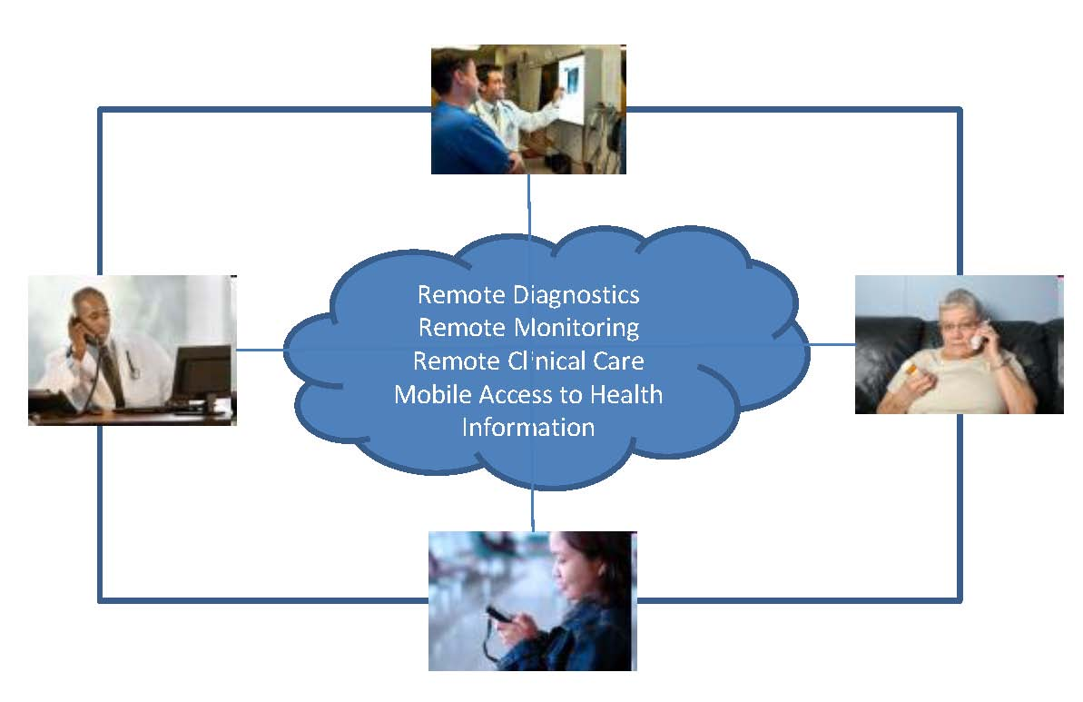

Remote Clinical Care
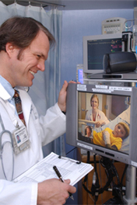
Remote clinical care increasingly enables doctors located at a distance from patients to provide electronic medical assessments, diagnoses, and treatments. It also allows doctors not in the same location to discuss patient diagnoses. If a patient is geographically distant from medical care but has access to a telecommunications network and computer or cell phone, medical providers can administer remote clinical care. This approach involves real-time and interactive communications between a doctor and a patient, either on a phone (landline or mobile) or via video communications over a computer. This direct clinical care via a telecommunications network usually requires the simultaneous online or electronic presence of both the patient and the medical provider/s.

Remote Diagnostic Processing
Other forms of remote diagnostics involve “store and forward” electronic health services that acquire some aspect of medical information (such as an MRI, ultrasound, or other radiological image) and then transmit this information to a medical practitioner for analysis at a later time. This routinely happens today for cost savings but also has great potential to bring medical expertise to areas otherwise underserved.
Electronic Patient Monitoring
Remote patient monitoring refers to the ability of medical providers to electronically observe a patient remotely using medical monitoring devices and telecommunication networks. For example, a medical practitioner can monitor such characteristics as a patient’s heart rhythms, blood pressure, pulse oximitry, pulmonary functionality, or blood glucose level. This type of remote health care monitoring can be used to cost effectively monitor patients with chronic conditions, the elderly, and patients recovering from a specific condition.
Mobile Healthcare
According to ITU statistics, there were an estimated 4.6 billion mobile phone subscribers worldwide at the end of 2009 and more than half of the population of the developing world had mobile phone service. Particularly in the developing world, mobile phones are becoming a new medium for health delivery, both through voice communications and via text messages and multimedia. This is the case both in urban areas and in poorer and more rural areas with limited computing infrastructures other than cellular phone networks. In some cases, government officials and NGOs use mobile phones to gather public health-related data and to monitor general health conditions. Mobile phones also help networks of health providers to stay current about general health issues, medical advancements, pharmaceutical notifications, or to access information about a particular patient. Remote patient-to-physician communication via a mobile device is an increasingly common part of health care as is patient self-education and access to medical information via mobile devices. Further advances are expected in medical monitoring technologies that can transmit diagnostic statistics to a provider via a mobile phone network.
Challenges to emerging mHealth (mobile health) applications are numerous, including how to ensure the accuracy of medical information obtained by patients via mobile devices, how to secure patient-to-provider communications over mobile networks, and how to guarantee adequate service reliability for remote monitoring functions.
Aggregated Public Health Data
The global eHealth landscape is still fragmented in that hospitals, physicians’ offices, pharmacies, and other healthcare providers have transitioned to digital record keeping systems but do not necessarily have systems that interoperate with each other. The data portability and system interoperability expected to accompany electronic health records and emerging eHealth systems will not only improve health delivery and create cost efficiencies, but will present unprecedented opportunities for the mining of aggregated public health data. The term “aggregated health data” refers to a large body of data obtained by combining some characteristics of standardized digital health records in a way that removes information that would identify any individual patient. This data is not used for direct care of individuals or for insurance and billing purposes but for some secondary use related to research, public health assessments, accreditation, patient education, or some commercial purpose. These functions are often referred to as “secondary uses of health data.”
Even though the vast majority of electronic health information is currently not aggregated, there is already a multi-million dollar business based on collections of health data, flowing through two primary aggregation points. Smaller aggregators include provider entities such as hospital networks and pharmacies. Many of these data collection efforts take place through billing systems and other administrative recordation. Larger aggregators include hospital associations and corporations who buy anonymized health data from smaller aggregators, further aggregate this information and then sell it for profit.
There are many practical reasons for aggregating health data into a public data repository. The greatest potential public health benefit of aggregated medical data is its use in health research. Having a large digital repository documenting patient responses to medical treatments and drug therapies helps medical researchers evaluate the effectiveness or lack of effectiveness of these treatments in a more comprehensive and longer term manner than more bounded clinical trials. This data can also help inform patients seeking treatments and be potentially used in evaluating the quality of hospitals and physicians’ offices as well as the efficacy of individual medical therapies. To medical providers, the potential reputational and economic risks of making aggregated data public can create incentives for institutional quality improvements. Finally, the data can help governments monitor overall public health conditions and trends and determine where to direct resources.
The aggregated health data repositories made possible by electronic health standards also raise many ethical and legal concerns, many of which will have to be addressed in standards as well as in legal structures. These concerns are related to individual privacy and information ownership. Who actually owns the data contained in an individual’s electronic health records? Who controls, or should control, the data? What secondary uses of data are permissible and who can access this data? What would constitute adequate anonymization of digital data to protect individual privacy within the bounds of existing legal structures? Concerns will be different in various national contexts but some of the most challenging issues involve the possibility of discrimination in employment and insurance. Researchers also raise concerns about how to verify the quality and accuracy of secondary data, particularly if it was originally entered into a system for insurance or another administrative, rather than clinical, purpose.
Standards will play a critical role in both achieving the public health benefits of aggregated patient data and providing solutions to requirements for security, privacy, quality assurance, and interoperability. As long as electronic health records are fragmented technically without adequate standardization among providers and vendors, meaningful public aggregation will not be possible. This standardization requirement spans all areas of information protocols ranging from standardized codes for specific procedures, data formatting standards, compression standards, and network level standards.

III. Landscape of eHealth Standardization
Many standardization organizations, including ITU, work on various areas of eHealth. The eHealth Standardization Coordination Group (eHSCG), supported by ITU-T Study Group 16, maintains a list of standards in both technical and non-technical areas of eHealth on the World Health Organization web site. The next section, Section IV, discusses some specific ITU initiatives. This section briefly describes a variety of eHealth standardization initiatives including: DICOM, CEN/TC 251, HL7, ISO/TC 215, and ISO/IEEE 11073.
DICOM
Digital Imaging and Communications in Medicine (DICOM) is a standard for exchanging medical images. More specifically, it is a file format and transmission standard for exchanging medical images and associated information between medical imaging equipment made by different manufacturers. The DICOM standards are widely adopted in equipment and information systems used in hospitals, imaging centers, and in providers’ offices to produce, display, store, or exchange medical images. The standard provides a number of specifications including:
• Network protocols
• Syntax and semantics of commands and associated information
• Media storage services, file formats, medical directory structure
There are twenty DICOM working groups, made up of technical and medical professionals, which maintain the various DICOM standards. The National Electrical Manufacturers Association (NEMA) oversees and holds a copyright to the DICOM standards, originally developed by a joint committee formed by NEMA and the American College of Radiology.
CEN/TC 251
The Comité Européen de Normalisation or European Committee for Standardization (CEN) is a standards development organization made up of 31 national members developing pan-European standards. CEN has a Health Informatics Technical Committee (TC 251) which coordinates the development of standards for eHealth. According to its business plan and recent activities, the focus of CEN/TC 251 is primarily on technologies at the content level rather than dealing with communication technologies. CEN/TC 251 is further broken down into working groups such as Working Group IV, which focuses on the interoperability of data among devices and information systems.
HL7
Health Level Seven (HL7) is a standards development organization which issues international application-layer healthcare standards for the electronic exchange and management of health information such as clinical data and administrative information. HL7 refers to the standards organization itself but is also commonly used to refer to specific standards the institution develops. HL7 dates back to the mid-1980s, when it was formed to develop a standard for hospital information systems. Like other standards organizations, HL7 is organized into Work Groups chaired by two or more co-chairs and responsible for defining some area of HL7 standards.
HL7 has dozens of Work Groups, including groups addressing electronic health records, infrastructure and messaging, and imaging integration. To provide one example of an HL7 specification, the HL7 Clinical Document Architecture (CDA) serves as an XML-based markup standard defining the structure, encoding parameters, and semantics of electronic clinical documents. There is also a Work Group on clinical genomics, formed to develop common standards for genomic information/data across many organizations ranging from research institutions, medical practitioners, and regulatory bodies as appropriate under existing law. Part of the Work Group’s charter is to review what data needs to be exchanged and to identify and review existing standards for genomic data.
HL7 partners with other institutions, such as the International Organization for Standardization (ISO) in issuing international eHealth standards, (ISO/HL7 21731:2006 Health Informatics-HL7 version 3-Reference Information Model).
ISO/TC 215
ISO's Technical Committee 215 also addresses health informatics. ISO/TC 215 focuses primarily on electronic health records. Various Working Groups (WGs) within TC 215 address topics such as data structure, messaging and communication, security, pharmacy and medication, devices, and business requirements for electronic health records. For example, ISO/TS 25237:2008 addresses pseudonymization principles and requirements for privacy protection of electronic health records. Many of ISO’s standards are collaborations or endorsements of standards developed by other standards organizations such as HL7 or IEEE. For example, ISO/HL7 27931:2009, “Data Exchange Standards -- Health Level Seven Version 2.5” establishes an application protocol for electronic data exchange in healthcare environments.
At present, ISO Technical Committee 215, WG 8 (Business Requirements for Electronic Health Records) is also developing a technical report (TR) in partnership with the WHO to make international eHealth standards more accessible to developing countries. The objective of this report will be to guide developing countries in adopting universal standards for health informatics systems. The first part of the report will be descriptive and provide an overview of existing international standards for eHealth. The second part of the report will offer a “roadmap for identifying business requirements to define an eHealth enterprise architecture.”
ISO/IEEE 11073
ISO/IEEE 11073 Medical/Health Device Communication Standards are a set of joint ISO, IEEE, and CEN standards for medical device interoperability. In this context, medical devices include primarily personnel, or end user, health devices such as blood glucose monitors, blood pressure monitors, thermometers, pulse oximeters, etc., that patients use in their own homes or other end points to monitor existing medical conditions. The ISO/IEEE 11073 (formerly called IEEE 1073) standards define messaging structures but not the transport layer upon which messages are transmitted.

IV. ITU-T Multimedia Framework for eHealth Applications
ITU Recommendations underlie much of the telecommunications infrastructure necessary for supporting the virtual multimedia delivery of medical care, remote diagnostic services, and electronic medical records. ITU Study Groups address these infrastructural issues as well as generally addressing many emerging eHealth related requirements for security (Study Group 17), performance and quality of service (Study Group 12), multimedia coding and systems (Study Group 16), mobile telecommunications networks (Study Group 13), and a host of other areas. For example, the H.300-series, H.260-series, V.18, T.80-series, and T.800-series all have direct bearing upon eHealth systems.
More specifically though, eHealth standardization studies in the Standardization Sector of the ITU-T are addressed by Question 28/16: “Multimedia Framework for e-health Applications.” This high-level Question, which coordinates the technical standardization of multimedia systems to support eHealth applications, is allocated under ITU-T Study Group 16, the Lead Study Group on ubiquitous applications (e.g. eHealth and eBusiness). This work originally emanated from a workshop held in 2003 involving the key standardization players at the time, together with the creation of the eHealth Standardization Coordination Group (eHSCG).
The overarching objective of the eHSCG is to “promote stronger coordination amongst the key players in the e-Health Standardization arena.” The eHSCG, through informal coordination on a voluntary basis, hopes to facilitate an exchange of information among standardization organizations to avoid duplication of effort. It seeks to consider the requirements of developing countries and to serve as a technical rather than regulatory coordination group, albeit taking into consideration social, economic, and regulatory factors. The Telecommunication Standardization Bureau of the ITU, through ITU-T Study Group 16, provides direct support for the activities of the eHSCG, including web site and membership management and the provisioning of necessary tools for the organization to work by correspondence.
Some of the study items for Question 28/16 include the development of an overall framework for eHealth applications, and telemedicine in particular; the development of a roadmap for eHealth standards; a generic architecture for eHealth applications, and specific system characteristics for eHealth applications such as video and still picture coding, audio coding, security, and directory architecture.
The tasks of Q28/16 include the following:
• Inventory of existing eHealth and telemedicine standards
• Roadmap for eHealth/telemedicine standards compiling and analyzing standardization requirements from eHealth stakeholders and identifying standardization items with priorities
• Involvement in the eHealth Standardization Coordination Group
• Contributions to extensions and improvements of existing Recommendations on multimedia systems (H.323, H.264, V.18, etc.)
• Development of new Recommendations if necessary.
Q28/16 focuses on the critical need for global interoperability among fragmented eHealth systems based on different standards and seeks to provide the necessary coordination among major global players (e.g. medical institutions, governments, inter-governmental organizations, non-profit groups, private industry). Q28/16 also produced a Roadmap for Telemedicine indicating major technologies that applicable to telemedicine and e-health and could benefit from standardization activities.
The ITU-T’s eHealth Question 28/16, via Study Group 16, works with relevant consortia and standardization bodies such as HL7, DICOM, ISO, ETSI, IETF, IEEE, IEC, CEN and other bodies, as well as the eHealth Standardization Coordination Group.

V. Conclusion: Standards and eHealth
eHealth standardization is inherently a complicated area. eHealth systems have to connect many stakeholders - hospitals, pharmacies, primary care physicians, patients in their homes, and administrative entities such as insurance companies or government agencies. Each of these entities has an enormous installed base of technologies, information systems, and medical devices, often based upon proprietary specifications. Electronically integrating these entities will be a great challenge for technical standardization. A second requirement complicating the standards landscape for eHealth is the inherently sensitive nature of the information, requiring a high degree of privacy protections, quality assurance, and security. The health sector is also heavily regulated by national authorities. New technologies can present a risk of not meeting those regulations. Furthermore, health practitioners can be inherently risk adverse and reluctant to adopt new technologies.
As described above, many eHealth standards initiatives exist but many questions remain about whether some of these initiatives are in competition or conflict; whether standards will be adequately implemented by health care providers; and whether there will be interoperability among various efforts. There are also different approaches to eHealth standardization in different countries and regions, a condition which will may impinge upon the efficacy of eHealth standards efforts and complicate standards adoption policies of device and systems manufacturers that sell globally.
There is no question that eHealth is in a period of rapid technical, economic, and social transition. In the foreseeable future, common digital formats and structures have the potential to allow for the exchange of integrated patient information among all of the patient’s medical providers. Multimedia and messaging standards can continue to improve remote clinical care, remote patient monitoring, and remote diagnostics. Beyond remote access, it can also facilitate exchange of information and collaboration among various health practitioners, as well as portability of results to be shared, for example, at a later date by the patient with another practitioner. Anonymized and aggregated public health data stored in common, digital formats can improve medical research and digitally stored genetic data can provide more customized medical care to patients. Universal standardization, whether driven through private industry collaborations or through government standards policies, is a necessary precursor for any of these eHealth advancements. There are three reasons for this:
Technical Interoperability: eHealth applications such as remote diagnostic systems and electronic medical records will only be successful if there is a high degree of interoperability among the institutional systems exchanging this information, and a high degree of compatibility among medical devices and digital systems, regardless of manufacturer;
Economic Efficiency: Medical providers and public entities will invest in costly eHealth solutions only if assured that the systems will have some longevity into the future rather than becoming quickly deprecated because of the introduction of yet more eHealth standards options. Globally (or at least regionally/nationally) agreed-upon standards can provide the necessary stability to economically incentivize new investments and, if openly available rather than proprietary, can help foster economic competition among compatible eHealth systems and equipment made by different manufacturers or systems developers.
Public Accountability: To an even greater extent than most types of technical standards, the design decisions underlying eHealth standards will have public interest effects in areas such as individual privacy, nondiscriminatory access to healthcare, and the overall public good. These decisions should be made with some type of global public accountability, whether developed in a multistakeholder fashion or at least openly available to the public for oversight.

Glossary of acronyms

CEN Comité Européen de Normalisation
CDA Clinical Document Architecture
DICOM Digital Imaging and Communications in Medicine
DNA DeoxyriboNucleic Acid
eHealth Electronic Health
EHR Electronic Health Record
eHSCG eHealth Standardization Coordination Group
ETSI European Telecommunications Standards Institute
ICT Information and Communication Technology
IEC International Electrotechnical Commission
IETF Internet Engineering Task Force
IEEE Institute of Electrical and Electronics Engineers
ISO International Organization for Standardization
ITU International Telecommunication Union
ITU-T ITU Telecommunication Standardization Sector
mHealth Mobile Health
NEMA National Electrical Manufacturers Association
NGO Non-Governmental Organization
SDO Standards Development Organization
SG Study Group
TC Technical Committee
WG Working Group
WHO World Health Organization

Notes, Sources, and Further Reading

W. Gregory Feero, M.D., et al., “Genomic Medicine – An Updated Primer,” The New England Journal of Medicine, Volume 362, Number 21, May 27, 2010. Accessed at http://content.nejm.org/cgi/content/‌full/362/21/2001.
Ibid.
Australian Government, Department of Health and Ageing, Health Budget 2010-2011, Personally Controlled Electronic Health Records for All Australians, 11 May 2010. Accessed at http://www.health.gov.au/internet/budget/publishing.nsf/Content/budget2010-hmedia09.htm.
See, for example, “Social Security Awards Nearly $20 Million in Recovery Act Contracts for Electronic Medical Records,” 1 February 2010, Accessed at http://www.recovery.gov/News/press/Pages/‌20100201_SSA_Electronic_Medical_Records.aspx; and “Secretary Sebelius Releases $27.8 Million in Recovery Act Funds to Expand the Use of Health Information Technology,” 29 September 2009, Accessed at http://www.recovery.gov/News/press/Pages/20090929_HHS_PR_HealthIT.aspx.
Koray Atalag, Douglas Kingsford, Chris Paton, and Jim Warren, “Putting Health Record Interoperability Standards to Work,” Electronic Journal of Health Informatics, Volume 5 (1) 2010.
For more information, see the Electronic Journal of Health Informatics, “Special Issue on Privacy and Security,” Volume 3, No 1 (2008), guest-edited by Peter R. Croll. See also Keith A. Bauer, MSW, Ph.D., “Privacy and Confidentiality in the Age of E-Medicine,” 12 Journal of Health Care Law and Policy 47, 2009.
Picture of remote clinical care taken from the web site of the American Telemedicine Association. http://www.americantelemed.org/i4a/pages/index.cfm?pageid=3333.
Health market research firm InMedica recently published a new report on global markets are predicting that “telehealth” will become a widespread and mainstream technology for remote health monitoring by 2011. “Telehealth ‘to take off by 2010,’” eHealth Insider, 28 January 2010. Accessed at http://www.ehiprimarycare.com/news/5588/telehealth_%27to_take_off_by_2012%27.
ITU, Measuring the Information Society 2010. Available at http://www.itu.int/ITU-D/ict/‌publications/‌idi/2010/index.html.
See Saroj Mishra and Indra Pratap Singh, “mHealth: A Developing Country Perspective,” Rockefeller Foundation Making the eHealth Connection, Bellagio, Italy, July 13-August 8, 2008. Accessed at http://www.ehealth-connection.org/files/conf-materials/mHealth_%20A%20Developing%20‌Country%20‌‌Perspective_0.pdf.
The eHealth Standardization Coordination Group’s list of eHealth standards is available at http://www.who.int/ehscg/resources/en/ehscg_standards_list.pdf.
National Electrical Manufacturers Association, “Digital Imaging and Communications in Medicine (DICOM), Part 1: Introduction and Overview,” ftp://medical.nema.org/medical/dicom/2009/‌09_01pu.pdf.
CEN/TC 251 Health Informatics Business Plan Version Autumn 2007.
The seven in Health Level Seven actually refers to Layer 7, the application layer, of the Open Systems Interconnection reference model.
Information about HL7 Clinical Document Architecture is available at http://hl7book.net/index.php?title=CDA.
The main web page of ISO/TC 215 Health Informatics is available at http://www.iso.org/iso/iso_technical_committee?commid=54960.
See ISO/TS 25237:2008 Health Informatics – Pseudonymization at http://www.iso.org/iso/catalogue_detail.htm?csnumber=42807.
See ISO/HL7 27931:2009, Data Exchange Standards -- Health Level Seven Version 2.5 at http://www.iso.org/iso/catalogue_detail.htm?csnumber=44428.
See ISO press release “ISO standardization initiative to facilitate eHealth in developing countries.” December 14, 2009 accessed at http://www.iso.org/iso/pressrelease.htm?refid=Ref1275.
Ibid.
See Question 28/16 – Multimedia Framework for e-Health Applications at http://www.itu.int/ITU-T/studygroups/com16/sg16-q28.html.
Information about the ITU-T’s 2003 eHealth workshop in Geneva, including the final report, programme, presentations, and convening letter, is available online at http://www.itu.int/ITU-T/‌worksem/‌e-health/.
Information about the eHealth Standardization Coordination Group is available online at the World Health Organization web site at http://www.who.int/ehscg/about/en/.
Question 28/16 study items accessed at http://www.itu.int/ITU-T/studygroups/com16/sg16-q28.html.
The ITU’s technical paper on “E-Health and Telemedicine” (2006) is available for download at http://www.itu.int/publ/T-TUT-EHT-2006-RTM/en.

