 | Workshop on Digital Signage  Tokyo, Japan, 13-14 December 2011 | 

GENERAL INFORMATION

ITU workshop on Digital Signage will be held from 13rd to 14th December 2011 in Tokyo, Japan. The workshop is organized by ITU and hosted by the Ministry of Internal affairs and Communications (MIC) of the Government of Japan.
The following information is provided for participants.

- VENUE:
Akiba Hall on the fifth floor of AKIBA PLAZA
Address: 3 Kanda-neribeicho, Chiyoda-ku, 101-0022 Japan
Tel: +81 3 5209 6285
Fax: +81 3 5209 5261
Website: http://www.fsi.co.jp/e/solutions/other_solutions/akibaplaza/index.html

- CONFERENCE FACILITIES AND REGISTRATION:
Registration will start from 8:30(Tentative) am Tuesday 13rd December 2011 on the fifth floor of AKIBA PLAZA.
Internet may be available at the meeting room “Akiba Hall” on the fifth floor of AKIBA PLAZA.

- HOTEL ACCOMMODATION:
The following hotels in Tables 1and 2 are recommended for all participants to stay during the workshop.
Participants are requested to book your hotel room by contacting directly to the hotel.
Rooms of below three hotels are not blocked for participants of this workshop, therefore, it is advised that participants from foreign countries are requested to their book hotel rooms as early as possible.

Room rates below three hotels are typical rates for one person. For detailed information, please contact hotel.

Table 1 Hotels near the venue(walking distance)
Distance to/from the venue | Nearest  Station | Hotel name | Room | rate
10minutes walk | Akihabara | ViaInn Akihabara | Single room | 8,100yen -  9,100yen
10minutes walk | Akihabara | https://www.rj-win.jp/USER_e/plan/list/?group_id=29&hotel_id=122
Less than 5 minutes by walking | Akihabara | Dormy Inn Akihabara | Single room | 9,500yen-
Less than 5 minutes by walking | Akihabara | http://web.travel.rakuten.co.jp/portal/my/info_page_e.Eng?f_no=39980
10minutes walk | Akihabara | Hotel My Stays Ochanomizu | Single room | 10,000yen-
10minutes walk | Akihabara | http://www.wmt.co.jp/en/location/ms_ochanomizu/index.html
5 minutes walk | Akihabara | Akihabara Washington Hotel | Single room | 13,000yen-
5 minutes walk | Akihabara | http://www.akihabara-wh.com/english/index.html
5 minutes walk | Akihabara | Remm Akihabara | Single room | 14,275yen
5 minutes walk | Akihabara | http://www.hankyu-hotel.com/cgi-bin2/cms2/index_en.cgi?hid=51remmakihabara

Table 2 Hotels by train or taxi to/from the venue
Distance to/from the venue | Nearest  Station | Hotel name | Room | rate
2 stations by Japan Railway  or 15minutes by taxi | Ueno  Station | Mitsui Garden Hotel Ueno | Single room | 13,650yen
2 stations by Japan Railway  or 15minutes by taxi | Ueno  Station | http://www.gardenhotels.co.jp/eng/ueno/
2 stations by Japan Railway  or 15minutes by taxi | Tokyo  Station | Yaesu Fujiya Hotel | Single room | 8,500yen -  13,500yen
2 stations by Japan Railway  or 15minutes by taxi | Tokyo  Station | http://www.yaesufujiya.com/english/
2 stations by Japan Railway  or 15minutes by taxi | Tokyo  Station | Hotel Metropolitan  Marunouchi | Single room | 18,500yen -  40,500yen
2 stations by Japan Railway  or 15minutes by taxi | Tokyo  Station | http://www.hotelmetropolitanmarunouchi.jp/
2 stations by Japan Railway  or 15minutes by taxi | Tokyo  Station | Four Seasons Hotel | Single room | 30,750yen -  64,000yen
2 stations by Japan Railway  or 15minutes by taxi | Tokyo  Station | http://www.fourseasons.com/marunouchi/hotel_fact_sheet/
2 stations by Japan Railway  or 15minutes by taxi | Tokyo  Station | Shangri-La Hotel | Single room | 43,000yen -  200,000yen
2 stations by Japan Railway  or 15minutes by taxi | Tokyo  Station | http://www.shangri-la.com/en/property/tokyo/shangrila

- TRANSPORTATION:
Participants from foreign countries will enter Japan through Narita Airport (New Tokyo International Airport) or Haneda Airport (Tokyo International Airport).
Regarding access to the hotel and the venue(AKIBA PLAZA) from these airports, please refer to ANNEX 1.
Narita Airport: http://www.narita-airport.jp/en/index.html
Haneda Airport: http://www.tokyo-airport-bldg.co.jp/en/

- VISA AND IMMIGRATION INFORMATION:
Participants who require a visa should apply for a visa at a Japanese consulate or diplomatic mission in their respective country well in advance of their departure.
Participants are also advised to contact their local travel agents or carriers. The Embassy may take at least two weeks for visa processing.
For more information, please visit the website of the Ministry of Foreign Affairs of Japan at:

http://www.mofa.go.jp/j_info/visit/visa/index.html

Please ensure that you fill out all items in Application Form in ANNEX 2 which will be used for the Visa Supporting documents, then email the form to the following contact point together with a copy of photograph page of the passport no later than 14th November 2011.

A contact point for an invitation letter and/or the visa supporting documents is as follows;
Mr. Yoshiaki Tomioka/ Mr. Shigeo Okamoto/ Mr. Tomohisa Shimoyama
Phone: +81 3 5253 5771 Fax : +81 3 52753 5764
Email: digital-signage-ws@ml.soumu.go.jp (Email is much more desirable.)

- PRACTICAL INFORMATION:
About Tokyo: Tokyo, the capital of Japan, is one of the largest cities of the world with a population of 12.64-million. The Central Tokyo (the ward area) is 621km2 in area, where 8.53-million people live.

http://www.metro.tokyo.jp/ENGLISH/PROFILE/overview01.htm
http://www.metro.tokyo.jp/ENGLISH/PROFILE/faces.htm

Weather: The temperature in Tokyo during December ranges from 2 to 12 degrees centigrade. Average rainfall in December is about 40 mm in Tokyo.

Time Zone: GMT + 9 hours.

Banks & Currency: The Japanese currency unit is Japanese Yen (JPY). There are four kinds of bills (10,000 yen, 5,000 yen, 2,000 yen and 1,000 yen) and six kinds of coins (500 yen, 100 yen, 50 yen, 10 yen, 5 yen and 1 yen) used. Only Japanese Yen (JPY) is accepted at stores and restaurants. Major foreign currencies may be exchanged to JPY at foreign exchange banks at the International Airports on presentation of your passport. Japanese banks are usually open Monday to Friday from 9:00 to 15:00. The exchange rate as of 15th September 2011 is 76.64 Japanese Yen to 1 US Dollar. Major credit cards are accepted by most hotels, restaurants, department stores, but not local small shops.

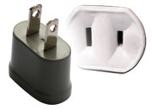
Tipping: Tipping is not customary in Japan.

Electricity: The standard power supply in Japan is 100 volts. The frequency is 50 Hz in eastern Japan including Tokyo. The type of power outlet/connector used in Japan is A type which is a two-parallel-pronged type.

- LOCAL HOST CONTACT INFORMATION:
For any information and arrangement of the events please contact:

Mr. Yoshiaki Tomioka/ Mr. Shigeo Okamoto/ Mr. Tomohisa Shimoyama

International Cooperation Division
Ministry of Internal affairs and Communications (MIC) of Japan
Tokyo 100-8926, Japan
Phone: +81 3 5253 5771 Fax : +81 3 52753 5764
Email: digital-signage-ws@ml.soumu.go.jp (Email is much more desirable.)

ANNEX 1

Transportation from Narita or Haneda Airport to Venue “Akiba Plaza”

There is no direct limousine bus from Narita or Haneda airport to the Akihabara area where the venue “Akiba Plaza” and a few hotels are located.
Therefore participants are requested to reach the Akihabara area by means of train or limousine bus with changing as shown in Figure 1.

However, please note that transportation to hotel from airport depends on location of hotel, participants are requested to confirm by contacting their hotel or by visiting website of the hotel.

Figure1 Transportation map using train from airport

Map of Akihabara area is shown in Figure 2.
Figure2 Akihabara Area Map

Regarding JR Akihabara Station, participants had better to use the “Central Ticket Gate” which is the nearest to the venue “Akiba Plaza” as shown in Figure 2.
The JR Yamanote Line is on the second floor and the JR Sobu Line is on the third floor of the station.

For detailed information on premise of JR Akihabara Station, please visit following website;
http://www.jreast.co.jp/e/stations/e41.html

There are several ways to reach Akihabara area from two airports. The recommended transportations from Narita Airport or Haneda Airport to Akihabara area are described in following two sections.

- From Narita Airport (New Tokyo International Airport) to Akihabara area
There are several ways to reach Akihabara area from Narita Airport as shown in Figure 3. Participants can choose routes. Time required and vehicle fees with remarks of useful information are respectively indicated in Table 1.

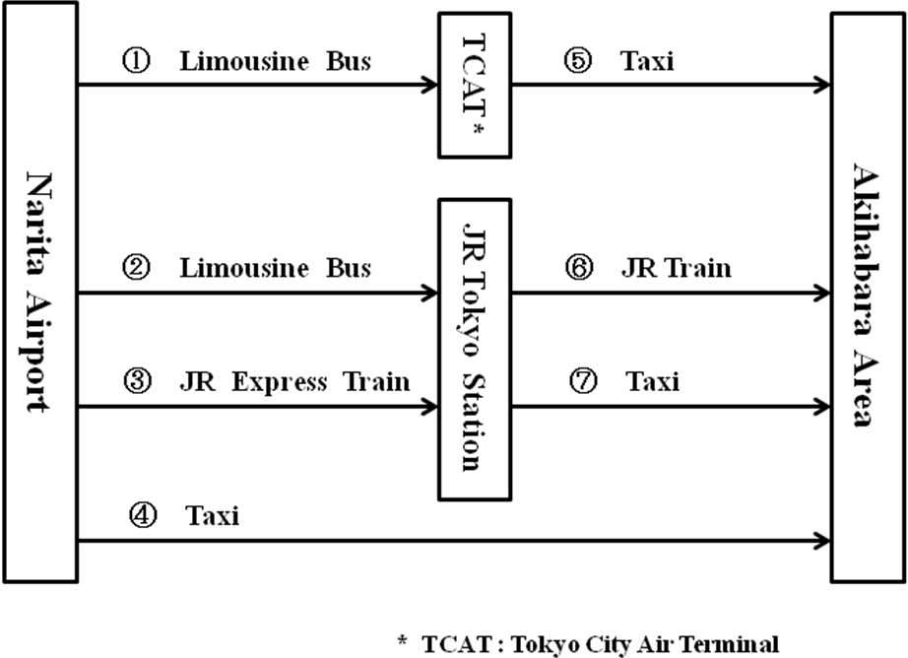
Figure 3 Transportation from Narita Airport to Akihabara area

Table 1 Time required and Vehicle Fee of transportation from Narita Airport to Akihabara area
(Numbers in row correspond to numbers in Figure 3)
No. | Vehicle | Approx. Time Required  (minutes) | Vehicle Fee  (Yen) | Remarks  (Information on limousine bus or train)
1 | Limousine bus | 90 | 2,900 | Ticket counter is located on the floor outside customs inspection room  http://www.limousinebus.co.jp/en/
2 | Limousine bus | 110 | 3,000
3 | JR Narita Express Train | 60 | 2,940 | http://www.jreast.co.jp/e/nex/index.html
4 | Taxi | 100 | approx.28,000
5 | Taxi | 15 | approx. 1,500
6 | JR Train | 5 | 130 | Platform No.4 of JR Yamanote Line toward Akihabara at JR Tokyo Station  http://www.jreast.co.jp/e/stations/e1039.html
7 | Taxi | 15 | approx. 1,500
Transportations No.1 and No.5
By way of TCAT (Tokyo City Air Terminal), participants can reach Akihabara area. It is easy for participants to pick up a taxi at TCAT.

Transportations No.2 or No.3 together with No.6 or No.7
If participants use limousine bus or train, please check comments and URL in related row of Table 1

- From Haneda Airport (Tokyo International Airport) to Akihabara area
There are several ways to reach Akihabara area from Haneda Airport as shown in Figure 4. Participants can choose routes. Time required and vehicle fees are respectively indicated in Table 2.

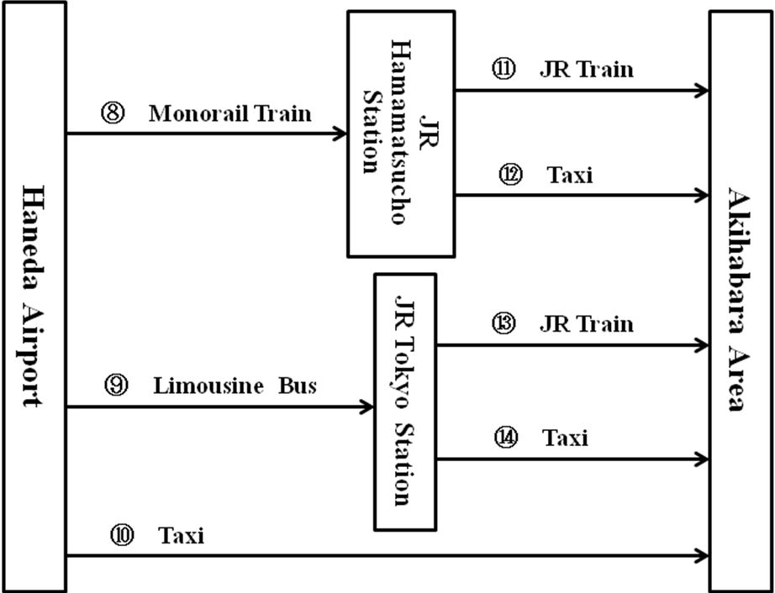
Figure 4 Transportation from Haneda Airport to Akihabara area

Table 2 Time required and Vehicle Fee of transportation from Haneda Airport to Akihabara area
(Numbers in row correspond to numbers in Figure 4)
No. | Vehicle | Approx. Time Required  (minutes) | Vehicle Fee  (Yen) | Remarks  (Information on limousine bus or train)
8 | Monorail Train | 30 | 470 | http://www.tokyo-monorail.co.jp/english/
 |  |  |  | http://www.tokyo-airport-bldg.co.jp/en/access/train/entrance_gate.html
9 | Limousine bus | 30 | 900 | http://hanedabus.jp/timeinfo_e.php?areano=A&routeno=033&busstop1=6036&busstop2=6002
10 | Taxi | 70 | approx.10,000 | http://www.jreast.co.jp/e/nex/index.html
11 | JR Train | 7 | approx. 150 | Platform No.2 of JR Yamanote Line toward Akihabara at JR Hamamatsucho Station  http://www.jreast.co.jp/e/stations/e1039.html
12 | Taxi | 20 | approx. 2,000
13 | JR Train | 5 | 130 | Platform No.4 of JR Yamanote Line toward Akihabara at JR Tokyo Station  http://www.jreast.co.jp/e/stations/e1248.html
14 | Taxi | 15 | approx. 1,500

Transportations No.8 together with No.11 or No.12
By way of JR Hamamatsucho Station, please check comments and URL in related row of Table 2.

Transportations No.9 together with No.13 and No.14
By way of JR Tokyo Station, please check comments and URL in related row of Table 2.
ANNEX 2 Application Form for Visa Supporting Documents
Workshop on Digital Signage
Tokyo, Japan, 13-14 December 2011
Application Form for Visa Supporting Documents

Name (□Mr. □Ms. □Dr.):

Family Name Middle Name Given Name
Your full name in Chinese characters(*):
*If you are a Chinese participant, please write your name in Chinese characters.

Official Title

Department:

Organization
(**):
**If you are a Chinese participant, please write your organization in Chinese characters as well.

Country (where you live)

Address (*1):
(*1) VISA supporting documents will be sent to the address above by courier service.

Phone No. Fax No. E-mail

PASSPORT INFORMATION:

Passport No. : Date of Issue: / / (DD/MM/YYYY)

ExpiryDate : / / (DD/MM/YYYY)

Place of Birth: Date of Birth: / / (DD/MM/YYYY)

Nationality:

FLIGHT INFORMATION(*2) :
Arrival in Tokyo (Haneda / Narita) from city Date__________ Flight No. Time
Departure from Tokyo(Haneda/Narita) to city Date__________ Flight No. Time
(*2) For VISA supporting documents, a planned flight schedule is available as well.

HOTEL ACCOMMODATION
This information is NOT for hotel reservation order sheet, but NEEDED for staying schedule for visa supporting documents.

Hotel name :
Check in date: (DD/MM/YY) Check out date: (DD/MM/YY)

If making your own accommodation arrangement other than recommended hotels in Tokyo, please indicate your contact address and phone number:

Hotel Address_______________________________________________________
Hotel phone No.
Date: Signature:
Deadline of Submission: 14 November 2011 for all visa related documents
Please Return this form To:
Mr. Yoshiaki Tomioka/ Mr. Shigeo Okamoto/ Mr. Tomohisa Shimoyama
Phone: +81 3 5253 5771 Fax : +81 3 52753 5764
Email: digital-signage-ws@ml.soumu.go.jp (Email is much more desirable.)

