Information on Mexico City

**Climate in Mexico**. The Federal District’s height above sea level means that its climate ranges from temperate to cold, humid and alpine tundra in the highest parts of the mountains in the south. The urban zone has a temperate, rainy climate, with temperatures that can exceed 28°C on some days in late spring and descend to as low as 0°C or less in January. The wet season in the Federal District lasts from May to November, with the heaviest rainfall between June and August.

Records give an average maximum temperature in September of 22°C, and a minimum of 11°C.

Local time. Time difference from GMT/UTC

|  |  |
| --- | --- |
| **Standard time:** | UTC/GMT -6 hours |
| **Summer time:** | +1 hour |
| **Current time zone difference:** | UTC/GMT -5 hours |
| **Time zone abbreviation:** | CDT |

Summer time

DST commenced at the official local time - Sunday, 3 April 2011, 02:00  
DST ends at the official local time - Sunday, 30 October 2011, 02:00

Electricity. 110 volts

**Currency.** The **Mexican peso** is Mexico’s official currency.

As an indication, the exchange rate on 27 July 2011 was:

Purchase: 11.6148 Sale: 11.6204

**Banks and credit cards.** Visa and MasterCard are widely accepted. Banks open Monday to Friday, and although timetables vary they are generally open between 0900 and 1600 hours.

**Vaccinations. Before travelling to Mexico, it may be necessary to have certain vaccinations or obtain certain medicines against ailments to which you may be at risk by travelling to this destination.** (Note: Your doctor or medical carer will decide what is required, based on factors such as your health, immunization history, the areas of the country you are to visit, and the activities foreseen.)

Transport

a) Tutors

• Will be picked up at the airport and taken to the Residencia de Investigadores, where they will receive accommodation for the required number of days. They will be taken back to the airport on their day of departure.

• Will be taken from their place of lodging to the workshop venue every day of their stay.

**b) ITU officials**

•Will be entitled to use the airport/hotel/airport and hotel/workshop-venue/hotel transfer services.

c) Participants

• Will have to make their own way from the airport to the hotel of their choice.

• Will be entitled to use the hotel/workshop-venue/hotel transfer service.

Hotel bookings:

Reservations should be made through:

Víctor Vázquez/American Express

**Travel Counselor/Business Travel  
 In-plant Sherwin Williams  
 Poniente 140 No. 595, col. Industrial Vallejo, Deleg. Azcapotzalco, México D.F. 02300  
 Telephone: (52) (55) 5333 1567  
 Fax: (52) (55) 5333 1527  
 E-mail:** [**exsherwin@aexp.com**](mailto:exsherwin@aexp.com)

This is because the rates offered by the hotels are preferential through this travel agency.

Hotel information

# 1. HAMPTON INN - CENTRO HISTORICO

**Price:** MXN 850.00

**Includes:** Buffet continental breakfast

**Address:** Calle 5 de Febrero, N º 24 Centro H, Ciudad de México, C.P. 06060   
Tel: 52-55-8000-5000 Fax: 52-55-8000-5001

**Web.** <http://hamptoninn.hilton.com/en/hp/hotels/index.jhtml;jsessionid=SIUWXX5WNY3T2CSGBJNM22Q?ctyhocn=MEXCHHX>

**Approximate distance from workshop venue:** 9 km

Map of hotel location

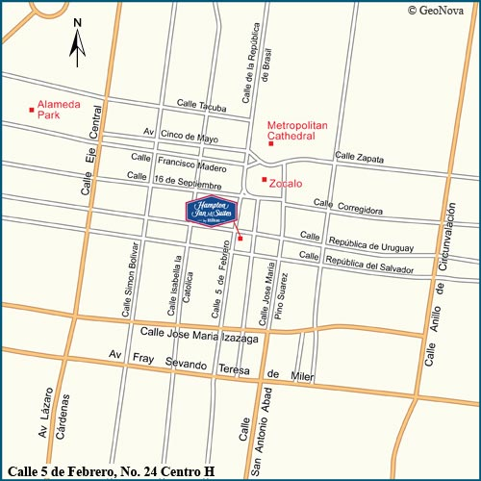

Local airports

**• Benito Juárez International Airport**

Distance from hotel: 5 miles.

Driving time: 15 min.

**Directions:** Exit Airport, turn left on Circuito Interior. Turn right onto Fray Servando, then right onto Moneda. Turn left on Seminario. Turn right on Pino Suárez Ave., then left onto Rep. de Uruguay. Hotel is on the left.

**• "Licenciado Adolfo López Mateos" airport**

**Distance from hotel:** 40 miles

http://hamptoninn.hilton.com/en/common/media/images/shim.gif**Driving time:** 1 hour

**Directions:** Exit Airport, turn left on Mexico/Toluca Rd. Drive to the Santa Fe toll. Continue onto Paseo de la Reforma, then turn right on Juarez Ave. Straight on Francisco I. Madero, San to Zócalo. Right onto 5 de Febrero. Hotel is on the left.

|  |
| --- |
| Directions to hotel from different points in the city |
| From the Intersection of Paseo de la Reforma Avenue and Juarez Avenue - Traveling north from Polanco turn right on Juarez Avenue and if travelling south from Garibaldi turn left on Juarez Avenue. Travel .4 mile and Juarez Avenue becomes Francisco I. Madero Street continue straight for .4 mile to the Zocalo, turn right onto 5 de Febrero and travel 2 blocks. The hotel entrance is on your left.  From Santa Fe - Polanco and Points Southwest. From Santa Fe take Prolongacion Paseo de la Reforma Avenue, then travel 3 miles to Polanco continue on Paseo de la Reforma Avenue for 3 miles and turn right on Juarez Avenue. Follow directions listed above from the Intersection of Paseo de le Reforma and Juarez Avenue.  From San Angel and Points Southeast - Exit San Angel on Insurgentes Avenue travel 6 miles and turn right on Paseo de la Reforma avenue, travel 2.3 miles and turn right on Juarez Avenue. Follow directions listed above from the intersection of Paseo de le Reforma and Juarez Avenue.  From Vallejo and Points Northwest - Exit Parque Industrial Vallejo on Vallejo Avenue travel 3 miles and turn right on Insurgentes Norte Avenue, travel 2 miles and turn left on Paseo de la Reforma avenue, travel 2.3 miles and turn right on Juarez Avenue. Follow directions listed above from the intersection of Paseo de le Reforma and Juarez Avenue.  From Xochimilco and Points South - Exit Xochimilco on Mexico-Xochimilco Avenue and travel 4 miles. Mexico-Xochimilco Avenue changes to Tlalpan Avenue. Continue straight 8 miles where Tlalpan Avenue changes to 20 de Noviembre Avenue. Continue straight .7 mile and turn left on Republica de Uruguay, travel 1 block and turn left on 5 de Febrero. The hotel entrance is on your left.  Cross Streets - 5 de Febrero and Republica de Uruguay |

# 2. FIESTA INN CENTRO HISTORICO

**Prices: MXN** $1 090.00 SGL (ONE PERSON) MXN 1 141.00 DBL (TWO PEOPLE)

**Includes:** CONTINENTAL BREAKFAST

**Address:** Av. Juárez 76 Col. Centro, 06010, Ciudad de México, Distrito Federal, México  
**Tel:** +52 01 (55) 51 30 29 00  
**Fax:** +52 01 (55) 51 30 29 10

**Web.** <http://www.fiestainn.com/es/mx-ciudad-de-mexico/hotel-centro-historico>  
<http://www.pricetravel.com.mx/fiesta-inn-centro-historico/mapa>

**Approximate distance from workshop venue:** 10.9 km

**Map of hotel location**

Located within the Parque Alameda Commercial Plaza, in the Historic Center, very close to Mexico City's main attractions, such as the Cathedral, the Casa de los Azulejos, Bellas Artes and countless museums. The hotel is situated just minutes from Reforma and Polanco Avenues, and important business, commercial and social districts.

The Fiesta Inn Centro Histórico is located in the Plaza Parque Alameda, opposite the Parque de la Alameda, close to the Plaza del Zócalo and Paseo de la Reforma. It offers immediate access to all forms of transport, and is one block away from the Secretariat of Foreign Relations. The international airport (MEX) is a mere 12 kilometres away.

The hotel offers 140 large rooms. Amenities include air conditioning, private bathrooms with bath and shower, cable television, coffee maker, minibar, large desktop and Internet access. There is a room specially equipped for differently abled persons.

The Fiesta Inn Centro Histórico has a restaurant that serves a wide variety of national and international dishes, as well as a lobby bar. For conferences, events and celebrations, it offers four event rooms and two meeting rooms able to host up to 210 people. Families with children can enjoy the Fiesta Kids Club during Sunday brunch. The Fiesta Inn Centro Histórico hotel also has a fully equipped business centre open 24 hours a day, a gym, 24-hour room service and wireless Internet access in the lobby. Transport to and from the airport is available at additional cost, as is parking in the nearby commercial centre (will be charged for).

Services included Business centre • Children’s club • Gym • Rooms for disabled people • Internet • Wireless Internet • Event rooms • Housekeeping service

Services at additional cost Nearby parking • Room service • Laundry • Airport transfer service

Restaurants (1) Café la Fiesta

Bars (1) Lobby Bar

Rooms

Capacity

Adults (13+ years old): max 2

Children (0–12 years old): max 1

Maximum capacity: **3 people**

**View:**  Street

**Check-in:** 15:00 | **Check-out:** 13:00

Children free: 0 to 12 years old

Amenities:

1 king-size or 2 double beds, air conditioning, coffee maker, direct-dial telephone with voice-mail, smart key, hair-drier, Internet access, iron and ironing board, private bathroom with shower, safe, desktop, cable/satellite TV.

# 3. CITY EXPRESS EL ANGEL

**Prices:** MXN1 063.00 (ONE PERSON) MXN 1 163.00 (TWO PEOPLE)

**Includes:** BUFFET CONTINENTAL BREAKFAST

**Address:** Avenida Paseo de la Reforma No. 334, Col. Juárez, Del. Cuauhtemoc, México D.F. C.P. 06600.  Adjacent to Ángel de la Independencia and 15 minutes from the historical centre.  
Tel: (55) 5228-7800  
01-800-248-9397

**Web.** <http://www.cityexpress.com.mx/WebNew/prop_diseno/elangel.htm>

**Approximate distance from workshop venue:** 11 kilometres

Map of hotel location

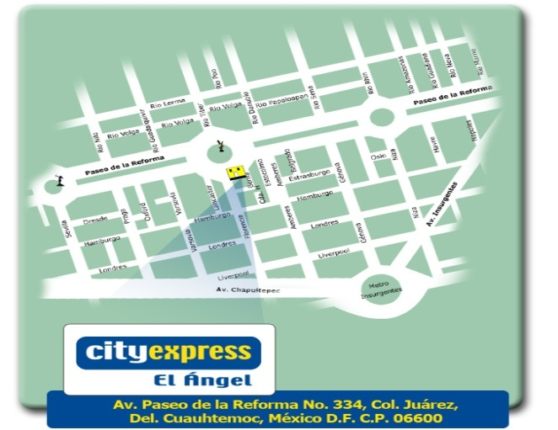

****Hotel services****

• 137 rooms

• Cable colour TV

• Air conditioning

• Meeting room

• Business centre

• Breakfast included

• Gym

• Terrace

• Free wire and wireless Internet

• Voice mail and Data Port.

• Restaurant

• Parking

• State of the art security systems and international standards

• Local and international calls

Distance from hotel to main interest points in the city

Benito Juárez airport 30 minutes  
North coach station 30 minutes  
South coach station 40 minutes  
Alameda Central, 10 minutes  
Zócalo Capitalino 15 minutes  
World Trade Center 15 minutes  
Torre Mayor 3 minutes  
Anthropology Museum 5 minutes  
Palacio de Bellas Artes 10 minutes  
National Auditorium 7 minutes

# 4. CITY EXPRESS EBC REFORMA

**Prices:**  MXN 753.00 (ONE PERSON) MXN 823.00 (TWO PEOPLE)

**Includes:** BUFFET CONTINENTAL BREAKFAST

**Address:** Havre No. 21 Col. Juárez, Ciudad de México, Distrito Federal (A block away from the corner of Reforma and Insurgentes, in front of the Reforma 222 shopping centre.)

**Tel: (55) 1102-0280  
01-800-248-9397  
Web.** [**www.cityexpress.com.mx**](http://www.cityexpress.com.mx)

**Approximate distance from workshop venue:** 10 kilometres

Map of hotel location

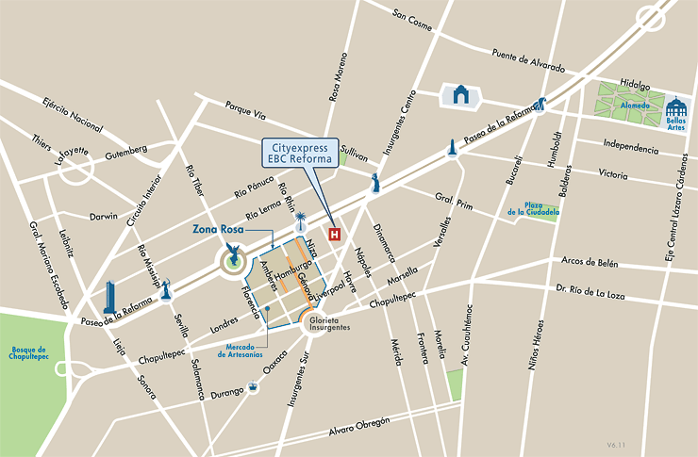

**SERVICES**

Continental breakfast included, free Internet, meeting room, restaurant, event room, business centre and gym.

**ROOMS**

Cable colour TV, long-distance telephone, Internet, air conditioning and automatic wake-up service.

# 5. QUALITY INN DE LINDAVISTA

**Price:** MXN 750.00  
**Includes:** Continental breakfast  
**Address:** Av. Miguel Bernard No 670, Col. La Escalera, CP. 07320, México D.F.

**Tel:** (0155) 5747-4520 Fax : (0155) 5747-4527 **Web.** <http://www.qualityinnlindavista.com/principal.html>

**Approximate distance from workshop venue:** 2.5 kilometres

Map of hotel location

[**http://maps.google.com.mx/maps?saddr=Instituto+Polit%C3%A9cnico+Nacional,+U.+Profesor+Adolfo+L%C3%B3pez+Mateos,+Gustavo+A.+Madero,+Ciudad+de+M%C3%A9xico&daddr=Avenida+Miguel+Bernard+670,+Col.+La+Escalera,+07320+Mexico+City,+DF+(Operadora+De+Hoteles+Lindavista,+S.A.+De+C.V.)&hl=es&ie=UTF8&sll=19.4369,-99.157841&sspn=0.369729,0.441513&geocode=FY9_KQEd-T4X-inVx9ZesfnRhTFpFTTSIUXGeg%3BFc2yKQEdND0X-iFNwHxnV_IMtiknsKIBzPnRhTGnMuoaDvZO0Q&mra=pd&t=h&z=15**](http://maps.google.com.mx/maps?saddr=Instituto+Polit%C3%A9cnico+Nacional,+U.+Profesor+Adolfo+L%C3%B3pez+Mateos,+Gustavo+A.+Madero,+Ciudad+de+M%C3%A9xico&daddr=Avenida+Miguel+Bernard+670,+Col.+La+Escalera,+07320+Mexico+City,+DF+(Operadora+De+Hoteles+Lindavista,+S.A.+De+C.V.)&hl=es&ie=UTF8&sll=19.4369,-99.157841&sspn=0.369729,0.441513&geocode=FY9_KQEd-T4X-inVx9ZesfnRhTFpFTTSIUXGeg%3BFc2yKQEdND0X-iFNwHxnV_IMtiknsKIBzPnRhTGnMuoaDvZO0Q&mra=pd&t=h&z=15)

Services

3 telephones with 2 lines.

Cable colour TV.

Free high-speed wireless Internet.

Room for differently abled persons.

Coffee maker with free coffee. Desktop.

Air conditioning and heating in rooms.

Iron and ironing board. Smokers’ rooms.

Room service/clock/alarm.

Hair-drier. Refrigerator.

______________