ITU-T Workshop on Bridging the Standardization Gap
(Cyberjaya, Malaysia, 29-30 June 2010)
Practical Information

VENUE

Malaysian Communications and Multimedia Commission
Off Persiaran Multimedia, 63000 Cyberjaya, Selangor, Malaysia
Tel: + 60 3 8688 8000
Fax : + 60 3 8688 1007
E mail : william@cmc.gov.my; nzurina@cmc.gov.my
Website: http://www.skmm.gov.my/

ACCOMMODATION

recommended hoteL

Grand Millennium Kuala Lumpur
160 Jalan Bukit Bintang, 55100 Kuala Lumpur, Malaysia
Tel: + 60 3 2117 4888
Fax : + 60 3 2142 1441
E mail : enquiry@grandmillenniumkul.com
Website: www.millenniumhotels.com/millenniumkualalumpur

Room Tariff per night:
Deluxe Single MYR 320++ (approx. USD119)
Deluxe Double MYR 350++ (approx. USD130)

The above rates are subject to 5% government tax and 10% service charge. The rates quoted are inclusive of buffet breakfast/s and 24 hours in-room high speed internet access.

Hotel Reservation Form is appended below.

TRANSPORTATION

Airport Transfers
Upon arrival at the Kuala Lumpur International Airport (KLIA), participants are advised to take an airport limo to the hotel.

Taxi fare from airport to the hotel is approximately RM80 (approx. USD25) for budget taxi and RM105 (approx. USD32) for premier taxi. Detailed information on airport transfers can be found at http://www.klia.com.my/index.php?ch=77&pg=216 .

Transport to Meeting Venue
The host will provide a bus to transport participants to and from the meeting venue. The journey will take approximately between half an hour to 45 minutes. The bus will depart from the Grand Millennium Kuala Lumpur at 8.15am sharp on 29 and 30 June 2010.

HEALTH REQUIREMENTS
Detailed information on Health Requirements for visitors entering Malaysia can be obtained at the following: http://www.klia.com.my/index.php?ch=68&pg=189&ac=3743

VISA REQUIREMENTS
As visa requirements change from time to time and vary for the citizens of different countries, participants are requested to check their visa requirements with the nearest Malaysian Embassy/High Commission. Visa application letter may be sent upon request. Please contact ITU Secretariat or Malaysian Secretariat for the letter.

Some Visa Information for foreigners intending to enter Malaysia can also be obtained from the Ministry of Foreign Affairs Malaysia - http://www.kln.gov.my/web/guest/requirement-for-foreigner

DEPARTURE TAX
Departure tax is included in the purchase price of the air ticket. No additional tax is required to be paid at the airport.

TIME ZONE
GMT + 8 hours.

weather
During May the average temperature varies from 22 to 32 degree Celsius with humidity level between 79% - 84%.

LANGUAGE
Although Bahasa Melayu is the official language of Malaysia, English is widely spoken.

ELECTRICITY

The electricity supply in Malaysia is 240 volts AC. Malaysia uses the Type G Plugs and Sockets, which is also commonly used in the United Kingdom, Singapore and Hong Kong)

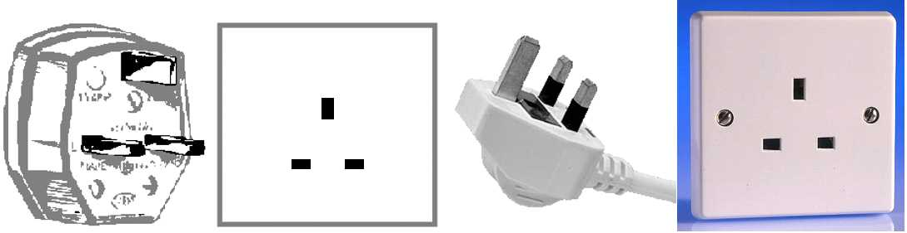

CURRENCY – EXCHANGE RATES
Current conversion rates are available on www.xe.com/ucc

HOTEL RESERVATION FORM

Please complete and return this form latest by 15 June 2010 to:
Ms. Norzurina Ismail, International Affairs, Malaysian Communications and Multimedia Commission
Tel.: + 60 3 – 8688 8211 Fax: + 60 3 – 8688 1007 Email: nzurina@cmc.gov.my

Guest Name: ……………….............................................................................................................……………………………

Company Name: ………….................……………..............................................................................…………………………...

Telephone: .…...........…………………. Fax Number: …….…........................ Email: ……………………
Address: ..………….......................................................................................................................……………………………

………………………………………………………………………………………………………………………..
Arrival Date: ......................................................................... Departure Date/: ...................................………...
Arrival Flight No/Time: ........................................................ Departure Flight No/Time: .................................

Please indicate preference by ticking the box provided.

GRAND MILLENNIUM KUALA LUMPUR
160, Jalan Bukit Bintang, 55100 Kuala Lumpur, Malaysia
Hotel Website: http:// www.grandmillenniumkl.com /

Room Type / Rates : -
- Deluxe Single RM320.00 per room per night inclusive of one breakfast and High Speed Internet (24 hours)
- Deluxe Double RM350.00per room per night inclusive of two breakfast and High Speed Internet (24 hours)

Smoking Non-Smoking King Bed Twin Bed

* All rates quoted are subject to 10% service charge and 5% government taxes

Check-in date: .......................................................... Check-out date: ...................................…………….

To Guarantee Credit Card No.: ..................................................…………… Expiry Date: ..................…………..…..

Card Member's Name: ...............................................................…………… Signature: ...........................…………....

Airport Pick-up: Yes …………..…. No ……………….… RM290.00 per car per way

There will be a 50% surcharge between 12:00 midnight to 6:00 am for airport transfer.

* Check-in time is 1400 hours.
Early check-in is subject to room availability upon arrival.
To guarantee early availability of your room before 1400 hours, the room needs to be reserved one night before, with one night charge.
To Pre-Block room for guaranteed early availability before 1400 hours, please tick here. Please note that this will incur one night room charge.

* Check-out time is 1200 hours
Any request for late check-out is subject to room availability.
Late check-out from 1200 hours to 1800 hours can be extended at 50% of room rate, thereafter a full day rate will applicable.

* Credit card details / deposit is required to guarantee reservation

In the event of no-show or cancellation less than 72 hours, one room night charge will be applicable.
An early departure fee will be charged to any guest who checks out of the hotel before the scheduled departure date.
Guests have the opportunity to change their departure date at check-in or 48 hours before scheduled departure date without paying the early departure fee.

* Please make your booking by 15th June 2010.
Reservations received after this date will be subject to prevailing rates and availability of that period.
Remarks:________________________________________________________________________________

_________________

