
Report by the Director, TSB
REPORT ON THE CONSULTATION MEETING ON
CONFORMITY ASSESSMENT AND INTEROPERABILITY TESTING
Geneva, 20-21 July 2009

Introduction

A two-day consultation on conformity assessment and interoperability testing was held at ITU Headquarters in Geneva on 20th and 21st July 2009. This had been notified to the membership in TSB Circular 45, which invited participation and written contributions. A number of documents were provided by TSB as background for the meeting. An audio archive of the event has been made available.

The meeting was chaired by the Director of TSB and in his absence by the Deputy Director with the following programme:

1. WTSA-08, developing countries and Resolution 76 1
2. Conformity assessment and accreditation 3
3. Mutual Recognition Agreements 4
4. Interoperability – Networks and regulatory issues 5
5. Interoperability – Government and emergency services 5
6. Test laboratories in developing countries 6
7. Electrical safety and electromagnetic compatibility 7
8. Conclusions 7

WTSA-08, developing countries and Resolution 76
The opening session reviewed the Resolutions adopted by the World Telecommunication Standardization Assembly (WTSA-08) that addressed issues concerning developing countries. In particular it considered Resolution 76, including the actions required to be undertaken by the ITU-T Study Groups in developing test suites for Recommendations and by the ITU-T in assisting developing countries.

Malcolm Johnson, Director of the Telecommunication Standardization Bureau (TSB), gave a presentation on Resolution 76. He noted the recent GSC-14 Resolution 28 on interoperability adopted by the Global Standards Cooperation (see Figure 1).
Figure 1 GSC Resolution 14/28 on interoperability (Geneva, July 2009)
Recognizing:
- that providing for interoperability is an aim of standards,
- that standards development processes, while promoting interoperability, should also foster innovation, competition and infrastructure development that address user needs on a timely and cost-effective basis;
- that supporting innovations in user applications and in network capabilities drive the development of standards;
- that product development and deployment cycles have become shorter and shorter over time to accommodate increasing features and capabilities to address user needs;
- that the pace of innovation will continue to accelerate;
- that various mechanism are available to enhance interoperability, including developing “interoperable standards”, providing implementation guidelines, hosting interoperability events and human capacity building;
- that compliance with technical standards is not a guarantee for interoperability;
Considering:
- that the availability of interoperable standards can be used to promote interoperability and facilitate interconnection negotiations
- that testing (e.g. plug fests and interoperability events) can enhance the interoperability of standards;
- that PSOs consider interoperability as well as the other factors in Recognizing b) as an explicit objective of standards development;
- that PSOs have experience with the value, of interoperability testing guidelines and events, and with the limitations and costs of interoperability testing;
- that there is no universal solution for interoperability, and different techniques may be appropriate for different network situations;
- that compliance with technical standards can increase the probability of end-to-end interoperability but will not guarantee interoperability;
Resolves:
  - to exchange information among PSOs which have experience in interoperability.
  - to encourage PSOs and related Fora/Consortia to discuss issues related to interoperability.

Alan Bryden, a Special Consultant to the ITU, gave a presentation on the various options examined for an ITU Mark Programme (see Figure 2) and outlined a proposal based on option 1.
Figure 2 Options for the ITU Mark Programme
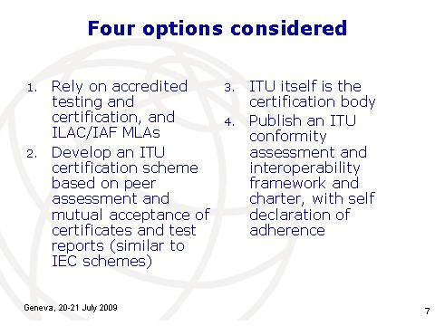
In the discussion, an important distinction was drawn between conformity assessment to comply with domestic regulations (Type Approval), primarily for essential requirements related to network harm, radio frequency interference and electromagnetic compatibility, and its use in order to improve interoperability between different equipment. It was also noted that the development of test suites is a prerequisite for conformity assessment and test suites written with the purpose of interoperability could increase the probability of interoperability.
It was noted that a number of test suites and programmes for conformity assessment already exist globally. There is no intention for the ITU duplicate work that is already being undertaken in this field, instead the ITU-T would seek to work with those already active in the field in the hope to make information available in a public database.
ETSI is presently spending some millions of Euro each year developing test suites.
For interoperability a practical route used by several organizations was to conduct “interoperability events” where companies try to interoperate their implementations of a standard with the corresponding implementations of other companies. Such “interop events” have different names and followed a wide range of procedures (e.g., some use a non-disclosure agreement). The following are examples of “interop events”:

  - ETSI Plugtests;
  - IETF bake-off (e.g., DHCPv6);
  - IMS Forum Plugfest;
  - Integrating the Healthcare Enterprise (IHE) Connectathon; and
  - Open Mobile Alliance TestFests.

These require test specifications but, in contrast to test specifications for conformity testing, they are usually written in prose. Errors or ambiguities detected in the standard during an interoperability event are fed back into the standards process. It was noted that interoperability testing was outside the CASCO framework and would require elaboration of the existing ISO/IEC standards.
The importance of the promotion of technological innovation was recognised, as was the need to avoid creating unintentional barriers to trade. The value of technology neutrality in policies and regulation was also noted.
Where a vendor misused the initials ITU in a possible future ITU mark programme then enforcement would be a matter for national governments, since it would be in violation of the Paris Convention. It was reported by the ITU that after ten years of operation of the GMPCS mark programme there had been no litigation. Questions were raised about the potential liability the ITU might face, however, with the misuse of any potential ITU Mark.

Conformity assessment and accreditation
This session examined global best practice for conformity assessment, the ISO/CASCO Toolkit, including the role of laboratory accreditation (ISO/IEC 17025), the supplier’s declaration of conformity (ISO/IEC 17050) and the certification of test results (ISO/IEC Guide 65, to become ISO/IEC 17065). It also considered actions being taken to support developing countries in bringing their conformity assessment regimes into line with global best practice.

Sean Mac Curtain, ISO/CASCO Secretary, gave a presentation on the work of the ISO Conformity Assessment Committee (CASCO), explaining the details of the CASCO Toolkit (see Figure 3).
Figure 3 The CASCO toolkit
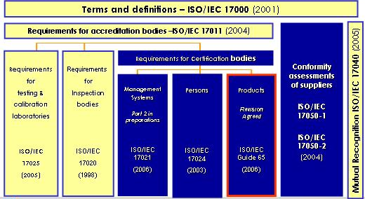

Through the International Accreditation Forum (IAF) and the International Laboratory Accreditation Cooperation (ILAC) procedures existed for the international mutual recognition of the competence of laboratories and acceptance of the results (see Figure 4). Procedures also existed through these bodies to make sector specific additions, to take account of their requirements.
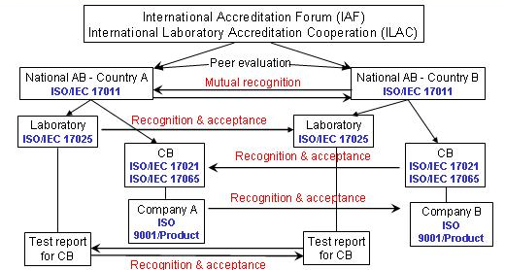
Figure 4 Voluntary systems for international mutual recognition

The approach taken depended on the level of risk. Where the risk was minimal or low, there was not likely to be the need for an independent laboratory to conduct the conformity assessment. However, for bio-medical implants and explosive environments a much more rigorous approach was required. The proposal for the future ITU mark programme was for that risk assessment to be made by the accredited laboratory or the accredited certification body.

Mutual Recognition Agreements
Mutual recognition of test results and certification of conformity between countries helped to achieve “tested once, accepted everywhere” and facilitated international trade. In particular, it supported the WTO Technical Barriers to Trade (TBT) Agreement.
Yoshikazu Ishii, Ministry of Information and Communications (MIC), Japan, gave a presentation on Mutual Recognition Agreements (MRAs) signed by his country and on the framework of NGN interoperability testing. The MRAs covered the mandatory requirements for products to enter Japan from the European Union, Singapore and the United States of America and vice versa. There was also a regional MRA under the Asia Pacific Economic Cooperation (APEC), with a similar MRA by the Organisation of American States (OAS).
The negotiation of MRAs had benefits in terms of educating policy makers and in making improvements to the regulatory regimes, in particular in improving transparency. Once in place, an MRA reduced time to market and reduced the costs of testing.
Interoperability would be outside the provisions of an MRA, but would typically rely on the use of ILAC and IAF multi-lateral agreements (see Figure 4). Such arrangements could be achieved more quickly than those involving governments, which might take several years.
Governments could be persuaded to use the ILAC and IAF agreements where they were convinced by their National Accreditation Body that the systems were sufficiently robust to meet their national needs and appropriate for the levels of risk.

Interoperability – Networks and regulatory issues
Some equipment is represented as complying with standards, when it has not been tested. This session considered options where equipment that did not fully meet the standards or contained a range of additional vendor-specific features that can make interoperability difficult and expensive to achieve.
Joshua Peprah, Director, Regulatory Administration, of the National Communications Authority of Ghana gave a presentation. He noted the absence of test laboratories and MRAs in many developing countries, which were experiencing growth of their ICT markets. A range of problems were present on their markets which national regulatory authorities were expected to address, including consumer welfare. For those living on less than $1 per day, the purchase of a $30 counterfeit or potentially dangerous mobile phone was not something easily remedied. There were general problems of poor quality of experience on mobile networks in developing countries. Several participants noted the need to better understand the problems faced by developing countries and the possible solutions. E.G.: eliminating counterfeit products is not solved by conformance to standards but rather is the domain of law enforcement – it is an intellectual property rights issue.
There was a need for legislation and for supporting systems to test equipment sold on the market. Industry Canada noted that one model of cellphone had recently to be withdrawn from its market, having been shown not to comply with standards.
One manufacturer pointed out that testing for interoperability is not normally the domain of member states or for their regulators, but is, in practice, the exclusive responsibility of the industry, and is often conducted/enforced by network operators who have a clear interest in ensuring that equipment connected to their networks is interoperable.
It was also noted that the concept of a potential ITU Mark would be voluntary for ITU members, but concerns were raised about the possibility of countries requiring the Mark for market access. Mr. Peprah indicated Ghana would not make it mandatory, but that preference would be given to equipment shown to comply with ITU standards, which would be more relevant than an FCC or CE mark for example.

Interoperability – Government and emergency services
The growth of e-government required high levels of interoperability to link different branches of government and to ensure easy and high quality interaction with citizens. One traditional area of particular concern has been to ensure full interoperability in emergency communications.
Denis Andreev, Director of Technopark, Central Science Research Telecommunication Institute (ZNIIS), gave a presentation on the work of the International Telecommunication Testing Center (ITTC) (see also ITU-D Project CIS08-02). The ITTC had developed a testbed for interoperability testing, in particular of Next Generation Networks (NGNs), with a view to the early identification of problems (see, for example, Figure 5). He also demonstrated access to the database of problems (in Russian).
Figure 5 Examples of problems identified by ITTC
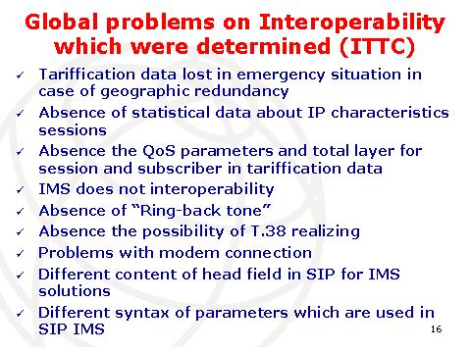

It was noted that one method to assist developing countries would be to implement virtual laboratories which could be used for remote training and practical exercises for specialists in developing countries. The BDT project (CIS08-02) on the establishment of the ITTC and its Knowledge Data Base could be of direct use in implementing Resolution 76.

Test laboratories in developing countries
Few developing countries have test laboratories, mostly those with a significant manufacturing base. This session addressed the measures needed to be undertaken to set up laboratories in the regions, including the provision of training.
Primož Jenko, Technical Expert, Sintesio, gave a presentation on the workshop in Dar es Salaam organized by Tanzania Communications Regulatory Authority (TCRA) the previous month. This had set out the priorities in Tanzania and in Kenya which were firstly essential safety requirements of type approval. After this, testing for interoperability could be useful. It was suggested that many of the issues identified as problems in developing countries (which were calling for an ITU Mark) could be solved by establishing and/or improving Type Approval regulations in developing countries.
The Industry Canada test laboratory had cost CA$ 5 million to establish, with CA$ 3 million of equipment and CA$ 3 million of annual running costs.
Without laboratories, developing countries were unable to verify if equipment truly met the requirements of, for example, CE or FCC Marks.
Julio Cesar Fonseca, ANATEL, gave a presentation on the mandatory testing regime in Brazil, including the work of CPqD.

Electrical safety and electromagnetic compatibility
The health and safety of consumers requires the conformity of equipment with standards for electrical safety and their electromagnetic emissions, the latter may also interfere with other telecommunication services.
Essential requirements for equipment, usually safety, can be fulfilled by means of the already existing IEC certification systems -- this is what they are designed for (IECEE and IECEx).
Claude Monney, Rapporteur Q.6/5, gave a presentation on the work of Study Group 5.
The World Health Organisation (WHO) provides the medical limits to which humans should be exposed, while Study Group 5 provided frameworks for the application of those limits to telecommunications equipment.
Many of the essential requirements for equipment could be fulfilled by means of the already existing IEC certification systems (i.e., IECEE and IECEx). The IEC standards had, almost always, been developed in coordination with ITU-T.

Conclusions
Malcolm Johnson, Director TSB, thanked all the presenters for their contributions. He noted that their presentations had been posted on the ITU web site and that a report of the consultation would be included in the information documents submitted to ITU Council.
He thanked all those who had attended and actively participated in the meeting. He invited comments on the various documents that had been posted on the web site, in particular additional information on the regions. Any thoughts or reflections after the meeting would also be welcomed. All ideas and material would be given appropriate consideration in the drafting of the report to Council.
The Director TSB noted the pre-eminence of the ITU as the global standards body. He recalled that the Global Standards Collaboration (GSC) meeting hosted recently by ITU has the objective to collaborate, avoid duplication of effort and to support ITU's role. It had adopted a new Resolution on collaboration on interoperability which created the framework for collaboration on this issue between ITU and the major regional ICT standards bodies. It was important to build on the status of the ITU but doing so through partnerships and avoiding duplication. He recognised that addressing this issue fully was going to take time and that there was no short term solution. However, ITU must respond to the concerns that had been raised and at least take a step forward.
He reminded participants that ITU-T has about 3300 standards, but it was estimated that only about 5 per cent of those currently provided for interoperability testing. This was because a lot of Recommendations had not been written in ways that provided for testing as they are not sufficiently specific or had too many options for this. For ITU to provide more conformity assessment and interoperability testing it was going to require a somewhat different approach to the development of standards in the study groups. They would have to be written in a different way, more like specifications, and then the associated test suites would have to be developed. He noted that developing test suites was an extremely specialized topic and the study groups would need to be encouraged to produce these, as Resolution 76 already instructs them to do. At the same time ITU has noted that other standards bodies have produced test suites, even to test against ITU Recommendations, so ITU should look to use them as far as possible. It was noted that ETSI pays for the development of test suites, so this was something ITU might have to consider.
The TSB Director recalled that some vendors currently test to some of the ITU-T standards, H.264 for example, one of the ITU's most popular standards that provides for conformity assessment testing. However, ITU does not keep a record of such tests. He noted it had been suggested ITU could offer vendors the possibility to inform ITU that their equipment had been tested satisfactorily to H.264 (or any other ITU-T standard) and that this information could be placed in a public database on the ITU-T website so that people could see what equipment had been tested to ITU standards, and the criteria for accepting the results, such as those put forward in the concept document.
He noted that it had been recognised that conformity assessment testing did not ensure interoperability, it was just one step towards interoperability. During the meeting participants had learned a lot about the interoperability events organized by other bodies. He recalled that ITU used to facilitate such events but has not done so for some years, and that this was something that ITU should do in future, perhaps, in partnership with the other bodies that organize interoperability events. ITU could facilitate such events and then keep a public database of the results on the ITU-T website. It had been suggested that ITU could allow some form of reference to the ITU recognition of conformity or interoperability of products or services on the website databases, and on the product or on the associated documentation should the vendor wish. This reference would mean that the product had been tested to conform to an ITU standard, or it could mean that the product had been successful at an interoperability event. There would be a need to distinguish between the two types of reference.
The TSB Director noted the many statements referring to the credibility of ITU, especially in the developing countries and the emerging markets. ITU recognition of products or services would be seen as giving some assurance of quality, so it could be an attraction to vendors to participate in an interoperability event.
He noted it had been suggested ITU could initiate a pilot interoperability event in association with a developing country that would be willing to volunteer to help. This could identify exactly the interoperability problems being faced, whether it is a connection problem, whether it is a service problem, the ITU Recommendations which would be implicated in such testing, and if they did not exist which Recommendations needed to be developed, including any test suites. This could also encourage the establishment of test centres in developing countries.
He noted that costs of establishing and running a test centre were high and that consequently it had been generally accepted that groups of countries would need to club together on a regional or sub-regional basis, and that initially such centres would probably be looking only at testing the essential requirements of electrical safety, electro-magnetic compatibility, specific absorption rate and network harm. Later these centres could evolve and countries have the ambition to establish centres which can do a range of quality checks similar to what had been described by Brazil. Although testing essential requirements was a regulatory, type approval issue, it was related to the package of Resolution 76, as a significant step forward.
He noted the suggestion to develop a business plan for the implementation of Resolution 76. .
The TSB Director noted that the need for human capacity building in the developing countries had been clearly articulated at various levels, in ministries, in regulatory agencies, and in operators. It had been recognised that it would take some time to address this, building up the necessary expertise in stages. He noted the suggestion that ITU could facilitate the secondment of engineers in developing countries to test centres in developed countries to help build this expertise.
There was already work being undertaken to improve conformity assessment systems in developing countries by UNIDO and ITC, plus the World Bank and the regional development banks. Initial discussions had taken place with UNIDO and he noted that ITU partnerships with these bodies have been encouraged. It was proposed to build on this to enhance conformity assessment in telecommunications.
_________________

