Information document
F
Lessons from other marks

1. Lessons from other marks 1
2. Intel Inside® 2
3. ISO 9001 5
4. Energy saving marks 6
5. FCC mark 11
6. CE Mark 13
7. The TETRA consortium 16
8. The certification of CDMA handsets 17

Lessons from other marks
In assessing the prospective value of an ITU Mark it is essential to draw on the lessons learned by other organisations in their use of different types of marks.
Traditionally, a mark was issued by a government body, based on the results of tests performed only in official laboratories. However, in recent years a much wider range of approaches has been taken, including purely commercial marks (see Figure 1).
Figure 1 Categories of mark
 | Mandatory | Voluntary | Commercial
Supplier’s declaration of conformity | CE  A to G | EnergyStar | Intel®
Certified laboratory | FCC | ISO 9000  TCO  CCF

Marks are generally subject to legal protection. All voluntary and some mandatory markets are registered trade marks, though the former must be registered country by country. It makes their misuse subject to civil litigation or criminal prosecution and sometimes both. Statutory protection is provided for the CE mark under European Union directives and the FCC mark under the USC.
The use of marks is also subject to market surveillance. This can be voluntary, for example, by relying on other market players and consumer organisations, alternatively it can be tests or inspections conducted by the public authorities before or after entry onto the market. The systems for market surveillance are generally proportionate to the danger they represent to potential users.
The structure of this section is to review seven quite different marks in order to identify lessons, both positive and negative. First, Intel Inside® is a set of commercial trade marks used to show the source of key components in computers. Secondly, ISO 9000 is used to show the adoption of quality management systems in which certification is provided by a third party (i.e., neither ISO nor the supplier). Thirdly, marks to show the levels of energy efficiency of ICT products, with examples of a technical standard and third party voluntary marks. Fourthly, the FCC mark issued under technical regulations following tests by certified laboratories. Fifthly and finally, the CE Mark used by manufacturers declaring their compliance with European Union technical regulations.

Intel Inside®
Intel Corporation, short for integrated electronics, was founded in Silicon Valley by Robert Noyce and Gordon Moore on leaving Fairchild Semiconductor in 1968. The initial logo was the name with a dropped e (Figure 2). Initially Intel made memory chips, but later abandoned this line of business to specialise in microprocessors, which it had invented. In 1981 it was selected to supply its 8088 microprocessor for the IBM Personal Computer®. As clones of the IBM PC flooded onto the market, Intel feared its microprocessors would become commodities, with competitors driving down prices and profit margins.
Figure 2 Intel dropped e logo

The significant challenge faced by Intel was that the microprocessor was largely unknown to end customers. Despite processing all the instruction in their computers, this chip was seen only as one of many components. In 1991 it launched the Intel Inside® programme, the first attempt by a manufacturer of electronic components to communicate directly to computer buyers. This involved co-operative marketing and co-branding programmes with large numbers of manufacturers of PCs which were licensed to use the Intel Inside® registered mark (see Figure 3).
Figure 3 Examples of Intel Inside logos
 | 

The Intel brand was relaunched in 2006 (see Figure 4) with the words “leap ahead” added to the corporation name, to signify its mission. The logo, without the words, was then used with a number of specific brands, such as Centrino® for Wi-Fi-enabled devices and Atom® for netbooks. The word “inside”, now an Intel trade mark in its own right, was separated from the Intel name and used in association with a range of microprocessors.
Figure 4 The new Intel logo in different forms
 | 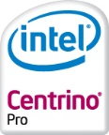 | 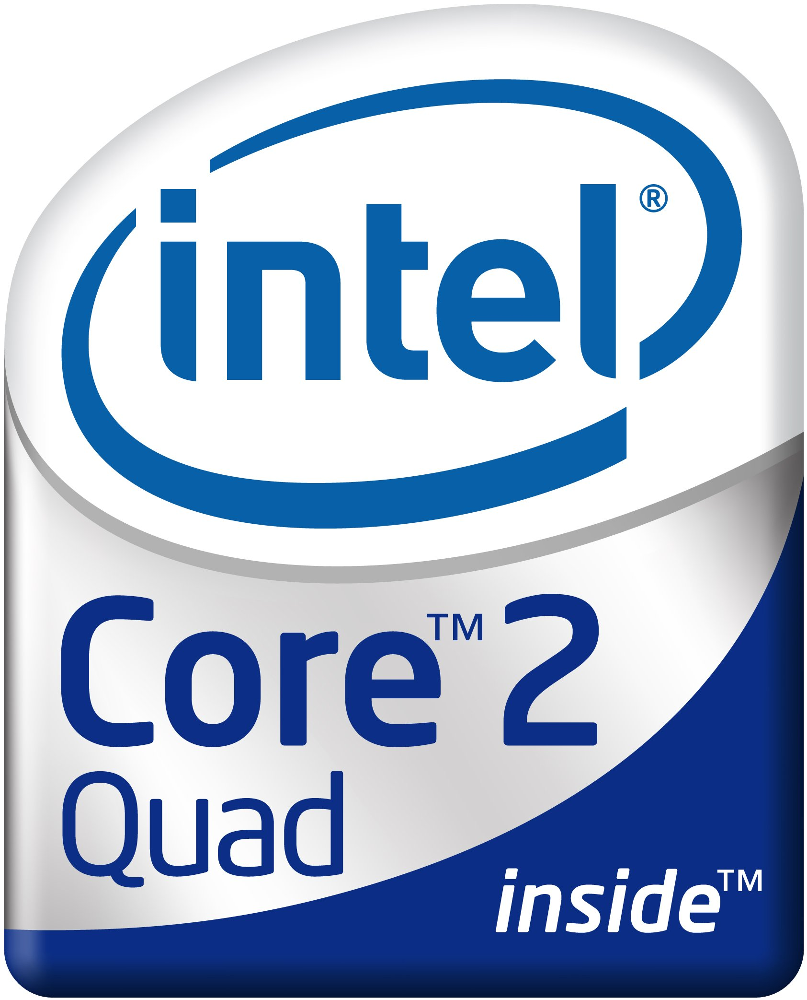 | 

Today, Intel was one of the top global brands with remarkable equity value, which Interbrand ranked as number 7 in 2008 (see Table 1).
Table 1 Interbrand best global brands
Brand | Sector | Value  US$ M | 2008 | 2007 | 2006 | 2005 | 2004 | 2003
Coca-Cola | Beverages | 66,667 | 1 | 1 | 1 | 1 | 1 | 1
IBM | Computer services | 59,031 | 2 | 3 | 3 | 3 | 3 | 3
Microsoft | Software | 59,007 | 3 | 2 | 2 | 2 | 2 | 2
General Electric | Conglomerate | 53,086 | 4 | 4 | 4 | 4 | 4 | 4
Nokia | Mobile phones | 35,942 | 5 | 5 | 6 | 6 | 8 | 6
Toyota | Automotive | 34,050 | 6 | 6 | 7 | 9 | 9 | 11
Intel | Semiconductors | 31,261 | 7 | 7 | 5 | 5 | 5 | 5
McDonalds | Hamburgers | 31,049 | 8 | 8 | 9 | 8 | 7 | 8
Disney | Media | 29,251 | 9 | 9 | 8 | 7 | 6 | 7
Google | Internet services | 25,590 | 10 | 20 | - | - | - | -

The rapid technical advances made in microprocessors, in line with Moore’s Law, played a central role in transforming the PC from the basic business tool of the early 1980s into a multi-purpose device for information, entertainment, education, business and personal productivity. Intel initially relied on its customers, the PC manufacturers, to convey the message of this increasing power and functionality to business users and to consumers. It had very limited brand identification among computer users, who knew little more, and perhaps less, about the processor than they did about the gear box or the engine in their cars.
In an increasingly fragmented PC market Intel believed that consumers should know more about the processor and the company that made them, in particular to remove some of the mystery around their chips. In 1989 an Intel marketing manager formed a small team that went on to launch its first programme aimed at marketing a microprocessor, the 386SX, to corporate IT managers responsible for purchasing PCs.
Marketing an electronic component directly to the end user was a novel idea, not only for a semiconductor company. Although the Intel brand was widely known among manufacturers, it had little recognition with end users and consequently limited influence over their buying decisions.
The Intel team was able to draw on successful consumer marketing campaigns for “ingredients” such as:
- Dolby™;
- NutraSweet™; and
- Teflon™.
It was an approach also used for fabrics such as Gore-Tex® from W L Gore and Associates Inc, Lycra® from Invista and Kevlar® from Dupont.
Intel’s aim was to create confidence in end customers about its brand, so that regardless of the make of PC they purchased, they would look for one with an Intel microprocessor.
In July 1991, the Intel Inside® co-operative marketing programme was launched. This was an incentive-based programme, in which Intel put 5 per cent of the purchase price of microprocessors into a fund available to pay for advertising. It shared the costs of print advertisements that included the Intel logo. This allowed the advertising expenditure of the PC manufacturers to go further, while promoting the Intel brand. It eventually overcame resistance from Compaq and Hewlett-Packard, two premier PC brands, which were concerned about diminution of their brand value.
By the end of 1991, 300 PC makers had signed up for joint advertising. In 1992, Intel recorded an increase in sales of 62 per cent.
Intel separately launched print and then television advertising to explain the logo to consumers. The TV adverts stressed the speed, power and affordability of its chips. It used state-of-the-art special effects to illustrate a trip through the inside of a personal computer, emphasising the then new Intel i486™ processor.
A five-note Intel jingle was introduced in 1992: D♭ D♭ G♭ D♭ A♭. It was written by Walter Werzowa from the 1980s Austrian sampling band Edelweiss and used globally on television advertisements.
Within a few years its substantial marketing spending began to pay-off in terms of consumer brand recognition. This was aided by high-profile campaigns for the launch of the Pentium® in 1993 and Pentium® Pro in 1994.
Intel consumer marketing campaigns are now nearly two decades old and have cost billions of dollars but have generated even greater sales. They successfully turned a manufacturer of unseen components into a visible and highly valuable brand. Consumers had been persuaded to select from amongst a wide array of PCs, at least, in part based on the brand of one of the components. Manufacturers were persuaded that they would benefit from co-branding in advertising and by placing on their PCs one or several Intel trade marks.
The profits made by Intel were increased by its ability to sell microprocessors in the short window before a newer and more powerful design was ready to be launched. Rivals struggled to keep pace with Intel as it adhered strictly to the acceleration of Moore’s Law.

ISO 9001
Management system standards, such as ISO 9001 help organizations produce consistent quality or address environmental impact. Registration organizations provide objective, third-party assessment that a management system has all of the necessary components and that it is consistently applied.
In some industries, however, an ordinary registration certificate is not enough. The automotive, telecommunication, aeronautics, medical devices and forestry industries have developed their own sector-specific extensions to ISO 9001. Some national systems have developed programs to allow registrars to provide registration in these extended areas.
ISO is not a certification body. Instead, this role is performed by over 1,000 other organisations that use procedures defined in ISO 9001 procedures and are themselves certified in terms of ISO 17021.

Energy saving marks
The issue of energy efficiency was recognised by the ITU-T in two global symposia and in the creation of the Focus Group on ICTs and Climate Change which concluded its work in April 2009. ICTs are estimated to contribute around 2 to 2.5 per cent of greenhouse gas emissions, a figure that can only rise as they became more widely used. However, with increased energy efficiency it is possible to contain the growth of these emissions and to deliver energy cost savings.
Amongst the approaches the Focus Group considered was the use of labels and marks to show energy efficiency. Labelling ICT devices informs consumers and business users about their potential power consumption and the associated energy costs and possible savings.
ISO 14024 recognises three types of voluntary environmental performance labelling:
- a voluntary, multiple-criteria based, third party programme that awards a licence authorizing the use of environmental labels on products indicating overall environmental preferability of a product within a particular category, based on life cycle assessment
- informative environmental self-declaration claims
- voluntary programmes that provide quantified environmental data for a product, using categories of parameters set by a qualified third party based on life cycle assessment, and verified by that or another qualified third party
The analysis here is limited to two voluntary marks, both of Type I, EnergyStar® and TCO (see Figure 5) and to a third mandatory mark (see Figure 7).
Figure 5 The Energy Star® and TCO marks
 | 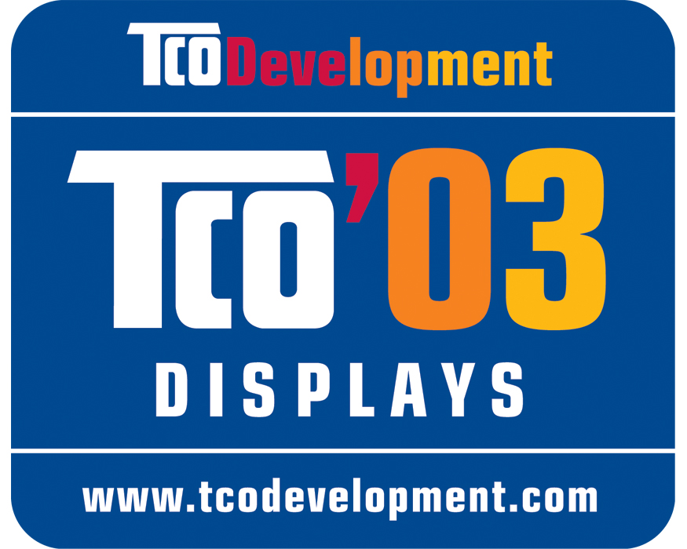

Energy Star® is a standard for energy efficiency first created in 1992 in the United States of America by the Environmental Protection Agency. It is a voluntary programme originally for office equipment, but now applied to a very wide range of products, even to homes. The Energy Star® mark can be attached to a device or, in the case of monitors, can be shown on the screen and on promotional materials. Details of products are also held in a database to allow prospective purchasers to obtain and to compare detailed information.
It is targeted at the top 25 per cent of the models on the market whose manufacturers are permitted to use the Energy Star® mark for marketing. The programme relies on manufacturers to report discrepancies concerning the products of their competitors. Through partnerships with more than 12,000 private and public sector organizations, the Energy Star® programme helps provide technical information and tools to customers purchasing energy-efficient devices.
The EPA undertakes market surveillance by monitoring stores, web sites and other forms of advertising to prevent misuse of the mark and follows up on problems. The Government Accountability Office (GAO) found few instances of the mark being misused.
The EPA states that:
Energy efficient choices can save families about a third on their energy bill with similar savings of greenhouse gas emissions, without sacrificing features, style or comfort.
It estimated that the programme provided energy cost savings of about US$ 16 billion in 2007.
The Energy Star® programme has been developed for a wide range of devices, including computers, fax machines, monitors and printers. For example, battery chargers that have earned the Energy Star mark must meet “strict energy-efficiency guidelines” determined by the US Environmental Protection Agency (EPA) and the US Department of Energy (DOE). On average, these are 30 per cent more efficient than conventional models and are lighter and smaller in size, making it easier for use with laptop computers. A specific mark is provided for such power adapters (see Figure 6).
Figure 6 Energy Star® adapter mark
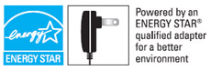

The Energy Star® brand has been adopted elsewhere, including:
- Australia
- Canada
- European Union
- Japan
- New Zealand
The EU Energy Star programme is based on a Council Decision in 1992 and managed by the European Commission. It maintains a database of products which have the Energy Star® mark, for example, for computers it includes their power consumption in:
- idle mode
- standby mode
- sleep mode
By providing this information to prospective customers it allows them to evaluate a range of possible devices before making a purchase. In this way energy consumption is reduced and GHG emissions limited.
While Energy Star® is backed by national governments, the TCO Mark is non-governmental and is subject to third party testing. The Swedish Confederation for Professional Employees (TCO), comprising some 16 trades unions with 1.2 million members in schools, healthcare, trade, the media, the police and industry, owns TCO Development which operates the TCO mark programme.
TCO quality and environmental labelling is intended to influence the development of products in order to ensure optimum user-friendliness and the least adverse effect on the environment. Annual global energy savings due to TCO-labelled displays are estimated to have been at least 25 TWh in 2006, corresponding to “approximately four standard-sized nuclear reactors”.
The TCO labelling system is intended to make it easier to choose ICT and office equipment which is beneficial both to the user and to the environment. The TCO label can be found on each product and, since 2005, must appear on the rating plate, which includes the model number and is normally found on the back of the product.
TCO labelling specifications presently cover a range of computers, peripheral devices and mobile phones. A small number of certified test laboratories determine whether a device is entitled to carry the relevant TCO mark.
TCO is a member of the Global Ecolabelling Network (GEN), a non-profit association of organizations providing third-party, environmental performance recognition, certification and labelling. It was founded in 1994 to improve, promote and develop the eco-labelling of products and services.
In 1992, the European Union adopted the Energy Labelling Directive (92/75/EC), followed by implementing legislation and supporting standards. European consumers now widely recognise the A to G rating scheme found on domestic appliances, such as refrigerators (see Figure 7). The scheme has been the subject of national marketing campaigns to encourage consumers to buy more efficient devices.
Figure 7 Example of an energy label for a refrigerator – Directive 94/2/EC
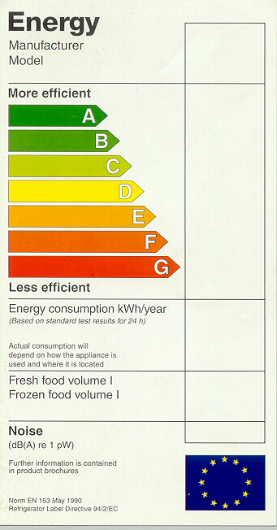

However, in assessing its possible application to some electronic devices, the EC rejected the use of labels. The impact assessment found it was likely to have only a very limited effect, because consumers do not pay sufficient attention to energy consumption. For example, on a simple set top box the energy savings over the lifetime of the device might be only €25, insufficient to be decisive in a purchasing decision. In many cases the devices would be part of a service package which would further reduce the likelihood of a consumer acting on energy labelling information.
Consequently, it introduced draft EC Regulations for:
- Standby and off-mode electric power consumption of electrical and electronic household and office equipment
- External power supplies
- Simple set top boxes
These impose minimum energy efficiency levels, phased over two to three years. The measures have been notified to the WTO Technical Barriers to Trade Committee. The first of these became Regulation EC No 1275/2008, coming into effect in January 2009.
The legal basis is the Directive on the Eco-design of Energy-using Products (2005/32/EC), intended to integrate environmental aspects into design in order to improve performance across the life cycle of a product. It provides a framework to ensure that disparities among national regulations do not become barriers to trade within the EU.
It seems very likely that the EC will issue further regulations under this Directive as it seeks to improve energy efficiency in order to achieve its targets under the Kyoto Protocol.

FCC mark
All electronic devices sold in the United States of America that transmit radio frequencies, whether intentionally or otherwise, are regulated under three parts of 47 USC:
§2 Equipment authorization procedures
§15 Radio frequency devices (explained in OET Bulletin 61)
§18 Prevention of harmful interference (explained in OET Bulletin 65)
The responsibility for this is exercised by the Federal Communications Commission (FCC), through the Laboratory Division of its Office of Engineering and Technology (OET).
It is illegal to sell or to advertise products until their radiated and conducted emissions have been measured and found to be in compliance. There are two categories of product, Class A for industrial or business environment which requires certification and Class B for use in the home which requires a declaration of conformity or certification.
There are three classes of compliance, each of which has its own labelling requirements:

- Verification (§2.902) - where the manufacturer makes measurements or takes the necessary steps to ensure that the equipment complies with the appropriate technical standards.
- Declaration of Conformity (§2.906) - where the responsible party makes measurements or takes other necessary steps to ensure that the equipment complies with the appropriate technical standards.
- Certification (§2.907 & 2.1033) - an authorization issued by the Commission, or on behalf of the Commission, based on representations and test data submitted by an applicant.

The FCC uses a hierarchical system of bodies which accredit laboratories, which in turn test the equipment and issue to manufacturers or importers the necessary test data. Accreditation Bodies (ABs) are recognized as complying with ISO/IEC 17011, while laboratory accreditation complies with ISO/IEC Guide 65. Details of testing firms are maintained in a public database, with a separate database for equipment that has been certified.
There are a large number of Test Firm Accrediting Bodies (TFABs) recognized by the FCC. Those in the USA are themselves accredited by National Institute of Standards and Technology (NIST), while those in foreign countries are nationally accredited and then recognized in the USA through one of several Mutual Recognition Agreements (MRAs). These include:

- American Association for Laboratory Accreditation (A2LA), USA;
- National Voluntary Laboratory Accreditation Program (NVLAP), USA;
- Industry Canada (IC), Canada;
- Infocomm Development Authority (IDA), Singapore;
- Ministry of Transport and Communications, Greece;
- Ministero delle Comunicazioni, Italy;
- Office of the Telecommunications Authority (OFTA), Hong Kong SAR; and
- Australian Communications and Media Authority ACMA, Australia.

Once tested and the results have been filed electronically with the FCC, the product can carry the simple FCC mark if under §18, while the trade name and model number are additionally required if under §15 (see Figure 8).
Figure 8 FCC Marks used for §15 and §18 certification
 | 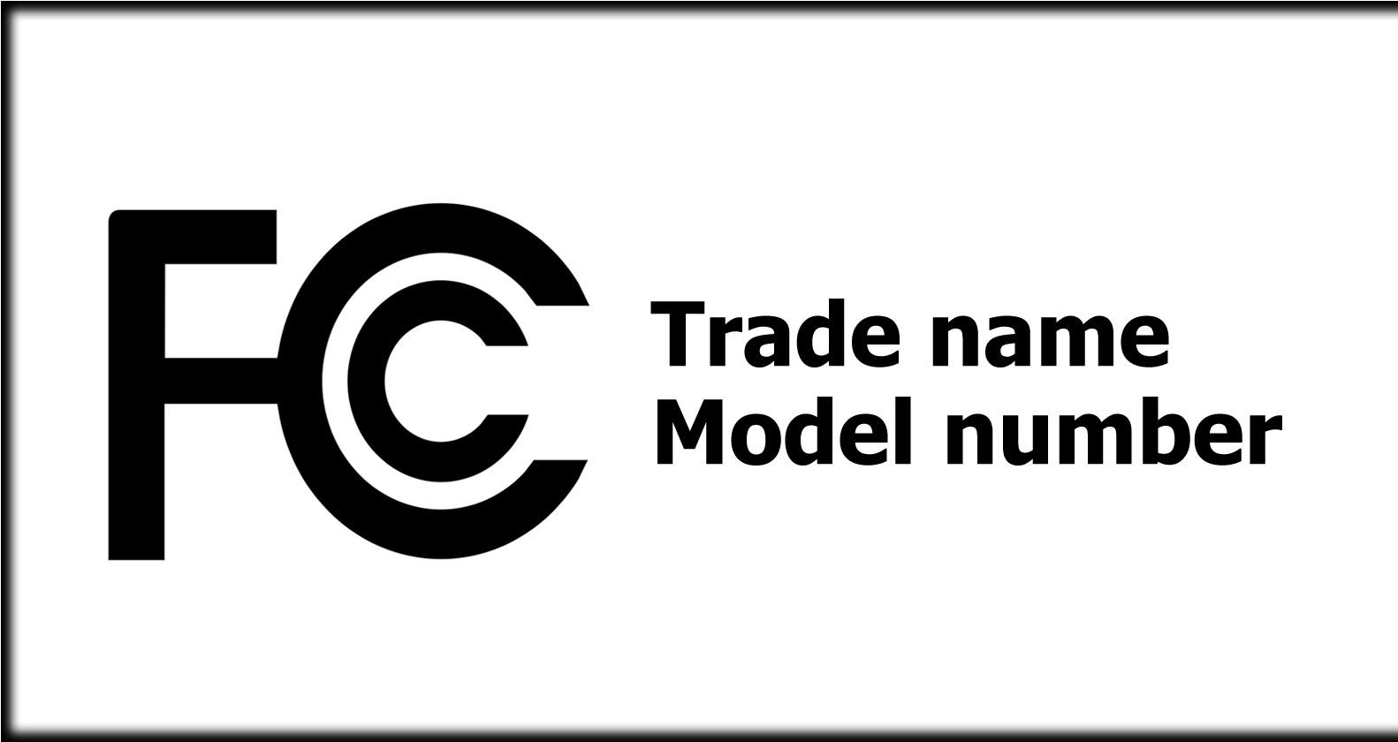 | 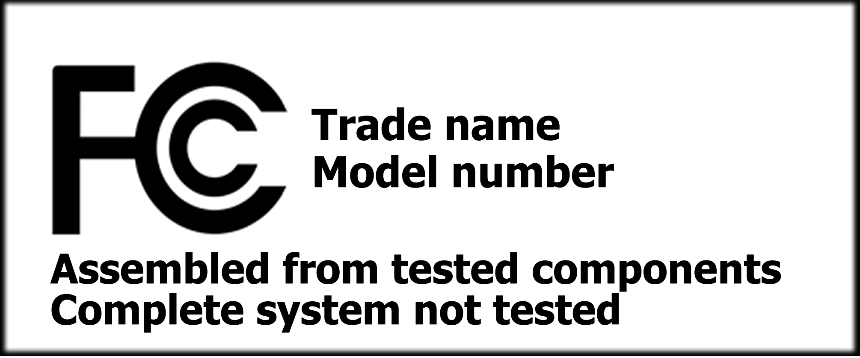

For example, the Apple iPhone was approved for sale in 2007 (code: BCGA1203). This required the filing with the FCC of almost 200 pages of documents including the following:

- internal and external photographs
- SAR report
- GSM report
- GSM EGPRS report

The test reports were provided for Apple by CETECOM in California, part of the German RWTÜV group. This laboratory is accredited by A2LA (in terms of ISO 17025 and the ILAC Arrangement) and is also a Bluetooth® Qualification Test Facility and a Wi-Fi Alliance® Authorized Test Lab.

CE Mark
The European Union adopted a “global approach” to conformity assessment in Council Decision 93/465/EEC to complement its “new approach” to standards (see information document C). This laid down general guidelines and the detailed procedures for conformity assessment to be used with a range of directives.
The CE mark is a declaration by a manufacturer or supplier that a product meets all the relevant provisions of EU legislation (see Figure 9). Use of the CE mark is intended to give companies easier access to the single European market in order to sell their products, without further adaptation or additional testing. The mark may not be applied to products if they are outside the scope of a limited and defined set of directives.
Figure 9 The CE mark
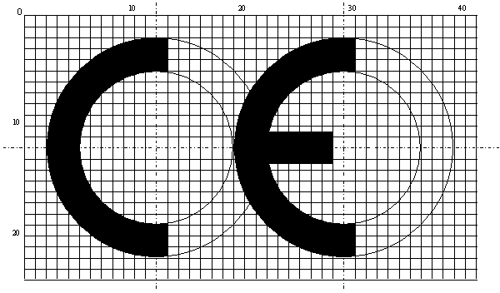
There are two forms of declaration, either a “Declaration of Conformity” or a “Declaration of Incorporation”. Under the Machinery Directive (98/37/EC) where a stand-alone machine, which requires only a power source to be operated would be given a Declaration of Conformity, while a machine which requires additional systems, attachments, feed conveyors, etc., before it can perform its intended function, is given a Declaration of Incorporation. In the latter case it is not permitted to affix a CE Mark to the machine itself, something that can only be done once the machine has been installed and the other elements incorporated into the system. After a final risk assessment has been performed to verify compliance of the system a final Declaration of Conformity can be issued.
The EC has published a guide to the directives to which the CE Mark applies. Those concerning telecommunications are:
- Low voltage (2006/95/EC) - equipment rated 50-1000V AC & 75-1500V DC;
- Electromagnetic compatibility (98/13/EC and 2004/108/EC); and
- Radio and telecommunications terminal equipment (99/05/EC).
Figure 10 shows the procedure to be followed for conformity assessment for electromagnetic compatibility. The various “modules” define the systems, tests and associated documents. For example, Module A requires a manufacturer to document processes, to ensure compliance and to retain copies of the self-certification, while Module B requires a notified body to conduct a type examination and issue a certificate.
Figure 10 Conformity assessment for EMC (Directive 89/336/EEC)

A “notified body” is a laboratory or testing centre performing conformity assessment procedures when a third party is required. The notification is made by the member state demonstrating that the body complies with the requirements of the directives and the principles laid down in the Council Decision on conformity assessment procedures (93/465/EEC). The body must have been assessed as technically competent and capable of carrying out the procedures in question, and demonstrate the necessary levels of independence, impartiality and integrity. That competence is subject to regular surveillance by the national accreditation body.
The New Approach Notified and Designated Organisations (Nando), contains all notified bodies, which fulfils the relevant requirements, has been designated to carry out conformity assessment according to one or more of the applicable directives. It also includes bodies in the countries with which the EU has a Mutual Recognition Agreement. For example, for electromagnetic compatibility, the EU has signed Mutual Recognition Agreements (MRAs) with a number of countries including: Australia, Canada, Japan and the USA. The are 185 bodies able to conduct EMC tests in: Austria, Belgium, Bulgaria, Czech Republic, Estonia, Finland, France, Germany, Hungary, Italy, Netherlands, Norway, Poland, Portugal, Slovakia, Slovenia, Spain, Switzerland, UK and the USA.
The Directive on Radio and Telecommunications Terminal Equipment (R&TTE) (99/5/EC) applies to almost all equipment that uses radio spectrum or which will be attached to a public telecommunication network. Devices covered by the R&TTE Directive include GSM handsets, car-door openers, telephones and cable modems. The procedure for conformity assessment under the R&TTE Directive (99/5/EC) is shown in Figure 11. Module A requires a manufacturer to document processes, to assure compliance and to retain copies of the self-certification, while with Module H a notified body assesses the quality system of the manufacturer, supervises the affixing of an ID number, makes periodic and unexpected site visits and keeps records of such information, while in Module Aa the notified body supervises tests by the manufacturer or carries out random tests.
Figure 11 Conformity assessment for terminal equipment Directive 99/5/EC
Note: At the choice of the manufacturer, compliance with the essential requirements may be demonstrated, as an alternative, using the procedures of the Directives relating to low voltage equipment and electromagnetic compatibility respectively, where the apparatus is within the scope of those Directives.
The EC is required by Article 17 of the R&TTE Directive to conduct periodic reviews of the effectiveness of the Directive. The first such review ended in 2004 with unanimous conclusions adopted by the Telecommunications Council of Ministers, noting the importance of the Directive and the need for coherence in its application. A second review was launched with a public consultation that closed on 30 September 2007.
The R&TTE Compliance Association is a forum for those involved with the compliance of terminal equipment with technical standards, open to any testing, manufacturing or other organisation willing to follow its aims and objectives. It has specific responsibilities in respect of notified bodies appointed under the R&TTE Directive and has published a number of technical guidance notes, for example, on RFIDs and on the Minimum Content of a Notified Body Opinion Document.
The Telecommunications Conformity Assessment and Market Surveillance Committee (TCAM) was established to facilitate the exchange of information between Member States and the EC and assists the EC in the management of the R&TTE Directive.
The use of a CE mark, apparently to mean Chinese Export, was raised in a question in the European Parliament by Zuzana Roithová MEP. Commissioner Verheugen noted that all marks, including CE, were subject to misuse and consequently there was a need to ensure a comprehensive EU legislative framework to ensure coherent market surveillance.
The EU framework for market surveillance is defined in the General Product Safety Directive (2001/95/EC), this is intended to ensure that products placed on the single European market are safe, protecting the health and safety of consumers. In response to concerns about inconsistencies in market surveillance, the EC adopted Regulation No 765/2008, to require each member state to have a single National Accreditation Body (NAB), one that participates in the European cooperation for Accreditation (EA) and is subject to peer review. NABs were required to be independent from and not to compete with organisations performing conformity assessment. These authorities were to perform documentary checks and “where appropriate” physical and laboratory tests. The control of products entering the single European market was to be undertaken at the point of entry.

The TETRA consortium
TETRA is a digital Professional Radio Mobile (PMR) system, used by public organisations such as the police, army, fire brigades, ambulance services, civil protection and government (national, regional and municipal), plus private industry.
The TETRA Memorandum of Understanding (MOU) Association developed the Interoperability Certification process which it manages in order to ensure a truly open market for TETRA equipment and systems. This multi-vendor market gives concrete benefits both to the users in terms of a wide portfolio of compatible equipment, rapid development of new products and competition, and to the industry in terms of a larger addressable market, faster market take-up and better possibilities to invest in research and development.
Manufacturers and operators recognised that important market requirements outside the responsibility of ETSI had to be addressed if the success of TETRA was to be ensured. The TETRA MOU Association was initially created in December 1994, subsequently growing significantly. It provides a forum for user organisations, manufacturers, application providers, integrators, operators, test houses, regulators and consultants. Its main objectives are to promote the TETRA standard and to ensure multi-vendor equipment interoperability.
The TIP (Tetra Interoperability Profile) specifications and Test Plans have been created by voluntary efforts of the members and are available to all the members of the Association free of charge. The detailed content of the TIPs are in the public domain in the issued certificates. The Interoperability Certificates are public documents and are published on its website.
The TETRA standard is in practice a suite of standards covering different technology aspects, for example, air interfaces, network interfaces and the services and facilities provided. TETRA is an open standard developed by the European Telecommunications Standards Institute (ETSI). The TETRA standard was defined in sufficient detail to enable independent manufacturers to develop infrastructure and terminal products that would fully interoperate with each other as well as meeting the needs of traditional PMR users.
The main benefits of adopting an open standard are:
- Economies of scale provided by a large harmonised market served by several independent manufacturers and suppliers competing for the same business, resulting in competitively priced solutions,
- Second source security if an existing supplier exits the market,
- Evolution (instead of revolution) of the technology standard ensuring longevity and good return on investment for both users and suppliers,
- Choice of manufacturers for new products keeping prices down,
- Greater choice of products for specialised applications, and
- Greater responsiveness to future needs by existing suppliers because of competition.
TETRA will evolve in a similar way to GSM, from providing a basic voice and data “one to one” telephony service the equivalent of 3G, supporting powerful multimedia applications and High Speed Data. TETRA networks are expected to be available for at least another 25 years, thereby ensuring a very good return on investment for user organisations as well as for manufacturers and suppliers.

The certification of CDMA handsets
The CDMA Certification Forum® (CCF) is a partnership between mobile network operators and terminal vendors that use Code Division Multiple Access (CDMA) for cellular wireless services. The initial focus of the CCF was to deliver quick and reliable device certification to emerging markets.
The certification process, with the use of the CCF seal, is global. Additionally, there may be certification for a specific national market or for acceptance by individual operators. (see Figure 12.)
Figure 12 Overview of CDMA certification process
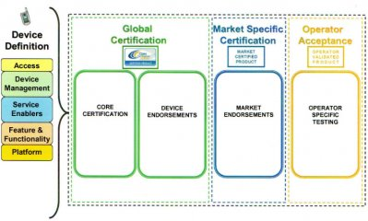
The CCF requires laboratories testing CDMA devices to be accredited – in terms of ISO/IEC 17025 – by an Accreditation Body (AB) that is a signatory to the ILAC Arrangement. Additionally, the laboratory must have a subject matter expert approved by the CCF.
Authorized test facilities are currently located in Haidian, Beijing, Hyderabad and on the east and west coasts of the USA.
Figure 13 CCF seals
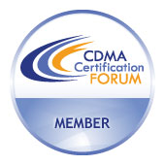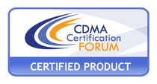
Members of the CCF are authorized to use a member seal in corporate materials, while a different seal is used on certified products and associated documents (see Figure 13).
There is a similar body, the Global Certification Forum, for GSM handsets.

Andy Grove (1999) Only the paranoid survive: How to exploit the crisis points that challenge every company. New York: Broadway Books.
Kevlar is used to make bulletproof garments. In the USA, NIST accredits laboratories that test ballistic- and stab-resistant personal body armour to support voluntary minimum performance standards. http://ts.nist.gov/Standards/scopes/pba.htm
For example, in 1999, it was estimated to be 8 per cent of sales or US$ 250 millions.
An extensive list of labels and standards can be found at: http://www.apec-esis.org/
Further details are contained in information document D.
Directives are EU legal instruments that are based on the EC Treaty and which Member States have bound themselves to transpose into national law.
Which may or may not stand for Conformité Européenne.

