TRANSPORTATION
NOTE: No transport arrangements will be made. It is suggested to rent a car.

How to reach Lannion and Perros-Guirec ?
Apologies, some websites are in French. For flight timetables, please see: http://www.amadeus.net/

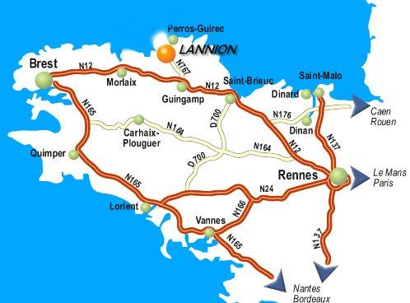

- By plane to Lannion
There are two or three flights a day between Paris Orly West airport and Lannion (except on Saturday). Please see:
http://www.lannion.aeroport.fr/recherche-vols/
For those who will arrive in Paris Roissy Charles-de-Gaulle airport (CDG) and have to transfer to Orly West, there are three possibilities:
- An Air France bus shuttle from Roissy to Orly West airport. This bus leaves every 30 minutes. The journey lasts approximately 60 minutes (possibly a little more depending on the traffic). Note: Do not forget that you will have to reclaim your luggage in Charles-de-Gaulle airport so plan to allow at least 3 hours between your two flights.
- Take a taxi: Costs between 40 and 50 euros (minimum time: 50 minutes - max depending on the traffic, generally busy).
- Public transportation in Paris: RER Line B + Orlyval (with connection in Antony), it will take more than 60 minutes.
At your arrival in Lannion airport, you can take a taxi or rent a car to go to Perros-Guirec (about 7 kms).

- By train to Lannion
Once in Paris, you need to go to Montparnasse SNCF train station. More information with timetables is available at:
http://www.voyages-sncf.com/dynamic/_SvTermCommVoySaisie?_TMS=1203512030844&_DLG=SvTermCommVoySaisie&_LANG=FR&_AGENCY=VSC
There is an Air France shuttle bus between Paris Roissy Charles-de-Gaulle airport and Montparnasse station. The journey time is approximately 60 minutes and this bus leaves every half an hour.
The same from Paris Orly airport to Montparnasse. The journey time is approximately 45 minutes and this bus leaves every 12 minutes.
The journey by train between Paris and Lannion takes 4 hours by TGV with a quick change either in Guingamp or in Plouaret. This way of travelling will allow you to fully appreciate the French landscape.
Warning: Reservation is mandatory for the TGV !
In Lannion station, you can take either a cab (about 25 euros) or a bus to go to Perros-Guirec.
- By plane via Brest
There are several flights a day between Paris Roissy, Charles-de-Gaulle airport and Brest airport http://www.airport.cci-brest.fr/
From there, 2 possibilities: either rent a car to go to Lannion. In this case, the journey between Brest and Lannion lasts 1 hour on an easy road; take the N12 road and after the Morlaix bridge take the direction of Lannion (see map).
Or take a train from Brest (15 km between Brest airport to Brest railway station) to Lannion. At your arrival in Lannion station, take a cab (about 25 euros) or a bus.
_________________

