 |  | International Telecommunication Union
 |  | ITU-T | Technical Paper
 |  | TELECOMMUNICATION  STANDARDIZATION SECTOR  OF ITU |  | (01/2022)
FSTP-VS-ECSR
Requirements for event centre server in video surveillance systems
© ITU 2022
All rights reserved. No part of this publication may be reproduced, by any means whatsoever, without the prior written permission of ITU.

Summary
In a traditional video surveillance system, the events between functional entities are processed synchronously, while in the event centre server, the producer and consumers of the event are separated in an asynchronous way to ensure efficient transmission of events and modules are decoupled. The event queue unit in an event centre server acts as a container for saving event messages, which can greatly alleviate the concurrency of video surveillance systems.
The event centre server of a video surveillance system decouples each functional entity of the system with the message push channel, to enhance the compatibility, reliability and scalability of the system, and meet the increasing and rapidly changing demand of event push. An event centre server-based video surveillance system consists of two parts, the traditional video surveillance system and event centre server. An event centre server mainly includes two parts, the event centre management and the event queue unit.
This Technical Paper specifies the requirements and a reference functional model for event centre servers in video surveillance systems.
Note
This is an informative ITU-T publication. Mandatory provisions, such as those found in ITU-T Recommendations, are outside the scope of this publication. This publication should only be referenced bibliographically in ITU-T Recommendations.
Keywords
Event centre server, reference functional model, requirements, video surveillance system.
Change log
This document contains Version 1 of Technical Paper ITU-T FSTP-VS-ECSR "Requirements for event centre server in video surveillance systems" approved at the ITU-T Study Group 16 meeting held online, 17-28 January 2022.

Editor and contributors:
 | Zhiji Deng  Zhejiang Dahua Technology  China | Tel: +86-18958107056  Fax: + 86-571-87688857  E-mail: deng_zhiji@dahuatech.com
 | Feng Lin  Zhejiang Dahua Technology  China | Tel: +86-18969164656  Fax: +86-571-87688857  E-mail: lin_feng1@dahuatech.com
 | Weisheng Kong  Zhejiang Dahua Technology  China | Tel: +86-18969121838  Fax: + 86-571-87688857  E-mail: kong_weisheng@dahuatech.com
 | Yuan Zhang  China Telecom  China | Tel: +86-18918588990  Email: zhangy666@chinatelecom
 | Haitao Zhang  BUPT  China | Tel: +86-10-62282767  Email: zht@bupt.edu.cn
 | Xiangyu Qu  Zhejiang Dahua Technology  China | Tel: +86-18100178299  E-mail: qu_xiangyu@dahuatech.com

Table of Contents
Page
1 Scope 1
2 References 1
3 Definitions 1
3.1 Terms defined elsewhere 1
3.2 Terms defined in this Technical Paper 2
4 Abbreviations and acronyms 2
5 Overview 2
6 Requirements for event centre server in video surveillance systems 3
6.1 Requirements for event data subscription and notification 3
6.2 Requirements for event data collection and aggregation 3
6.3 Requirements for event data linkage 4
6.4 Requirements for load balancing 4
6.5 Requirements for scalability 4
6.6 Requirements for fault tolerance 4
6.7 Requirements for log management 4
7 Reference functional model for event centre server in video surveillance systems 5

Technical Paper ITU-T FSTP-VS-ECSR
Requirements for event centre server in video surveillance systems

1 Scope
This Technical Paper specifies the requirements and a reference functional model for an event centre server (ECS) in a video surveillance system (VSS).
The scope of this Technical Paper includes:
– requirements for ECS in VSS;
– reference functional model for ECS in VSS.

2 References
[ITU-T F.743.1] Recommendation ITU-T F.743.1 (2015), Requirements for intelligent visual surveillance.
[ITU-T H.626V2] Recommendation ITU-T H.626 (V2) (2019), Architecture requirements for video surveillance system.
[ITU-T H.626.1] Recommendation ITU-T H.626.1 (2013), Architecture for mobile visual surveillance.
[ITU-T H.626.5] Recommendation ITU-T H.626.5 (2019), Architecture for intelligent video surveillance systems.

3 Definitions

3.1 Terms defined elsewhere
This Technical Paper uses the following terms defined elsewhere:
3.1.1 customer unit [ITU-T H.626V2]: A device located at the customer part of a visual surveillance system and used to present multimedia information (such as audio, video, image, alarm signal, etc.) to the end user.
3.1.2 intelligent customer unit [ITU-T H.626.5]: The intelligent customer unit (ICU) is the client subsystem within the intelligent visual surveillance system. The client intelligent video (CIV) is added to the customer unit (CU) in order to achieve comprehensive intelligent video analysis.
3.1.3 intelligent premises unit [ITU-T H.626.5]: The intelligent premises unit (IPU) is the premises subsystem within the intelligent visual surveillance system. The premises intelligent video (PIV) module is added to the premises unit (PU) for intelligent video analysis.
3.1.4 intelligent video unit [ITU-T H.626.5]: The intelligent video unit (IVU) identifies specific objects automatically, and outputs recognition results to an intelligent video management (IVM) system. The recognition information includes triggered events and acquired data. One or more intelligent analysis algorithms can be loaded or unloaded on an intelligent video unit (IVU) according to different requirements.
3.1.5 mobile customer unit [ITU-T H.626.1]: Mobile client software installed in a customer's mobile devices. The M_CU is used to initiate the service and provide customers with video viewing.
3.1.6 premises unit [ITU-T H.626V2]: A device located at the remote part of a visual surveillance system and used to capture multimedia information (such as audio, video, image, alarm signal, etc.) from a surveilled object.
3.1.7 video surveillance system [ITU-T H.626V2]: A telecommunication system focusing on video (but including audio) application technology, which is used to remotely capture multimedia (such as audio, video, image, alarm signals, etc.) and present them to the end user in a friendly manner, based on a managed broadband network with quality, security and reliability ensured.

3.2 Terms defined in this Technical Paper
This Technical Paper defines the following terms:
3.2.1 event centre management: A functionality of an event centre server which provides the management services for the event centre server and responds to service requests of the video surveillance system. It pushes a large number of event messages to other functional entities.
3.2.2 event centre server: A unit of a video surveillance system which decouples each functional entity of the system with the message push channel, so as to enhance the compatibility, reliability and scalability of the system, and meet the increasing and rapidly changing demand of events.
3.2.3 event queue unit: A node in an event centre server which accepts a large number of event messages from other functional entities. A typical video surveillance event centre server has a number of event queue units using virtualization technology.

4 Abbreviations and acronyms
This Technical Paper uses the following abbreviations and acronyms:
CCS Central Control Server
CIV Client Intelligent Video
CU Customer Unit
ECM Event Centre Management
ECS Event Centre Server
EQU Event Queue Unit
ICU Intelligent Customer Unit
IPU Intelligent Premises Unit
IVM Intelligent Video Management
IVU Intelligent Video Unit
M_CU Mobile Customer Unit
MS Media Server
PU Premises Unit
VS Video Surveillance
VSS Video Surveillance System

5 Overview
Nowadays video surveillance has been widely used in various industries (such as transportation, security, education and finance). The deployment of large-scale video surveillance systems has promoted the explosive growth of surveillance video data; in particular, with the rapid development of intelligent video surveillance systems, events have increased rapidly. In video surveillance systems, the connection between devices will generate a large amount of event data, such as device online and offline events, device storage abnormal events, device network connection abnormal events and other alarm events. In intelligent video surveillance systems, there are events such as population statistics, regional intrusions and rapid population aggregation, and in the field of transportation, there are events such as license plate detection, traffic statistics, vehicle speeding, etc. These results are stored in the system in the form of events and pushed to the client. Current video surveillance system users hope to obtain events and results from video data analytics more than the video data itself.
Traditional video surveillance systems mainly provide video services, and the design of the system mainly regards video services. However, with the large-scale deployment of intelligent video analysis equipment, current video surveillance systems can easily reach the maximum processing limit in event analysis, reception and processing. It is difficult to manage a large amount of video surveillance event data.
Event centre servers are an emerging technology that aims to separate event producers and consumers in an asynchronous manner by providing the buffer pool function of event queues to ensure efficient event transmission. The event queue unit in an event centre server provides an asynchronous processing mechanism, which separates the entry of events into the queue from the read-out events, and provides a buffer layer to ensure that the speed of writing to the queue is not affected by events being read from the queue. Asynchronous processing ensures that events can be processed efficiently. Using virtualization and distributed cluster technologies, the event centre server can provide a resource pool with flexibility and scalability, and can quickly configure and release the resource pool according to user needs with minimal management workload or service provider interaction.

6 Requirements for event centre server in video surveillance systems

6.1 Requirements for event data subscription and notification
– An ECS is required to support CU, ICU and other customer units subscribe the event to ECS according to the configured event plan.
– An ECS is required to support event plan management, including the addition, deletion, modification and query of event plans.
– The type of event plan in an ECS is required to include an alarm plan, service notification plan, perceived message plan and device status plan.
– The alarm plan in an ECS is required to distinguish between ordinary customer units and administrator customers units, and there is different linkage processing for different types of customers.
– Event plan management in an ECS is required to support filtering the reported events according to different plans.
– An ECS is required to support sending event data to the corresponding customer unit according to the plan configured by the customer units. The event types include alarm events, service notification events, perceived message events and device status events.
– The database in an ECS is required to support the storage of event plan data and record the distribution situation of event plans.
– The database in an ECS is required to continue loading work tasks and keep working, when the plan management service fails.

6.2 Requirements for event data collection and aggregation
– An ECS is required to support PU, IPU and other service units push event data to the event centre server.
– An ECS is required to save the collected event data to a storage medium such as a database. The event data is required to record only once in the database, and the database is not required to store the same record repeatedly.
– An ECS database is required to have the characteristics of principal and agent, and support single error.

6.3 Requirements for event data linkage
– After receiving event data, an ECS is required to support analysis linkage content of event plans and execute a linkage service.
– After receiving the event data, an ECS is recommended to link the alarm and notification services such as video, email, and message, etc.
– After receiving the event data, an ECS is recommended to display in link with the screen of a data centre.
– After receiving the event data, an ECS is recommended to support the simultaneous trigger of multiple linkage items according to the linkage items configured by users.

6.4 Requirements for load balancing
– When a node of the ECS fails, the ECS is required to schedule other nodes to take over and continue working.
– An ECS is recommended to support the balanced distribution of the configured event plans to the plan scheduling service of the ECS.
– When a certain plan scheduling service fails, the ECS is required to be rebalanced with the higher pressure and assigned to the less stressed plan scheduling service.
– An ECS is required to load according to the number of users of the client corresponding to the event notification service, and the event notification service with a lower number of users is preferentially selected for scheduling.

6.5 Requirements for scalability
– The event queue unit of an ECS is required to expand when the individual service capacity is insufficient.
– The plan filtering service of an ECS is required to expand when the individual service capacity is insufficient.
– The event notification service of an ECS is required to expand if its individual service capacity is insufficient.
– The event linkage service of an ECS is required to be appropriately expanded and able to support access to multiple execution units when the individual service capacity is insufficient.

6.6 Requirements for fault tolerance
– The event management service of an ECS is required to support fault tolerant processing; that is support the principal and agent mode, which persist some information of the scheduled task and save it to the database synchronously.
– The plan filtering service of an ECS is required to support fault tolerant processing; that is, when a node fails the ECS can evenly distribute the load of the node to other nodes.
– The event notification of an ECS is required to support fault tolerant processing; that is when a node fails it can update the available event notification service, and subsequent clients can periodically obtain the address of the event notification, thereby avoiding the problem of a notification service failure.
– The database in an ECS is required to support fault tolerant processing.

6.7 Requirements for log management
– An ECS is required to support log recording and querying functions.
– An ECS is required to support log recording of event data subscriptions, notifications.
– An ECS is required to support log recording of abnormal situations of event data collection and linkage.
– An ECS is required to support a log cleaning plan and perform cleaning according to the plan.

7 Reference functional model for event centre server in video surveillance systems
In a traditional video surveillance system, the messages between functional entities are processed synchronously, while in the ECS the producer and consumers of the event are separated in an asynchronous way to ensure efficient transmission of events and modules decoupled. The event queue unit in an ECS acts as a container for saving event messages, which can greatly alleviate the concurrency of video surveillance systems.
An ECS of a video surveillance system decouples each functional entity of the system with the message push channel, to enhance the compatibility, reliability and scalability of the system, and meet the increasing and rapidly changing demand of event push. An ECS-based video surveillance system consists of two parts, the traditional video surveillance system and ECS. An ECS mainly includes two parts, ECM and EQU.
An ECM provides the management services for an ECS and responds to service requests of the video surveillance system. It pushes a large number of event messages to other functional entities.
An EQU is the event queue node in an ECS. It accepts a large number of event messages from other functional entities. A typical video surveillance ECS has a number of EQUs using virtualization and distributed cluster technologies.
An ECS can also be integrated with other video surveillance subsystems such as intelligent video surveillance and mobile video surveillance. Figure 1 shows the reference functional model for an event centre server in a video surveillance system.
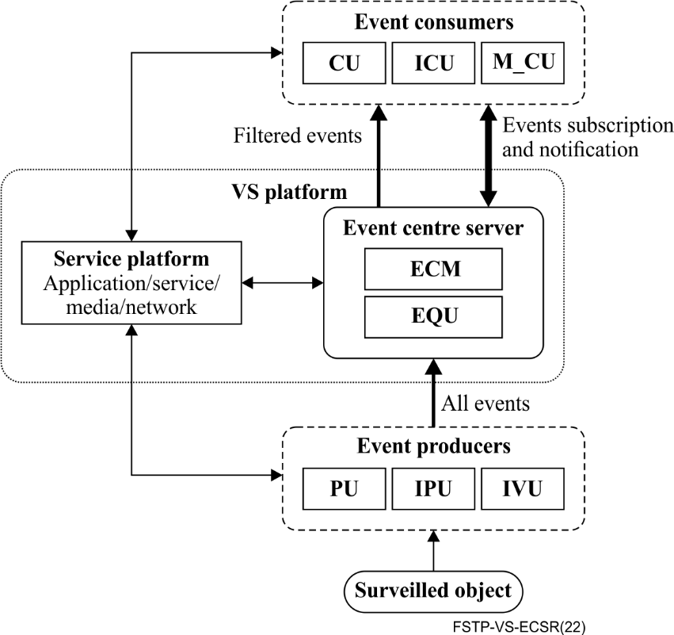
Figure 1 – Reference functional model for event centre server in video surveillance systems
The service platform of a video surveillance system, including CCS, MS and IVM, performs management functions for event producers, the ECS and event consumers.
Event producers, such as the PU of a video surveillance system, IPU and IVU of an intelligent video surveillance system, or other functional entities push the generated event messages to the ECS.
Event consumers, such as the CU of a video surveillance system, ICU of an intelligent video surveillance system, M_CU of a mobile video surveillance system and other functional entities, subscribe to the concerned event messages in the ECS.
According to the event message subscription of various clients and other functional entities, the ECS sends the processed event messages to the clients and other related functional entities after filtering the event plan.

______________

