
Standardization Sector
ITU-T Technical Report
(06/2024)
TR.M.omr-fmls
Operation requirements for federated machine learning based applications
ITUPublications | International Telecommunication Union

Technical Report ITU-T TR.M.omr-fmls
Operation requirements for federated machine learning based applications

Summary
Technical Report ITU-T TR.M.omr-fmls provides the operation requirements for federated machine learning (FML) based applications, specifies the functional framework for operation, and provides the description of the operation functional components for operation.

Keywords
Federated machine learning based application.

Note
This is an informative ITU-T publication. Mandatory provisions, such as those found in ITU-T Recommendations, are outside the scope of this publication. This publication should only be referenced bibliographically in ITU-T Recommendations.

© ITU 2025
All rights reserved. No part of this publication may be reproduced, by any means whatsoever, without the prior written permission of ITU.

Table of Contents
Page
1 Scope 1
2 References 1
3 Definitions 1
3.1 Terms defined elsewhere 1
3.2 Terms defined this Technical Report 1
4 Abbreviations and acronyms 1
5 Overview of FML services and FML-based applications 2
6 Overview of FML-based application operation 3
7 Registration management requirements 5
7.1 Suppliers registration 5
7.2 Suppliers data registration 6
7.3 Customers registration 6
7.4 FML system configuration 6
8 Service management requirements 6
8.1 Services matching 6
8.2 Services arrangement 7
8.3 Authority management 7
8.4 Services supervision 7
9 Billing management requirements 7
9.1 Order pricing 7
9.2 Charge collection 7
9.3 Benefit distribution 7
10 Assurance management requirements 8
10.1 Services review management 8
10.2 Alarming management 8
10.3 Service problem management 8

Technical Report ITU-T TR.M.omr-fmls
Operation requirements for federated machine learning based applications

1 Scope
This Technical Report describes the operation requirements in the whole implementation process of federated machine learning (FML) based applications, the functional framework for operation, and provides a description of the functional components for operation, including registration management, service management, billing management, assurance management and so on.

2 References
[ITU-T M.3387] Recommendation ITU-T M.3387 (2024), Management requirements for federated machine learning systems.
[IEEE 3652.1] IEEE Standards Association 3652.1-2020, IEEE Guide for Architectural Framework and Application of Federated Machine Learning.

3 Definitions

3.1 Terms defined elsewhere
This Technical Report uses the following terms defined elsewhere:
3.1.1 federated machine learning [ITU-T M.3387]: A machine learning framework that facilitates collaborative construction of machine learning models among multiple distributed training nodes without exposing the private data owned by the data owners.
3.1.2 federated machine learning model [ITU-T M.3387]: The result of the training process of a federated machine learning system. The trained model is used for inference tasks on new data.
3.1.3 federated machine learning service [ITU-T M.3387]: An artificial intelligence model training service that uses the federated machine learning method and outputs a globally trained model.
3.1.4 federated machine learning service client [ITU-T M.3387]: An application entity that initiates the federated machine learning service request and uses a federated machine learning model in various tasks.
3.1.5 federated machine learning system [ITU-T M.3387]: A system that involves multiple training nodes which collaboratively build and use machine learning models without disclosing the raw and private data owned by the participants.

3.2 Terms defined this Technical Report
This Technical Report defines the following term:
3.2.1 federated machine learning (FML) based application: A collection of application processes which utilize the services provided by the federated machine learning (FML) system to perform the processing necessary to meet the requirements of the customer.

4 Abbreviations and acronyms
This Technical Report uses the following abbreviations and acronyms:
B2B Business-to-Business
B2C Business-to-Consumer
B2G Business-to-Government
FML Federated Machine Learning
FMLM Federated Machine Learning Model
FMLS Federated Machine Learning System
IoT Internet of Things

5 Overview of FML services and FML-based applications
FML services are artificial intelligence model training services that use the federated machine learning method and output a global learned model. FML-based applications can initiate FML service requests or use the FML model in various tasks. [ITU-T M.3387]
As an innovative modelling mechanism that can train a united model on data from multiple parties without compromising the privacy and security of those data, federated machine learning has a promising application in sales, financial, and many other industries, in which data cannot be directly aggregated for training machine learning models due to factors such as intellectual property rights, privacy protection, and data security.
FML-based applications that are instantiated within the FML system can provide or consume FML services to meet the needs of the customers. The applications include different use cases, which have different features of FML function. FML-based application areas are broadly categorized into three types, according to requirements from different marketing sectors, including business-to-consumer (B2C) (such as telecommunication, education, Internet of Things (IoT), etc.), business-to-business (B2B) (such as finance, health, marketing, etc.) and business-to-government (B2G) (such as government governance, government services, urban computing, etc.). [IEEE 3652.1]
FML-based applications can utilize customized FML processing capabilities and services provided by the FML system due to the needs of cross different industries. The specific FML service capabilities can be tailored to specific FML-based applications (such as finance, health industry applications and so on).
FML-based applications are meant to interact with different industry users, whereas FML services work across the FML system, but do not interact with users directly. Figure 1 shows the relationship between the top layered functional frameworks of FML-based application and FML service.
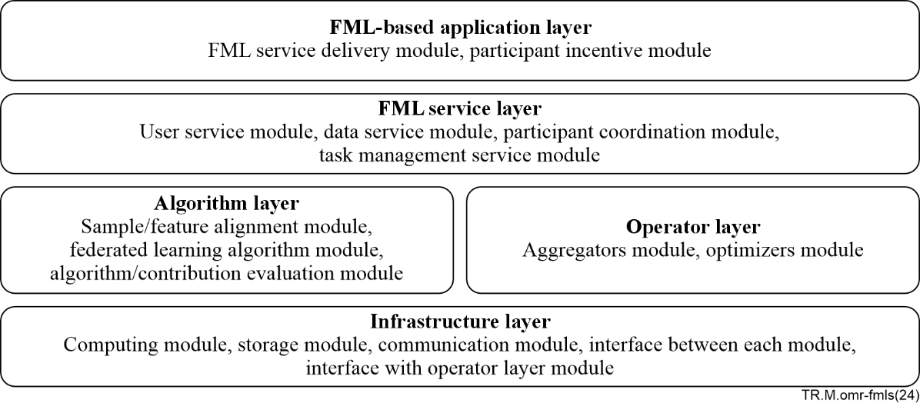
Figure 1 – The relationship between the top layered functional frameworks
of FML-based application and FML service
FML-based application layer: This layer provides personalization, customization and integrated delivery of FML services to specific industry customers. This layer includes functionalities necessary for FML-based application fulfilment, assurance, billing and so on.
FML service layer: This layer provides the fundamental functions of FML services which are opened to the FML-based application layer. The FML service functions of this layer include FML service development and delivery, FML service configuration, FML service quality evaluation and so on.
Algorithm layer: This layer implements federated machine learning algorithmic logics and provides support for the FML service layer. Activities associated with this layer include sample alignment, feature alignment, federated feature engineering, federated machine learning algorithm, algorithm evaluation, contribution evaluation, economic incentive calculation and so on.
Operator layer: This layer provides elementary operations that are needed by federated machine learning algorithms. The operations of this layer include aggregation, activation, regularization, optimization, computation and so on.
Infrastructure layer: This layer is the foundation for the FML system. It provides capabilities of computing, storage and communication for the operator layer of the FML system. This layer includes all components and interfaces to support the functions needed by federated machine learning.
NOTE – [ITU-T M.3387] focuses on the management requirements for federated machine learning systems (FMLSs), that support FML systems and services management. This Technical Report focuses on the operation requirements for federated machine learning based applications, that support FML-based application operational processes such as managing customers, FML services, suppliers' interaction and so on. These two Technical Reports together provide all operations and management requirements covering different layers of FML-based application, FML services and system.

6 Overview of FML-based application operation
FML-based application operations process includes all management of operations to support customer, FML service and supplier interactions.
In the specific FML-based application scenario, the FML-based application operation system should select the appropriate FML suppliers and FML services to meet customers' expectations. FML-based application operation system should also be responsible for collecting appropriate FML system usage records, evaluating the service quality of suppliers, ensuring FML service is continuously available and so on.
As FML service clients, FML-based applications could initiate FML service request and use an FML model in various tasks. FMS management system is responsible for providing safe and efficient FML services. The management functions that are hosted by the FML management system are defined in [ITU-T M.3387]. These management functions are different from FML-based application operation functions and are out of the scope of this Technical Report.
In a federated machine learning system (FMLS), the FML training nodes are regarded as having different roles according to their functions, including the coordinator, auditor and data owner [ITU-T M.3387]. In the FML-based application operation system, the roles include FML-based application provider, customer and supplier.
Combining the operation management process and the unique attributes of the federal framework, this Technical Report presents the functional requirements framework for the operation of FML-based applications, as shown in Figure 2.
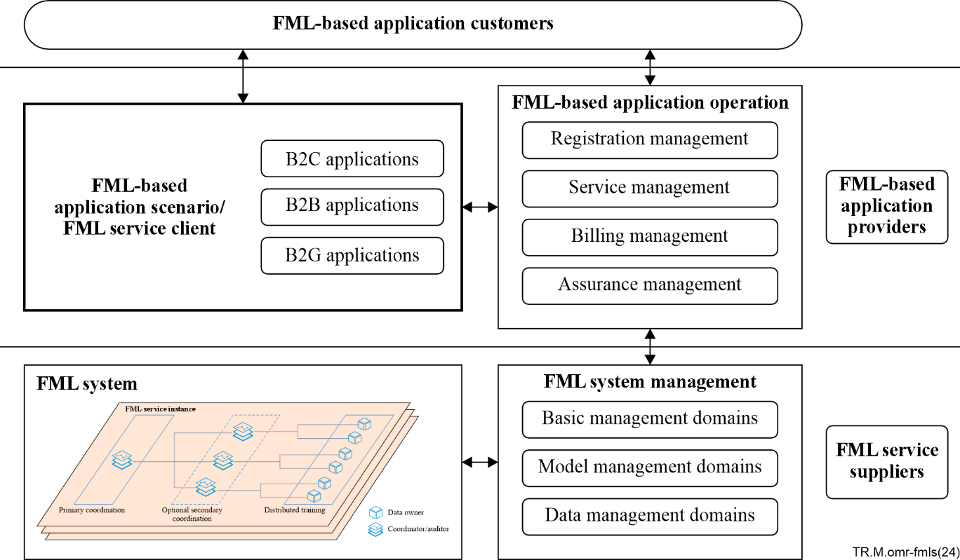
Figure 2 – The functional requirements framework for the operation
of FML-based applications
Registration management is responsible for providing management functions of suppliers registration, suppliers data registration, customers registration, FML system configuration and so on.
– suppliers registration, manage suppliers to register identification information for the FML-based application operation system, such as registration date, industry, credit rating, available computing resources and so on. This function supports to create, modify, delete, and query of the suppliers and corresponding identification information of the suppliers in the FML-based application operation system.
– suppliers data registration, manage suppliers to register the data information for the FML-based application operation system, such as data overview, data characteristics and sample size, data distribution, mean and variance statistics, feature introduction and so on. This function supports to create, modify, delete, and query the data information in the FML-based application operation system.
– customers registration, manage customers to register identification information for the FML-based application operation system, such as registration date, industry, credit rating, expected service scenario demands and so on. This function supports to create, modify, delete, and query of the customers and the corresponding identification information of the customers in the FML-based application operation system.
– FML system configuration, deploy, modify, and delete the federated learning system for the registered suppliers in the FML-based application operation system.
Service management is responsible for providing suitable FML services to customers based on their service demands in a timely manner. This function includes services matching, services arrangement, authority management, services supervision and so on.
– services matching, accept the customer's service demands, and match available suppliers that meet the service demands, and which have been registered in the FML-based application operation system, support to list display, delete, and query services which have been matched in the FML-based application operation system.
– services arrangement, manage the executing process of the services. This function supports to send task instructions to suppliers to perform data query, data modelling, online prediction, and other services. This function also supports receiving the services execution results and returning those to the corresponding customers.
– authority management, the customer verifies and receives the service in the matched service list and selects the specified data set to add to the project through the supplier data registration information, i.e., applies for the right to use the data. The supplier grants the application authority to the customer, withdraws the authority, sets the upper limit of the number of authorized data and so on.
– services supervision, supervise the quality of service provided by suppliers, including the task execution process, recording the number of tasks and the number of data sets used, and the evaluation and ranking of service quality of suppliers in the FML-based application operation system.
Billing management is responsible for the production of timely and accurate bills, providing use information and billing to customers, processing their payments, and payment service fees to suppliers and service providers, including order pricing management, charge collection, benefit distribution and so on.
– order pricing management, manage pricing for a full-cycle service (whether it succeeds or fails), including to formulate the billing rules and service order pricing method based on data sample size, data feature dimension, service times, data usage times, etc.
– charge collection, manage the execution process of charge collection. Including to formulate charging rules, query charging details, service order query, and charge payment settings and payment methods choosing.
– benefit distribution, manage the execution process of service benefit distribution, including to formulate the benefit distribution rules and methods, such as those based on data quality score ratio, data contribution ratio, etc.
Assurance management is responsible for the execution of maintenance activities to ensure that services provided to customers are continuously available, including services review management, alarming management, service problem management and so on.
– services review management, including to record, query, delete the services execution log. Including to formulate the saving rules of historical services, support to query and delete the historical services, etc.
– alarming management, aims to ensure successful execution of services, including to formulate resource alarming, risk alarming and security alarming rules, check and deal with possible fault events in the process of service operation and management.
– service problem management, aims to improve service satisfaction, including to set service problem management rules, evaluate the problem, diagnose the problem, plan and assign resolution, and track and manage resolution.

7 Registration management requirements

7.1 Suppliers registration
Suppliers of FML services interact with FML-based application provider in providing model training services to model user by using a federated machine learning system. Suppliers of FML services firstly register to the FML-based application provider before they can deliver and support FML services.
During registration, suppliers of FML services need to provide supplier information including the industry involved, supplier identity (which can be used in interactions with FML-based application provider), credit rating, available resource capacities (including computation capacity, communication capacity, storage capacity, etc.), registration date and so on.
FML-based application provider needs to store the registration information of suppliers of FML services while the registration is successful. If the registration fails, the suppliers can obtain the registration failure information, including the failure causes.

7.2 Suppliers data registration
Suppliers of FML services need to register data information in the FML-based application provider before it can deliver the information about the metadata of raw data to the customer in retrieving the model-training-related raw data from the supplier's local datasets.
During registration, suppliers of FML services need to provide supplier data information including metadata of raw data and model data (e.g., data sample ID, data characteristic, data sample size, data distribution, feature attributes, mean and variance statistics and so on), and parameters of the federated machine learning model (FMLM).
FML-based application provider needs to store these data registration information of suppliers of FML services while the registration is successful. If the registration fails, the suppliers can obtain the registration failure information, including the failure causes.

7.3 Customers registration
Customer firstly registers to the FML-based application provider before it can provide potential FML service functions to align with the customers' needs.
During registration, the customer needs to provide the industry involved, credit rating, expected service scenario demands, registration date and so on.
FML-based application provider needs to store the customer registration information while the registration is successful. If the registration fails, the customers can obtain the registration failure information, including the failure causes.
FML-based application provider can select the appropriate supplier to provide FML services based on the customer's registration information.

7.4 FML system configuration
FML-based application provider can deploy the appropriate FML system based on the customer's registration information. The operational management module of the FML-based application provider can interact with the FML system and configure it, including system property configuration, node permission configuration, node property configuration, system topology configuration, FML service quality evaluation and so on.

8 Service management requirements

8.1 Services matching
FML-based application provider can match the appropriate FML service functions which are delivered by suppliers of FML services with customer's service demands. FML-based application provider needs to maintain the association between customer ordered FML-based application offering instances and FML service instances.
FML-based application operation system should establish, manage, and administer FML service inventory, and monitor and report on the usage and access to FML service inventory.

8.2 Services arrangement
FML-based application provider can design and provide specific service arrangements which complies with a particular customer's requirements. These service arrangements may be invoked as part of a service feasibility assessment, or as a result of a confirmed customer order. These service arrangements include data query, data modelling, online prediction and so on.
FML-based application operation system should provide a user interface which allows customers to interact with FML services and submit service requirements such as querying, modelling and inferencing and so on.

8.3 Authority management
FML-based application provider can protect sensitive information of FML service from leakage or illegal access so that information can only be accessed with full authorization. FML-based application operation system should verify that the relevant customer can only operate on the authorized information of FML service.

8.4 Services supervision
FML-based application provider can track, monitor, analyse, improve and report on the performance of FML service. FML-based application operation system should assess, and record received specific FML service performance quality data to ensure an appropriate revenue as a result of the FML service and underlying resource investment.

9 Billing management requirements
FML-based application is based on an economic process, whereas the FMLMs are utilized to provide various FML services to customers. Once an FML service task is accomplished in order to maintain the economic sustainability of FML-based applications, FML-based application operation system should transfer monetary payments from customers to suppliers of FML services.

9.1 Order pricing
FML-based application provider can design appropriate FML service pricing schemes and deliver FML service order pricing to a customer according to their service usage times and data usage times, their ordered data sample size and data feature dimension which is provided by the supplier of FML service.

9.2 Charge collection
FML-based application provider can formulate and issue charging rules to the customer and provide charging details and relative service order information to the customer.
FML-based application operation system should provide a user interface which allows a customer to select the charge payment methods, query charging details, charge payment settings or service order information, and so on.

9.3 Benefit distribution
FML-based application provider can adopt an appropriate economic incentive scheme to reward data owners with their contribution to the performance of FMLM. FML-based application operation systems can evaluate the cost of each data owner for collecting a dataset and calculate payments to data owners.

10 Assurance management requirements

10.1 Services review management
FML-based application providers can perform continuous FML service status monitoring to proactively detect possible failures. FML-based application operation system should record the FML service instance execution log and save the historical services which can be queried by customers or system administrators.

10.2 Alarming management
FML-based application provider can collect security risk or performance data about FML services and analyse them to identify potential problems. FML-based application operation system should detect the alarming events including FML system resource alarming, security risk alarming, fault alarming and so on.

10.3 Service problem management
FML-based application providers can resolve FML service problems without impact to the customer. FML-based application operation system should evaluate the impact of the problem, diagnose the cause of the problem, assign the resolution to FML services problem and track the result of the resolution.
______________

