Standardization Sector
ITU-T Technical Report
(09/2025)
GSTR-Perf_Req
IMS/PES/VoLTE/VoNR exchange performance requirements
ITUPublications | International Telecommunication Union


Technical Report ITU-T GSTR-Perf_Req
IMS/PES/VoLTE/VoNR exchange performance requirements

Summary
This Technical Report contains design requirements applicable to IMS/PES/VoLTE/VoNR exchange implementations based on the principles of Recommendation ITU-T Q.543, retaining some parameters for the purpose of continuity from a user’s perspective.

Keywords
5G, IMS, performance, QoS, VoLTE, VoNR

Note
This is an informative ITU-T publication. Mandatory provisions, such as those found in ITU-T Recommendations, are outside the scope of this publication. This publication should only be referenced bibliographically in ITU-T Recommendations.

Change Log
This document contains Version 1 of the ITU-T Technical Report GSTR-Perf_Req on "IMS/PES/VoLTE/VoNR exchange performance requirements" approved at the ITU-T Study Group 12 meeting held in Geneva, 9-18 September 2025.

Editor: | Martin BRAND  Federal Ministry for Housing, Arts, Culture, Media and Sport  Austria | Email: martin.brand@brand-net.at
Editor: | Joachim POMY  Opticom GmbH  Germany | Email: consultant@joachimpomy.de

© ITU 2026
All rights reserved. No part of this publication may be reproduced, by any means whatsoever, without the prior written permission of ITU.
Table of Contents
Page
1 Scope 1
2 References 1
3 Terms and definitions 2
4 Abbreviations 2
5 Network performance functional requirements for IMS/PES/VoLTE/VoNR 3
6 Reference loads and parameter requirements 4
7 PSTN reference loads definitions 4
8 IMS/PES and LTE/VoNR reference configurations 4
9 Parameter requirements 6
10 Call processing performance objectives 15
11 Premature release 15
12 Release failure 15
13 Incorrect charging or accounting 15
14 Misrouting 15
15 No tone 4 15
16 Other failures 15
17 Transmission performance 15
18 64 kbit/s switched connections 16
19 Slip rate 16
20 Normal conditions 16
21 Temporary loss of timing control 16
22 Abnormal conditions at the exchange input 16
23 RTP delay of EPC/5GC from A-SBC to B-SBC 16
24 End-to-end listening quality MOS-LQxF 17
25 Requirements for an end-to-end narrowband service 17
26 Requirements for an end-to-end wideband service 18
27 Requirements for an end-to-end fullband service 18

Technical Report ITU-T GSTR-Perf_Req
IMS/PES/VoLTE/VoNR exchange performance requirements
Summary
This Technical Report contains design requirements applicable to IP multimedia subsystem (IMS) / PSTN/ISDN emulation subsystem (PES) / voice over LTE (VoLTE) / voice over new radio (VoNR) exchange implementations based on the principles of Recommendation ITU-T Q.543, retaining some parameters for the purpose of continuity from a user’s perspective.

1 Scope
The present document contains design requirements applicable to IP multimedia subsystem (IMS) / PSTN/ISDN emulation subsystem (PES) / voice over LTE (VoLTE) / voice over new radio (VoNR) exchange implementations based on the principles of Recommendation ITU-T Q.543. The definitions of IMS/PES/VoLTE/VoNR design objectives are based on "best-practice" performance of legacy PSTN, VoLTE and VoNR signalling. The requirements contained in the present document are based on "best-practice" performance values measured on IMS and new generation network (NGN) implementations.

2 References
[ITU-T G.107] Recommendation ITU-T G.107 (2015), The E-model: a computational model for use in transmission planning.
[ITU-T G.107.1] Recommendation ITU-T G.107.1 (2019), Wideband E-model.
[ITU-T G.107.2] Recommendation ITU-T G.107.2 (2023), Fullband E-model.
[ITU-T G.113] Recommendation ITU-T G.113 (2024), Transmission impairments due to speech processing.
[ITU-T G.722] Recommendation ITU-T G.722 (2012), 7 kHz audio-coding within 64 kbit/s.
[ITU-T G.812] Recommendation ITU-T G.812 (2004), Timing requirements of slave clocks suitable for use as node clocks in synchronization networks.
[ITU-T G.823] Recommendation ITU-T G.823 (2000), The control of jitter and wander within digital networks which are based on the 2048 kbit/s hierarchy.
[ITU-T P.863] Recommendation ITU-T P.863 (2018), Perceptual objective listening quality prediction.
[ITU-T Q.541] Recommendation ITU-T Q.541 (1993), Digital exchange design objectives – General.
[ITU-T Q.543] Recommendation ITU-T Q.543 (1993), Digital exchange performance design objectives.
[ETSI TS 124 229] ETSI TS 124 229 V10.29.0 (2019), Digital cellular telecommunications system (Phase 2+); Universal Mobile Telecommunications System (UMTS); LTE; 5G; IP multimedia call control protocol based on Session Initiation Protocol (SIP) and Session Description Protocol (SDP); Stage 3 (3GPP TS 24.229).
[ETSI TS 183 043] ETSI TS 183 043 V3.4.1 (2011), Telecommunications and Internet converged Services and Protocols for Advanced Networking (TISPAN); IMS-based PSTN/ISDN Emulation; Stage 3 specification.
[ETSI TS 101 563] ETSI TS 101 563 V2.1.1 (2024) Speech and multimedia Transmission Quality (STQ); IMS/PES/VoLTE/VoNR exchange performance requirements.

3 Terms and definitions
None.

4 Abbreviations and acronyms
AGCF Access Gateway Control Function
ASBC Access Session Border Controller
CSCF Call Session Control Function
CST Call Setup Time
IAD Integrated Access Device
Ie Equipment Impairment Factor
IMS IP Multimedia Subsystem
ISDN Integrated Service Digital Network
LTE Long Term Evolution
MGW Media Gateway
MO Mobile Originating
MOS Mean Opinion Score
MOS-LQE MOS Listening Quality Estimated
MOS-LQEF MOS Listening Quality Estimated in Fullband context
MOS-LQO MOS Listening Quality Objective
MOS-LQOF MOS Listening Quality Objective in Fullband context
MOS-LQxF MOS Listening Quality in Fullband
MSAN Multi Service Access Node
MT Mobile Terminating
NB Narrowband
NGN New Generation Network
NNI Network Network Interface
NSA Non-Standalone
NTP Network Time Protocol
P-CSCF Proxy Call Server Control Function
PES PSTN/ISDN Emulation Subsystem
PSTN Public Switched Telephone Network
PTP Precision Time Protocol
QCI QoS Class Identifier
QoS Quality of Service
R_{FB} Transmission Rating in fullband context
RRC Radio Resource Control
RTP Real Time Protocol
SBC Session Border Control
Sce Service
SDP Session Description Protocol
SIP Session Initiation Protocol
TIE Time Interval Error
UE User Equipment
UNI User Network Interface
VGW Voice Gateway
VoLTE Voice over LTE
VoNR Voice over New Radio
WB Wideband

5 Network performance functional requirements for IMS/PES/VoLTE/VoNR
Ensuring optimal performance in the network connection supporting various services like IP multimedia subsystem (IMS) / PSTN/ISDN emulation subsystem (PES) / voice over LTE (VoLTE) / voice over new radio (VoNR) relies on meeting specific performance requirements for each connection scenarios. Various functional requirements involved in the same are mentioned below:
– Quality of service (QoS) management: The foundation of the network performance lies in the robust end-to-end QoS mechanism. The network must support appropriate QoS class identifier (QCI) values for the voice services.
– Latency and delay performance: Latency-sensitive applications such as voice calls over IMS, require stringent control of end-to-end delay.
– Throughput and load handling: The network should be capable of handling high volumes of concurrent sessions and signalling traffic, maintaining performance even during peak loads.
– Call reliability and continuity: The network must provide high reliability for voice sessions. To support mobility, seamless handovers must be ensured, thus ensuring voice continuity when transitioning across radio access technologies.
– Emergency services: Emergency services require specialized performance handling. The network must prioritize emergency voice sessions and ensure a call is set up with a minimum delay. Further, emergency calls must be supported without the IP multimedia subsystem (IMS) registration and routed to appropriate emergency service entities.
– Network timing and synchronization: All critical network components must maintain precise time synchronization using network time protocol (NTP) or precision time protocol (PTP) protocols. This will ensure consistent call logging, billing, diagnostics and coordination of media streams.
– Interoperability and codec handling: In order to guarantee service across diverse networks and devices, IMS systems must support a wide range of voice codecs.

6 Reference loads and parameter requirements

7 PSTN reference loads definitions
The public switched telephone network (PSTN) reference load definitions and values described in Tables 1 to 6 are the reference load definitions described in [ITU-T Q.543]. The derived PES procedures are based on the IMS/PES emulation specification [ETSI TS 183 043] and the derived session initiation protocol (SIP) procedures are based on session initiation protocol (SIP) and session description protocol (SDP) [ETSI TS 124 229].

8 IMS/PES and LTE/VoNR reference configurations
This clause introduces the IMS/PES and long term evolution (LTE) /VoNR reference configurations for which the performance parameter values are specified in the subsequent clauses. Figure 1 illustrates the basic configuration of a 5G/IMS network, highlighting the integration of the IP multimedia subsystem into the 5G core to enable voice and multimedia services through key functions such as call session control function (CSCF) and session border control (SBC). Figure 2 presents the IMS/LTE basic configuration, showing how IMS services are deployed over LTE with VoLTE support, emphasising the interaction between the LTE access network, EPC, and IMS components for SIP-based session control. Figure 3 depicts the access gateway control function (AGCF) / voice gateway (VGW) session processing models developed by TISPAN, which represent the IMS/PES configuration and explain how traditional PSTN/ integrated service digital network (ISDN) services are emulated over IP networks, ensuring interoperability between legacy telephony and modern IMS-based infrastructures.
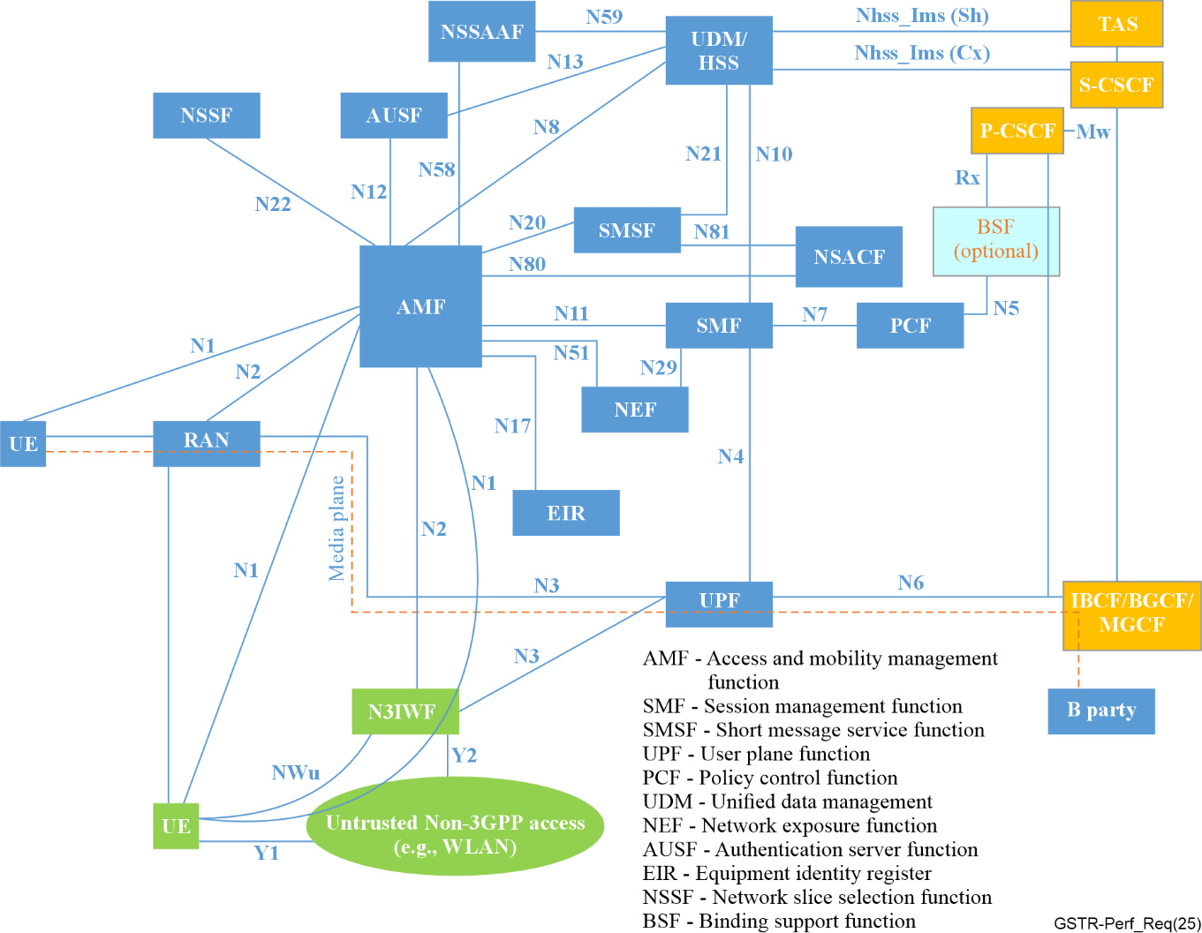
Figure 1 – 5G/IMS basic configuration
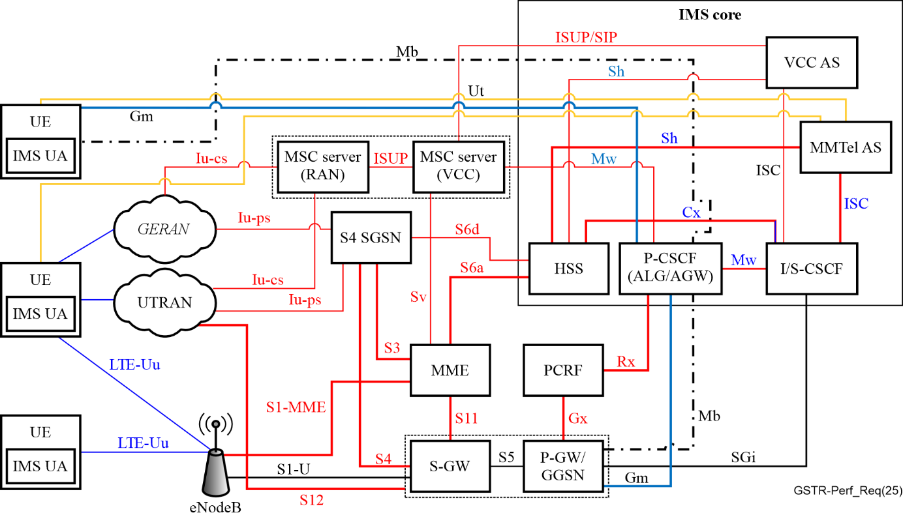
Figure 2 – IMS/LTE basic configuration
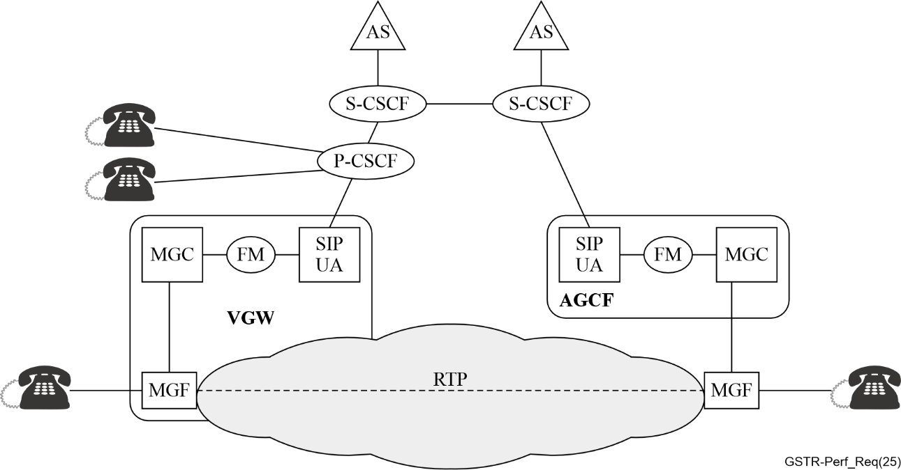
Figure 3 – IMS/PES configuration depicting the AGCF/VGW session processing models

9 Parameter requirements
IMS systems will comply with the requirements given in Tables 1 to 7. The timer designations used in this clause are, where possible, derived from [ITU-T Q.543] in order to ensure consistency with established exchange performance objectives. The corresponding performance values are adopted from [ETSI TS 101 563], providing a harmonized basis for defining IMS and PES parameter requirements in the context of modern IP-based and emulation environments.
The fields in the column Parameter [ITU-T Q.543] are left blank in cases where no corresponding definition is provided in [ITU-T Q.543]. In such cases, the parameters are described in the column IMS, PES equivalent.
Figure 4 illustrates the call request delay for a local analogue subscriber line using overlap sending, while Figure 5 shows the IMS transit time measured at MO-ASBC and MT-ASBC NNI.

Table 1 – IMS systems requirements for Local exchange call request delay
Meaning of timers | Parameter [ITU-T Q.543] | IMS, PES equivalent | Reference load A  [ETSI TS 101 563] |  | Reference load B  [ETSI TS 101 563]
 | Detailed description |  | Mean value | 95 % probability of not exceeding | 95 % probability of not exceeding
Local exchange call request delay – originating outgoing and internal traffic connections
ANALOGUE SUBSCRIBER LINES  Local exchange call request delay – originating outgoing and internal traffic connections. | Clause 2.3.2.1 of [ITU-T Q.543]  For ANALOGUE SUBSCRIBER LINES, the call request delay is defined as the interval from the instant when the off-hook condition is recognizable at the subscriber line interface of the exchange until the exchange begins to apply dial tone to the line. The call request delay interval is assumed to correspond to the period at the beginning of a call attempt during which the exchange is unable to receive any call address information from the subscriber. | PES [ETSI TS 183 043]  For ANALOGUE SUBSCRIBER LINES connected to the AGCF/ multi-service access node (MSAN).  Call request delay is defined as the interval from the instant when the off-hook condition is recognizable at the subscriber line interface of the AGCF/MSAN until the AGCF/MSAN begins to apply dial tone to the line. | ≤ 400 ms | ≤ 600 ms | ≤ 1 000 ms
ANALOGUE SUBSCRIBER with IAD (VGW)  Local exchange call request delay – originating outgoing and internal traffic connections. |  | PES [ETSI TS 183 043]  For ANALOGUE SUBSCRIBER LINES connected to the VGW.  Call request delay is defined as the interval from the instant when the off-hook condition is recognizable at the subscriber line interface of the VGW until the VGW begins to apply dial tone to the line. | ≤ 400 ms | ≤ 600 ms | ≤ 1 000 ms
IMS local exchange call request delay
IMS SUBSCRIBER  Local exchange call request delay. |  | IMS [ETSI TS 183 043]  Call request delay is defined as the interval from the instant at which the INVITE message has been received from the SIP subscriber until the 100 Trying from the SBC/ proxy call server control Function (P-CSCF) is passed back to the subscriber. | ≤ 11 ms | ≤ 98 ms | ≤ 98 ms
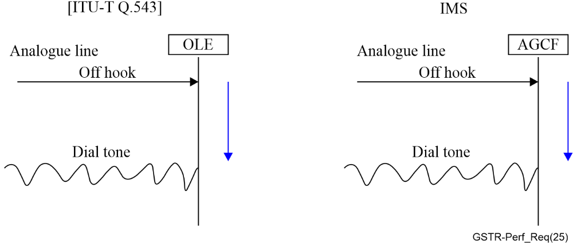
Figure 4 – Local exchange analogue subscriber call request delay: overlap sending
Table 2 – IMS systems requirements for analogue subscriber lines
Meaning of timers | Parameter [ITU-T Q.543] | IMS, PES equivalent | Reference load A  [ETSI TS 101 563] |  | Reference load B  [ETSI TS 101 563]
 | Detailed description |  | Mean value | 95 % probability of not exceeding | 95 % probability of not exceeding
ANALOGUE SUBSCRIBER LINES  Alerting sending  Delay for terminating traffic. | Clause 2.3.6.1.1 of [ITU-T Q.543]  For calls terminating on ANALOGUE SUBSCRIBER LINES, the alerting sending delay is defined as the interval from the instant when the last digit is available for processing in the exchange until the ringing tone is sent backwards toward the calling user. | PES [ETSI TS 183 043]  For calls terminating on ANALOGUE SUBSCRIBER LINES, the alerting sending delay is defined as the interval from the instant when the last digit is available for processing in the AGCF/MSAN until the ringing tone is sent towards the calling user. | ≤ 300 ms | ≤ 450 ms | ≤ 750 ms
Table 3 – IMS systems requirements for alerting delay
Meaning of timers | Parameter [ITU-T Q.543] | IMS, PES equivalent | Reference load A  [ETSI TS 101 563] |  | Reference load B  [ETSI TS 101 563]
 | Detailed description |  | Mean value | 95 % probability of not exceeding | 95 % probability of not exceeding
Alerting sending delay for internal traffic (the users are in same locations, controlled by same AGCF/VGW or P-CSCF)
ANALOGUE SUBSCRIBER LINES  Alerting sending  Delay for internal traffic. | Clause 2.3.6.2.1 of [ITU-T Q.543]  For calls terminating on ANALOGUE SUBSCRIBER LINES, the alerting sending delay is defined as the interval from the instant that the signalling information is available for processing in the exchange until the ringing tone is applied to an ANALOGUE calling subscriber. | PES [ETSI TS 183 043]  For calls terminating on ANALOGUE SUBSCRIBER LINES, the alerting sending delay is defined as the interval from the instant that the signalling information is available for processing in the AGCF/MSAN until thr ringing tone is sent towards the calling subscriber. | ≤ 300 ms | ≤ 450 ms | ≤ 750 ms
ANALOGUE SUBSCRIBER LINES  Alerting sending  Delay for internal traffic. |  | PES [ETSI TS 183 043]  For calls terminating on ANALOGUE SUBSCRIBER LINES, alerting sending delay is defined as the interval from the instant that the signalling information is available for processing in the media gateway (MGW) /VGW until the ringing tone is sent towards the calling subscriber. | ≤ 550 ms | ≤ 800 ms | ≤ 1 100 ms
VoLTE/VoNR measured at MO-ASBC and MT -ASBC NNI:  180 sending |  | VoLTE/VoNR [ETSI TS 183 043]  For calls terminating sending delay is defined as the interval from the instant that a 180 message at the VoLTE - user equipment (UE) interface has been received and 180 is sent on the VoLTE – UE towards the calling subscriber. | ≤ 46 ms | ≤ 68 ms | ≤ 68 ms
VoLTE measured at MO and MT UNI:  180 sending (NSA) |  | VoLTE [ETSI TS 183 043]  For calls terminating sending delay is defined as the interval from the instant that a 180 message at the VoLTE - UE interface has been received and 180 is sent on the VoLTE – UE towards the calling subscriber. | ≤ 60 ms | ≤ 82 ms | ≤ 82 ms
VoNR measured at MO and MT UNI:  180 sending (NSA) |  | VoNR  For calls terminating sending delay is defined as the interval from the instant that a 180 message at the VoNR – UE interface has been received and 180 is sent on the VoNR – UE towards the calling subscriber. | ≤ 60 ms | ≤ 82 ms | ≤ 82 ms
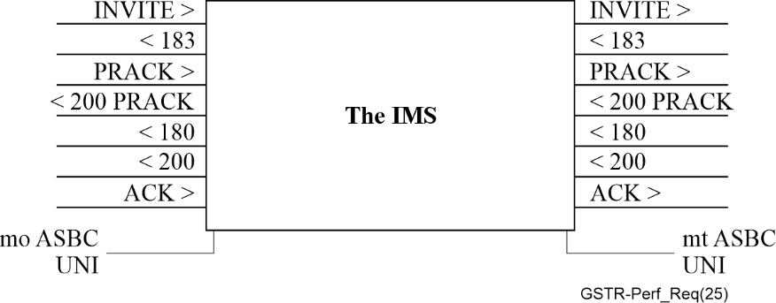
Figure 5 – IMS transit time measured at MO-ASBC and MT-ASBC NNI
Table 4 – IMS systems requirements for call setup delay
Meaning of timers | Parameter [ITU-T Q.543] | IMS, PES equivalent | Reference load A  [ETSI TS 101 563] |  | Reference load B  [ETSI TS 101 563]
 | Detailed description |  | Mean value | 95 % probability of not exceeding | 95 % probability of not exceeding
Call set up delay:
IMS SUBSCRIBER Call setup delay for landline networks. |  | IMS [ETSI TS 124 229]  Session initiation delay is defined as the interval from the instant when the INVITE signalling information is received from the calling user on the originating Gm interface until the instant when the corresponding INVITE signalling information is passed onto the terminating Gm interface to the called user. | ≤ 124 ms | ≤ 362 ms | ≤ 380 ms
Call set-up delay mobile subscriber |  | IMS [ETSI TS 124 229]  Session initiation delay is defined as the interval from the instant when the INVITE signalling information is received from the calling user on the originating A-SBC  until the instant when the corresponding INVITE signalling information is passed onto the terminating B-SBC interface to the called user. | ≤ 356 ms | ≤ 385 | ≤ 422
Table 5 – IMS systems requirements for call setup time (CST)
Meaning of timers | Parameter [ITU-T Q.543] | IMS, PES equivalent | Reference load A  [ETSI TS 101 563] |  | Reference load B  [ETSI TS 101 563]
 | Detailed description |  | Mean value | 95 % probability of not exceeding | 95 % probability of not exceeding
Call setup time (CST):
IMS SUBSCRIBER CST |  | Call setup time (CST) is the duration from when a call is made to the time of receiving a 180 ringing on the originating Gm interface. | ≤ 192 ms | ≤ 190 ms | ≤ 412 ms
Call setup time measured at MO-ASBC and MT-ASBC NNI: |  | VoLTE/VoNR  Call setup time (CST) is the duration from when a call is made to the time of receiving a 180 ringing. | ≤ 1 099 ms | ≤ 1 234 ms | ≤ 1 456ms
Call setup time measured at MO- and MT UNI |  | VoLTE  Call setup time (CST) is thhe duration from when a call is made to the time of receiving a 180 ringing.  MT UE being radio resource control (RRC) Connected (no paging needed) | ≤ 1 113 ms | ≤ 1 248 ms | ≤ 1 470 ms
Call setup time measured at MO- and MT UNI (NSA) |  | VoNR  Call setup time (CST) is the duration from when a call is made to the time of receiving a 180 ringing.  MT UE being RRC Connected (no paging needed) | ≤ 1 113 ms | ≤ 1 248 ms | ≤ 1 470 ms
Table 6 – IMS systems requirements for through-connection delay
Meaning of timers | Parameter [ITU-T Q.543] | IMS, PES equivalent | Reference load A  [ETSI TS 101 563] |  | Reference load B  [ETSI TS 101 563]
 | Detailed description |  | Mean value | 95 % probability of not exceeding | 95 % probability of not exceeding
Through-connection delay
IMS  Through-connection delay |  | IMS [ETSI TS 124 229]  The through-connection delay is defined as the interval from the instant that the 200 OK message is received from the called user at the terminating Gm interface until the through connection is established and available for carrying traffic, and the 200 OK message has been sent to the calling user on the originating Gm interface. | ≤ 46 ms | ≤ 52ms | ≤ 52 ms
IMS  Through-connection delay measured at MO-ASBC and MT-ASBC NNI: |  | IMS [ETSI TS 124 229]  The through-connection delay is defined as the interval from the instant that the 200 OK message is received from the called user at the terminating B-SBC interface until the through connection is established and available for carrying traffic, and the 200 OK message has been sent to the calling user on the originating SBC Interface. | ≤ 46 ms | ≤ 52ms | ≤ 52 ms
VoLTE (NSA) |  | VoLTE  The through-connection delay is defined as the interval from the instant that the 200 OK message is received from the called user at the terminating VoLTE – UE interface until the through connection is established and available for carrying traffic, and the 200 OK message has been sent to the calling user on the originating VoLTE – UE interface. | ≤ 60 ms | ≤ 66 ms | ≤ 66 ms
VoNR (NSA) |  | VoNR  The through-connection delay is defined as the interval from the instant that the 200 OK message is received from the called user at the terminating VoNR – UE interface until the through connection is established and available for carrying traffic, and the 200 OK message has been sent to the calling user on the originating VoLTE – UE interface. | ≤ 60 ms | ≤ 66 ms | ≤ 66 ms
Table 7 – IMS systems requirements for connection release delay
Meaning of timers | Parameter [ITU-T Q.543] | IMS, PES equivalent | Reference load A  [ETSI TS 101 563] |  | Reference load B  [ETSI TS 101 563]
 | Detailed description |  | Mean value | 95 % probability of not exceeding | 95 % probability of not exceeding
Connection release delay:
IMS SUBSCRIBER  Connection call release delay  delay for internal traffic, landline. |  | IMS [ETSI TS 124 229]  Connection release delay is defined as the interval from the instant when a BYE message is received at the originating or terminating Gm interface until the instant when 200OK is sent and a corresponding BYE message is sent at the terminating or originating Gm interface respectively. | ≤ 44 ms | ≤ 49 ms | ≤ 52 ms
VoLTEConnection call release delay  measured at MO-ASBC and MT -ASBC NNI: |  | IMS [ETSI TS 124 229]  Connection release delay is defined as the interval from the instant when a BYE message is received at the originating or terminating VoLTE – UE interface until the instant when 200OK is sent and a corresponding BYE message is sent at the terminating or originating SBC interface respectively. | ≤ 47 ms | ≤ 57 ms | ≤ 57 ms
VoLTE (NSA)  release delay  measured at MO- and MT UNI: |  | VoLTE  Connection release delay is defined as the interval from the instant when a BYE message is received at the originating or terminating VoLTE – UE interface until the instant when 200OK is sent and a corresponding BYE message is sent at the terminating or originating VoLTE – UE interface respectively. | ≤ 61 ms | ≤ 71 ms | ≤ 71 ms
VoNR (NSA)  release delay  measured at MO- and MT UNI: |  | VoNR  Connection release delay is defined as the interval from the instant when a BYE message is received at the originating or terminating VoLTE - UE interface until the instant when 200OK is sent and a corresponding BYE message is sent at the terminating or originating VoNR – UE interface respectively. | ≤ 61 ms | ≤ 71 ms | ≤ 71 ms

10 Call processing performance objectives
The call processing performance objectives specified in this clause are directly taken from [ITU-T Q.543]. These objectives ensure that IMS/PES/VoLTE/VoNR exchanges maintain the same reliability and operational integrity as defined for traditional digital exchanges.

11 Premature release
The probability that an exchange malfunction will result in the premature release of an established connection in any one-minute interval will be:
P ≤ 2 x 10⁻⁵

12 Release failure
The probability that an exchange malfunction will prevent the required release of a connection will be:
P ≤ 2 x 10⁻⁵

13 Incorrect charging or accounting
The probability of a call attempt receiving incorrect charging or accounting treatment due to an exchange malfunction will be:
P ≤ 10⁻⁴

14 Misrouting
The probability of a call attempt misrouted following receipt by the exchange of a valid address will be:
P ≤ 10⁻⁴

15 No tone 4
The probability of a call attempt encountering no tone following receipt of a valid address by the exchange will be:
P ≤ 10⁻⁴

16 Other failures
The probability of the exchange causing a call failure for any other reason not identified specifically above will be:
P ≤ 10⁻⁴

17 Transmission performance
The transmission performance requirements specified in this clause are adopted from [ITU-T Q.543]. They provide the baseline criteria to guarantee acceptable transmission quality across IMS/PES/VoLTE/VoNR exchanges, consistent with established standards for digital networks.

18 64 kbit/s switched connections
The probability of a connection being established with an unacceptable transmission quality across the exchange will be:
P ≤ 10⁻⁵
The transmission quality across the exchange is said to be unacceptable when the bit error ratio is above the alarm condition.
NOTE – In Recommendation ITU-T G.826, budgets of 18.5 % of 1.5 × 10−6 were allocated to each national network, so the packet loss for a national connection should be no more than 2.75 × 10−7.

19 Slip rate

20 Normal conditions
The slip rate under normal conditions is covered in [ITU-T Q.541].

21 Temporary loss of timing control
The case of temporary loss of timing control corresponds to the "holdover operation" defined and recommended in [ITU-T G.812]. The allowable slip rate will correspond to the maximum relative time interval error (TIE) also recommended therein.

22 Abnormal conditions at the exchange input
The slip rate in case of abnormal conditions (wide phase deviations, etc.) at the exchange input is the subject of further study taking into account the requirements of [ITU-T G.823].

23 RTP delay of EPC/5GC from A-SBC to B-SBC
In a 5G Core network, A-SBC and B-SBC play crucial roles in managing and routing multimedia sessions between users and external networks. When transcoding is involved, it implies the conversion of media streams from one codec format to another, typically to ensure interoperability or accommodate network requirements.
Real-time protocol (RTP) delay refers to the time taken for a packet containing audio or video data to travel from the access session border controller (A-SBC) to the border session border controller (B-SBC) within a 5G core (5GC) network, with transcoding occurring at the user network interface (UNI) side.
Table 8 presents the maximum values observed between two session border controllers (SBCs), which are determined by factors influencing RTP delay in this scenario. Such factors include network congestion, processing time required for transcoding, queuing delays at intermediate network elements, and propagation time across transmission links. Minimizing RTP delay is essential to ensure a high quality of experience (QoE) in real-time multimedia applications, such as voice communication and video conferencing, within the context of 5G core network architectures.
Table 8 – Maximum values determined by factors influencing RTP delay
Time delays incurred during transcoding and RTP packet transfer between SBCs | Reference load A  mean value (ms) | Reference load B  95 % probability of not exceeding (ms)
Transcoding delay at the SBC between the UNI side and NNI (AMR/G.711) | 80 | 100  See note
RTP Delay from ASBC to BSBC without transcoding on UNI side | 3 | 3
NOTE – T(plc) < 20 ms, T(jb) < 20.

24 End-to-end listening quality MOS-LQxF
The requirements for listening quality apply to both transmission directions.
Since IMS/PES/VoLTE/VoNR exchange implementations can safely be assumed to be capable of delivering end-to-end fullband voice services, the requirements are assessed on both
• the fullband scale for the MOS objective listening quality in fullband context (MOS-LQOF); and
• the fullband scale for the estimation of listening quality (MOS estimated listening quality in fullband context (MOS-LQEF)).
MOS objective listening quality (MOS-LQO) will be assessed in accordance with [ITU-T P.863] in conjunction with its application guide [ITU-T P.863.1]. The algorithm of [ITU-T P.863] must be used in the fullband mode.
NOTE 1 – [ITU-T P.863] in fullband mode takes into account bandwidth limitations by detecting the absence of any speech energy above 3.8 kHz to indicate a narrowband degraded file, and the absence of any speech energy above 7 kHz to indicate a wideband degraded file. With a narrowband signal the maximum achievable score is 3.8. The scale for mean opinion score (MOS) therefore is always from 1 to 5.
MOS estimated listening quality (MOS-LQE) will be assessed in accordance with [ITU-T G.107.2] in conjunction with equipment impairment factors equipment impairment factor (Ie) published in the Appendices I, IV and V of [ITU-T G.113]. The requirements for the E-model derived quality estimates will be given on the transmission rating scale of the fullband e-model which extends from R = 0 to R = 148 (This avoids re-transformation to the MOS scale).
NOTE 2 – Ie values for wideband codecs need to be scale-transformed according to the formula provided in Appendix V to [ITU-T G.113]. Ie values for narrowband codecs need to be scale-transformed by combining the formulae provided in in Appendix IV and Appendix V to [ITU-T G.113].
NOTE 3 – For the narrowband (NB) case described in [ITU-T G.107], the transmission rating scale ranges from R = 0 (lowest possible quality) to R = 100 (optimum quality). On this scale, a default NB transmission channel including logarithmic PCM coding obtains a rating of R = 93.2. For a wideband (WB) speech transmission channel, the quality is generally judged better than that for an NB channel. Thus, this scale range was extended in [ITU-T G.107.1] to a maximum value of R = 129 for a clean wideband (50 – 7 000 Hz) channel, as it is defined in [ITU-T G.722]. In the fullband (FB) case, this scale was further extended to R = 148 to reflect the even higher quality of the fullband (20 – 20 000 Hz) channel.
The requirements in the following section are subdivided into requirements for:
• end-to-end narrowband service
• end-to-end wideband services
• end-to-end fullband services (includes super-wideband).

25 Requirements for an end-to-end narrowband service
NB Sce. MOS-LQOF > 3.5
NB Sce. Transmission Rating R_{FB} > 90

26 Requirements for an end-to-end wideband service
Wideband (WB) service (Sce) MOS-LQOF > 3.9
WB Sce. Transmission Rating R_{FB} > 110

27 Requirements for an end-to-end fullband service
FB Sce. MOS-LQOF > 4.2
FB Sce. Transmission Rating R_{FB} > 130

______________

