|  |  |  |
| --- | --- | --- |
|  | | Standardization Sector |
| ITU-T Technical Report | |
| (02/2025) | |
|  | **QSTR-GDM** | |
|  | Guide on development and maintenance of open networking platforms (ONPs) and federations for IMT-2020 and beyond | |

|  |  |
| --- | --- |
| **ITUPublications** | **International Telecommunication Union** |



|  |
| --- |
| Technical Report ITU-T QSTR-GDM  Guide on development and maintenance of open networking platforms (ONPs) and federations for IMT-2020 and beyond  Summary  This Technical Report describes the concept of an open networking platform (ONP) as a special testbed built for the purpose of validating the fusion of multi-SDO/fora standards, harmonization, and trials on the use and interworking of the standards from different SDO/Fora that are the target for integration testing and harmonization objectives.  The Technical Report provides the definition of steps that can be pursued by the information and communication technology (ICT) industry towards developing, operationalizing and maintaining ONPs for IMT-2020 and beyond. One of the main aspects of this document is the use of the federated testbeds reference model and APIs (as a metamodel) to build ONPs. The case presented for ONPs in this present document should be treated as a special use case and an ICT industry requirement for testbeds federations for addressing driven by standards development organizations (SDOs) / Fora requirements specifically.  The industry (SDOs/Fora, 5G network operators, telecom equipment suppliers, enterprises, small and medium enterprises (SMEs), users) is in dire need of open networking testbeds (ONTs) for use in the validation of the fusion of multi-SDO/Fora standards, harmonization, and trials through industry-grade proving grounds testbeds. Unfortunately, most of the ONTs available (e.g., for 5G) are mainly suitable for research purposes only and are not built based on standards and for standards validations driven by SDOs/Fora standards-driven requirements as drivers for building the testbeds. From some viewpoints, the proposed ONTs and approach encourage standards -riven innovations – an approach that enables resultant solutions to be quickly accepted and consumed by the industry more readily than proprietary non-standards driven innovations that often face low intake due to their inability to integrate well with components built based on ICT industry standards. In fact, deployments involving evolving and new technologies often require multiple standards coming from different SDOs/Fora to be deployed and made to interwork with each other. Testbeds are a good instrument to deploy and interwork multi-SDO/Fora standards and validate their interworking so that any problems discovered can be communicated to the responsible SDOs/Fora responsible for the standards in order for issues to be resolved and for harmonization of the standards to take place.  What would help to achieve this goal is to creation of special testbeds in the form of ONPs that are built based on input and priorities from the Multi-SDOs/Fora pertaining to the standards that need to be interworked and tested at a particular timeframe, for which the SDOs/Fora need feedback from the test activities. ONPs can primarily serve this purpose as instruments for the validation of the fusion of multi-SDO/Fora standards, harmonization, and trials through industry-grade proving grounds testbeds, both standalone and federated testbeds. Secondly, they can also foster standards-driven innovation and help serve as a playground (proving ground) for network operators and enterprises (including small organizations that do not have resources to build their own testbeds) to try new technology in pre-deployment real use cases for 5G and beyond, based on ICT industry harmonized and cross-SDO/Fora fusion of standards within the ONP as the fundamental requirement and enabler.  The Technical Report also focuses on:  • The role of the testbeds federations reference model based on Recommendation ITU-T Q.4068 in designing ONPs and federating them as federated testbeds;  • The categories of stakeholders who can benefit from ONPs, with a focus on the benefits to specific stakeholders;  • The methods for maintenance and sustenance of ONPs. |
| NOTE 1 – ONP is a special use case for testbed federations. The work presented in this Technical Report on the concept of ONP and federation of ONPs is an example of a use cases for testbeds federations (along with other use cases compiled in ITU-T Technical Report QSTR-UCFTBS) as the case presented for ONPs is a special case for testbeds and federated testbeds requirement. ONPs should be treated as a special use case and industry requirement for testbeds federations.  NOTE 2 – ONP can also be used as a special "testbed-as a-service" (TaaS) – a concept described in Recommendation ITU-T Q.4078. There is a relationship between the TaaS concept and ONP concept in that an ONP can be viewed as a special case of TaaS.  NOTE 3 – In addition, ONP can benefit from insights derived from the IEEE 5G & Beyond Testbed Initiative (b‑IEEE-TI) and therefore, there is a need for ONP implementers to explore such initiatives in order to derive insights on how such a testbed and processes involved in its construction, use, and maintenance possess certain characteristics of relevance to consider when designing, building and using ONPs and federating them with other types of testbeds. |
|  |
| Keywords  APIs, IMT-2020, 5G, open networking platforms, playground, proving ground, testbed(s), testbeds federation, testbeds federations reference model. |

Note

This is an informative ITU-T publication. Mandatory provisions, such as those found in ITU-T Recommendations, are outside the scope of this publication. This publication should only be referenced bibliographically in ITU-T Recommendations.

Change Log

This document contains Version 1.0 of the ITU-T Technical Report QSTR-GDM "Guide on development and maintenance of ONPs (Open Networking Platforms) and federations for IMT-2020 and beyond" approved at ITU-T SG11 meeting held in Geneva from 19 to 28 February 2025.

|  |  |  |
| --- | --- | --- |
| **Editor**: | Martin Brand A1 Telekom Austria Austria | Email: [martin.brand@a1.at](mailto:martin.brand@a1.at) |
|  | Dr Sébastien Ziegler Mandat International Switzerland | Email: [sziegler@mandint.org](mailto:sziegler@mandint.org) |
|  | Cédric Crettaz, Mandat International Switzerland | Email: [ccrettaz@mandint.org](mailto:ccrettaz@mandint.org) |

© ITU 2025

All rights reserved. No part of this publication may be reproduced, by any means whatsoever, without the prior written permission of ITU.

**Table of Contents**

Page

1 Scope 1

2 References 1

3 Definitions 2

3.1 Terms defined elsewhere 2

3.2 Terms defined in this Technical Report 2

4 Abbreviations and acronyms 2

5 Introduction 2

6 Concept of ONP, its federations and deployment flavours 3

7 The role of the reference model for testbeds federations on design and implementation of ONPs 6

7.1 Overview of the reference model for testbed federation 6

7.2 Mapping blueprint of ONP with the reference model for testbed federation 7

7.3 Mapping of the reference model for testbed federation and ONP at stakeholders level (Run-Time) 8

8 Guide for stakeholders 9

8.1 Objectives 9

8.2 Benefits 9

9 Instruments suitable for sustainability in development and maintenance of ONPs 10

Bibliography 11

Technical Report ITU-T QSTR-GDM

Guide on development and maintenance of open networking platforms (ONPs) and federations for IMT-2020 and beyond

# 1 Scope

This Technical Report provides a guide on how to foster the development and maintenance of multi-standards development organization (SDO) / Fora standards-driven open networking platforms (ONPs) for standards-driven innovation, multi-SDO standards harmonization, and validation of pre-deployment technology use cases in international mobile telecommunications for 2020 (IMT-2020) and beyond, can be achieved.

The Technical Report may be used by deferent stakeholders for the following:

1) Steps and processes that should be pursued by the ICT industry towards developing and maintaining ONPs for IMT-2020 and beyond, and the use of the testbeds federations reference model defined in [ITU-T Q.4068] and application programming interfaces (APIs) for building ONPs;

2) Perspectives on how the ICT industry can engage SDOs/Fora that may be able to join the ecosystem around establishments funding, facilitation, exposure of ONPs to key targeted users, and maintenance of ONPs;

3) The nature and composition of ONPs required for certain scenarios;

4) How to build an ONP and identify barriers to be overcome;

5) How to enable the federation of multiple ONPs across administrative domains and geographical areas;

6) The need for funding schemes and how to leverage existing testbeds, while providing recommendations on how certain types of testbeds for IMT-2020 can be transformed to conform to the reference model for federated testbeds defined in [ITU-T Q.4068].

The stakeholders of this Technical Report include, but are not limited to, open source/hardware projects, SDOs/Fora, and R&D projects.

# 2 References

[[ITU-T Q.4068](https://handle.itu.int/11.1002/1000/14765)] Recommendation ITU-T Q.4068 (2021), *Open application program interfaces (APIs) for interoperable testbed federations.*

[[ITU-T Q.4078](https://handle.itu.int/11.1002/1000/16294)] Recommendation ITU-T Q.4078 (2025), *User requirements and reference model for testbed as a service.*

[ITU-T QSTR-UCFTBS] ITU-T QSTR-UCFTBS, *Use cases for Federated testbeds and business scenarios*.

[ETSI TR 103 747] ETSI TR 103 747, v.1.1.1 (2021-11), *Core Network and Interoperability Testing (INT/WG AFI); Federated GANA Knowledge Planes (KPs) for Multi-Domain Autonomic Management & Control (AMC) of Slices in the NGMN® 5G End-to-End Architecture Framework*.

[ETSI TS 103 195-2] ETSI TS 103 195-2 v.1.1.1 (2018-05), *Autonomic network engineering for the self-managing Future Internet (AFI); Generic Autonomic Network Architecture; Part 2: An Architectural Reference Model for Autonomic Networking, Cognitive Networking and Self-Management*.

# 3 Definitions

## 3.1 Terms defined elsewhere

None.

## 3.2 Terms defined in this Technical Report

None.

# 4 Abbreviations and acronyms

This Technical Report uses the following abbreviations and acronyms:

5GTTI 5G Trial and Testing Initiative

AMC Autonomic Management and Control

API Application Programming Interface

CSP Communications Service Provider

EC European Commission

FIRE Future Internet Research and Experimentation

FWA Fixed Wireless Access

GANA Generic Autonomic Networking Architecture

GENI Global Environment for Networking Innovations

ICT Information and Communication Technology

IMT-2020 International Mobile Telecommunications for 2020

IoT Internet of Things

ISV Independent Software Vendor

MEC Multi-Access Edge Computing

MoU Memorandum of Understanding

ONP Open Networking Platform

ONT Open Networking Testbeds

RAN Radio Access Network

SDO Standards Development Organization

SME Small and Medium Enterprise

TaaS Testbed-as-a-Service

# 5 Introduction

This Technical Report was developed to address the request for the development of a guide to serve as an ICT industry recommendation for fostering the development and maintenance of multi SDO/Fora standards-driven ONPs. At the ITU-ETSI-IEEE Joint SDOs Brainstorming Workshop [b‑ITU-Workshop-TBF-2021], the concept of ONPs was presented. In a simplified view, an ONP is to be considered as a playground (proving ground) for trying out new technology in pre-deployment real use cases for 5G and beyond, based on ICT industry harmonized and cross-SDO/Fora fusion of standards within theONP as the fundamental requirement and enabler, while leveraging as much as possible open-source and open hardware products to build an ONP.

The Technical Report also defines an ecosystem for establishing and maintaining standards-driven ONPs that are testbeds-oriented.

# 6 Concept of ONP, its federations and deployment flavours

An ONP maybe a single testbed or a group of testbeds that form a unified/integrated system (platform). Therefore, an ONP offers an opportunity for existing research-driven testbed platforms to be quickly aligned and onboarded into this operational and standard-based style to deliver immediate benefits to the industry with reduced overhead and shorter adaption cycles.

The building of ONPs needs to be driven by the need for multi-SDO/Fora standards fusion and by the testbeds federation reference model and APIs defined in [ITU-T Q.4068]. Being "open" in an ONP means providing an easily and openly accessible facility (testbed) for innovators to integrate deployment-ready (production-level quality) products and services, as well as for testers based on a non-restrictive access policy to users (though with clear procedures defined for access and use of the facility). It also means enabling open access for voluntary contributors of software and hardware components (mainly open software and open hardware, but also commercial products where necessary) to contribute to the ONP platform for non-commercial objectives.

Figure 1 shows an example of processes that can be involved in the build, operation and maintenance of an ONP and provides a detailed ONP ecosystem (environment) and its interactions with its building blocks as key components. It also identifies the main actors and their roles in this ecosystem. It should be noted that such an ecosystem is not rigid: rather, it is flexible and allows for the continuous onboarding of new actors that bring assets or consume offered services under a profitable business model and sharing created value.

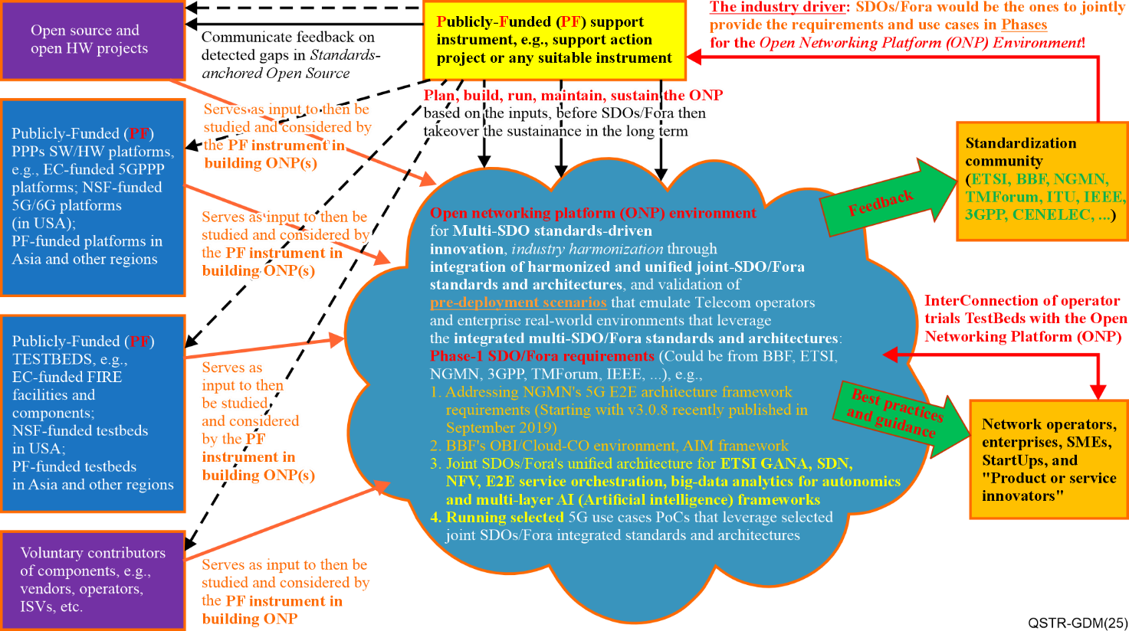

Figure 1 – ONP ecosystem

Table 1 lists and describes the key building blocks of the ONP ecosystem, as along with the involved actors and associated roles within this ONP ecosystem. It also includes "touch points" where interactions between building blocks take place for value creation and sharing, service delivery and insights exchange.

Table 1 – Key building blocks and actors of the ONP ecosystem

| ONP building block Name | Description | Actor(s) and their role(s) | Interface for interactions |
| --- | --- | --- | --- |
| Sustainable instrument (project)  "touch point A" | The following processes are executed: THINK, BUILD, RUN, MAINTAIN, SUSTAIN | Take care of the processes associated with ONP operationalization. This could be the owner of ONP himself or herself, but not necessarily | A to C  A to F |
| ONP environment  "touch point C" | Core component, built under a consensus-driven multi-SDO approach (multi-standards-based packages).  Operational test scenarios and test cases  Validation framework | Governor / administrator / owner of the ONP (consensus based, or voting model-based approach) | C to F  C to G |
| Open source and open hardware projects  "touch point D" | Open-source assets | Open-source communities | D to C |
| Government funded testbeds (EC, NSF / US, Asia)  "touch point X" | Assets of relevance | Project leaders and experts | X to C |
| Voluntary contributors of components  "touch point E" | Components from their product offering catalogues | Operators, communications service providers (CSPs), independent software vendors (ISVs), telecom products and service suppliers, OSS vendors | E to C |
| Standards in various areas (networks, services, operations and maintenance, security, ….)  "touch point F" | Standards and other published standardized frameworks, requirements, business scenarios, use cases, with the exception of feedback on gaps and errors detected during the testing and validation process undertaken once the ONP is instantiated and operationalized | All SDOs / for a (no restriction)  They play role of "prosumers". They provide standards and consume results emerged after validation of their standards by ONP | F to C  F to A |
| Commercial products and services, testbeds  "touch point G" | They expect to consume takeaways and best practices emerging from ONP operationalizing their assets, to help them fine-tune their product lines and product offering catalogues | Network operators, SMEs, enterprises, startups, products and services innovators | G to C |

The characteristics of a desirable multi-SDO/Fora standards-driven ONP are listed and described in Table 2.

| Table 2 – Key characteristics of the ONP platform | |
| --- | --- |
| ONP platform characteristic # | Description |
| ONP platform characteristic # 1  "ONP as manageable and federable ecosystem per design" | 1) An ONP is specifically designed and built to be a manageable ecosystem that can be considered as a testbed platform for enabling IMT-2020 and beyond, and can be federated with other platforms of relevant value, e.g., ICT industry-grade IMT-2020 platforms provided by some testbeds owners. |
| ONP platform characteristic # 2  "ONP as neutral environment" | 2) An ONP is a neutral environment intended to be an open integration and test platform enabling the testing of certain targeted standards fusions and use cases from the SDOs/Fora that provide inputs for the fusion of standards selected for integration and validation at a particular time. |
| ONP platform characteristic # 3  "ONP is built upon *glass box and **black box"  *open source  **commercial | 3) An ONP should be built upon open-source and open hardware products as much as possible, while allowing open contributions of commercial products when necessary, but not necessarily for commercial purposes. |
| ONP platform characteristic # 4  "interoperability of ONPs" | 4) An ONP is intended to enable standards interoperability and to provide an easily and openly accessible facility for innovators to integrate deployment-ready (production-level quality) products and services, as well as for testers. |
| ONP platform characteristic # 5  "ONP governance" | 5) An ONP should be governed by the standards community (SDOs/Fora) and open-source and open hardware projects involved. |
| ONP platform characteristic # 6  "ONP as muti-stakeholders / multi-SDO platform" | 6) An ONP can be a multi-stakeholder co-funded open platform environment that is built and tested to specifically support the requirements and use cases of collaborating standardization/industry communities (taking a phased approach to accommodating multi-SDOs/Fora and requirements for multi-SDO/Fora standards fusions and validations and harmonization). |
| ONP platform characteristic # 7  "ONP as service broker to various stakeholders" | 7) An ONP helps network operators, telecom equipment suppliers, enterprises, SMEs and startups obtain realistic and practical guidance on how to use harmonized standards and frameworks, and open platforms (including open source/hardware and commercial platforms) for business innovation, products and services innovation; and guidance on how to create cost-effective approaches to creating migration paths from complex legacy networks. |
| ONP platform characteristic # 8  "ONP as scalable and sustainable platform" | 8) An ONP should accommodate an increasing number of use cases and enablers for IMT-2020 and beyond once it has been established. NOTE – The SDOs/Fora communities attended the ITU-ETSI-IEEE Workshop [b-ITU-Workshop-TBF-2021] expressed interest to the ONP platforms. |
| ONP platform characteristic # 9  "OBP as playground to various stakeholders" | 9) An ONP is considered a playground (proving ground) for trying out pre-deployment use cases by network operators, enterprises and even SDOs/Fora based on industry harmonized and cross-SDO/Fora interworking standards (in order to implement cross-SDO industry harmonization of multi-SDO/Fora standards). |
| ONP platform characteristic # 10  "ONP offers "test-as-a-service" | 10) ONPs can benefit smaller operators and SMEs that do not have the capital to invest in testbeds facilities for standards based products innovations and testing. |
| ONP platform characteristic # 11  "ONP exhibits both global and single view" | 11) A federation of ONPs should be viewed as global testbed(s) platform but a single ONP should have a central location (hosted by one of the partners selected for that role). |

NOTE 1 – This guide shall also serve to offer guidance to IMT-2020 and beyond industrial and research projects on how to use the testbeds federations reference model defined in [ITU-T Q.4068] to contribute to the development of the APIs prescribed by the testbeds reference model and also contribute to various instantiations cases of the reference model in the development of ONPs.

NOTE 2 – The concept of ONPs and the testbeds federations reference model [ITU-T Q.4068] and its APIs have great potential to capitalize on the achievements and investments made by the publicly funded R&D Projects as examples in Europe, USA, Asia and others (e.g., software platforms, such as EC 5GPPP Platforms [b-EC-5GPP]) and testbeds facilities like Fed4FIRE [b-Fed4Fire], global environment for networking innovations (GENI) [b-GENI], etc. by fostering the contributions of certain components from such facilities into the building process for ONPs.

# 7 The role of the reference model for testbeds federations on design and implementation of ONPs

## 7.1 Overview of the reference model for testbed federation

Figure 2 shows the generic model for testbeds federations as defined in [ITU-T Q.4068].

The concept of an ONP maps to the testbed domain concept in general, or at a lower level of granularity and abstraction, it could represent a composition of a level-1 resource in combination with an integrated set of level-0 resources, or it could represent a level-0 resource.

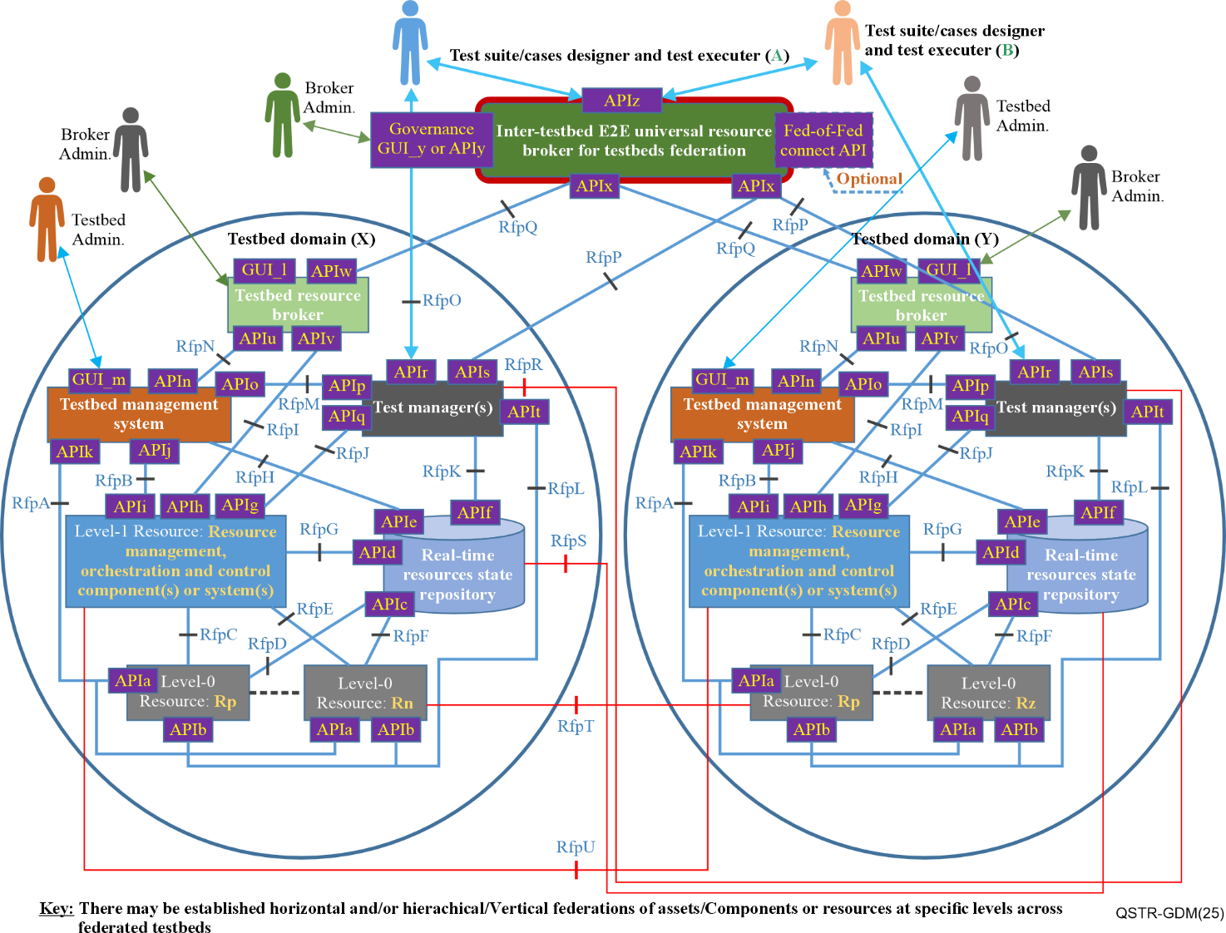

Figure 2 – Generic federated testbed model (ref. [ITU-T Q.4068])

## 7.2 Mapping blueprint of ONP with the reference model for testbed federation

Figure 3 shows a mapping blueprint to compare and contrast the reference model for testbed federation defined in [ITU-T Q.4068] with the ONP model.

It is built upon various perspectives described in the previous figures and tables.

• Building blocks

• Touch points vs reference points / APIs / GUI

• Actors and their roles

• Characteristics

• Interactions

• Interactions

• Business scenarios

• Use cases

• Business models

• Business canvas

• Others

This mapping blueprint (as a design blueprint) can be instantiated and mechanized onto various real-time implementations for various use cases, needs and purposes.

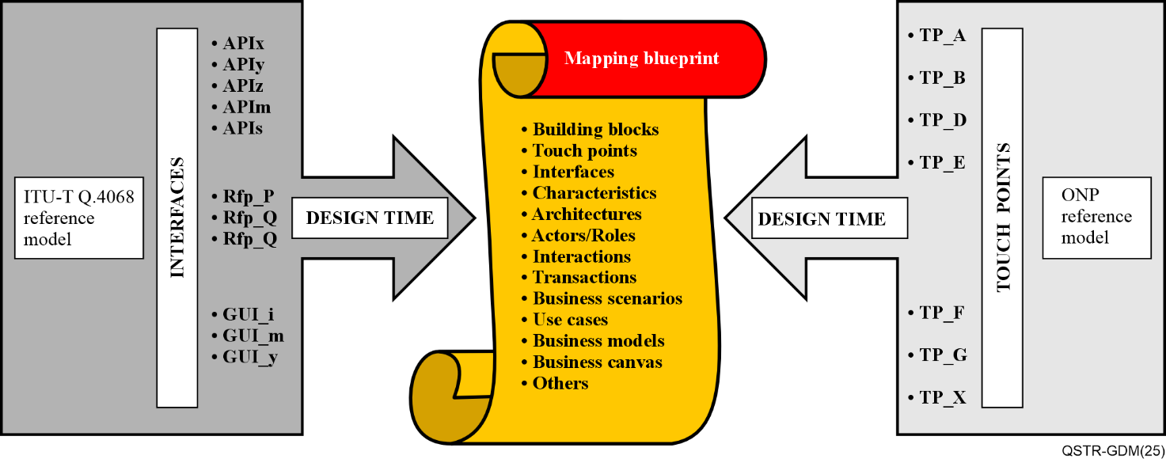

Figure 3 – Mapping blueprint on comparison of the reference model for testbed federation [ITU-T Q.4068] with ONP reference model

NOTE – To make this mapping blueprint easy to use, it needs to be automated, meaning populated using a "machine readable" language such as JSON. Once operationalized, the outcome can be translated or made available in a human understandable language, exposing directly interpretable and consumable indicators upon expected purposes. This aspect is useful but goes beyond the design blueprint and is not in the scope of this Technical Report. It pertains to the tooling development aspect.

## 7.3 Mapping of the reference model for testbed federation and ONP at stakeholders level (Run-Time)

This mapping aims at leveraging the reference model's [ITU-T Q.4068] well-defined stakeholder roles in order to prevent specific definitions of such common roles in the ONP space. An ONP can be seen or viewed from the reference model perspective [ITU-T Q.4068] as a specific reference implementation. The mapping exercise is a pre-requisite to make the ONP aligned to maximize the benefit it gets from reference model [ITU-T Q.4068] as standard.

Figure 4 depicts this mapping of the blueprint at the real-time phase.

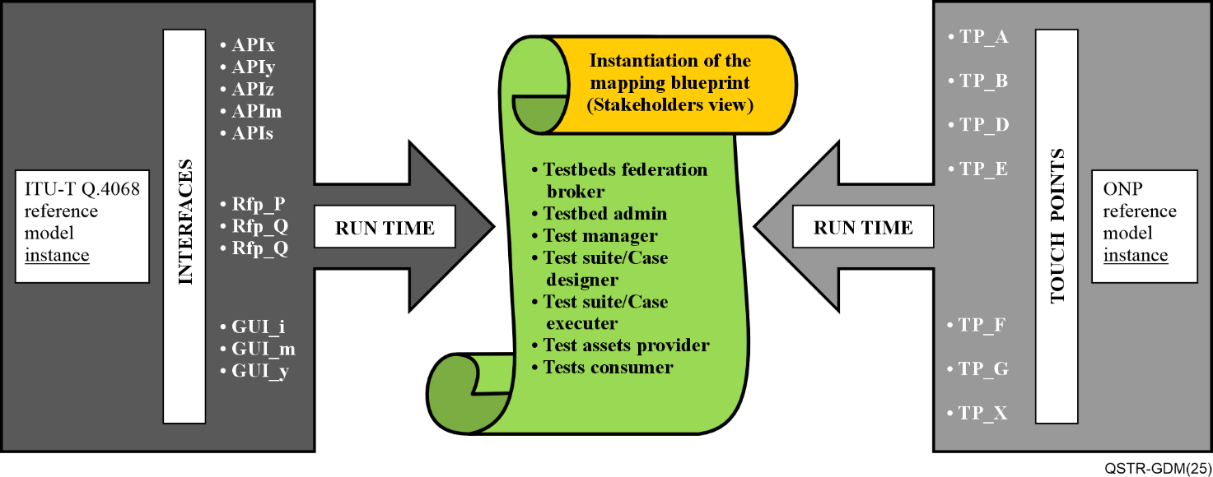

Figure 4 *–* Mapping of the blueprint at real-time phase

# 8 Guide for stakeholders

## 8.1 Objectives

This part focuses on selected types of ONPs in order to illustrate how this Technical Report can be exercised and used, e.g., federation of ONPs for converged access networks that include the fixed wireless access (FWA) and cable network architectures and their associated autonomic management and control (AMC) ETSI generic autonomic networking architecture (GANA) KP [ETSI TS 103 195-2], as well as multi-access edge computing (MEC) edge and transport networks for 5G networks and their associated AMC ETSI GANA KP as illustrated in [ETSI TR 103 747].

The variety of testbeds that can be built as ONPs and federated means bringing various SDOs/Fora and open source and open hardware projects closer together in standards validation, harmonization and standards-driven innovation, due to ONPs concept and [ITU-T Q.4068].

## 8.2 Benefits

This Technical Report is bound to offer the following value:

• Serve as a guiding blueprint for promoting the idea of developing and maintaining ONPs for 5G and beyond by SDOs/Fora and other stakeholders such as open-source projects and open hardware projects/forums. This also opens opportunities for industry to invest more in open platforms that enable SMEs to enhance their business models by leveraging the ONPs ecosystem or by contributing to the development of the ONPs ecosystem that enables them to innovate, develop and test products and bring them to market much faster due to ONPs.

• Serve to offer guidance to research communities and ICT industry working on 5G and beyond on how to use the testbeds reference model [ITU-T Q.4068] to contribute to the development of the APIs prescribed by the testbeds reference model, and also contribute to various instantiations cases of the reference model in the development of ONPs. The concept of ONPs and the testbeds reference model and its APIs have great potential to capitalize on the achievements and investments made by public funding organizations by fostering the contributions of certain components from such facilities into the building process for ONPs while conforming to the testbeds reference model [ITU-T Q.4068]. That enables interoperability and federation of testbeds of varying types of testbeds for Internet of things (IoT), RAN (radio access network), MEC (multi-access edge computing), transport network, core network, data centre, industrial Internet, etc.

• Help the ICT industry to identify regulatory aspects and security implications of relevance to ONPs federations and engage the relevant stakeholders to address such aspects.

• Shed light on roles that research communities and the ICT industry (solutions vendors/suppliers, CSPs, enterprises, and SDOs/Fora can play in this desired ecosystem on ONPs that should be built based on the reference model [ITU-T Q.4068] now and into the future. The softwarization and disaggregation of ICT networks, 5G and beyond trends benefit from ONP's concept. Open-source and open hardware projects/forums can help contribute to the building of ONPs testbeds that conform to the testbeds federation reference model and its associated APIs [ITU-T Q.4068]. Open-source and open hardware projects can also make efforts on the instantiations of the testbeds federations reference model in building industry-grade new testbeds and/or perform transformations of existing Testbeds to meet such requirements and provide testbed-as-a-service (TaaS) service offering.

NOTE – SMEs and independent software vendors (ISVs) can build business models/products based on the concept of ONPs, because there is a huge potential for some SMEs and ISVs to tap into becoming integrators of testbeds ONPs and offer TaaS business model in cases where certain ONPs may require users to pay administrative fee for accessing and using the ONP.

# 9 Instruments suitable for sustainability in development and maintenance of ONPs

This clause provides examples of potential instruments suitable for sustainability in development and maintenance of ONPs.

There are two categories of stakeholders who could play a role in providing instruments (that include testbeds facilities and/or funding for testbeds build and maintenance):

a) Instruments under the leadership and control of institutions-driven stakeholders.

The following instruments are useful for consideration, though limited to these. They could be potential candidates for sustaining the ONP the ecosystem:

• Funded projects (e.g., public funded projects);

• Government-funded initiatives (e.g., government funded projects);

• Cross-government/standardization/standards-driven innovation projects

b) Neutral SDOs/Fora or other kinds of organizations could play some role. The following bodies seem appropriate as examples:

• TM Forum established a concept named "catalyst" instrument (playground) [b-TMF-Catalyst] that brings together stakeholders (CSPs, ICT solutions suppliers, OSS vendors, ISVs, SMEs, start-ups, consumers, regulators) for trying out and testing products and solutions to help industry to mature new technologies faster;

• The European Telecommunications Standards Institute (ETSI), through its plug test instrument [b-ETSI-PT] could also play such a host role of the ONP and its sustainability;

• NGMN, through its 5G trial and testing initiative (5GTTI) projects [b-NGMN-5GTTI-1] assets that could possibly be availed for the use of building and maintaining ONPs. This also enables to take into consideration the experiences and ideas advanced by TTI projects [b-NGMN-5GTTI-2], [b-NGMN-5GTTI-3].

• Joint SDO/multi-SDO instrument as part of an established memorandum of understanding (MoU) (that needs to be created or updated and extended for this ONP sustainability matter).

• ONP implementers could possibly leverage and explore in order to derive insights from the 5G platform built by IEEE 5G testbed initiative [b-IEEE-TI], as the platform supports federation or testbeds interconnect capabilities. Also, IEEE 5G platform [b-IEEE-TI] testbed and processes involved in its build, its use and maintenance present certain characteristics of relevance to consider when designing, building and using ONPs and federating them with other types of testbeds.

Other enablers for sustainability of the ONP ecosystem include having users with non-free access for using an ONP facility.

Bibliography

[b-EC-5GPP] EC-5GPP. <https://5g-ppp.eu/>

[b-ETSI-PT] <https://www.etsi.org/events/plugtests>;

[b-Fed4Fire] Fed4FIRE+ project. <https://www.fed4fire.eu/>

[b-GENI] GENI website. [https://www.geni.net/.](https://www.geni.net/)

[b-IEEE-TI] <https://futurenetworks.ieee.org/topics/5g-testbed>

[b-ITU-Workshop-TBF-2021] ITU-ETSI-IEEE Joint SDOs Brainstorming Workshop on Testbeds Federations for 5G and Beyond: Interoperability, Standardization, Reference Model and APIs, <https://itu.int/go/BTF4-5G>

[b-NGMN-5GTTI-1] <https://www.ngmn.org/wp-content/uploads/221216-Definition-of-the-Testing-Framework-for-the-NGMN-5G-Trial-and-Testing-Initiative-Phase-2_v1.8.pdf>

[b-NGMN-5GTTI-2] <https://www.ngmn.org/publications/pre-commercial-networks-trials-major-conclusions-v2.html>

[b-NGMN-5GTTI-3] <https://www.ngmn.org/publications/definition-of-the-testing-framework-for-the-ngmn-5g-tti-interoperability.html>

[b-TMF-Catalyst] <https://www.tmforum.org/catalysts/join-in/>

___________