|  |  |  |
| --- | --- | --- |
|  | | Standardization Sector |
| ITU-T Technical Report | |
| (02/2025) | |
|  | **QSTR-TFR** | |
|  | Testbeds federation roadmap | |

|  |  |
| --- | --- |
| **ITUPublications** | **International Telecommunication Union** |



|  |
| --- |
| Technical Report ITU-T QSTR-TFR  Testbeds federation roadmap |

|  |
| --- |
| Summary  This Technical Report specifies the index and its relation to ITU-T Recommendations and Technical Reports concerning federated testbeds. |

|  |
| --- |
| Keywords  Federation, index, reports, roadmap, specifications, testbeds. |

Note

This is an informative ITU-T publication. Mandatory provisions, such as those found in ITU-T Recommendations, are outside the scope of this publication. This publication should only be referenced bibliographically in ITU-T Recommendations.

Change log

This document contains Version 1.0 of the ITU-T Technical Report QSTR-TFR "Testbeds federation roadmap" approved at ITU-T Study Group meeting held in Geneva from 19 to 28 February 2025.

|  |  |  |
| --- | --- | --- |
| **Editors:** | Martin Brand A1 Telekom Austria Austria | Email: [martin.brand@a1.at](mailto:martin.brand@a1.at) |
| Dr Sébastien Ziegler Mandat International Switzerland | E-mail: [sziegler@mandint.org](mailto:sziegler@mandint.org) |
| Cédric Crettaz, Mandat International Switzerland | E-mail: [ccrettaz@mandint.org](mailto:ccrettaz@mandint.org) |

© ITU 2025

All rights reserved. No part of this publication may be reproduced, by any means whatsoever, without the prior written permission of ITU.

**Table of Contents**

Page

1 Scope 1

2 References 1

3 Definitions 1

3.1 Terms defined elsewhere 1

3.2 Terms defined in this Technical Report 1

4 Abbreviations and acronyms 1

5 Reference model and mapping of the ITU-T Recommendations and Technical Reports related to federated testbeds 2

Technical Report ITU-T QSTR-TFR

Testbeds federation roadmap

# 1 Scope

The scope of this roadmap is to provide an overall index and its relation to the ITU-T Recommendations and Technical Reports on testbeds federations for IMT-2020 and beyond.

The stakeholders are encouraged to use it for arranging a proof-of-concept.

# 2 References

[[ITU-T Q.4068](https://handle.itu.int/11.1002/1000/14765)] Recommendation ITU-T Q.4068 (2021), *Open application program interfaces (APIs) for interoperable testbed federations.*

[[ITU-T Q.4076](https://handle.itu.int/11.1002/1000/16292)] Recommendation ITU-T Q.4076 (2025), *Evolution of the testbeds federations reference model.*

[[ITU-T Q.4077](https://handle.itu.int/11.1002/1000/16293)] Recommendation ITU-T Q.4077 (2025), *Testbed as a service application program interfaces descriptions and interoperability requirements.*

[[ITU-T Q.4078](https://handle.itu.int/11.1002/1000/16294)] Recommendation ITU-T Q.4078 (2025), *User requirements and reference model for testbed as a service.*

[ITU-T QSTR.FTT] Technical Report ITU-T QSTR.FTT, *Federated testbeds taxonomy.*

[ITU-T QSTR-GDM] Technical Report ITU-T QSTR-GDM, *Guide on development and maintenance of ONPs (Open Networking Platforms) and federations for IMT-2020 and beyond.*

[ITU-T QSTR-UCFTBS] Technical Report ITU-T QSTR-UCFTBS, *Use cases for federated testbeds and business scenarios.*

[ITU-T QSTR-USO] Technical Report ITU-T QSTR-USO, *Use of open-source and open hardware projects/products in testbed federations for IMT-2020 and beyond*.

# 3 Definitions

## 3.1 Terms defined elsewhere

This Technical Report uses the following term defined elsewhere:

**3.1.1** **testbed** [ITU-T Q.4068]: Platform to realise scientific tests with new technologies on an environment fully controlled by experimenters.

## 3.2 Terms defined in this Technical Report

None.

# 4 Abbreviations and acronyms

This Technical Report uses the following abbreviations and acronyms:

API Application Programming Interface

GUI Graphical User Interface

ICT Information and Communication Technology

IMT-2020 International Mobile Telecommunications for 2020

MEC Multi-access Edge Computing

ONP Open Networking Platform

RAN Radio Access Network

Rfp Reference Point

SDO Standards Developing Organization

# 5 Reference model and mapping of the ITU-T Recommendations and Technical Reports related to federated testbeds

The reference model is defined in [ITU-T Q.4068]. Figure 1 shows the generic federated testbed model [ITU-T Q.4068].

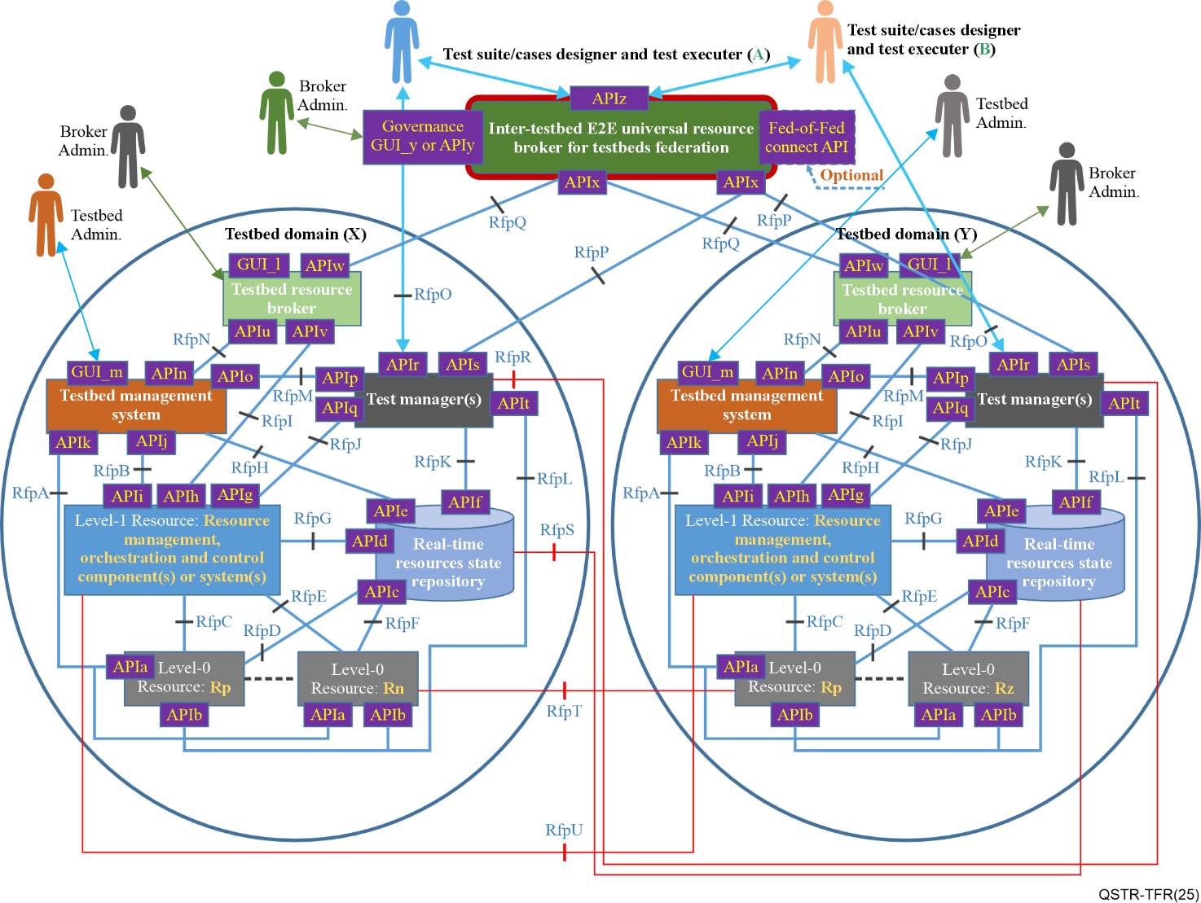

Figure 1 – Generic federated testbed model [ITU-T Q.4068]

More specifically, the primary objectives and the scope of the ITU-T Recommendations and Technical Reports focus on the reference points and interfaces relevant for the federated testbeds, as shown in Table 1 (the other application programming interfaces (APIs) and reference points are also relevant but were outside of FG-TBFxG scope). Among the requirements for APIs, the FG-TBFxG considered the following reference points: (Rfp) RfpO, RfpP, RfpQ, RfpR, RfpS, RfpT, RfpU, APIr, APIs, APIw, APIx, APIy / graphical user interface (GUI)_y, APIz.

| Table 1 – Scope of the ITU-T Recommendations and Technical Reports relevant for the federated testbeds | |
| --- | --- |
| Title | Scope |
| **ITU-T Technical Report QSTR.FTT**: Federated testbeds taxonomy | This ITU-T Technical Report contains all the terms and their definitions used in the context of testbeds federation. It provides references to the ITU-T Recommendations and other references defining existing terms related to testbeds federations. The sources of the definitions are published ITU-T Recommendations and other standards issued by other standards developing organizations (SDOs). This ITU-T Technical Report presents the taxonomy for federated testbeds. |
| **ITU-T Technical Report QSTR-TFR**: Testbeds federation roadmap | The scope of this roadmap is to provide an overall index and relationship of the ITU-T Recommendations and Technical Reports on testbeds federations for international mobile telecommunications for 2020 (IMT-2020) and beyond.  The stakeholders are encouraged to use it for arranging a proof-of-concept. |
| **ITU-T Technical Report QSTR‑UCFTBS**: Use cases for federated testbeds and business scenarios | This Technical Report serves as a guide for extracting the target functionality of available use cases on testbeds and their federations, and mapping them to different segments (e.g., network segments as multi-access edge computing (MEC), Core, radio access network (RAN), transport). The use cases descriptions (e.g., requirements, features, challenges, key performance indicators (KPIs), etc.) are used for developing general requirements for APIs to be used in testbed federations. |
| **Recommendation ITU-T Q.4078**: User requirements and reference model for testbed as a service | This ITU-T Recommendation defines the user requirements and reference model for testbed as a service (TaaS). It defines the specific requirements for TaaS from the user's perspective. This Recommendation describes the interconnection of testbeds through the testbed management system. Other aspects like business, polices and monetization are taken into account in this Recommendation. The Recommendation is also leveraging the experience and results gained by international research projects in this domain, such as F-Interop, Fed4FIRE+, PAWR, and SLICES. |
| **Recommendation ITU-T Q.4077**: Testbed as a service application program interfaces descriptions and interoperability requirements | This document describes the testbed as a service APIs and interoperability requirements. The APIs specified in this document are dedicated exclusively to TaaS. Integration, interoperability and extensibility of the TaaS are also studied in this Recommendation. |
| **Recommendation ITU-T Q.4076**: Evolution of the testbeds federations reference model | The scope covers the following items that complement topics covered in [ITU-T Q.4068]:  • "APIs Invocations Framework" that clarifies how generic APIs invoke testbed-specific APIs.  • Workflow scenario illustration involving a user accessing and using a testbeds federation ecosystem based on the testbeds federation reference model APIs defined in [ITU‑T Q.4068] and the extensions listed in this Recommendation.  • Security framework that should be applied to the testbeds federations reference model defined in [ITU-T Q.4068].  A guide on how to perform instantiations of the testbeds federation reference model [ITU-T Q.4068] in creating testbeds that exhibit the capability to federate with other testbeds due to their conformance to the "*Testbed domain concept*" prescribed by the reference model defined in [ITU‑T Q.4068] and to their implementation of APIs for federation of testbeds. Guiding illustrations on how instantiations of the testbeds federation reference model [ITU‑T Q.4068] should be carried out by the global community. It also serves as a guide to transforming existing testbeds so that they conform to the *testbed domain concept* prescribed by the reference model and to their implementation of APIs for federation of testbeds. It serves as a guide to testbeds owners and developers on how to apply the reference model [ITU-T Q.4068] in clean-slate or greenfield development of testbeds. It also provides testbed developers/implementers with guidance on how transformations or enhancements/evolutions may be pursued by the global community to make existing IMT-2020/5G related testbeds APIs fit or conform to the testbeds federation reference model [ITU-T Q.4068] and its "APIs invocations framework".  • Important KPIs for framing and capturing the performance of federated testbeds as individual testbeds and testbeds federations themselves. Several KPI categories are covered in relation to federated testbeds, including availability and resilience KPIs, cost/performance related KPIs, and testbed services KPIs. The KPIs, as outlined in this document, capture the essential features and requirements necessary to make federation of testbeds successful from a technical/utility as well as business/commercial point of view. As such, important KPIs for framing and capturing the performance of federated testbeds and testbeds federations themselves are defined in this document. KPIs specific to federation of testbeds help assess the sustainability of testbeds federations ecosystem from the perspective of technical/utility as well as business/commercial point of view. |
| **ITU-T Technical Report QSTR‑GDM**: Guide on development and maintenance of ONPs (Open Networking Platforms) and federations for IMT-2020 and beyond | The Technical Report provides a guide on how to foster the development and maintenance of multi SDO/Fora standards‑driven open networking platforms (ONPs) for standards-driven innovation, multi-SDO standards harmonization, and validation of pre-deployment technology use cases in IMT-2020 and beyond, which can be achieved.  The Technical Report might be used by different stakeholders for the following:  1) Steps and processes that should be pursued by the ICT industry towards developing and maintaining ONPs for IMT-2020 and beyond, and the use of the testbeds federations reference model defined in [ITU-T Q.4068] and APIs in building ONPs;  2) Perspectives on how information and communication technology (ICT) industry can engage SDOs/Fora which may be able to join the ecosystem around establishments, funding, facilitations, exposure of ONPs to key targeted users, and maintenance of ONPs;  3) The nature and composition of ONPs required for certain scenarios;  4) How to build an ONP and identify barriers to overcome;  5) How to enable the federation of multiple ONPs across administrative domains and geographical areas;  6) The needs for funding schemes and how to leverage existing testbeds, while providing recommendations on how certain types of testbeds for IMT-2020 can be transformed to conform to the reference model for federated testbeds defined in [ITU-T Q.4068].  The stakeholders of this Technical Report are not limited to open source/hardware projects, SDOs/Fora, R&D projects. |
| **ITU-T Technical Report QSTR-USO**: Use of open-source and open hardware projects/products in testbed federations for IMT-2020 and beyond | This Technical Report is to serve as a guide on the use of open‑source and open hardware projects/products in testbed federations for IMT-2020/5G and beyond that conform to the reference model for testbeds federations [ITU-T Q.4068] and its APIs.  In applying this Technical Report when considering open-source and open hardware in building testbeds and implementing the federation of the testbeds, it is also necessary to consider existing testbeds that may be easy to adopt and enhance with the open source and open hardware-based components, while at the same time transforming the existing testbeds to conform to the testbeds federation reference model [ITU-T Q.4068]. Use cases (listed in QSTR-UCFTBS) for testbeds federations should also be taken into account when applying the Technical Report. Not only adopting existing testbeds where possible, but also considering applicable test scenarios, test specifications or test plans that may also be available from certain communities such as standards development organizations (SDOs) or Fora. |

______________